Name :David Babarinde Class pays 213 Section3

Lab Report 9 Force Table (23 points)
To get credit, always show your work and explain the number of significant digits you use
Table 1 (1 point)
Force name | Mass (kg) | Weight (N) | Angle
A | .110 | 0.882 | 40
B | .070 | 0.686 | 290
E | .115 | 1.127 | 183

Table 2 (1 point)
Force name | Mass (kg) | Weight (N) | Angle
A | ? | ? | 40
B | .080 | 0.784 | 290
E | .150 | 1.47 | 191

1. Use the head to tail method to add 𝑨 and 𝑩. Use the magnitudes/directions from Table 1.
Find an appropriate scale factor to convert from kg to cm (either you fill the space provided below or use the attached graph paper). Using your ruler and protractor add the two vectors to find the resultant. Measure the magnitude with a ruler (convert back from cm to kg) and direction with a protractor and record below. (2 points: scale and diagram

Scale: 1 kg = 50 cm
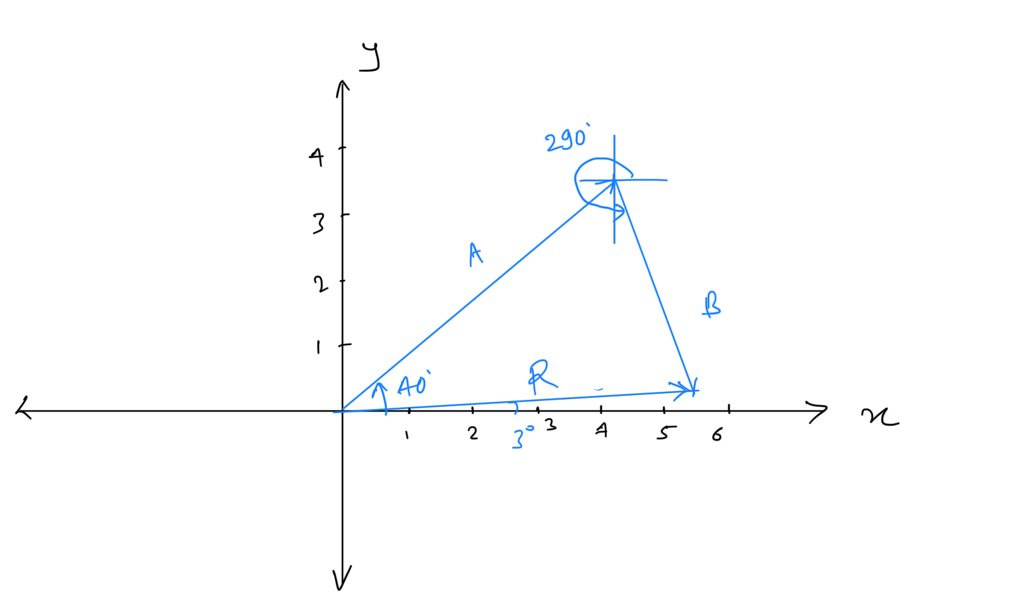

Magnitude of resultant 𝑹= 5.4 cm = 0.108 kg = 1.058 N (1 point)

Direction of resultant 𝑹= 3 ⁰ (1 point)

2. The equilibrant found in Table 1 by performing the experiment is equal (or close) in magnitude to
the resultant but its direction is opposite to that of the resultant (the difference in angle is 180⁰).

Calculate the percentage error for magnitude between the experimental equilibrant (Table 1)
(consider this value as measured) and resultant (consider this value as standard)

% error=|M-S|x 100/S, where M=measured value, S=standard value. (1 point)

% error=|1.127-1.058|x 100/1.058
% error= 6.52

3. Calculate the percentage error for direction between the experimental equilibrant (consider this
value as measured) and resultant (consider this value as standard). Remember that -as they are opposite in direction- you have to add 180⁰ to the smaller of the two angles to compare them. (1 point)

% error=|M-S|x 100/S
% error=|183-(180+3)|x 100/(180+3)
% error= 0

4. Use component method to add 𝑨 and 𝑩. Use the magnitudes (in Newtons) and directions from Table 1 to find the x and y components of A and B and record them in the first two lines of Table 3. Calculate the x and y components of R and record them in the last line of Table 3.

Table 3 (1 point)
 | X-component (N) | Y-component (N)
A | Ax= 0.676 | Ay = 0.567
𝑩 | Bx = 0.235 | By = -0.645
R | Rx= Ax +Bx= 0.911 | Ry= Ay+By= -0.078

5. Calculate the magnitude and direction of the resultant 𝑹 using the components Rx and Ry.
Show your calculation and the equations that you used:

R = (Rx²+Ry²)^{0.5}
R = (0.911²+(-0.078²)^{0.5}
R = 0.914 N

Magnitude of 𝑹= 0.914 (unit: N ) (1 point)

Direction of R = tan⁻¹(|Ry|/|Rx|)
Direction of R = tan⁻¹((|-0.078|)/|0.911|)
Direction of R = 4.9 degree

Direction of 𝑹= 4.9 (unit: degree ) (1 point)

6. repeat points 2 and 3 using the magnitude and direction of the resultant obtained with the component method:

% error for magnitude= |1.127-0.914|x 100/0.914

% error for magnitude= 23.30 (1 point)

% error for direction= |183-(180+4.9)|x 100/(180+4.9)
% error= 1.03
(1 point)

7. By looking at the two methods used (head to tail or component) to add vectors, what method
agrees best with the experiment? Comment why. (1 point)

The head to tail method agrees best because the errors are less in this method.

8. In Table 2, you know the magnitude and direction of the equilibrant 𝑬 and of 𝑩 . Use the values
in Table 2 and the component method to solve for the magnitude and direction of the unknown
force 𝑨. Record your findings in Table 4. (1 point)
Table 4
 | X-component (N) | Y-component (N)
𝑬 | Ex= -1.44 | Ey = -0.28
𝑩 | Bx = 0.268 | By = -0.737
𝑨 | Ax=-Ex-Bx= 1.172 | Ay=-Ey-By= 1.017

9. Solve for the magnitude and direction of the unknown force 𝑨. Show the equations you used.

A = (Ax²+Ay²)^{0.5}
A = (1.172²+1.017²)^{0.5}
A = 1.552 N

Magnitude of 𝑨= 1.552 (unit: N ) (1 point)

Direction of A = tan⁻¹(|Ay|/|Ax|)
Direction of A = tan⁻¹((|1.017)/|1.172|)
Direction of A = 40.95 degree

Direction of 𝑨= 40.95 (unit: degree ) (1 point)

10. Calculate the mass of the unknown object A by dividing the magnitude of the force 𝑨
by g=9.80 m/s² (1 point)
Mass of A = 1.552/9.80
Mass of A = 0.158 kg

11. Measure the mass of the unknown object using a scale:

Mass of the unknown object using a scale = __150_________ g = 0.150 kg (1 point)

12. Calculate the percent difference between the experimental mass (found at point 10.) and the standard mass of the unknown object (found by scale at point 11.). (1 point)

The percent difference = |M-S|x 100/S
The percent difference = |0.158-0.150|x 100/0.150
The percent difference = 5.33

13. Is the experimental mass accurate? YES NO Why? (1 point)
No, the experimental mass is slightly more than the actual mass. It might because of experimental errors and friction in pulley.

14. Find the percent difference between the direction of A calculated at point 9. and the known direction (30⁰). (1 point)

% error=|M-S|x 100/S
% error=|40.95-30|x 100/30
% error= 35.5

15. Is the calculated direction accurate? YES NO Why? (1 point)
No, the calculated direction is not accurate, it is more than the actual direction.

