Big Data Analytics Assessment

Rent Price Investigation
The rent price investigation was performed on the training data set, which consists of 32,587 records across an ID variable, 24 potential predictors, and the target variable, rent price. The data was pre-processed in Excel to standardize the price variable and remove redundant categories for the categorical variables. Rent was denominated in AMD, EUR, USD, and RUB with prices expressed on a monthly or daily basis. The analyst first converted the rents to euros using exchange rates obtained from xe.com, summarized in Table 1 below [1]. The duration was then standardized to monthly by multiplying the euro prices by 30 for the November rents and by 31 for the December and January rents. The duplicate values present in the construction type, balconies, furniture, and renovation – e.g., stone and Stone for construction type – were also removed.
Date | AMD to Euro | USD to Euro | RUB to Euro
24/11/2022 | 0.002443 | 0.960784 | 0.015870
15/12/2022 | 0.002386 | 0.940101 | 0.014524
07/01/2023 | 0.002377 | 0.938912 | 0.012950
Table 1 AMD, USD, and RUB to EUR exchange rates
The subsequent pre-processing steps were performed in Python. The new target, monthly price in euros, had two missing values, which were dropped from the dataset. A boxplot of the target showed large right-side outliers, which overshadowed the typical price observations and obscured differences in the price distribution across levels of the discrete variables. The upper fence for normal monthly rent observations using the 1.5*IQR rule was calculated as €2,497.35 with rents exceeding this threshold identified as outliers (N = 1622) and dropped from the dataset. A total of 30,965 valid records were retained and used for the exploratory and regression analyses.

Discrete Predictors of Rent
Side-by-side boxplots were used to visualize the distribution of rent prices across the levels of the discrete variables to identify the variables for which price varied most significantly across categories. Eight of the 14 discrete variables had six or less unique categories while the number of unique categories was as high as 4,598 (address) for the remaining variables. For the variables with more than six categories, the five most populated categories were retained with the remaining categories combined into a single level labelled “Other” to facilitate boxplot comparisons. New construction, renovation, and construction type had the most significant effect on price as evident from the dissimilar price distributions across the four levels, as depicted in Figures 1 and 2 below.
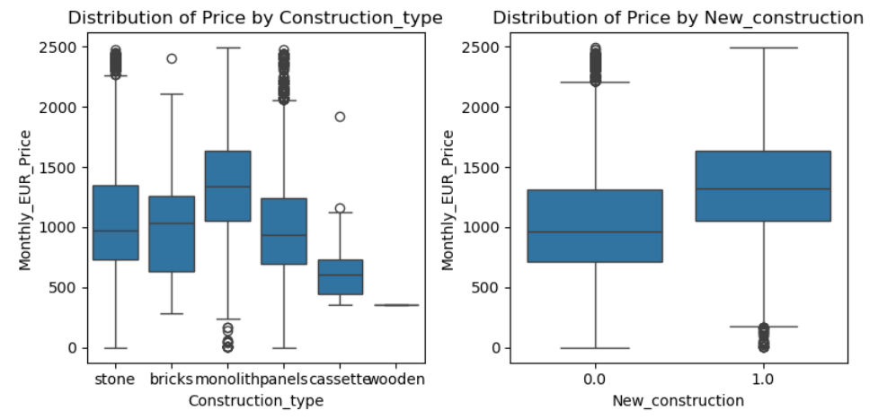
Fig 1 Distribution of Price by Construction Type and New Construction
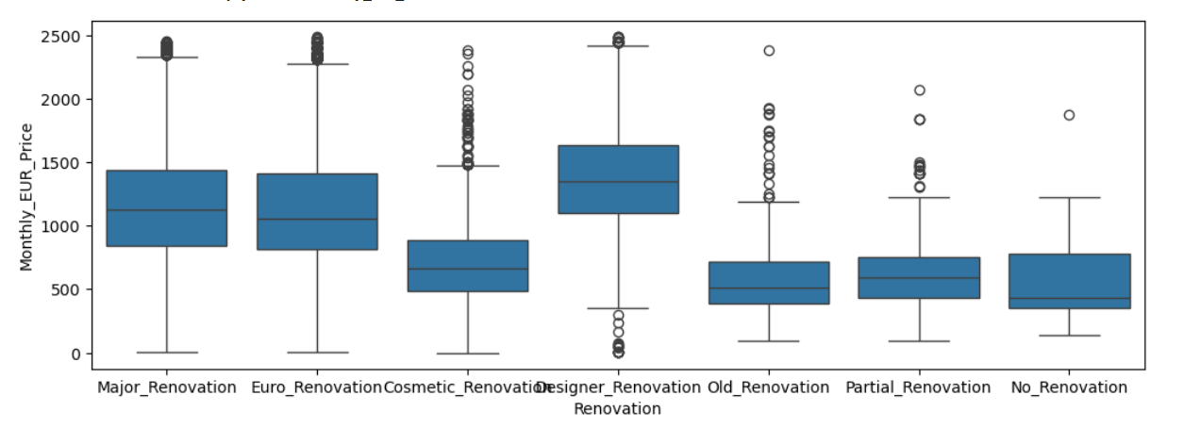
Fig 2 Distribution of Price by Renovation

While the boxplot analysis provides an approximation of the most significant discrete predictors of price, one-way ANOVA provides more definitive results. The F and p statistics were used to assess the significance of the discrete predictors. All predictors other than gender had a significant effect on rent at a 1% significance level. The three variables with the largest F statistic and therefore, the greatest effect on price were: new construction (F = 3856), renovation (F = 1285), and construction type (876). A linear regression model with the three discrete predictors was used to determine if the predictive effect of each predictor remained even after controlling for the other two variables. If the predictors are correlated, they could explain the same proportion of variance in rent prices such that at least one predictor loses significance in a multiple regression model. From the adjusted R-square, new construction, renovation, and construction type jointly explained 22.9% of the variation in monthly rents. Additionally, all three variables had a significant effect on price except that the distribution of price for units in brick, panels, stone, and wood did not differ significantly.
From the coefficients table, the monthly rent for units in new constructions was on average €87.99 higher than the rent for old constructions, when controlling for construction type and renovation. Units in monolith constructions were on average priced €217 higher than units in brick/wood/stone/panel buildings while cassette construction types were significantly cheaper, and were priced at roughly €239 lower than brick houses. Units in buildings with designer renovations had the highest pricing of the six categories: compared to the reference category, cosmetic renovations, designer renovation units were priced at €534 higher. Major and euro renovations were priced at roughly €377 and €332 higher than cosmetic renovations. In contrast, units with old renovations rented at €123 less than cosmetic renovations while units with no or partial renovations (captured in one group labelled Other) rented at €92 less than cosmetic renovations.
Correlation Analysis
The correlation of monthly rents with the seven interval/ratio level predictors – tenant age, number of floors in the building, floor area, number of rooms, number of bathrooms, ceiling height, and floor – was assessed using Pearson’s correlation coefficient. Rent had a positive but small correlation with all variables except age for which the correlation was negligible. Rent was most significantly correlated with number of bathrooms (r = 0.33), number of rooms (r = 0.31), ceiling height (r = 0.30), and floors in the building (0.26). A multiple regression model with the six significant numeric predictors explained 23.5% of the variation in monthly rents. All variables were individually significant indicating unique contribution to the prediction of price. From the t-statistic, ceiling height was the strongest predictor of price after controlling for the other numeric predictors with a unit increase in ceiling height associated with a €609 increase in price. Number of bathrooms and number of rooms were the next best predictors with an additional bathroom expected to increase rent by €231 while an additional room was associated with a €112 increase in rent. Units in taller buildings were priced higher with a unit increase in the number of floors in the building associated with a €17 increase in price while units in higher floors were priced higher with movement up a floor expected to increase rents by €6. While significant, floor area was the weakest predictor of rent with rent expected to increase by €0.08 for a unit increase in floor area.

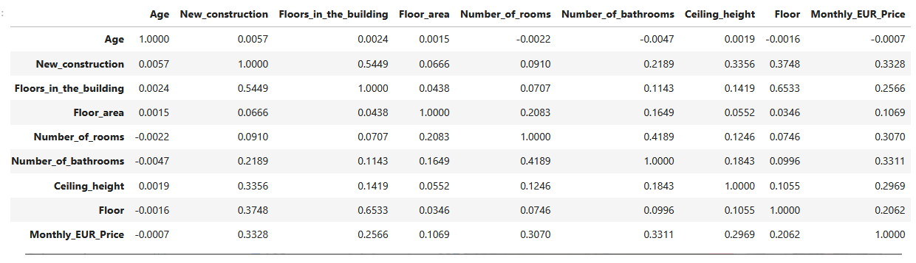
Fig 3 Correlation of Rent and Numeric Predictors

Effect of Price on Rent Changes
Ordinarily, location is a primary determinant of real estate value with higher rents in choice locations. For the present dataset, apartment addresses varied widely with 4,598 unique addresses. The number of unique categories was collapsed to six in the exploratory analysis with most of the units included in the “Other” category while the five addresses with the highest frequencies were: Komitas Avenue, Yerevan (N = 1331), Yerevan Kentron (N = 1120), Amiryan Street, Yerevan (664), Mesrop Mahtos Avenue, Yerevan (N = 603), and Tumanyan Street, Yerevan (N = 526). From the ANOVA results address was a significant predictor of price with significant difference in price across the six address categories. To examine the rate of change in rent by address, the average Nov 2022, Dec 2022, and Jan 2023 rent was calculated by address. The November and December datasets were then joined with the Dec rent hike calculated and the same was done with the December and January datasets. Only 696 addresses were included in both the December and November datasets. Rent changes exceeding 81% and less than -91% were outliers and were excluded from the analysis of rent changes by address.
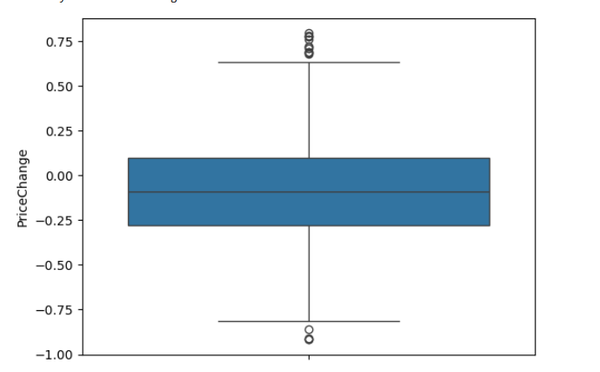
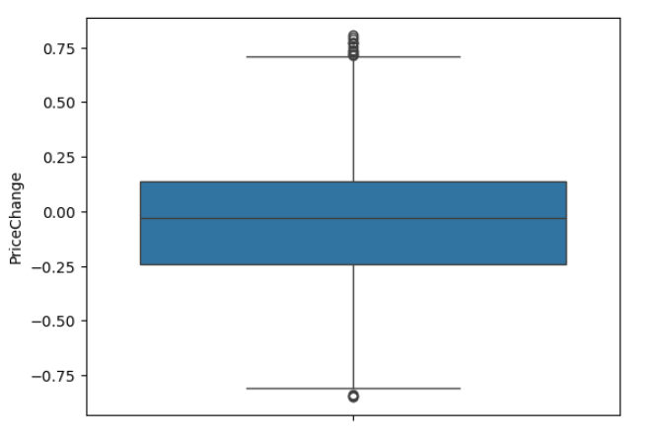
Fig 4 Rent Change, Dec 2022 Fig 5 Rent Change, Jan 2023

The minimum, first quartile, and median rent changes in Dec were -91.8%, -27.9%, and -9.2%: for 25% of the examined addresses, the average rent decreased by between 28% and 92% while for another 25%, rents decreased by between 9.2% and 27.9% (Figure 4). The 75th percentile was 9.9% with the rent change varying between -9% and 10% for 25% of addresses. For the 25% of addresses with the highest increase in rents, the rent hike was between 10% and 79%. The median price change by address in January 2023 was -3.2% (Figure 5). While the negative median indicates more rent decreases than hikes, rents decreased for fewer addresses in January 2023 when compared to December 2022. From the wide disparity in rent change by address, it is evident that the changes in the real estate market are location dependent as rents could be falling drastically in some addresses but rising by a significant margin in a different location.

Storing Data and Possible Solutions

Relational Database Design
The attributes were first grouped to create a logical relational schema consistent with normalization principles. The data variables correspond to three separate entities – building, rental unit, and tenant. The distinction of building and rental unit attributes is consistent with the 3NF objective of minimizing data redundancy: attributes that apply to all the units in a building are stored as a single row in the Building table resulting in an efficient update process as a change in the attribute of a building, e.g., the decision to disallow pets when they were previously allowed, is easily implemented in the Building table and reflected for all units in the Unit table. Utility payments, amenities, parking, and renovation were assumed to be building level attributes as depicted in the ER diagram below. Buildings have a valid primary key labelled Reg_id in the current dataset, which was updated to BuildingID in the database. For units, a primary key was added to the data as none of the existing columns can be used to uniquely identify a building unit. A building must have at least one rental unit and all rental units must be linked to a building.

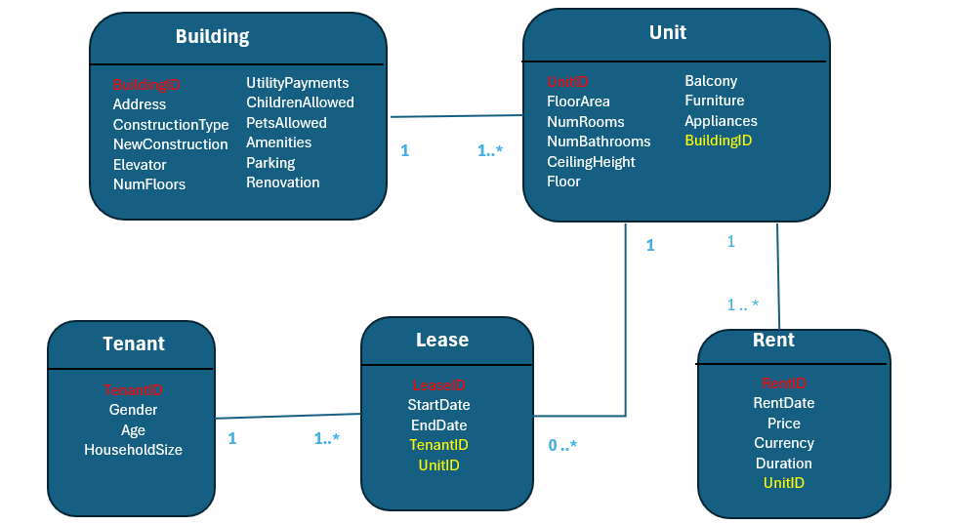
Fig 6 Apartment Management ER Diagram

The necessity of additional entities other than buildings and units becomes apparent when the date/time variable is considered. In the current dataset, rents had been updated thrice, with rent hikes expected to continue in future periods. At the simplest level, the previous rent could be overwritten with the current rent. However, this approach will reduce the richness of the data and prevent its use for rent price change analyses. A rent entity was created to store both the current and historic rents. The rent amount, currency in which it is denominated, and rent duration, and the date on which the rent was enacted for each rental unit will be stored as a single record in the Rent table. With each change in the rent price, a new record is inserted into the table with the new values. The shortcoming of this approach is that a change in rents for some units requires an update for all units as the RentDate value determines whether the rent amount is current or historical when running queries. Additionally, changes in the currency and duration can only be enacted when rent changes occur, although this is likely to be the case in the real world. The Unit and Rent tables have a one-to-many relationship as each unit must have at least one recorded rent.
Tenant information would provide useful information to managers for market and customer analysis. Management should collect as much information without violating tenant’s privacy or relevant rental legislation. At minimum, tenants age, gender, and household size can be tracked. A Lease table was added to allow management to store information about previous and current tenants instead of overwriting previous tenant information as would be required if tenants were directly related with units. The renewal of a lease by an existing tenant will warrant an additional row in the leases table with a one-to-many relationship between the tables as a tenant must have at least one recorded lease. The sample SQL statements for inserting records and querying the database are given in Figures 6 and 7 below.

Sample SQL

Fig 7 Inserting Records

Fig. 8 Query Statements

Scaling Considerations
The criteria for the selection of a data storage solution for the apartment management company included the ability to support large datasets in a cost-effective manner, scalability as the company’s storage and analysis needs are expected to increase with time, support of automated analyses with immediate alerts, rapid response capacity, and distributed processing. The considered solutions include on-premise data warehouses, cloud data warehouses, and data lake houses. An on-premise data warehouse would extract data from the individual data silos used by the apartment management company and will support data mining and automated analyses, such as alerts if occupancy rates fall below a certain threshold albeit with slow response times [2]. Compared to the other two alternatives, an on-premise warehouse is scored least across all selection criteria. To begin with, establish an on-premise warehouse requires considerable up-front capital expenditure, when compared to the use of cloud capacity for the latter two alternatives where the company would incur only operating costs [3].
The on-premise solution also suffers from the scalability problem – acquiring resources based on the expected processing load in future results in the underuse of the system and excessive operating costs while acquiring resources commensurate with the short-term processing load results in additional expenses in future periods to integrate new components into the system [3]. Both cloud data warehouses and data lakes houses with virtualization offer greater scalability with affordable operating costs [3]. Additionally, while an on-premise warehouse can distribute processing across machines, the setup is inefficient as all machines need to host compute and storage functions [4]. In contrast, cloud solutions support the split of compute and storage, offering greater efficiency and cost-effectiveness [4]. Business analytic software and other data mining tools can be integrated into both the on-premise data warehouse and the cloud-based warehouse and lake house to support automated analyses. However, the response time for analyses using data stored in warehouses will be delayed and will be unlikely to integrate new and pertinent data in a timely manner. Data warehouses use extract-transform-load (ETL) processes with considerable delays between the extraction of data from the relevant department systems, transformation of data to align with the warehouse’s schema, and the loading of the data to the warehouse, such that new data is not reflected in analysis results in a timely manner [4, 5].
Additionally, the ETL process occurs on a set schedule causing gaps between the receipt of critical data and the reflection of the new information in management reports [4, 5]. In contrast, data lake houses prioritize the processing of both streaming and batch processing such that the information gained from streaming is rapidly communicated after receipt allowing management to take action on received alerts on a timely manner [3, 4]. Data lake houses meet all the criteria required by the management team although the cost of operating a lake house is substantially higher than the cost of a cloud-based warehouse. I would recommend the data lake house if cost is not a significant concern but the manager should consider the trade-offs between cost and rapid response for the two alternatives in the short and medium-term.

Tenant Privacy Issues
Collecting and storing customer information raises three major privacy concerns – the high risk of database security breach and resultant theft of sensitive data, individuals’ loss of control over their personal data, and the long-term availability and proliferation of personal data regardless of the individual’s continued consent [6]. While age and gender are the only tenant attributes stored in the present dataset, the switch from the flat file system to a relational database will drastically increase the sensitive tenant information stored by the property managers. Customers provide earnings and next-of-kin information during the lease application and approval process and other sensitive information such as payment patterns, bank account numbers can be retrieved from payment records stored by the company. The property management company’s desire to perform data mining on stored data to gain business insights and use of cloud computing resources requires that the data be accessible via networks, which increases the likelihood of a data breach. The combination of financial and personal information places tenants at significant risk for financial losses should a data breach occur. The risk of data breaches could be reduced through the storage of non-sensitive client information and data encryption. The anonymization of client data has, however, been shown to be nigh impossible as data can be deanonymized with only a few attributes such as date of birth and general address making a strong cybersecurity plan the best defense against data breaches [6-8].
While the baseline tenant data, such as gender and age, is provided willingly by customers, the application of data mining to all transactions processed by the management company provides customer information that was not explicitly provided by the individual hence the loss over personal data flows [6-7]. For example, the company could predict tenants’ payment patterns, likelihood of lease renewal, likelihood of lease cancellation if rents are hiked, among other potential inferences that can be drawn from customer transactions and communications with management [6 -7]. Customers have no control over these processes and in many cases are unaware of the use of implicitly revealed data for decisions that might be of individual consequence, e.g., enacting a rent hike.
Customers lack of control over implicitly collected data leads to the third privacy issues arising from data mining – the long-term availability and continued sharing of personal data regardless of whether the individual continues to consent to data use. Tenants are willing to furnish property managers with personal data to determine their rentability but are less willing to allow the information to be used for non-authorized purposes. A significant concern is the sale of provided customer data to marketing companies for targeted advertising [9]. The withdrawal of explicitly provided data after the termination of the lease will be difficult with the proposed relational database as tenant data continues to be used for analyses even after their lease expiration. The continued availability of both explicit and implicitly provided data even after the lease is terminated could negatively affect a client as a history of late payment could hamper the individual’s ability to secure a lease in a building managed by the same property company even after their earnings status and consequently, their ability to make rent payments in a timely manner improves.

References
[1] Xe.com. Historical rate tables. [Online]. Available: https://www.xe.com/currencytables/ [Accessed: Aug. 8, 2025]
[2] R. Van Der Lans, Data Virtualization for business intelligence systems: revolutionizing data integration for data warehouses. Elsevier, 2012
[3] B. Lipp, Modern data architectures with Python. Packt Publishing, 2023.
[4] R. Bodapati, “Data evolution: Virtualization and lakehouse architectures for
Integrated business intelligence” European Journal of Computer Science and Information
Technology, vol. 13, no. 42, pp. 12-23, 2025
[5] A. Reddy, “Demystifying data lakes and data warehouses: A technical perspective” World Journal of Advanced Engineering Technology and Sciences, vol. 15, no. 03, pp. 2056-2069, 2025
[6] S. Fhom, "Big data: opportunities and privacy challenges" arXiv e-prints, 2015
[7] W. Jaap, P. K. Kannan, X. Ma, T. Reutterer, H. Risselada, and B. Skiera, "Data analytics in a privacy-concerned world." Journal of Business Research, vol. 122, pp. 915-925, 2021.
[8] P. Ohm, “Broken promises of privacy: Responding to the surprising failure of anonymization.” UCLA l. Rev., vol. 57, p.1701, 2009
[9] O. Oreofe, T. Clement, O. Adanigbo, T. Gbenle, and B. Adekunle, "A review of ethical considerations in AI-driven marketing analytics: Privacy, transparency, and consumer trust." International Journal Of Multidisciplinary Research and Growth Evaluation 2, vol. 2, pp428-435, 2021

