Royal Dutch Shell Believes In Implementation Of Competitive Yet
Innovative Strategy While Dealing Market Position And Customer
Acquisition: Accessing The Above Statement With Reference To UK Industry

Abstract
The primary aim of the dissertation is to analyse the strategy and the consumer acquisition. The researcher in this project will project the details with relevant information and concept that will enable the readers to understand the process of the market positioning and the steps that are involved in the competitive strategy and innovative strategy. Therefore, the researcher believes that this project will help to unravel the information accordingly and place all the vital information for a better and a clear understanding.
The researcher will be doing a proper research on the project and make sure that the information, which will be gathered, will be used for proper analysis so that a proper outcome can be achieved. The researcher will be discussing the matter with the help of the proper strategies and models that will help in proper filtration of the information.
The researcher will be using varieties of technique to make sure that the research outcome will provide appropriate understanding. The researcher will be highlighting the data with the help of the tables and diagrams to provide a transparent understanding that will enable the reader to understand the matter productively.
The researcher believes that with the information collected and analysed it will help the future researchers for the study.

Acknowledgement
The researcher would like to articulate thanks to countless people who have helped throughout the study. I would like to thank my teacher, MR ___________________________, for his support. I would like to thanks my parents for their direction and love. I would also like to thank my superior MR_____________________ for giving me the information and providing leads to complete my study. Lastly, I would like to thank the customers and employees of Royal Dutch Shell, UK that helped me to complete the project without any interruption and helping me in developing the information and awareness about the dissertation.

Table of Contents

Chapter 1 9
Introduction 9
1.0 Introduction 9
1.1 Background of the topic 9
1.2 Background of the company 9
1.3 Rationale of the study 10
1.4 Research aim 10
1.5 Research objectives 10
1.6 Research questions 10
1.7 Structure of the dissertation 11
1.8 Summary 11
Chapter 2 12
Literature Review 12
2.1 Introduction 12
2.2 Conceptual Framework 13
2.3 Competitive and Innovative Strategy 13
2.4 Market Position 15
2.4.1 Market Positioning Strategy 17
2.5 Consumer Acquisition 18
2.5.1 Consumer acquisition and retention strategy 19
2.6 Gap of Literature 20
2.7 Summary 20
Chapter 3 21
Research Design and Methodology 21
3.1 Introduction 21
3.2 Method outline 21
3.3 Research onion 22
3.4 Research philosophy 22
3.4.1 Justification for the selected philosophy 23
3.5 Research approach 23
3.5.1 Justification for the selected approach 23
3.6 Research design 24
3.6.1 Justification for the selected design 24
3.7 Research purpose 24
3.7.1 Data sources: primary and secondary 24
3.7.2 Data collection method: qualitative and quantitative 25
3.7.3 Data analysis 25
3.8 Data collection procedure 25
3.8.1 Population and sampling 25
3.8.2 Sampling technique 25
3.8.3 Sample size 26
3.9 Ethical considerations 26
3.10 Research limitation 26
3.11 Time horizon 26
3.12 Summary 26
Chapter 4 27
Data Analysis and Interpretation 27
4.0 Introduction 27
4.1 Quantitative Analysis 28
4.2 Qualitative analysis 37
4.3 Summary 39
Chapter 5 40
Conclusion and recommendation 40
5.0 Conclusion 40
5.1 Linking with the objectives 40
5.2 Recommendation 41
5.3 Limitations of the research 41
5.4 Further scope of the study 41
Reference List 42
Appendices 45

List of figures
Figure 1: Conceptual framework ............................................................................................. 13
Figure 2: The S- Curve .............................................................................................................. 14
Figure 3: Research Onion ......................................................................................................... 22
Figure 4: Tenure of being a customer ...................................................................................... 28
Figure 5: Satisfaction with the product quality ....................................................................... 29
Figure 6: Products at reasonable price .................................................................................... 30
Figure 7: Influencing factors for purchasing products from the Royal Dutch Shell Company 31
Figure 8: Effective and innovative strategies for attracting customers .................................. 32
Figure 9: Ability of the innovative strategy to gain repeat purchase ...................................... 33
Figure 10: Purchasing oil and gas apart from Royal Dutch Shell Company ............................. 34
Figure 11: Competitors of the Royal Dutch Shell Company .................................................... 35
Figure 12: Factors that make people buy oil and gas apart from Royal Dutch Shell Company
.................................................................................................................................................. 36
Figure 13: The areas that should be focused by the marketers of Royal Dutch Shell Company
.................................................................................................................................................. 37

List of Tables
Table 1: Tenure of being a customer ....................................................................................... 28
Table: 2 Satisfaction with the product quality ......................................................................... 29
Table: 3 Products at reasonable price ..................................................................................... 30
Table: 4 Influencing factors for purchasing products from the Royal Dutch Shell Company . 30
Table: 5 Effective and innovative strategies for attracting customers .................................... 32
Table: 6 Ability of the innovative strategy to gain repeat purchase ....................................... 33
Table: 7 Purchasing oil and gas apart from Royal Dutch Shell Company ................................ 34
Table: 8 Competitors of the Royal Dutch Shell Company ........................................................ 35
Table: 9 Factors that make people buy oil and gas apart from Royal Dutch Shell Company . 36
Table: 10 The areas that should be focused by the marketers of Royal Dutch Shell Company
.................................................................................................................................................. 37

Chapter 1

Introduction

1.0 Introduction
In this first chapter of dissertation, the researcher will give the aim, objectives and questions of the concerned research topic. Here the researcher will also provide the background of the topic, background of the company, rationale of the study and a structure of the dissertation.
As opined by Shaw (2008, p-89), competitive and innovative strategies have the power to deal with the market position and customer acquisition. Thus, this can help the company to increase their business locally, nationally and globally. Therefore, different industries should be focused on collecting and analysing information from the market related to customers’ choices, preferences and expectations as it plays a vital role while generating the ideas of the strategy that is to be implemented. However creating a competitive yet innovative strategy requires a vast knowledge and skill of understanding the business activities and the factors that can flourish a business. Otherwise, if the innovative strategy cannot be effective then it can have a wide negative impact on the business of the company. Therefore the managers should be very careful and concentrated while making such strategies.
Here the researcher has chosen the Royal Dutch Shell Company in UK to carry out the research in order to analyse the effectiveness of competitive yet innovative strategy to sustain the market position and to gain more customers on UK industry.

1.1 Background of the topic
Formulating and implementing effective business strategy is considered as the most important aspect of recent business world. Market competition has become so high that the companies need to be focused on their strategic implementation. In order to make an effective strategy it is very important for the management team of a company to analyse the internal and external business environment and formulate their strategy accordingly so that it can be fruitful for the company (Barney, 2009, p-1231).
Boulton et al. (2009, p-29) opines that controlling customer acquisition includes several interconnected commissions and activities. In order to develop a customer-familiarized company the mangers should have the skills of different selling methods. Customer acquisition generates the sustenance of sales and return visit crucial to the long-term success of the company.

1.2 Background of the company
The Royal Dutch Shell Company is also known as Shell which s an Anglo-Dutch multinational oil and gas company. He company’s headquarter is in Hague, the Netherlands and slot in UK. This company is created through the incorporation of two competitor companies are Royal Dutch Petroleum Company and the ‘Shell’ Transport and Trading Company Ltd in The UK in February 1907. The Royal
Dutch Petroleum Company was founded in 1890 to expand their oil field in Sumatra and the Shell’ Transport and Trading Company Ltd was founded in 1897, which was a British company. It is the fourth largest company of the world in 2014 in provisos of profits and it was one of the six oil and gas companies (Shell.co.uk, 2015).

1.3 Rationale of the study
Royal Dutch Shell Company is a popular oil and gas company of UK. They provide fuel for transport to 10 million customers every day through their 44,000 service stations over the world. They are inclined to supply cleaner blazing and more proficient fuels to their customers. Their aim is to meet the requirements of the aviation industry, chemical and shipping industry. Therefore, the company is focused on implementing competitive however innovative strategies to carry on their position in market and to gain more and more customers. This is the rationale of this research to analyse the effectiveness of the competitive yet innovative strategy implementation by the marketers of the company. The researcher will find out the problems those are faced by the company due to the increasing market competition and will provide some suitable suggestions to mitigate those problems and to implement the strategies to continue their market position and customer acquisition efficiently (Shell.co.uk, 2015).

1.4 Research aim
The key aim of this research is to understand the effectiveness of implementing competitive yet innovative strategies in business to deal with the market position and customer acquisition of UK industry.

1.5 Research objectives
As per the aim of the research, the objectives are as follows:
- To understand the competitive however innovative strategies
- To analyse the impact of implementing competitive yet innovative strategies on market position and customer acquisition
- To identify the loopholes of the Royal Dutch Shell company to implement these strategies
- To recommend some suitable suggestions to mitigate those problems

1.6 Research questions
The questions of this research are:
- What is the concept of competitive yet innovative strategies?
- What are the impact of competitive yet innovative strategies to carry on market position and customer acquisition?
- What are the issues related to implementation of these strategies for the Royal Dutch Shell Company in UK?

1.7 Structure of the dissertation
Here is a structure of the dissertation has been provided by the researcher to make it easier for the reader to understand the topic adequately.
In the first introductory chapter, the researcher has provided the basic knowledge of the topic and the aim and objectives of the research. The background of the research and the company and the rationale of the study have also been stated here.
Second chapter of the dissertation includes the related models and theories of the research topic to acquire better knowledge about the topic.
In the third chapter, the researcher will choose the proper design, methodologies, and techniques to carry out the research work efficiently.
In the fourth chapter, the researcher will analyse the collected data from the primary and secondary survey.
In the fifth chapter the researcher will provide a conclusion of the whole research and provide some apt recommendations if required.

1.8 Summary
In this chapter, the researcher has provided the description of the topic, background of the company, rationale of the study and the aim, o0bjectives and questions accordingly. In the next chapter, the researcher will provide relevant models and theories regarding the topic to attain a deeper and clearer knowledge about the research topic in order to gain a better outcome.

Chapter 2

Literature Review

2.1 Introduction
The researcher in this section has presented the information through critical discussion with the help of the models and theories. Strategising is considered an important task for the company to sustain in the market (Afuah, 2007, p-111). Hence, the need for proper implementation is vital for the company. With the help of the theories and information, which will be gathered for the study, will help the researcher in making the necessary structure for the same. The section has important figures, which will help the reader in understanding the issue accordingly. The dissertation will cover the consumer acquisition and the strategies placed by the company in the market to attract the consumers. The researcher has also looked after the most important sections to make sure it adds quality data in the study.

2.2 Conceptual Framework



Competitive and
innovative strategy

Market position

Consumer acquisition

S
-
Curve, Incline on Consumers,
Creative Thinking, Effective
Leadership

Pricing, Quality, Service,
Distribution, Packaging

Market Positioning Strategy

Brand Positioning, Product Positioning,
Competitive Positioning

Figure 1: Conceptual framework
Source: as created by Author

2.3 Competitive and Innovative Strategy
In order to sustain in this competitive business market place, the company has to develop certain ideas and strategies to make sure that they are in the competition (Davis, 2010, p-231). For this, the company has to look on several sections, which can be explained as,
- The next S-Curve
- Incline on the consumers
- Creative thinking
- Effective leadership
With the help of these strategies, it can be stated that the company can find a solution, which will help them in dominating the business world accordingly.
The S-Curve: the companies have to realise that the validity of a product or a service is not forever.
Every product has a life cycle, which is declined at some stage. It can be early or late depending on the product. Hence, the role of the company is to make something new and come up to the consumers accordingly so that they can be in the market. The company has to specifically look on the time and the revenue the product has fetched for the company and accordingly plan for the next move, which will help them to rise in the market again. The company has to make changes because they have to understand the trend and the services the consumers are looking for in the current market and accordingly push the product top the consumers (Kumar, 2009, p-311). It has helped

many companies in making changes in the market share and the perception accordingly.

Figure
2
:
The S
-

Curve

(
Source:

Kapferer,
2008
, p
-

548
)

Innovation
Window

REVENUE

TIME

Original
Strategy

New Growth
Strategy

Incline on Consumers: the companies have to look after their consumers accordingly if they have to grow in the market. The services provided by the company have to be higher than the product value and keep them satisfied with different offers (Akroush et al. 2011, p-159). It is observed that companies, which are successful, are always having a support of the consumers, because they provide their consumers with good offers that help them in retaining the consumers accordingly. The companies create proper steps in handling the consumers accordingly and with the help of proper strategies; they are able to gain the trust of the consumers.
Creative thinking: in order to do something new to achieve the market and dominate it, the need of a proper thinking strategy is needed. A company has to think creatively in order to market their product. Due to the rise of new technologies, the companies are making various paths to market their product accordingly for domination. Therefore, the company has to take inputs from the consumers and the employees to fetch information, which can be proved positive. Interaction and communication is considered to be the best source of brainstorming which helps an organisation or a personnel to crack new ideas which have never been applied before (Dahiyat et al. 2011, p-169).
Effective Leadership: Leaders of a company are considered the most innovative and effective soldier of a company. The leaders of the companies are the ones to come up with new ideas and help in developing the company. The need of an effective leader is very much necessary if the companies have to sustain in the market and gain position accordingly. The leaders have to think about the strategy that will help them to gain revenue in future instead of earning profits in the present (Gharaibeh et al. 2011, p-162). The role of a leader is very difficult and challenging as it involves a lot of effort and hard work.
With the help of the innovative strategies, the company can make sure in increasing the competition in the market and gain power in the business. The need for proper competition is extremely necessary, as effective leaders take the advantage and utilise in learning the flaws of the strategies and the marketing methods. Consumers are considered the decider of a company’s future. As argued by Abu et al. (2011, p-186), the consumers have to be treated accordingly and provided all sort of services a company can afford. Due to the advancement in the technology, companies are now making various strategy and plantings depending on the analysis that are provided by the machines. Companies have to utilise the human touch, as machines are not able to decide certain section.
The innovative thinking and strategy will help the company in gaining the market and consumers’ respectively and can expect to excel in future with their new products and services. Therefore, the need to understand the consumers and communicating with them is extremely essential. There are many alternatives, which can help companies in sustaining. The need to apply the appropriate strategy is important. it is important to know about the correct time and predict the business accordingly which helps the company indecision making process
For a proper growth, companies have to look after their consumer, maintain communication with them, understand the current trends and develop themselves through technology. The company can be considered active and effective if they have proper reach to the consumers. With the help of the social network, companies can now inform the consumers about their upcoming product and publish information, which helps them in being a transparent company in market (Alvarez and Casielles, 2008, p-66).

2.4 Market Position
As stated by Alvarez and Casielles (2008, p-59), market position is considered a vital step in identifying the company status accordingly. Market Position is identified with the help of the consumers and the product popularity. It is analysed with the help of the dominant market place. Market Position is an important benchmarking phrase, which helps in identifying the company accordingly (Balaram and Adhikari, 2010, p-69).
The primary elements of market position are categorised in,
- Pricing
- Quality • Service
- Distribution
- Packaging
A company identify the market position effectively with the help of the following stages, which are effective in analysing the position of the company in the market.
- Difference
- Appeal
- Characteristic
- Consumers
- Market
With the help of these stages, the position can be identified effectively. Position is the appropriate competitive strategy. With the market position, it is possible for the company to relate and understand the position of the company in the market, which helps in identifying the rivals and their strategies accordingly (Barney, 2009, p-1233).
The focus of the market positioning is on,
- Advantages of the product
- Opposition
- Product customer
- Function of the product
- Group of the product
- Symbols
As opposed by Bearden and Jesse (2006, p-21), the company has to gain proper reputation in the market and for that, the company has to provide appropriate proper product and good quality to the consumers. They have to make uniqueness in the product and make it more relevant for the consumers and use appropriate pricing strategy to make sure that the consumers are attracted to the brand respectively.
The role of the positioning in the market can be stated as,
- Assistance to overall strategy
- Differentiate the offerings
- Competitive Positioning
- Gain proper revenue and loyalty of the consumers
- Transparent communication and consistency
- Reduce price sensitivity
- Investment in low goods purchase
- Acceptable for habitual purchase
- WOM
- Assistance to marketing mix development
In order to market a product effectively, the need to make proper position strategy in the market is considered very important and hence the company has to come up with good ideas and concept if they have to reach the appropriate level. When a company has something clear and lucid to offer the consumers, the company immediately gains an attention of the consumers thereby creating opportunities for the company in making applicable position in the market. It is the responsibility of the company to make something innovative and different for the consumer for the attentions. The company can increase the market strength or competition by offering a numerous products for the consumers, which also helps the company in gaining the competitive edge in the market place, and hence it is needed for the company to make such products with quality that has the strength to pull the company in a leading position. When the consumers accept a product, it is possible for the increase in the revenue and increases the sales hugely (Biggadike, 2010, p-629). Therefore, the company has to offer the consumers something different for the consumers, which can make this happen.
The company has to maintain proper consistency in the growth and maintain a proper communication with the marketing to make sure that the product is capable of making different position in the market (Bloemer and Kasper, 2006, p-312). The company has to maintain the position in the market by making products available to the consumers that are considered effective for the consumers’ health wise and it will be highly beneficial for the purchase accordingly. Not only this, the company will also receive a free word of mouth of publicity which is considered to be a free advertisement for the consumers as it will spread the message from consumer to another and will be an ongoing process due to the effectiveness of the product accordingly.

2.4.1 Market Positioning Strategy
Positioning strategy is considered to very important for the business as it helps them in making the market share of the company (Boulding et al. 2010, p-156). The need to make appropriate strategy, which can have the power to cover all the aspect of the business, is considered an effective business strategy for the business and the positioning development accordingly.
The positioning strategy can be effective if it has the necessary areas covered for the business development. The areas are,
- Brand Positioning
- Product Positioning
- Competitive Positioning
If the strategy has all these section covered, the business is sure to make adequate amount of revenue. However, with the rise of the new companies, the competition is increasing day by day and therefore the need to make proper strategy to sustain in the market as it helps them in creating the competition. Brand position helps the company in sustaining the market wars. It depends on the popularity of the product and hence it helps the company accordingly for the survival (Staelin et al. 2010, p-160). It creates waves for other companies, which are considered difficult for other companies.
The consumers are the most important aspect of the business and with the support of the consumers; the company can help make the increase in the demand of the product. it completely depends on the company to make appropriate changes on the products from time to time to keep up with the trends and make products and services accordingly. Consumers and company are interlinked with each other and thus the necessity to make the proper availability of products is equally important for the development of the product and the market position accordingly (Ehret et al. 2010, p-161). Proper strategy and marketing helps the company to make the changes accordingly and gain proper position in the market.

2.5 Consumer Acquisition
A business is solely dependent on the consumer for the business. Therefore, the company has to offer the consumers products, which can attract the consumers accordingly and retain them for the longer run. Consumer Acquisition is considered very important for the company and hence the need to make appropriate products for the market is equally important (Johnston et al. 2010, p-166). It helps the company in gaining the market share as well as make development in the business accordingly. This can be identified with the help of the revenue, product demand and consumer base respectively.
As opposed by Boulton et al. (2009, p-32), due to globalisation, the company nowadays faces a lot of competition in the market, which is said to be tough for the business for the survival. The company has to offer the consumers with something different and innovative, which will help them in gaining the old consumers back for retention and gain new consumers in the process directly.
The company has to make appropriate marketing and promotion of the product in order to gain the consumers. Gaining the consumers will help the company in making adequate amount of revenue and appreciation, which will eventually increase the sales. As the consumers are changing from day to day therefore the company has to make appropriate changes for the consumers and offer them with products, which are trending. Consumers have become cautious about the company policy and their functions and therefore the company has to change for the consumer from time to time to make sure that they sustain in the market and hold the position accordingly for a better market share (Libert et al. 2009, p-29). A popular product service wills always attract the new consumers as they are aware that the company has gained the position due to the effective services that the old consumers have provided with. The consumers have many options in the market, which helps them to choose wisely. Consumers will always be attracted to the products, which are affordable in the nature and have a good quality.
As opposed by Samek et al. (2009, p-33), the company has to make products which will be able to grab the attention of the consumers and will accordingly make the sales and increase the revenue in time. Having a good consumer acquisition is considered vital for the company as it helps them in receiving free consumers, which generally occurs due to the WOM publicity. Word of mouth publicity helps the company in gaining new consumers due to reference from other products.
Gaining the consumer is not easy as it demands a lot of effort and hard work and therefore the company has to make appropriate marketing strategy for the development of the consumer base.
The company has to invest many funds for the proper promotion of the product to recover the cost of manufacturing and make sure that the strategies are positive and effective.
However the company has to keep in mind that the retaining the old consumers is very important as new consumers have to be treated and provided offers to retain them which will expensive for the company. Retaining the old consumers is not difficult or complex as it helps the company in making fewer expenses (Cool and Schendel, 2010, p-210). The company has to understand the consumers accordingly for the proper business, which can be beneficial for a transparent relation between the consumer and the organisation.
The company has to maintain proper relation with the consumers and make sure to provide the necessary offers to retain them. Having a consumer helps the business in making the necessary changes in the business development accordingly.

2.5.1 Consumer acquisition and retention strategy
The consumers are the most important element of the business, which helps in the development of the business accordingly and helps the market to gain appropriate position in the market. Consumers are of many types defining different age groups and other factors, hence the need to understand the consumers is very important, and that can be identified with the help of three levels which can be identified as (Corstjens and Lal, 2008, p-285),
- Finance
- Finance and social
- Finance, social, and structure
The company can identify the consumers accordingly and provide additional benefit, which can help them in retaining the consumers. Retaining the consumers will help the company in getting free publicity of the product or services, which are considered as the word of mouth publicity and are considered an additional feature of the consumer loyalty.
In order to retain the consumers, the company has to provide several benefits to the consumers to keep them retained. Therefore, the company has to come up with innovative ideas and benefits, which are attractive for the consumer. The consumers are identified based on the social and financial status. Many consumers are believed to be difficult for the retention and hence the need to make the consumers satisfied is believed to be a difficult job (Das and Kumar, 2009, p-18).
Companies can make relationship with the consumers to know their preference and needs from time to time to make sure they are in the trend. As argued by Elena and Jose (2005, p-190), the need of surveys and feedback calls are believed to be very important for the development of the business. It helps the business in identifying the new ideas and concepts, which helps the company in making new products for the consumers, and attracts them for retention (The duty of the company is make products, which are considered very effective for the consumers, as there are no substitutes for the same now.
The financial social and the structure is also integral part indentifying the consumers accordingly for the development. The company has to understand the consumers based on these criteria, which will help them in evaluating the consumers accordingly, and enable them to understand the type of consumers they have for their products (Ethiraj and Zhu, 2011, p-799).

2.6 Gap of Literature
During the research, the researcher has faced difficulties in gaining the information of the theory and the models accordingly. The researcher had to make proper structure for the information gathering, which was a difficult task, and it involved a lot of research, which consumed time. The researcher also faced difficulty in collecting the information from the internet. The information was incomplete and had inappropriate data that was manipulated. Therefore collecting the information was difficult. Due to time limitation, the researcher was unable to perform an in-depth research. The researcher had to rely on the journals and reports, which were at least 5 years old.

2.7 Summary
The researcher has discussed about the positioning and the consumer acquisition accordingly with the help of the relevant models and strategy, which has proven to be beneficial for the completion of the discussion. The researcher has also presented the conceptual framework for the readers for understanding.

Chapter 3

Research Design and Methodology

3.1 Introduction
Research design and methodology is considered an integral part for the project development as it involves the stages of the research that will be useful in collecting the data accordingly (Bergh and Ketchen, 2009, p-131). In this chapter, the researcher will be discussing the various research methods and style for the data collection that will help for the data gathering. The researcher will be explaining the various philosophies, approach and design to state the purpose of the research and provide information on the data collection method. The researcher believes that with the help of the research, collection of the data will be more organised and appropriate for the benefit of the study for proper understanding the topic.

3.2 Method outline
The researcher believes that with the help of proper direction, fetching the information will be appropriate for the study and help the researcher in collecting the information effectively. The method outline of the research is,
- Research Onion
- Research Philosophy
- Research Approach
- Research Design
- Data Collection
- Sampling
The researcher believes that with the help of this format and proper elaboration and understanding, the researcher will be able to fetch the required information accordingly for the benefit of the study accordingly. The researcher believes that with the help of these stages the research can find appropriate data for analysis.

3.3 Research onion
Research Onion is an effective stage for shaping up the research as it helps in doing the research effectively. The layers of the research onion helps the researcher in making proper approach and provide proper understanding to the research and the data. The research onion has several layers, which helps the research for the appropriate development (Bernard, 2011, p-247).
The stages in the research onion are,
- Philosophy
- Approach
- Strategy
- Choice
- Time horizon
- Techniques and procedures
With the help of the research and its stages, the researcher believes it will provide adequate amount of data and help the researcher in selecting the appropriate research data collection.
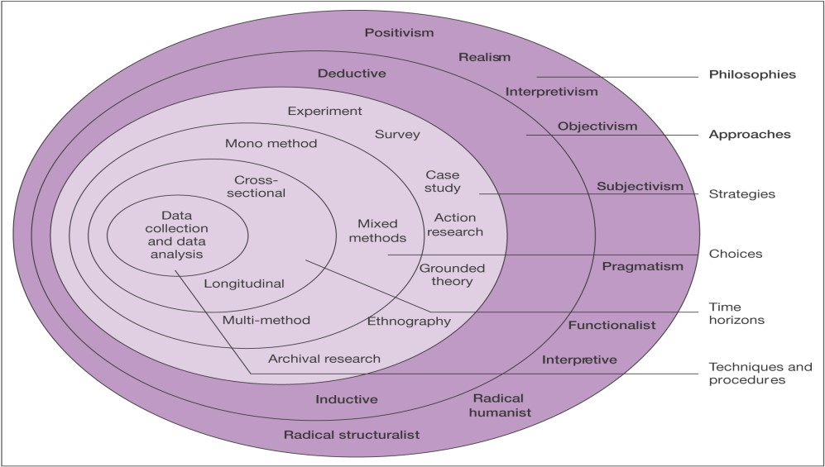

Figure

3
:
Research Onion

(Source: Saunders et al. 2009, p-52)
With the help of the research onion, the researcher will be able to provide appropriate information on the research study accordingly.

3.4 Research philosophy
Research philosophy is vital for the selection of the research process as it helps in understanding the nature of the research accordingly (Cameron, 2009, p-142). For most of the research study, the researcher believes that the philosophy guides the research accordingly. The philosophies are,
- Positivism
- Interpretivism
- Realism
The researcher believes that these stages are most effective for the research.
Positivism is gathered from the experiences and facts, which deals with the facts and data, which are believed to be positive in nature. These are done through logical, rational and mathematical treatment, which helps the researcher in gaining appropriate information (Ellis and Levy, 2009, p333). Interpretivism and realism helps the researcher in making the appropriate connection to the philosophy and believes that it helps in identifying the cause of the research more transparently.

3.4.1 Justification for the selected philosophy
The researcher believes the use positivism philosophy for the will be beneficial for the research and help for the proper development of the study. Positivism will help the researcher in providing the practical knowledge of the data and help the reader to provide the logical treatment accordingly for the better understanding of the research.

3.5 Research approach
Research approach is the stage, which helps the researcher in shaping the research study further by understanding the different approach for the study. The researcher believes that the approach will help in shaping up the section accordingly for data collection study. The research approach is divided on to 2 categories, which are,
- Deductive
- Inductive
With the help of the research onion the study of the research has become organised and therefore the understanding of the segments have become clearer.
Deductive Approach is the approach, which helps the researcher in making logical reasoning with valuable points and facts, which are not vulnerable due to the presence of the real time data and information. It has several layers, which can help the researcher in making the research more productive and effective (Freshwater, 2007, p-136).
Inductive Approach can be explained where the approach states that it is opposite of the deductive approach and uses a proper explanation for the study, it is divided in to the stages of the proposition and presumption that helps the researcher in making the steps wisely for usage.

3.5.1 Justification for the selected approach
The researcher believes that with the help of the deductive approach, the researcher will be able to provide the information more effectively as it uses several layers, which are considered real in nature, and has appropriate information for the analysis (Harrison and Reilly, 2011, p-13). The Deductive approach will help the researcher in making proper presentation of the study.

3.6 Research design
The researcher believes that with the use of the proper research design, the researcher will be able to point out the effective research data collection for the collection of the data and believes that with the help of the information gathered from the research, the researcher will be able to portray the data respectively.
The research design is divided in to 3 parts, which are,
- Exploratory
- Explanatory
- Descriptive
Exploratory is the stage where the researcher believes that the information be fetched with the help of the sources and the proper network, which will enable the grasp of the study to be strong. Explanatory is the stage, which will deal in the stages of the explanations that be proven beneficial for the study accordingly. Descriptive research design will help the researcher in making data more effectively as it will involve a real time data collection for the research and thus the information will be completely fresh for the analysis (Huxham and Vangen, 2008, p-389).

3.6.1 Justification for the selected design
The researcher believes that the use of the descriptive approach of the study will help the researcher in making proper presentation of the study, which will be effective for the collection of the data and help the researcher in making proper presentation.

3.7 Research purpose
The purpose of the research is to collect data, which will help in providing the needed information for the study. The purpose of the research is to identify the market position of the company, which is Royal Dutch Shell and understand the consumer acquisition of the company.

3.7.1 Data sources: primary and secondary
The data will be collected for the research based on two criteria, which are primary and secondary. The primary data will consist of the information, which are completely fresh and raw in nature and will be perfect for the analysis. The secondary sources of information will be based on the data gathered with the help of the internet and the journals, which will be at least 5 years old (Johnson et al. 2007, p-118) The researcher believes that with the help of these sources the research will get the appropriate and needed shape for the development of the data collections.

3.7.2 Data collection method: qualitative and quantitative
The use of the primary and the secondary sources of information will be useful for the data collection as it involves the stages of qualitative and quantitative (Knox, 2008, p-121). With the help of the primary data, the researcher will able to fetch the information directly from the real time world, which will help for the proper development of the study and enable the researcher in presenting the information productively. The researcher believes that the use of the participants in quantitative and qualitative will be appropriate for the data collection and will enable the researcher to collect information for the study respectively.

3.7.3 Data analysis
Data analysis is the stage where the researcher describes the use of the tools which will be used for the analysis of the data (Magilvy and Thomas, 2009, p-299). The researcher believes that the use of the internet and computer are essential for the analysis. With the help of the data analysis, the information will be verified effectively and make proper understanding on the study. Data analysis is an integral part for the outcome of the study and helps to identify the loopholes (Morgan, 2007, p51). The researcher believes that the use of analysis will be an important section in the research study respectively.

3.8 Data collection procedure
The researcher will be collecting the information with the help of the survey, which will help the researcher in identifying the topic respectively. The researcher will be taking the assistance of the respondents and the managers for the development of the business accordingly. The researcher will be using the primary data stage and its subsection, which are the qualitative and quantitative stages. With the help of these two stages, the data will be more effective and very easy to understand and analyse. The collection procedure has to be effective as the data is completely dependent on the appropriate collection procedure (Onwuegbuzie and Leech, 2009, p-381).

3.8.1 Population and sampling
The researcher believes that population and sampling are considered to be the most important for the development of the research accordingly as it helps the researcher in gathering the information with the help of these participants. The participants of the quantitative analysis are the population of the research along with the managers of the company. Samplings are based on two stages, which are the probability and non-probability techniques, which are said to be useful for the research accordingly as it helps in proper development of the study and enables the researcher in making proper progress with the help of the population.

3.8.2 Sampling technique
The researcher will be using the probability and non-probability sampling for the research to make the study effective. It is more concrete and supportive for the data collection. For the quantitative data, the researcher believes in collecting the information with the probability sampling technique and qualitative information with the non-probability sampling.

3.8.3 Sample size
The researcher believes that the assistance of 3 managers and 50 respondents for the study is enough for the collection of the data in the provided time window. The researcher expects the information to be appropriate with the help of these participants and collect productive information for the study.

3.9 Ethical considerations
The researcher understands and believes the risk factors that are involves in the stages of data collection and therefore makes sure in making the risk minimal by,
Approval: the researcher will take approval of the company to interview the managers of the company over Skype. This will help the researcher and the managers to save time.
Respondent Identity: the researcher will make sure of not using any names in the research and will not use the list for commercial purpose. The identity of the participant will be anonymous.
Participation: the researcher will make the interaction of the respondents voluntary and will not force or pressurise for completing the research. They are free to quit the process whenever they feel like.

3.10 Research limitation
There are certain limitations, which are faced by the researcher during the completion of the research. The researcher believes that the use of the secondary sources, which is journals and reports, are considered to be in appropriate for the study and are manipulated for the commercial use. The researcher also believes that there might be a biased statement from the managers of the company as they are the employees of the company and they are not going to state information against the company.

3.11 Time horizon
Please refer to Appendix-1

3.12 Summary
The researcher has stated the information against the study based on the information, which is related to the topic. The researcher has explained the research philosophies critically and has stated the research approach and design of the study. The researcher believes that the use of the primary and secondary data will be useful for the information analysis. The researcher has also used the research onion to state the information of the study affectively, which will help the reader in making necessary presentation of the study with participation of the respondent and Managers.

Chapter 4

Data Analysis and Interpretation

4.0 Introduction
In this chapter, the researcher will collect all the relevant data of the research topic through primary and secondary survey and then the data will be analysed by the researcher to attain a better result and to identify the issues of the research. Therefore, this is considered as the most important chapter of dissertation. Here the researcher will gather the opinion of the customers and mangers of the Royal Dutch Shell Company to carry out the primary survey in order to analyse the impact of the competitive yet innovative strategies on sustaining market position and customer acquisition. After analysing the gathered feedback of the customers and the mangers, the researcher will be able to provide a clearer outcome of the research.

4.1 Quantitative Analysis

Q.1 For how long have you been the customer of Royal Dutch Shell?
Options | Response% | No. of Respondents | Total Respondents
Less than 1 year | 14 | 7 | 50
More than 1 year | 44 | 22 | 50
More than 3 years | 26 | 13 | 50
More than 5 years | 16 | 8 | 50
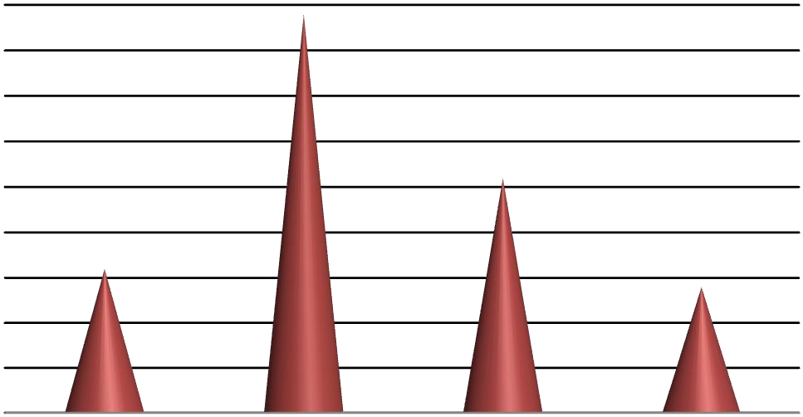
Table

1
:
Tenure of
being a customer

Figure 4: Tenure of being a customer

Findings and analysis-
Above table and figure denotes that most of the respondents of the research are purchasing oil and gas from Royal Dutch Shell Company for more than 1 year and the percentage of the people is 44%. This is percentage is followed by 26% that signifies the people who are the customers of Royal Dutch Shell Company for more than 3 years. 16% f the participants are the customers of the company is more than 5 years and 14% are the new customers of Royal Dutch Shell Company who are using the oil and gas of the company for less than 1 year.

Q.2 How far is you satisfied with the provided quality of the products in Royal Dutch Shell Company?
Options | Response% | No. of Respondents | Total Respondents
Strongly satisfied | 12 | 6 | 50
Satisfied | 34 | 17 | 50
Neutral | 28 | 14 | 50
Dissatisfied | 20 | 10 | 50
Strongly Dissatisfied | 6 | 3 | 50
Mean | Median | Mode | SD
2.74 | 3 | 2 | 1.103057

Table: 2 Satisfaction with the product quality

Strongly satisfied
Satisfied
Neutral
Dissatisfied
Strongly Dissatisfied

Figure 5: Satisfaction with the product quality

Findings and analysis-
As described in chapter 2 the primary elements of market position describes the effect of the quality of products on satisfying customers here also can be seen the same.
From the above table and figure, it can be seen that 46% (12%+34%) of the respondents are satisfied with the provided product quality of the Royal Dutch Shell Company and 12% of the people are strongly satisfied. However, 26% of the participants are not satisfied with the quality. 6% of them are strongly dissatisfied and 28% people stayed neutral in this matter.
As the mode is 2 that denotes that most of the people are satisfied with the product quality but as the SD is more than 1 therefore there is a risk factor for the company if they cannot continue with this quality or develop this quality.

Q.3 How far do you agree that the Royal Dutch Shell Company provides the products at a reasonable price?
Options | Response% | No of Respondents | Total Respondents
Strongly agree | 8 | 4 | 50
Agree | 26 | 13 | 50
Neutral | 24 | 12 | 50
Disagree | 28 | 14 | 50
Strongly disagree | 14 | 7 | 50
Mean | Median | Mode | SD
3.14 | 3 | 4 | 1.1954

Table: 3 Products at reasonable price

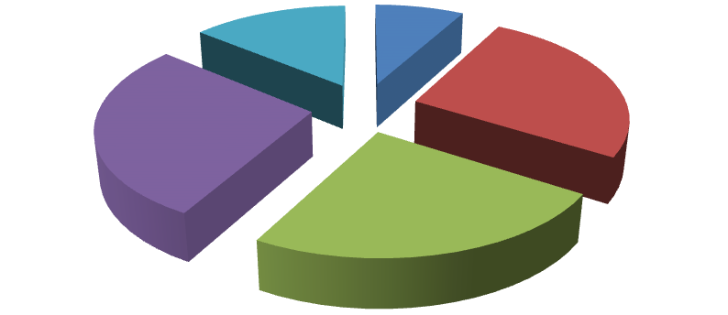

Strongly agree
Agree
Neutral
Disagree
Strongly disagree

Figure 6: Products at reasonable price

Findings and analysis-
In the literature review chapter it has also discussed that how the pricing strategy can attract a customer through the competitive and innovative strategies.. As presented in the table most of the participants are not satisfied with the pricing strategy of the Royal Dutch Shell Company. This category includes (28+14) % = 42% of the participants. 24% of the respondents did not give any opinion in this matter and 34% of the people are satisfied with the pricing strategy of the company.
The mode is 4 that indicates that most of the participants are not agreed with the matter that Royal Dutch Shell Company provides products at a reasonable price. SD is more than 1 that is a indication of risk for the company that if the company do not change their pricing strategy then it can be very harmful for the growth of the company. Therefore, the marketers of the company need to be focused on redesigning their pricing strategy to make it reasonable.
Q.4 What are the factors that influence you to buy oil and gas from the Royal Dutch Shell Company?
Options | Response% | No of Respondents | Total Respondents
Product Quality | 24 | 12 | 50
Reasonable price | 16 | 8 | 50
Availability | 36 | 18 | 50
Others | 24 | 12 | 50
Mean | Median | Mode | SD
2.6 | 3 | 3 | 1.10657

Table: 4 Influencing factors for purchasing products from the Royal Dutch Shell Company

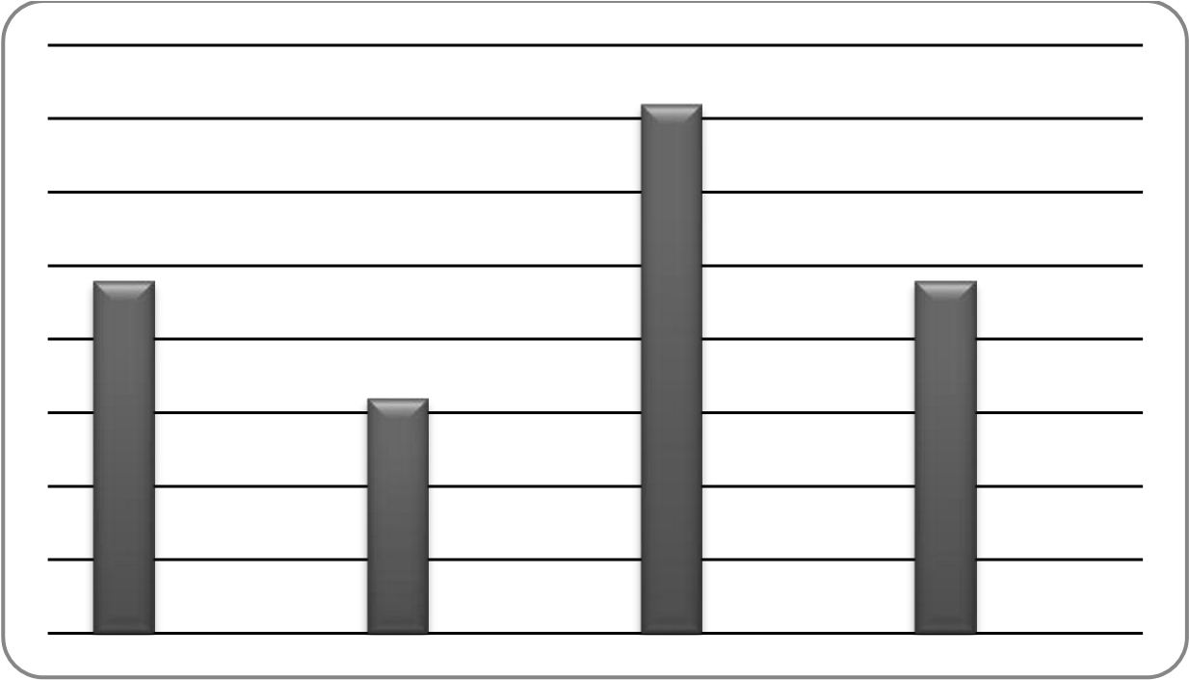

Figure 7: Influencing factors for purchasing products from the Royal Dutch Shell Company

Findings and analysis-
In chapter 2 the researcher has provide the factors that influence the behaviour of the customers in the market positioning strategy. Here it can be seen that there are different factors that make the customers of Royal Dutch Shell Company buy products apart from the company.
The above table and figure represents that the factor that influence the customers of the Royal Dutch Shell Company is the availability of their product. 36% of the respondents chose this option. 24% of the respondents purchase oil and gas from Royal Dutch Shell Company due to their quality of products whereas 16% chose the option of reasonable price as the reason of buying oil and gas from the company. 24% people remained silent in this matter.
The mode denotes that most of the people use oil and gas of Royal Dutch Shell Company due to the availability of their product. However, the SD is more than 1 that indicates the risk the company if they cannot carry on their product availability in future also.
Q.5 Do you agree that the Royal Dutch Shell Company apply effective and innovative strategies to attract their customers?
Options | Response% | No of Respondents | Total Respondents
Strongly agree | 8 | 4 | 50
Agree | 26 | 13 | 50
Neutral | 30 | 15 | 50
Disagree | 24 | 12 | 50
Strongly disagree | 12 | 6 | 50
Mean | Median | Mode | SD
3.06 | 3 | 3 | 1.15016

Table: 5 Effective and innovative strategies for attracting customers
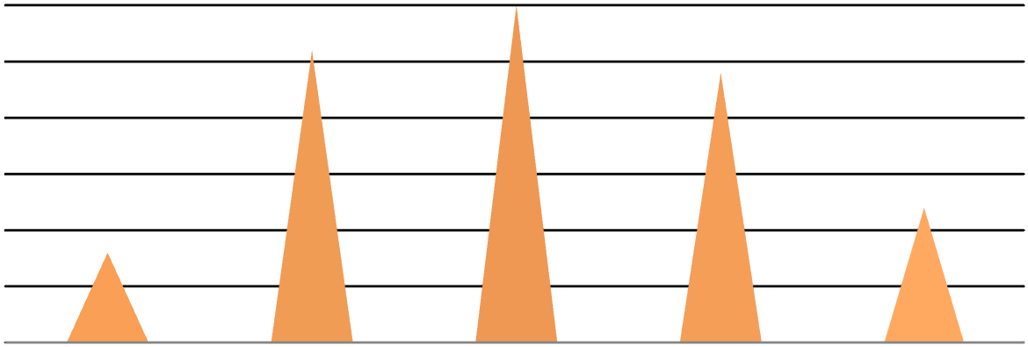

Figure 8: Effective and innovative strategies for attracting customers

Findings and analysis-
The table and figure denotes that 34% respondents agreed the fact that the Royal Dutch Shell Company applies effective and innovative strategies to attract their customers. 8% of them strongly agreed the matter. However, 36% participants did not agree the matter and 30% remained neutral.
As the mode is 3, it denotes that majority of the respondents remained neutral in this specific question that creates a confusion over the matter. Beside this SD is more than 1 therefore the company needs to be focused on creating and implementing effective and innovative strategies otherwise it can affect their business negatively in future.

Q.6 How far do you agree that the innovative strategy of the Royal Dutch Shell Company have the ability to gain your repeat purchase?
Options | Response% | No of Respondents | Total Respondents
Strongly agree | 8 | 4 | 50
Agree | 22 | 11 | 50
Neutral | 34 | 17 | 50
Disagree | 24 | 12 | 50
Strongly disagree | 12 | 6 | 50
Mean | Median | Mode | SD
3.1 | 3 | 3 | 1.12938

Table: 6 Ability of the innovative strategy to gain repeat purchase

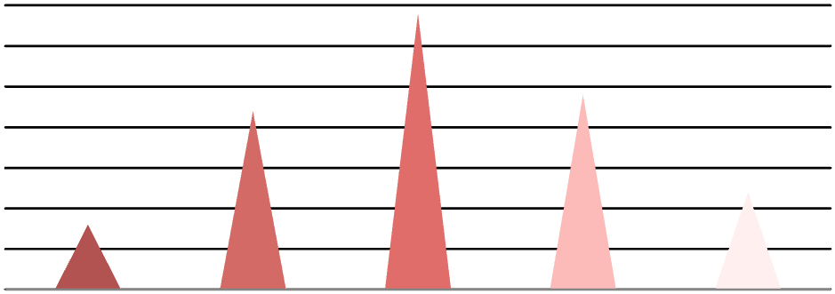

Figure 9: Ability of the innovative strategy to gain repeat purchase

Findings and analysis-
As discuss in the chapter 2 effective strategies have the ability to attract more customers that has been mentioned in consumer acquisition and retention strategy. The above presented table and figure indicates that 30% (8%+22%) of the respondents agreed that the innovative strategies implemented by Royal Dutch Shell has the ability to attract their customers and to gain their customers’ loyalty and 8% of them strongly believes the matter. However, there are other respondents also who did not agree this and they do not think that the implemented strategies are very much effective and this category’s people signify 36%. The people who did not give their any positive or negative opinion on this question signify 34%.
The mode which is 3 denotes that most of the people remained neutral over the matter therefore again it creates confusion. SD is greater than 1 that indicates a risk factor for the company that if the company do not enhance their effectiveness of the implemented strategies then it can be harmful for their business.

Q.7 Do you purchase oil and gas apart from Royal Dutch Shell Company?
Options | Response% | No of Respondents | Total Respondents
Yes, to high extent | 10 | 5 | 50
Yes, to some extent | 46 | 23 | 50
Not at all | 44 | 22 | 50

Table: 7 Purchasing oil and gas apart from Royal Dutch Shell Company

Yes, to high extent
Yes, to some extent
Not at all

Figure 10: Purchasing oil and gas apart from Royal Dutch Shell Company

Findings and analysis-
From the above table it is seen that 46% of the participants opined that they buy oil and gas apart from Royal Dutch Shell Company in some extent and 10% of the people purchase oil and gas apart from Royal Dutch Shell Company in high extent. However, 44% of the respondents do not buy oil and gas apart from the Company.
Q.8 Which other companies do you buy oil and gas apart from Royal Dutch Shell Company?
Options | Response% | No of Respondents | Total Respondents
Exxon Mobil Corporation | 12 | 6 | 50
TOTAL SA | 16 | 8 | 50
BP P.L.C. | 18 | 9 | 50
Others | 10 | 5 | 50
Not applicable | 44 | 22 | 50

Table: 8 Competitors of the Royal Dutch Shell Company



Exxon Mobil Corporation
TOTAL SA
BP P.L.C.
Others
Not applicable

Figure 11: Competitors of the Royal Dutch Shell Company

Findings and analysis-
The participants those purchase oil and gas apart from Royal Dutch Shell Company, they purchase the products from the other competitor companies of Royal Dutch Shell Company are Exxon Mobil Corporation, TOTAL SA, BP P.L.C. and others. Most of the respondents voted for BP P.L.C. that signifies 18%. 16% of the people buy from TOTAL SA and 12% buy from Exxon Mobil Corporation whereas 10% purchase from other companies. 44% of the respondents do not buy the products apart from Royal Dutch Shell Company.
Q.9 What are the factors that make you buy oil and gas apart from Royal Dutch Shell Company?
Options | Response% | No of Respondents | Total Respondents
Promotional strategy | 28.57 | 8 | 28
Pricing factor | 53.57 | 15 | 28
Product differentiation | 17.87 | 5 | 28
Mean | Median | Mode | SD
3 | 2 | 2 | 0.492365964

Table: 9 Factors that make people buy oil and gas apart from Royal Dutch Shell Company


Figure 12: Factors that make people buy oil and gas apart from Royal Dutch Shell Company

Findings and analysis-
The above table and figure represents that most of the people purchase oil and gas apart from Royal Dutch Shell Company due to the pricing factor that signify 53.57%. 28.57% of the people buy the products apart from the company are due to the different promotional strategies applied by the other companies. 17.87% opined for product differentiation as a factor for buying products apart from Royal Dutch Shell Company.
Here the mode is 2 that denote the pricing factor that is the key factor that influence people to buy products apart from Royal Dutch Shell Company. SD is less than 1 that denotes there is low risk for the company if they focus on their pricing factor.
Q.10 Which are the areas those should be focused by the marketers of Royal Dutch Shell Company to improve their market position?
Options | Response% | No of Respondents | Total Respondents
Product quality | 18 | 9 | 50
Pricing strategy | 44 | 22 | 50
Availability | 20 | 10 | 50
Others | 18 | 9 | 50
Mean | Median | Mode | SD
2.38 | 2 | 2 | 0.98747

Table: 10 The areas that should be focused by the marketers of Royal Dutch Shell Company

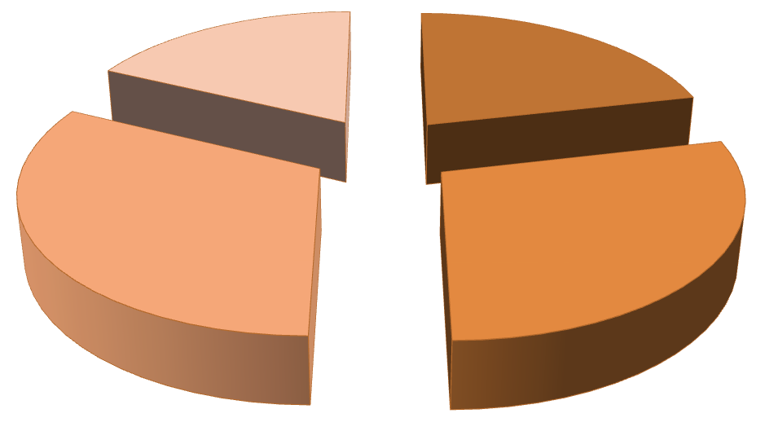

Exxon Mobil Corporation
TOTAL SA
BP P.L.C.
Others

Figure 13: The areas that should be focused by the marketers of Royal Dutch Shell Company

Findings and analysis-
In the above table, it can be seen that most of the people suggested that the Royal Dutch Shell Company should focus on their pricing strategy and to make it reasonable. 44% people suggested for pricing factor and 20% of the participants voted for product availability. 18% of the respondents suggested the company to increase their product quality and 18% for others.
The mode is 2 that denotes that the company mostly concentrate on their pricing factor and to make it affordable for all kind of people. Though the SD is less than 1 that denotes lower risk for the company still the company should think on their pricing strategy to not let to increase the risk due to this fact.

4.2 Qualitative analysis
Q.1 what are the factors that are required in creating competitive yet innovative business strategies?
The first manger opines that creating effective strategies requires an expert view, knowledge and skill about the all features of a business to create the strategies accordingly. In order to create an effective business strategy it is very important to gather a clear and deeper knowledge about the internal and external factors of the business that can be done by conducting a market research. The result of the research will help the company to analyse the areas where the company needs to be improved as per the demand of the market.
The second and third manager opines almost dame that market survey is very important to identify the business factors before creating a business strategy. Taking feedback of the customers is considered as the most important aspect of formulating a business strategy. These strategies can enhance the reputation of the company and raise the growth of the business.
So it can be said that all the mangers of Royal Dutch Shell Company agreed the factor that the company needs to conduct market survey before making their strategies those are to be implemented. This will help them to formulate effective business strategies that can have positive impact on the business.
Q.2 what are the importance of competitive yet innovative strategies on customer acquisition and market position?
According to the first and second manager in order to survive in the competitive business environment, it is very important to formulate effective strategies by gaining an immense knowledge about the different aspects of the business. A clear analysis of the competitive business environment helps to make competitive strategies. However, the strategies must be innovative also; the competitors cannot easily copy that. These strategies have a great impact on flourish the business by gaining more customers and sustaining the market position through this.
According to the third manager, innovation is very important in recent business world in order to develop the effectiveness of the strategies. As the market competition is too high in the recent days, therefore, the strategies have to be not only competitive but innovative also and these have the ability to sustain the market position by gaining competitive advantages from the market. The customers have become so much choosy as they have many options to choose their products as per their requirements. Therefore, it is getting tougher for the company to attract the customers and gain their loyalty. For this purpose, the company has to be inclined on making and increasing the aptitudes of the implemented strategies that can acquire more customers.
So it is clear that there is a great impact of competitive yet innovative strategies on customers’ acquisition and thus increase the growth of business and sustain the competitive position in the market.
Q.3 What are the strategies implemented by the Royal Dutch Shell to acquire more customers?
According to the manager of Royal Dutch Shell Company, the company implements different strategies to obtain more customers. The first and third manager accessed their view that the aim of the company is not only to retain more customers but also to carry on their market position. Therefore, the Royal Dutch Shell Company concentrates on those strategies that can earn their customers’ trust and satisfaction. The lifestyle of the people being modernized and their expectations are getting high in terms of product quality and availability. Therefore, while designing a product it is very crucial to use the process of innovation in order to make th4 product quality superior and unbeatable so that the customers get stick to the company and cannot go to any other company.
As per the perspective of the second manager, the Royal Dutch Shell Company believes in implementing competitive yet innovative strategies. In order to deal with the increasing competitiveness of the business environment it is vital for the company to make their product available with superior quality so that the customers do not have to go to the other company. Therefore, the company is focused on their product availability by using advanced technology in the process of production. Beside this, the company is also focused on making their price of the products reasonable as per the product quality and are inclined to make the products cheaper than that of its competitors by cutting their cost of production that can help them to earn customers’ satisfaction.
After taking the opinions of the managers of the Royal Dutch Shell Company, it can be said various strategies are there. The company implement to carry out their business activities adequately by enhancing customer satisfaction and loyalty.
Q.4 what are the problems faced by the company while making and implementing the strategies?
All the managers highlighted some issues of making and implementing the strategies on their business. The expectations of the customers are getting high with time and if they do not found a product appropriate as per their demand, they take a few second to move to the other company, as there are so many choices available for them. Therefore, the companies have to deal with several issues on formulating and implementing strategies that can satisfy their customers.
As per the viewpoint of the first manager the first problem that Royal Dutch Shell Company has to face while making the strategy is the re reliability of the data that they have gathered through the market survey. Lack of the authentication of the collected data acted as a barrier of making a competitive yet innovative strategy.
The second and third manager opines that making effective and innovative strategies needs a definite investment to carry out the market survey and for the innovation process. However, there is no surety about the effectiveness of the company until it is implemented to the business. This uncertainty also plays a vital role of obstacle for formulating a competitive yet innovative strategy.
It is also seen that while implementing the competitive yet innovative strategies by the Royal Dutch Shell Company various problems have to face them due to some limitations those are stated by the mangers of the company.

4.3 Summary
In this chapter the researcher, gain the opinions of the managers and customers of the Royal Dutch Shell Company in order to gain a deeper knowledge about the concerned topic. The collected data of the research have been presented through various figures that will help the reader to understand the different factors of the research easily and clearly.

Chapter 5

Conclusion and recommendation

5.0 Conclusion
Based on the topic of the research that is the effectiveness of competitive and innovative strategies in order to maintain market position and to retain customers the researcher has gathered all relevant information through primary and secondary survey. The collected data has been analysed by the researcher and in this chapter, the researcher will link the research objectives with the findings of the research. This will help the researcher to identify the loopholes of the Royal Dutch Shell Company and provide recommendation accordingly. In this chapter, the researcher will also mention the issues or limitations that have been faced by the researcher while carrying out the research and the further scope of the research.

5.1 Linking with the objectives
Linking the research findings with the research objectives helps the researcher to analyse the success or failure of the research.

Linking objective 1: To understand the competitive however innovative strategies
In the literature review chapter, the researcher has given a detail description about the concepts of competitive yet innovative strategies. It explains about the innovative strategies and their effectiveness and how the strategies can be formulated. Te researcher has discussed matter deeply in chapter 2. In the qualitative part of chapter 4 question number 1 describes the important factors regarding to competitive yet innovative strategies.

Linking objective 2: To analyse the impact of implementing competitive yet innovative strategies on market position and customer acquisition
The literature review chapter provides a brief description of this objective. The quantitative and qualitative questions of chapter 4 also give the answers of the impact of implementing competitive yet innovative strategies sustain the market position and customer acquisition. In chapter 2 the theory related to the topic has been discussed. The Royal Dutch Shell Company applies different innovative strategies to attract their customers. The link of the findings on this with the objective clearly states that there is a positive influence of competitive strategies n customer acquisition and maintain the market position.

Linking objective 3: To identify the loopholes of the Royal Dutch Shell company to implement these strategies
In chapter 4, in the quantitative part almost all the questions are framed to find out the loopholes of the Royal Dutch Shell Company. In the qualitative part question, number 3 is made to understand the problems those are faced by the company. This will help the Royal Dutch Shell Company to make their strategies as per the customers’ need.

Linking objective 4: To recommend some suitable suggestions to mitigate those problems
Question number 10 in the quantitative part of chapter 4 is given to take the opinion of the customers over the matter that in which areas the Royal Dutch Shell Company needs to be focused. Most of the customers suggested the company to think on their pricing strategy. According to the respondents, the pricing strategy of the Royal Dutch Shell Company is not appropriate. so the company should change it.

5.2 Recommendation
The researcher to the loopholes of the Royal Dutch Shell Company gives few recommendations.

Focus on the pricing factor
In this research, most of the respondents suggested the company for changing their pricing strategy. It proofs that the customers are not satisfied with the pricing strategy of the company therefore; the company needs to redesign their pricing of the product as per their quality and affordability of the customers so that the customers do not go to the other companies for purchasing.

More concentration on making innovative competitive strategies
In order to increase the effectiveness of their competitive strategies the Royal Dutch Shell Company is required to be more focused. A complete knowledge over the business environments and the activities of their competitors is important for them to make their initiatives efficiently and to earn the repeat purchase of their customers. As seen in the findings and analysis of the research it is seen that not all the customers are satisfied with the product quality, the implemented strategies of the company, therefore it can e recommend to the Royal Dutch Shell Company to focus o their process of strategy making that can satisfy their customers.

5.3 Limitations of the research
The limitation of this research is the limited budget and restricted timeframe for which the researcher has to select a small sample size and due to this fact, the researcher cannot gather deeper knowledge about the concerned topic. The SPSS software can also not be used by the researcher for the limited budget.

5.4 Further scope of the study
Although the research has been done under some limitations and ethical issues, still there is a scope for future research. The data those are collected in this research can be used as secondary source for future and the future researcher can be able to carry out a comparative research of other company with the Royal Dutch Shell.

Reference List

Books
Afuah, A. (2007) "Business models: A strategic management approach," 4th ed. New York: McGraw-
Hill
Bergh, D. and Ketchen, D. J. (2009) Research methodology in Strategy and Management, 1st ed. Bingley: Emerald Group Publishing Ltd
Bernard, H. R. (2011) Research Methods in Anthropology: Qualitative and Quantitative Approaches. 5th ed. Plymouth: Alta Mira Press.
Davis, J. A. (2010) Competitive Success, How Branding Adds Value. 5th ed. London: Kogan Page.
Kapferer, N. J. (2008) The New Strategic Brand Management: Creating and Sustaining Brand Equity Long Term. 6th ed. Harlow: Prentice Hall Companion.
Kumar, S. R. (2009) Consumer Behaviour and Branding, 3rd ed. New York: Wiley.
Saunders, M. N., Lewis, P. and Thornhill, A. (2009) Research methods for business students, Page 52, 5th ed. Harlow: Prentice Hall
Shaw, J. K. (2008) Strategic management in telecommunications, 4th ed. Belgium: Peeters Publisher.

Journals
Akroush, N.M., Dahiyat, E.S., Gharaibeh, S.H. and Abu-Lail, N.B. (2011) “Customer relationship management implementation. An investigation of a scale’s generalizability and its relationship with business performance in a developing country context.” International Journal of Commerce and Management, 21(2), pp- 158-191.
Alvarez, B. A. and Casielles, R. V. (2008) “Consumer evaluations of sales promotion: The effect on brand choice.” European Journal of Marketing, 39 (1), pp- 54-70.
Balaram, A. and Adhikari, B. (2010) “Managing Customer Relationships in Service Organizations”. Administration and Management Review, 21(2), pp- 65-78.
Barney, J. B. (2009) 'Strategic factor markets: Expectations, luck, and business strategy',
Management Science 32( 1 ) , pp. 1231-1241
Bearden, W. O. and Teel, J. E. (2007) "Selected Determinants of Consumer Satisfaction and Complaint Reports," Journal of Marketing Research, 20, pp- 21-28.
Biggadike, E. R. (2010) "The contributions of marketing to strategic management," Academy of
Management Review, 6, pp- 621-632
Bloemer, J. M. M. and Kasper, H. D. P. (2006) “The Complex Relationship Between Consumer Satisfaction and Brand Loyalty,” Journal of Economic Psychology, 16, pp- 311-29.
Boulding, W., Staelin, R., Ehret, M. and Johnston, W. J. (2010) “A customer relationship management roadmap: what is known, potential pitfalls, and where to go” Journal of Marketing, 69(4), pp- 155– 66
Boulton, R. E. S., Libert, B. D. and Samek, S. M. (2009) “A Business Model for the New Economy.” Journal of Business Strategy, pp- 29-35.
Cameron, R. (2009) 'A sequential mixed model research design: design, analytical and display issues',
International Journal of Multiple Research Approaches, 3(2), pp-140-152,
Chesbrough, H. W. (2009) “Business model innovation:” It’s not just about technology anymore. Strategy and Leadership, 35: pp- 12-17.
Cool, K. and Schendel, D. (2010) 'Performance differences among strategic group members', Strategic Management Journal, 9(3) , pp. 207-223.
Corstjens, M. and Lal, R. (2008) “Building store loyalty through store brands.” Journal of Marketing Research, 37 pp- 281-291.
Das, G. and Kumar, R. V. (2009) “Impact of sales promotion on buyers behaviour: an empirical study of Indian retail customers.” Global Marketing Journal, 3 (1), pp- 11-24.
Elena, B. D. and Jose, A. M. (2005) "Does Brand Trust Matter To Brand Equity?", Journal of Product and Brand Management, Vol.14, No.3, pp.187-196.
Ellis, T. and Levy, Y. (2009) ‘Towards a guide for novice researchers on research methodology: Review and proposed methods’, Issues in Informing Science and Information Technology, 6, pp- 323337.
Ethiraj, S. K. and Zhu, D. H. (2011) “Performance effects of imitative entry,” Strategic Management Journal, 29(8), pp- 797–817.
Freshwater, D. (2007) “Reading mixed methods research: contexts for criticism”, Journal of Mixed Methods Research, 1(2), pp. 134-146.
Harrison, R. L. and Reilly, T. M. (2011) "Mixed methods designs in marketing research", Qualitative
Market Research: an International Journal, 14(1), pp. 7 – 26
Huxham, C. and Vangen, S. (2008) Researching organizational practice through action research: Case studies and design choices. Organizational Research Methods, 6, pp- 383-404.
Johnson, R. B., Onwuegbuzie, A. J. and Turner, L. A. (2007) “Toward a definition of mixed methods research”, Journal of Mixed Methods Research, 1(2), pp. 112-133
Knox, K. (2008) A researchers’ dilemma: Philosophical and methodological pluralism, Electronic journal of business research methods, 2(2), pp. 119- 128.
Magilvy, J. K. and Thomas, E. (2009) ‘A first qualitative project: Qualitative description design for novice researcher’, Journal of the Society for Paediatric Nurses, vol. 14, no. 1, pp. 298-300.
Morgan, D. L. (2007) “Paradigms lost and pragmatism regained: methodological implications of combining qualitative and quantitative methods”, Journal of Mixed Methods Research, 1(1), pp. 48-
76.
Onwuegbuzie, A. J. and Leech, N. J. (2009) On becoming a pragmatic researcher: The importance of combining quantitative and qualitative research methodologies. International Journal of Social Research Methodology, 8, 375-387.
Website
Shell.co.uk, (2015), Shell in UK, Available from: http://www.shell.co.uk/, [Accessed on 2 Aug. 2015].

Appendices

Appendix-1
