Chapter I: INTRODUCTION

The introduction describes the research problem or research question and lays out the reasoning behind it. This reasoning is sometimes called a theoretical argument. It justifies the study, in terms of a need for the information it will provide, in order to develop or test a theory or to understand, explain, or further describe an educational phenomenon. Refer to the APA manual for additional information about the introduction.

1. General description of the areas of concern – set the stage (3-4 paragraphs).

2. Significance of the Problem
- Include explicit statement of significance specific to the topic studied.
- Why is it important to conduct the study?
- This section will probably not be very long but it should be very powerful!
- What theoretical/practical reasons are there for wanting to know the answers to the research questions?
- Analyze the Theoretical Basis for the Study
  - The organization of the variables that will be considered to answer the research questions likely will have a theoretical basis. Explicate how the most appropriate theoretical perspective helps conceptualize the study. Competing theoretical perspectives should be analyzed in Chapter 2 Literature Review.
  - Include theoretical definitions of important terms and all constructs (should not include operational definitions that will appear in the methods section).
- Synthesize and Critically Analyze the “Very Relevant Literature”
  - Make the argument for the dissertation using the “studies in the existing literature that incorporate all the major variables or constructs that are present in the proposed study” (Rudestam & Newton, 2001, p. 63). Figure 4.1 (Rudestam &
Newton, 2001, p. 64) provides a visual conceptualization of relevance of literature.
  - This may require examining the intersection of only a subset of variables and repeating the process with another subset of variables because the literature does not have all variables incorporated in extant research.
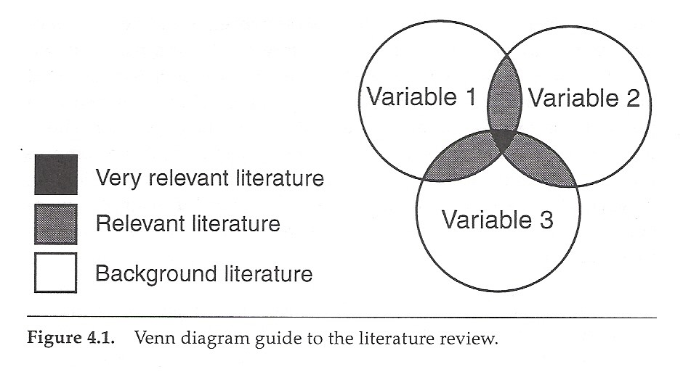

5. Problem Statement
- State the purpose of the research explicitly and succinctly.
- The introduction should lead up to and provide support for the problem statement.

6. Research Questions and Hypotheses
- Ordinarily the researcher will have a few research questions, with a number of hypotheses for each.
- Do not operationalize variables in this section. Use theoretical questions and hypotheses written in the language of constructs.
- A research question should (a) be in the form of a question, (b) suggest a relationship among constructs, and (c) be empirically testable.
- Hypotheses are declarative statements written in the expected or predicted direction (usually an alternate hypothesis). Such hypotheses are called research, scientific, or theoretical hypotheses and are written in the present tense.
- Example adapted from Rudestam & Newton (2001, pp. 67-68).
  - Research Question: How do adolescents with dyslexia cope with the effects of their learning disabilities?
  - Hypothesis 1: Adolescents with dyslexia who accept the diagnosis of having a learning disability use more problem-focused coping strategies than adolescents with dyslexia who reject or deny the diagnosis.
  - Hypothesis 2: Adolescents with dyslexia who accept the diagnosis of having a learning disability rely more on social support than adolescents with dyslexia who reject or deny the diagnosis.
  - Hypothesis 3: Adolescents with dyslexia who reject or deny the diagnosis of having a learning disability use more avoidant coping strategies than adolescents with dyslexia who accept the diagnosis.
  - Note how hypothesis 2 and 3 are worded so that the coping strategy hypothesized matches the specific group. Also note that terms are not operationalized here.

Chapter II: LITERATURE REVIEW

This chapter reviews what has already been written in the field on the topic of the research. The literature cited should support the theoretical argument being made and demonstrate that the author has a grasp of the major ideas and findings that pertain to his or her topic. Refer to APA manual for additional information concerning literature reviews.

- Historical Background
  - Put things in perspective. This is more than just a chronology and does not necessarily have to include every detail since day one.
  - What are the major issues, controversies, etc. that impact your study. Include background on all relevant variables.

- Theory Relevant to Research Questions/Hypotheses.
  - What theoretical models/perspectives inform your research?
  - Compare and contrast competing theories and justify the theoretical foundation of the dissertation.
  - Describe how the theoretical foundation of the dissertation applies to the problem.

- Current Empirical Literature Relevant to Research Questions/Hypotheses
  - Include in this section:
    - literature relating to individual variables
    - literature relating to specific combination of variables (specifically examine background and relevant background literature as shown in
Figure 4.1) relevant to the dissertation
  - This should be more than a listing of studies. What common thread holds them together? Use transitions to effectively tie one section with another.
  - Incorporate discussion of strengths/weaknesses of methodology in previous studies and which you are building on/hoping to avoid/improve upon in your study.
- Use headings and subheadings liberally to organize this section. Consider making a “concept map” of relevant literature for organizational purposes (do not include in the dissertation text, however). This section should be reflective of deductive reasoning; starting broadly and narrowing the focus as the chapter progresses

Chapter III. METHOD

The method chapter should give sufficient detail about the methodology used that the study could be replicated. Sections in a Method chapter often include, but are not limited to, the following: participants, instruments, materials, procedure, and analysis. Refer to APA manual for additional information concerning methods sections.

1. Participants
- Human subject’s consideration and clearance from IRB (IRB is submitted after the proposal and documented as passed in the final document).
- Describe subjects in enough detail so the reader can visualize the subjects. Important characteristics should be delineated (often not available until after data collection, these data should be presented here rather than in the results section).
- Describe methods for sample selection in detail. For example if a sample of convenience is used, this should be explicitly stated. Specific inclusion and exclusion criteria should be noted in this section.
- Conduct and report a power analysis to determine the sample size for the proposal. Keep these findings in the final document and provide an explanation if there are meaningfully more or less subjects in the final analyses.
- If there was attrition, state the number of subjects who dropped out (or with unusable data), the reasons for attrition, and information about the dropouts.
- Discuss handling of missing data.
- If a survey is used report the rate of return in this section.

2. Measures
- If an unpublished instrument or new measurement technique is used, describe it in detail. Include copies of all unpublished instruments in the appendices. It is likely reliability and validity analyses will need to be part of the dissertation when unpublished instruments are used.
- Published instruments or techniques that have been used before should be referenced with appropriate citations.
- For all measures, evidence of reliability and validity should be stated explicitly. If this information is not available from prior studies, piloting of the instrument/procedures should be conducted. For all instruments, the researcher should include reliability information specific to the study sample (Thompson, 1994).
- Organize this section in terms of constructs measured. For measures that include several constructs be clear in describing the measure which constructs are assessed and provide specific reliability and validity data for the subscale.

3. Research Design
- Include general description of the research design in accepted terminology (e.g., Cook & Campbell, 1979; Kirk, 1982). Include possible threats to internal and external validity of the chosen design.
- List independent and dependent variables and their operational definitions.
- It is often useful to include a diagram/figure of the design.

4. Procedures
- Procedures should be described in sufficient detail, that a reader could replicate the study if so desired.
- If a survey is used, the method of collecting data, the rate of return, and description of the procedures used in follow up and a description of the nonresponders should be provided.
- Copies of materials used in intervention, etc. should be included in an appendix.

5. Data Analysis
- Restate each research question and hypothesis.
- Each hypothesis should be followed by choice of statistical analysis to address each.
- Include brief description, the assumptions regarding the statistical analysis that will be tested, and rationale for each statistical technique chosen.
- State alpha levels to be used to determine statistical significance.

Chapter IV. RESULTS

This chapter presents the results of the analyses, usually in order by research question, and any results of further analyses (that is, analyses that were not proposed but which were carried out). Results should be presented without interpretation; interpretation is reserved for the discussion in chapter V. Refer to APA manual for additional information concerning methods sections.

- Order of Presentation for Nomothetic Studies
  - Descriptive Statistics (includes means, standard deviations, frequencies, etc. for all variables in the study)
  - Preliminary Statistical Analyses (correlation matrices, etc.)
  - Statistical analyses to answer research questions/hypotheses.
  - Note: for single-subject, small n, and qualitative studies develop the order of presentation with the dissertation chair.

- Statistical Analyses to Answer Research Questions/Hypotheses
  - Use questions/hypotheses as an outline to organize results.
  - Each question/hypothesis should be restated followed by the results of the tests of assumptions and then by the data analyses which provide answers to that question/hypothesis.
  - Report statistical power of the test and effect sizes.

- Organize Data into Tables and Figures
  - Each Table or Figure must be referenced in the text.
  - Tables and Figures should include complete information so that they can be understood without reference to the text.
  - Place tables and figures as soon after their first mention in the text as is possible.

Chapter V. DISCUSSION

Results are interpreted in light of the research questions and discussed in conjunction with other literature. Limitations of interpretation and implications for further research may be presented. Refer to APA manual for additional information concerning methods sections.

1. Summary
- Summarize results briefly.
- Discuss results in non-statistical terms. Answer the research question and hypothesis

2. Conclusions
- Organize this section with headings
- Explicitly discuss the implications of the results. Integrate your results with the theoretical background and very relevant literature findings.
- Relate to literature review - point out (a) consistencies and (b) inconsistencies with results of those studies reported in the literature cited.
- Did findings provide support or differ from extant theoretical positions.
- It is appropriate to speculate on the meaning of the results as long as it is made explicit that that is what the writer is doing.

3. Limitations
- A limitation is a weakness or handicap that potentially limits the internal or external validity of the results, such as using a sample with a particular characteristic such as all males. Most limitations should have been considered when the study was conceptualized. Therefore, limitations in this section are those that were largely outside the control of the researcher.
- Often limitations include a statement of the generalizability of the results, controls that may be impossible to meet, etc. For example, if you must use intact groups rather than random assignment, how might this affect the interpretation of your results?

4. Recommendations for Future Research
- Provide specific guidance based on the dissertation finds and they relate to the extant theoretical and empirical base.
- Why is the proposed research needed and what form should it take.

REFERENCES

APPENDICES

Dissertation Outline References

Cook, T. D., & Campbell, D. T. (1979). Quasi-experimentation: Design & analysis issues for field settings. Boston: Houghton Mifflin.
Kirk, R. E. (1982). Experimental design: Procedures for the behavioral sciences (2nd ed.). Pacific Grove, CA: Brooks/Cole.
Rudestam, K. E., & Newton, R. R. (2001). Surviving your dissertation: A comprehensive guide to content and process (2nd ed.). Thousand Oaks: Sage.
Thompson, B. (1994). Guidelines for authors. Educational and Psychological Measurement, 54, 837-847.

Resources

Read all documents at http://www.education.duq.edu/currentStudents/dissertations.html Get the most current version of the APA Publication Manual

Cone, J. D., & Foster, S. L. (2006). Dissertations and theses from start to finish: Psychology and related fields (2nd ed.). Washington, DC: American Psychological Association.
Grimm, L. G., & Yarnold, P. R. (1995). Reading and understanding multivariate statistics.
Washington, DC: American Psychological Association.
Grimm, L. G., & Yarnold, P. R. (2000). Reading and understanding more multivariate statistics. Washington, DC: American Psychological Association.
Kazdin, A. E. (1982). Single case research designs: Methods for clinical and applied settings. New York: Oxford University Press.
Mertler, C. A., & Vannatta, R. A. (2005). Advanced and multivariate statistical methods:
Practical application and interpretation (3rd ed.). Glendale, CA: Pyrczak Publishing.
Miles, M. B., & Huberman, A. M. (1994). Qualitative data analysis (2nd ed.). Thousand Oaks: Sage.
Pyrczak, F., & Bruce, R. R. (2003). Writing empirical research reports: A basic guide for students of the social and behavioral sciences (4th ed.). Glendale, CA: Pyrczak Publishing.
Rudestam, K. E., & Newton, R. R. (2001). Surviving your dissertation: A comprehensive guide to content and process (2nd ed.). Thousand Oaks: Sage.
Tabachnick, B. G., & Fidell, L. S. (2007). Using multivariate statistics (5th ed.). Boston: Allyn & Bacon.

