Research project assignment on Gig Economy
Question
Criteria
- A brief statement of the problem, research aim and objectives
- A brief methodology
- Sources of secondary data, data presentation and analysis methods
- Accurate referencing, use of correct English and logical sequences between sentences and paragraphs.
Answer
1. Introduction
The impact of globalisation has been massive that has caused organisations all across the world to go through a series of constant transitions and face changes from various external and internal sources. It has to be noted that the organisations are willing to stay highly competitive and adapt the best style of leadership, production, and marketing to maintain their respective competitive advantages. One of the new trends in the global market has been the new mode of business called the Gig Economy. The Gig Economy is a type of economy that allows business organisations to opt for short-term and temporary services from workers that will enable them to keep changing their styles of business ethics and practices for better profit (De Stefano, 2015).
This particular research project assignment is going to look closely into the aspects of Gig Economy and the ways in which the global business organisations are increasing their effectiveness through this practice. This research project assignment aims to achieve a few goals that will help in understanding the concept and labour force of Gig Economy in more detailed and critical ways. The following is a well-drafted research proposal for the concerned topic of Gig Economy.
2 A detailed statement of the problem
Gig Economy can be easily explained by looking at the temporary positions of the workers in many emerging and already established organisations. The business organisations are opting for this particular form of about force where employees are allowed to work as freelancers and at part-time or temporary positions for the organisation to fulfil their current objectives (Steinberger, 2017). The changes in the market bring changes to the organisation’s practices too. The business organisations are always facing threats from newly formed companies as they emerge as competitors.
It is, indeed, necessary for the business organisations to find the right leadership approaches, the right styles of marketing and production practices to cope up with the changing demands and requirements from the customers (Greenwood, Burtch & Carnahan, 2017). Hence, the temporary position of the employees helps the organisations to understand the best practices and change them accordingly to suit the changing practices. In doing so, many problems arise, and they are adding to the whole concept of Gig Economy in today’s world. Primarily, this whole phenomenon is caused due to the heavy impact of globalisation and remarkable discoveries of science and technology that allow people to be constant upgrade their stature and opt for better positions and job profiles (Abraham et al., 2016). The actual problem is a constant debate regarding the effectiveness and generic practice of Gig Economy and its significance. This particular research intends to look closely into the problem and evaluate important facets of the same.
3 Research aim, objectives and research questions
Like all major research projects, this particular research project assignment also has its aim to full fill along with a few objectives to achieve with proper research and investigation of literature. Setting the aim, goals, objectives and questions for the research project assignment, help in framing the research practice in the most effective way that eventually contributes to the field of study or subject discipline.
3.1 Aim of this research: This research project assignment aims to examine the reasons due to which the organisations in the world are willing to opt for this Gig Economy as a new labour force as highly opposed to the temporary and short-term contracts.
3.2 Objectives of the research: Some of the objectives that this particular research project assignment intends to achieve through research and investigations are listed in the content hereafter.
- To understand and identify with the most suitable style and approaches of leadership that will be beneficial for the organisations and allow leaders to concentrate on achieving workplace competence.
- To identify with an organisation that reciprocates to the labor force changes through training and other factors
- To evaluate and elucidate the present structure of the organization and how the concept of Gig Economy can be well fitted to the present structure
- To understand how cultural transitions and changes can affect and add to the new labour force of Gig Economy in relation to the objectives from the leader’s perspectives.
3.3 Research questions:The research questions for this particular research project assignment are listed as follows.
- What are the most appropriate styles and approaches of leadership that will allow the workers to achieve organisational competence?
- What can be an organisation that reflects through changes in labour force through other factors and training?
- What is the present structure of the organisation and how the concept of Gig Economy can be appropriately fitted into the structure and practice?
- What can be the impact of cultural transitions and changes to the new labour force of Gig Economy in relation to the objectives from the leader’s perspectives?
4 Hypotheses
The fact that the Gig Economy is highly debatable has developed a multifaceted concept that commingles people’s perception and ideas on applying the right form of leadership that will help in adding positively to the organisation. As a theorem, this can be looked as the core reasoning for the project by reflecting the correlation between leadership approaches and Gig Economy and how it has impacts on the overall output.
H₀: null hypotheses- the null hypotheses is used for statistics that reflects no apparent importance exist in the observations. It emphasises showing that no variation is there between the variables.
H₁: qualitative hypotheses- this is often termed as the hypotheses generating research. It uses the qualitative data that is collected and then the hypotheses are developed accordingly.
5 Justification and potential output of the research project
The concept of Gig Economy lies in the very fact that the employees are hired as freelancers and as temporary workers to manage certain tasks and fulfil the objective for that time (Kässi & Lehdonvirta, 2018). Changes keep coming to the organisations from various sources such as internal and external, and Gig Economy allows the organisations to opt for the most suitable practice according to the change that comes. It may also allow the company to hire new employees who are more suited to pursue the task and demote the existing employees from their positions (Wright, 2018). In this whole process, the leadership approaches do play a vital role. There are leadership approaches and styles that are easily implemented in an organisation by understanding its practices and objectives. However, it is the leader who, with great responsibilities, tries to implement the best leadership style to attain the most productive output. This particular research will look into that aspect and hence, it is highly significant. The research will create an understanding of how the leadership plays a significant role and impacts on the idea and practice of Gig Economy that eventually raises the production level of an organisation.
The discussion above and the significance of this particular project will prove helpful in identifying with the right output of the research, as it will look closely into the approaches and styles of leadership and evaluate its impact on Gig Economy. The potential output of the research is going to highly significant and path-breaking in its field of study. The output of this research will establish a set of knowledge and understanding on how the impact of leadership adds to the whole process of Gig Economy and its practice. It will develop an understanding of the correlation between the two.
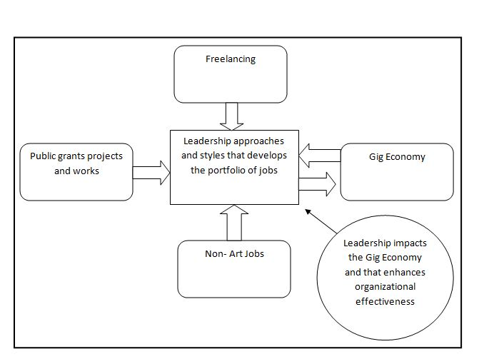
Figure- Conceptual framework
(Source- created by the author)
United Kingdom’s government research document titled as “The experiences of individuals in the gig economy” is one of the most significant research works that gives a vivid idea on the concept and practice of Gig Economy ("The experiences of individuals in the gig economy", 2018). This research document mentions about the various facets of the Gig economy and how it has impact on the job effectiveness. Gig Economy is highly flexible, says the writer of the document and it also mentions that people who are associated with the Gig Economy tend to appreciate its operations and functions ("The experiences of individuals in the gig economy", 2018).
The Online Labour Index is the first online Gig Economy indicator that has been designed by the researchers from the University of Oxford ("The Online Labour Index |", 2018). This particular index helps in understanding the number of Gig Economy projects and the severity of its practices in the present world. Scholars do state that the concept of Gig Economy as a new trend in business is going to grow faster than expected by most of the organisations ("The Online Labour Index |", 2018). It has to be stated that the employees all across the world, especially in developing nations, are more prone to change their job positions and go for better opportunities. The concept of Gig Economy as a flexible form of practice and work will allow the employees to do this on a very frequent level.
Gig Economy is a very new form of business where people are given the freedom to work as a freelancer and attain success and experience being a part-time or short time work. It is highly debatable in various spheres of business in the present society. It must be noted that scholars always emphasise on the effectiveness of job posts once they are permanent and gives an assurance to the employee on constantly developing ideas and scope of creativity at the workplace (Graham, Hjorth & Lehdonvirta, 2017). However, the modern day organizations are opting for unique and highly productive ways to employ workers on a temporary basis that is adding to their overall rate of production and making them attain the right strategies and approaches of leadership by analyzing the market trends and changes ("Parliament of Victoria - Research Papers", 2018). It is something that can be understood from the perspective of the Gig Economy.
Dr Emilia Istrate, the managing director of the Countries of Future Lab, has co-written a document that with Jonathan Harris who is a prolific researcher that is titled as “The Future of Work, the Rise of Gig Economy” (Istrate & Harris, 2017). It is a well-drafted work of research that analyses the various sides of the Gig economy as a trend that is on the rise. In this document, the writers have argued on the various facets of the gig economy. They have reflected and drafted on the three main components of the gig economy that can be identified in the current world. Firstly, it deals with the independent workers; secondly, it deals with the consumers who are the important stakeholders in all businesses. Thirdly, the companies that are harnessing the concept and practising the idea of gig economy form the three components (Istrate & Harris, 2017).
According to Kalleberg & Dunn, (2016), it can be stated that sources of literature have defined the gig economy as a very impactful and impressive form of business that is highly flexible for the organisations as well as for the workers. This concept of business demonstrates the ability of the workers and the companies to implement leadership styles and approaches for the betterment of the companies by making them go flexible and easily attainable (Aloisi, 2015). It must be noted that scholarly preferences and perceptions do add a lot to the overall understanding of gig economy, but as a radical and revolutionary practice, the idea of gig economy will soon change the ethics and form of business in the present society. Scholarly suggestions and elaborations of the concept is well estimated, and it is observed that the new age scholars and universities are adding more positive aspects to the whole idea of generating gig economy all over the world.
7 Methodology and presenting secondary data
It is the section of the research project assignment that will reflect in collecting the data and information to fulfil the objectives of the project. As a section of methodology, this content will draft the methods of collecting data and analysing them in detail. The data are going to be collected from secondary sources on Gig Economy and the concept of temporary employability that the organisations are opting for in recent times. The flexible Gig Economy will be well analysed by estimating the data and information that will be gathered through secondary sources of information like books, magazines, research journals, articles, online research works, and many other genuine and valid works from scholars and business experts.
7.1 Data series and surveys: This particular research project assignment will initiate an online survey that will be involving the leaders of many organisations and the employees who are associated with the Gig Economy. The leaders and the employees will act as candidates and participate in the survey by answering the questionnaire that will be sent to them. The research will also aim to conduct online interviews for the leaders to understand the most preferred style of leadership and approach that they are inheriting at the organisation. It must be noted that these interviews and observations will be analysed alongside the collected data and information from the secondary sources of literature. It reflects the unique style of mixed methods of analysing the data and collecting information. The mixed method will help in enriching the research and make it more valid and genuine from different perspectives.
7.2 Secondary data and methods of analysis: According to scholars, there are primarily two types of data and information that are collected for research works; the primary and the secondary data (Mackey & Gass, 2015). The primary data refers to the data, which are gathered directly from a set of respondents and on the other hand, secondary data refers to the information collected from existing research papers (Taylor, Bogdan & DeVault, 2015). The second stage deals with analysing the data that must be done in the right order. There are, popularly, two types of data analysis methods; the qualitative and the quantitative analysis methods. This particular research is going to use both the methods as the research is going to collect data from both online surveys and secondary sources like books and journals.
7.2.1 Qualitative method: This particular research project assignment project is going to utilise data and information from interviews to understand the links and connections between the leadership and Gig Economy. The questions for the interviews will be segregated into groups, and the observations will reflect the characteristics and behaviour of the leaders. Qualitative approaches to data analysis are non-numerical, and they can be easily understood theoretically and through human behaviour (Silverman, 2016).
7.2.2 Quantitative method: This particular approach involves the use of numbers and statistics (Flick, 2015). These are going to be collected in the online survey and are going to get access for the research project. The likert scale will be used for the online poll. The data analysis will include the creation of charts and graphs that will help in creating a bridge between the research variables. It must be noted that this approach is going to be holistic in its approach and helps in providing the right data and information.
8 Organisation of the study, project budget and schedule: project budget Gantt chart
8.1 Organisation of the study
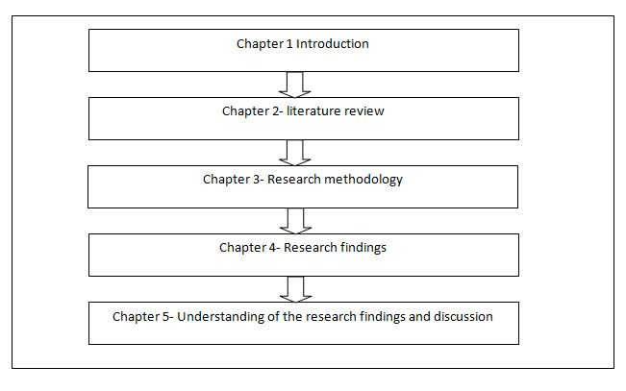
Figure- Organization of the study (Source- created by the author)
- The first chapter will be the initial section of the project as the introductory part. This section is the introduction and will introduce the whole research project in detail.
- The second chapter is the literature review. It is a very important section, and it will look into the literature that is associated with the concept of Gig Economy. This section will draft the various views and research understandings from scholars all across the world.
- The third chapter is the research methodology. This chapter will deal with the understanding of data collection methods, the types of data analysis and the most suited method of data analysis of the project.
- The fourth chapter is the research findings. This chapter will analyse the collected information. This section is going to examine the collected data thoroughly for the further understanding.
- The fifth chapter is the final chapter that will discuss the entire understanding of the knowledge that has been developed after collecting and analysing the data and information that will finally fulfil the objectives.
8.2 Project budgeting: Finances are highly essential to estimate and look at while preparing any research work (Ledford & Gast, 2018). After analysing the research methods and related aspects, this particular section is dedicated to drafting the budget for the research.
Task | Duration | Estimated budget (in Australian Dollars)
Preparation of the research proposal and understanding literature | 3 months | 100 dollars
Collecting required data and information | 2 months | 200 dollars
Analyzing the data | 1 month | 200 dollars
8.3 Gantt chart
Task | Starting day | Ending day | Duration
Research proposal | 10th January, 2019 | 4th February 2019 | 26 days
Designing literature reviews | 05th February 2019 | 30th March 2019 | 53 days
Data collection | 1st April , 2019 | 30th May, 2019 | 60 days
Data analysis | 1st June 2019 | 30th June, 2019 | 30 days
Final report | 1st July 2019 | 2nd July 2019 | 02 days
Milestones and Deliverables
 | 10 /01 /2019 to 04/02/ 2019 | 05 /02 /2019 to 30/03 /2019 | 01 /04 /2019 to 30 /05 /2019 | 01 /06 /2019 to 30 /06 /2019 | 01/07 /2019 to 02 /07 /2019
Project proposal
Literature review
Data collection
Analysis of the data
Final submission of the project
(Source- created by author)
9. Conclusion
This particular research project assignment proposal has drafted all the necessary sections in collecting data and eventually analysing them in detail. It needs to be stated, as a conclusion, that drafting this research proposal has been highly enriching and educational. It has been observed that the project will use mixed methods and that would help in gathering data and information to full fill the objectives of the research project. The research project assignment has been enlightening in developing a thorough knowledge in understanding the project in detail and preparing for further investigations and research. Research project assignments are being prepared by our Economy homework help experts from top universities which let us to provide you a reliable assignment help online service.
References
Abraham, K. G., Haltiwanger, J. C., Sandusky, K., & Spletzer, J. R. (2018). Measuring the gig economy: Current knowledge and open issues (No. w24950). National Bureau of Economic Research.
Abraham, K. G., Haltiwanger, J. C., Sandusky, K., & Spletzer, J. R. (2018). Measuring the gig economy: Current knowledge and open issues (No. w24950). National Bureau of Economic Research.
Adams, A., Freedman, J., & Prassl, J. (2018). Rethinking legal taxonomies for the gig economy. Oxford Review of Economic Policy, 34(3), 475-494.
Aloisi, A. (2015). Commoditized workers: Case study research on labor law issues arising from a set of on-demand/gig economy platforms. Comp. Lab. L. & Pol'y J., 37, 653.
Bajwa, U., Knorr, L., Di Ruggiero, E., Gastaldo, D., & Zendel, A. (2018). Towards an Understanding of Workers’ Experiences in the Global Gig Economy.
Cook, C., Diamond, R., Hall, J., List, J. A., & Oyer, P. (2018). The Gender Earnings Gap in the Gig Economy: Evidence from over a Million Rideshare Drivers. Upubliceret paper. Tilgængelig på: https://web. stanford. edu/~ diamondr/UberPayGap. pdf. Besøgt, 26-04.
De Stefano, V. (2015). The rise of the just-in-time workforce: On-demand work, crowdwork, and labor protection in the gig-economy. Comp. Lab. L. & Pol'y J., 37, 471.
Etzioni, A. (2018). Benefits for Gig Workers. Challenge, 1-14.
Flick, U. (2015). Introducing research methodology: A beginner's guide to doing a research project. Sage.
Graham, M., Hjorth, I., & Lehdonvirta, V. (2017). Digital labour and development: impacts of global digital labour platforms and the gig economy on worker livelihoods. Transfer: European Review of Labour and Research, 23(2), 135-162.
Greenwood, B., Burtch, G., & Carnahan, S. (2017). Unknowns of the gig-economy. Communications of the ACM, 60(7), 27-29.
Gross, S. A., Musgrave, G., & Janciute, L. (2018). Well-Being and Mental Health in the Gig Economy.
Harris, S. D. (2018). Workers, Protections, and Benefits in the US Gig Economy.
Hsiao, J. C. Y., Moser, C., Schoenebeck, S., & Dillahunt, T. R. (2018, June). The Role of Demographics, Trust, Computer Self-efficacy, and Ease of Use in the Sharing Economy. In Proceedings of the 1st ACM SIGCAS Conference on Computing and Sustainable Societies (p. 37). ACM.
Istrate, D., & Harris, J. (2017). The Future of Work The Rise of the Gig Economy. Retrieved from http://www.naco.org/sites/default/files/documents/Gig-Economy.pdf
Kalleberg, A. L., & Dunn, M. (2016). Good jobs, bad jobs in the Gig Economy. LERA For Libraries, 20(1-2).
Kässi, O., & Lehdonvirta, V. (2018). Online labour index: measuring the online gig economy for policy and research. Technological Forecasting and Social Change.
Ledford, J. R., & Gast, D. L. (2018). Single case research methodology: Applications in special education and behavioral sciences. Routledge.
Lehdonvirta, V. (2018). Flexibility in the gig economy: managing time on three online piecework platforms. New Technology, Work and Employment, 33(1), 13-29.
Mackey, A., & Gass, S. M. (2015). Second language research: Methodology and design. Routledge.
Mallett, S., & Cooney-O'Donoghue, D. (2018). Basic income: a soluition to what?.
Parliament of Victoria - Research Papers. (2018). Retrieved from https://www.parliament.vic.gov.au/publications/research-papers/category/36-research-papers
Silverman, D. (Ed.). (2016). Qualitative research. Sage.
Steinberger, B. Z. (2017). Redefining Employee in the Gig Economy: Shielding Workers from the Uber Model. Fordham J. Corp. & Fin. L., 23, 577.
Taylor, S. J., Bogdan, R., & DeVault, M. (2015). Introduction to qualitative research methods: A guidebook and resource. John Wiley & Sons.
The experiences of individuals in the gig economy. (2018). Retrieved from https://assets.publishing.service.gov.uk/government/uploads/system/uploads/attachment_data/file/ 679987/171107_The_experiences_of_those_in_the_gig_economy.pdf
The Online Labour Index |. (2018). Retrieved from http://ilabour.oii.ox.ac.uk/online-labour-index/
Tolley, K. (Ed.). (2018). Professors in the Gig Economy: Unionizing Adjunct Faculty in America. JHU Press.
Wright, P. (2018). News from the net: Gig economy workers. Advocate: Journal of the National Tertiary Education Union, 25(1), 44.

