Running Head: Readiness for Innovation in Abu Dhabi

ARE ABU DHABI PUBLIC SECTOR ORGANIZATIONS READY
FOR OPEN INNOVATION?
NAME OF THE STUDENT:
STUDENT’S ID:
NAME OF THE UNIVERSITY:
Abstract
The topic of the research paper is open innovation in public sector organization in UAE. In this dissertation, the innovation management is discussed with the combination of different components of knowledge. The first chapter dealt with the introduction of the topic which included the background of the study as it is based on the adoption of open innovation in the Public Sector Organizations in the UAE. The task has been set to encourage the advancement of firm learning of the unique issues impacting the compelling administration of development and exhibit the capacity to apply applicable ideas to rehearses. This chapter also included the discussion of problems based on the topic of this dissertation as HH Sheikh Mohammed Bin Rashid aimed to create the Public Sector Organizations in the UAE much better shortly and the analysis on this is done in later chapters.
Additionally, the purpose of the research is stated with the objectives along with the kind of scope that helped the open innovation in the Public Sector Organizations to reach new heights.
The second chapter dealt with the brief explanation and analysis with various hypotheses. Discussion on the adoption of Innovation and its advantages along with the disadvantages also this section included the state of knowledge which enabled to understand about the data analysis about the open innovation.
The third chapter deals with the methodology to adopt open innovation with different types of tools and strategies for the exploration which also enabled to learn about the readiness of the Public Sector Organization are ready to take open innovations. Data analysis chapter analyzed the data obtained from the survey to achieve the desired outcome. Further, the chapter 5 of the dissertation dealt with the conclusion and recommendation to provide the entities strategies and ideas to achieve innovation efficiently.

Acknowledgment
I want to thank my professor for giving us the opportunity and allowing us to work on such an exciting topic. A lot of information has been gained while working on the project. I would further thank all the other people who have contributed to the work by providing me data, help, and assistance. Also, I appreciate the respondents who assisted in the completion of the project.
This work has been fascinating and helpful for me. Thank you.

Table of Contents
Chapter 1: Introduction ................................................................................................................... 7
1.1 Background ........................................................................................................................... 7
1.2 Problem statement ................................................................................................................. 7
1.3 Aims of the research ............................................................................................................. 8
1.4 Objectives of the research ..................................................................................................... 8
1.5 Scope of the research ............................................................................................................ 9
1.6 Research Questions ............................................................................................................... 9
Chapter 2: Literature Review .......................................................................................................... 9
2.1 Introduction ........................................................................................................................... 9
2.2 Innovation ........................................................................................................................... 10
2.3 Open innovation .................................................................................................................. 11
2.4 State of Knowledge ............................................................................................................. 13
2.5. Conceptual Framework ...................................................................................................... 15
2.6 Summary ............................................................................................................................. 16
Chapter 3: Methodology ............................................................................................................... 17
3.1 Introduction ......................................................................................................................... 17
3.2 Research philosophy ........................................................................................................... 17
3.3 Research approach .............................................................................................................. 18
3.4 Research design .................................................................................................................. 19
3.5 Data collection process ....................................................................................................... 20
3.6 Sampling method ................................................................................................................ 22
3.7 Sample size ......................................................................................................................... 23
3.8 Ethical consideration ........................................................................................................... 23
3.9 Gantt chart ........................................................................................................................... 24
3.10 Summary ........................................................................................................................... 26
Chapter 4: Data analysis ............................................................................................................... 28
4.1 Introduction ......................................................................................................................... 28
4.2 Main findings ...................................................................................................................... 28
4.3 Interpretation ....................................................................................................................... 43
4.4 Summary ............................................................................................................................. 45
Chapter 5: Conclusions and Recommendations ........................................................................... 47
5.1 Conclusion .......................................................................................................................... 47
5.2 Recommendation ................................................................................................................ 47
5.3 Limitations of the study ...................................................................................................... 48
5.4 Future scope ........................................................................................................................ 49
References ..................................................................................................................................... 50 Appendix ....................................................................................................................................... 54

Chapter 1: Introduction

1.1 Background
The most significant segment of the present society is innovation. Different associations have a considerable part to guarantee that they execute the various operations in the variety of ways that hold fast to the current types of innovative systems. Moreover, the governments all around the globe enforced the innovation issue to the companies. According to the UAE Government Innovation Strategy, the government prioritized innovation in the organizations. Also, in the past few years, the Abu Dhabi Government organized 132 initiatives regarding the change.
As these decisions are the symbol of a dedication of the government which ensures the innovative operations are carried out within the organizations. Altogether, the primary focus of this research is to clarify if the public sector organizations in Abu Dhabi are ready for innovations. The start of the initiative states the government of UAE is expecting to analyze the innovation concept in the organizations thoroughly. It also shows that there is an enormous amount of motivation to adopt open innovations.
Consequently, the government took a step forward to guide the organizations at different stages. It could be critical for the organizations to consider the issue of open innovation as it leads to development. The public changes are being used in a wide range by a variety of organizations like Lego, Amazon, IBM and various organizations have been proposed to adopt the federal changes. Furthermore, the results will form a clear base for the recommendations regarding the open innovations.

1.2 Problem statement
The problem that was affecting the organizations in the UAE was the announcement by HH
Sheikh Mohammed Bin Rashid which produced a vast amount of pressure as the decision was regarding the goal of UAE becoming the best in innovative operations, and these changes would be on a long-term plan. To evaluate the problems further analysis and researchers are performed.
In recent times, innovation has been playing a crucial role in every industry. The public sector of Abu Dhabi is no exception in this context. It has been clear that to stay competitive; it is important to innovate on a regular basis. In that context, the researcher has chosen the topic as the subject is vast enough to make a critical analysis. On the other hand, the Public Sector Organizations of UAE is one of the important sectors that can be profoundly affected by the innovation and its consequences. This topic has thus analyzed whether it is beneficial for the companies to be ready for open innovation or not.

1.3 Aims of the research
The primary goal of this section is to calculate the impact of innovation in the context of Public Sectors in the UAE. Also, this project helped to verify the readiness for the pen innovations in the different public sectors of Abu Dhabi. The analyzed data and the findings have assisted in the confirmation of the availability concerning open innovations.

1.4 Objectives of the research
The primary aims of this study are stated below:
- To analyze the organization in the public sectors in Abu Dhabi.
- To critically evaluate the importance of innovation in markets.
- To examine the readiness of public sectors organization for open innovation.
- To recommend effective strategies for innovation management.

1.5 Scope of the research
This study mainly focused on the open innovation in the Public Sector Organizations in UAE. Also, this study helped the researcher in analyzing the advantages and disadvantages of the initiatives for open innovation in the organizations. However, the readiness to adopt an open innovation is examined with the evaluation of the importance of open innovation in the Public Sector Organizations. This particular research has some scope for the future researchers also.
The researchers can use this information to make further research on this particular topic. On the other hand, the data obtained through the survey are raw data and can be utilized for further analysis. On completion of the project, one will gain an explicit knowledge of the public sector of UAE and its operating activities. One further understands whether the public sector entities are ready for open innovation or not. And whether it will be effective in the long term or not.

1.6 Research questions
The research questions that are considered in this particular study are as follows:
- What is the importance of innovation in the market?
- What are the practical strategies for innovation management?
- How to examine the readiness of Public Sector Organization for innovation?
- How to analyze the various organizations in Abu Dhabi for innovation?

Chapter 2: Literature Review

2.1 Introduction
In this section, the mandatory audit of the writing is completed to clarify the open innovations with the assistance of different hypotheses and models. The essential concepts from the topic had been discussed to gather proper information on the project.

2.2 Innovation
Change is primarily defined as the application of different new products or procedures in an organization which is mainly emphasized to use for the benefits and profits of the stakeholders. Also, innovation in business is the ability to create new opportunities for the development of the organizations. The new knowledge and different ideas to enhance the outcomes of the company in the Public Sector Organizations in the UAE.
The main aim of the innovation purpose is to improve the processes in business and different structures which help in the creation of products and services that are driven by the markets. In recent times innovation has become an essential part of the strategic planning of the organizations. The internal processes that involve change are related to the production of goods with the involvement of new technologies, and likewise, organizational techniques are used for the production of better services in the markets (Bommert, 17). Innovations are mainly divided into three phases which are initiation, adoption, implementation, and the management of these phases depends on various other factors such as technology, innovation process, corporate strategies, organizational structure, culture, employees and much more. Innovation is a planned process and cannot occur instantly and the initiatives that were organized by the government of UAE (West and Chesbrough, 396).
According to the researchers, the competition in the markets which ensure the demands of products is majorly driven by the innovations as it helps in the determination of the intensity of the contest. Alongside, Chesbrough (85) mentioned that various goods and services, the installation of newer processes, techniques, and strategies for the management purposes also affects the growth and productivity of the organization. Furthermore, the support of ideas related to innovation helps in providing the strength to the economic conditions and also helps in the improvement of various sectors of the business. There are different varieties of the sources of innovation which includes external and internal, and mainly the organizations carry internal innovation source as it covers the information of employees, management along with the knowledge of research and development. However, the Public Sector Organizations in the UAE aims of becoming the best in innovative operations all around the globe as these services will add extra value and enhance the base of the employment in the different organizations. Property to achieve these goals
The Government of UAE is resolved by changing the new reality of lower oil costs by, where proper, decreasing appropriations. Also, making cuts in specific regions of open spending, while in the meantime proceeding with a more extensive account of advance through a clearness of vision and the shrewd reinventing of assets and assets. In a time portrayed by starkness and swinging slices to open spending far and wide, the Government of UAE has looked to adjust the necessities of the economy with the everyday needs of subjects.
The present concentrate on advancement demonstrates the UAE's responsibility regarding building up its economy and expanding its worldwide aggressiveness. , the Having a dedicated store for development will bolster the UAE's vision to put itself among the ten most inventive nations globally by 2021 (Damanpour et al. 653). Innovation is an integral part of the business as it can produce a better working environment and provide quality products. In addition to these, adopting the change is not a small term plan, it is capable of making the world a better place for the coming future generations.

2.3 Open innovation
The open change can be defined as the inflows and the outflows purposely to enhance the speed of internal change and to help in the expansion of the markets for the usage of changes externally. The adoption of open innovation allows the Public Sector Organizations of UAE to combine the resources with the other co-operators present externally (Edelmann and Sachs, 28). Additionally, open innovation empowers the stakeholders to enhance the organization to develop, while considering the innovation as the central segment in the success of the business. The public changes are mainly for the owners of the company and the employees and must be regarded as ahead of every plan and strategies.
The reason for which the adoption of open innovation is necessary is to enforce the business to evolve to a greater extent. Also, the public changes help the managers to carry out better decisions, a better relationship with people in the industry as innovation regularly provides different challenges which are accepted as the truth. Under the open advancement worldview, there is a significant stream of outside information into the association which transforms into ventures in cooperation with outer accomplices and causes the buy and consolidation of external advances (Felin and Zenger, 923). In the meantime, the advancements produced inside the organization can be sold as innovation or potentially new property to different associations since possibly they are not material inside their plan of action or because the organization has no limit or experience to build up the creation (Huizingh, 6).
The last outcome is that a few items achieve the market by utilizing solely interior assets from the underlying thought up to the commercialization of the previous issue. Different things are the consequence of consolidating external information at various phases of their advancement. Open innovations also enforce the employees to think differently and fulfill the responsibilities that were provided at every position of the Public Sector Organizations in the UAE. Furthermore, a few more different reasons force the organizations to adopt open innovations which include the sales of more products and services to the customers. The change also helps in turning the one time customers to regular customers. Moreover, move in a business can help the organization to reach a different level in the competitions all around the world. The advantages for which it is necessary to adopt the open innovations also include the organizational benefits as it can provide the entries in different markets easily along with the interests of the acquisition of the resources (Gurhan et al. 670). This also helps in increasing the area of ideas and uses of technologies and the intellectual properties as the essential aspects of the strategies. Additionally, the use of open innovation also causes some problems for the businesses in the organization such as the cost regarding the processes may increase rapidly with the implementations of new techniques.
Flexibility is also lost along with the creativity and power in the strategies as there is an extreme dependence on the knowledge present externally. s inside the firm are requested. Advancement forms are mind-boggling and include peculiar people, offices, and orders. In this manner, several elements are required to defeat inactivity in complex improvement ventures (Meeus and Edquist, 32). Three sorts of the part can help a Public Sector Organizations to beat the internal strengths that can conceivably block open advancement. The last outcome is that a few items achieve the market by utilizing only interior assets from the underlying thought up to the commercialization of the previous thing (Marisa et al. 662). Different items are the aftereffect of fusing outside learning at various phases of their improvement.

2.4 State of knowledge
These days’ advancement achievement is ending up significantly more critical. After months and years of rebuilding and cost slicing to recover gainfulness, many firms are compelled to recharge their item portfolio. Just with new items would they be able to support their aggressive position by expanding incomes and benefit, prompting enhanced organization esteem. The always growing significance of learning in contemporary society requires a move in our thinking concerning advancement in business Public Sector Organizations be it specialized development, item or, then again prepare development, or core or authoritative promotion (Kerzner, 78).
Information is setting particular, as it relies on a specific time and space. Without being put into the setting, it is merely data, not data. Data progresses toward becoming information when it is translated by people and given a unique circumstance and moored in the convictions and responsibilities of people. Learning which is new to a Public Sector Organizations needs to either be designed inside or obtained from outside sources. There are two sorts of knowledge: explicit information and implicit information (Marisa et al. 671). Implicit learning is prepared through a vibrant mix of the diverse methods of learning transformation in prepared, which can be known as a "winding model" of learning creation. Implicit learning is a vital driver in the advancement procedure, and its application has a significant effect on the development proceedings and, hence, assumes a prominent part as an organizational asset and achievement factor. Contrasted with the work on clear information, the administration of unsaid learning is moderately unexplored (Mir and Pennington, 209).
To have the capacity to examine the effect of inferred knowledge on development we require a correct understanding of the meaning of advancement. The developing enthusiasm for improvement and its relationship to financial development has brought about an assortment of particular writing on different aspects of the procedure of promotion beginning with primary direct "innovation push." The creators of this paper need to survey the noteworthiness and ramifications of inferred information in the development procedure (Hwang and Wei Jian Ng, 279).
In this way, it is fundamental to comprehend the diverse methodologies of unsaid information in learning administration and development. To help and animate the application and exchange of comprehended details in affiliations, and to underline the effect in the change system, Public Sector Organizations of associations should make a workplace which bolsters regard for various sense styles without disciplines for disappointment, which disheartens experimentation. It is clarified that innovation administration relating to its sort of industry, kind of development, and its authoritative structure, needs to utilize distinctive instruments and arrangements to have the capacity to use the current inferred learning resources for each organization's development achievement (Yoo, 227). Issues which happen inside the extent of the innovation procedure are frequently too complex to be in any way unraveled just on an expository premise. Public Sector Organizations can modify the level of the novel finding by empowering an open culture and having fewer initiative orders in affiliations.

. Conceptual Framework
2.5

Figure 1: Conceptual framework

Proactiveness

Risk
-
taking

Autonomy

Network

Outbound open
innovation

Inbound open
innovation

Firm’s
Performance

Entrepreneurial
Open innovation

Performance

(Source: As created by the researcher)

2.6 Summary
There are a few constraints in this examination. Firstly, the investigation considered sufficient instances of open innovation. This chapter of the study completes the comprehensive analysis of the apparent change in the Public Sectors in the UAE. This section deals with the full evaluation of the free change in the UAE also, the study shows the advantages and disadvantages of every segment that is stated in the chapter. Furthermore, the state of knowledge helps to understand the data related part of the open innovation in the Public Organizations in the UAE as it conveys useful information for the adoption of open innovation is a long-term strategy which somehow benefits in the development of the organizations. This chapter also shows that organizations may procure thoughts, advancements, and events from outside sources, to supplement inside sources as well as adding to get different courses for significant sourcing learning from outside their limits. Public Sector Organizations in UAE can build up their stages and welcome outside individuals to give arrangements. Contingent upon the level of many-sided quality, they can offer prizes for a valid agreement.

Chapter 3: Methodology

3.1 Introduction
This part of the study analyzes a different kind of strategies and tools that are required for the complete analysis of the exploration. This particular research study has focused on the organization in public sector of Abu Dhabi. It is focused on whether these teams are ready for open innovation or not. This research helps to identify that if the companies in Abu Dhabi were willing to use the change or not. In this research paper, the researcher discussed the various approaches, research philosophy, research design, data collection methods, etc. The methodology section has thus allowed the researcher to gather information and perform the analysis in a simple yet systematic manner to achieve the desired outcome.

3.2 Research philosophy
The research philosophy mainly consists different sources, nature, and enhancement of knowledge. The collection of primary and secondary data and further data analysis is required to clarify the research question, and therefore, these answers are the basis of new knowledge. Furthermore, the addressed research philosophy in the study involved awareness and formulation of different assumptions. The research philosophy is divided into various branches which are related to a variety of disciplines. There are four main research theories within the area of business studies; pragmatism, positivism, realism, and interpretivism (Volberda et al. 11).

Research philosophy

P
ositivism

I
nterpretivism

P
ragmatism

Realism

Figure 2: Research Philosophy
(Source: Volberda et al. 11)
In this research work, the researcher is using interpretivism research philosophy as interpretivism is a socially constructed theory which helps to understand the beliefs and the open innovation in UAE. The advantages of choosing interpretivism research philosophy are that it provides small samples which are mainly presented in depth with a different investigation and qualitative analysis.

3.3 Research approach
The questions of research stated above required much more comprehensive learning, and therefore, an efficient research approach is carried out by observations and data which helped in meeting the objectives of the investigation (Martín-de Castro, 145). There are usually two types of research approaches that are used by the researcher which includes: inductive and deductive methods.

Inductive

Deductive

Research
Approach

Figure 3: a Research approach
(Source: Martín-de Castro, 145)
For this study the researcher used an inductive research approach as the light is thrown on the observation of adoption of open innovation in the Public Sector Organizations in the UAE. This research also helped in the evaluation of initiatives regarding the changes. Furthermore, the inductive approach contributed to achieving the most beautiful result for the research work.

3.4 Research design
The study design is referred to the entire strategy that is chosen by the researcher to merge the different parts of the studies in a well-organized manner which helps in evaluating the research problems. It also includes the design of the data collection and analysis of the data (West and Bogers, 826). There is the full range of ways to distinguish the research designs which include: graphic research design, exploratory research design, and the descriptive research design.
Explanatory

exploratory

Descriptive

Research
design

Figure 4: Research Design
(Source: West and Bogers, 826)
In this research, the researcher uses the exploratory study design to identify the original issues.
The different types of perceptions and concepts of innovations are employed in this research.
Also, the exploratory design helps to explain the impact of open innovations in the Public Sector Organizations in the UAE. The exploratory research mainly improves the knowledge of the researcher regarding the open innovations, and as it lacks in the strength of stats, a definite conclusion cannot be drawn. However, this design can determine the reason for open innovations in UAE. Furthermore, the exploratory research design helps in the verification of different concepts regarding open innovations in the Public Sector Organizations of UAE.

3.5 Data collection process
Data Collection is a procedure of collecting and evaluating various types of information on the selected variables in a developed systematic manner, which helps the researcher to consider related answers and calculate the outcomes. Data collection is an important segment in the research works. There are different methods of collecting data, but the main objective is to stay accurate with the collections of data (Lichtenthaler, 607). The primary goal of the collection of data is to keeps the quality of the analysis which will further lead to appropriate answers to the proposed questions. There are two types of the method related to the collection of data which includes: primary data collection method and secondary data collection method.
Data
collection
process

primary data
collection

Surveys

Interviews

secondary
data
collection

Journals,
websites,
books

Figure 5: Data collection process
(Source: Lichtenthaler, 607)
As in this study, the researcher uses both these methods to evaluate the results. The primary research is a survey of the individuals and for the open innovations purpose of the Public Sectors Organizations in the UAE selected employees are proposed to carry out the online survey, and by this review, the result is evaluated. The secondary method for the data collection of this research is conducted with the help of different literature reviews and journals, and by these, the result is evaluated.

3.6 Sampling method
The sampling method is a procedure which selects a member of the sample from some population. There are mainly four commonly known sampling methods which include simple random sampling, stratified sampling, cluster sampling and probability, non-probability sampling method (Vishnevskiy et al. 443). As for this particular research, the researcher used probability sampling method along with the non-probability sampling method. The probability sampling method is utilized by the researcher to choose the samples in quick succession of time and an unbiased manner. The researcher also uses this method to select different respondents to carry out the survey. Likewise, the non-probability sampling method restricts various individuals to gain chances for the interview purpose and to examine the defendants for the interview purposes; the non-probability sampling method is used.


simple
random
sampling

stratified
sampling

cluster
sampling

probability,
non
-
probability
sampling

Figure 6: Sampling method
(Source: Vishnevskiy et al. 443)

3.7 Sample size
In this part of the research paper, the researcher demonstrated the number of inspection and copies as it is to be included in the sample size to the sample placed in the statistic section. It is a fundamental component of any research paper. The sample size also helps to construct and as it is to be included in the sample size to the statistical sample where the peoples are involved. The researcher chooses 75 number of despondency for this particular research. A questionnaire is formed by the researcher, and it includes a total number of 15 questions regarding the open innovations and will be answered by the Public Sector Organizations in the UAE. The researcher used 75 sample size is considering significant sample size which helps the researcher to find out the outcome of the research work.

3.8 Ethical consideration
When a research work was done by the researcher, the researcher has to follow some moral consideration. The researcher has to keep the data confidential which is described in data protection act 1998. The research data which is taken by the researcher have to be authentic and taken from as new as possible data. For this research paper, the researcher has to do a survey to receive the most appropriate data. The researcher has to avoid any bias decision in data analysis process also the researcher have to look that the research paper did not affect by any personal or financial interest. The researcher has to keep the promises and maintain the proper agreement. The researcher has to avoid the negligence and do the work or analysis very carefully. The main thing of the researcher is always introducing new ideas, tools or sources. If the researcher collects data from any intellectual property, the researcher will have to give proper acknowledgment or give the credit. The researcher has to maintain that they did not use any unpublished data or never give plagiarizes.

3.9 Gantt chart
Main  activities/ stages | Week  1 | Week  2 | Wee  k 3 | Week  4 | Wee  k 5 | Week  6 | Week  7 | Week  8 | Week  9 | Week  10 | Week  11 | Week  12 | Week  13 | Week  14
Select the subject
Data
Collection (Secondar y Sources)
Layout
Formatio
n
Formatio
n of the
Research

Plan
Literature review
Selection of
Research
Technique
Data
Collection
(Primary data sources)
Analysis and Interpreta tion of the data
Findings from the
Data
Conclusio
n of the
Research study
Creation of Rough
Draft
Final
Submissio
n of the research
Work
Table 1: Gantt chart
(Source: As created by the author)

3.10 Summary
When the researcher did research work, the researcher has to follow some moral consideration.
The researcher has to keep the data confidential which is described in data protection act 1998. The research data which is taken by the researcher have to be authentic and made from as new as possible data. For this research paper, the researcher has to survey to receive the most appropriate data. The researcher has to avoid any bias decision in data analysis process also the researcher have to look that the research paper did not affect any personal or financial interest. The researcher has to keep the promises and maintain the proper agreement. The researcher has to avoid the negligence and do the work or analysis very carefully. The main thing of the researcher is always introducing new ideas, tools or sources.
If the researcher collects data from any intellectual property, the researcher has to give proper acknowledgment or give the credit. The researcher has to maintain that they did not use any
unpublished data or never give plagiarizes.

Chapter 4: Data analysis

4.1 Introduction
In this particular chapter of the dissertation, the findings achieved with the help of primary research has been analyzed to understand the concept of open innovation in the public sector. Furthermore, this section of the study has been helpful in understanding whether the public sector organizations in Abu Dhabi are ready to consider and accept open innovation or not.

4.2 Main findings
Additionally, to achieve the required outcome for this particular topic, the researcher had conducted a primary research analysis considering different entities in Abu Dhabi that are government oriented. The survey has been carried out systematically to understand the readiness of the organization regarding open innovation and further focus on their organizational practices in four different areas such as the engagement with the customers, knowledge management, innovation readiness and network participation. The questionnaire contained a set of close-ended questions that were further grouped to focus on the four areas of concern. The views of the employees of those governmental entities have been considered to achieve the outcome. The result or findings of the primary research are discussed below:
1. To which gender do you belong?
Options | No. of respondents | Total number  respondents | of | Percentage respondents | of
Male | 48 | 75 |  | 64%
Female | 27 | 75 |  | 36%
Table 2: Response to question 1
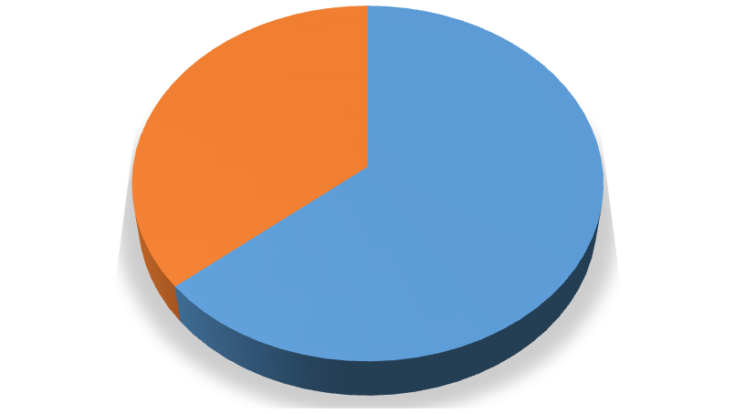

64
%

36
%

Percentage of respondents

Male
Female
Figure 7: Chart for the response 2. To which age group do you belong?
Options | No. of respondents | Total number  respondents | of | Percentage respondents | of
15-25 | 6 | 75 |  | 8%
25-40 | 39 | 75 |  | 52%
40-60 | 18 | 75 |  | 24%
Above 60 | 12 | 75 |  | 16%
Table 3: Response to question 2


Percentage of respondents
Less than 6
months
months to
6
2
years
5
years to
2
years
10
years to
5
years
%
16

%
24

%
21.30

18.70
%

PERCENTAGE OF RESPONDENTS

Figure 8: Chart for the response 3. How long have you been a part of this entity?
Options | No. of respondents | Total number  respondents | of | Percentage respondents | of
Less than six months | 12 | 75 |  | 16%
Six months to 2 years | 18 | 75 |  | 24%
Two years to 5 years | 16 | 75 |  | 21.3%
Five years to 10 years | 14 | 75 |  | 18.7%
More than ten years | 15 | 75 |  | 20%
Table 4: Response to question 3
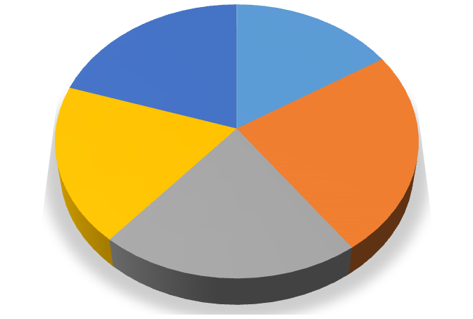

16
%

%
24

%
21

%
19

20
%

Percentage of respondents

Less than 6 months
6
months to 2 years
2
years to 5 years
5
years to 10 years
More than 10 years
Figure 9: Chart for the response
- Does your organization implement innovation in its organizational activities?
Options | No. of respondents | Total number  respondents | of | Percentage respondents | of
Frequently | 26 | 75 |  | 34.7%
Sometimes | 31 | 75 |  | 41.3%
Neutral | 2 | 75 |  | 2.7%
Rarely | 9 | 75 |  | 12%
Not at all | 7 | 75 |  | 9.3%
Table 5: Response to question 4
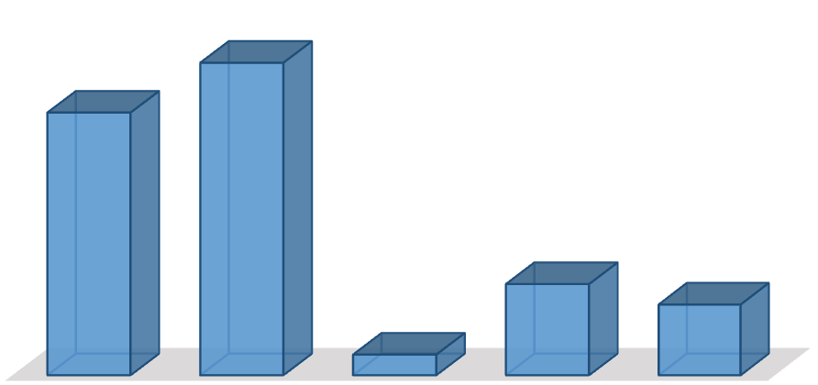

Frequently
Sometimes
Neutral
Rarely
Not at all
%
34.70

%
41.30

2.70
%

12
%

9.30
%

PERCENTAGE OF RESPONDENTS

Figure 10: Chart for the response
- Does your organization consider customer feedback as innovation’s source?
Options | No. of respondents | Total number  respondents | of | Percentage respondents | of
Frequently | 40 | 75 |  | 53.3%
Sometimes | 14 | 75 |  | 18.7%
Neutral | 1 | 75 |  | 1.3%
Rarely | 15 | 75 |  | 20%
Not at all | 5 | 75 |  | 6.7%
Table 6: Response to question 5
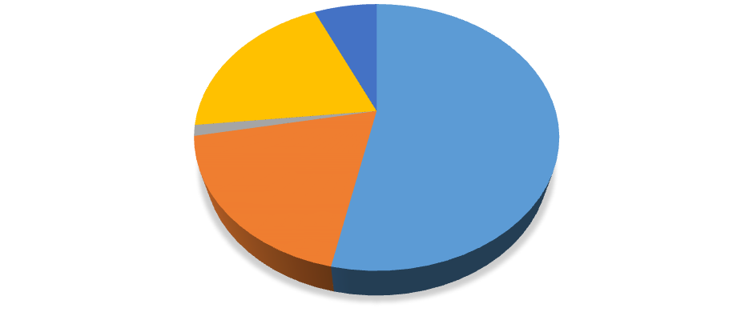

Frequently

53
%

Sometimes

19
%

Neutral

%
1

Rarely

%
20

Not at all

7
%

Percentage of respondents

Frequently
Sometimes
Neutral
Rarely
Not at all
Figure 11: Chart for the response
- How far are you satisfied with the innovation management?
Options | No. of respondents | Total number  respondents | of | Percentage respondents | of
Highly satisfied | 16 | 75 |  | 21.3%
Satisfied | 25 | 75 |  | 33.3%
Neutral | 7 | 75 |  | 9.3%
Dissatisfied | 15 | 75 |  | 20%
Highly disappointed | 12 | 75 |  | 16%
Table 7: Response to question 6


%
21.30

33.30
%

9.30
%

20
%

16
%

Highly satisfied
Satisfied
Neutral
Dissatisfied
Highly dissatisfied
Percentage of respondents

Figure 12: Chart for the response
- How far do you agree that your organization accepts new ideas?
Options | No. of respondents | Total number  respondents | of | Percentage respondents | of
Strongly agree | 23 | 75 |  | 30.7%
Agree | 29 | 75 |  | 38.7%
Neutral | 11 | 75 |  | 14.7%
Disagree | 10 | 75 |  | 13.3%
Strongly disagree | 2 | 75 |  | 2.7%
Table 8: Response to question 7


%
31

40
%

%
15

14
%

Percentage of respondents

Strongly agree
Agree
Neutral
Disagree
Strongly disagree
Figure 13: Chart for the response
- How far do you agree that there is a need for change within the organization?
Options | No. of respondents | Total number  respondents | of | Percentage respondents | of
Strongly agree | 20 | 75 |  | 26.7%
Agree | 33 | 75 |  | 44%
Neutral | 5 | 75 |  | 6.7%
Disagree | 9 | 75 |  | 12%
Strongly disagree | 8 | 75 |  | 10.7%
Table 9: Response to question 8
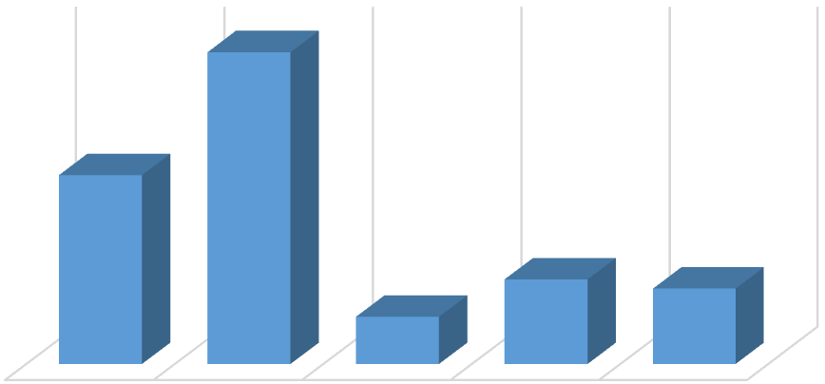

STRONGLY
AGREE

AGREE

NEUTRAL

DISAGREE

STRONGLY
DISAGREE

26.70
%

44
%

6.70
%

12
%

10.70
%

PERCENTAGE OF RESPONDENTS

Figure 14: Chart for the response
- How far are you satisfied with employee involvement in organizational events?
Options | No. of respondents | Total number  respondents | of | Percentage respondents | of
Highly satisfied | 21 | 75 |  | 28%
Satisfied | 32 | 75 |  | 42.7%
Neutral | 6 | 75 |  | 8%
Dissatisfied | 12 | 75 |  | 16%
Highly disappointed | 4 | 75 |  | 5.3%
Table 10: Response to question 9

28
%

42.70
%

8
%

%
16

5.30
%

HIGHLY SATISFIED

SATISFIED

NEUTRAL

DISSATISFIED

HIGHLY DISSATISFIED

PERCENTAGE OF RESPONDENTS

Figure 15: Chart for the response
- Does the company consider previous projects while planning new projects?
Options | No. of respondents | Total number  respondents | of | Percentage respondents | of
Frequently | 14 | 75 |  | 18.7%
Sometimes | 26 | 75 |  | 34.7%
Neutral | 4 | 75 |  | 5.3%
Rarely | 13 | 75 |  | 17.3%
Not at all | 18 | 75 |  | 24%
Table 1: Response to question 10
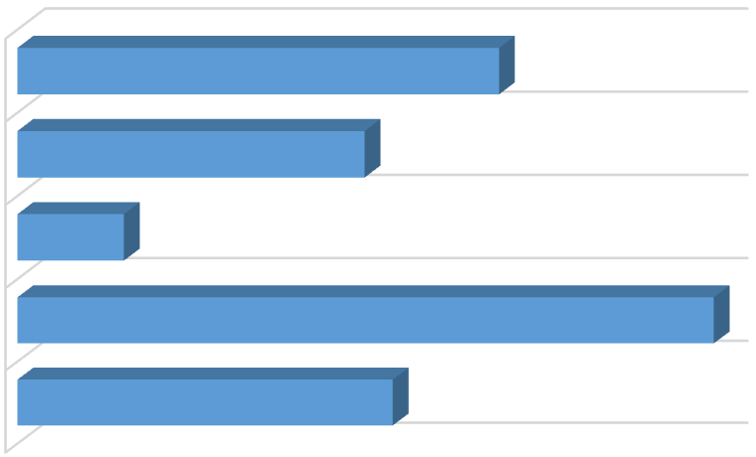

FREQUENTLY

SOMETIMES

NEUTRAL

RARELY

NOT AT ALL

18.70
%

34.70
%

5.30
%

17.30
%

24
%

PERCENTAGE OF RESPONDENTS

Figure 16: Chart for the response
- How far are you satisfied with the use of data while making changes?
Options | No. of respondents | Total number  respondents | of | Percentage respondents | of
Highly satisfied | 5 | 75 |  | 6.7%
Satisfied | 27 | 75 |  | 36%
Neutral | 15 | 75 |  | 20%
Dissatisfied | 19 | 75 |  | 25.3%
Highly disappointed | 9 | 75 |  | 12%
Table 12: Response to question 11


7
%

36
%

20
%

25
%

12
%

Percentage of respondents

Highly satisfied
Satisfied
Neutral
Dissatisfied
Highly dissatisfied
Figure 17: Chart for the response
- How far do you agree that your organization has proper customer engagement?
Options | No. of respondents | Total number  respondents | of | Percentage respondents | of
Strongly agree | 11 | 75 |  | 14.7%
Agree | 29 | 75 |  | 38.7%
Neutral | 7 | 75 |  | 9.3%
Disagree | 16 | 75 |  | 21.3%
Strongly disagree | 12 | 75 |  | 16%
Table 13: Response to question 12
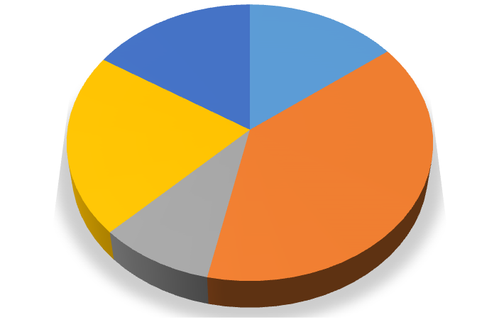

%
15

%
39

9
%

%
21

%
16

Percentage of respondents

Strongly agree
Agree
Neutral
Disagree
Strongly disagree
Figure 18: Chart for the response
- How far do you agree that your organization has sufficient formal relationships with other companies?
Options | No. of respondents | Total number  respondents | of | Percentage respondents | of
Strongly agree | 23 | 75 |  | 30.7%
Agree | 31 | 75 |  | 41.3%
Neutral | 3 | 75 |  | 4%
Disagree | 13 | 75 |  | 17.3%
Strongly disagree | 5 | 75 |  | 6.7%
Table 14: Response to question 13
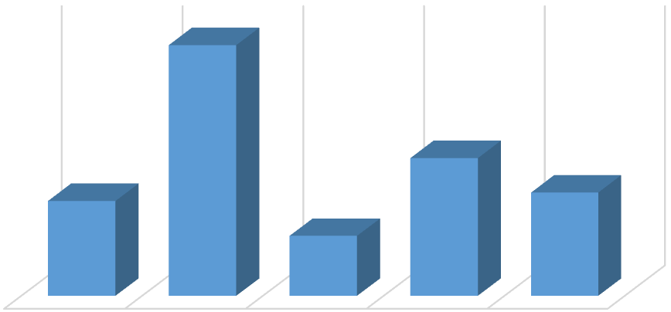

STRONGLY
AGREE

AGREE

NEUTRAL

DISAGREE

STRONGLY
DISAGREE

14.70
%

38.70
%

9.30
%

21.30
%

16
%

CHART TITLE

Figure 19: Chart for the response
- How far are you satisfied with the collaboration of organization with other companies for projects?
Options | No. of respondents | Total number  respondents | of | Percentage respondents | of
Highly satisfied | 13 | 75 |  | 17.3%
Satisfied | 18 | 75 |  | 24%
Neutral | 11 | 75 |  | 14.7%
Dissatisfied | 23 | 75 |  | 30.7%
Highly disappointed | 10 | 75 |  | 13.3%
Table 15: Response to question 14
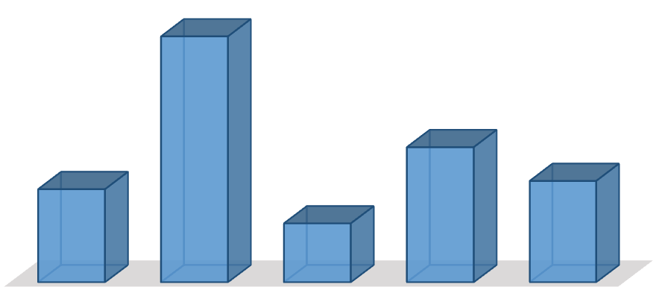

Strongly
agree
Agree
Neutral
Disagree
Strongly
disagree
%
14.70

38.70
%

%
9.30

21.30
%

16
%

PERCENTAGE OF RESPONDENTS

Figure 20: Chart for the response
- How far do you agree that your organization needs to consider strategies for effective innovation management?
Options | No. of respondents | Total number  respondents | of | Percentage respondents | of
Strongly agree | 23 | 75 |  | 30.7%
Agree | 29 | 75 |  | 38.7%
Neutral | 6 | 75 |  | 8%
Disagree | 11 | 75 |  | 14.7%
Strongly disagree | 6 | 75 |  | 8%
Table 16: Response to question 15
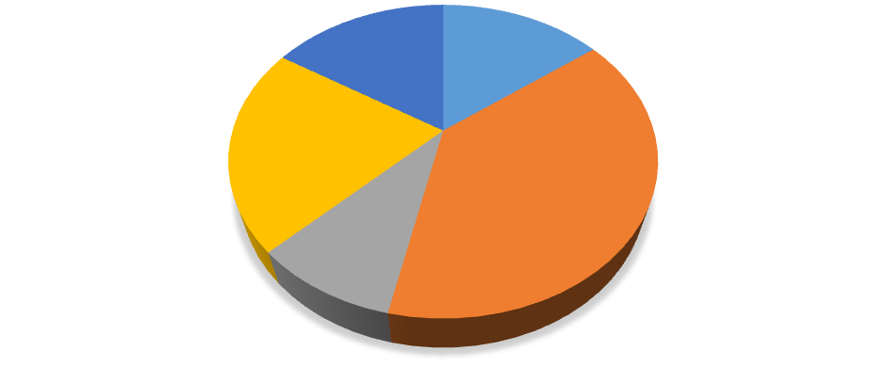

Strongly agree

15
%

Agree

%
39

Neutral

%
9

Disagree

21
%

Strongly disagree

%
16

Percentage of respondents

Strongly agree
Agree
Neutral
Disagree
Strongly disagree
Figure 21: Chart for the response

4.3 Interpretation
From the above data that has been collected through the primary data collection method is useful in obtaining the desired outcome for the research. As the first three questions of the survey were demographic based, it can be inferred that maximum respondents participating in the inquiry were male. Therefore, the employees working in the public sector organizations are mainly male candidates. In addition to that major of the respondents (52%) working in the public sector are of the age group 25-40 years.
In response to the fourth question, the majority of the respondents opined that the organization in which they work implements innovation within its organizational activities. This infers that to remain in a stable position in the highly competitive market, it is essential for the public sector entities to consider innovation in every step of its business activity. Failing to do so might result in moving out of the competition. The managers of these entities might thus consider implementing innovation in its organizational activities. However, there is a certain percentage of respondents who stated that their bodies do not find innovation implementation. It can be thus mentioned that these companies are either not facing much competition that does not require much innovation or these companies are not ahead regarding position and profitability.
In addition to that, out of the 75 respondents, 72% of the respondents stated that their organizations consider the feedback of the customers important. As per the client's feedback, the managers try to analyze where the team needs to bring about more changes within the organizational activities and innovate or not. Thus, for them, the customer's feedback acts as an excellent source of innovation. However, for the other group, the input does not seem to be that important. They either depend on other sources or are not much in favor of innovations.
Not much of the employees of the public sector entities in Abu Dhabi seemed to be satisfied with the innovation management prevailing within the workplace. Almost equal number of respondents claimed to be satisfied while others were dissatisfied. It thus indicates that the organization needs to work more on innovation management. The dissatisfaction might be a result of the failure to understand the innovative ideas or its effect on the employees or other stakeholders. If such case happens, it becomes difficult for the entity to develop much as employee dissatisfaction causes damage to the organization.
However, the survey that was carried out indicated that most of the respondents agreed that the organizations are willing to accept new ideas that affect the body. It meant that the public sector organizations in Abu Dhabi are ready for open innovation. Furthermore, most of the employees considered that it is essential for the organizations to accept change and bring changes to the workplace as the market and the work environment keeps changing. With the variations in the demand pattern of customers, it is necessary for the organization to accept the changes and bring out innovative ideas. 60 percent of the respondents mentioned that they had been satisfied as their organization gives them the opportunity to become a part of the events. On the other hand, the rest of the respondents seemed to be dissatisfied as they are not allowed to involve in organizational activities. When the employees are restricted from participating in the corporate events, they fail to understand the company and their productivity decreases.
The survey has been helpful in understanding that most of the companies do not consider the previous projects while planning new projects. However, it seems to be necessary as it allows the decision makers to understand the strengths and weakness of the decisions they consider for designing the new projects. Most of the respondents again mentioned that the method of using data at times of making change within the organization seemed to be effective. They could make changes and implement innovations with ease. As most of the entities consider customer engagement as one of the critical ways in achieving alter other companies need to follow them too. Customer engagement has been reported to be a useful method for change and innovation implementation as it allows the managers to understand the views of the clients and accordingly bring changes.
Further, most of the entities have been found to have the real formal relationship with other companies of the same. It has been stated that the companies gain a lot of mutual benefits from the legal relationship they develop with each other. On the contradictory, the employees have not been highly satisfied with the collaboration with other entities regarding projects. It might have been so due to the improper management or strategies. The respondents thus stated that they agree that organizations need to adopt practical innovation and change management strategies.

4.4 Summary
From the data analysis of the obtained result of the primary research indicated that the public sector entities in Abu Dhabi are ready for open innovation. The companies are willing for open innovation. However, there are some who are not capable of accepting the changes and thereby bring innovations. The strategies for innovation management is thus necessary for the companies to change. It helps to achieve the objectives regarding setting long-term innovation as the norm. It will further contribute to gain success in implementing a new idea (design, process, technology, etc.) in a project.

Chapter 5: Conclusions and Recommendations

5.1 Conclusion
The complete dissertation has been helpful in understanding the concept of open innovation, the public sector entities in Abu Dhabi and the relation between the both. It has been observed from the secondary data and primary data analysis that the organizations in the public sector of Abu Dhabi are ready for open innovation. The intense pressure on many organizations in the UAE to change has proved to be useful in bringing about the change. Also, setting the goal of the UAE becoming the number one in innovation in seven-year time has been possible. It meant that being innovative should become the norm and the change will not be short term. The project further highlights that the companies are successful in implementing new ideas within the various organizational projects.
The overall study has been critically linked to the research objectives. The detailed review of the dissertation will allow the learner to understand the concept of innovation and its importance. In addition to that one will gain a clear image of the public sector entities in Abu Dhabi. Furthermore, the study created a scope to understand that the bodies are ready to accept the open innovation within its organizations. The recommendation provided also helps the companies to manage change efficiently and thereby achieve the desired outcome.

5.2 Recommendation
The benefits of open innovation are mainly collected by the small and medium enterprises (SMEs). It is essential for the public sector entities of Abu Dhabi to manage the productive relationship with the partners and innovation networks. Lichtenthaler (608) mentioned that it is necessary for the companies to select the appropriate partner since open innovation is a collection of attitude, investment in new ideas, concept and time, share knowledge, information, and risk. In addition to that the innovating companies that take up the initiative to develop product need to lead the innovation network. This can be done by proving that there is active cooperation between the leaders and its partners.
In addition to this, Vishnevskiy et al. (442) opined that compliance with the rules are necessary and there has to be transparency and openness in the communication between the different companies of the network. Moreover, a proper balance between the internal and external management helps to achieve open innovation in a much easier way. On the other hand, Kerzner (256) contradicted that collaboration within the companies is difficult. The relationship is under constant pressure due to the problems and failure. One of the ways to overcome the issue is to organize frequent meetings to discuss the difficulties. Following these few recommendation will help the government companies of Abu Dhabi to be ready for open innovation.

5.3 Limitations of the study
The researcher had faced some weakness while working on this particular research. As the dissertation has been conducted by both primary and secondary data, different restrictions have occurred that caused the quality of the paper to degrade up to a certain quantity. The researcher had been facing limitations regarding time, data and finances. The time available to the researcher to collect the required data, evaluate and interpret them, was comparatively less. Due to the limited period, it had not been possible for the researcher to collect more relevant data and make a detailed analysis. Thus the quality of the dissertation could have improved more.
In addition to that, there were financial limitations too. The researcher did not have much financial accessibility. There were some sites on the internet that needed the subscription to receive data for the study. Therefore, all relevant data and information could not be taken into consideration. In the primary data collection, the raw data which was gathered cannot be much relied on as it might be possible that the respondents have not provided actual information. Due to the code of ethics, the managers of the public sector entities were not able to give all the information. It can be thus stated that these limitations have degraded the quality of the work to certain extent.

5.4 Future scope
As a result of the various limitations present in the research, there exist a lot of future scopes. If the future researcher invests more time and money for collecting data, the research will become more detailed. In addition to that considering, a different area for focusing on the respondents might help the researchers to obtain a better result.

References
Bommert, Ben. "Collaborative innovation in the public sector." International public management review 11.1 (2010): 15-33.
Chesbrough, Henry W. "Bringing open innovation to services." MIT Sloan Management
Review 52.2 (2011): 85.
Chesbrough, Henry W. "Bringing open innovation to services." MIT Sloan Management
Review 52.2 (2011): 85.
Damanpour, Fariborz, Richard M. Walker, and Claudia N. Avellaneda. "Combinative effects of innovation types and organizational performance: A longitudinal study of service organizations." Journal of management studies46.4 (2009): 650-675.
Edelmann, Noella, Johann Höchtl, and Michael Sachs. "Collaboration for open innovation processes in public administrations." Empowering open and collaborative governance. Springer Berlin Heidelberg, 2012. 21-37.
Felin, Teppo, and Todd R. Zenger. "Closed or open innovation? Problem-solving and the governance choice." Research Policy 43.5 (2014): 914-925.
Sunday, Gurhan, et al. "Effects of innovation types on firm performance." International Journal of production economics 133.2 (2011): 662-676.
Huizingh, Eelko KRE. "Open innovation: State of the art and future
perspectives." Technovation 31.1 (2011): 2-9.
Hwang, Bon-Gang, and Wei Jian Ng. "Project management knowledge and skills for green construction: Overcoming challenges." International Journal of Project Management 31.2 (2013): 272-284.
Kerzner, Harold. Project management: a systems approach to planning, scheduling, and controlling. John Wiley & Sons, 2013.
Lichtenthaler, Ulrich. "A note on outbound open innovation and firm performance." R&D
Management 45.5 (2015): 606-608.
Martín-de Castro, Gregorio. "Knowledge management and innovation in knowledge-based and high-tech industrial markets: The role of openness and absorptive capacity." Industrial Marketing Management 47 (2015): 143-146.
Meeus, Marius, and Charles Edquist. "Introduction to Part I. Product and Process Innovation." Innovation, Science and Institutional Change. A Research Handbook (2006): 23-37.
Mir, Farzana Asad, and Ashly H. Pennington. "Exploring the value of project management:
linking project management performance and project success." International journal of project management 32.2 (2014): 202-217.
Smith, Marisa, et al. "Factors influencing an organization's ability to manage innovation: a structured literature review and conceptual model." International Journal of innovation management 12.04 (2008): 655-676.
Vishnevskiy, Konstantin, Oleg Karasev, and Dirk Meissner. "Integrated roadmaps and corporate
foresight as tools of innovation management: the case of Russian
companies." Technological Forecasting and Social Change90 (2015): 433-443.
Volberda, Henk W., Frans AJ Van Den Bosch, and Cornelis V. Heij. "Management innovation: Management as fertile ground for innovation." European Management Review 10.1 (2013): 1-15.
West, Joel, and Marcel Bogers. "Leveraging external sources of innovation: a review of research on open innovation." Journal of Product Innovation Management 31.4 (2014): 814-831.
West, Joel, Wim Vanhaverbeke, and Henry Chesbrough. "Open innovation: a research agenda." Open innovation: Researching a new paradigm (2006): 285-307.
Yoo, Youngjin. "The tables have turned: How can the information systems field contribute to technology and innovation management research?." Journal of the Association for Information Systems 14.5 (2013): 227.

Appendix
Questionnaire for the survey are:
- To which gender do you belong?
- To which age group does you belong?
- How long have you been a part of the entity?
- Does your organization implement innovation in its organizational activities?
- Does your organization consider customer feedback as innovation’s source?
- How far are you satisfied with the innovation management?
- How far do you agree that your organization accepts new ideas?
- How far do you agree that there is the need for change within the organization?
- How far are you satisfied with employee involvement in organizational events?
- Does the company consider previous projects while planning new projects?
- How far are you satisfied with the use of data while making changes?
- How far do you agree that your organization has proper customer engagement?
- How far do you agree that your organization has sufficient formal relationships with other companies?
- How far are you satisfied with the collaboration of organization with other companies for projects?
- How far do you agree that your organization needs to consider strategies for effective innovation management?

UAE innovation award framework
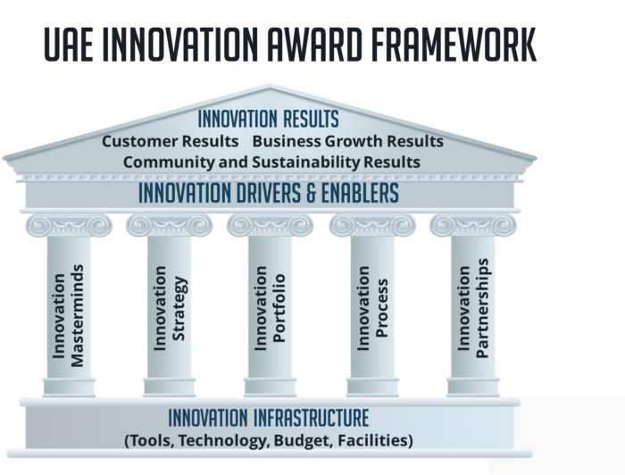
Middle East Growth, Innovation, and Leadership
