Abstract
The main purpose of this project is interfacing of vehicles with radio frequency identification (RFID) tags. It is very useful application for transport systems, military operations and for navigation systems. GSM and other technologies are very expensive that a common person can't use these technologies individually. Passive tags are free from power requirement and inexpensive. So it is an essential requirement to develop a robot vehicle that could be interfaced with passive tags and navigate the location. This project comprises of mainly three parts. The first step is designing of a robot with the help of four dc gear motors using h-bridge drivers. The second part is interfacing of sensor that can detect hurdles. The third and main part of this project is to interfacing of passive tags with robot. Range depends on your RFID passive tags. In this project short range passive tags are used for testing. Generally Radio frequency range is 3 kHz to 300 GHz but range can be increased by using Long Range RFID Passive tags.

ABBREVIATIONS
DC: Direct motor
ENCD: Department of Electronic Engineering
IDEs: Integrated development environments
MCU: Microcontroller unit
RF: Radio Frequency
RFID: Radio Frequency Identification
Rx: Receiver
Tx: Transmitter
UET: University of Engineering & Technology

TABLE OF CONTENTS
Click to expand Table of Contents

Chapter I: INTRODUCTION
In this project we are interfacing of vehicles with radio frequency identification (RFID) tags. It is very useful application for transport systems, military operations and for navigation systems. GSM and other technologies are very expensive that a common person can't use these technologies individually. Passive tags are free from power requirement and inexpensive. So it is an essential requirement to develop a robot vehicle that could be interfaced with passive tags and navigate the location.
This project comprises of mainly three parts.

1.1 Unmanned Vehicles
The first step is designing of a robot with the help of four dc gear motors using h-bridge drivers. We control these four motors by artificial intelligence using programming. Motors are controlled by h-bridges. We control forward, reverse, right and left turn, break and sudden stop steps of motors using techniques of programming on h-bridges.

1.2 Interfacing of Hurdle Sensors
The second part is interfacing of sensor that can detect hurdles. Actually we want to develop a system in which our vehicle (unmanned) can detect hurdle and give response to the controller for further actions. We are using HC-SR04 hurdle detector for this purpose. This sensor can detect the hurdle from 2cm - 400cm.

1.3 Interfacing of Robot with RFID Tags
The last part of this project is to interfacing of passive tags with robot. Range depends on your RFID passive tags. In this project short range passive tags are used for testing. Generally
Radio frequency range is 3 kHz to 300 GHz but range can be increased by using Long Range RFID Passive tags. In this project RFID tags have two parts, RFID transmitter and RFID receiver. We send our destination through RFID transmitter. RFID receiver detects our destination and sends exact location .Now our microcontroller detects its destination where it will go. So it reaches to its destination by programming.

1.4 Advantages
This project is used in navigation system, military purpose, mine detection for a specific area. GSM and other technologies are very expensive and can't be used in a daily life processes. On the other hand RFID navigation technology are inexpensive and depends upon the range of radio frequency tags.

1.5 Disadvantages
There is no such disadvantage however tags are not accurate according to requirement.
RFID tags having frequency matching problems but it can be ignore for small areas.

Chapter II: Design of Unmanned Vehicle

2.1 Construction

2.1.1 Construction of H-bridge
First of all we make H-bridge as it the basic motor driver to control motor. H-bridge comprises of P-MOSFET & N-MOSFET. Actually MOSFET's are current controlled
devices and give high protection for motors from high current. A common use of the Hbridge is an inverter. The arrangement is sometimes known as a single-phase bridge inverter.
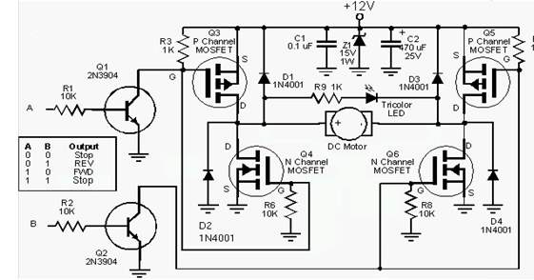
Fig 2.1: Circuit Diagram of H_bridge
The H-bridge with a DC supply will generate a square wave voltage waveform across the load. For a purely inductive load, the current waveform would be a triangle wave, with its peak depending on the inductance, switching frequency, and input voltage.

2.1.2 Working of H-bridge
DC motor can run in two direction both forward & reverse depending upon the polarity. To run the motor in forward, connect positive & negative terminal of supply. For reverse direction, reverse the connection polarity. BJT's with logic controlled inputs are connected for switching the MOSFET. Logic inputs are used to select the mode of operation.
- It is a motor state/mode controller.
- It operates motor in four modes.
- Uses four logic inputs to operate in four modes.
1 - Clockwise rotation
2 - Anticlockwise rotation
3 - Coarse (normally stop)
4 - Break
Table 2: Four Modes of H-bridges
Input 1 | Input 2 | Output mode
0 | 0 | BREAK
0 | 1 | REVERSE
1 | 0 | FORWARD
1 | 1 | COARSE

2.1.3 Working in a Switching Diagram
The switching diagram of H-bridge can be shown as:
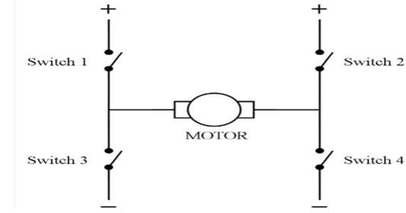
Fig 2.2: MOSFET Internal Switching Diagram

2.1.4 Forward Rotation
To turn the motor on in the forward direction, switches 1 and 4 must be closed to power the motor.
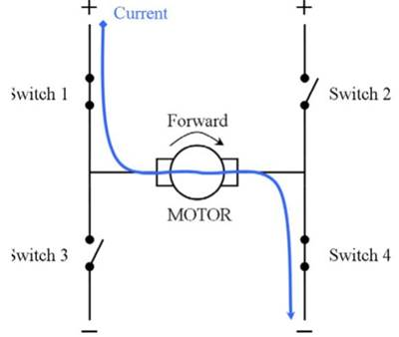
Fig 2.3: Forward Rotation of Motor

2.1.5 Reverse Rotation
To turn the motor on in the reverse direction, switches 2 and 3 must be closed to power the motor.
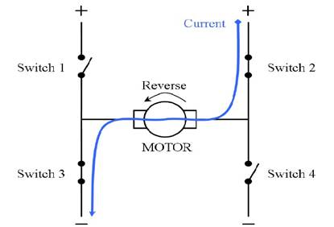
Fig 2.4: Reverse Rotation of Motor.

2.1.6 Flow Chart of H-bridge
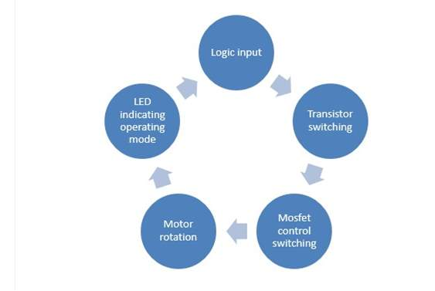
Fig 2.5: Flow Chart of H-bridge

2.1.7 Block Diagram of H-bridge
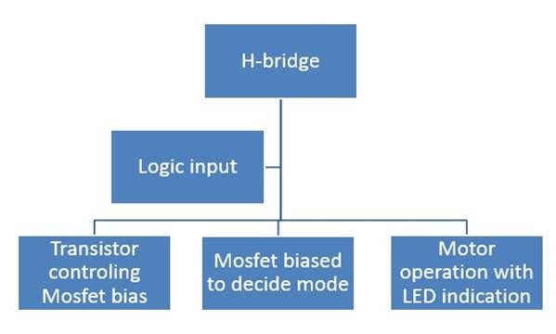
Fig 2.6: Block Diagram of H-bridge.

2.1.8 Schematic Diagram of H-bridge
Schematic shows results are satisfied according to our requirement.
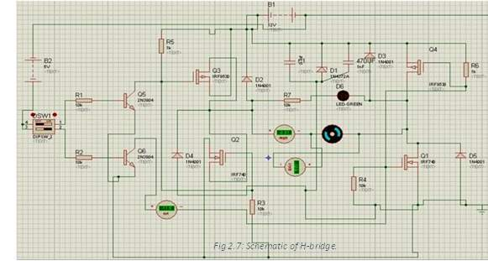

2.1.9 Results
We check our circuit in proteus and later in hardware. The circuit is working properly and gives results according to our requirement. Outputs move motor in forward, reverse, coarse and stop properly as shown in above Fig 2.7.

2.2 Construction of 4 H-bridge module
Four H-bridge are planted on a board to make H-bridge module. We can use each module individually but it will be helpful for compact form so we can develop maximum room for our project. Each H-bridge has two bit input and two bit output as shown in Fig 2.8.
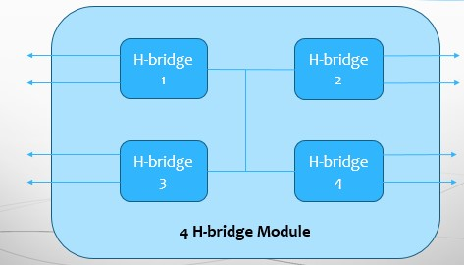
Fig 2.8: Four motor H-bridge module

2.3 L298 for Motor Driver
We can also use L298 IC for H-bridge purpose. A single IC have two H-bridges to drive two dc motors. So total two L298 will be used for our convenience. The L298 is an integrated monolithic circuit in a 15-lead Multiwatt and PowerSO20 packages. It is a high voltage, high current dual full-bridge driver designed to accept standard TTL logic levels and drive inductive loads such as relays, solenoids, DC and stepping motors. Two enable inputs are provided to enable or disable the device independently of the input signals. The emitters of the lower transistors of each bridge are connected together and the corresponding external terminal can be used for the connection of an external sensing resistor. An additional supply input is provided so that the logic works at a lower voltage.
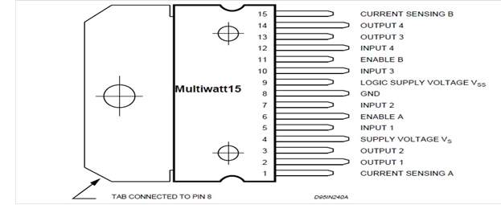
Fig 2.9: Front view of L298 (bi H-bridges IC)

Chapter III: Design of Generic Board

3.1 Introduction
Generic Board or developer board having all set of components including microcontroller. We are using ATmega16 in our generic board. We make generic board for our convenience so that it is also act as a burner and we can direct load our program by serial port from our system to our generic board.

3.2 ATmega16
ATmega have 40 pins AVR microcontroller which has 4 ports of input/output which is PORT A, B, C & D .Each port has 8 pins which can be used either input or output pins, other pins are reset , V_{cc}, GND, Crystal pins etc.
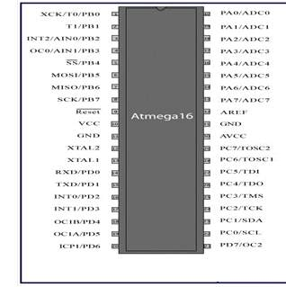
Fig 3.1: ATmega 16 pin Layout

3.3 Pin Configuration with Generic Board
1- Port A A0-A7 | (Use as I/O ports)
2- Port B B0-B7 | (Use as I/O ports)
3- Port C C0-C7 | (Use as I/O ports)
4- Port D D0-D7 | (Use as I/O ports)
5- Reset | For reset of the whole program which is running
6- XTAL1 & XTAL2 | For crystal interfacing
7- Vcc AVcc | For Digital and Analog supply
8- GND | For ground the microcontroller

3.4 Crystal 16 MHz
It is also called oscillator. We are using 16 MHz crystal for our microcontroller. It is attached with XTAL1 & XTAL2. Oscillators are connected externally with the microcontroller to provide high frequency signal to the oscillator circuit in the microcontroller. The oscillator circuit provides the clock signal to the micro controller.

3.5 Fuse Bit
Fuse bit are internally microcontroller bit which should be compatible with external crystal frequency. If they are not compatible fuse bit will not be on and microcontroller will not be work properly. Fuse bit should be set by changing microcontroller pin configuration.

3.6 Generic Board
Generic Board is set of all the possible configuration which can facilitate following things:
- We cannot need to change position of microcontroller as its pins are very soft and can be destroyed by changing its position again and again.
- Crystal is fixed here so there will be no problem of clock.
- Input and Output ports are connected to male or female header so that we can direct connect wire with microcontroller through pins.
- There is serial data port which can transfer our program from system to microcontroller.

Chapter IV: Interfacing of Hurdle Sensor & RFID Tags

4.1 Hurdle Sensors HC-SR04
Ultrasonic ranging module HC - SR04 provides 2cm - 400cm non-contact measurement function, the ranging accuracy can reach to 3mm. The modules includes ultrasonic transmitters, receiver and control circuit.
The basic principle of work using IO trigger for at least 10us high level signal. The Module automatically transmit eight 40 kHz and detect whether there is a pulse signal back. If the signal comes back, time duration will be counted.
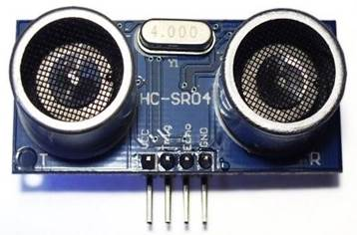
Fig 4.1: HC-SR04 Hurdle Detector Module
Test distance = (peak level time x velocity of sound (340ms⁻¹) / 2 … … (Eq 4.1)
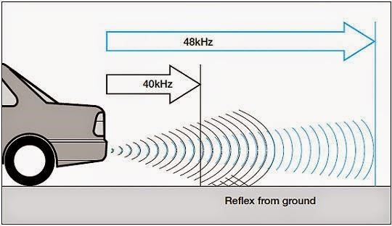
Fig 4.2: Reflex Of Hurdle Sensor waves.

4.2 Circuit Diagram of HC-SR04
Detail circuit diagram of HC-SR04 interfacing with MCU is shown in bellow in figure 4.3
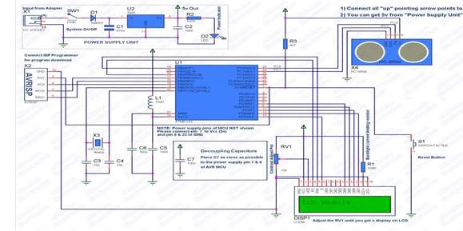
Fig 4.3: Circuit Diagram of HC-SR04 interfacing with MCU.

4.3 Calculation of the Distance
The Timing diagram is shown below in figure 4.4. You only need to supply a short 10uS pulse to the trigger input to start the ranging, and then the module will send out an 8 cycle burst of ultrasound at 40 kHz and raise its echo.
The Echo is a distance object that is pulse width and the range in proportion .You can calculate the range through the time interval between sending trigger signal and receiving echo signal.
Formula:
uS / 58 = centimeters
or uS / 148 =inch;
or the range = high level time * velocity (340M/S) / 2;
we suggest to use over 60ms measurement cycle, in order to prevent trigger signal to the echo signal.
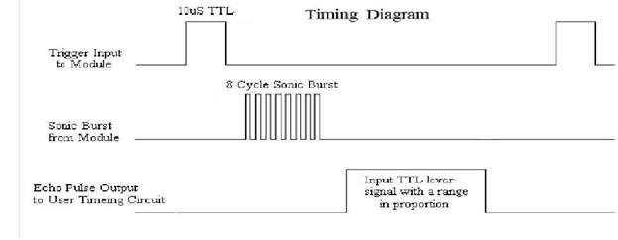
Fig 4.4: Input & output wave forms of HC-SR04 module.

4.4 Interfacing with microcontroller
The output will be in the form of 4 bit binary number. We can change it according to our requirement by using decoder, encoder and multiplexing.
For showing result we use 16x2 LCD. At which we can display our distance or a distance at a specific distance in inch or centimeters which can be converted according to our requirement by using formula.
We can also obtain 8-bit data from microcontroller.
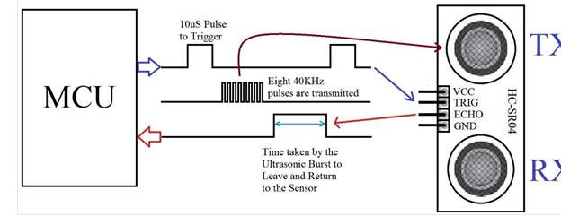
Fig 4.5: Pin Configuration of HC-SR04 with MCU.

4.5 Interfacing with RFID Tags
We interfaced RFID Tags/module with unmanned vehicle. Following is some explanation of interfacing steps.

4.6 RFID TAGS/MODULE
Radio Frequency Identification (RFID) tags are used for determine the destination.
We fix destination according frequency number in our microcontroller.
We are using R433 frequency number will be in a binary form.
Radio communications between two AVR microcontrollers can be easy when specialized modules are used for RF modules TX433 and RX433.
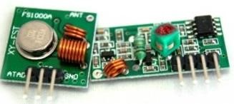
Fig 4.6: Tx & Rx Separate package.
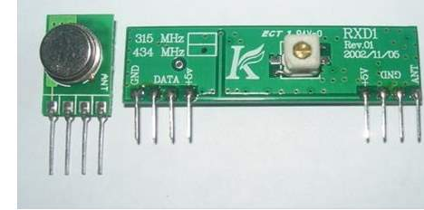
Fig 4.7: Tx & Rx on same kit.

4.7 RFID Transmitter
Transmitter and receiver module tuned to work correctly at 433.92MHz.
Transmitter can be powered from 3 to 12V power supply while receiver accepts 5V.
5V is common for AVR microcontrollers so no problems with interfacing.
Modules don't require addition components just apply power and connect single data line to send information to/from and that's it.
For better distances apply 30 – 35cm antennas. Modules use Amplitude-Shift Keying (ASK) modulation method and uses 1MHz bandwidth.
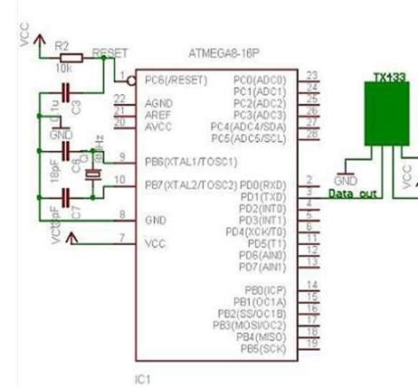
Fig 4.8: RFID Tx interfacing with MCU.

4.8 RFID Receiver
Receiver module is also tuned to work correctly at 433.92MHz.
Receiver accepts 5V power.
5V is common for AVR microcontrollers so no problems with interfacing.
Receiver will match RF which is transmitting from Tx433.
If its RF will match or compatible with RF of Tx.
Finally, it will send signal to the microcontroller about its destination.
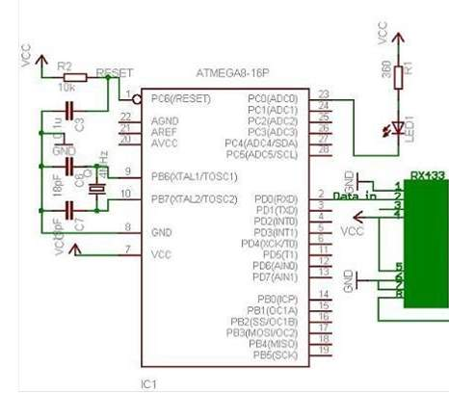
Fig 4.9: RFID Rx interfacing with MCU.

4.9 Working of RFID T_{x} & R_{x} Module
Radio transmission is a bit more complicated than wired communications because you never know what radio signals are present on air. So all matters how transmitted signal is encoded.
This is a part where we have many choices to use hardware encoding like USART or write your own based on one of many ending methods like NRZ, Manchester etc. In my example we have used AVR USART module to form data packs.
Using hardware encoders solves many problems like synchronization, start and stop, various signal checks. But as long as we were practicing we cannot rely on plain USART signal. Here we can actually improvise by adding various checks and so on.
I decided to form 4 byte data packages in order to send one byte information.
These include:
- one dummy synchronization byte (10101010)
- one address byte – in case there are more receivers(or transmitters).
- one data byte.
- and checksum which is actually a sum of address and data(address+data).
We use a dummy byte at the beginning of package because when transmitter doesn't transmit any data – receiver catches various noises that come from power supply or other sources because receiver likes adjust its input gain depending on input signal level.
First byte tunes receiver to accept normal signal after then address byte, data and checksum can be read more reliably. Probably with different transmission modules you may exclude this dummy byte.
We shows at the end data packets of 4 bytes seen on the oscilloscopes. Yellow signal is from transmission data line(TX) while blue is taken from receiver data line(RX).
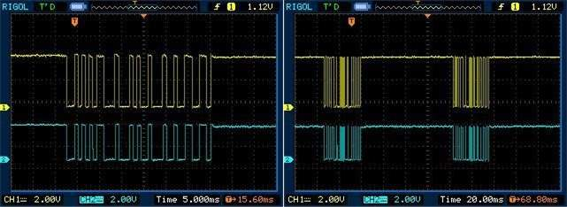
Fig 4.10 Tx & Rx signal matching with high bandwidth Fig 4.11: Tx & Rx signal matching with low bandwidth

4.10 Checksum Value
Receiver program receives all four bytes, then checks if checksum of received bytes is same as received checksum value.
If checksum test passes then receiver addresses are compared and if signal is addressed to receiver it analyses data.
Without antennas transmission is more erroneous even if modules are standing nearby. Of course with all my power chords around the room I was getting lots of noises that receiver was catching between data transmissions.
We again send one more 'A'
Then we send the actual data.
Now we send the inverse of data. That is all 0′s are converted to 1 and vice-versa.
We end the packet by sending 'Z'.
In this way we create a simple packet based transmission with error detection. Now in the RX side MCU our program follows the algorithm given below.
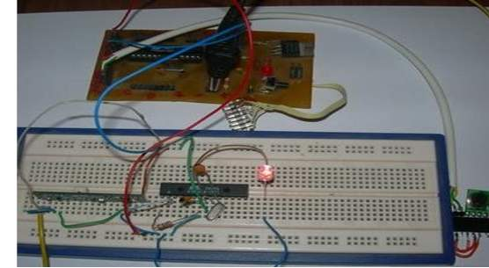
Fig 4.12: Hardware implementation of RFID Tx &Rx.

Chapter V: Logic Implementation & Simulation

5.1 Logic Sequence
We are making logics for a system that can reach to its destination through proper sequences. Logic can also give response against hurdle and choose another path. We made four points of destination. Each path have following sequence of destination:
- Right turn sequence
- Left turn sequence
- Right left sequence
- Left right sequence

5.2 Right Turn Sequence
In this logic sequence our unmanned vehicle will first choose shortest route by taking right turn.
If there is hurdle in its sequence it will choose another path. It can take left, backward forward movement also according situation and possible shortest route.

5.3 Right Turn Sequence
In this logic sequence our unmanned vehicle will prefer first choose shortest route by taking left turn.
If there is hurdle in its sequence it will choose another path. It can take right, backward forward movement also according situation and possible shortest route.

5.4 Right Left Turn Sequence
In this logic sequence our unmanned vehicle will first choose shortest route by taking right turn and then prefer left turn.
If there is hurdle in its sequences of all sides it will choose another path.

5.5 Left Right Turn Sequence
In this logic sequence our unmanned vehicle will first choose shortest route by taking right turn and then prefer left turn.
If there is hurdle in its sequences of all sides it will choose another path.

5.6 Introduction to Software
We are using two main software in our project. Proteus & Atmel studio for programming which are following in detail.

5.7 Introduction to Proteus
We first implement our circuit on Proteus so that we can verify our hardware whether it is compatible or not. It will provide convenience to our hardware.

5.7.1 Schematic capture
The Proteus schematic capture module lies at the heart of the system, and is far more than just another schematics package. It combines a powerful design environment with the ability to define most aspects of the drawing appearance. Whether your requirement is the rapid entry of complex designs for simulation and PCB layout, or the creation of attractive schematics for publication, Proteus Capture is the tool for the job.

5.7.2 PCB Layout
Our high performance netlist based PCB design package perfectly complements our powerfulschematic capturesoftware and features both automatic component placement and a truly world classshape based auto-router. Use the left hand navigation menu for more information on various features of the ARES PCB software or click on the movie on the right for a quick end-toend overview.

5.7.3 Project Schematics
L298 Schematic for using to drive two motors. Results are satisfactory. Following schematic shows we can drive two motors in it.
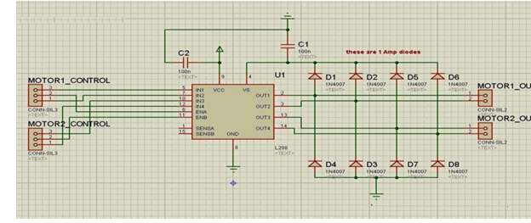
Fig 5.1: L298 H-bridge driver Schematic on proteus

5.8 Introduction to Atmel Studio
Atmel Studio 6.0 is the integrated development platform (IDP) for developing and debugging our program.
Atmel ARM Cortex-M and Atmel AVR microcontroller (MCU) based applications.
The Atmel Studio 6 IDP gives you a seamless and easy-to-use environment to write, build and debug your applications written in C/C++ or assembly code.
Atmel Studio 6 is free of charge and is integrated with the Atmel Software Framework (ASF) - a large library of free source code with 1,600 ARM and AVR project examples.
ASF strengthens the IDP by providing, in the same environment, access to ready-to-use code that minimizes much of the low-level design required for projects. Use the IDP for our wide variety of AVR and ARM Cortex-M processor-based MCUs, including our broadened portfolio of Atmel SAM3 ARM Cortex-M3 and M4 Flash devices.
Atmel Studio 6.2 is now available, adding advanced debugging features such as Data and Interrupt Trace, improved RTOS integration, and better ability to debug code that has been optimized.
With the introduction of Atmel Gallery and Atmel Spaces, Atmel Studio 6 further simplifies embedded MCU designs to reduce development time and cost.
Atmel Gallery is an online apps store for development tools and embedded software. Atmel Spaces is a cloud-based collaborative development workspace allowing you to host software and hardware projects targeting Atmel MCUs.
In summary, standard integrated development environments (IDEs) are suited for creating new software for an MCU project. By contrast, the Atmel Studio 6 IDP also.
Facilitates reuse of existing software and, by doing so, enables design differentiation.
Supports the product development process with easy access to integrated tools and software extensions through Atmel Gallery.
Reduces time to market by providing advanced features, an extensible software ecosystem, and powerful debug integration.

5.8.1 Program Structure
#include // libray addition
#include // Delay Library.
#define F_CPU 16000000UL int main (void)
{
DDRB=0xFF; // Port I/O declration while(1)
{
}
}

5.8.2 Libraries
1- io.h:
The io (input/output) library manages file descriptors. It can:
- Create descriptors talking to disk files, other programs, etc.
- Receive ("read") data from a descriptor, if the descriptor has data to provide.
- Provide (``write'') data to a descriptor, if the descriptor has space for data.
- If no descriptors are ready for reading or writing, pause until the situation changes.
- Identify the descriptors that are ready for reading or writing.

2- Delay.h
The function in this header file are wrappers around the basic busy-wait fuctions from .
It is the basic fuction where actual time values can be specified rather than a number of cycles to wait for.
In this way compile constant expression will be eliminated by compiler optimization so floating-point expression can be used to calculate the number of cycles of delay needed based on central processing unit frequency passed by the macro F_CPU.
3- F_CPU 16000000UL
Set the frequency of the microcontroller to 16 MHz. If the frequency is different, the corresponding value should be set.
4- While Loop
We use while loop in the main program so that code in this loop will run repeatedly.

CONCLUSION
We have designed an unmanned vehicle which is controlling by RFID technology. Unmanned vehicle has a feature to reach its destination using shortest route. Any hurdle in front of vehicle can detect and vehicle will response against by choosing another shortest path. We also learn the behavior of H-bridge to drive DC motor. We also interfaced hurdle sensors with microcontroller and also indirectly interfaced with unmanned vehicle. We also determine the behavior of transmitter and receiver of RFID modules/tags. We conclude that RFID technology is inexpensive than other technologies and give accurate results for a specific area. Logic sequence provide shortest route to its destination.

REFERENCES
[1] Lun-Wu Yeha, Ming-Hsiu Hsu, Hong-Ying Huanga, Yu-Chee Tseng,"Design and implementation of a self-guided indoor robot based on atwo-tier localization" , in Pervasive and Mobile Computing , vol. 8,no. 2, pp.271-281, April 2012
[2] Heesung Chae and Kyuseo Han, "Combination of RFID and Vision for Mobile Robot" , in Proceedings of the International Conference on Intelligent Sensors, Sensor Networks and Information Processing Conference, pp.75-80, 2005
[3] Yelamarthi, K., Haas, D., Nielsen, D., Mothersell, S., "RFID and GPS integrated navigation system for the visually impaired" , in Proceedings of the 53rd IEEE International Midwest Symposium on Circuits and Systems (MWSCAS), pp.1149 - 1152, 2008
[4] Yu Zhou,Wenfei Liu, Peisen Huang "Laser-activated RFID-based Indoor Localization System for Mobile Robots" , in Proceedings of the IEEE International Conference on Robotics and Automation, pp.4600 - 4605, 2007
[5] Byoung-Suk Choi, Joon-Woo Lee, Ju-Jang Lee "An improved localization system with RFID technology for a mobile robot" , in Proceedings of the conference of IEEE Industrial Electronics, IECO, pp.3409 - 3413, 2008
[6] HyungSoo Lim, ByoungSuk Choi, JangMyung Lee "An efficient localization algorithm for mobile robots based on RFID system" , in Proceedings of the International Joint Conference on SICE-ICASE, pp.5945 - 5950, 2006
[7] Byoung-Suk Choi, Joon-Woo Lee, Ju-Jang Lee, "Localization and mapbuilding of mobile robot based on RFID sensor fusion system" , in Proceedings of the International Confernece on Industrial Informatics(INDIN), pp.412-417, 2008
[8] Yelamarthi, K., Sherbrook, S., Beckwith, J., Williams, M., Lefief, R.,"An RFID based autonomous indoor tour guide robot" , in Proceedings of the 55th IEEE International Midwest Symposium on Circuits and Systems (MWSCAS), pp.562 - 565, 2012
[9] Di Giampaolo, E., "A passive-RFID based indoor navigation system for visually impaired people" , in Proceedings of the 3rd International Symposium on Applied Sciences in Biomedical and Communication Technologies (ISABEL), pp.1-5, 2010
[10] Mishra, S., Bande, P., "Maze Solving Algorithms for Micro Mouse " , in Proceedings of the IEEE International Conference on Signal Image Technology and Internet Based Systems(SITIS), pp.86-93, 2008
[11] B. Fletcher, "FPGA Embedded Processors: Revealing True System Performance", in Proceedings of the Embedded Training Program Embedded Systems Conference, San Francisco, 2005


