MANAGING ORGANIZATIONAL CHANGE
Critically evaluate the implementation of a specific case of organizational change. Building on this, reflect on what you can personally learn from this case analysis about change management and how you might benefit from these insights in the future.
Part 1

Introductory Overview
The main aim of the research paper is to critically evaluate the implementation of a specific case of organizational change management in General Motors which is an American multinational company. The paper in the initial section will be drawing an understanding of the case and with the help of descriptive approach will be incorporating a theoretical study to the change management case. With the right incorporation of communication and management related theories, the research paper will be presenting the arguments related to change management case study in accordance to General Motors. Arguments will be established based on the specific case of organizational change. With the help of the application of a wide range of theories the essay will also reflect on what is learnt from the critical evaluation of the case study and also determine how a person can benefit from these insights in the near future.

Case Study Introduction
General Motors was one of the biggest car manufacturing companies in America till
1920, but unfortunately after the involvement of the Japanese car manufacturing company Toyota came into existence General Motors had lost its market share in various parts of the country. The sales graph was going down for the company which was the main reason why it faced bankruptcy issues and sold out the company to a China Based manufacturing firm. However with the process of change management the company has now overturned the game of car manufacturing and is operating business with brands like Chevrolet, GMC, Buick and Cadillac in America and other countries worldwide. Due to improper financial management and lack of appropriate decision making among the board of directors or the managerial body, the business organization had to incorporate change management in its operations as a whole. However with proper change management the company has come up with new strategies and new business culture to start with new objectives in business.

Case Analysis
The business world in the current date is very diverse and is growing very fast with new technological improvements or methods in products of goods and services to accommodate the new taste and preferences of the customers. Furthermore business organizations in order to accommodate the new trends in the market are also investing billions of dollars on the research and development to use the new methods of production and operations process. Therefore keeping all these factors in view according to the author Galli (2018) it is very important for business managers and experts associated with the business to decide about the organizational change management in the business firm. Due to the globalization of the business activities the concept of organizational change management or organization change has started.
As reported by the authors Barrow and Butler (2017) it can be said that change management is often led by external factors like increase in the demand of the product or services, change in the needs of the customers or due to the lack of resources. But however arguing the fact the group of scholars Burnes and Bargal (2017) discusses that when the company feels that the culture of the organization, the use of technology, the human resource policies and the managerial activities if not done in a proper manner leads to the process of organizational change management.
General Motors thus had failed to realize that the industry required a change with the incorporation of better technology available in the market as well as with better designs. This way the company General Motors was slowly losing its market share to the largest Japanese car manufacturing company Toyota. According to the author Bhayangkara et al., (2020) even with the support issued from the government General Motors had to file chapter 11 bankruptcy in the year 2009.

Theme 1 – Creating a vibe of change among members in General Motors
John Kotter in his book ‘Leading to Change’ in the year 1995 had use the first model of change management. Built on the work of Kurt Lewin, John Kotter argues that leaving or neglecting any of the discussed step among the eight steps will be enough for the whole initiative taken by the organization to fail in the business process. The eight steps of John Kotter change management are:
- Step One: Creating an Urgency.
- Step Two: Forming a Powerful Coalition.
- Step Three: Creating a Vision for the Change.
- Step Four: Communicating the Vision for change.
- Step Five: Removing the direct Obstacles.
- Step Six: Creating various types of Short-Term Wins
- Step Seven: Building on the Change.
- Step Eight: Anchoring the Changes into a Corporate Culture
The first step is all about creating a need or urgency to move forward with change management that is developing the need of an idea to help the company change or update the existing operations to become more powerful. General Motors had kick started to jump in to the car manufacturing business with the use of latest technologies understanding the need for change. The second stage is all about forming an appropriate coalition which will be helping the company to derive a range of powerful skilled and experienced people to come up with different sections of the business. The third step includes of creating an effective vision which was quite prominent in the change management process at General Motors. Therefore while the adoption of Kotters eight step model is easiest, according to the authors Rosenbaum, More and Steane (2018) it might focus largely on the widespread adoption of the changes while eliminating the employees so as by forcing them to do what is demanded out from them.
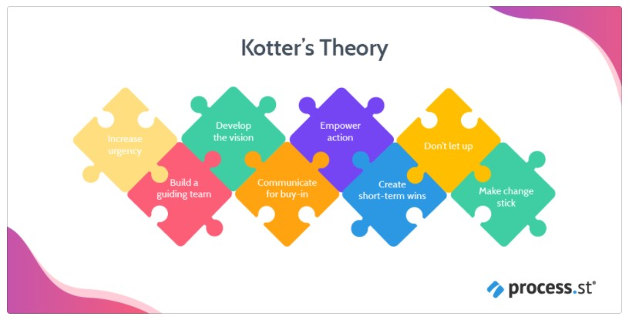
Fig 1. Represents the factors involved in Kotter theory
Source: (Gerbec 2017)
Creating better and smart cars with better safety features was the main vision of the company which supported their inspiration and hard work in gaining the position among the other competitors. On the other hand step four is all about communicating the vision to the members and employees associated with the company to generate maximum support from the system and achieve the goal in an appropriate manner. General Motors had made its continuous communication process with the directors and members to improve the business culture and build better quality cars from before. Step five and six removes the obstacles and creates short term wins for the company to achieve the bigger goals. Whereas step seven and eight were all about building on with the change and anchoring the change in corporate culture. On the other hand the authors Carman et al., (2019) determine that the change management steps of Kotter is forced among the employees to derive a foundation of success, the process is also helpful in creating a set of urgency and understanding the importance of change management among the other theories.

Theme 2 – Inculcating change and making it a part of the structure
On the other hand according to the author Jones-Schenk (2017) Kotter eight step change management is a very complex model which recognizes the need for change but however there is a lack in identifying the variables and need of change among the individuals in the organization therefore he proposes that the Lewins Model of change management is far more better than eight step model.
The Lewin model of change management is a simple model that highlights the approach of fitting for all business organizations. However contrasting the approach of Rosenbaum, More and Steane (2018) the authors suggests that Lewin change management model does not comprises of various factors which are fully covered in eight step of model of John Kotter.
However the Kewins model of change management basically includes three steps which are:
- Unfree stage
- Change management stage
- Refreeze stage
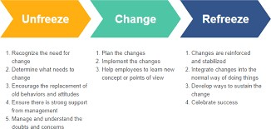
Fig 2. Represents the stages in Lewin Change management model
Source: (Teixeira, Gregory and Austin 2017)
The unfreeze stage of Lewin’s change management model mainly discusses the current paradigms of the organization and understands the need for change which is covered in Kotters eight step change management. Furthermore the change management process mainly involves asking the employees or members the importance of change management and gaining important feedback from them. Whereas the third step is all about refreezing the changed paradigm and indicating people to follow the change. Comparing the model of Lewin with Eight step of Kotter it can be said that due to the scale of unfreezing process the Lewin change management system might not be applicable in all the cases. Incorporation of the model might also lead to massive elimination of employees since their performance will be drastically different than before.

Theme 3 – Forming Support Structure and Strategy
The author Al et al., (2017) puts forward his argument on the benefits of incorporating organizational change management so as by incorporating the 7S model of McKinsey so as by stating that over all the two theories the McKinsey 7S theory show the weakness in the company and also highlights the areas which should be modified or altered when deploying the changes. Beyond that the theory supports the change and makes sure that every aspect of the change is supported by formidable change plans thus bringing flexibility into the performance as a whole. However the scholar Alqatawenh (2018) state that McKinsey 7S theory is only applicable to organizations which applies very few employees, the model is ineffective to run a multinational company like General Motor. The McKinsey 7S model is thus best suitable for those who demand change and are eager to accept them in their lives.
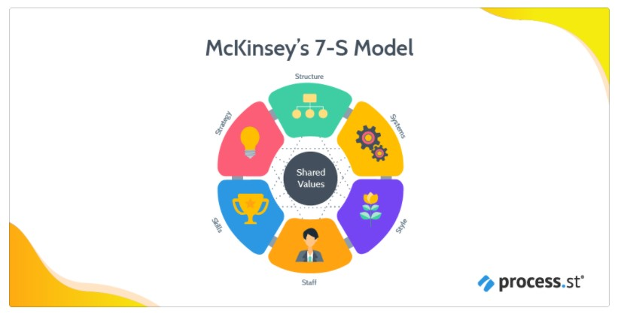
Fig 3. Discusses the factors in McKinsey model
Source: (Zheng, Chen and Shang 2019)

Evaluation
Here in the case study of Organizational Change Management at General Motor, it can be said that General Motor till the year 1920 earned the position of manufacturing huge number of vehicles and transported them to all around the world. Glory from the past few decades in being one of the greatest car manufacturers to a bankrupt company General Motors has made their way a long one. Until the entry of Japanese cars in the US market General Motors was the great car giant in the market. According to the authors Skogland and Hansen (2017) the Japanese company
Toyota in America sold cheap cars which were far better in looks and designs from that of the General Motors. This was the main reason why General Motors had fallen back in the car manufacture race. This required the organizational change management system in the operations of General Motors which will be helping the company to lift up and set back new business targets among the other.
It has been clearly understood from the case study that the driving forces on General Motors required to change the existing traditional strategies and align the business operations with sustainability. Therefore it was very important for the company to incorporate the Kotters 8 model has helped the company to create the urgency for change in the whole organization so that it can continue on the same path thriving better opportunities. But however it can be said that according to the research work of Domingues et al., (2018) it was the worst situation faced by the company as because it was going through the liquidation and bankruptcy. Furthermore with the help of change management the company was able to create a vision for the change and dedicate in providing products and services to the customers who received superior value with the products. Furthermore the employees and business partners will also share their success with the stockholders associated with the company thus helping the company to receive sustained and superior return on investment.
By incorporating the Kotter 8 step change management process has not only helped the company to inspire the employees with the urgency in need for change management but has also maintained the momentum to use better resources and analyzing the current trends in the market. The best part of the theory applied in the General Motor organizational change management is that it gave the team and leaders in managerial department to enact the change with people a sense of urgency and the power to convince them in an accurate manner.
Therefore in order to conclude it can be said that business organizations who fail to cope up with the change management will have to crumble under the competition brands or might also disappear with time. The case study of General Motors shows that the company made it necessary for the employee to accept the change and once implemented with the process of continuous evaluation and revaluation sustained to grow in the car manufacturing industry.
PART 2

Introductory Overview
This section of the reflection paper will be mainly detailing the main thematic understandings from the case study and will be presenting main arguments in response to the task. The paper will be presenting the use of theoretical approaches and determine the best theory which could be used by the company prior to the application of change management. The paper will be critically reviewing a reflection on the experience gained through change management giving illustrative examples. In relation to the successful people, the paper will be highlighting how they have changed their life so as by incorporating change management opportunities.

Introduction on Personal experience
Although my passion for change management never began until and unless I started studying them it from my high school on diverse theories and models on change management till graduate. Furthermore I looked back onto my life and realized that I have experienced varied degrees of change management in my professional life and in my personal life. Therefore as I try to reflect on various events in my own life I find it out that change management has indeed had put a great impact in my life in a positive manner. It can be said that it touches all of us in some way or the other.

Personal reflection on Change management
Talking about my professional career, I have spent few years of my life in an industry that was very static and slow moving. As because accuracy and a sense of validity is so clear to the end users implementing any sort of change was very difficult then. In most of the cases change never took place so easily to keep up with the pace in the market of operation. At every stage off my career I have faced numerous challenges and I will deliberately continue to accept the challenge in the near future as a well in every premises. As to me it is nothing but just a fear within myself which I have to over with the help of change management models I have learned over the time period. It can be said that with proper time and planning work people can enjoy their lives to the fullest with the help of change management. But however everyone has to serve as a change management agent in their lives and willing should accept the adverse effect or consequences. I have throughout my lifetime accepted risks of doing in various types of industries and gain diverse knowledge from each and every segment.
The range of new theories on change management that I have covered in the research paper are Kotter 8 step model, McKinsey 7S model and Lewin change management model. From my personal experiences on each and every model used in change management it can be said that Kotter 8 step model is the first model among other which less in changing itself but focuses more on the people who are involved with the business organization that is the employees. The Kotter 8 step model helps in creating an urgency for the need of change and also maintains the memorandum in the business. Kotter 8 step model mainly uses its eight steps which includes:
- Creating a sense of urgency
- Building a core coalition
- Forming a strategic vision
- Getting everyone on board
- Removing barriers and reducing friction
- Generating short-term wins
- Sustaining acceleration
- Setting the changes in stone
According to my expenses in life the Kotter 8 step model is a fantastic theory that forces a person to create a change within the business, it also urges in convincing everyone in making them understand the importance of change management. This will definitely help in guiding the team to understand the need for change and how to enact the change at each and every stage. But however comparing it with Lewin change management model it can be said that it focuses on widespread adoption of changes that is it has its main focus on the top down approach which creates a risk of eliminating employees.
Appling the Kotter 8 step model in business the employees has to abide by the rules and regulations provided by top management whereas as in the case of Lewin change management theory it is one of the most popular approaches used by business individual for it being simple. The Lewin change management theory basically breaks itself into three different stages unfreeze, change management and refreeze. Lewin change management theory is best applicable when a business organization needs to drastically change in order to success in the particular moment. The best part of Lewin change management theory is that it analyzes each and every aspect of whatever changes is made at each and every step of the overall process.
When comparing it with the McKinsey 7S model it can be said that Lewin change management theory will be difficult to incorporate and is a time consuming act because of the extension in the unfreezing process. Furthermore I have found out that Lewin change management theory also requires a great deal of love and care to be provided to the employees beyond the base of instructions provided by the board of directors in the initial stage. However the theory of McKinsey 7S model cannot be applied in big or multinational organizations. Among the other two theories it helps in highlighting the changes required in the business and also supports the most so as to help in bringing out the change. This theory helps in building business plans which will be undoubtedly helping the company to be flexible enough for further changes.
In order to conclude the above research paper on change management it can be said that using the insights from the managing directors of GM I have changed my life so as by bouncing back with new outcomes while facing a problematic situation.

References
Al-Ali, A.A., Singh, S.K., Al-Nahyan, M. and Sohal, A.S., 2017. Change management through leadership: the mediating role of organizational culture. International Journal of Organizational Analysis.
Alqatawenh, A.S., 2018. Transformational leadership style and its relationship with change management. Verslas: teorija ir praktika, 19(1), pp.17-24.
Barrow, J.M. and Toney-Butler, T.J., 2017. Change management.
Bhatt, R., 2017. Theoretical perspective of change management. CLEAR International Journal of Research in Commerce & Management, 8(2).
Bhayangkara, A.N., Ahmadi, W.H., Firdaus, D.B., Prestiadi, D. and Sumarsono, R.B., 2020,
November. The Role of Instructional Leadership Through Kurt Lewin Model in Improving the
Teacher Capability. In 2nd Early Childhood and Primary Childhood Education (ECPE 2020) (pp. 307-317). Atlantis Press.
Burnes, B. and Bargal, D., 2017. Kurt Lewin: 70 years on. Journal of Change Management, 17(2), pp.91-100.
Carman, A.L., Vanderpool, R.C., Stradtman, L.R. and Edmiston, E.A., 2019. Peer Reviewed: A
Change-Management Approach to Closing Care Gaps in a Federally Qualified Health Center: A Rural Kentucky Case Study. Preventing chronic disease, 16.
Domingues, A.R., Lozano, R., Ceulemans, K. and Ramos, T.B., 2017. Sustainability reporting in public sector organisations: Exploring the relation between the reporting process and organisational change management for sustainability. Journal of environmental management, 192, pp.292-301.
Galli, B.J., 2018. Change management models: A comparative analysis and concerns. IEEE Engineering Management Review, 46(3), pp.124-132.
Gerbec, M., 2017. Safety change management–A new method for integrated management of organizational and technical changes. Safety Science, 100, pp.225-234.
Jayatilleke, S. and Lai, R., 2018. A systematic review of requirements change management. Information and Software Technology, 93, pp.163-185.
Jones-Schenk, J., 2017. Fostering personal power during change. The Journal of Continuing Education in Nursing, 48(8), pp.343-344.
Rajan, R. and Ganesan, R., 2017. A critical analysis of John P. Kotter's change management framework. Asian Journal of Research in Business Economics and Management, 7(7), pp.181203.
Rosenbaum, D., More, E. and Steane, P., 2018. Planned organisational change management: Forward to the past? An exploratory literature review. Journal of Organizational Change Management.
Rosenbaum, D., More, E. and Steane, P., 2018. Planned organisational change management: Forward to the past? An exploratory literature review. Journal of Organizational Change Management.
Skogland, M.A.C. and Hansen, G.K., 2017. Change your space, change your culture: exploring spatial change management strategies. Journal of Corporate Real Estate.
Teixeira, B., Gregory, P.A. and Austin, Z., 2017. How are pharmacists in Ontario adapting to practice change? Results of a qualitative analysis using Kotter’s change management model. Canadian Pharmacists Journal/Revue des Pharmaciens du Canada, 150(3), pp.198-205.
Wentworth, D.K., Behson, S.J. and Kelley, C.L., 2020. Implementing a new student evaluation of teaching system using the Kotter change model. Studies in Higher Education, 45(3), pp.511-523.
Zheng, P., Chen, C.H. and Shang, S., 2019. Towards an automatic engineering change management in smart product-service systems–A DSM-based learning approach. Advanced engineering informatics, 39, pp.203-213.

