Investigation of Optimization of Risk Allocation in Construction Projects
Introduction
A review of the appropriateness of public-private partnerships in major drainage and water supply projects and the impact of procurement on competition and flexibility.
Governments are the most important client in terms of the provision of major drainage and water supply projects. However, as they are publically accountable they are constantly looking for methods to improve procurement processes and to provide greater value-for-money. This dissertation will use case study analysis methods. The dissertation will demonstrate specifically how governments have the ability to minimise the likelihood of market failure by leveraging the technological advantages of the market.
In comparison to other industries (organisations involved in the production of goods or services) the “Construction Industry” is different in largely due to the diversification of the projects. Moreover, projects in the construction industry occur in a dynamic environment (Zhang et al. 2014). The assortment of projects together with the dynamic environment of the construction industry leads to an increase in situations of high uncertainty (Mitkus and Mitkus 2014). Hence, risks involved in construction industry are higher as compared to other industries.
A proper evaluation of the risks involved in a construction project would aid in identification of processes to be allocated to minimize the risks (Arashpour at al. 2016). Minimization of risks in the industry would translate into larger profits for the industry. Moreover, judicious allocation of resources would lead to reduction in friction amongst the workforce at the workplace, thus increasing the efficiency of the project (Hwang et al. 2013).
The present research would search for measures being taken in the construction industry for risk optimisation and thus to suggest best possible measures. However, it is to be taken into consideration that the practice of risk optimisation and allocation does not fully lead to reduction of the risks. It is but just a means of reduction in risks and thus increase in the probability of success of industry in a particular situation.
In the construction industry risks has a broad concept. Various researchers have identified the risks prevalent in the construction industry. According to Shehu, Endut and Akintoye (2014) the Malaysian construction industry is plagued with to time and financial risks. Goh and Abdul-Rahman (2013) have emphasized on health and safety risks, schedule risks and contractual risks. In the informal building construction industry in Nigeria sub-contracting creates labour risks (Olusanya 2018).
1.2 Statement of the Problem
Every construction project is unique in the sense that it carries its own set of risks. The risks involved in a construction project affect each and every stakeholder (Aminbakhsh et al. 2013). All stakeholder involved in a project carry a proportion of the risk. The difference between the actual results and the expected can be defined as risk. “Risk” in a project cannot be ignored, however, the stakeholders through their endeavour can manage and thus reduce the chances of risk. Risks can also be transferred to a third party – subcontractors and suppliers (Yang and Zou 2014).
The construction industry completion of a project within the scheduled time as well as the estimated budget is the ultimate objective. However, time and costs can be considered as quid pro quo. Whereas loss of time for the industry can be related to escalation of costs, saving of time would benefit both the stakeholders. Although, saving of time in a construction project is related to an increase of both direct and indirect costs (Alinaitwe, Apolot and Tindiwensi 2013).
Initiation of a construction project is a contract between owner and contractor. The contract forms the basis of the apportionment of rights, risks, duties and responsibilities. The risks in the industry can never be eliminated, they however can be transferred to a second party (Marzouk and El-Rasas 2014). Thus the contract in other words means the process of allocation of the risks. As a rule, the owner transfers most of the risks to the contactor, who in turn increases the cost of the project for bearing the burden of the risks.
Risks in the construction industry is compounded by the fact that it a highly fragmented industry. Fragmentation can be defined as separation of the design aspects from the construction aspects. A construction can be viewed as a collaboration of multiple stakeholders for a single project. At the industry level, the construction industry involves multiple professionals and diverse organizations to deliver a project.
Further the industry is highly sensitive to economic cycles and presence of financial competition between participants. In addition to this the industry is beset with management problems, unforeseen events like natural calamities. The risks in the industry can be categorised as Physical, Financial, political and Engineering. Optimisation of each of the risk processes involves different approaches. The dynamic environment of construction projects creates a situation of uncertainty. Moreover, the inter-relation between the risk factors hinders an easy optimisation process.
The work wishes to investigate, evaluate and thus classify the risk allocation process in the construction industry. Further, the project envisages to recognise the barriers to optimal risk allocation. It is envisaged that an understanding of the risk would lead to addressing of the barriers to the allocation of risks in the construction industry.
Researchers have provided different definitions of risk. Risks can be defined as the probability of a hazard occurring resulting in potential loss or gain. Risks in construction industry may be Financial, Time, physical, personnel, design and technical, contractual, political, regulatory and safety (Goh and Abdul-Rahman 2013). The present project considers risks in the building construction industry. Risks in the building construction industry involves times, quality, health and safety aspects and financial risk. Time risks involve project schedule and as corollary allocation of time for every part of the project. Financial risks take into account the problems of cash flow, price fluctuation, inflation and payment schedule by the client. Health and safety risks are concerned with workers involved in the project. Quality of construction projects is concerned with quality of work and materials used in the project.
1.3 Research Aim
Construction project objective entails completion of the project in time within a given budget. The probability of completion of a project in time within the allocated finances can be defined as Risk. Hence optimization would mean the utilization of optimal resources to complete the project within the given time frame. Moreover, the judicious allocation of the resources is essential for the timely completion of the project. Further the research would also investigate how quality risks in building construction projects are managed. In addition, the research also focuses on how health and safety risks of construction projects are managed. Aim of this research study is to identify and investigate the optimization techniques and risk allocation process in construction project.
1.4 Objectives of the Study
The following research study has following research objectives-
- To provide a review on how risks are allocated and optimized in construction projects.
- To identify the importance of risk optimization in determining project success.
- To propose a pathway through which construction project can manage risk and create balance between project success as well as stakeholder’s standpoints.
1.5 Research Questions
The research questions provide answers to the research objectives. Thus the research questions are formulated as-
- How are risks identified in a construction project?
- How are risks allocated in a construction project?
- How can risks be optimized in a construction project?
- Does risks optimization lead to the success of a project?
- What are the problems with sub-optimal risk optimization?
- What are the hurdles to optimal risk management in the construction industry?
1.6 Research Methodology
In order to investigate the risk optimization and allocation features in the construction industry both primary and secondary data analysis would be used.
For the primary evaluation of the research project managers associated with the construction project would be interviewed. The interview would be analysed to understand the risk optimisation and risk allocation process being used in the particular project (Osipova and Eriksson 2013).
Secondary data analysis would involve previous published articles being analysed for steps taken by the industry under similar circumstances (Al Haj and El-Sayegh 2015).
After the successful collection of the data by interviewing the project managers of the different construction projects, the importance of the risk allocation will be evaluated on basis of those data. The answers that are recorded from the survey will help in answer the identified research questions and the objectives of the research (Ikpeze 2015).
1.7 Significance of the Study
Risk allocation and risk optimization is very important in ensuring the success of any project. This is because every project is associated with certain risks, majority of which cannot be mitigated. Therefore, the process of risk allocation helps in proper management of such risk (Taylan et al. 2014). This research study will therefore be valuable to the industry practitioners associated with the different construction projects in developing a better idea about the process and importance of risk allocation and optimization in the different construction projects.
1.8 Organisation of Chapters
For undertaking the present research, the thesis has conveniently been divided into five chapters. The introductory chapter provides an overview together with the background of the study, its aims, objectives and research questions. The prelude to the study is set forth through the problem statement. Prior work done to understand and thus provide solutions to the problems associated with risk allocation in construction industry is presented in chapter two. In chapter three we discuss the method to be used to investigate the optimisation process of risk allocation in the construction industry. The analysis of the collected data and evaluation of previous research is done in the fourth chapter. The final chapter draws a conclusion to the project by evaluating the risk allocation and risk optimisation in the construction industry.
Chapter 2: Literature Review
2.1 Introduction: The construction industry, as discussed above, is one of the most dynamic industries across the globe, with new developments and expansion of the industry taking place as a continuous process. As asserted by Wang (2014), the concerned industry differs from that of most of the other industries in the sense that the industry is highly diversified, both from the demand side as well as from the supply side. This diverse nature of the construction industry, across the global framework and the dynamic nature of the same contributes to higher than normal probabilities of risks arising in the concerned industry. The risks involved in the construction industry generally tends to be higher compared to other types of industries as argued by Pinto, Nunes and Ribeiro (2011).
The aspects of risks and the methods to address and minimise the same have been issues of immense concern in the construction industry and there exists substantial literary evidences regarding the aspects of risks in the construction industry, the factors contributing to the same, the types of risks as well as the ways to manage and mitigate the problems optimally, in the country specific as well as in the global framework in the contemporary scenario (Ball 2014).
Keeping this into consideration, the concerned section of the thesis tries to conduct an extensive review of the existing literatures, scholarly works and interpretations of empirical evidences, which are present in the global framework, in these aspects, thereby exploring the different opinions and assertions existent in the concerned domains in the global construction industry, emphasizing specifically on the building construction industries of the United Kingdom.
2.2 Construction Industry Overview: Global and United Kingdom
2.2.1 Global Construction Industry: To gauge the types of risks and their management dynamics it is of utmost importance to have an overview of the construction industry as a whole and the dynamics in the building and housing construction industry in the United Kingdom. As shown by Hampson, Kraatz and Sanchez (2014), the global construction industry is one of the most dynamic prospering industry, with a projected global output of more than 10.1 trillion US dollars by 2021, as can be seen from the following figure:
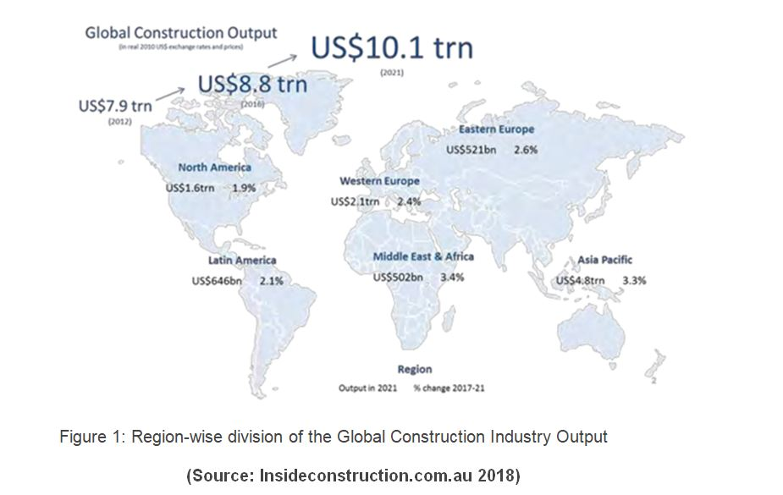
The reports of the National Research Council (2009), in this context argues that the primary countries emerging as the top construction markets in the global scenario, over the years and showing highly positive future trends of expansion and rise in productivities are:
- China
- USA
- India
- Japan
- European countries especially United Kingdom
The evidences provided by the above-mentioned report, is found to be augmented by the empirically evidenced scholarly work of Ortiz, Castells and Sonnemann (2009), according to whom, the construction industry can be seen to be growing even more in the emerging economies than that of the developed economies, in the recent period, with the trend of growth expected to be remaining the same over the coming years.
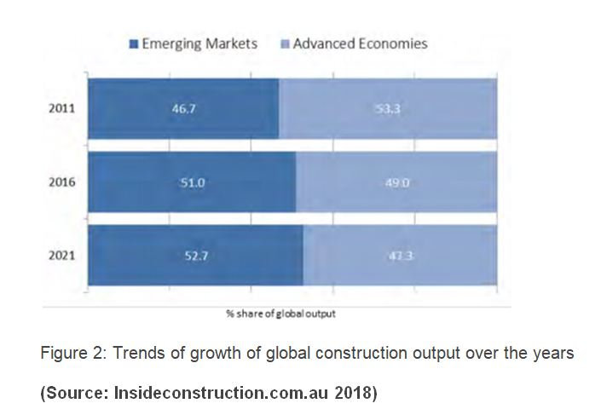
2.2.2 Construction Industry in the United Kingdom
The European countries can be seen to be expected to be consisting of a significant share of the global output in the coming years, attributing to the growth in the concerned industry of the country over the last few decades, a considerable share of the same being coming from the construction industry of the United Kingdom (Ball 2014).
One of the most comprehensive overviews of the construction industry of the United Kingdom can be seen to be present in the work of Sherratt (2014), according to whom, the construction industry of the country, contributed nearly 103 billion pounds in the economic output of the country (as per 2014 statistics). Apart from that, the industry also creates nearly 2.1 million jobs, thereby posing as one of the primary employment generating industries in the country (Oluwole Akadiri and Olaniran Fadiya 2013). The gross value added of the construction industry in the country, over the years, can be seen to be as follows:
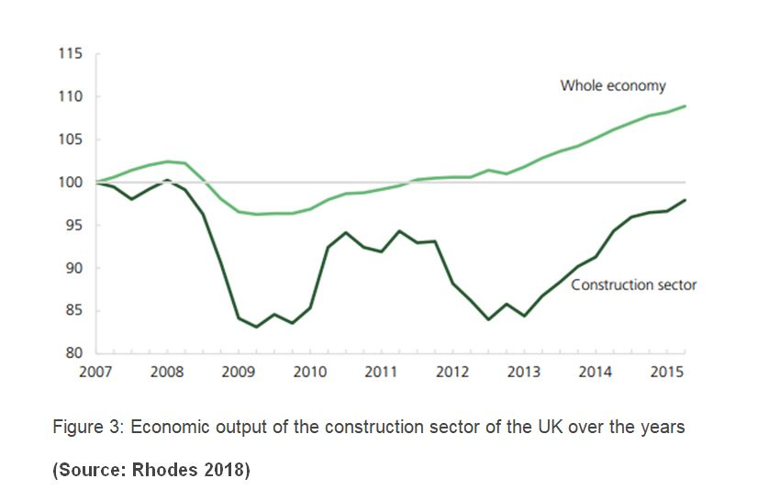
As per Ashworth and Perera (2018), both the public sector as well as the public sector contributes considerably in the total output generation in the construction sector of the country, with the private sector contribution being considerably higher than the public sector:
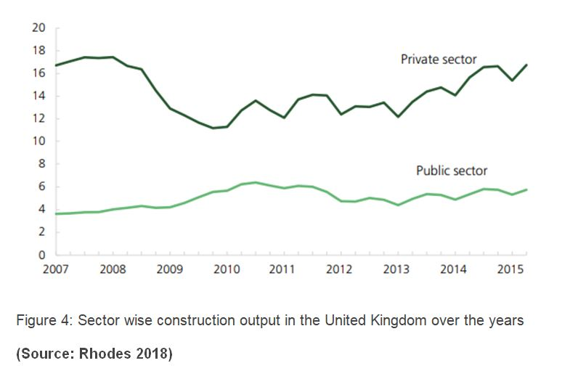
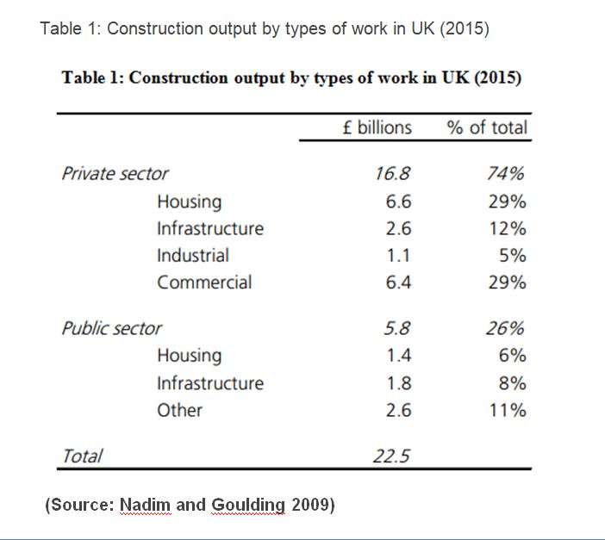
Thus, from the above evidences it can be asserted that the construction industry as a whole, can be considered to be one of the most prominent and economically contributing industries in the United Kingdom, with both the private and the public sectors contributing significantly in its development and the building construction industry forms a prominent sub-group under the domain of the concerned industry (Brindley 2017).
2.3 Risks in the Construction Industry
2.3.1 Construction Risks: Definitions and MeaningsThe term “risk”, being a broad conceptual one, generally refers to the situations which involve exposure to some sort of danger, harm or loss. In this context, there exists different interpretations of risks in the construction industry, of which the most comprehensive one can be seen to be provided by Abdelgawad and Fayek (2010). As per the assertions of the authors, the risks in construction industry refer to any exposure to the types of possible losses which can occur in the supply side dynamics of the industry. Augmenting this perception, Mhetre, Konnur and Landage (2016), suggest that risk in the construction industries are generally the differences between the expected outcomes from the different construction projects and the actual outcomes, which is turn affects different stakeholders in the project and thus, have to be considered seriously for the businesses in the industry to sustain in the long run.
2.3.2 Types of risks in the construction industry
Venturing in the construction sector of Thailand, the empirically evidenced literary work of Ghosh and Jintanapakanont (2004), identifies the main risks prevalent in the construction sectors to be as follows:
- Fund unavailability- The primary risk endured by the concerned industry is the risk of irregularity in fund gathering and allocation through the entire tenure of the projects.
- Construction delays- Various exogenous as well as endogenous reasons can lead to stagnation in operational activities of the companies, thereby leading to construction delays (Chien, Wu and Huang 2014).
- Financial and Accounting Failures- The construction companies may often face the risk of financial failure, mostly due to the lack of insights and accounting abilities as well as lack of prediction of cash flows and problems with capitalization and improper cost and project management frameworks (Renuka, Umarani and Kamal 2014).
- Unclear work scopes- This type of risk, as suggested by Bryde and Volm (2009), is considerably subjected to the construction industry itself, where there often remains confusion regarding the project milestones, deliverables and end products from the supply side providers.
- Contractual delays- One of the most common form of risk in the construction industry, arises from the differences between the expected and actual durations of the construction projects. Eybpoosh, Dikmen and Talat Birgonul (2011), in this context, indicates that the delay in the construction process often leads to the creation of risks of loss of profits on part of the project owners and higher costs on part of the contractors.
- Third party delays- Marzouk and El-Rasas (2014), in their paper exploring the risk factors in the construction industry of Egypt, emphasizes on the problems of delays by the third parties which lead to the creation of risks in the construction industries. The third parties, in this context, refers to the participants in the construction sector, apart from the direct contractors or companies, who play crucial roles in the different intermediate operational activities (Hamzah et al. 2011). Delay on part of them leads to an overall risk in the construction sector
Although the above-mentioned risk factors can be frequently observed in the operational framework of the construction industries, there however remains many other diverse forms of risks arising in the concerned industries. In their elaborate research paper over the building construction industry in Indonesia, Wiguna and Scott (2005), the authors identify more elementary and targeted risks, unlike those broad ones mentioned above. The primary risks identified in the building construction sector, by the authors, include the following:
- Cost burdens in construction due to presence of high inflations
- Risks arising out of the defective designs of the buildings
- Frequent changes in project and building designs by the owners
- Risks of climatic fluctuations
- Unforeseen risks of conditions of the site ground
- Defective works of construction (Olawale and Sun 2010)
- Problems related to availability of factors of production, including labours as well as equipment and raw materials
- Clashes with the labour unions
The works of Goh and Abdul-Rahman (2013), in the Malaysian construction industry also found more or less similar types of risks to be associated with the industry as found by the previous authors, however they also found some additional risk factors, which can be seen to be as follows:
- The ambiguous contract provisions often lead to confusions, thereby leading to increase in the risk factors
- Project schedule mismatches
- Project schedule mismatches
- Safety and health risks of the workers in the construction sector
- Unstable politics
- Accidents
- Poor communication among the construction stakeholders and parties
Thus, from the above discussion of the existing literatures and scholarly evidences it can be asserted that there exist different types of risks in the construction sector, in a globalised framework, attributing to the diversified nature of the industry itself and the exogenous as well as the endogenous attributes which the industry is subjected to in different regions at different points of time.
2.3.3 Classification of Risks in Building Construction Industry
Keeping into account the different types of risks in the construction industry as a whole and in the building construction industry in particular, the risks which generally arise in the industry can be classified into several sub-groups, depending on their nature, reason for occurrence and impacts. These classifications, with the help of the existent literary and empirical evidences are discussed in the concerned section, as follows:
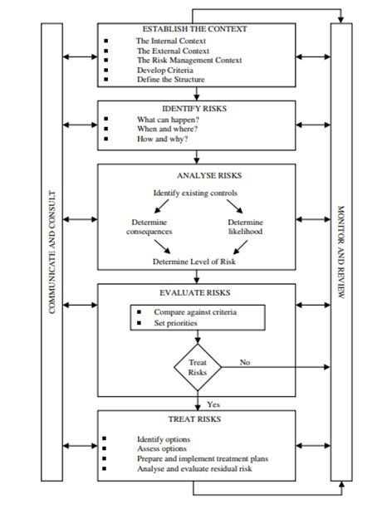
2.3.3.1 Financial Risks: As per the assertions of Antón, Rodríguez and López (2011), one of the primary forms of risks associated with the construction industry is that of the financial risks which the industry experiences. According to the authors, the significant forms of financial risks arise from fluctuations in the inflation, tax rate dynamics, exchange rate dynamics as well as fluctuations in the availability and allocation of funds in the construction projects and these types of risks are usually aggravated in the construction industry due to their diversified nature of operations and supply side dynamics.
2.3.3.2 Technical Risks: Another highly frequent form of risk which the construction industry as a whole and the building construction industry in particular faces, as per the arguments put forward by Ling and Hoi (2006), is that of the technical risks in the operational framework of the concerned industry. Exploring the risks experienced by the construction firms of Singapore in India, their paper highlights that often the construction firms face delays in provision of their promises to their clients due to technical risks which include uncertainty of availability of resources and construction materials as well as efficient and skilled workers. These types of risks also arise from inadequate investigation of sites and frequent changes in the requirements and scopes of projects, which jeopardise the flow of the projects (Dikmen and Birgonul 2006).
2.3.3.3 Health and Safety Risks According to the arguments put forward by Zhou, Goh and Li (2015), one of the negative aspects of construction industry in general is the presence of high health hazard issues, most of which are experienced by the workers due to the nature of the jobs and the harmful substances which they are exposed to, in the construction industry. Zainon et al. (2018), in this context, identified different risks in the Construction industry.
- Risks involved due to heights
- Health risks due to exposure to harmful chemicals
- Presence of Soil-dust and Asbestos
- Calcium Oxide
- Crystalline Silica and Portland Cement (Lacourt et al., 2015)
- Presence of Asbestos at Construction industry increases the risk of Cancer amongst construction workers (Järvholm 2014)
- Risks of unintended collapses which may include the following types of risks:
- Falling into the excavations
- Faults in determination of the integrity of the surrounding buildings which leads to their collapse
- Injuries from falling substances (Gillen et al. 2002)
- Scaffolding of vehicles due to overloading
- Presence of high amount of noise
- Risks of damages of soft tissues like neck, wrists, legs, hips, arms and feet due to moving, lifting and carrying of material loads
- Non-fatal risks of most common forms of injuries related to slips and trips
- Risks of working from height, which causes nearly fifty per cent of the fatal injuries in the construction industries in the global framework as per the assertions of Haslam et al.(2005). As per the authors, these forms of risks in the construction sites mostly arise due to the following issues:
- Lack of edge protection
- Absence of guardrails
- Unsecured ladders
- Scaffolding problems
- Loose tools and improperly stored materials
- Exhaustion and mental health-related risks which are also highly common in the concerned industry
1. Design Risks: Behm (2005) highlights the different design related risks which arise in the construction industry, which may arise from:
- Involvement of owners in designing process
- Incomplete, inadequate and faulty construction project design
- Seismic criteria related confusions/li>
- Errors in structural and geotechnical aspects
- Material selection problems
- Risks of faulty take-off data (which include water, traffic and other aspects)
- Choice of wrong equipment
2.3.3.4 Environmental Risks: Kartam and Kartam (2001), while portraying the risks in the construction industry, from the contractors’ points of view, highlight the construction industry, in the global domain, is frequently subjected to risks related to environment as a whole, which arise primarily due to the faulty or incomplete environmental analysis, presence of wetlands, creation of hazardous wastes, lack of skilled and specialised personnel and others (Thevendran and Mawdesley 2004). These risks in turn have immense negative implications in terms of increase in costs and delay in delivery of different construction projects.
In this context, several risks identified in building or residential constructions are identified in the report of International Risk Management Institute, to be as follows:
- Fumes, emissions, spills of chemicals
- Heating and ventilations and their maintenance errors which increase carbon monoxide formation in air
- Risks of environmental damage from lead containing painting materials
- Disturbance and increase in contamination due to excavation works (Irmi.com 2018)
- Underground lines and constructions causing damages
- Risks from leakage of underground or aboveground tanks
- Improper waste disposal methods
2.3.3.5 Construction Risks: Different types of risks also arise in the operational framework of the construction industries, owing to the glitches or issues faced in the construction process only. Menzel and Gutierrez (2010), in this context, identifies the primary construction risks to be those arising from inaccurate estimates of contract line, troubles related to occupational safety, construction procedure related glitches, late surveys, work permission related risks.
2.3.3.6 Project Management Risks: Banaitiene and Banaitis (2012) studied project management risks at Lithuania. According to the researchers apart from the above mentioned types of risks, there are also several risks which arise in terms of project management which primarily arise due to the design errors, inability to carry out changes according to the stakeholder, tax change, presence of inadequate or inexperienced workforce or resources, incomplete environmental analysis, cost overruns and project team conflicts.
One considerably different and unique form of classification of risks can be seen to be provided in the work of Mbachu and Taylor (2014), where the author classifies the different risks arising in the construction industry in terms of the different stakeholders in the construction and also talks about the allocation of risks to the stakeholders by classifying the risk factors as follows:
- Client related risk factors
- Contractor related risk factors
- Consultant related risk factors
- Exogenously related risk factors
2.4 Risk Management
2.4.1 Meaning and Implications: From the above discussion and review of the existing literatures, it becomes evident that risk is one of the most crucial aspects of construction industries in general, across the globe and attributing to the nature of works and operations in the concerned industry, the level, nature, types and occurrences of different risks are also high. This in turn indicates towards the need for proper risk management processes and frameworks, which the construction companies need to incorporate in order to maximise their profits, prospects, competitiveness and also in order to ensure their sustainability in the long run.
Jorion (2009) defines the term “risk management” in commercial scenario to be the process in which the business organizations assess, identify and control the possible threats and risks which arise in their operational framework, which in turn have the potentials to hamper the companies’ capital and earnings. As per Mhetre, Konnur and Landage (2016), this phenomenon is of absolute importance especially in the construction industry, in which the probabilities and occurrences of various types of risks are considerably high.
2.4.2 Conceptual Framework
There exists substantial debates and opinions regarding the steps and ways in which risks can be managed in the construction industry as scholars differ in their perceptions of risks and the need to eliminate or mitigate the same. Mead (2007), in this context, provides a detailed and one of the most comprehensive conceptual frameworks for risk management, emphasizing on the construction industries, which is as follows:
Augmenting the above conceptual model, in their elaborate research paper, Motiar Rahman and Kumaraswamy (2002), explains the steps involved in a robust risk management plan and their chronology in the construction industry elaborately.
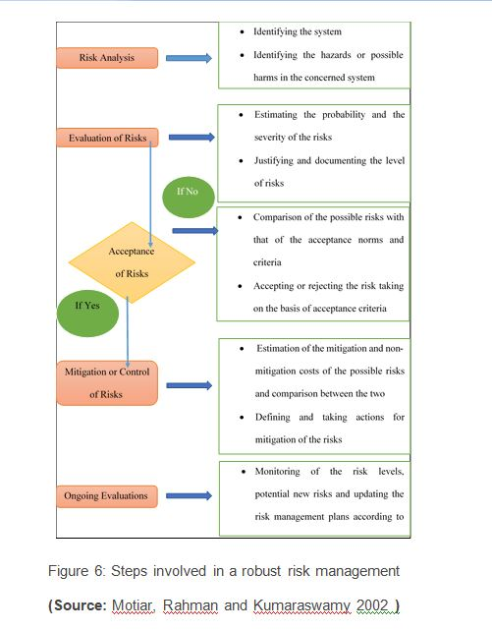
According to the Ehsan et al. (2010), there can be four distinct responses which can be implemented by the companies, as per the nature and types of risks. These primary responses to risk, by the construction companies are as follows:
- Risk acceptance or risk retention
- Risk mitigation or risk reduction
- Risk elimination or risk avoidance
- Risk transfer or risk allocation
2.4.3 Risk Management in construction industry: Scenario in United Kingdom
Risk Management Approach:
- Identification
- Assessment
- Risk Reduction
- Implementation of actions
- Business Policies
- Business Culture
- Resources and tools
- Organizations
The general risk management plan, which can be seen to be implemented by the construction businesses in the United Kingdom, can be shown with the help of the following diagrammatical interpretation:
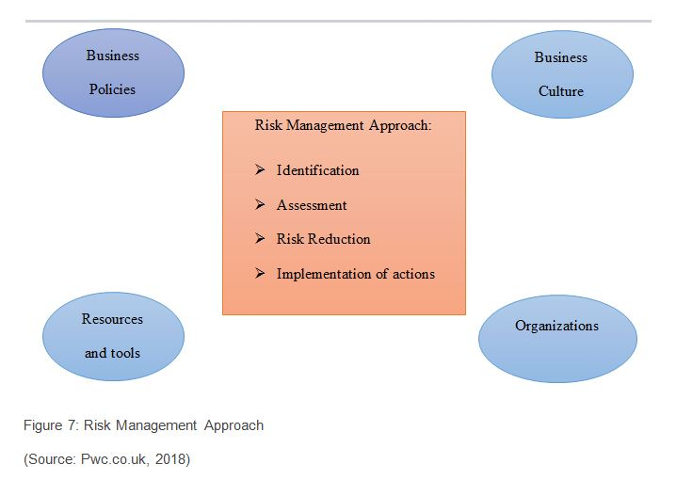
2.5 Risk Allocation in the Construction Industry
One of the major steps of management of risks arising in any industry in general and construction industry in particular is that of the allocation of risks. As per the assertions of Iqbal et al. (2015), due to the presence of diverse construction risks, it is often not possible for the participants in this industry to eliminate or mitigate all the risks which are associated with a particular project. There also exist several risks which cannot be avoided by the stakeholders of the projects and have to be endured by some of them. In such cases, the different parties involved in the construction projects try to transfer or shift major shares of the projected risks from their shoulders to other parties (Ng and Loosemore 2007).
The above argument is supported by Loosemore and McCarthy (2008), according to whom risk allocation, being the decision of the parties which need to bear the consequences of the risks evolving in any project, is even more significant in the construction industry in a generalised global framework as usually these types of businesses consists of different parties or stakeholders in most of the projects- owner, contractors, sub-contractors, project designers as well as material suppliers and those other in the supply-side dynamics of the projects. In his paper, exploring the risks in the construction industry in the UAE, El-Sayegh (2008), argues that not only in the UAE but also in the global framework, there remains a tendency amongst the different stakeholders of the construction industry, to shift most of the burdens of projected risks from them to other stakeholders, thereby trying to maximizing their individual profits from the projects.
Cheung et al., (2014), in this context highlights that one of the most widely used mediums or provisions for allocation of any kind of risk in the construction industry is that of contracts. The contractual forms, in these types of projects, generally contain various provisions for desired allocations or shifts of risks from one party to another, in the supply-side of the industry. However, as rightly argued by Ward, Chapman and Curtis (1991), there should exist proper and robust risk allocation frameworks with the construction companies as much of the behaviour of the participants as well as success of the construction projects and the costs endured in the process depend on the patterns of allocation of risks existing in the construction projects among the different stakeholders and skewed and biased allocations of the same can jeopardise the projects in the long-run, in the quest to maximise the profits of discrete interest groups at the cost of all the other stakeholders in the concerned construction .
2.5.1 Methods for Risk Allocation
Different researchers and scholars have put forward different methods of risk allocation, especially emphasizing the construction industry. The primary and comprehensive ones, as can be seen to be existent in the global literary framework, are discussed as follows:
2.5.1.1 Contract Clauses Method: According to the working paper of Wang and Chou (2003), risks, in the construction industry, can be allocated between the different participants or stakeholders, both with the help of the contracts as well as outside the contractual agreements. The authors show the procedure of allocation of the risks, both in contract and out of the same with the help of the following flow chart:
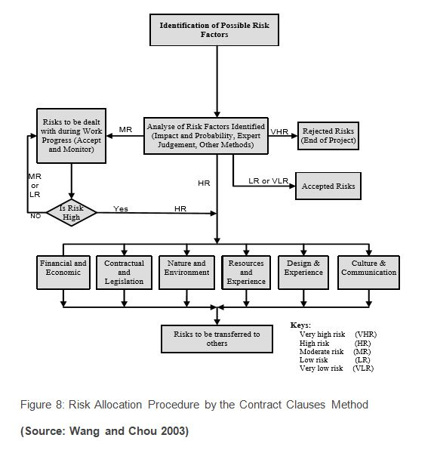
2.5.1.2 Risk Assessment Model: One of the most robust models formed to deal with the risks arising in any kind of projects is that of the Risk Assessment Model. Yafai et al. (2014), in this context, uses this model to analyse the aspects of risk identification, analysis, assessment and allocation in the construction industry of Oman, which the authors show with the help of the following figure:
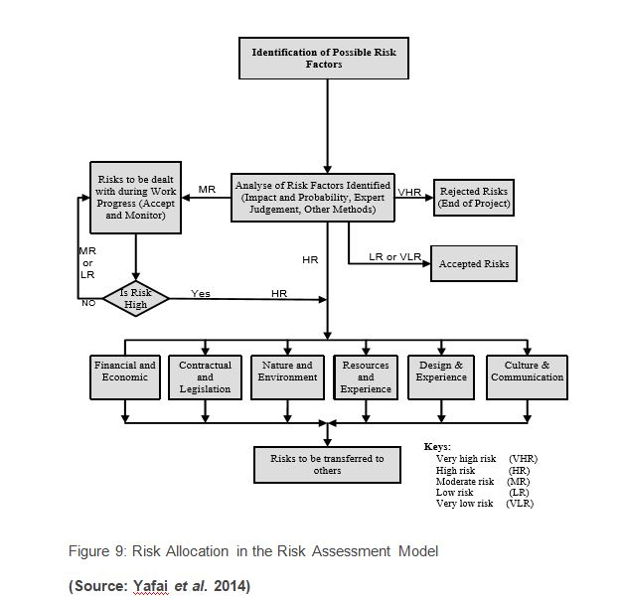
The model, as seen in the above figure, indicates that after identification of the risk factors, they are analysed under various categories like Financial, Contractual, Environmental, Resources, Design or Cultural. Post classification of the risks and analysis of the intensity of the same (very high, high, moderate, low or very low) the nature and extent of allocations of the risks to various stakeholders are analysed.
2.5.1.3 Risk allocation in PPP Projects: Li, Akintoye and Hardcastle (2001), in their paper, venturing in the construction projects carried out in Public Private Partnerships, proposes a three-tier classification of risk factors, which are as followed:
Macro- Ecological, Political, Economic, Natural, Social and Environmental
Meso- Project engineering risks
Micro- Soft or low intensity risks
In their model, the risks arising out of the public and the private sector collaboration are analysed and their costs are estimated by the private sector, which are then submitted in the tenders to the public sector. Depending on the costs of risks, proposed by the private sector, the public sector either accepts the proposal or goes into negotiation with the private sectors. This in turn leads to the decision of the public and the private sectors, regarding accepting, allocating, sharing or retaining the risks and their consequences. The process of risk allocation, as per the concerned model can be diagrammatically shown as follows:
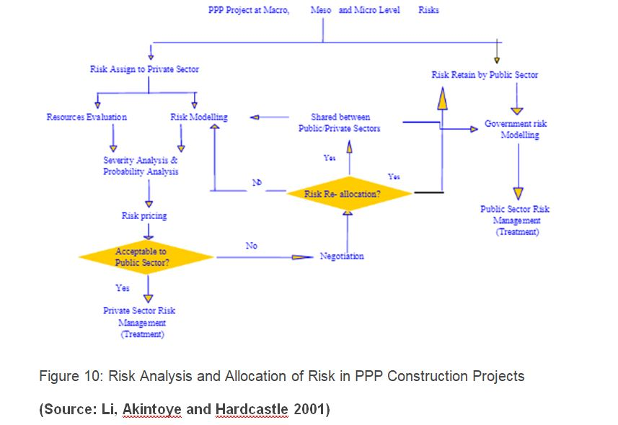
2.5.2 Problems in existing Risk Allocation Methods
There are various other models and procedures of risk allocation apart from the previous three models which are discussed in the above section. However, there are several flaws in the existing risk allocation methods, especially in the contemporary construction industry, which, often leads to disputes, cost overrun, delays, quality issues and tensions in the construction industry very frequently (Dubois and Gadde 2002). These issues, with reference to the existing literatures and scholarly evidences are discussed in the concerned section of the literature review:
2.5.2.1 Mistrusts and Disputes: As per the assertions of Chalker and Loosemore (2016), contracts in the construction industry in Australia, the major contractual methods for avoidance of any kind of disputes is that of fair allocation of risks among the contracting parties in the industry. However, the study conducted by Chan et al. (2011), indicates that the contractual risk misallocation acts as one of the leading factors creating major disputes in the construction across the globe as a whole and in the USA, in particular.
2.5.2.2 Claims and Tensions: The research finding of Cheung et al. (2014), on that of the construction industry, indicates that in this industry, as the different participants try to consistently shift their risks to other parties, this in turn, leads to more claims and disputes, which in turn results in involvement of more lawyers and legal procedures, thereby affecting costs, quality, potentials and time of the construction projects.
2.5.2.3 Increase in costs: According to Baloi and Price (2003), one of the most obvious fallouts of misallocation of risks in the construction industry, across the world, which leads to higher disputes, claims, legal activities and delays, automatically raises the costs of the construction projects, which are accrued to both the demand and the supply side parties and also affect the performance of the concerned projects, thereby making this one of the significant issues underlying the risk allocation procedures in the construction industry.
2.6. Optimal Risk Allocation:
The above fallouts of unfair risk allocation and their possible impacts on the different stakeholders of the industry indicates towards the need for optimal allocation of risks, such that the welfare of each of the stakeholders are maximised and the costs and disputes in the industry is minimised as a whole.
2.6.1 Definition and Implications: The term “Optimal Risk Allocation” has been defined by various scholars from various perspectives. As per Chen, Yan and Chen (2017), Risk allocation possess a major challenge in PPP projects
- It is the most important feature for managing projects efficientl
- Reduces the cost
- Can assume the same at the lowest cost
Ke, Wang and Chan (2011), in this context, argue that optimal allocation of risks does not imply passing of risks from one party to another and is more of seeking the ways to minimize the costs arising out of risks in the project as a whole. Several rules, in this aspect, are found to be suggested by Ng and Loosemore (2007), which are as follows:
As per the authors, the party receiving the risks should be:
- Fully aware of the same
- Should be capable enough to manage the risk most efficiently
- The party the resources with them to deal with consequences
- Desires to take the risks
- Has sufficient incentives to take the risks
2.6.2 Factors for optimal allocation of risk
- Communication and Negotiation- As per the assertions of the authors as the construction industry, in general, consists of many stakeholders, strong communication channels among them can help in effective negotiations among the parties, thereby facilitating efficient risk management and allocation, by facilitating free flow of information and optimum decision-making for conducting the projects.
- Trust- Imbeah and Guikema (2009), rightly points out that for any positive and effective collaboration, trust is a primary component and there also exist significant positive relationship between the trust among the different parties and the optimal allocation of risks among them, especially in the construction industry, which in turn can help in cost reduction and smooth operations.
Risk aversion- In the construction industry, the owners are mainly risk averse or risk neutral people while the contractors are the risk takers. According to Froud (2003), in such a scenario often the risk allocation takes place by aversion of risks, which in turn leads to transfer of the same to the weakest ones, which in turn poses as significant hurdle for optimal allocation of risks in the concerned industry.
- Perceptions- The construction industry, generally being a multi-player setup, with each interest group having their own set of aims, interests and objectives, which in turn leads to different perceptions of risks by different parties and their capabilities to manage and tackle the risks (Wang, Zou and Li 2016). The perceptions regarding the costs of risks also vary across different stakeholders and thus the perceptions regarding risks play a crucial role in the optimal allocation of risks among the stakeholders, especially in the construction industry.
2.7 Literature Gap
As can be seen from the above discussion of the existing literatures, the construction industry, consisting of huge diversifications in activities and stakeholders, are subjected to different types of risks, for which it is essential to have proper risk management framework with the companies. The literatures can be seen to be discussion in details, the types of risks, risk management processes, aspects of risk allocation, issues in the same, optimality in allocation of risks and the components of optimal risk allocation in the construction industry as a whole. However, not substantial literary or scholarly evidences can be seen to be existing in the aspects of the building construction industry in specific, especially in the United Kingdom as most of the literatures can be seen to be generic. The concerned research tries to address these particular gaps found in the literatures, thereby studying the aspects of optimization of allocation of different types of risks arising specifically in the building construction industry, in the business framework of the United Kingdom.
Chapter 3: Research Methodology
3.1 Introduction: Methodology used to carry out the present research is highlighted in this chapter. The chapter starts with defining the research problem. Research design process followed in the present chapter is detailed next. We follow this us with the research approach, purpose and methodology used to investigate optimization of risk allocation in construction projects. The objective of the present research and research questions used to evaluate optimisation of risk allocation is presented later. Sampling technique along with statistical tests used to assess the suitability of optimization techniques is also presented.
3.2 Problem Statement
One of the primary objectives of a construction project is to complete the project within the given time frame without escalation of cost. Stakeholders in a construction project thus estimate budget of a construction project prior to starting of the venture. A construction project is a trade-off between time and cost. The trade-off has influenced projects to transfer the burden of costs to other members of the firm like contractors and designers in order to escape the situation (Al Haj and El-Sayegh 2015).
Risks in the construction industry have been identified as due to unavailability of funds, delays in construction, financial and contractual delays (Jarkas and Haupt 2015). Financial and technical risks are the most frequent of the risks in construction projects. While financial risks arise out of market dynamics (Antón, Rodríguez and López 2011), technical risks arise due to shortage of construction materials as well as skilled labour (Durdyev et al., 2017).
According to Iqbal et al., (2015) risks in construction projects is negatively affected by time, quality of product and finance. Under such circumstances the industry tries to shift major shares of the projected risks from their shoulders to other parties (Ng and Loosemore 2007). Thus risk allocation becomes essential since parties have to bear the consequences of the risks (Loosemore and McCarthy 2008). Risks in the industry are thus distributed through either of contract or through risk assessment.
Construction industry tends to optimise the risk allocation through various means. Communication and negotiation is an essential technique in optimisation. Risk aversion by contractors is based on his evaluation of the upside and downside uncertainties of the construction project (Kim and Reinschmidt 2010). Researchers argue optimisation process of risk allocation in the industry. The present work is a study to investigate the optimal risk allocation techniques being supported by professionals.
3.3 Research Design
Framework for collection of data and its analysis is provided by research design (Bryman 2016). A perspective on how the research questions would be answered is presented in research design. The present section in addition explains the research approach, purpose, methodology for conducting the present research.
3.3.1 Research Approach: A deductive research approach has been used in order to derive information on optimization of risk allocation in construction projects. Questionnaire has been developed based on previous research done by Yafai et al. (2014), Iqbal et al., (2015) on risks – optimization and allocation in construction projects.
3.3.2 Research Purpose: The research critically examines the optimization of risk allocation in construction projects. Thus the research is explanatory in nature since it investigates the suitability of optimization techniques in risk allocation in construction projects. Further, the research is descriptive since it provides an understanding of the participant’s perception into risk optimisation in the construction industry.
3.3.3 Research Methodology: Quantitative research methodology is used to investigate optimization of risk allocation in construction projects. Quantitative research methodology uses numeric data analysis of which is easily understandable. The numerical data is collected through the distribution of survey questionnaire (Saunders et al., 2009).
3.4 Research Objectives
The following research study has following research objectives-
- To provide a review on how risks are allocated and optimized in construction projects
- To identify the importance of risk optimization in determining project success
- To propose a pathway through which construction project can manage risk and create balance between project success as well as stakeholder’s standpoints;
3.5 Research Questions
The research questions provide answers to the research objectives. Thus the research questions are formulated as-
- How are risks identified in a construction project?
- How are risks allocated in a construction project?
- How are risks allocated in a construction project?
- Does risks optimization lead to the success of a project?
- What are the problems with sub-optimal risk optimization?
- What are the hurdles to optimal risk management in the construction industry?
3.6 Data Collection Questionnaire
Survey questionnaire was designed to collect information regarding the effectivity of optimisation techniques in risk allocation in construction projects. After the questions were developed were developed in word, they were circulated to two professionals from the construction industry. This was done to check the reliability of the questionnaires. Feedback from the professionals was used to make adjustments to the questionnaire.
The survey questionnaire related to the testing of the effectivity of the optimization techniques in risk allocation. A five-point scale was used to test the effectiveness of the optimization techniques. The scale was designed with score 1 being least effective and 5 being most effective.
3.7 Research Assumptions
For the research the following assumptions have been considered:
- The responses to the survey questionnaire are personal opinions of the professionals.
- Professionals are in knowledge of optimisation techniques of risk allocation in construction projects
- Professionals filed the survey questionnaire without any bias
3.8 Target Population and Sampling methods
Industry professionals involved in construction projects were target population for the research. Convenience sampling was used to select industry professionals. The sampling procedure used is a non-probability sampling process. Non-probability sampling is used since they provide easy access to professionals in knowhow of the subject.
Reference List
Abdelgawad, M. and Fayek, A.R., 2010. Risk management in the construction industry using co mbined fuzzy FMEA and fuzzy AHP. Journal of Construction Engineering and Management, 136(9), pp.1028-1036.
Al Haj, R.A. and El-Sayegh, S.M., 2015. Time–cost optimization model considering float-consumption impact. Journal of Construction Engineering and Management, 141(5)
Alashwal, A. and Hamzah, A.R., 2014. Developing a conceptual framework of fragmentation in construction.
Alinaitwe, H., Apolot, R. and Tindiwensi, D., 2013. Investigation into the causes of delays and cost overruns in Uganda’s public sector construction projects. Journal of Construction in Developing Countries, 18(2), p.33.
Aminbakhsh, S., Gunduz, M. and Sonmez, R., 2013. Safety risk assessment using analytic hierarchy process (AHP) during planning and budgeting of construction projects. Journal of safety research, 46, pp.99-105.
Antón, A.J.M., Rodríguez, G.S. and López, Á.R., 2011. Financial risks in construction projects. African journal of business management, 5(31), p.12325.
Arashpour, M., Wakefield, R., Lee, E.W.M., Chan, R. and Hosseini, M.R., 2016. Analysis of interacting uncertainties in on-site and off-site activities: Implications for hybrid construction. International Journal of Project Management, 34(7), pp.1393-1402.
Ashworth, A. and Perera, S., 2018. Contractual procedures in the construction industry. Routledge.
Ball, M., 2014. Rebuilding Construction (Routledge Revivals): Economic Change in the British Construction Industry. Routledge.
Baloi, D. and Price, A.D., 2003. Modelling global risk factors affecting construction cost performance. International journal of project management, 21(4), pp.261-269.
Banaitiene, N. and Banaitis, A., 2012. Risk management in construction projects. In Risk Management-Current Issues and Challenges. InTech.
Behm, M., 2005. Linking construction fatalities to the design for construction safety concept. Safety science, 43(8), pp.589-611.
Brindley, C. ed., 2017. Supply chain risk. Taylor & Francis.
Bryde, D.J. and Volm, J.M., 2009. Perceptions of owners in German construction projects: congruence with project risk theory. Construction Management and Economics, 27(11), pp.1059-1071.
Bryman, A., 2016. Social research methods. Oxford university press.
Chalker, M. and Loosemore, M., 2016. Trust and productivity in Australian construction projects: a subcontractor perspective. Engineering, Construction and Architectural Management, 23(2), pp.192-210.
Chan, J.H., Chan, D.W., Lam, P.T. and Chan, A.P., 2011. Preferred risk allocation in target cost contracts in construction. Facilities, 29(13/14), pp.542-562.
Chen, C., Yan, T. and Chen, P., 2017, July. Research on Risk Allocation Model in PPP Projects: Perspectives from the SOEs. In International Conference on Management Science and Engineering Management (pp. 1559-1572). Springer, Cham.
Cheung, S.O., Wong, W.K., Yiu, T.W. and Pang, H.Y., 2014. Developing a trust inventory for construction contracting. In Construction Dispute Research (pp. 147-168). Springer, Cham.
Chien, K.F., Wu, Z.H. and Huang, S.C., 2014. Identifying and assessing critical risk factors for BIM projects: Empirical study. Automation in Construction, 45, pp.1-15.
Dikmen, I. and Birgonul, M.T., 2006. An analytic hierarchy process based model for risk and opportunity assessment of international construction projects. Canadian Journal of Civil Engineering, 33(1), pp.58-68.
Dubois, A. and Gadde, L.E., 2002. The construction industry as a loosely coupled system: implications for productivity and innovation. Construction Management & Economics, 20(7), pp.621-631.
Durdyev, S., Omarov, M. and Ismail, S., 2017. Causes of delay in residential construction projects in Cambodia. Cogent Engineering, 4(1), p.1291117.
Ehsan, N., Mirza, E., Alam, M. and Ishaque, A., 2010, July. Notice of Retraction Risk management in construction industry. In Computer Science and Information Technology (ICCSIT), 2010 3rd IEEE International Conference on (Vol. 9, pp. 16-21). IEEE.
El-Sayegh, S.M., 2008. Risk assessment and allocation in the UAE construction industry. International journal of project management, 26(4), pp.431-438.
Eybpoosh, M., Dikmen, I. and Talat Birgonul, M., 2011. Identification of risk paths in international construction projects using structural equation modeling. Journal of Construction Engineering and Management, 137(12), pp.1164-1175.
Froud, J., 2003. The Private Finance Initiative: risk, uncertainty and the state. Accounting, Organizations and Society, 28(6), pp.567-589.
Gillen, M., Baltz, D., Gassel, M., Kirsch, L. and Vaccaro, D., 2002. Perceived safety climate, job demands, and coworker support among union and nonunion injured construction workers. Journal of safety research, 33(1), pp.33-51.
Goh, C.S. and Abdul-Rahman, H., 2013. The identification and management of major risks in the Malaysian construction industry. Journal of Construction in Developing Countries, 18(1), pp.19-32.
Hampson, K., Kraatz, J.A. and Sanchez, A.X. eds., 2014. R&D investment and impact in the global construction industry. Routledge.
Hamzah, N., Khoiry, M.A., Arshad, I., Tawil, N.M. and Ani, A.C., 2011. Cause of construction delay-Theoretical framework. Procedia Engineering, 20, pp.490-495.
Hanna, A.S., Thomas, G. and Swanson, J.R., 2013. Construction risk identification and allocation: Cooperative approach. Journal of Construction Engineering and Management, 139(9), pp.1098-1107.
Haslam, R.A., Hide, S.A., Gibb, A.G., Gyi, D.E., Pavitt, T., Atkinson, S. and Duff, A.R., 2005. Contributing factors in construction accidents. Applied ergonomics, 36(4), pp.401-415.
Hwang, B.G., Zhao, X. and Gay, M.J.S., 2013. Public private partnership projects in Singapore: Factors, critical risks and preferred risk allocation from the perspective of contractors. International Journal of Project Management, 31(3), pp.424-433.
Ikpeze, C.H., 2015. Data Collection and Analysis. In Teaching across Cultures (pp. 29-37). Sense Publishers, Rotterdam.
Imbeah, W. and Guikema, S., 2009. Managing construction projects using the advanced programmatic risk analysis and management model. Journal of Construction Engineering and Management, 135(8), pp.772-781.
Insideconstruction.com.au (2018). KEY HIGHLIGHTS FROM GLOBAL CONSTRUCTION OUTLOOK 2021. [online] Insideconstruction.com.au. Available at: https://www.insideconstruction.com.au/digital_assets/3e11ae3b-9978-46f6-8296-0d9be5dafe91/Global-Construction-2021-Outlook—White-Paper-(1).pdf [Accessed 22 Jun. 2018].
Iqbal, S., Choudhry, R.M., Holschemacher, K., Ali, A. and Tamošaitien?, J., 2015. Risk management in construction projects. Technological and Economic Development of Economy, 21(1), pp.65-78.
Irmi.com (2018). The Environmental Risks of Residential Construction | IRMI.com. [online] Irmi.com. Available at: https://www.irmi.com/articles/expert-commentary/the-environmental-risks-of-residential-construction [Accessed 23 Jun. 2018].
Jarkas, A.M. and Haupt, T.C., 2015. Major construction risk factors considered by general contractors in Qatar. Journal of Engineering, Design and Technology, 13(1), pp.165-194.
Jorion, P., 2009. Value at risk: the new benchmark for managing financial risk (Vol. 2, Ed. 3). New York: McGraw-Hill.
Kartam, N.A. and Kartam, S.A., 2001. Risk and its management in the Kuwaiti construction industry: a contractors’ perspective. International journal of project management, 19(6), pp.325-335.
Ke, Y., Wang, S. and Chan, A.P., 2011. Equitable risks allocation of projects inside China: analyses from Delphi survey studies. Chinese Management Studies, 5(3), pp.298-310.
Kim, H.J. and Reinschmidt, K.F., 2010. Effects of contractors’ risk attitude on competition in construction. Journal of Construction Engineering and Management, 137(4), pp.275-283.
Lacourt, A., Pintos, J., Lavoué, J., Richardson, L. and Siemiatycki, J., 2015. Lung cancer risk among workers in the construction industry: results from two case–control studies in Montreal. BMC public health, 15(1), p.941.
Li, B., Akintoye, A. and Hardcastle, C., 2001. VFM and risk allocation models in construction PPP projects. School of Built and Natural Environment, Glasgow Caledonian University, Glasgow G4 0BA, Working Paper for Ph. D. Study.
Loosemore, M. and McCarthy, C.S., 2008. Perceptions of contractual risk allocation in construction supply chains. Journal of professional issues in engineering education and practice, 134(1), pp.95-105.
Marzouk, M.M. and El-Rasas, T.I., 2014. Analyzing delay causes in Egyptian construction projects. Journal of advanced research, 5(1), pp.49-55.
Mbachu, J. and Taylor, S., 2014. Contractual risks in the New Zealand construction industry: Analysis and mitigation measures. International Journal of Construction Supply Chain, 4(2), pp.22-33.
Mead, P., 2007. Current trends in risk allocation in construction projects and their implications for industry participants. Construction Law Journal, 23(1), p.23.
Menzel, N.N. and Gutierrez, A.P., 2010. Latino worker perceptions of construction risks. American journal of industrial medicine, 53(2), pp.179-187.
Mhetre, K., Konnur, B.A. and Landage, A.B., 2016. Risk management in construction industry. International Journal of Engineering Research, Volume, (5), pp.153-155.
Mitkus, S. and Mitkus, T., 2014. Causes of conflicts in a construction industry: A communicational approach. Procedia-Social and Behavioral Sciences, 110, pp.777-786.
Motiar Rahman, M. and Kumaraswamy, M.M., 2002. Risk management trends in the construction industry: moving towards joint risk management. Engineering, Construction and Architectural Management, 9(2), pp.131-151.
Nadim, W. and Goulding, J.S., 2009. Offsite production in the UK: The construction industry and academia. Architectural Engineering and Design Management, 5(3), pp.136-152.
National Research Council, 2009. Advancing the competitiveness and efficiency of the US construction industry. National Academies Press.
Ng, A. and Loosemore, M., 2007. Risk allocation in the private provision of public infrastructure. International Journal of Project Management, 25(1), pp.66-76.
Olawale, Y.A. and Sun, M., 2010. Cost and time control of construction projects: inhibiting factors and mitigating measures in practice. Construction management and economics, 28(5), pp.509-526.
Olusanya, O.A., 2018. Subcontracting Systems and Social Protection in the Informal Building Construction Industry in Lagos, Nigeria. Journal of Construction Business and Management, 2(1), pp.10-19.
Oluwole Akadiri, P. and Olaniran Fadiya, O., 2013. Empirical analysis of the determinants of environmentally sustainable practices in the UK construction industry. Construction Innovation, 13(4), pp.352-373.
Ortiz, O., Castells, F. and Sonnemann, G., 2009. Sustainability in the construction industry: A review of recent developments based on LCA. Construction and Building Materials, 23(1), pp.28-39.
Osipova, E. and Eriksson, P.E., 2013. Balancing control and flexibility in joint risk management: Lessons learned from two construction projects. International Journal of Project Management, 31(3), pp.391-399.
Pinto, A., Nunes, I.L. and Ribeiro, R.A., 2011. Occupational risk assessment in construction industry–Overview and reflection. Safety science, 49(5), pp.616-624.
Pwc.co.uk (2018). Managing risk in construction projects – how to achieve a successful outcome. [online] Pwc.co.uk. Available at: https://www.pwc.co.uk/assets/pdf/pwc-cps-risk-construction.pdf [Accessed 23 Jun. 2018].
Renuka, S.M., Umarani, C. and Kamal, S., 2014. A review on critical risk factors in the life cycle of construction projects. Journal of Civil Engineering Research, 4(2A), pp.31-36.
Rhodes, C. (2018). The construction industry: statistics and policy. [online] Researchbriefings.parliament.uk. Available at: http://researchbriefings.parliament.uk/ResearchBriefing/Summary/SN01432 [Accessed 22 Jun. 2018].
Saunders, M.L. and Lewis, P., & Thornhill, A., 2015. Research methods for business students, 4th Ed. Pearson Education Limited
Shehu, Z., Endut, I.R. and Akintoye, A., 2014. Factors contributing to project time and hence cost overrun in the Malaysian construction industry. Journal of Financial Management of Property and Construction, 19(1), pp.55-75.
Sherratt, F., 2014. Exploring ‘Zero Target’safety programmes in the UK construction industry. Construction Management and Economics, 32(7-8), pp.737-748.
Taylan, O., Bafail, A.O., Abdulaal, R.M. and Kabli, M.R., 2014. Construction projects selection and risk assessment by fuzzy AHP and fuzzy TOPSIS methodologies. Applied Soft computing, 17, pp.105-116.
Thevendran, V. and Mawdesley, M.J., 2004. Perception of human risk factors in construction projects: an exploratory study. International Journal of Project Management, 22(2), pp.131-137.
Wang, J., Zou, P.X. and Li, P.P., 2016. Critical factors and paths influencing construction workers’ safety risk tolerances. Accident Analysis & Prevention, 93, pp.267-279
Wang, M.T. and Chou, H.Y., 2003. Risk allocation and risk handling of highway projects in Taiwan. Journal of management in Engineering, 19(2), pp.60-68.
Wang, N., 2014. The role of the construction industry in China’s sustainable urban development. Habitat International, 44, pp.442-450.
Ward, S.C., Chapman, C.B. and Curtis, B., 1991. On the allocation of risk in construction projects. International Journal of Project Management, 9(3), pp.140-147.
Yafai, K.N., Hassan, J.S., Balubaid, S., Zin, R.M. and Hainin, M.R., 2014. Development of a risk assessment model for Oman Construction industry. Jurnal Teknologi, 70(7), pp.55-64.
Yang, R.J. and Zou, P.X., 2014. Stakeholder-associated risks and their interactions in complex green building projects: A social network model. Building and Environment, 73, pp.208-222.
Zainon, N., Chuing, L.S., Mohd-Rahim, F.A., Aziz, N.M., Wan, C.W.N.S.C. and Pauzi, A., 2018. A preliminary study of health problems among construction workers in Malaysia. Journal of Surveying, Construction and Property, 9(1), pp.1-8.
Zhang, S., Teizer, J., Lee, J.K., Eastman, C.M. and Venugopal, M., 2013. Building information modeling (BIM) and safety: Automatic safety checking of construction models and schedules. Automation in Construction, 29, pp.183-195.
Zhou, Z., Goh, Y.M. and Li, Q., 2015. Overview and analysis of safety management studies in the construction industry. Safety science, 72, pp.337-350.

