Introduction
A review of the appropriateness of public-private partnerships in major drainage and water supply projects and the impact of procurement on competition and flexibility.
Governments are the most important client in terms of the provision of major drainage and water supply projects. However, as they are publically accountable they are constantly looking for methods to improve procurement processes and to provide greater value-for-money. This dissertation will use case study analysis methods. The dissertation will demonstrate specifically how governments have the ability to minimise the likelihood of market failure by leveraging the technological advantages of the market.
In comparison to other industries (organisations involved in the production of goods or services) the “Construction Industry” is different in largely due to the diversification of the projects. Moreover, projects in the construction industry occur in a dynamic environment (Zhang et al. 2014). The assortment of projects together with the dynamic environment of the construction industry leads to an increase in situations of high uncertainty (Mitkus and Mitkus 2014). Hence, risks involved in construction industry are higher as compared to other industries.
A proper evaluation of the risks involved in a construction project would aid in identification of processes to be allocated to minimize the risks (Arashpour at al. 2016). Minimization of risks in the industry would translate into larger profits for the industry. Moreover, judicious allocation of resources would lead to reduction in friction amongst the workforce at the workplace, thus increasing the efficiency of the project (Hwang et al. 2013).
The present research would search for measures being taken in the construction industry for risk optimisation and thus to suggest best possible measures. However, it is to be taken into consideration that the practice of risk optimisation and allocation does not fully lead to reduction of the risks. It is but just a means of reduction in risks and thus increase in the probability of success of industry in a particular situation.
In the construction industry risks has a broad concept. Various researchers have identified the risks prevalent in the construction industry. According to Shehu, Endut and Akintoye (2014) the Malaysian construction industry is plagued with to time and financial risks. Goh and Abdul-Rahman (2013) have emphasized on health and safety risks, schedule risks and contractual risks. In the informal building construction industry in Nigeria sub-contracting creates labour risks (Olusanya 2018).
1.2 Statement of the Problem
Every construction project is unique in the sense that it carries its own set of risks. The risks involved in a construction project affect each and every stakeholder (Aminbakhsh et al. 2013). All stakeholder involved in a project carry a proportion of the risk. The difference between the actual results and the expected can be defined as risk. “Risk” in a project cannot be ignored, however, the stakeholders through their endeavour can manage and thus reduce the chances of risk. Risks can also be transferred to a third party – subcontractors and suppliers (Yang and Zou 2014).
The construction industry completion of a project within the scheduled time as well as the estimated budget is the ultimate objective. However, time and costs can be considered as quid pro quo. Whereas loss of time for the industry can be related to escalation of costs, saving of time would benefit both the stakeholders. Although, saving of time in a construction project is related to an increase of both direct and indirect costs (Alinaitwe, Apolot and Tindiwensi 2013).
Initiation of a construction project is a contract between owner and contractor. The contract forms the basis of the apportionment of rights, risks, duties and responsibilities. The risks in the industry can never be eliminated, they however can be transferred to a second party (Marzouk and El-Rasas 2014). Thus the contract in other words means the process of allocation of the risks. As a rule, the owner transfers most of the risks to the contactor, who in turn increases the cost of the project for bearing the burden of the risks.
Risks in the construction industry is compounded by the fact that it a highly fragmented industry. Fragmentation can be defined as separation of the design aspects from the construction aspects. A construction can be viewed as a collaboration of multiple stakeholders for a single project. At the industry level, the construction industry involves multiple professionals and diverse organizations to deliver a project.
Further the industry is highly sensitive to economic cycles and presence of financial competition between participants. In addition to this the industry is beset with management problems, unforeseen events like natural calamities. The risks in the industry can be categorised as Physical, Financial, political and Engineering. Optimisation of each of the risk processes involves different approaches. The dynamic environment of construction projects creates a situation of uncertainty. Moreover, the inter-relation between the risk factors hinders an easy optimisation process.
The work wishes to investigate, evaluate and thus classify the risk allocation process in the construction industry. Further, the project envisages to recognise the barriers to optimal risk allocation. It is envisaged that an understanding of the risk would lead to addressing of the barriers to the allocation of risks in the construction industry.
Researchers have provided different definitions of risk. Risks can be defined as the probability of a hazard occurring resulting in potential loss or gain. Risks in construction industry may be Financial, Time, physical, personnel, design and technical, contractual, political, regulatory and safety (Goh and Abdul-Rahman 2013). The present project considers risks in the building construction industry. Risks in the building construction industry involves times, quality, health and safety aspects and financial risk. Time risks involve project schedule and as corollary allocation of time for every part of the project. Financial risks take into account the problems of cash flow, price fluctuation, inflation and payment schedule by the client. Health and safety risks are concerned with workers involved in the project. Quality of construction projects is concerned with quality of work and materials used in the project.
1.3 Research Aim
Construction project objective entails completion of the project in time within a given budget. The probability of completion of a project in time within the allocated finances can be defined as Risk. Hence optimization would mean the utilization of optimal resources to complete the project within the given time frame. Moreover, the judicious allocation of the resources is essential for the timely completion of the project. Further the research would also investigate how quality risks in building construction projects are managed. In addition, the research also focuses on how health and safety risks of construction projects are managed. Aim of this research study is to identify and investigate the optimization techniques and risk allocation process in construction project.
1.4 Objectives of the Study
The following research study has following research objectives-
- To provide a review on how risks are allocated and optimized in construction projects.
- To identify the importance of risk optimization in determining project success.
- To propose a pathway through which construction project can manage risk and create balance between project success as well as stakeholder’s standpoints.
1.5 Research Questions
The research questions provide answers to the research objectives. Thus the research questions are formulated as-
- How are risks identified in a construction project?
- How are risks allocated in a construction project?
- How can risks be optimized in a construction project?
- Does risks optimization lead to the success of a project?
- What are the problems with sub-optimal risk optimization?
- What are the hurdles to optimal risk management in the construction industry?
1.6 Research Methodology
In order to investigate the risk optimization and allocation features in the construction industry both primary and secondary data analysis would be used.
For the primary evaluation of the research project managers associated with the construction project would be interviewed. The interview would be analysed to understand the risk optimisation and risk allocation process being used in the particular project (Osipova and Eriksson 2013).
Secondary data analysis would involve previous published articles being analysed for steps taken by the industry under similar circumstances (Al Haj and El-Sayegh 2015).
After the successful collection of the data by interviewing the project managers of the different construction projects, the importance of the risk allocation will be evaluated on basis of those data. The answers that are recorded from the survey will help in answer the identified research questions and the objectives of the research (Ikpeze 2015).
1.7 Significance of the Study
Risk allocation and risk optimization is very important in ensuring the success of any project. This is because every project is associated with certain risks, majority of which cannot be mitigated. Therefore, the process of risk allocation helps in proper management of such risk (Taylan et al. 2014). This research study will therefore be valuable to the industry practitioners associated with the different construction projects in developing a better idea about the process and importance of risk allocation and optimization in the different construction projects.
1.8 Organisation of Chapters
For undertaking the present research, the thesis has conveniently been divided into five chapters. The introductory chapter provides an overview together with the background of the study, its aims, objectives and research questions. The prelude to the study is set forth through the problem statement. Prior work done to understand and thus provide solutions to the problems associated with risk allocation in construction industry is presented in chapter two. In chapter three we discuss the method to be used to investigate the optimisation process of risk allocation in the construction industry. The analysis of the collected data and evaluation of previous research is done in the fourth chapter. The final chapter draws a conclusion to the project by evaluating the risk allocation and risk optimisation in the construction industry.
Chapter 2: Literature Review
2.1 Introduction: The construction industry, as discussed above, is one of the most dynamic industries across the globe, with new developments and expansion of the industry taking place as a continuous process. As asserted by Wang (2014), the concerned industry differs from that of most of the other industries in the sense that the industry is highly diversified, both from the demand side as well as from the supply side. This diverse nature of the construction industry, across the global framework and the dynamic nature of the same contributes to higher than normal probabilities of risks arising in the concerned industry. The risks involved in the construction industry generally tends to be higher compared to other types of industries as argued by Pinto, Nunes and Ribeiro (2011).
The aspects of risks and the methods to address and minimise the same have been issues of immense concern in the construction industry and there exists substantial literary evidences regarding the aspects of risks in the construction industry, the factors contributing to the same, the types of risks as well as the ways to manage and mitigate the problems optimally, in the country specific as well as in the global framework in the contemporary scenario (Ball 2014).
Keeping this into consideration, the concerned section of the thesis tries to conduct an extensive review of the existing literatures, scholarly works and interpretations of empirical evidences, which are present in the global framework, in these aspects, thereby exploring the different opinions and assertions existent in the concerned domains in the global construction industry, emphasizing specifically on the building construction industries of the United Kingdom.
2.2 Construction Industry Overview: Global and United Kingdom
2.2.1 Global Construction Industry: To gauge the types of risks and their management dynamics it is of utmost importance to have an overview of the construction industry as a whole and the dynamics in the building and housing construction industry in the United Kingdom. As shown by Hampson, Kraatz and Sanchez (2014), the global construction industry is one of the most dynamic prospering industry, with a projected global output of more than 10.1 trillion US dollars by 2021, as can be seen from the following figure:

The reports of the National Research Council (2009), in this context argues that the primary countries emerging as the top construction markets in the global scenario, over the years and showing highly positive future trends of expansion and rise in productivities are:
- China
- USA
- India
- Japan
- European countries especially United Kingdom
The evidences provided by the above-mentioned report, is found to be augmented by the empirically evidenced scholarly work of Ortiz, Castells and Sonnemann (2009), according to whom, the construction industry can be seen to be growing even more in the emerging economies than that of the developed economies, in the recent period, with the trend of growth expected to be remaining the same over the coming years.
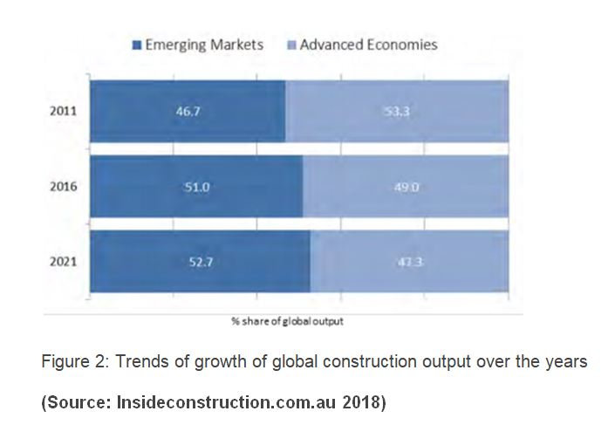
2.2.2 Construction Industry in the United Kingdom
The European countries can be seen to be expected to be consisting of a significant share of the global output in the coming years, attributing to the growth in the concerned industry of the country over the last few decades, a considerable share of the same being coming from the construction industry of the United Kingdom (Ball 2014).
One of the most comprehensive overviews of the construction industry of the United Kingdom can be seen to be present in the work of Sherratt (2014), according to whom, the construction industry of the country, contributed nearly 103 billion pounds in the economic output of the country (as per 2014 statistics). Apart from that, the industry also creates nearly 2.1 million jobs, thereby posing as one of the primary employment generating industries in the country (Oluwole Akadiri and Olaniran Fadiya 2013). The gross value added of the construction industry in the country, over the years, can be seen to be as follows:
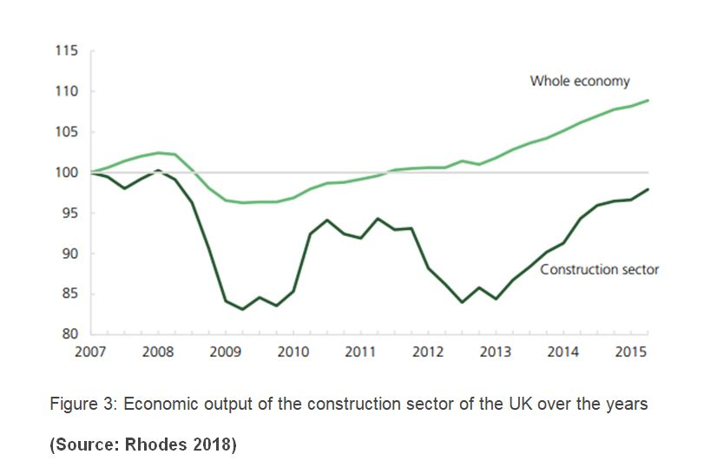
As per Ashworth and Perera (2018), both the public sector as well as the public sector contributes considerably in the total output generation in the construction sector of the country, with the private sector contribution being considerably higher than the public sector:
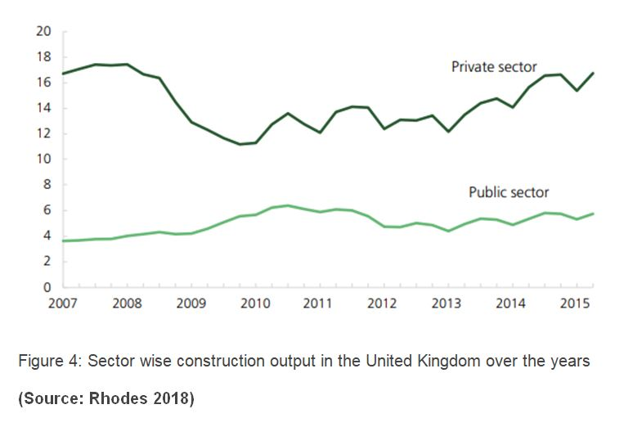
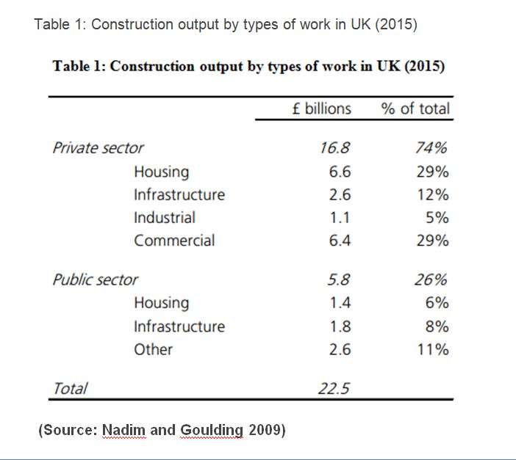
Thus, from the above evidences it can be asserted that the construction industry as a whole, can be considered to be one of the most prominent and economically contributing industries in the United Kingdom, with both the private and the public sectors contributing significantly in its development and the building construction industry forms a prominent sub-group under the domain of the concerned industry (Brindley 2017).
2.3 Risks in the Construction Industry
2.3.1 Construction Risks: Definitions and MeaningsThe term “risk”, being a broad conceptual one, generally refers to the situations which involve exposure to some sort of danger, harm or loss. In this context, there exists different interpretations of risks in the construction industry, of which the most comprehensive one can be seen to be provided by Abdelgawad and Fayek (2010). As per the assertions of the authors, the risks in construction industry refer to any exposure to the types of possible losses which can occur in the supply side dynamics of the industry. Augmenting this perception, Mhetre, Konnur and Landage (2016), suggest that risk in the construction industries are generally the differences between the expected outcomes from the different construction projects and the actual outcomes, which is turn affects different stakeholders in the project and thus, have to be considered seriously for the businesses in the industry to sustain in the long run.
2.3.2 Types of risks in the construction industry
Venturing in the construction sector of Thailand, the empirically evidenced literary work of Ghosh and Jintanapakanont (2004), identifies the main risks prevalent in the construction sectors to be as follows:
- Fund unavailability- The primary risk endured by the concerned industry is the risk of irregularity in fund gathering and allocation through the entire tenure of the projects.
- Construction delays- Various exogenous as well as endogenous reasons can lead to stagnation in operational activities of the companies, thereby leading to construction delays (Chien, Wu and Huang 2014).
- Financial and Accounting Failures- The construction companies may often face the risk of financial failure, mostly due to the lack of insights and accounting abilities as well as lack of prediction of cash flows and problems with capitalization and improper cost and project management frameworks (Renuka, Umarani and Kamal 2014).
- Unclear work scopes- This type of risk, as suggested by Bryde and Volm (2009), is considerably subjected to the construction industry itself, where there often remains confusion regarding the project milestones, deliverables and end products from the supply side providers.
- Contractual delays- One of the most common form of risk in the construction industry, arises from the differences between the expected and actual durations of the construction projects. Eybpoosh, Dikmen and Talat Birgonul (2011), in this context, indicates that the delay in the construction process often leads to the creation of risks of loss of profits on part of the project owners and higher costs on part of the contractors.
- Third party delays- Marzouk and El-Rasas (2014), in their paper exploring the risk factors in the construction industry of Egypt, emphasizes on the problems of delays by the third parties which lead to the creation of risks in the construction industries. The third parties, in this context, refers to the participants in the construction sector, apart from the direct contractors or companies, who play crucial roles in the different intermediate operational activities (Hamzah et al. 2011). Delay on part of them leads to an overall risk in the construction sector
Although the above-mentioned risk factors can be frequently observed in the operational framework of the construction industries, there however remains many other diverse forms of risks arising in the concerned industries. In their elaborate research paper over the building construction industry in Indonesia, Wiguna and Scott (2005), the authors identify more elementary and targeted risks, unlike those broad ones mentioned above. The primary risks identified in the building construction sector, by the authors, include the following:
- Cost burdens in construction due to presence of high inflations
- Risks arising out of the defective designs of the buildings
- Frequent changes in project and building designs by the owners
- Risks of climatic fluctuations
- Unforeseen risks of conditions of the site ground
- Defective works of construction (Olawale and Sun 2010)
- Problems related to availability of factors of production, including labours as well as equipment and raw materials
- Clashes with the labour unions
The works of Goh and Abdul-Rahman (2013), in the Malaysian construction industry also found more or less similar types of risks to be associated with the industry as found by the previous authors, however they also found some additional risk factors, which can be seen to be as follows:
- The ambiguous contract provisions often lead to confusions, thereby leading to increase in the risk factors
- Project schedule mismatches
- Project schedule mismatches
- Safety and health risks of the workers in the construction sector
- Unstable politics
- Accidents
- Poor communication among the construction stakeholders and parties
Thus, from the above discussion of the existing literatures and scholarly evidences it can be asserted that there exist different types of risks in the construction sector, in a globalised framework, attributing to the diversified nature of the industry itself and the exogenous as well as the endogenous attributes which the industry is subjected to in different regions at different points of time.
2.3.3 Classification of Risks in Building Construction Industry
Keeping into account the different types of risks in the construction industry as a whole and in the building construction industry in particular, the risks which generally arise in the industry can be classified into several sub-groups, depending on their nature, reason for occurrence and impacts. These classifications, with the help of the existent literary and empirical evidences are discussed in the concerned section, as follows:
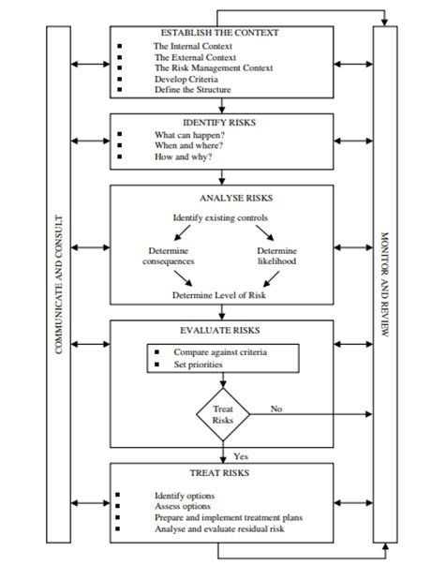
2.3.3.1 Financial Risks: As per the assertions of Antón, Rodríguez and López (2011), one of the primary forms of risks associated with the construction industry is that of the financial risks which the industry experiences. According to the authors, the significant forms of financial risks arise from fluctuations in the inflation, tax rate dynamics, exchange rate dynamics as well as fluctuations in the availability and allocation of funds in the construction projects and these types of risks are usually aggravated in the construction industry due to their diversified nature of operations and supply side dynamics.
2.3.3.2 Technical Risks: Another highly frequent form of risk which the construction industry as a whole and the building construction industry in particular faces, as per the arguments put forward by Ling and Hoi (2006), is that of the technical risks in the operational framework of the concerned industry. Exploring the risks experienced by the construction firms of Singapore in India, their paper highlights that often the construction firms face delays in provision of their promises to their clients due to technical risks which include uncertainty of availability of resources and construction materials as well as efficient and skilled workers. These types of risks also arise from inadequate investigation of sites and frequent changes in the requirements and scopes of projects, which jeopardise the flow of the projects (Dikmen and Birgonul 2006).
2.3.3.3 Health and Safety Risks According to the arguments put forward by Zhou, Goh and Li (2015), one of the negative aspects of construction industry in general is the presence of high health hazard issues, most of which are experienced by the workers due to the nature of the jobs and the harmful substances which they are exposed to, in the construction industry. Zainon et al. (2018), in this context, identified different risks in the Construction industry.
- Risks involved due to heights
- Health risks due to exposure to harmful chemicals
- Presence of Soil-dust and Asbestos
- Calcium Oxide
- Crystalline Silica and Portland Cement (Lacourt et al., 2015)
- Presence of Asbestos at Construction industry increases the risk of Cancer amongst construction workers (Järvholm 2014)
- Risks of unintended collapses which may include the following types of risks:
- Falling into the excavations
- Faults in determination of the integrity of the surrounding buildings which leads to their collapse
- Injuries from falling substances (Gillen et al. 2002)
- Scaffolding of vehicles due to overloading
- Presence of high amount of noise
- Risks of damages of soft tissues like neck, wrists, legs, hips, arms and feet due to moving, lifting and carrying of material loads
- Non-fatal risks of most common forms of injuries related to slips and trips
- Risks of working from height, which causes nearly fifty per cent of the fatal injuries in the construction industries in the global framework as per the assertions of Haslam et al.(2005). As per the authors, these forms of risks in the construction sites mostly arise due to the following issues:
- Lack of edge protection
- Absence of guardrails
- Unsecured ladders
- Scaffolding problems
- Loose tools and improperly stored materials
- Exhaustion and mental health-related risks which are also highly common in the concerned industry
1. Design Risks: Behm (2005) highlights the different design related risks which arise in the construction industry, which may arise from:
- Involvement of owners in designing process
- Incomplete, inadequate and faulty construction project design
- Seismic criteria related confusions/li>
- Errors in structural and geotechnical aspects
- Material selection problems
- Risks of faulty take-off data (which include water, traffic and other aspects)
- Choice of wrong equipment
2.3.3.4 Environmental Risks: Kartam and Kartam (2001), while portraying the risks in the construction industry, from the contractors’ points of view, highlight the construction industry, in the global domain, is frequently subjected to risks related to environment as a whole, which arise primarily due to the faulty or incomplete environmental analysis, presence of wetlands, creation of hazardous wastes, lack of skilled and specialised personnel and others (Thevendran and Mawdesley 2004). These risks in turn have immense negative implications in terms of increase in costs and delay in delivery of different construction projects.
In this context, several risks identified in building or residential constructions are identified in the report of International Risk Management Institute, to be as follows:
- Fumes, emissions, spills of chemicals
- Heating and ventilations and their maintenance errors which increase carbon monoxide formation in air
- Risks of environmental damage from lead containing painting materials
- Disturbance and increase in contamination due to excavation works (Irmi.com 2018)
- Underground lines and constructions causing damages
- Risks from leakage of underground or aboveground tanks
- Improper waste disposal methods
2.3.3.5 Construction Risks: Different types of risks also arise in the operational framework of the construction industries, owing to the glitches or issues faced in the construction process only. Menzel and Gutierrez (2010), in this context, identifies the primary construction risks to be those arising from inaccurate estimates of contract line, troubles related to occupational safety, construction procedure related glitches, late surveys, work permission related risks.
2.3.3.6 Project Management Risks: Banaitiene and Banaitis (2012) studied project management risks at Lithuania. According to the researchers apart from the above mentioned types of risks, there are also several risks which arise in terms of project management which primarily arise due to the design errors, inability to carry out changes according to the stakeholder, tax change, presence of inadequate or inexperienced workforce or resources, incomplete environmental analysis, cost overruns and project team conflicts.
One considerably different and unique form of classification of risks can be seen to be provided in the work of Mbachu and Taylor (2014), where the author classifies the different risks arising in the construction industry in terms of the different stakeholders in the construction and also talks about the allocation of risks to the stakeholders by classifying the risk factors as follows:
- Client related risk factors
- Contractor related risk factors
- Consultant related risk factors
- Exogenously related risk factors
2.4 Risk Management
2.4.1 Meaning and Implications: From the above discussion and review of the existing literatures, it becomes evident that risk is one of the most crucial aspects of construction industries in general, across the globe and attributing to the nature of works and operations in the concerned industry, the level, nature, types and occurrences of different risks are also high. This in turn indicates towards the need for proper risk management processes and frameworks, which the construction companies need to incorporate in order to maximise their profits, prospects, competitiveness and also in order to ensure their sustainability in the long run.
Jorion (2009) defines the term “risk management” in commercial scenario to be the process in which the business organizations assess, identify and control the possible threats and risks which arise in their operational framework, which in turn have the potentials to hamper the companies’ capital and earnings. As per Mhetre, Konnur and Landage (2016), this phenomenon is of absolute importance especially in the construction industry, in which the probabilities and occurrences of various types of risks are considerably high.
2.4.2 Conceptual Framework
There exists substantial debates and opinions regarding the steps and ways in which risks can be managed in the construction industry as scholars differ in their perceptions of risks and the need to eliminate or mitigate the same. Mead (2007), in this context, provides a detailed and one of the most comprehensive conceptual frameworks for risk management, emphasizing on the construction industries, which is as follows:
Augmenting the above conceptual model, in their elaborate research paper, Motiar Rahman and Kumaraswamy (2002), explains the steps involved in a robust risk management plan and their chronology in the construction industry elaborately.
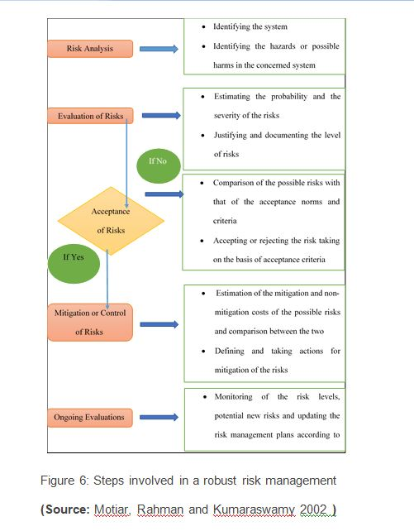
According to the Ehsan et al. (2010), there can be four distinct responses which can be implemented by the companies, as per the nature and types of risks. These primary responses to risk, by the construction companies are as follows:
- Risk acceptance or risk retention
- Risk mitigation or risk reduction
- Risk elimination or risk avoidance
- Risk transfer or risk allocation
2.4.3 Risk Management in construction industry: Scenario in United Kingdom
Risk Management Approach:
- Identification
- Assessment
- Risk Reduction
- Implementation of actions
- Business Policies
- Business Culture
- Resources and tools
- Organizations
The general risk management plan, which can be seen to be implemented by the construction businesses in the United Kingdom, can be shown with the help of the following diagrammatical interpretation:
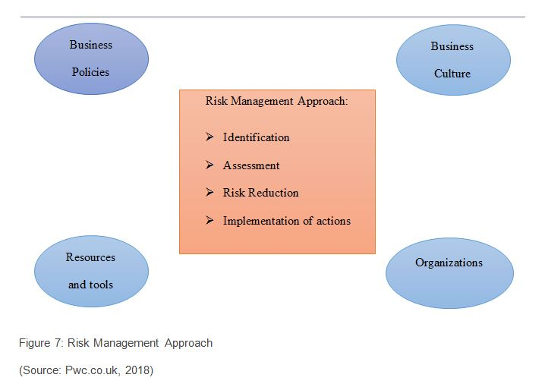
2.5 Risk Allocation in the Construction Industry
One of the major steps of management of risks arising in any industry in general and construction industry in particular is that of the allocation of risks. As per the assertions of Iqbal et al. (2015), due to the presence of diverse construction risks, it is often not possible for the participants in this industry to eliminate or mitigate all the risks which are associated with a particular project. There also exist several risks which cannot be avoided by the stakeholders of the projects and have to be endured by some of them. In such cases, the different parties involved in the construction projects try to transfer or shift major shares of the projected risks from their shoulders to other parties (Ng and Loosemore 2007).
The above argument is supported by Loosemore and McCarthy (2008), according to whom risk allocation, being the decision of the parties which need to bear the consequences of the risks evolving in any project, is even more significant in the construction industry in a generalised global framework as usually these types of businesses consists of different parties or stakeholders in most of the projects- owner, contractors, sub-contractors, project designers as well as material suppliers and those other in the supply-side dynamics of the projects. In his paper, exploring the risks in the construction industry in the UAE, El-Sayegh (2008), argues that not only in the UAE but also in the global framework, there remains a tendency amongst the different stakeholders of the construction industry, to shift most of the burdens of projected risks from them to other stakeholders, thereby trying to maximizing their individual profits from the projects.
Cheung et al., (2014), in this context highlights that one of the most widely used mediums or provisions for allocation of any kind of risk in the construction industry is that of contracts. The contractual forms, in these types of projects, generally contain various provisions for desired allocations or shifts of risks from one party to another, in the supply-side of the industry. However, as rightly argued by Ward, Chapman and Curtis (1991), there should exist proper and robust risk allocation frameworks with the construction companies as much of the behaviour of the participants as well as success of the construction projects and the costs endured in the process depend on the patterns of allocation of risks existing in the construction projects among the different stakeholders and skewed and biased allocations of the same can jeopardise the projects in the long-run, in the quest to maximise the profits of discrete interest groups at the cost of all the other stakeholders in the concerned construction .
2.5.1 Methods for Risk Allocation
Different researchers and scholars have put forward different methods of risk allocation, especially emphasizing the construction industry. The primary and comprehensive ones, as can be seen to be existent in the global literary framework, are discussed as follows:
2.5.1.1 Contract Clauses Method: According to the working paper of Wang and Chou (2003), risks, in the construction industry, can be allocated between the different participants or stakeholders, both with the help of the contracts as well as outside the contractual agreements. The authors show the procedure of allocation of the risks, both in contract and out of the same with the help of the following flow chart:
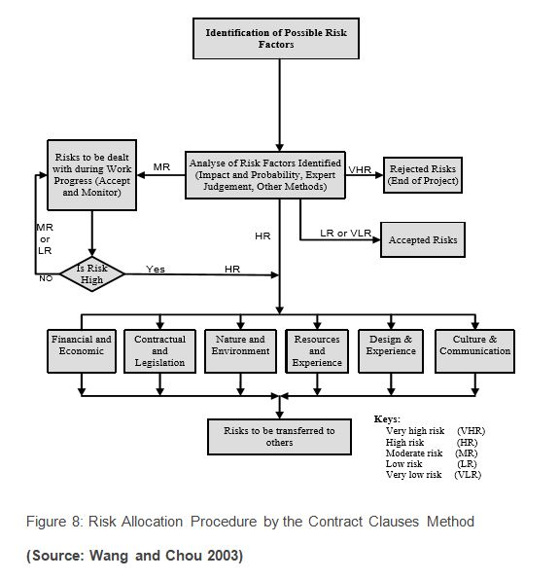
2.5.1.2 Risk Assessment Model: One of the most robust models formed to deal with the risks arising in any kind of projects is that of the Risk Assessment Model. Yafai et al. (2014), in this context, uses this model to analyse the aspects of risk identification, analysis, assessment and allocation in the construction industry of Oman, which the authors show with the help of the following figure:
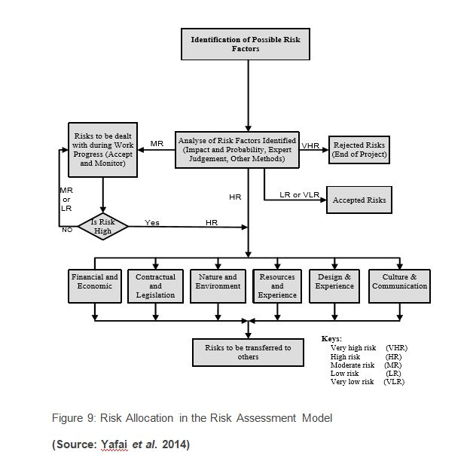
The model, as seen in the above figure, indicates that after identification of the risk factors, they are analysed under various categories like Financial, Contractual, Environmental, Resources, Design or Cultural. Post classification of the risks and analysis of the intensity of the same (very high, high, moderate, low or very low) the nature and extent of allocations of the risks to various stakeholders are analysed.
2.5.1.3 Risk allocation in PPP Projects: Li, Akintoye and Hardcastle (2001), in their paper, venturing in the construction projects carried out in Public Private Partnerships, proposes a three-tier classification of risk factors, which are as followed:
Macro- Ecological, Political, Economic, Natural, Social and Environmental
Meso- Project engineering risks
Micro- Soft or low intensity risks
In their model, the risks arising out of the public and the private sector collaboration are analysed and their costs are estimated by the private sector, which are then submitted in the tenders to the public sector. Depending on the costs of risks, proposed by the private sector, the public sector either accepts the proposal or goes into negotiation with the private sectors. This in turn leads to the decision of the public and the private sectors, regarding accepting, allocating, sharing or retaining the risks and their consequences. The process of risk allocation, as per the concerned model can be diagrammatically shown as follows:
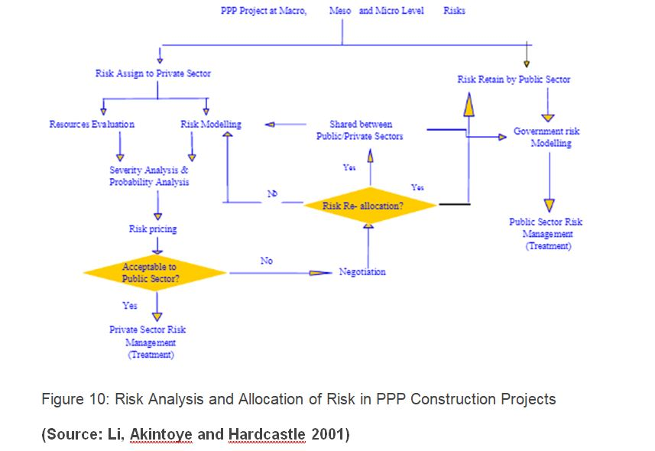
2.5.2 Problems in existing Risk Allocation Methods
There are various other models and procedures of risk allocation apart from the previous three models which are discussed in the above section. However, there are several flaws in the existing risk allocation methods, especially in the contemporary construction industry, which, often leads to disputes, cost overrun, delays, quality issues and tensions in the construction industry very frequently (Dubois and Gadde 2002). These issues, with reference to the existing literatures and scholarly evidences are discussed in the concerned section of the literature review:
2.5.2.1 Mistrusts and Disputes: As per the assertions of Chalker and Loosemore (2016), contracts in the construction industry in Australia, the major contractual methods for avoidance of any kind of disputes is that of fair allocation of risks among the contracting parties in the industry. However, the study conducted by Chan et al. (2011), indicates that the contractual risk misallocation acts as one of the leading factors creating major disputes in the construction across the globe as a whole and in the USA, in particular.
2.5.2.2 Claims and Tensions: The research finding of Cheung et al. (2014), on that of the construction industry, indicates that in this industry, as the different participants try to consistently shift their risks to other parties, this in turn, leads to more claims and disputes, which in turn results in involvement of more lawyers and legal procedures, thereby affecting costs, quality, potentials and time of the construction projects.
2.5.2.3 Increase in costs: According to Baloi and Price (2003), one of the most obvious fallouts of misallocation of risks in the construction industry, across the world, which leads to higher disputes, claims, legal activities and delays, automatically raises the costs of the construction projects, which are accrued to both the demand and the supply side parties and also affect the performance of the concerned projects, thereby making this one of the significant issues underlying the risk allocation procedures in the construction industry.
2.6. Optimal Risk Allocation:
The above fallouts of unfair risk allocation and their possible impacts on the different stakeholders of the industry indicates towards the need for optimal allocation of risks, such that the welfare of each of the stakeholders are maximised and the costs and disputes in the industry is minimised as a whole.
2.6.1 Definition and Implications: The term “Optimal Risk Allocation” has been defined by various scholars from various perspectives. As per Chen, Yan and Chen (2017), Risk allocation possess a major challenge in PPP projects
- It is the most important feature for managing projects efficientl
- Reduces the cost
- Can assume the same at the lowest cost
Ke, Wang and Chan (2011), in this context, argue that optimal allocation of risks does not imply passing of risks from one party to another and is more of seeking the ways to minimize the costs arising out of risks in the project as a whole. Several rules, in this aspect, are found to be suggested by Ng and Loosemore (2007), which are as follows:
As per the authors, the party receiving the risks should be:
- Fully aware of the same
- Should be capable enough to manage the risk most efficiently
- The party the resources with them to deal with consequences
- Desires to take the risks
- Has sufficient incentives to take the risks
2.6.2 Factors for optimal allocation of risk
- Communication and Negotiation- As per the assertions of the authors as the construction industry, in general, consists of many stakeholders, strong communication channels among them can help in effective negotiations among the parties, thereby facilitating efficient risk management and allocation, by facilitating free flow of information and optimum decision-making for conducting the projects.
- Trust- Imbeah and Guikema (2009), rightly points out that for any positive and effective collaboration, trust is a primary component and there also exist significant positive relationship between the trust among the different parties and the optimal allocation of risks among them, especially in the construction industry, which in turn can help in cost reduction and smooth operations.
Risk aversion- In the construction industry, the owners are mainly risk averse or risk neutral people while the contractors are the risk takers. According to Froud (2003), in such a scenario often the risk allocation takes place by aversion of risks, which in turn leads to transfer of the same to the weakest ones, which in turn poses as significant hurdle for optimal allocation of risks in the concerned industry.
- Perceptions- The construction industry, generally being a multi-player setup, with each interest group having their own set of aims, interests and objectives, which in turn leads to different perceptions of risks by different parties and their capabilities to manage and tackle the risks (Wang, Zou and Li 2016). The perceptions regarding the costs of risks also vary across different stakeholders and thus the perceptions regarding risks play a crucial role in the optimal allocation of risks among the stakeholders, especially in the construction industry.
2.7 Literature Gap
As can be seen from the above discussion of the existing literatures, the construction industry, consisting of huge diversifications in activities and stakeholders, are subjected to different types of risks, for which it is essential to have proper risk management framework with the companies. The literatures can be seen to be discussion in details, the types of risks, risk management processes, aspects of risk allocation, issues in the same, optimality in allocation of risks and the components of optimal risk allocation in the construction industry as a whole. However, not substantial literary or scholarly evidences can be seen to be existing in the aspects of the building construction industry in specific, especially in the United Kingdom as most of the literatures can be seen to be generic. The concerned research tries to address these particular gaps found in the literatures, thereby studying the aspects of optimization of allocation of different types of risks arising specifically in the building construction industry, in the business framework of the United Kingdom.
Chapter 3: Research Methodology
3.1 Introduction: Methodology used to carry out the present research is highlighted in this chapter. The chapter starts with defining the research problem. Research design process followed in the present chapter is detailed next. We follow this us with the research approach, purpose and methodology used to investigate optimization of risk allocation in construction projects. The objective of the present research and research questions used to evaluate optimisation of risk allocation is presented later. Sampling technique along with statistical tests used to assess the suitability of optimization techniques is also presented.
3.2 Problem Statement
One of the primary objectives of a construction project is to complete the project within the given time frame without escalation of cost. Stakeholders in a construction project thus estimate budget of a construction project prior to starting of the venture. A construction project is a trade-off between time and cost. The trade-off has influenced projects to transfer the burden of costs to other members of the firm like contractors and designers in order to escape the situation (Al Haj and El-Sayegh 2015).
Risks in the construction industry have been identified as due to unavailability of funds, delays in construction, financial and contractual delays (Jarkas and Haupt 2015). Financial and technical risks are the most frequent of the risks in construction projects. While financial risks arise out of market dynamics (Antón, Rodríguez and López 2011), technical risks arise due to shortage of construction materials as well as skilled labour (Durdyev et al., 2017).
According to Iqbal et al., (2015) risks in construction projects is negatively affected by time, quality of product and finance. Under such circumstances the industry tries to shift major shares of the projected risks from their shoulders to other parties (Ng and Loosemore 2007). Thus risk allocation becomes essential since parties have to bear the consequences of the risks (Loosemore and McCarthy 2008). Risks in the industry are thus distributed through either of contract or through risk assessment.
Construction industry tends to optimise the risk allocation through various means. Communication and negotiation is an essential technique in optimisation. Risk aversion by contractors is based on his evaluation of the upside and downside uncertainties of the construction project (Kim and Reinschmidt 2010). Researchers argue optimisation process of risk allocation in the industry. The present work is a study to investigate the optimal risk allocation techniques being supported by professionals.
3.3 Research Design
Framework for collection of data and its analysis is provided by research design (Bryman 2016). A perspective on how the research questions would be answered is presented in research design. The present section in addition explains the research approach, purpose, methodology for conducting the present research.
3.3.1 Research Approach: A deductive research approach has been used in order to derive information on optimization of risk allocation in construction projects. Questionnaire has been developed based on previous research done by Yafai et al. (2014), Iqbal et al., (2015) on risks – optimization and allocation in construction projects.
3.3.2 Research Purpose: The research critically examines the optimization of risk allocation in construction projects. Thus the research is explanatory in nature since it investigates the suitability of optimization techniques in risk allocation in construction projects. Further, the research is descriptive since it provides an understanding of the participant’s perception into risk optimisation in the construction industry.
3.3.3 Research Methodology: Quantitative research methodology is used to investigate optimization of risk allocation in construction projects. Quantitative research methodology uses numeric data analysis of which is easily understandable. The numerical data is collected through the distribution of survey questionnaire (Saunders et al., 2009).
3.4 Research Objectives
The following research study has following research objectives-
- To provide a review on how risks are allocated and optimized in construction projects
- To identify the importance of risk optimization in determining project success
- To propose a pathway through which construction project can manage risk and create balance between project success as well as stakeholder’s standpoints;
3.5 Research Questions
The research questions provide answers to the research objectives. Thus the research questions are formulated as-
- How are risks identified in a construction project?
- How are risks allocated in a construction project?
- How are risks allocated in a construction project?
- Does risks optimization lead to the success of a project?
- What are the problems with sub-optimal risk optimization?
- What are the hurdles to optimal risk management in the construction industry?
3.6 Data Collection Questionnaire
Survey questionnaire was designed to collect information regarding the effectivity of optimisation techniques in risk allocation in construction projects. After the questions were developed were developed in word, they were circulated to two professionals from the construction industry. This was done to check the reliability of the questionnaires. Feedback from the professionals was used to make adjustments to the questionnaire.
The survey questionnaire related to the testing of the effectivity of the optimization techniques in risk allocation. A five-point scale was used to test the effectiveness of the optimization techniques. The scale was designed with score 1 being least effective and 5 being most effective.
3.7 Research Assumptions
For the research the following assumptions have been considered:
- The responses to the survey questionnaire are personal opinions of the professionals.
- Professionals are in knowledge of optimisation techniques of risk allocation in construction projects
- Professionals filed the survey questionnaire without any bias
3.8 Target Population and Sampling methods
Industry professionals involved in construction projects were target population for the research. Convenience sampling was used to select industry professionals. The sampling procedure used is a non-probability sampling process. Non-probability sampling is used since they provide easy access to professionals in knowhow of the subject.
Reference List
Abdelgawad, M. and Fayek, A.R., 2010. Risk management in the construction industry using co mbined fuzzy FMEA and fuzzy AHP. Journal of Construction Engineering and Management, 136(9), pp.1028-1036.
Al Haj, R.A. and El-Sayegh, S.M., 2015. Time–cost optimization model considering float-consumption impact. Journal of Construction Engineering and Management, 141(5)
Alashwal, A. and Hamzah, A.R., 2014. Developing a conceptual framework of fragmentation in construction.
Alinaitwe, H., Apolot, R. and Tindiwensi, D., 2013. Investigation into the causes of delays and cost overruns in Uganda’s public sector construction projects. Journal of Construction in Developing Countries, 18(2), p.33.
Aminbakhsh, S., Gunduz, M. and Sonmez, R., 2013. Safety risk assessment using analytic hierarchy process (AHP) during planning and budgeting of construction projects. Journal of safety research, 46, pp.99-105.
Antón, A.J.M., Rodríguez, G.S. and López, Á.R., 2011. Financial risks in construction projects. African journal of business management, 5(31), p.12325.
Arashpour, M., Wakefield, R., Lee, E.W.M., Chan, R. and Hosseini, M.R., 2016. Analysis of interacting uncertainties in on-site and off-site activities: Implications for hybrid construction. International Journal of Project Management, 34(7), pp.1393-1402.
Ashworth, A. and Perera, S., 2018. Contractual procedures in the construction industry. Routledge.
Ball, M., 2014. Rebuilding Construction (Routledge Revivals): Economic Change in the British Construction Industry. Routledge.
Baloi, D. and Price, A.D., 2003. Modelling global risk factors affecting construction cost performance. International journal of project management, 21(4), pp.261-269.
Banaitiene, N. and Banaitis, A., 2012. Risk management in construction projects. In Risk Management-Current Issues and Challenges. InTech.
Behm, M., 2005. Linking construction fatalities to the design for construction safety concept. Safety science, 43(8), pp.589-611.
Brindley, C. ed., 2017. Supply chain risk. Taylor & Francis.
Bryde, D.J. and Volm, J.M., 2009. Perceptions of owners in German construction projects: congruence with project risk theory. Construction Management and Economics, 27(11), pp.1059-1071.
Bryman, A., 2016. Social research methods. Oxford university press.
Chalker, M. and Loosemore, M., 2016. Trust and productivity in Australian construction projects: a subcontractor perspective. Engineering, Construction and Architectural Management, 23(2), pp.192-210.
Chan, J.H., Chan, D.W., Lam, P.T. and Chan, A.P., 2011. Preferred risk allocation in target cost contracts in construction. Facilities, 29(13/14), pp.542-562.
Chen, C., Yan, T. and Chen, P., 2017, July. Research on Risk Allocation Model in PPP Projects: Perspectives from the SOEs. In International Conference on Management Science and Engineering Management (pp. 1559-1572). Springer, Cham.
Cheung, S.O., Wong, W.K., Yiu, T.W. and Pang, H.Y., 2014. Developing a trust inventory for construction contracting. In Construction Dispute Research (pp. 147-168). Springer, Cham.
Chien, K.F., Wu, Z.H. and Huang, S.C., 2014. Identifying and assessing critical risk factors for BIM projects: Empirical study. Automation in Construction, 45, pp.1-15.
Dikmen, I. and Birgonul, M.T., 2006. An analytic hierarchy process based model for risk and opportunity assessment of international construction projects. Canadian Journal of Civil Engineering, 33(1), pp.58-68.
Dubois, A. and Gadde, L.E., 2002. The construction industry as a loosely coupled system: implications for productivity and innovation. Construction Management & Economics, 20(7), pp.621-631.
Durdyev, S., Omarov, M. and Ismail, S., 2017. Causes of delay in residential construction projects in Cambodia. Cogent Engineering, 4(1), p.1291117.
Ehsan, N., Mirza, E., Alam, M. and Ishaque, A., 2010, July. Notice of Retraction Risk management in construction industry. In Computer Science and Information Technology (ICCSIT), 2010 3rd IEEE International Conference on (Vol. 9, pp. 16-21). IEEE.
El-Sayegh, S.M., 2008. Risk assessment and allocation in the UAE construction industry. International journal of project management, 26(4), pp.431-438.
Eybpoosh, M., Dikmen, I. and Talat Birgonul, M., 2011. Identification of risk paths in international construction projects using structural equation modeling. Journal of Construction Engineering and Management, 137(12), pp.1164-1175.
Froud, J., 2003. The Private Finance Initiative: risk, uncertainty and the state. Accounting, Organizations and Society, 28(6), pp.567-589.
Gillen, M., Baltz, D., Gassel, M., Kirsch, L. and Vaccaro, D., 2002. Perceived safety climate, job demands, and coworker support among union and nonunion injured construction workers. Journal of safety research, 33(1), pp.33-51.
Goh, C.S. and Abdul-Rahman, H., 2013. The identification and management of major risks in the Malaysian construction industry. Journal of Construction in Developing Countries, 18(1), pp.19-32.
Hampson, K., Kraatz, J.A. and Sanchez, A.X. eds., 2014. R&D investment and impact in the global construction industry. Routledge.
Hamzah, N., Khoiry, M.A., Arshad, I., Tawil, N.M. and Ani, A.C., 2011. Cause of construction delay-Theoretical framework. Procedia Engineering, 20, pp.490-495.
Hanna, A.S., Thomas, G. and Swanson, J.R., 2013. Construction risk identification and allocation: Cooperative approach. Journal of Construction Engineering and Management, 139(9), pp.1098-1107.
Haslam, R.A., Hide, S.A., Gibb, A.G., Gyi, D.E., Pavitt, T., Atkinson, S. and Duff, A.R., 2005. Contributing factors in construction accidents. Applied ergonomics, 36(4), pp.401-415.
Hwang, B.G., Zhao, X. and Gay, M.J.S., 2013. Public private partnership projects in Singapore: Factors, critical risks and preferred risk allocation from the perspective of contractors. International Journal of Project Management, 31(3), pp.424-433.
Ikpeze, C.H., 2015. Data Collection and Analysis. In Teaching across Cultures (pp. 29-37). Sense Publishers, Rotterdam.
Imbeah, W. and Guikema, S., 2009. Managing construction projects using the advanced programmatic risk analysis and management model. Journal of Construction Engineering and Management, 135(8), pp.772-781.
Insideconstruction.com.au (2018). KEY HIGHLIGHTS FROM GLOBAL CONSTRUCTION OUTLOOK 2021. [online] Insideconstruction.com.au. Available at: https://www.insideconstruction.com.au/digital_assets/3e11ae3b-9978-46f6-8296-0d9be5dafe91/Global-Construction-2021-Outlook—White-Paper-(1).pdf [Accessed 22 Jun. 2018].
Iqbal, S., Choudhry, R.M., Holschemacher, K., Ali, A. and Tamošaitien?, J., 2015. Risk management in construction projects. Technological and Economic Development of Economy, 21(1), pp.65-78.
Irmi.com (2018). The Environmental Risks of Residential Construction | IRMI.com. [online] Irmi.com. Available at: https://www.irmi.com/articles/expert-commentary/the-environmental-risks-of-residential-construction [Accessed 23 Jun. 2018].
Jarkas, A.M. and Haupt, T.C., 2015. Major construction risk factors considered by general contractors in Qatar. Journal of Engineering, Design and Technology, 13(1), pp.165-194.
Jorion, P., 2009. Value at risk: the new benchmark for managing financial risk (Vol. 2, Ed. 3). New York: McGraw-Hill.
Kartam, N.A. and Kartam, S.A., 2001. Risk and its management in the Kuwaiti construction industry: a contractors’ perspective. International journal of project management, 19(6), pp.325-335.
Ke, Y., Wang, S. and Chan, A.P., 2011. Equitable risks allocation of projects inside China: analyses from Delphi survey studies. Chinese Management Studies, 5(3), pp.298-310.
Kim, H.J. and Reinschmidt, K.F., 2010. Effects of contractors’ risk attitude on competition in construction. Journal of Construction Engineering and Management, 137(4), pp.275-283.
Lacourt, A., Pintos, J., Lavoué, J., Richardson, L. and Siemiatycki, J., 2015. Lung cancer risk among workers in the construction industry: results from two case–control studies in Montreal. BMC public health, 15(1), p.941.
Li, B., Akintoye, A. and Hardcastle, C., 2001. VFM and risk allocation models in construction PPP projects. School of Built and Natural Environment, Glasgow Caledonian University, Glasgow G4 0BA, Working Paper for Ph. D. Study.
Loosemore, M. and McCarthy, C.S., 2008. Perceptions of contractual risk allocation in construction supply chains. Journal of professional issues in engineering education and practice, 134(1), pp.95-105.
Marzouk, M.M. and El-Rasas, T.I., 2014. Analyzing delay causes in Egyptian construction projects. Journal of advanced research, 5(1), pp.49-55.
Mbachu, J. and Taylor, S., 2014. Contractual risks in the New Zealand construction industry: Analysis and mitigation measures. International Journal of Construction Supply Chain, 4(2), pp.22-33.
Mead, P., 2007. Current trends in risk allocation in construction projects and their implications for industry participants. Construction Law Journal, 23(1), p.23.
Menzel, N.N. and Gutierrez, A.P., 2010. Latino worker perceptions of construction risks. American journal of industrial medicine, 53(2), pp.179-187.
Mhetre, K., Konnur, B.A. and Landage, A.B., 2016. Risk management in construction industry. International Journal of Engineering Research, Volume, (5), pp.153-155.
Mitkus, S. and Mitkus, T., 2014. Causes of conflicts in a construction industry: A communicational approach. Procedia-Social and Behavioral Sciences, 110, pp.777-786.
Motiar Rahman, M. and Kumaraswamy, M.M., 2002. Risk management trends in the construction industry: moving towards joint risk management. Engineering, Construction and Architectural Management, 9(2), pp.131-151.
Nadim, W. and Goulding, J.S., 2009. Offsite production in the UK: The construction industry and academia. Architectural Engineering and Design Management, 5(3), pp.136-152.
National Research Council, 2009. Advancing the competitiveness and efficiency of the US construction industry. National Academies Press.
Ng, A. and Loosemore, M., 2007. Risk allocation in the private provision of public infrastructure. International Journal of Project Management, 25(1), pp.66-76.
Olawale, Y.A. and Sun, M., 2010. Cost and time control of construction projects: inhibiting factors and mitigating measures in practice. Construction management and economics, 28(5), pp.509-526.
Olusanya, O.A., 2018. Subcontracting Systems and Social Protection in the Informal Building Construction Industry in Lagos, Nigeria. Journal of Construction Business and Management, 2(1), pp.10-19.
Oluwole Akadiri, P. and Olaniran Fadiya, O., 2013. Empirical analysis of the determinants of environmentally sustainable practices in the UK construction industry. Construction Innovation, 13(4), pp.352-373.
Ortiz, O., Castells, F. and Sonnemann, G., 2009. Sustainability in the construction industry: A review of recent developments based on LCA. Construction and Building Materials, 23(1), pp.28-39.
Osipova, E. and Eriksson, P.E., 2013. Balancing control and flexibility in joint risk management: Lessons learned from two construction projects. International Journal of Project Management, 31(3), pp.391-399.
Pinto, A., Nunes, I.L. and Ribeiro, R.A., 2011. Occupational risk assessment in construction industry–Overview and reflection. Safety science, 49(5), pp.616-624.
Pwc.co.uk (2018). Managing risk in construction projects – how to achieve a successful outcome. [online] Pwc.co.uk. Available at: https://www.pwc.co.uk/assets/pdf/pwc-cps-risk-construction.pdf [Accessed 23 Jun. 2018].
Renuka, S.M., Umarani, C. and Kamal, S., 2014. A review on critical risk factors in the life cycle of construction projects. Journal of Civil Engineering Research, 4(2A), pp.31-36.
Rhodes, C. (2018). The construction industry: statistics and policy. [online] Researchbriefings.parliament.uk. Available at: http://researchbriefings.parliament.uk/ResearchBriefing/Summary/SN01432 [Accessed 22 Jun. 2018].
Saunders, M.L. and Lewis, P., & Thornhill, A., 2015. Research methods for business students, 4th Ed. Pearson Education Limited
Shehu, Z., Endut, I.R. and Akintoye, A., 2014. Factors contributing to project time and hence cost overrun in the Malaysian construction industry. Journal of Financial Management of Property and Construction, 19(1), pp.55-75.
Sherratt, F., 2014. Exploring ‘Zero Target’safety programmes in the UK construction industry. Construction Management and Economics, 32(7-8), pp.737-748.
Taylan, O., Bafail, A.O., Abdulaal, R.M. and Kabli, M.R., 2014. Construction projects selection and risk assessment by fuzzy AHP and fuzzy TOPSIS methodologies. Applied Soft computing, 17, pp.105-116.
Thevendran, V. and Mawdesley, M.J., 2004. Perception of human risk factors in construction projects: an exploratory study. International Journal of Project Management, 22(2), pp.131-137.
Wang, J., Zou, P.X. and Li, P.P., 2016. Critical factors and paths influencing construction workers’ safety risk tolerances. Accident Analysis & Prevention, 93, pp.267-279
Wang, M.T. and Chou, H.Y., 2003. Risk allocation and risk handling of highway projects in Taiwan. Journal of management in Engineering, 19(2), pp.60-68.
Wang, N., 2014. The role of the construction industry in China’s sustainable urban development. Habitat International, 44, pp.442-450.
Ward, S.C., Chapman, C.B. and Curtis, B., 1991. On the allocation of risk in construction projects. International Journal of Project Management, 9(3), pp.140-147.
Yafai, K.N., Hassan, J.S., Balubaid, S., Zin, R.M. and Hainin, M.R., 2014. Development of a risk assessment model for Oman Construction industry. Jurnal Teknologi, 70(7), pp.55-64.
Yang, R.J. and Zou, P.X., 2014. Stakeholder-associated risks and their interactions in complex green building projects: A social network model. Building and Environment, 73, pp.208-222.
Zainon, N., Chuing, L.S., Mohd-Rahim, F.A., Aziz, N.M., Wan, C.W.N.S.C. and Pauzi, A., 2018. A preliminary study of health problems among construction workers in Malaysia. Journal of Surveying, Construction and Property, 9(1), pp.1-8.
Zhang, S., Teizer, J., Lee, J.K., Eastman, C.M. and Venugopal, M., 2013. Building information modeling (BIM) and safety: Automatic safety checking of construction models and schedules. Automation in Construction, 29, pp.183-195.
Zhou, Z., Goh, Y.M. and Li, Q., 2015. Overview and analysis of safety management studies in the construction industry. Safety science, 72, pp.337-350.
Tags: Risk Management United Kingdom
NEXT SAMPLE

Describe the Fast Track Couriers Pty Ltd?
Question
Task: Describe the Fast Track Couriers Pty Ltd?
Answer
Overview of the Business
The Fast Track Courier business is a highly reputed market participant that is involved in making the delivery consignments within the New South Wales region. It has been delivering consistent performance in the market for the past fifteen years. The major operations that the business is involved in include, the shipment of medium to large sized parcels across the metropolitan Sydney.
Subscribe to our YouTube channel for more related videos
The Fast Track Courier business is a highly reputed market participant that is involved in making the delivery consignments within the New South Wales region. It has been delivering consistent performance in the market for the past fifteen years. The major operations that the business is involved in include, the shipment of medium to large sized parcels across the metropolitan Sydney.
The team of the Fast Track is always dedicated towards its services as it believes in producing the best for the customers. The team puts constant efforts to create the best possible out of everything in a professional manner and takes less time for the delivering of the products. The team strives to meet the expectations of the customers as well as to maintain the standards for various personal services in a healthy and friendly manner.
Report on the changes of Fast track courier services
Brief analysis of the company's objectives to identify the changes required:
Change in goals:
Target 1: The main target of the company is to achieve the strategic goals as well as to maintain the operational factors to ensure a better business scale for the company. The organization has aims to enhance the market structure in more locations so that the firm can reach to more number of people within a short time.
But, to develop this, the organization needs to have a better understanding of the technology, should know about the intention of the competitors, as well as requires support from the workers. When a company makes their base strong in terms of technology, then it surely gives a tough competition to the other competitors.
The advancement in the technological fields helps to get a better market price and share and improves the image of the organization. The technology is a vital part of every firm as it helps to track the records of each moment digitally. The digital records are more secure and give the proper results than pen and paper.
The firm can't run smoothly all the time. The hurdles are common to every sector, but the approaches are of course different. Some try to resolve the matter by going deep into it, and few often try to cut the cause to avoid further crises. Therefore, technology helps to track the details and even helps in case of emergency, which is the best part of this organization.
Target 2: Apart from tracking the records, the digital methods or approaches are helping the firm to collect the crucial data or information regarding the policies and other procedures that help in maintaining the systems perfectly. Policies are the important part, of every firm; therefore these are needed to be followed by every employee working for the organization. The technology also helps to check the use of resources and gives a correct report on this to the higher authorities.
Who: The Company has planned to develop the employment of technology like the GPS systems or the PDA to enhance the distribution systems of the organization. The organization proposes to expand the business in more metropolitan cities, which will ultimately increase the share of the company in the marketplace by delivering more number of products that will vary from small size to large size.
This can only be achieved by the efficient workforce as well as with developed or advanced technology. The company also plans to expand its productivity reports by using the proper PDA data. The slow distribution systems of the company produce late delivery service to the users who can put a negative image on the others; hence the developers of the firm are trying hard to decrease the delivery system by making some effective changes.
How: The lack in the training sessions leads to some issues, so the organization is planning to change the systems to bring back the trust from the employees as well as to motivate the workers to yield better products for more profit. The training programs are given to the particular set of people who are in need of that as the changes are sometimes difficult to adopt by all.
These categories of employees are put in a different organizational structure to reduce the number of threats from the organization. The employees need to take the process seriously to adopt the changes as soon as possible to bring the better productivity for the organization that will help in the long run. The management has the entire responsibility to change the training programs, to maintain the goals as well as to add new elements for the proper functioning of staffs.
Link between the identified changes and firm strategic plan goals
Strategic goals | Related change in goals
To develop the business in more of cities, especially in the metropolitan cities. | The target 1 is about the maintenance as well as the implementation of the GPS system, which are considered as the best options for tracking the details about the delivery and supplies. The firm aims to achieve better productivity by improving the efficiency of the GPS systems, which will automatically enhance the scope in the marketplace.
Plans to deliver medium as well as large size products in the delivery process to increase the market share by 7.5%. | It is true that to increase the scope of the market or to open someoptions for delivering large size of products always needs the technological support. The technology will help the firm to grow more and more within a short time and will increase the scale of productivity.
Managing the employees in the form of the integrated loom by using the advanced versions of the technology. | To improve the bonds between the employees and track the records of them needs the proper installation of technical tools, which will help to mark the process as well as will locate the location easily. The GPS systems can only do this, so the firm needs to have a better version of the GPS systems.
To develop the workplace effectively and efficiently. | Workers always need some motivation and easy services to deliver the products in time. Therefore, the firm decides to develop the automated gate systems, which will help the drivers to a great extent. The manual labor will be reduced to a huge extent, and they will feel rejuvenated to work for longer period.
Analysis of cost
What are the requirements?
As per the analysis about the organization, the firm has planned to set up new technical tools, to increase the numbers of trucks as well as to change the strategic implementation within the company. When the changes are done, of course, it will require more amounts of money, human resources, and tools.
Lifting up new automatic gates, change in the style of technological tools and using commercial trucks will demand more cost from the organization. Apart from this, the firm has also decided to increase the share market rate to 7.5% as a result of which they are expecting more profits for the organization. The cost will be more for the organization in fulfilling these requirements for the betterment of the productivity.
Define the change of cost
Initially, the company has decided to change the policy of the truck drivers. They have thought to follow the procedure like two drivers per truck, but it has been changed. The new policy is to send one driver per truck. The firm made the changes to bring benefits to the organization by increasing theircomfortability.
The drivers are advised to use one truck for one driver, and the other employees or drivers need to drive the new truck they are going to purchase. The organization has also planned to increase the number of trucks to give increase the productivity. They have finally decided to increase the number of trucks, and they have expanded by eight trucks.
These novel trucks will help the drivers to deliver within a short time to more areas, which will result in a positive manner. To increase the pattern of the delivery as well as to minimize the delivery time, the company has increased the number of trucks. Extra charges are included in the list due to the relocation of the employees, changing the shifts, as well as by adding other external factors.
The addition of new employees will demand or incur a cost for the organization, which will also attract expenses. To increase the delivery options, extra charges are required. The company is trying to set up new things to develop the rate of productivity, but special things cost more. The firm has also decided to add new hubs in the organization that is estimated properly. This again adds more burdens as well as cost on the concerned department.
What are the risks?
The risks of the organization are regarding the practices, operations, and policies that have a major impact on the strategic goals. Initially, the risks are associated with the firm's investment as well as with the other things, which are mentioned below:
Impact of people:
As per the sources, the major issues are linked with the organization's strategic goals. Until the employees feel secure and get the motivation from the workplace, they will not be able to work properly to give maximum productivity to the firm. The desired results will not be achieved as per the planned structure. The drivers of the organization feel that the installation of the PDA systems in the trucks prove that the organization doesn't trust them.
This is the main reason for which they don't want to install the devices in the organization. They are strictly against this system and don't want to indulge in it. The firm has also changed the policy for the drivers that one driver is assigned to a particular truck instead of two. This policy hurts the truck drivers and also results in the poor management process. The adverse effects on the drivers lead to a bad working condition of them.
Impact of the processes
The organization has planned to change the systems for better performance of the drivers. Due to the slow distribution process in delivery systems, the organization has decided to install the PDA systems, which are supposed to minimize the workloads and will deliver the products within a short time. But, the drivers are not feeling well with the processes as they are thinking that the automatic gates, as well as the PDA systems, are affecting the delivery process due to the involvement of the man-handled unloading and loading services.
Impact of the Technology
The organization has planned to change the monitoring process by planning proper GPS systems as well as PDA systems within the firm. These devices are supposed to increase the security process and will enhance the productivity of the company by providing better services in less time.
The employees, especially the drivers are against the services and didn't want to adopt it. They feel as the company doesn't trust them. Therefore they are installing the devices and monitor their tracks. Due to this reason, they are not willing to accept the changes within the organization that ultimately affects in the late delay of the products.
Impact of the structure
Most of the time, the General Manager of the organization is out of town and have no direct communication with the workers. They are unable to see the working condition of the workers as well as of the organization. They get the reports from other authorities regarding the work and sitting from a far distance; they are making the changes for the workers.
It leads to demotivate the workers as they are feeling helpless to share their views on the implementation of the policies. There is no such administration, control or workforce for the workers in motivating their spirit to work effectively.
What are the benefits of every change?
There are several benefits associated with the new changes that are supposed to be implemented in the organization. The firm has planned to change the GPS system by improving the technical tools. The GPS systems are very useful in tracking the details of the employees, direction of the vehicles as well as other essential information about the company.
The rise in the technology has made the lifestyle so easy and charming. Now, it's very easy to get the details regarding anything without wasting time. The advanced tools are used in the companies to avoid the unknown attacks and to maintain the workplace in a definite pattern. To maintain a secure workplace, it is vital to install the devices like GPS and PDA systems within the firm.
Apart from the technical tools, there are other positive impacts on the services due to the change in the systems. These changes are possible after implementing new truck services in the company. When the number of trucks is more, then the delivery of the materials will increase, and the trucks will be able to carry some larger or medium size materials.
The workloads of the drivers will also decrease as they will get enough time to deliver the products when the number of trucks increased. There will be less restriction on the time factor as the driver will get sufficient time to communicate with each other while delivering the services.
With the rise in the trucks within the firm, the efficiency of the work will also increase as a result of which the company will enhance the scale of productivity. As per the company's policy, the firm has decided to appoint one driver in one truck due to the increase in the trucks. It leads to decrease the pressure from the workers as they will feel in the vehicles.
Due to the change in the structure, like the firm has planned to change the gates will make them automatic, so the tension of gate system will be released to a great extent. The drivers will feel relax as they will have no tensions of loading and unloading the materials within the firm. All the time, the employees will enjoy their work and will be feeling motivated by the new changes.
Analyzing the benefits of the risks
Change | Cost | Risk | Benefit
Change in the GPS system |  | Due to the implementation of the GPS systems; the drivers are not feeling as good as they think that the organization does not trust them. Therefore, they are installing the devices to interfere in their matter as well as track the details. | GPS will give proper information as it is not possible to maintain the records in pen and paper. The digital technology helps in maintaining the data within a short time and will produce relevant data.  The new changes in the GPS systems will give a clear idea about the competitors in the marketplace.
Including more number of trucks, | Cost may be 6000000 | The organization will face certain issues while delivering the products to the regional locations within the next three years. | With the rise in the trucks, the efficiency of the work will also enhance. The delivery capacity of the organization will also rise as they will enough options to transfer the products of any size within the stipulated time frame.
Change in the policy of drivers; One driver per truck | May affect the salary process or wages | Drivers are ready to accept the change that the firm has planned to make. The drivers think that they might face in loading and unload the products when they deal alone with it.  They are completely unsatisfied with the services as well as with the decision of the firm. | The change in the policy of the drivers will reduce much of the tensions.  They can easily use the resources and can fulfill the requirements in time.  The chances of getting any issues related to the delivery process will reduce to a great extent.  The probability of the injuries will also decrease with the implementation of the new systems within the organization.
Categorized changes
Structural changes
It is true that the changes are inevitable. Every firm needs to accept the changes, but the changes should be by the strategic goals of the firm. The firm needs to change both the internal as well as the external environment of it. While redesigning the structure, the company has to see all the possibilities that are associated with it.
Initially, the goal of the firm needs to be changed as with the rise in time; the organization has to build strength with others by implementing the new changes as well as accepting various procedures. The structural changes mainly include the hierarchy, characteristics, and goals of the organization. Any of the changes in these three categories within the firm will fall under the structural changes. Therefore, it is necessary to check or monitor the structural changes as the entire division of the company depends on these categories.
Process oriented:
It is always essential to recheck the processes that are implemented in the firm. Monitoring the processes at a regular period will ensure better productivity for the organization and will allow the company to run smoothly. The services that are already established in the organization needs to change as there are several options to carry forward the process in an effective manner.
People-oriented:
Whatever the changes are made or will be made in the organization, will be only for the employees or workers working within the company. They need to accept the changes for yielding more productivity.
Feasibilities:
Sometimes the changes are highly feasible as they are providing a huge number of options to change the present scenario. Of course, the changes will ensure more amount of cost, but once the changes are done, then the benefits will automatically come for the rest of the future. The plans will be set, and the organization will run relevantly.
Risks associated with the changes requirements:
Change | Risk | Barrier
Implementation of the GPS | The workers who are not willing to accept the changes as they have different thinking, which is similar to the old employees.  The old workers of the organization may not accept the results that are coming in the new GPS systems.  Even if the workers are accepting the changes, then it will take much time to train them regarding the new services, which will again require much cost. | Sometimes the experts are not available to teach the new devices to the employees.  Staffs are not ready to accept the changes and start to compare it with the records.  Drivers are against these GPS systems as they don’t someone to track them always.
New automatic gates | Drivers face problems while loading and unloading.  It needs a huge amount of money to set up the structure. | The professional workers might face certain difficulties during the setup time.  The new drivers are unaware of the facts, so they face issues while transferring from place to place.
One driver is assigned to one truck. | There are chances of losing the old employees.  Drivers will be unable to release the pressure when they are alone. | Motivating the staffs to accept the changes is one of the toughest things in every organization.
Strategies for the mitigation
The mitigation strategies are required to reduce the overall impact of the risk that is probably occurring in the organization. Therefore, it is vital to develop a high-level of mitigation strategy; otherwise, the effects will be more like increasing staffing or reducing the shape. The risk mitigation strategies are the processes that help in developing the actions to enhance the opportunities as well as to reduce the chances of threats.
Assume: Assume or acknowledge the particular risk, and make some deliberate decisions to accept it without involving or engaging the special efforts to control it.
Avoid: Adjust programs constraints are helping to reduce the risk. These adjustments can be accommodated by changing the funds, technical requirements or schedule.
Control: Implement the actions properly.
Transfer: Redesigning the organization regarding accountability, responsibility as well as authority.
Watch/monitor: Monitor the surroundings to see the effects of changes or impact of changes.
Change management plan
The change management system is adopted in the organization due to poor performances of the employees as well as managers.
- Determine: It is necessary to determine what are the changes are required for the firm, from where the resources will come, how to implement the changes and what it will do for the target audience.
- Brainstorm the ideas: After determining the factors, collect various ideas from various resources to reach a particular solution. Brainstorming helps in evaluating as well as analyzing the possible ways to get out of the problems.
- Decide the path to proceed: After brainstorming the ideas, decide the path to carry forward the process which will bring profits for the firm.
- Write the necessary steps to follow: Step by step follow the procedure to avoid any unnecessary burdens while changing the system of the company.
- Set the time: Maintaining the time is the crucial part. Otherwise, it would take much time to reach the goal.
- Reflect the changes: The changes that are implemented in the firm should be beneficial for everyone who is working for the organization. Managers should may sure about changes in each department.
- Identify risks: Risks should be identified within the time frame, else will be too difficult to manage them later.
- Put the idea on paper: Write the strategies on the paper for better understanding and to maintain the document work.
What are the components of the plan?
- Stakeholder management
  - Role of the main stakeholder: The top-level managers are coming under this category, and they are responsible for the entire change of the firm.
  - Level of commitment: The commitment should be there at each level to avoid the risks.
  - Problems: The main problems are linked with the drivers as well as with the stakeholders.
Therefore, the firm needs to take certain steps to avoid the risks of losing the connection with the stakeholders in future.
- Communication plan:?
  - Audience: The drivers and stakeholders are the targets.
  - Message: The information about the changes should reach everyone so that one of the workers will not face any issues while using it.
  - Proper communication: The flow of communication should be maintained with the stakeholders during the changes, otherwise firm may face some loses.
  - How to do this: Communication can be done through meetings or personal discussion.
  - Who is responsible: Leaders are there in each group to pass the message.
Measuring success
The success rates are always analyzed for the future perspectives.
How to maintain success report:
- The format of the report: Every firm has a reporting method to maintain the changes that will occur in the firm.
- When-Monthly or yearly basis.
- Several copies are maintained.
List of resources
- Firm needs experts to implement the changes.
- The requirement of Training materials like books, pen, and papers.
- Motivational speakers.
- Bonus arrangement.
- Advanced devices to handle the changes.
Review of the company
The organization always aims to build up the market share so to be preferred as the best choice by the customers. Every time the company wants to change the delivery system to facilitate some products and to offer better facilities to the customers. The company has always maintained the strong bond with the employees, and many such workers are with the organization for a long time.
The motto of the company is to build up the trust among the employees, as well as even with the drivers, and motivate them to work productively for the betterment of the organization. Whatever the changes are made in the organization are quickly informed to every member of different teams. The drivers are even are trained to accept the changes as the company doesn't want to leave a bad impression on the customers, and thus details are fulfilled in mind to satisfy the requirements.
Result of Survey
- Higher authorities are satisfied with the changes.
- Communication process becomes more flexible between the staffs.
- Employees are happy after the motivational speeches and classes.
- New technical groups are allotted to carry forward the process.
Revised plan of communication
- Scrutinizing the old data.
- Analyze them properly.
- Fills all the gaps.
- See for alternatives.
- Arrange meeting.
- Use proper communication channels.
Importance of stakeholders
- They will give details information about the changes.
- Proper communication and understanding will be maintained as per the requirements.
- Financial details will be analyzed correctly by them.
Creative technique
- Improvement in employee relationship.
- Personal meetings or group discussion.
- Healthy atmosphere.
How to maintain communication with truck drivers?
- Analyze their problem.
- Make effective decision to fulfill their demands.
- Explain them the changes properly.
- Solve their issues in time.
- Arrange a frequent meeting to know the details about them.
Conclusion
The organizations have gone through several changes, but have also faced the resistance on the part of the workers. The firm has certain issues with the truck drivers regarding the implementation of the PDA and GPS system, which needs to sort out quickly. Otherwise, the company may lose some old staffs. The management needs to adopt few things that are essential for the employees like motivational classes, experts to teach about the advanced tools and other changes in the firm.
Tags: Fast Track CouriersAustraliaMarketing
NEXT SAMPLE

Intrapersonal Effectiveness of Organizational Effectiveness and the Critical Incident
Question
Task: Introduce theory/definition of interpersonal effectiveness and include the critical incident, using the Smart framework, clearly identify areas for personal or professional development?
Answer
1.0 Introduction to the Assignment
Interpersonal Effectiveness is vital to attaining organizational goals and success of any organization. It pays a crucial role in striking a balance between the priorities and demands with a sense of self-respect (Ellwardt, Wittek & Wielers, 2012). To possess this skill one needs a blend of proper information and practical experience that can be used to develop and enhance one’s interpersonal skills. In this assignment, the emphasis is on understanding the basic concept of Interpersonal Effectiveness, conflict resolution, team development and significance of communication. Along with this, the motive of the study, the significance of conflict management in the workplace, the role of effective communication, the importance of building cohesion in the team, potential goals and strategies, are also discussed in the assignment.
2.0 Interpersonal Effectiveness
2.1 Introduction: Interpersonal skills in simple words are referred to those everyday skills, which we use to communicate with others, may that be at individual or group level. It is often seen that individuals with good interpersonal skills are more popular, successful and liked by most of the people at professional as well as personal front. Social skills, life skills, soft skills or people skills are also referred as interpersonal skill, though they are much broader terms. Sometimes interpersonal skill is confused with communication skill, while interpersonal skill is much more than that. It includes various attributes like the ability to work in a group, ability to understand and manage own and other’s emotions, problem-solving, decision-making, emotional intelligence and many more.
2.2 Definition: Interpersonal effectiveness involves dealing with the priorities and demands while balancing the needs and preferences.
Interpersonal effectiveness is all about getting done what is required out of a situation. Strong interpersonal skills facilitate one to ask with self-respect to get the specific things done in a specific way without hurting other person’s feelings and causing any negative impact on the relationship. A person’s daily interactions can be a constant reason for increasing stress, anxiety causing unhealthy behavior pattern and harming overall relations: in family, society, and work.
2.3 Area of Focus
2.3.1 Workplace Theories
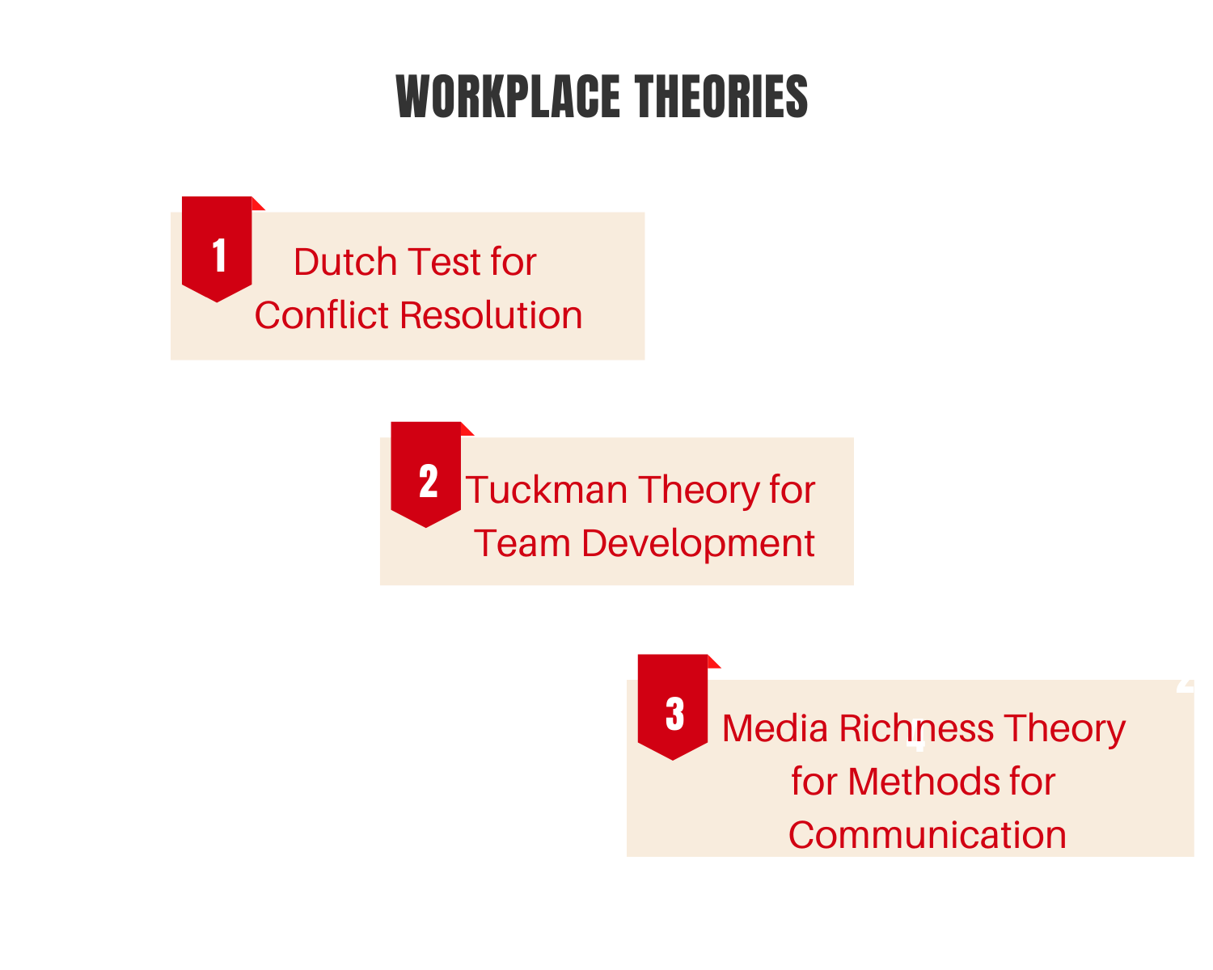
Dutch Test for Conflict Resolution- To measure the conflict in the process of conflict management Dutch Test is being effectively used. The basis for the development of the instruments to assess the strategies of conflict management is provided by this theory (Bond & Haynes, 2014). The problem-solving scale of the theory provides positive and negative integrative conformity during a negotiation in the groups.
Tuckman Theory for Team Development- The theory consists of four steps; Forming, Storming, Norming, and Performing. Forming stage; the team is formed, where the team members are polite and positive, in sort of serious issues or feelings are ignored and people are busy with the daily routine. Storming; initial trust is developed amongst team members, they comfortably challenge and express discontent with each other. Norming; the team members discuss how to fulfill the given goal. Performing; the teams are capable and responsible enough to carry out the given task smoothly.
Media Richness Theory for Methods of Communication- The theory facilitates a better understanding of the optimum methods of communication that are crucial for sharing ideas in a workplace (Shamsudin, Subramaniam & Sri Ramalu, 2014). The theory provides effective tools for language variety, feedback, personal focus and multiple cues for useful interpersonal communication.
2.3.2 Motive of the Study: The motive of the study is to get a proper insight of the various contributors that affect an individual’s interpersonal effectiveness. Ways to attain competitive advantages and improving the overall performance potential of own people. Interpersonal techniques to build a mutual relationship which enhances self-esteem while fulfilling the identified needs to achieve desired results together.
2.3.3 Interpersonal Effectiveness – A Relevant Example
During a negotiation between management and trade unions, regarding bonus. The management approved of 150 dollars bonus, stating that they have such instructions from the corporate office. On this, the trade union representative, who was acknowledged for his interpersonal skills, brought up things in a way that he made management admitting the fact that the unit’s budget allows them to go up to160 dollars but because of higher instructions they are bound to do so. Firstly, he appreciated the management and asked all the other present employees to join him in giving an applause to their very caring and considerate management. Then he convinced the management of the unit to provide the bonus within the limit set by the management and if they are willing then they can provide a gift of rest of the 10 dollars that their budget allow.
This example depicts the very strong conviction, the presence of mind, calmness, convincing and other interpersonal skills of the trade union representative.
2.4 Essentials of Organizational Effectiveness
2.4.1 Importance of Conflict Management at Workplace
Conflicts in the workplace are inevitable. A conflict takes place when different individuals have varied opinions, thought processes, interests, and are not willing to adjust to each other in the specific situation. Often different personal as well as professional priorities, value systems, status, and personality traits lead to such emotional responses that cause conflicts. Hence, the proactive approach must be opted to address any such underlying issues or taking precautions even before a real conflict takes its place. Conflict at the workplace should never be taken lightly, as its outcome can never be depicted. An effective interpersonal skill can assure a prompt and efficient way of managing the conflicts in order to get optimum efficiency and productivity while maintaining a healthy working environment.
Successful conflict management;
- Minimizes interruptions caused due to existing conflicts,
- Ensuring a satisfactory resolution that is accepted by all the acting actors,
- The person who is skilled in managing the conflicts effectively learns to act in a detached way from all the individuals involved in the conflict. He/she learns to intervene, listen, probe, interview and explicit explanation of the issues of the conflict based on an unbiased self-diagnosis.
- It does not only rectify the existing issue but also successfully change the whole tensed situation into a positive one. It facilitates reducing anxiety, negative attitude, low self-esteem, unproductive behavior.
2.4.2 Importance of Effective Communication at Workplace
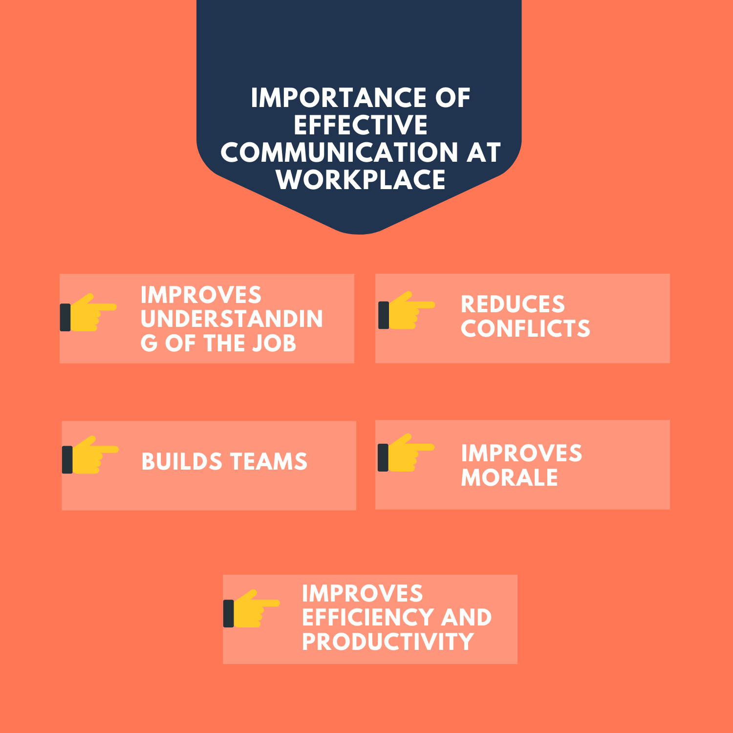
In an organization, effective communication is an imperative tool in achieving optimum productivity and maintaining healthy and, strong working relations at all levels. Companies must understand the importance of strong communication system to avoid misunderstanding arising due to wrong interpretation or miscommunication.
Effective communication fosters a better understanding of the job, reduces conflicts, builds potential teams and improves employees’ morale, which helps the companies in improving their efficiency and productivity (Albert & Moskowitz (2013).
2.4.3 Benefits of Building a Cohesive Team
A cohesive team improves the performance and outcome of the task to an unmatched level. When team members, posses a binding bond with the sense of responsibility and understanding of individual’s role in the team then it is said to be in cohesion. It is often observed that many companies perform far better even with not having optimum available resources and infrastructure. While some other companies having comparatively better resources and infrastructure are not able to perform that well. This is so because it is the people of the organization and the way they work, as individuals and team. Companies that value its people and understand the importance of cohesive team across the departments ensure to provide every possible guidance, support, and acknowledgment.
When employees work in cohesion, their team spirit ensures they will surely accomplish their common goals in the favor of the company. Cohesion in teams, lead to interdependency amongst the colleagues with greater productivity and they accomplish the work within the stipulated time (DeKay, 2012).
2.5 Effects of Cultural Awareness and Diversity within Organizations
Due to globalization, cultural diversity has become a trend over the past years. To sustain the competition and embark its position in the market, an organization needs to embrace cultural diversity in its work culture. Cultural diversity signifies the presence of different races, languages, ethnicity, religion, and nationality in one community or place.
Impact of cultural diversity can be positive or negative in the workplace. It majorly depends on how the leaders of the organization manage it. Miscommunication, newly created barriers, and dysfunctional behaviors are some of the negative effects of cultural diversity in an organization. However, with proper strategic management more positive effects can be enhanced. As per Dekay (2012) it also promotes understanding of the strengths and weaknesses of the workforce, which can be addressed properly after an open discussion and good interaction.
2.6 Example in Relation to the Crucial Factors of the Workplace
An organization comprises of numerous employees coming from different backgrounds, cultures, value systems, societies, nations etc. Due to which a workplace becomes so diversified and complex that it causes friction amongst the workforce. While through effective interpersonal skills, the issues can be addressed in more appropriate and constructive manner. The diversity in the workplace can be turned into the strength of the organization through effective communication. The issues and conflicts can effectively be addressed through open discussions, regular interactions, efforts to increase sensitivity, training sessions.
3.0 Future Goals and Strategies
3.1 Future Goals: No matter how brilliant a person is in his/her work, if he/she cannot get along well with the other people in the organization, he/she cannot get what he/she actually deserves. Same with the organization, if it cannot treat its people right it can never attain its organizational goal. Fortunately, these are the skills that can be easily worked upon.
- Develop an improved and effective communication channel between the employees and management. Giving priority to better interpersonal effectiveness, this will also lead to organizational effectiveness (Shamsudin, Subramaniam & Sri Ramalu, 2014).
- Focus on resolving the conflicts and encouraging people to have open discussions in the workplace. As it helps in enhancing the organizational effectiveness through improved interpersonal effectiveness (Ellwardt, Wittek & Wielers, 2012).
3.2 Personal Insight
To attain effective interpersonal effectiveness, I need to
- Work on my communication skills with my superiors, peers, and subordinates. This will help me in improving my self-image and relations within the organization.
- Ensure that discussions always take place in the planned and structured way within the frame line of the expected outcome.
- Work on my negotiating, decision-making skills.
- Focus on more on self-awareness, self-management, social awareness, and relationship management.
3.3 SMART framework
Through this framework, the focus can be laid on such target areas through which professional, as well as personal development, can be assured. Three key skills help in achieving interpersonal effectiveness: objective effectiveness, relationship effectiveness, self-respect effectiveness.
4.0 Conclusion
To conclude, interpersonal skills are not confined to an individual rather it impacts the whole organization and its working. To improve the efficiency and break the barriers in the workplace, it is imperative to improve the communication amongst the people. Developing the sense of cooperation, support and working in cohesion is very vital. It is evident that interpersonal skills are the tangible assets, outcome of which can be easily seen in terms of stronger relationships between the people and different departments, improved rapport and credibility, increase in business and productivity. The role of interpersonal skills and how they are in relation to workplace theories and workplace diversity are also discussed at length. This assignment focuses on analyzing the strengths and weaknesses and the ways to improve own ability in terms of an individual and organization. Interpersonal Effectiveness assignments are being prepared by our online management assignment help experts from top universities which let us to provide you a reliable assignment help online service.
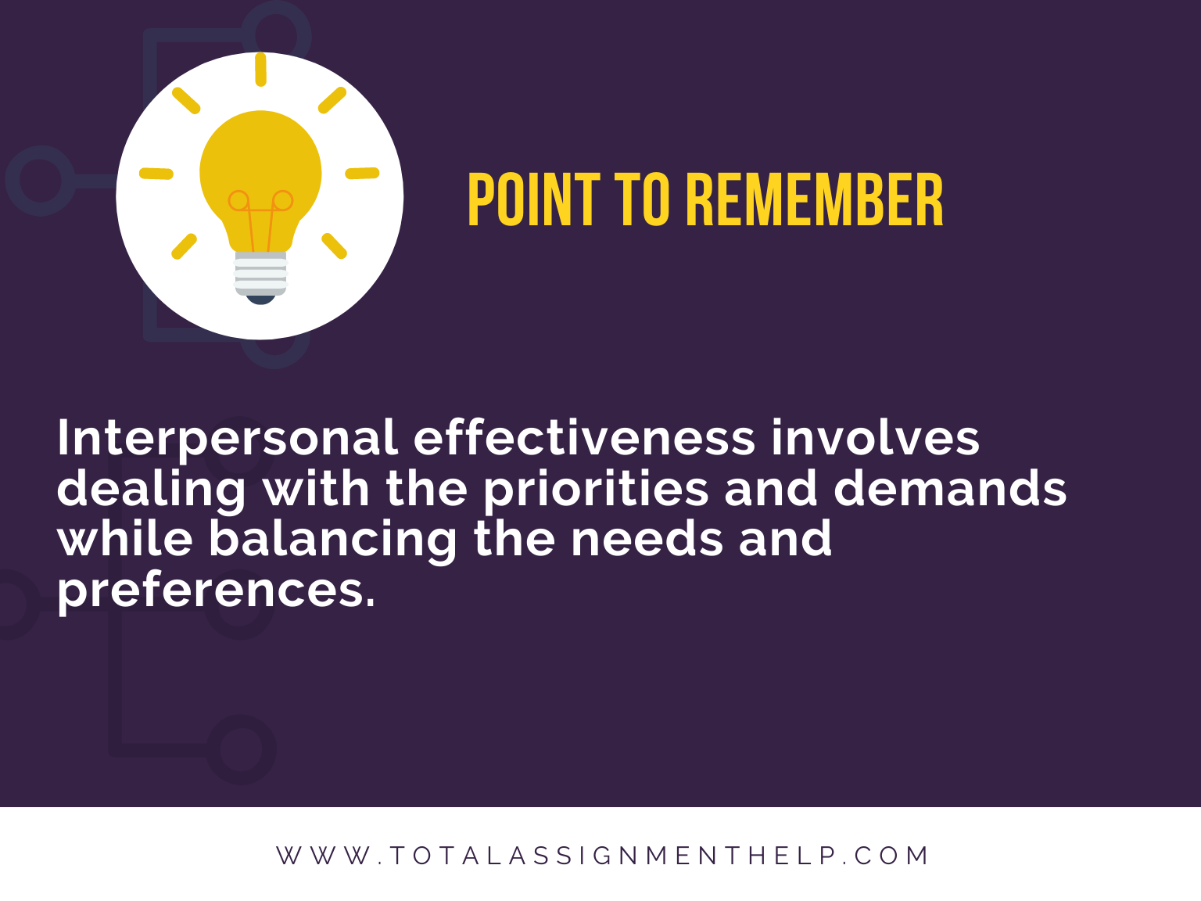
Reference List
DeVito, J. (2009) The interpersonal communication book, Boston, MA: Pearson/Allyn and Bacon
Albert, L. & Moskowitz, D. (2013) “Quarrelsomeness in the workplace: An exploration of the interpersonal construct within the organizational context”, Organizational Psychology Review, 4(1), 27-48
DeKay, S. (2012) “Interpersonal Communication in the Workplace: A Largely Unexplored Region”, Business Communication Quarterly, 75(4), 449-452
Ellwardt, L., Wittek, R. & Wielers, R. (2012) “Talking About the Boss: Effects of Generalized and Interpersonal Trust on Workplace Gossip”, Group & Organization Management, 37(4), 521-549
Shamsudin, F., Subramaniam, C. & Sri Ramalu, S. (2014) “The influence of HR practices and job satisfaction on interpersonal deviance in the workplace”, Journal Of Management & Organization, 20(05), 691-709
Bond, M. & Haynes, M. (2014) “Workplace Diversity: A Social-Ecological Framework and Policy Implications”, Social Issues And Policy Review, 8(1), 167-201
Tags: Effective CommunicationManagement
NEXT SAMPLE

Corporate Social Responsibility - Merits and Demerits
Question
Task: Explain the merits and demerits of Corporate Social Responsibility (CSR) with examples.
Answer
Introduction
Every organization has framed different definitions of Corporate Social Responsibility (CSR). Although they share a basic concept of CSR that, it is a voluntary process of an organization, which it carries out for the welfare of its employees, society, and environment as an obligation towards all three. In simpler terms, for using community’s resources to make revenues and profits out of them the company pays back to it by different means.
Subscribe our YouTube channel for more related videos
Corporate Social Responsibility:
There is vagueness and a lot of argument associated to what is owing of CSR in an organization (Horrigan, 2010). Through CSR, organizations create a constructive and affirmative image in the society (Baker, 2004).
Emergence of CSR
Year | Emergence
1930 | CSR first came into existence in the year 1930. It was after the Great Depression in 1929, when two professors of Harvard University, Prof. A.A. Berle, and Prof. C.G. Means realized that corporations must come forward and take the responsibility. They also claimed that such a condition would not have taken place if the corporations had acted responsibly.
1960s & 70s | In account of changing the perspective of society towards business in regard to civil rights movement, consumerism, and environmentalism. Many instances related to CSR were put forth in the business world. Convention and guidelines of Organization for Economic Co-Operation and Development (OECD) were formulated in the year 1960 with the intention of advocating the policies that can ensure the economic growth, better employment, and improved living standards amongst in nations that are its members during maintaining the financial conditions.
1980s &90s | International Union for Conversation of Nature (IUCN), in 1980 published the World Conversation Strategy. As per this, aim was to make more consistent world economy, enhancing world growth, world equalities and alleviate poverty and its impacts. While in 1992, a summit named the UN Earth Summit was convened in Rio De Janeiro, in which ‘triple bottom line’ model for business was formulated, with the basic idea of having sustainable development with the company’s competitive benefit.
Since then many other important and noteworthy incidents have happened that played a significant role in establishing the concept with even more strength and convinced the business establishments to enforce it with conviction.
Types of CSR
Four Types of CSR based on its beneficiaries:
- Environment-Based Corporate Social Responsibility (CSR): Through this, a company’s attention is on reducing the harmful effects caused on environment due to its various operations. The company invents such processes at their production level so that they can minimize the production of such by-products that are causing damage to the environment. It also takes preventive measures to avoid caused damage by burning fossil fuels to its environment by encouraging the use of non-renewable energy.
- Community-Based Corporate Social Responsibility (CSR): To safeguard the well-being of the society, the company with the help of other organizations, which are usually Non-profit organizations, comes forward with various programs. To enhance the living standard and conditions of the people of society, a company either provides funds or arranges funds from other companies to carry out the planned programs.
- Human Resource-Based Corporate Social Responsibility (CSR): Human resource of an organization plays a vital role in its smooth functioning and success. Hence, companies pay close attention to the needs of its human resource to make their lives better. Companies do so in various ways like some companies provide extra leaves to the male employees so that they can take better care of their newly born child. In case any employee encounters an accident due to on-job danger, companies offer better medical insurance so that the employee can be healed and cured in the best possible way.
- Charity-Based Corporate Social Responsibility (CSR): Companies often engage other organizations as partners for charity. Companies contribute charity to individuals and other organizations to assist them financially to meet their general needs. This is the most preferred type of CSR being used by the companies.
Merits of Corporate Social Responsibility:
After understanding the meaning and various types of CSR, it is important to know its major merits.
- Enhancement of the Company Image: The most advantageous and obvious merit of CSR to a company is that its value in terms of goodwill increases. It has two major direct benefits to the company. One is, customers are always willing to purchase products of a company that has good image in the market. The other is, in general, other companies wish to get associated with such companies to do business. CSR influences the reputation of the company in the society as the consistent and trustworthy name. It is a general human tendency that they always want to be connected with a name that is reliable and enjoys a good status that makes it the best in the market.
- Enhancement in Attraction towards Company and Retention of Employees: Candidates are attracted towards the companies that have strong CSR policies and comply them responsibly. Hence, such companies get good pool of potential candidates and their employee turnover is very low. Everyone wishes to work with a company that is concerned about its employees and makes efforts towards betterment of working and living conditions of its employees. Existing employees, as well as new employees, wish that the company has an empathetic approach towards them. Fair treatment, regular appraisals, assistance may that be financial or any other in the time of need, recognition on achievements, attention on special days like birthdays, anniversaries etc. are the few basic things that act as a major difference between a company of people and a company for people.
During tough times like condition of tight labor market, these policies of company win an edge over others. It also helps in minimizing the induction training costs and incentives cost of old employees. Employees are motivated to perform even better with incentives. This can be concluded in one statement and i.e. a company is induced to make better profits with increased productivity and reduced rework with the satisfied and contented workers.
- Regulatory Authorities Become Less Intimidating: Regulatory authorities often lay more focus on the companies that do not perform CSR for scrutiny, over the companies that do. The authorities are set to believe that the company that is performing CSR for the welfare of the society and environment and has a good rapport with the people and other organizations that means it must be complying other rules as well, such mindset allows them to be easy-going with them. To get the most out of the CSR programs other than profits, companies having well-defined CSR policies always abide by other regulations as well.
Such companies receive a fast process of scrutiny by the authorities. At times, if the competent authority realizes that any particular project of a company is going to benefit the society then it may ignore the absence of required paperwork too.
- Attracts more Investors from Various Sources: Investors are most likely to invest in the company, which has a good image in the market. Goodwill of a company is significantly enhanced if it is doing well in CSR and makes more people interested in investing in its crucial programs. Such a company will also get foreign investors in the form of FDI. Hence, it also becomes a contributing factor in the foreign exchange of the country. It is known as a reliable and trusted name, due to which it gets investors from other companies and industries as well.
In some conditions, the government of the country also reflects its willingness to invest the company, which leads to minimal regulation issues and red-tapism.
- Production of Clean and Renewable Energy through Environmental CSR Program: Companies that run environmental CSR programs, always make sure that none of their processes cause any damage to the environment. They introduce such production methods, machinery, and techniques that are in favor of the environment and also reduce any sort of damaging effect if it does cause any, then a clean and healthy environment can be provided to the society. During this process company also access the possibilities of generating and using renewable energy in its different processes.
By investing one-time in renewable energy for production process, company reduces its cost of overall production and fossil fuels.
- Positive Promotion: There is a huge difference in publicity and positive publicity. As in the business world, there is popular saying that, ‘no matter what any publicity is good publicity’. It is really important that to make people buy your products one should be a known name amongst them. However, it is also important to have a good name in the eyes of public, because being known for wrong reason also causes downfall in the sales. Hence, a company must always focus on positive promotion. A good publicity can easily be earned by performing decent CSR program. Without even investing in advertising, it works as a good advertising campaign giving you a positive promotion.
Not only this, it also acts as a differentiating factor from its competitors. Even if the competitors are selling their products at lower prices, but the company paying attention to the community and environment always wins over. People readily pay a little more, if they are aware of the contribution of the company to the environment and society.
Demerits of Corporate Social Responsibility
The points on which the business groups are condemning CSR are discussed below:-
- Deviation from the Profit-Making Objective: A popular economist named Milton Friedman is the biggest criticizer of CSR. As per him, CSR deviates the basic purpose of the business from earning profit to using its profit for the welfare. He suggested that the sole objective of starting any business activity is to earn maximum profit out of it. A business entity has commitment towards its shareholders, who are hoping to earn from their shares. All these needs can be met only if a company focuses completely on inventing methods by which it can make more and more profits. While companies are using their funds to carry out CSR programs for the welfare of the society and charity.
Hence, if we put it in straight words, then a company is intentionally increasing its expenditure which has no payback or role in profit-making rather it is a pure outflow with no return.
- Company Reputation is at stake: If a company has to comply with the CSR policies, then it is supposed to inform all the limitations associated with its own products. If there is any CSR policy violation in their product then it has to be made public. It can cause bizarre to the image of the company. For instance, once a car manufacturing company has to call back all of its sold cars after finding out malfunction in the model, it damaged the image of the company and its effect was seen on the sale of its other products as well.
This not only causes loss of trust amongst customers but also causes hassle to them.
- Customer Conviction: At the start, people had good impression about these CSR programs. They also tend to be more inclined towards companies that have CSR programs. But, as the time passes people become more impatient and start to expect instant results out of such programs. When they could not notice instant results or instant impact on the society then they start to feel CSR programs as mere publicity stunts. For enterprises, it becomes really hard to make customers understand that such programs take time to show results. It is important for the company to have patience and trust of the customers while the company continues the programs with dedication and conviction.
Even several efforts of convincing the customers to go in vein. Constant efforts of convincing people is an extra and unproductive activity for business enterprises.
- Increase in Cost of Production: CSR programs lead to an extra cost to the company. The increment in cost forces the company to increase the basic price of the product, which is ultimately paid by the customer. This is an extra burden on the company, which is being imposed to customers.
Big companies or business leaders can easily afford such increased costs and may not increase the prices of the products. However, the small players are forced to increase the prices, as they simply cannot afford this increased cost. They are already struggling to fight against the big players in the market and these increased prices make it even more difficult for them.
CSR Related Legislation and Provisions
The provisions and legislation in regard to CSR differ from place to place. The CSR legislation being imposed on the companies varies in different perspectives, may that be based on the geography, environment, culture or legal context of different countries. The major factors in legal context that affect the organizations of three different countries – Australia, UK, and the USA are discussed below:-
OECD Guidelines for Corporate Social Responsibility
Organization for Economic Cooperation and Development (OECD) is one platform, where 30 democratic countries can get their matters resolved in terms of social, economic, and environment-related issues. It has laid well-defined guidelines based on ethics and responsible business operations for multinational companies to operate. The guidelines clearly address the issues related to CSR. Being members of OECD, Australia, UK, USA, all the companies operating in these countries have to follow the OECD guidelines without any failure.
General Policies:
Complying with the OECD guidelines alone is not sufficient; companies need to take into account the general policies of the countries they are operating. Taking care of interest of its stakeholders like suppliers, workforce, society, investors etc in accordance with the country rules is also mandatory. Few essentials for a company to do -
- With the intention to attain sustainable development, a company must give its genuine contribution towards growth of society, environment, and economy.
- Honor the national human rights and human rights set by different countries.
- Efforts should be made to maintain strong relations with the locals to ensure the progress of local community along with the business interest. Expansion of business in domestic as well as international market should be the focus of the company to attain wider exposure.
- Contribution in maintaining the policies related to maintain good corporate governance. In order to fulfill good corporate governance practice, competent principles must be formulated, implemented and practiced at regular basis.
- Instead of avoiding statutory compliances regarding human rights, working conditions, human resource, health, safety, environment, taxation and others; it should be a practice to comply them.
- Promote such policies that motivate to work with effective work systems and boosts self-responsibility to practice all the regulatory actions not under legal pressure but as work culture; as it can develop a strong relation and mutual trust between company and customers.
- Regular attempts should be made by the MNCs to make its workforce completely aware of the company rules and policies through regular training programs.
- Discrimination in any form should be prohibited within the organization.
- Proper assessment of possible risk should be assessed timely, due decisions and actions should be taken to mitigate them.
- OECD guidelines should be consulted in a way that no negative impact can be caused or contributed by the company in regard to the topics covered in the guidelines. If in case, any unpleasant circumstance arises then a genuine instant action must be taken.
- If unfavorable circumstances have not caused any direct adverse impact on processes, products or services but in future can lead to an uncomfortable situation, then appropriate action must be taken in advance to reduce its adverse impact in future.
- Relations with stakeholders must be taken care of. They should be provided with better options and opportunities to express their viewpoint on future actions of the business and decision-making process regarding projects and various other actions that affect the locals.
The companies are motivated to :
- provide full internet access in the name of freedom of expression, alliance, and online assembly, whenever it is feasible and in accordance with the company’s operations.
- involve or sustain the appropriate private and various stakeholders enterprise. In addition, the organization must make sure its initiatives should be influential and contributing to the developing countries along with the current set international acclaimed standards.
For more detailed information on the guidelines, one can refer to the official website of OECD, where the guidelines are available in the PDF format.
Corporate Social Responsibility: Australia
The companies, which wish to or operate in Australia may contact to OECD national contact place to know more about OECD guidelines to act as an OECD member. It is mandatory for a company to be aware of CSR laws in Australia to be able to comply with as the court system of Australian local and centralized sections. For any or all the cases, High Court is the supreme and final jurisdiction. The essential parts that influence the factors of CSR in global processes are discussed below:-
  - Legislation: Australian companies are legally bound by a surplus of Australian laws to abide by the human rights standard. For example, there are various laws made to prohibit any sort of harassment and discrimination at workplace, ensuring that employers provide equal employment opportunities. In law, there are numerous aspects that regulate or control work environment have greater impact on the implementation of CSR like occupational health and safety, minimum wage, terms and conditions of employment, collective bargaining etc. For instance, Laws imposing absolute liability on corporations’ acts that have bad consequences on human rights, such as bribery offerings to foreign officials, involvement in any misconduct against humanity.
The Corporation Act and Common Law enforce the directors with power and duties for acting in shareholder’s best financial interest. The directors are entailed under the Corporations Act, Section 181(1) to act in a manner in which they work or ensure the best interest of the corporation
  - Human Rights: The Australian government supports all the key conventions included in the UN regarding human rights. To protect and promote human rights in Australia, an autonomous body called ‘Australian Human Rights Commission’ has been created by the Australian authorities. This agency involves many responsibilities out of which most prominent ones are to safeguard the human rights and focus on CSR.
  - Working Life: Companies who are functional or aim to commence business in Australia must strictly obey the local rules and regulations, for instance, employees working hours, frequency of breaks in between the work. Australian employment policy is regulated by the local and central legislation systems, laws and collaborative contracts that apply to specified categories like working hours, salaries, and remuneration, overtime, dispute settlement. The International Labor Organization (ILO) has identified eight main conventions that are being promoted by Australia.
  - Environment: The environmental aspect of Australia should be taken into account for operating any business activity or aim to operate in Australia. As Australia’s environmental factor acts as a crucial factor in the implementation of CSR. Laws related to protect or safeguard the environment are formed and imposed by the central, state and local authorities of Australia. Law is made because work performed by some companies can cause bad effect to the environment. For this matter, an enterprise requires license and is liable to report to the authorities. Enterprises are supposed to report the greenhouse gas emission, energy production and consumption by them.
  - Corruption: The UN convention to fight against corruption has been ratified by Australia. That is the reason, why it is considered as least corrupted nation worldwide.
  - Indigenous Population: The enterprises, which intend to extract natural resources, should take into confidence the native people of the area. In Australia, laws enforce even the consultation. Enterprises that are operating in Australia must check with local authorities and business organizations.
Violation of CSR Norms in Australia: Consequences and Punishments
CSR norms are emerging rapidly due to which expectations from the corporations are also increasing day by day. So, when it comes to violating any norms of CSR, companies can face various consequences extending from loss of goodwill to its market shares.
Australian Securities and Investments Commission (ASIC) is an independent Australian government body that acts in accordance to regulate and control Australia’s corporate, markets and financial service. It is the duty of ASIC to determine and make sure that economic status and well- being of Australia, continues to be in safe condition. Along with that, ASIC ensures fiscal markets control or regulate justly and keep transparency. If ASIC finds out that any enterprise operating in Australia has violated any of the above-mentioned corporation law, then it identifies and carries out available remedial actions.
Type of Action | Description of Punishment
Punitive | In case of any misconduct, ASIC may approach the court to take action against such organization or person. The action could be of two types: 1. Criminal penalties in form of imprisonment, community service. 2. Civil monetary penalties, which should be paid to the commonwealth.
Protective | In order to safeguard interest of customers and investors, ASIC may take administrative actions that include: 1. Disqualify to manage any organization. 2. Forbid from offering any financial service and getting into any credit services. 3. Retraction, termination, rectification of license terms. 4. Notices of public warnings.
Preservative | In order to protect the assets, ASIC may take valid judicial action and compel one to follow the law.
Corrective | Corrective disclosure can be made after seeking a court order.
Compensatory | To ensure that all who have suffered damage and recover the losses, ASIC may request the court to take a representative action.
Negotiated and Agreed Outcome | To get an effective lawful result, ASIC can negotiate on the alternatives that may include: 1. Legally enforced disclaimers. 2. Payment for breached notices.
Corporate Social Responsibility: UK
Just like Australia, UK is one of the OECD members. This means that organizations in UK do comply the general OECD guidelines in terms of CSR. Though, there are some other laws as well that affect working of an organization in the UK.
- The Town and Country Planning Act demand the organizations to seek permission and clearance from local authorities if in case they wish to utilize natural resources for particular type of installation and development programs.
- The Management of Health and Safety at Work Regulations (1992) is formed on the basis of the Principles of Health and Safety at Work Act (1974). The act is formed to make sure that an organization is set liable for developing and maintaining safe work environment.
- The Trade Union and Labour Relations Act (1992) instructs the employers that if the organization is trade union recognized then it must reveal the employment policies and conditions to the employees.
- The Environment Agency was established by the Environmental Act (1995), which came into action in 1996. The agency has the power of investigating the IPC application and publishing the names of the organizations, which are fined for causing damage to the environment.
- The Environmental Impact Assessment Regulations (1999) is one of the EU Councils Directive (97/11/EC) which came into force on 14-03-1999. This assist in forming relations between organizations and planners, as the local planning authorities need to provide a written consent to public authority informing that the organization requires going through EIA.
- To promote CSR by using supply chain contracts, Contract Law is very crucial. Various western companies usually implement CSR policies into their complete supply chain with all their suppliers, for example, UK Trades.
- The Race Relations Act (1976) is formed to take care of the direct and indirect biases based on racial, ethnic, and nation origin, in the workplace.
- The Companies Act (2006) which has significance to CSR demands the directors to make an absolute and early revelation about the dealing commerce and shares. In addition, it also asks the directors to make disclosure of their other interests including related to their family members may that be spouses or an infant baby. Furthermore, it binds the directors to form a body, which is set to such standards that it gives consistency to company accounts, reports of directors and auditors.
A New Enacted Law:
Specifically, the organizations, which have their financial year ending on 31-03-2016, are the first ones to create the statement as per the UK Modern Slavery Act. It is so because the Business & Human Resource Centre reached the conclusion that the registry would be maintained of the organization statements pursuant to the act.
Violation of CSR Norms in the UK: Consequences and Punishments
It is mandatory for companies that are operational in the UK to have such policies that honor the human rights. Clearly, they must abstain from any sort of breach of corporate laws, human rights and promptly address impact of any negative human rights action may occur in their processes.
- CSR provisions mentioned under Companies Act (2006) are mandatory to follow by all the organizations. In case of any failure in compliance or non-compliance of these, then the organization is liable to pay defined penalties. These penalties are defined under two provisions: Section 134 (6) and Section 134 (7) – (8).
  - Monetary penalty of £528 up to £26410.
  - Each officer of the organization shall be punished with imprisonment of up to 3 years.
  - Court may levy penalty on the organization’s officers to pay an amount that can be £528 to £5282.
- Under Section 450 and 451, UK organizations have to face other general penalties. The below-mentioned repercussion is to be encountered in the operation system if an organization violates any of these laws.
  - Monetary penalty of £4 up to £105. If the organization continues to violate then the penalty of £10 per day until the violation continued will be forced on the person or organization.
  - Under Section 451, the offender will be either levied with monetary penalty or imprisonment. If the defaulter continues the same crime within the three years of the first time, then the company and its officials will be penalized with the double amount along with the imprisonment that is decided for the offense.
Corporate Social Responsibility: USA
Corporations, intended to operate in the United States, have to keep up with an extensive variety of legislation obligations defining responsibilities towards shareholders and stakeholders. For example, US have come up with the ruling that ensures corporations must guarantee interest of shareholders and stakeholders. A legal outline ensures fiduciary duties of fidelity in order to make directors act and use corporation resources more cautiously and responsibly. It makes sure that directors required performing the activities in corporation’s interests and holding back all the ill intentions, motives, bad purposes and objectives that can manipulate director’s behavior negatively. Fiduciary duties meaning is ‘the best concern of the corporation’ that includes the interests of shareholder as well as the stakeholders.
All the enterprises intended to operate in the US should do charitable contribution that is supposed to be acknowledged well by the US. Seven states of The US persuade organizations to do donations regardless of corporate profit. While there are 19 other states that motivate organizations to do charity that could be benefited to the company itself as well as society. Though in rest of 24 states, the rules are not clearly defined that donations can be made or not if it is not in the interest of corporation.
Corporate laws, formed by the states enforce legal duty on enterprises and permit corporations to participate in lawful activities. Companies can form their own charters where they can precisely take participation in the CSR activities. For instance, New York Times has been established to work in accordance with the objectives of social welfare than to make profits.
The business judgment rule makes a strong assumption for affirming manager’s activity. In the ratification of this act, a manager’s decision can be challenged by the court until decision assures to meet all the essential needs linked to the clashes of interests and ignorance.
Violation of CSR Norms in USA: Consequences and Punishments
Companies who are not complying the corporate laws need to understand they can have substantially bad consequences on companies’ image
- Directors held responsible for personal liability if there is any breach of fiduciary duties.
- Breach of CSR laws can cause severe financial loss and harm to company’s image. If consumers’ rights are exploited company may have to face boycotts which lead to down market shares especially in goods and clothing.
- Various multinationals are getting inspired towards implying supplier codes of conduct under CSR policies. Such companies get debarred from the important contracts. For instance, an American MNC, Wall Mart, has suspended one of its key seafood suppliers after getting a report of its bad working conditions in its processes.
- A breakdown in following CSR system can result in dispute with the mass that can cause legal threat. Other than legal risk, there are various threats involved in protests, strikes that can increase the cost to any organization.
- Furthermore, possible risk in the absence of implementing CSR systems can usher to various loss to the company.
- Company who do not fulfill CSR principles could face legal trouble or proceedings. To get them pardoned from the obligation of the caused harm by their foreign subsidiaries, some organizations have given arguments about their organizational structure and jurisdiction. However lately, various country's court like U.S. UK and Canada stated this subject matters inadequate.
Examples of CSR Activities
CSR activities carrying out in leading companies reflecting how CSR system is advantageous to a company than having its demerits.
class="assignmentfont">
- Google’s Corporate Social Responsibility Activities:
There are notable attempts made by Google to improve. Forbes has listed Google having the best CSR activities.
  - Google’s CSR based on Community
    - There is a competition named Google China Social Innovation Cup for College Students in which winner or champion is supported by funds by Google so that their schemes or ideas can be implemented. It focuses on empowerment of Chinese youth to turn them into driving force of Social Development.
  - Google’s CSR based on Environment:
    - There is a thoughtful effort by Google called Google Green in which it uses resources wisely and promotes renewable energy resources. Due to this prudent idea, Google has witnessed largely fall of around 50 percent in power requirement. The cut-down cost from power requirement can bring more innovative ideas that will help people worldwide.
  - Google’s CSR based on Charity:
    - Google permits or provides advertisements words at no cost for particular charities. These advertisements ensure charities to display their cause properly and educate people about the cause. Such causes involve rights of animals to blinds to HIV education. Google has vast range and it is possible because Google has larger length of reaching out.
Effects: Due to Google’s green initiatives, greater impact was seen on power consumption by big enterprises. Google has become footprint for all such organizations for following such idea of less power consumption. It got involved in charitable activities like permitting them to publicize free of cost.
- Microsoft’s Corporate Social Responsibility Activities
Microsoft Company is well acknowledged for its contribution or support for the social welfare or development. Bill Gates (owner of Microsoft) is well-known for his humanitarian approach or charities giving billions of dollars in donation. There is a private foundation formed by Bill Gates and Melinda Gates named as ‘The Bill and Melinda Gates Foundation’ that has supported millions of people by funds, medical services, and financial support to get through in medical research.
Microsoft’s CSR activities based on Community:
  - In 2004-2006, two programs were formed - ‘Partners in Learning,’ and ‘Partners in Learning Grants.’ Both the programs concerned with technology and essential training, to use those technologies in schools. It focused on deprived schools, unable to afford and did not have easy access to said technologies.
  - $253 million had been spent for the training of faculties and students to make them well-informed and use the technology in the best possible way
  - Microsoft aims to impart technology and well - educate about the technology to the underprivileged schools.
  - ‘YouthSpark’ program (2012), which intended to facilitate students for the technology to accomplish goal and attain success. Microsoft presented software to the schools so that it can enhance their learning. For instance, a special provision for visually impaired applicants in form of software called ‘Job Access With Speech (JAWS)’ for blind students like Ignacia Picas where such impaired people are able to read without converting the text into Braille. It assisted to deal with this disability of her visually impaired colleagues. It was a successful or beneficially initiative not only for her but for her teachers too, as they were not converting the text for Ignacia into Braille. It was time-saving.
  - The software called ‘Office 365’ in 2013 was offered by Microsoft for free to appropriate NGOs. Its software was distributed in 92 countries worldwide at minimal price or even Free of cost whose worth is about $55 million.
Effects: CSR activities of Microsoft have left a massive effect on development of the community and satisfaction of employees. According to a study, 86% of Microsoft employees recommend others to work with Microsoft. The same study says its 94% employees are satisfied with the justifiable treatment they receive by their superiors and commendable efforts in improving the lives of humans, it is also called ‘a good corporate citizen’.
- Bosch’s Corporate Social Responsibility Activities
Bosch is a well-known name in the field of automotive and industrial field. The company is based out of Germany and is extremely focused on keeping its operations in accordance with the environment norms –
  - CSR of Bosch – based on HR
    - The company has set a committee to regulate ‘HSE (Health, Safety, Environmental and Fire Protection and Emergency Control) Steering Committee’ regulates the major activities of an organization that can be sustained for longer period. The board holds the charge of all the environmental and safety related issues and it consists of officers from 12 different regions.
  - Bosch’s CSR Activities based on Environment
    - Bosch has a policy called ‘going green’, under this policy it has obtained Ersol Solar Energy i.e. the leading manufacturer of solar cells.
    - With the intention of clearly being aware of the amount of energy being saved by the organization during various operations, and indicator called ‘CO2-Flag’ was launched by Bosch Thermotechnik. This clear information in terms of quantity of energy saved by the organization facilitated customers in being aware of the fact that they are purchasing products that are energy saving hence, contributing in decreasing the level of energy wastage.
Effects: Bosch through inventing this technology has made public more conscious of saving energy. Bosch ensured to have a better and cleaner surrounding around its production sites by self-imposed regulation in the form of HSE rules.
- Hewlett-Packard Germany Corporate Social Responsibility Activities
Hewlett-Packard is a well-known name of the IT industry. It is also known for using and making popular such technologies and approaches by which usage of lesser energy can be ensured.
  - HP’s CSR Activities based on Environment
    - HP has opted to replace usage of copper made electric wires with optical wires for energy transmission with increased efficiency by 20 times. The technology is known for saving electricity of Gigawatts.
    - HP constituted a team named ‘Eco-Solutions Engagement Team’ in 2008. Its all business units and operations are included in it and have to think from the customers’ point of view to invent accordingly.
    - In 2008 along with HP Education Services, ‘Eco Solutions Workshop’ was developed by the environmental management. Through these workshops, it focuses on providing complete information on innovations related to clean energy in HP to the customers.
    - It majorly aims at: Green Data Centre Environment and Workshops Buying Green IT Solutions.
Effects: Through innovative programmes of HP, customers and public are more aware and concerned about production of clean energy and ways to keep environment cleaner.

