17

Business Management

Contents
1. Research aims as well as objectives 3
2. Literature Review 3
2.1 Human Resource Planning 3
2.2 Human Resource Planning Process 4
2.3 Models of succession planning 4
2.4 Role of HR planning in Artelia International Company 5
3. Research Philosophy, Approach as well as Strategy 5
3.1 Research Philosophy 5
3.2 Research Approach 5
3.3 Research strategy 5
4. Ethical Consideration 6
5. Research Methodology 6
Research Design 6
Sampling Technique 7
Data Collection 7
Tools used for analysis 8
Structure of the questionnaire 8
Pilot Study 8
6. b. Quantitative data analysis questionnaire 8
6. d. Quantitative Analysis of the Data 10
7. Reliability and validity of the research 12
Reference 13

1. Research aims as well as objectives
Aims:
The respective aim regarding this particular research paper is to understand the importance of employees within an organization. With the intention of sustain the overall growth induced from the aspects in the global competitive market; it is quite compulsory for the respective management concerning the entity so as to focus upon the Human Resource Planning of the organization.
Objectives:
Objectives of this researcher paper are:
- To understand substantial interest regarding human resource planning and succession planning within the organization
- To evaluate the strategies adopted by HR manager of Artelia regarding Human Resource Planning
- To excavate the necessity of Human Resource Planning
- To have better understanding successful succession planning

2. Literature Review
Literature Review is the integral part of every research paper, with the help of literature review, researcher can able to collect secondary data. several journals, articles, books and magazines are considered for analyzing the role of Human Resource Planning and succession planning.

2.1 Human Resource Planning
Employees are the key stakeholder of the organization; management should implement several strategies to mitigate employee retention rate within organization. By implementing human resource strategies, objectives of the organization can be achieved. It is considered as one of the systematic and continuous process to analyze the need of human resource management within the organization. As per stated by Rothwell (2010), it has been understood that Human resource planning is a process of ensuring requirements of organization to satisfy those requirements. On the other hand, it has been stated by Armstrong & Taylor (2014) that Human Resource Planning is a decision making process. This process is focusing on three activities of the organization and those activities are identify the need of the organization and recruit exact numbers of employees; providing them training and stimulating them so that they can able to attain high performance within organization. Lastly, it is focusing on the interactive relationship between objectives of the organization and activities of human resource planning.

2.2 Human Resource Planning Process
Before engaging employees within organization, it is needful for the management of the organization understands the need. After understanding the need of the organization, management should recruit exact number of employees. After recruiting them, HR manager and leader should understand the issues and knowledge gap among the employees. Managers have to foresee difficulties within organization to understand surplus and deficits of human resource planning. HR manager should inform the employees that changes are the inevitable part of the organization and workforce should be flexible enough so that they can adopt changes at any time. In order to control the cost, Ulrich, (2013) depicted that management has often outsourced human resources. However, management should take care of Human resource management and reduce dependency on external recruitment. Companies should focus on providing them a flexible working in which, employees are treated with utmost dignity and respect. Appraisal and reward management are also necessary for initiating more flexible workforce.

2.3 Models of succession planning
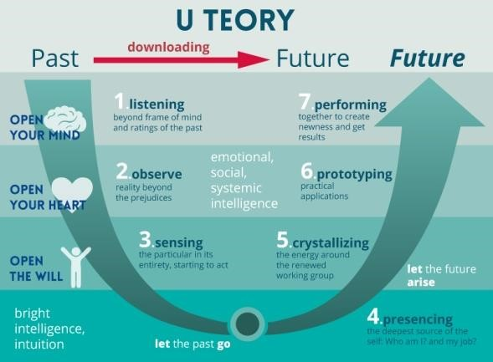
Scharmer’s Theory U Model extremities that Top management of the organization should support teams towards executing succession plan of the organization. In accordance to this model, succession planning is considered as the beginning of prospective and lucrative future of the organization. U in the model is symbolized as five movements that help in transforming unachievable goals to achievable goals. First movement is for co-initiating potential stakeholders of the organization. Second is about Cosensing the need of the organization across the border. Third is about considering the change as an inevitable part of the organization. Leaders should lose unsettled previous condition and practice for pragmatic future at this stage. Fifth and last stage is about the co-evolving for successful execution of succession planning schemes (Rothwell, 2010).

2.4 Role of HR planning in Artelia International Company
Artelia International Company is a well known project management company and prime focus of this organization is on the engineering, project management and consultancy. Company is working on multiple directions and handing several types of projects. Armstrong & Taylor (2014) opined that to sustain the position of the organization in the national market, it is necessary to recruit efficient staffs. Proper human resource planning is necessary for recruiting efficient and skilled up for maintaining quality of project.

3. Research Philosophy, Approach as well as Strategy

3.1 Research Philosophy
Research Philosophy is the integral part of every research paper; this is the first step of every research paper. Research philosophy is divided into three parts and those are Positivism Research Philosophy, Realism Research Philosophy and Interpretivism Research Philosophy. Among these three research philosophies, researcher has taken help of Positivism Research Philosophy to have better understanding of the paper (Haddon, 2010). Researcher has taken help of Primary quantitative research philosophy; therefore, it is necessary for researcher to choose Positivism Research Philosophy. This philosophy is necessary to analyze numerical data, graphs and charts.
To have positive outcome of this research, researcher has taken help of this research philosophy.

3.2 Research Approach
This has been divided into two parts like Deductive Research Approach and Inductive Research Approach. Researcher has chosen Deductive Research Approach as it correctly goes with quantitative research approach (Khandker et al., 2010). Analysis of raw data with the help of different statistical tools can be done through Deductive Research Approach.

3.3 Research strategy
Between two types of research strategies, Researcher has taken help of Quantitative Research Strategy. In case of this research strategy, researcher has analyzed numerical data only. As researcher has taken help of quantitative research strategy; therefore, researcher should focus on Descriptive Research Design also in which researcher only describes findings of research paper (Samad, 2010).

4. Ethical Consideration
While conductive the research, researcher has to comply by several ethical factors and those are:
- Researcher cannot able to force any of respondents to answer their question
- Data of employees and managers should be maintained confidentiality
- Questionnaire must be concrete and small
- Questions should not hurt emotion of respondents
- Researcher should conduct entire strategy within specific time and money

5. Research Methodology
Research methodology is one of the pivotal chapters in the research process. By the help of effective use of different tools and technique the researcher could find the effective outcomes in the business process. In the research methodology section the researcher could find the unidentified truth and unknown facts regarding the particular subject matter (Jha, 2008). To analyze the overall planning regarding human resource within an organization and the impact of the human resource planning for the betterment of the performance of the organization in this research process the researcher can find the various important facts regarding this topic. Research philosophy is one of the effectual parts in this research methodology segment (Davies, 1987). In this research methodology segment the researcher utilized diverse tools and techniques to get the productive outcomes on the particular research topic. To analyze the effective result in this particular topic the researcher has attained proper data collection procedure and proper research design.

Research Design
Research design is one of significant area in the research philosophy section. Assistance from choosing effective and suitable research design section the researcher could find the best and suitable outcomes in the business process. In the methodology section the research design can be classified in to two different sorts such as exploratory research design and descriptive research design process (Davies, 1987). By the help of both this two types of research process the researcher could find the best and suitable outcomes in their research aims and objectives. To conduct this research effectively the researcher has obtained mixed research design process in this particular topic. To get an effective data and findings regarding this subject matter choosing mixed research design is quite effective task for the researcher.

Sampling Technique
In the sampling procedure diverse sorts of inspecting systems has been acquired by the analyst. In the sampling procedure there are two sorts of sampling strategies. Inspecting is one of critical device in the examination system prepare. By the assistance of compelling examining method the analyst could locate the viable results in the examination procedure (Ketchen, and Bergh, 2004). To get the exploration in a powerful way the analyst needs to locate the best possible method for the examining strategy. The examining procedure can be delegated Non probability or Probability sampling strategies. To get this exploration in a productive way the specialist has chosen 50 respondents. Among these respondents 30 number respondents are employees and 20 numbers managers from Artelia International Organization. In this particular case the researcher has obtained non probability sampling methods for the better outcomes of the business procedure in the market for the organization (Ketchen, and Bergh, 2004).

Data Collection
To make the research effective the researcher has to concentrate on the proper data collection technique. Data Collection techniques can be entailed into four sorts such as:
- Primary qualitative process of data collection
- Secondary qualitative process of data collection
- Primary quantitative process of data collection
- Secondary quantitative process of data collection
In this particular topic the researcher has mainly concentrated on the primary quantitative data collection process to get the unknown truth regarding the subject matter.

Tools used for analysis
In the primary quantitative process the researcher has used graph charts for analysis. In this study process the researcher has attained several graph charts for analyze the research in an effective manner.

Structure of the questionnaire
In this research process to analyze the impact of the human resource planning and successive planning the researcher has set up some close ended questionnaire for the respondents (Ketchen, and Bergh, 2004).

Pilot Study
Among the 50 respondents to make the research more fruitful the researcher conducts pilot study for this particular subject. To predict the data regarding this topic the researcher has concentrated on 10 respondents.

6. b. Quantitative data analysis questionnaire
Do you think that human resource planning and succession planning is necessary within Artelia International Company?
- Strongly Agree
- Agree
- Neutral
- Strongly Disagree
- Disagree
Do you think that, training and development programme is important for the employees and managers for Artelia International Company?
- Strongly Agree
- Agree
- Neutral
- Strongly Disagree
- Disagree
Do you as well as we think that, human resource planning has to or should always include low cost management elements within organization?
- Strongly Agree
- Agree
- Neutral
- Strongly Disagree
- Disagree
Do you as well as we think that, effective human resource planning would motivate the respective employees within the respective organization?
- Agree Strongly
- Agree
- Neutral
- Disagree Strongly
- Disagree

6. d. Quantitative Analysis of the Data

Question Number 01 Analysis
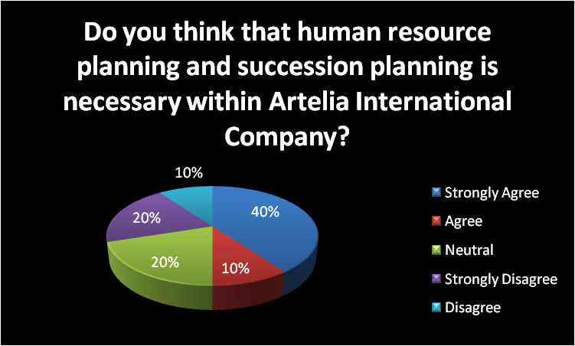
The representation of graph it can be generated that 50% concerning the total respondents think that that, Human Resource Planning and succession planning is necessary within Artelia International Company. On the other hand, 30% of the total respondents in the organisation did not rely with the facts. 20% of the respondent stays neutral regarding this allocated question. Question Number 02 Analysis
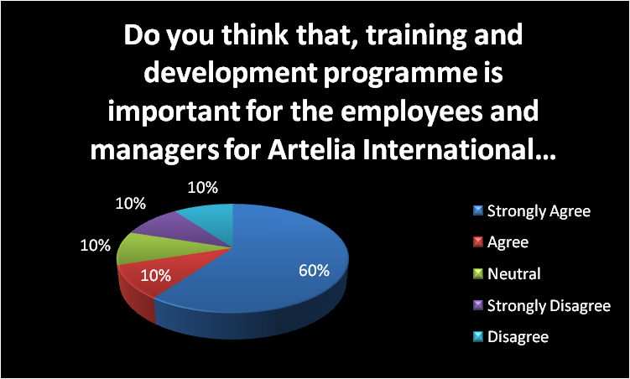
The overall chart has represented that 70% concerning the total respondents think that that, training and development programme is important for the employees and managers for Artelia International Company. On the other hand, 20% of the total respondents in the organisation did not rely with the facts. 10% of the respondent stays neutral regarding this allocated question. Question Number 03 Analysis
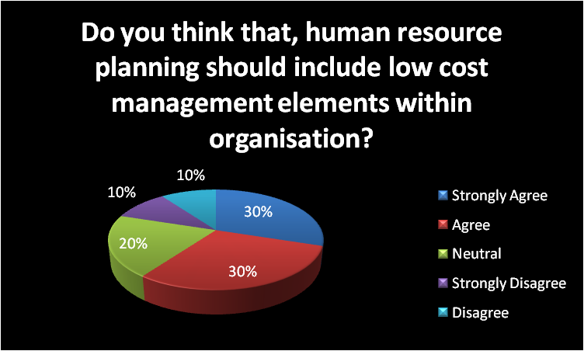
The overall graphical representation has encapsulated that 60% regarding the total respondents think that that, human resource planning should include low cost management elements within organisation. On the other hand, 20% of the total respondents in the organisation did not rely with the facts. 20% of the respondent stays neutral regarding this question.

Question Number 04 Analysis
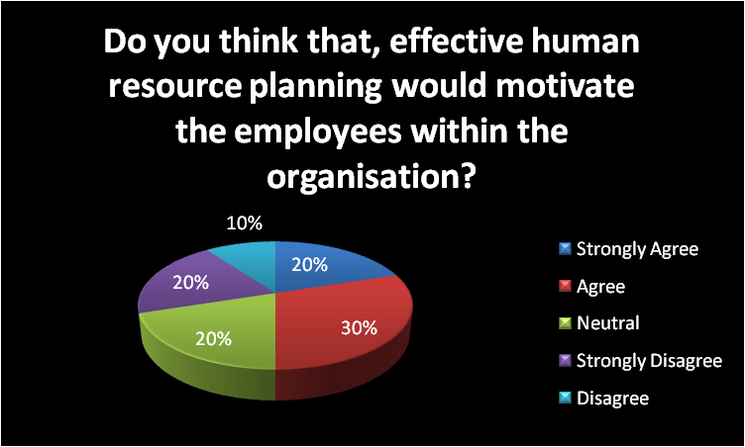
The above graphical representation has showcased that 50% concerning the total respondents think that that, effective human resource planning would motivate the employees within the organisation. On the other hand, 30% of the total respondents in the organisation did not rely with the facts. 20% of the respondent stays neutral regarding this question.

7. Reliability and validity of the research
The overall research data needs to be valid and reliable. All the resources of the data collection must be reliable and validate for the consistent outcomes of the research paper.

Reference
Rothwell, W. J. (2010). Effective succession planning: Ensuring leadership continuity and building talent from within. AMACOM Div American Mgmt Assn.
Armstrong, M., & Taylor, S. (2014). Armstrong's handbook of human resource management practice. Kogan Page Publishers.
Ulrich, D. (2013). Human resource champions: The next agenda for adding value and delivering results. Harvard Business Press.
Haddon, M. (2010). Modelling and quantitative methods in fisheries. CRC press.
Khandker, S. R., Koolwal, G. B., & Samad, H. A. (2010). Handbook on impact evaluation: quantitative methods and practices. World Bank Publications.
Davies, D. (1987). Methodology. San Diego: Academic Press.
Jha, N. (2008). Research methodology. Chandigarh: Abhishek Publications.
Ketchen, D. and Bergh, D. (2004). Research methodology in strategy and management.
Amsterdam: Elsevier.

