Dynamics Assignment
Question 1
a) a = p + q
a = 1.233 + 500 = 501
a = 501
b) $b= \frac{p}{r+s}$
$b= \frac{1.233}{5.90 ×{10}^{3}+0.004010}$
$b=2.08930508 ×{10}^{-9}$
$b=2.09×{10}^{-9}$
c) $c=\frac{\sqrt{p}}{s}$
$c= \frac{\sqrt{1.233}}{0.004010}$
$c=276.9$
d) $d= \frac{200}{{0.004010}^{3}}$
$d=3.102 ×{10}^{9}$
Question 2
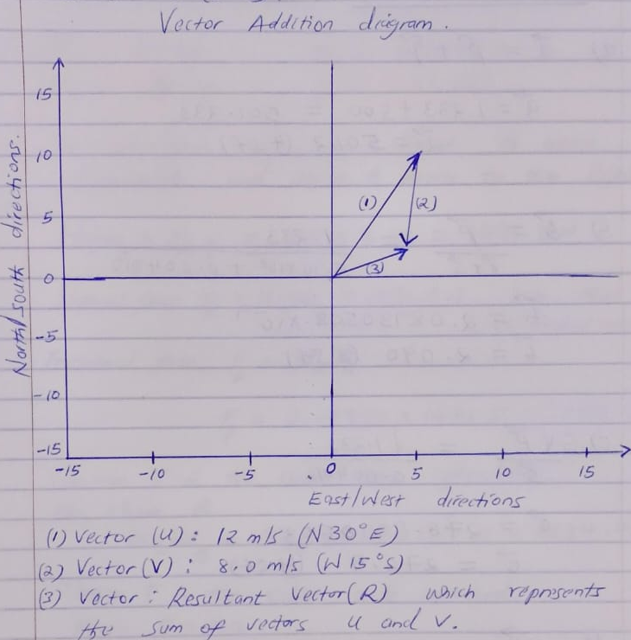
Question 3
$\vec{w}=96.00km (E {35}^{0} S)$
Find the Eastward component, $w_{x}$ and Southward component, $w_{y}$
$w_{x}=w\cos{35=96\cos{35}}$
$w_{x}=78.64 km (E)$
$w_{y}=w\sin{35=96\sin{35}}$
$w_{y}=55.06 km (S)$
Question 4
Vectors:
$\vec{a}=12 N (E {12}^{0} S)$
$\vec{b}=80.0 N (S {20}^{0} E)$
Vector addition using the sine and cosine law:
Angle between the vector, $θ=90-12+20={98}^{0}$
Using cosine law:
$R^{2}=a^{2}+b^{2}-2ab\cos{θ}$
$R^{2}={12}^{2}+{80}^{2}-2×12×80\cos{98}$
$R^{2}=6544-267.2124$
R = 82.5N
Using the sine law to find the direction
$\frac{Sin A}{a}=\frac{Sin B}{b}=\frac{Sin C}{R}$
Solving for angle α, which is between R and vector $\vec{b}$
$\sin{α= \frac{b\sin{θ}}{R}=\frac{80.0\sin{98}}{82.5}}=0.96026$
$α= \sin^{-1}{0.96026}=73.79$
$α ≈{73.8}^{0}$
The resultant force, R = 82.5N (S 73.8 E)
Question 5
Current river velocity, $V_{r}=2.35 m/s (S)$
Alex’s paddling velocity, $V_{c}=3.14 m/s \left(NW\right)at{ 13}^{0}$
Alex’s paddling velocity relative to the shore:
Alex is paddling at 13⁰ NW, we now find $V_{c}$ its westward (x) and northward (y) components
$V_{c, x}=V_{c}\cos{{13}^{0}=3.14\cos{{13}^{0}}=3.0595}$
$V_{c, y}=V_{c}\sin{{13}^{0}=3.14\sin{{13}^{0}}=0.7063}$
Adding the river velocity to canoe velocity:
$V_{y}= V_{cy}-V_{r}$ = 0.71 – 2.35 = -1.64 m/s (S)
$V_{x}=3.06 m/s$ (W)
V = resultant velocity
$V= \sqrt{V_{x}^{2}+V_{y}^{2}}=\sqrt{{3.06}^{2}+{1.64}^{2}}$
V = 3.47 m/s
Finding the direction:
$θ=\tan^{-1}{\frac{|V_{y}|}{|V_{x}|}}=\tan^{-1}{\frac{1.64}{3.06}}$
$θ=28.1889={28.2}^{0}$
Alex’s velocity relative to the shore is 3.47 m/s (${28.2}^{0} SW)$
Question 6
u = 19.3 m/s at 65⁰ above horizontal
Final height, h_{f} = 15.0m
g = 9.8 m/s²
Horizontal displacement, x = ?
Horizontal velocity, $u_{x}=u\cos{{65}^{0}}=8.2m/s$
Vertical velocity, $u_{y}=u\sin{{65}^{0}}=17.5 m/s$
$h_{f}=u_{y}t+\frac{1}{2}\left(-g\right)t^{2}$
$15.0 = 17.49t -\frac{1}{2}\left(9.8\right)t^{2}$
$15.0 = 17.49t – 4.905 t^{2}$
$4.905 t^{2}-17.49t+15.0 = 0$
Solving by quadratic formula:
$t= \frac{17.49 ±\sqrt{-{17.49}^{2}-(4 ×4.905 ×15.0)}}{2×4.905}$
t = 2.130 or t = 1.44
We take the lower value of t, Now
x = $u_{x}t=8.157×1.436$
x = 11.713 m
The cannon should be positioned at 11.7m horizontally from the stands.
Question 7
u = 1.005 m/s (E) t = 10.5s
a = 8.350 m/s² (N) Final velocity, V = ?
The motion involves perpendicular velocity and acceleration vectors
$V_{x}=u_{x}+a_{x}t=1.005+0*10.5=1.005 m/s$
$V_{y}=u_{y}+a_{y}t=0+8.350×10.5=87.675 m/s$
$V= \sqrt{V_{x}^{2}+V_{y}^{2}}=\sqrt{{1.005}^{2}+{87.675}^{2}}$
V = 87.6808
V = 87.68 m/s
Direction: $θ=\tan^{-1}{\frac{87.675}{1.005}={89.34}^{0}}$
The final velocity is 87.68 m/s (${89.3}^{0} NE)$
Question 8
u = 12 km/h (E) Time, t = 10.5s
V = 3.0 km/h (S) s =
u = 3.33 m/s v = 0.833 m/s
Since the motion involves changing direction, we break into two, x for east and y for south
$u_{x}=3.33 m/s (E)$
$u_{y}=0 m/s\left(No initial velocity in the South direction\right)$
$v_{x}=0 m/s\left(No velocity in the East direction\right)$
$v_{y}=0.833 m/s (S)$
From the kinematics equation; $s=ut+\frac{1}{2}at^{2}$
Finding the acceleration in each direction using $a= \frac{v-u}{t}$
a in the East, $a_{x}=\frac{0-3.33}{10.5}=-0.3171 m/s^{2}$
a in the South, $a_{y}=\frac{0.833-0}{10.5}=0.0793 m/s^{2}$
Then the displacement in each direction,
$S_{x}=3.33×10.5+\frac{1}{2}×\left(-0.317\right){10.5}^{2}=17.49m$
$S_{y}=0×10.5+\frac{1}{2}×0.0793×{10.5}^{2}=4.371 m$
$S=\sqrt{s_{x}^{2}+s_{y}^{2}}=\sqrt{{17.49}^{2}+{4.371}^{2}}=18.03$
Finding the direction, $θ=\tan^{-1}{\frac{4.371}{17.49}={14.03}^{0}}$
The displacement is 18.0m (${14.0}^{0} SE)$
Question 9
Using the kinematic equation for displacement: $s=ut+\frac{1}{2}at^{2}$
Where; s = displacement = 11.5m (NE)
u = initial velocity = 1.500 m/s (S)
t = 125 seconds
a = acceleration vector
Breaking the vectors into x and y for East and North respectively
$s_{x}=11.5\cos{{45}^{0}=8.1317m}$
$s_{y}=11.5\sin{{45}^{0}=8.1317m}$
u = 0 m/s v = -1.500 m/s (since South is negative)
For East direction:
$s_{x}=u_{x}t+\frac{1}{2}a_{x}t^{2}$, but $u_{x}=0$
$s_{x}=\frac{1}{2}a_{x}t^{2}$
$a_{x}=(2×8.131727)/{125}^{2}$
$a_{x}=1.04 ×{10}^{-3}m/s^{2}$
For y-direction (North-South)
$s_{y}=u_{y}t+\frac{1}{2}a_{y}t^{2}$
$8.13= -1.500×125+\frac{1}{2}×a_{y}×{125}^{2}$
$a_{y}=\frac{195.63}{7812.5}=0.0250 m/s^{2}$
a = $\sqrt{a_{x}^{2}+a_{y}^{2}}=\sqrt{{0.00104}^{2}+0.0250^2}$
a = 0.0250 m/s²
To find the direction of the acceleration:
$θ=\tan^{-1}{\frac{0.0250}{0.00104}={87.618}^{0}}$
$θ={87.6}^{0}$
The acceleration is slightly Eastward veering towards the North. Therefore, the constant acceleration is 0.0250 m/s² (2.4⁰ E of N).
Question 10
From the kinematic equation:
$v^{2}=u^{2}+2as$
Where v = final velocity; u = initial velocity; a = acceleration; s = displacement
$v^{2}=0^{2}+2×10×450=9,000$
Final velocity, V = 94.87 m/s (East)
Question 11
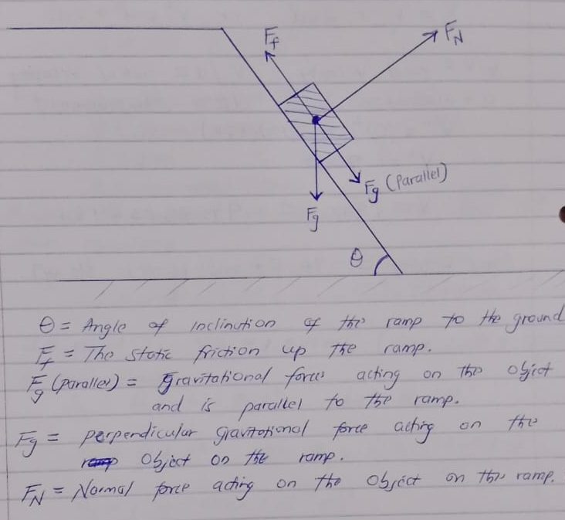
Question 12
Mass, m = 317 kg c_{k} = 0.225
Angle, θ = 18⁰ g = 9.8 m/s²
Component of gravity parallel to the ramp, F _{parallel} = mg sin θ
F _{parallel} = 317 x 9.8 x cos 18 = 960.9718 N
Force perpendicular to the ramp, $F_{N}=mg\cos{θ}$
$F_{N}=317×9.8×\cos{18}=2957.5670N$
Frictional force, $F_{f}=$ $F_{N}× c_{k}$
$F_{f}=0.225×2957.5670=665.4526N$
From Newton’s second law:
$F_{Net}=F_{parallel}-F_{f}$
ma = 960.9718 – 665.4526
$a=\frac{295.5192}{317}$
a = 0.9322 m/s²
Question 13
For the basket to maintain uniform circular motion, the minimum speed occurs at the top. At this point the only force providing the required centripetal force is gravity.
$F_{C}=F_{g}$
$\frac{{mV}_{min}^{2}}{r}=mg$
$\frac{V_{min}^{2}}{r}=g$
$V_{min}=\sqrt{rg}$
$V_{min}=\sqrt{9.8×0.75}$
$V_{min}=2.711 m/s$
At the bottom, the forces acting on the basket are tension (T), weight (mg), and centripetal force (F_{C}) required to keep the basket in circular motion. From Newton’s second law,
F = ma
$T-mg= \frac{mV^{2}}{r}$
$T=3.12×9.8+\frac{3.12×{2.71}^{2}}{0.75}$
T = 61.13 N
Question 14
M_{A} = 150kg C_{K} = 0.09950
M_{B} = 238kg g = 9.8 m/s²
The assumption is that object B moves downward and object A moves to the right.
${Weight}_{A}=m_{A}g=150×9.8=1470N$ since there is no vertical motion
Normal force, F_{N} = Weight _{A} = 1470N
Frictional force, $F_{f}=C_{K}F_{N}$
$F_{f}=0.09950×1470=146.3N$
Tension, T in the cable acts rightwards
For object B
Weight _{B} = M_{B}G = 238 * 9.8 = 2,332.4N
Tension T in the cable acts upwards
From F = ma
$T- F_{f}=M_{A}a$
$T- 146.3 =150a$
$T=150a+ 146.3$
$-T+ W_{B}=M_{B}a; 2332.4-T=238a$
$T=2332.4-238a$
Solving for a
150a + 146.3 = 2332.4 – 238a
Acceleration, a = 5.6 m/s²

