1. Introduction
In the light of the non-stop globalisation process, the issue of cultural diversity has received a close academic attention (Hsiao et al., 2015, p.102). Profit-making organisations, especially those operating on an international scale, have to deal with cultural diversity issues, which can result in communication problems and conflicts in the workplace (Ashikali and Groeneveld, 2015, p.773). This issue is especially relevant to the hospitality industry, which is characterised by a high proportion of expatriate workers, both in the UK and globally (Fe Causin et al., 2011, p.885; Malik et al., 2017, p.323). Therefore, hospitality companies’ managers should effectively deal with the issue of cultural diversity in order to avoid conflicts in the workplace, maximise the performance of their subordinates and contribute to the achievement of their firm’s objectives (Guillaume et al., 2013, p.15). The purpose of this essay is to critically review the most relevant models of employee diversity management as well as the strategies and techniques of diversity management, which are highly applicable to the context of the hospitality industry.

2. Models of Employee Diversity Management
Managing employee diversity in the hospitality industry refers to appreciating differences with respect to the non-discrimination of employees in their workplace, disregarding of their nationality and gender among other disparities (Sharma, 2016, p.2). According to Hsiao et al. (2015, p.102), hospitality organisations that employ a diversified workforce have a competitive advantage on the marketplace since they are more capable of coming up with creative ideas and solutions generated by their employees. At the same time, cultural diversity in the hospitality industry can potentially lead to negative consequences. The point is that consumers may experience communication difficulties with hotel employees from different cultural backgrounds (Shaban, 2016, p.76). The theoretical model shown in Figure 1 presents the key variables of diversity at work, namely age, gender, caste and religion, professional qualification, different perceptions and attitudes, language and geographical regions (Saxena, 2014, p.77).
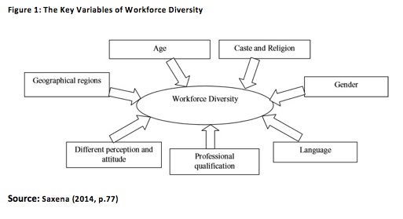
According to Saxena (2014, p.77) managers should put a heavy emphasis on these dimensions in order to minimise the negative impact of cultural diversity in the workplace. At the same time, the researcher overlooked the role of education, economy, heritage, communication and social participation as cultural diversity dimensions (Guillaume et al., 2013, p.15). The findings of Sharma (2016, p.3) are consistent with the observations of Saxena (2014, p.79) who also concluded that if all variables affecting workforce diversity were managed properly, it would lead to an increase in employee productivity. According to Sharma (2016, p.3), cordial interpersonal relationships enhance productivity and create helping behaviour. This is due to the fact that interpersonal connection directs towards employees within a particular organisation, which can potentially lead to a greater organisational performance (Liang et al., 2014, p.2).
There are several limitations and gaps of the model developed by Saxena (2014, p.79). The number of workforce diversity factors and effects in the model was limited. It could be improved by introducing additional positive outcomes (e.g. enhanced performance, higher level of innovation and improved employees’ helping behaviour) and additional factors affecting workforce diversity (e.g. teamwork cooperation and work motivation) (Liang et al., 2014, p.9). It must be noted that the exact type and level of employee diversity discussed in the model was not clearly specified (i.e. supervisor-subordinate or coworker-coworker diversity) (Liang et al., 2014, p.9). Finally, Saxena’s (2014, p.79) findings are based on secondary data, which can pose a potential threat to their validity and reliability.
To overcome the limitations mentioned above, Guillaume et al. (2013, p.4) presented a cross-level model focused on the individual-level outcomes of diversity. The model bridged the gap related to the lack of factors affecting diversity by including social, organisational and work group factors and identified new positive outcomes of employee workforce diversity (e.g. higher level of innovation, effectiveness and well-being) (Guillaume et al., 2013, p.4).
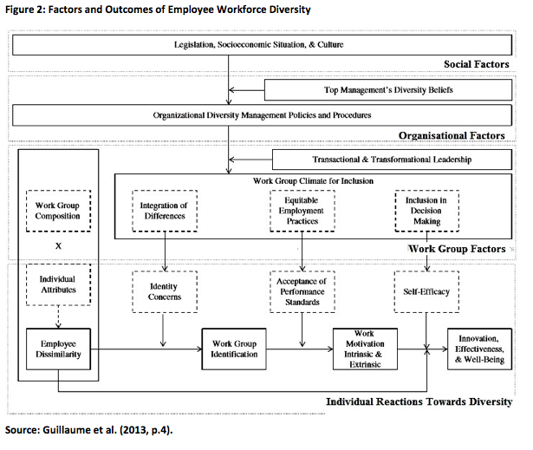
This model provides very useful information for organisational managers who tend to improve not only the market share in the domestic market, but also expand globally and create a discrimination-free work environment (Mollel et al., 2015, p.164). Given that hospitality organisations predominantly operate on the global scale, this theoretical framework is highly applicable to the hospitality industry. Nevertheless, diversity variables might vary within different organisations and might change over time. Hence, it is required to not just apply the original model, but adapt it to a particular organisational structure and make an extension by adding additional factors if needed (e.g. individual differences related to talents and experiences) (Guillaume et al., 2013, p.15).
Additional diversity management outcomes were identified in the findings of Hsiao et al. (2015, p.102), namely employees’ job performance, organisational citizenship behaviour and turnover intentions. All three outcomes depend on the perceived diversity of employees, which is also connected with their ethnic status (Hsiao et al., 2015, p.102). The findings of Hsiao et al. (2015, p.102) are consistent with the observations of Ashikali and Groeneveld (2015, p.757) who also identified organisational citizenship behaviour (i.e. an employee’s voluntarily commitment within the organisation) as an outcome of employees’ diversity in the workplace. The research results by Hsiao et al. (2015, p.110) are highly relevant to this essay since they gathered data for the hospitality industry.

3. Strategies and Techniques of Diversity Management in the Workplace
Human resource management (HRM) plays the main role in the process of managing workforce diversity in the workplace. Despite the fact that managing diversity effectively might significantly improve the overall organisational performance in the hospitality industry, there are still many challenges and barriers related to weak communication due to cultural differences and slow integration of ethnic employees (D’Netto et al., 2014, p.1246). Organisations have adopted various HRM techniques, which include recruitment and selection, promotions and rewards, different trainings, leadership development programmes and coaching (Davis et al., 2016, p.2). Improvement in communication in the workplace might increase workplace performance by providing an effective information flow among all employees and encouraging them to make decisions and share their ideas, which would increase their self-esteem (Davis et al., 2016, p.6). According to the findings by Shaban (2016, p.79), in order to improve the effectiveness of workforce diversity management, managers are required to adjust values and attitudes within organisations, which would increase diversity awareness. These findings suggest that hospitality companies’ managers need to embrace and make a commitment as an essential part of the strategy for diversity management. The outcomes by Davis et al. (2016, p.2) are in agreement with the observations of Shaban (2016, p.79) who also identified promotions, rewards and fair compensation among employees as a component for the implementation of an effective diversity management strategy.
The idea of workforce diversity should be supported by the top management of hospitality organisations as it might have a great impact on the formation of how their employees shape their personal diversity strategy (European Commission, 2015, p.17). HR mangers should have the necessary competences to manage culturally diverse workforces, namely cultural empathy, high expertise of the job, communication skills, managerial skills and leadership style (Dalton et al., 2015, p.78). The findings of Dalton et al. (2015, p.81) presented the Diversity Management Competencies Model (DMCM) and identified managerial competences on an individual and organisational level, required for establishing the most effective workforce diversity strategies and techniques. The DMCM has four components; self-awareness, cross-cultural awareness, diversity management awareness and diversity management implementation. For example, managers’ ability to understand their subordinates’ beliefs and monitor their own diversity sensitivity are attributed to the self-awareness dimension, while the ability to acquire cultural knowledge is usually attributed to the cross-cultural awareness dimension (Shaban, 2016, p.76). The DMCM is a very useful technique as it provides directions for hospitality companies’ management to focus on specific areas and improve their capabilities. However, the DMCM model did not take into account other aspects of diversity (e.g. age, gender or ethical aspects) and it was built on data gathered from one region (Dalton et al., 2015, p.81). Therefore, the generalisability of this framework is not considerable.
Another aspect of diversity in the workplace refers to the ethnical component that might be difficult to influence or change. Organisations that operate in the hospitality industry could use many different training techniques (e.g. classroom training, seminars and interactive courses and computer-based training) (Dwyer and Azevedo, 2016, p.290). Each of these techniques is very important as it could provide an insight into the values of different ethnic groups, their work ethics, different cultural habits and how each of them influences the organisation. Also, it must be noted that age differences among employees create workforce diversity and require different diversity management tools. Managers use different techniques to successfully manage and fill the gap between two different generations (e.g. including different reward systems according to their own generation’s values as some employees might require more time-off or another might appreciate a performance bonus) (Dwyer and Azevedo, 2016, p.290). According to Lee (2016, p.13) another useful technique of diversity management of two different generations of employees is internal audience segmentation, which can enhance employees’ effectiveness of internal communication tasks.
In addition to different techniques, the findings of Alcazar et al. (2013, p.43) identified various diversity management practices that influenced organisational performance, namely flexible compensation, flexible working hours, equality, intercultural training and participative performance assessment. The model shown in Figure 4 includes both internal and external factors as mediating variables in the process of diversity management.
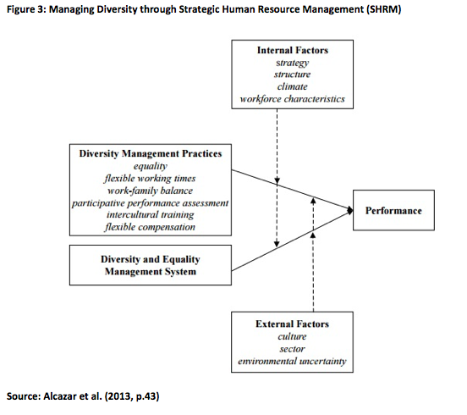
Although this model provides the reader with a better understanding of diversity management in the workplace, no effects of diversity were identified by Alcazar et al. (2013, p.43) and it was not specified which organisational performance might be improved. Nevertheless, this model is still applicable to the hospitality industry and its workforce as it identifies the most effective diversity management practices as well as the factors that influence the performance of culturally diverse workers (Malik et al., 2017, p.323). The findings by Mollel et al. (2015, p.170) allowed for making this model more focused and extended by analysing the effects of diversity. According to the researchers, diversity management through the speak-out culture leads to an increase in creativity and innovations (Mollel et al., 2015, p.170). In turn, a higher level of employee creativity in the workplace can significantly contribute to hospitality companies’ market share and even create a new market (Malik et al., 2017, p.323).

4. Conclusion
Diversity management plays an important role in hospitality companies’ survival and financial sustainability, especially in the context of the recent internationalisation and globalisation processes (Malik et al., 2017, p.323). By appreciating and successfully managing cultural diversity in the workplace, hospitality firms’ managers are able to enhance their subordinates’ productivity, establish better communication with them and add to the level of their motivation, commitment and satisfaction with their work (Liang et al., 2014, p.9). By adopting various HRM techniques (e.g. recruitment and selection, promotions and rewards, different trainings, leadership development programmes and coaching), hospitality organisations’ managers can successfully manage cultural diversity in the workplace and avoid its negative effects and consequences (Fe Causin et al., 2011, p.885). At the same time, the issue of cultural diversity also requires the commitment of the upper management since it affects the formation of how workers shape their personal diversity strategy (European Commission, 2015, p.17).

References
Alcazar, F., Romero Fernandez, P. and Gardey, G. (2013) “Workforce diversity in strategic human resource management models: A critical review of the literature and implications for future research”, Cross Cultural Management, 20 (1), pp. 39-49.
Ashikali, T. and Groeneveld, S. (2015) “Diversity Management for All? An Empirical Analysis of Diversity Management Outcomes across Groups”, Personnel Review, 44 (5), pp. 757-780.
D’Netto, B., Shen, J., Chelliah, J. and Monga, M. (2014) “Human resource diversity management practices in the Australian manufacturing sector”, The International Journal of Human Resource Management, 25 (9), pp. 1243-1266.
Dalton, L., D’Netto, B. and Bhanugopan, R. (2015) “Using the Diversity Management Competencies Model to Manage Diversity Effectively”, World Journal of Management, 6 (1), pp. 75-89.
Davis, P., Frolova, Y. and Callahan, W. (2016) “Workplace diversity management in Australia: what do managers think and what are organisations doing?”, Equality, Diversity and Inclusion: An International Journal, 35 (2), pp. 1-20.
Dwyer, R. and Azevedo, A. (2016) “Preparing leaders for the multi-generational workforce”, Journal of Enterprising Communities: People and Places in the Global Economy, 10 (3), pp. 281-305.
European Commission (2015) “Diversity within small and medium-sized enterprises best practices and approaches for moving ahead”, [online] Available at: http://ec.europa.eu/justice/discrimination/files/diversity_sme2015_en.pdf [Accessed on 16 December 2016].
Fe Causin, G., Ayoun, B. and Moreo, P. (2011) “Expatriation in the hotel industry: An exploratory study of management skills and cultural training”, International Journal of Contemporary Hospitality Management, 23 (7), pp. 885-901.
Guillaume, Y., Dawson, J., Priola, V., Sacramento, C., Woods, S., Higson, H., Budhwar, P. and
West, M. (2013) “Managing diversity in organisations: An integrative model and agenda for future research”, European Journal of Work and Organisational Psychology, 1 (1), pp. 1-20.
Hsiao, A., Auld, C. and Ma, E. (2015) “Perceived Organisational Diversity and Employee Behaviour”, International Journal of Hospitality Management, 48(1), pp. 102-112.
Lee, T. (2016) “Internal audience segmentation and diversity in internal communication”, Corporate Communications: An International Journal, 21 (4), pp. 1-27.
Liang, H., Shih, H. and Chiang, Y. (2014) “Team Diversity and Team Helping Behaviour: The Mediating Roles of Team Cooperation and Team Cohesion”, European Management Journal, 31 (1), pp. 1-12.
Malik, R., Madappa, T. and Chitranshi, J. (2017) “Diversity management in tourism & hospitality: An exploratory study”, Foresight, 19 (3), pp. 323-336.
Mollel, E., Mulongo, L. and Maket, L. (2015) “Workforce diversity management and global organisational growth in the 21st century”, Journal of Scientific Research and Studies, 2 (7), pp. 164-175.
Saxena, A. (2014) “Workforce Diversity: A Key to Improve Productivity”, Procedia Economics and Finance, 11 (1), pp. 76-85.
Shaban, A. (2016) “Managing and Leading a Diverse Workforce: One of the Main Challenges in Management”, Procedia- Social and Behavioural Sciences, 230 (1), pp. 76-84.
Sharma, A. (2016) “Managing Diversity and Equality in the Workplace”, Cogent Business & Management Journal, 3 (1), p

