Introduction to Economics of Real Estate
Real Estate is a major part of the economy in the United States. This is because it is one of the word’s largest markets, for most every citizen has a home or land they own. For example, in 2018, there were 5.34 million homes sold and 667,000 newly constructed homes sold in America according to the National Association of Realtors. Real Estate Economics is a term used to describe the utilization of economic concepts to further communicate patterns in real estate prices and expenditures. The term real estate economics can also be defined as housing economics, which is a term used for residential markets. An aspect of Economic Real Estate Concepts are the supply and demand of a market. Using this concept, investors, realtors, and home owners can make investments within their home or the market and determine the supply and demand through pricing patterns and trends. These market factors can also be affected by interest rates, government policies, demographics, and the overall economy of a state or region. Fundamentally, real estate economics is an endless cycle of buying and selling, which makes the figures for supply and demand constantly interchanging due to the many factors that focus in on the market of real estate.

Investors of the Real Estate Market
Investors are a significant group of people that buy and sell real estate within the market. They keep the real estate market’s supply and demand chain cycling to keep the market in balance. Investing in real estate is similar to investing within the stock market, there are risks and certain situations an investor must consider. The profits of real estate investing can be rewarding and exceptional; however, without the proper knowledge and experience, the profit can be less than what the expenses were on the project or home. There are also the factors of market value of the property that can either make the project worth more or less than paid for. Market values are determined by areas, and within those areas the value if affected by location, economy of the state or region, amount of acreage, and the general value of the neighborhood. In real estate investing, there are four types of investing and four types of investors. The first type of investing is the appreciation of a home or property, this occurs when the property increases in value over time rather than decreasing in value over time. Properties that would increase in value are preferably solid foundation homes that would be able to be renovated or updated in order to regain value over a course of several years. Also, land acreage value and properties of supply and demand are factors that would add value to a home or property. The second way to invest is through the profit of rental properties. This profit is from an investor buying property and renting it to a consumer that will pay a monthly sum for usage of a home, apartment, or land. The third investment is general real estate related income. This income is made from buying and selling homes then earning commission from those profits. The fourth and final type of investing is ancillary real estate income. This investment is minuscule compared to the other types of investing; however, it can have the highest rate of profit from selling. Ancillary real estate includes gum ball machines, vending machines, and other types of dispenser machines that can earn profit for the owner from being placed in office buildings, recreational areas, venues, and apartment lobbies. Looking further into detail of these four types of investments are the four types of investors that utilize these types of investing for greater profits. The four types of investors include homeowners, developers/renovators, land owners, and real estate brokers. Since homeowners are the main consumers of the real estate market, they are also considered investors in real estate. After buying or building a home they will invest their time and money into the home or land. Landowners are much like rental property investors by buying and leasing land to consumers. Many of these land leasing consumers are farmers who use the land for livestock or extra farming land or advertisers that use the land for billboards. The land property is an investment for the investor and remains so if ownership lasts. Renovators/ Developers are the third party of investors of the real estate market. They are the laborers who work diligently to build and repair properties to modern standards to insure quality and style. They are often hired or buy real estate to renovate or develop new landmarks for clients. Developers and renovators also gain profitable figures from projects and bids. The final group of investors are the real estate brokers. Real estate brokers sell home and other properties and receive commission from what they sell. Behind the simple process of selling is the tedious work of advertising, filing legal paperwork, and showing clients various homes. Between the investors and the investing types, the real estate market is always engaged from buying, selling, renovating, and developing, each of which go along the economic laws of real estate and the factors of supply and demand.
The Economic Crash of 2008
The economic crash beginning in 2008 was devastating to the American economy. It arose turmoil within the United States causing millions to lose their jobs, citizens owed more on their mortgage than their home was worth, and banks ran low on money. Despite the nine-year difference, however, the economic crash began to arise in 1999 creating trouble for the future of the American economy. Starting in 1999, subprime loans were given to citizens with low credit scores, low savings, and low incomes. This occurred because the Federal National Mortgage Association, also known as Fannie Mae, wanted to make mortgage loan accessible to those with lower monetary criteria than usual. The original plan for the movement was to assist each American citizen obtain the dream of homeownership; however, considering the borrowers were high risk, their interest rates and payments were set at a higher value. This was a considerable opportunity for those who sought to buy a home; nonetheless, it began to raise eyebrows and red flags of others who saw it as a harm to the economy. Eventually, by 2002, Fannie Mae had granted over three trillion dollars to subprime borrowers. Until 2006, the housing market was in considerable standards; however, there were the beginning signs of failure within the subprime loans. In 2007, subprime credit loans shifted to a halt and interest rate credit, and other loans increased substantially. On September 29th, 2008, the stock market crashed, causing many to lose their homes through foreclosure and file for bankruptcy, while millions of jobs were also lost within the United States. The effects were shattering to the United States economy and for the American people. Unemployment rates increased to ten percent and ten million people lost their homes to foreclosure during 2006 to 2014. The stock market crash is known as The Great Recession and the real estate market to this day is still coping with the effects of the crash, despite the efforts of the government to recovery the American economy.

How Did the Government Fix the Crash?
Despite the major losses of The Great Recession, the American government brought forth efforts to recover the American economy and housing market. Due to the drastic effects of the crash, the American government passed many controversial and strict monetary and fiscal policies. In February of 2009, Congress passed the American Recovery Reinvestment Act of 2009. The act was an effort to save the economy, save and create millions of jobs, and insure economic growth.

The Real Estate Market Today
Currently, there is a positive outlook for the future of the real estate economy. Last year in 2018, real estate transaction volumes were $579 billion, the second largest levels of transaction volumes since the financial crash of 2008. However, real estate economists have an outlook for the next three years and it might be alarming to many. In 2019, 2020, and 2021, the transaction volumes are expected to decrease; nonetheless, the numbers are moderating from the spike in 2018, which is completely normal. The numbers are also much higher than previous year’s numbers; therefore, the transaction volumes and real estate economy are still standing tall. Stated in the “ULI Real Estate Economic Forecast,” economists have predicted no end to the ongoing record of economic and real estate expansion. The growth of the industry, as well as the GDP and job growth are expected, making interest rates lower for the economy.
Aside from the moderation of the real estate economy, many American citizens fear for another returning collapse within the industry. Nevertheless, citizens do not have to pack their things up and file for bankruptcy, for there is a positive outlook from the last fatality. Since the crash, in recent years, there have been strict policies regarding loans and the way consumers go about buying and selling real estate. The government, along beside banks and other monetary lenders, keep a watchful eye the way cash is spent, loaned, and handled.
Figures
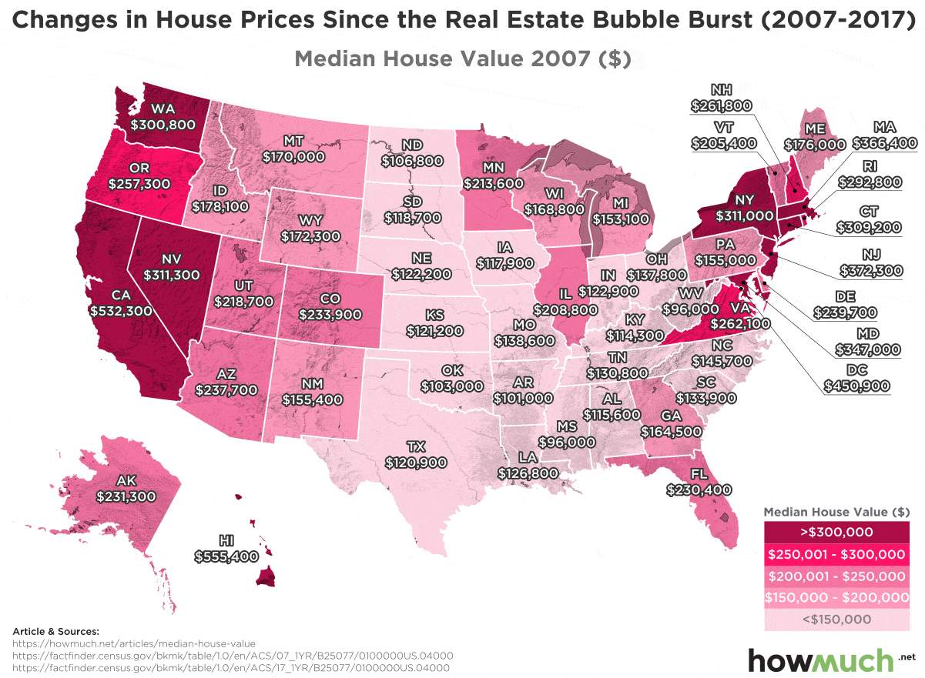
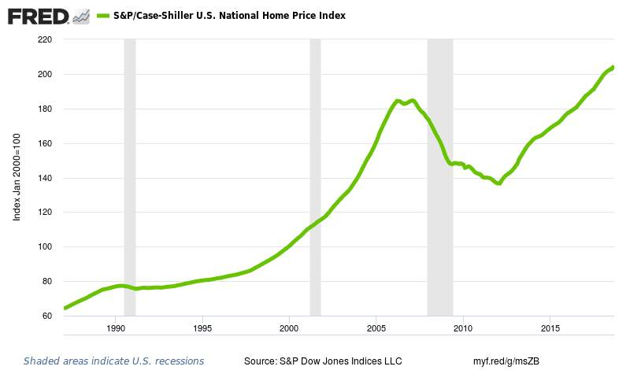

These figures show the price index of the housing market that were affected by the 2008 stock market and real estate housing crash. Many are still trying to recover from the losses they incurred.

Conclusion
The economy of real estate is a constant interchanging industry between supply and demand. It is a major industry that is crucial to the American economy because most every citizen has a home, rents, or invests within real estate. There have been issues in the past, creating devastating outcomes for many United States citizens that ended up causing them to lose their jobs, their homes, and file for bankruptcy. However, despite previous years, the present outlook for the American real estate economy is positive. It is expected to moderate and continue to grow for the next few years. Real estate is a source of profit and the feeling of the “American Dream” for many, it is valuable to the American nation.

Works Cited
- (adsbygoogle = window.adsbygoogle || []).push({}); Real estate economics. (n.d.). Retrieved September 23, 2019, from https://www.edinformatics.com/real_estate/real_estate_economics.htm.
- Bauman, V. (2018, December 3). States winning – and losing – the American real estate game, a decade after the housing bubble burst. Retrieved from https://www.dailymail.co.uk/news/article-6455843/States-winning-losing-American-real-estate-game-decade-housing-bubble-burst.html.
- Divided Decade: How the financial crisis changed housing. (2019, April 29). Retrieved October 1, 2019, from https://www.marketplace.org/2018/12/17/what-we-learned-housing/.
- Kennon, J. (n.d.). Investing in Real Estate. Retrieved September 28, 2019, from https://www.thebalance.com/investing-in-real-estate-4073643.
- Kosakowski, P. (2019, July 6). The Fall of the Market in the Fall of 2008. Retrieved September 30, 2019, from https://www.investopedia.com/articles/economics/09/subprime-market-2008.asp.
- Lusk, V. (n.d.). The Market Crash of 2008 Explained. Retrieved from https://www.wealthsimple.com/en-us/learn/2008-market-crash#about_the_2008_stock_market_crash.
- Metro Atlanta Home Group. (2018, December 22). US Housing Bubble: Will Real Estate Crash In 2019? Retrieved October 6, 2019, from https://www.metroatlantahome.com/blog/housing-bubble-real-estate-crash-2019/.
- Staff, I. G. (n.d.). An Economic View of Real Estate. Retrieved September 20, 2019, from http://www.investorguide.com/article/11734/an-economic-view-of-real-estate/.
- The Housing Market Crash of 2007 and What Caused the Crash. (n.d.). Retrieved September 28, 2019, from http://www.stockpickssystem.com/housing-market-crash-2007/.
- Treece, K. (2019, August 28). Real Estate Economics: Definition, Characteristics & Influencing Factors. Retrieved from https://fitsmallbusiness.com/what-is-real-estate-economics/.
- ULI Forecast Says Longest U.S. Economic and Real Estate Expansion to Continue through 2021. (2019, October 2). Retrieved from https://urbanland.uli.org/capital-markets/uli-forecast-says-longest-u-s-economic-and-real-estate-expansion-to-continue-through-2021/.

