Economics Assignment:Price of Basic Utilities
Question
Task:Globally food price has increased during the past year. In this context, answer the following questions;
- Explain why the law of demand applies to food just as it does to all other goods and services.
- Explain how the substitution effect influences food purchases. Provide some examples of substitutions that people might make when the price ol food rises, and other things remain the same.
- Explain how the income effect influences rood purchases and provide some examples of the income effect that might occur when the price of food rises, and other things remain the same.
Prices of houses in Australian metropolitan cities, particularly in Darwln Sydney and Metoume are on the rise in recent year, which is mainly due to surging land prices. In this context, answer the following questions:
- Why is the land price rising ¡n the metropolitan cities and what are the major drivers of rising house prices in these cities
- Using an appropriate diagram, explain your answer in part.
- Is the supply of land in the metropolitan cities perfectly inelastic? Why?
Sorne Australian state and territory governments have banned or are planning to ban plastic shopping bags due to negative externalities rising from their excessive use.
- Describe the externality that arises from plastic containers and bags. What is the best way to avoid or regulate negative externalities? Discuss.
- Draw a graph to illustrate how plastic containers and bags create welfare loss.
Answer
Introduction
In the past few years, the food price has accelerated dramatically and this overall affected common people. The low-income residents are the most impacted ones and substitution effect has major consequences on these food purchases. Furthermore, people’s income also has an impact on the food purchases and this would be explained in this economics assignment. Apart from global food prices, the Australian property also witnessed a major hike in their pricing framework and the reasons behind such a hike in pricing rate would also be detailed in this economics assignment. Moreover, the Australian government has proposed to ban the use of plastic containers due to its harmful impact on the environment. Plastic containers, as well as bags, create welfare loss and this will also be detailed in this economics assignment.
1. Increased global food price
1.1 Law of demand for food: Law of demand states that increased price of any goods would result in a decreased sales rate of the particular food products. In microeconomics, an increase in price is inversely proportional to the purchase rate of that item. Therefore, in case the prices of foods get increased this would result in lower demand for the food items. Barclay & Smith (2016:19) commented that the law of demand is applicable for food items due to the impact of substitution effect on these food items. It has been observed that with raise or accelerated food prices, people try to substitute food items with some other food products. Most of the people prefer to consume home-cooked foods as they are much cheaper as compared to the purchased foods. Asche et al. (2015:151-160) opined that this highly priced food would adversely impact the purchase rate of them.
It has been observed that the majority of people have shifted to home cooked meals and this increased price is one of the major reason behind such accelerated food prices. Therefore, it can be said that based on this law of demand, the increased food prices have adversely impacted the rate of purchase of foods.
1.2 Influence of substitution effect on global food purchases: It has been observed that most of the people shift to home cooked meals due to the increased food prices. Valin et al. (2014:51-67) stated that in the past few years, the food prices have increased drastically and this overall affected their purchase rates. People substitute to cheaper quality of foods and this affect their health conditions. It has been observed that the physical condition of most of the people gets affected by consuming cheaper quality of foods. The low-income people are mostly affected as they could not afford these high priced foods. Furthermore, many people change their diets so that they could consume less food in a day. This would help them to save money for future usage and therefore, it can be seen that this increased purchase rate of foods overall affected their health.
It has been observed that many people consume food two-times in a day in order to save money. This increased duration of fasting again affects their physical well-being. Therefore, it can be said that this increased price of foods have overall affected the health of the people as they have substituted their diet with cheaper food products.
1.3 Effect on income on food purchases: Constant earning level is adversely proportionate with the price hike and low price of food products. A person who has constant earnings $400 might be able to access standard food products. In case the same person when access a monthly wage of $1000, it will make the person interested to access some high quality and expensive food products. On the other hand, when the income is constant but the food price is going higher, it will be difficult to access high-quality food regularly. Australia is the 12th highest cost of living country in the world. The overall cost of living in this country is 9% higher than USA.
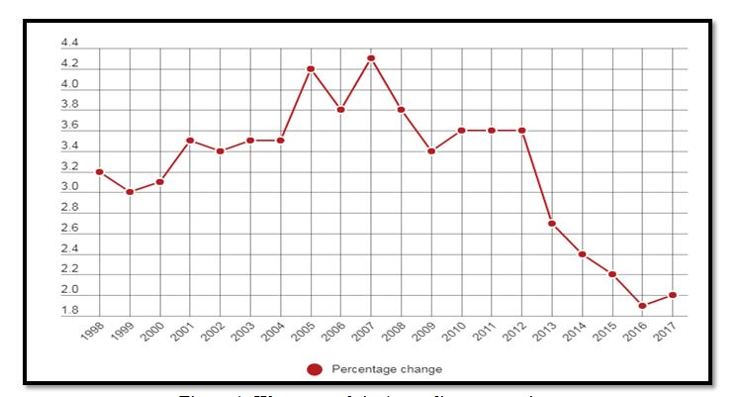
Figure 1: Wage growth in Australian companies
(Source: news.com.au, 2018)
As shown in the above graph the wage increasing rate is not much higher in the Australian economy. The effect of higher food price is affecting the living cost. It has assumed that in a middle-class Australian family people have to spend $45 daily. In contrary, the low growth rate in earnings creates barriers to accessing standard food products for all people. Low bargaining power of consumers cannot meet the satisfactory range of accessing products from the market.
2. Increased pricing rate of houses in Australian metropolitan cities
2.1 Reason for an accelerated land price in Australia: The population growth in Australia is highest in the last decade other than previous years. Additionally, the stable mortgage rate is getting remarkably lower in comparison with the economic stability. In order to purchase the stable mortgage people are getting interested in purchasing lands in Australia. In the housing industry, the companies are facing challenges in supplying new dwellings as the demand is reflecting inconsistency of land supply pipeline. On the other hand, Favilukis et al. (2017:140) said that it is only the strong demands for housing as well as people are looking to access a stable property in market.
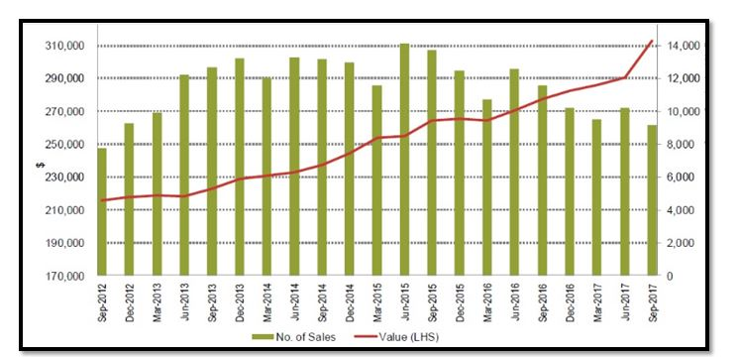
Figure 2: Number of sales and high value in Land purchasing market of Australia
(Source: corelogic.com.au, 2018)
Based on the above analysis it can be shown that from the year of 2016, the difference is getting higher in land purchase rate. Sydney, Melbourne and Perth are the main three places where the rate per square meter is much above normal selling rate.
2.2 Explanation of the accelerated housing prices with the help of a diagram: Housing affordability is another major issue that is the main reason behind the price hike of housing in Australian cities. Being the busiest part of the country along with good transport, communication facility housing range in Sydney is quite higher than other places. On the other hand, the places like Darwin, Melbourne are very attractive and effective places for leisure living. Beer et al. (2016:1542) said that people are highly focusing on these parts as they are looking to live in a comparatively peaceful place. Cashed up Gen x and Baby Boomers are accessing these places due to lifestyle reason. Often the wealthy people use to buy the houses just to stay for two or three weeks in a year. Indirectly, these tendencies are giving impact on the housing market which is long-term as well as cumulative.
Additionally, the issue of immigration has also pointed out as a serious issue that influencing housing price at this place. The immigrants more prefer to access accommodation in big cities which is creating a scarcity of living places. According to the statics of population growth, it has found that 86% of immigrants live in major cities in Australia whereas; 65% of citizens live in such places.
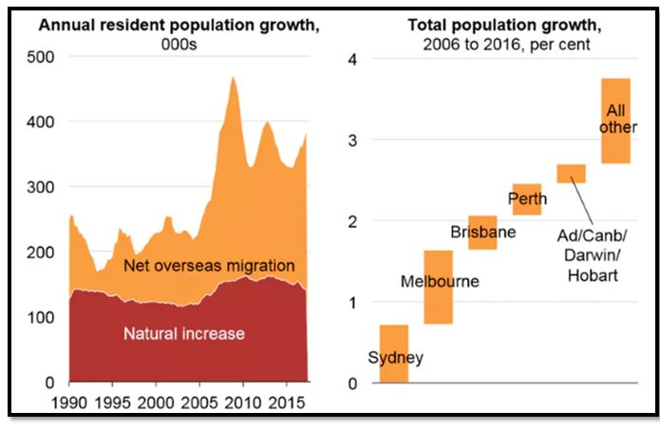
Figure 3: Accelerated housing sales in Australia
(Source: corelogic.com.au, 2018)
2.3 Elasticity of land in metropolitan cities: The supply of land has always defined as inelastic as according to the land economics land prices have no impact on the supply of land. As suggested by Kim et al. (2018:39), land value tax that recovers the land rent for public purposes does not affect on the opportunity cost of using land whereas, it only decreases the value of owing. Based on this opinion, it can be analyzed that land come on and off the market, inventories of land represent that an inverse relationship to price which can be implied as negative elasticity. Land elasticity can imply that it mainly happens for sectional employment growth in a country. An assertion about inelastic land supply presents with common experience. As suggested by Sato & Xiao (2015:63) cities with high land values generally experience less development than the cities with low land values. Based on this opinion, it can be said that either the supply of land is inelastic or the land price has little impact on supply of housing.
3. Banning of plastic shopping bags in by Australian territory
3.1 Rising externality from plastic containers
Damages from plastic containers: Disposal of plastic bags and containers has been growing as a serious problem due to its decomposing nature. Chemical stability prevents the plastic materials to be intact in environment. Plastic waste in sea beaches, parks, tourist spot create negative impact on the tourists.
Impact on Marine ecological system: 60-80% plastic waste mixes in seawater that effect on the marine ecological system. Ingestion and entanglement of harmful plastic waste turn in toxins for the marine life. Photo degradation and mechanical attrition make the plastic waste breakdown in small particles of detritus. It is indeed difficult to observe and quantify especially on the sea beaches.
Toxic emissions from plastics: The precarious emission from incineration of solid waste material is a major factor to generate negative externalities. The gases released from the decomposition process are extremely harmful as it includes cyclic chlorinated hydrocarbons. Emission of PVC incineration and hydrogen chloride is very much toxic for the human as well as animals. As suggested by Wardrop et al. (2017:74), the effect of such emissions contributes in generating acid rain.
Ineffective recycling process: Recycling rate for plastics is still less than 25% which comparatively much lower than other recycling materials. Inconsistency in recycling process has been resulting in the steady growth of plastic waste and enhancing environmental impact in every year. As suggested by Landon-Lane (2018:310), low demand of product manufactured by previously used plastic material is the reason behind low recycling rate. The plastic industry is focusing to use polymer based materials that are low in cost whereas; the materials cannot be used again. These factors continuously affect the environment of the country.
In order to avoid the negative impacts, it is necessary to avoid the use of plastic bags and containers in everyday life. Initially, it is necessary to keep a banning on the plastic bags. As opined by Willis et al. (2017:45), it is not possible to entirely ban plastic bags as it is a part of everyday use. According to the scholar, using some substitution material of the same value can be a better solution. Ireland has already imposed a tax rate on plastic bags which is an effective measure to decrease the use. Based on the biodiversity conservation Act 1999, use of plastic bags must be minimum in the country. Based on this act, the negative impact can be decreased rapidly in the state of Australia.
>3.2 Graphical representation of the creation of welfare loss due to the use of plastic containers
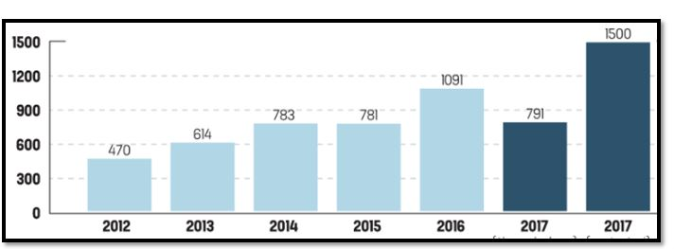
Figure 4: Number of welfare activities that hampered due to plastic containers
(Source: corelogic.com.au, 2018)
As shown in the above graph, it can be said that Australia has been suffering from the plastic waste disposal. As suggested by Lamb et al. (2018.460), the welfare activities have been consistently hampering from the rapid use of plastic bags. As a non-biodegradable product, plastic bags take 400 years for being decomposed. Australia is an enriched place due to its attractiveness and heritage tourist places. Where the country is growing as a place of culture and tourist spots, plastic waste is affecting the scenic beauty of this place. As there is no restriction in using plastic bags tourists and native people usually throw the bags after use. It not only effects on the environment but also hampered the beauty of this place. Another major impact falls on the health welfare activities. Australia usually provides the best medical infrastructure for the health services users. Due to large waste that is generated from medical operations and activities also consume 69% plastics.
These large percentages of medical waste are not only effective to hamper welfare activities but also provide negative impact on the services users. According to the viewpoint, Auxilio et al. (2017:143) supply of fresh water may not be possible within a few years as there is a layer of plastic and plastic waste in the internal part of this earth. It will create the scarcity of water not only Australia but also in several other countries. Australian cities are best known for its cleanliness and decorative representation. Plastic containers also hampered the drainage system that will affect human life due to water logging and several other activities. Pollution level is another major issue that is indirectly increasing by plastic bags in the cities of Australia. Whereas, the government is trying to mitigate the carbon emissions from industries and automobile usage, the effect of plastic bags is creating a long-term negative impact on the environment as well as human welfare.
4. Conclusion
It can be concluded from the above economics assignment that the global factors, as well as changes, are affecting the human life as well as environment. Based on three issues the economics assignment has evaluated the present condition that affects the lifestyle of Australian cities. Concerning increasing food price has defined that there are several indirect factors that affect on the price of food. In analysing the reasons it has pointed out in this economics assignment that not only production cost but also increasing earnings influence for the enhancement of food products. Based on Australian metropolitan cities, the issue has highlighted about the price hike of land and housing. Increasing percentage of immigratory people and tendency to buy stable mortgage is the key factors in this case. Additionally, the habit of living in most advanced places is another influencing factor. Banning of plastic bags is another key issue that affect on environment as well as human lifestyle. The discussion has suggested that though the government is trying to decrease the rate of plastic use yet there is loss in welfare activities.
References
Barclay, K., & Smith, G. (Eds.). (2016) East Asia's Demand for Energy, Minerals and Food: The International Politics of Resources. Abingdon: Routledge.
Asche, F., Bellemare, M. F., Roheim, C., Smith, M. D., & Tveteras, S. (2015) Fair enough? Food security and the international trade of seafood. World Development, 67, 151-160.
Auxilio, A. R., Choo, W. L., Kohli, I., Srivatsa, S. C., & Bhattacharya, S. (2017). An experimental study on thermo-catalytic pyrolysis of plastic waste using a continuous pyrolyser. Waste Management, 67, 143-154.
Beer, A., Bentley, R., Baker, E., Mason, K., Mallett, S., Kavanagh, A., & LaMontagne, T. (2016). Neoliberalism, economic restructuring and policy change: Precarious housing and precarious employment in Australia. Urban studies, 53(8), 1542-1558.
Favilukis, J., Ludvigson, S. C., & Van Nieuwerburgh, S. (2017). The macroeconomic effects of housing wealth, housing finance, and limited risk sharing in general equilibrium. Journal of Political Economy, 125(1), 140-223.
Kim, J. H., Hipp, J. R., Basolo, V., & Dillon, H. S. (2018). Land Use Change Dynamics in Southern California: Does Geographic Elasticity Matter?. Journal of Planning Education and Research, 38(1), 39-53.
Lamb, J. B., Willis, B. L., Fiorenza, E. A., Couch, C. S., Howard, R., Rader, D. N., ... & Harvell, C. D. (2018). Plastic waste associated with disease on coral reefs. Science, 359(6374), 460-462. Landon-Lane, M. (2018). Corporate social responsibility in marine plastic debris governance. Marine pollution bulletin, 127, 310-319.
Sato, Y., & Xiao, W. (2015). Land development, search frictions and city structure. Regional Science and Urban Economics, 50, 63-76.
Valin, H., Sands, R. D., van der Mensbrugghe, D., Nelson, G. C., Ahammad, H., Blanc, E., ... & Heyhoe, E. (2014) The future of food demand: understanding differences in global economic models. Agricultural Economics, 45(1), 51-67.
Wardrop, N. A., Dzodzomenyo, M., Aryeetey, G., Hill, A. G., Bain, R. E., & Wright, J. (2017). Estimation of packaged water consumption and associated plastic waste production from household budget surveys. Environmental Research Letters, 12(7), 74-85.
Willis, K., Maureaud, C., Wilcox, C., & Hardesty, B. D. (2017). How successful are waste abatement campaigns and government policies at reducing plastic waste into the marine environment?. Marine Policy, 12(7), 45-55. Available from: https://www.sciencedirect.com/science/article/pii/S0308597X17305171[Accessed 30th August 2018]
corelogic.com.au (2018). Corelogic.Com.Au Available from: https://www.corelogic.com.au/sites/default/files/2017-08/2015-09-17--property-pulse-article.pdf [Accessed 30th August 2018]
corelogic.com.au (2018). Corelogic.Com.Au Available from: https://www.corelogic.com.au/sites/default/files/2017-08/2015-09-17--property-pulse-article.pdf [Accessed 30th August 2018]

