Climate Change Adaptation Interventions in Machakos County, Kenya

TABLE OF CONTENTS
DEDICATION i
ACKNOWLEDGEMENT ii
TABLE OF CONTENTS iii
LIST OF TABLES v
LIST OF FIGURES vi
ACRONYMS vii
ABSTRACT viii
CHAPTER 1: INTRODUCTION 1
1.1 Climate change and agriculture 1
1.2 Overview of climate change adaptation (CCA) 3
1.3 Problem statement 5
1.4 Research objectives and Research questions 6
1.5 Dissertation structure 7
CHAPTER 2: LITERATURE REVIEW 8
2.1 Introduction 8
2.2 Empirical review on climate change adaptation 8
2.3 The role of agricultural extension and advisory services 12
2.4 Theoretical framework 15
2.5 Conclusion 17
CHAPTER 3: METHODOLOGY 18
3.1 Introduction 18
3.2 Study area 18
3.3 Data 19
3.4 Data analysis 20
3.5 Limitations of the study 24
3.6 Conclusion 25
CHAPTER 4: EXTENSION OFFICERS’ PERCEPTIONS ON CLIMATE CHANGE IN RELATION TO CLIMATE DATA 26
4.1 Introduction 26
4.2 Descriptive analysis of climate variables 26
4.3 Comparison of first and second season 27
4.4 Evolution of climate variables 28
4.5 Results of auto regressive distributed lag model for climate variables 32
4.6 Extension officers’ perceptions on climate change 37
4.7 Conclusion 42
CHAPTER 5: EXTENSION OFFICERS’ CLIMATE CHANGE ADAPTATION RECOMMENDATIONS 43
5.1 Introduction 43
5.2 Management practices recommended by extension officers 43
5.3 Results of factor analysis of drivers of climate adaptation recommendations 44
5.4 Results of logit model of extension officers’ climate change adaptation recommendations to farmers 46
5.5 Results of cluster analysis of crops recommended by extension officers 58
5.6 Results of the logit model of extension officers’ crop recommendations 61
5.7 Conclusion 65
CHAPTER 6: CONCLUSION AND RECOMMENDADTIONS 66
6.1 Conclusions 66
6.2 Policy implication 67
6.2 Areas for further research 68
REFERENCES 69
APPENDICES 74
A.1 Extension officers’ questionnaire 74
A. 2 Ethical clearance sheet 83

LIST OF TABLES
Table 1: Descriptive analysis of climate variables .......................................................................... 27
Table 2: Comparison of the first and second season ....................................................................... 28
Table 3: Augmented Dickey- Fuller test for stationarity and Jarque Bera’s test for normality of
climate variables .............................................................................................................................. 32 Table 4: Regression of temperature variables ................................................................................. 33
Table 5: Regression of change in rainfall related variables............................................................. 35
Table 6: Extension officers’ socioeconomic characteristics............................................................ 37
Table 7: Component loadings .......................................................................................................... 45
Table 8: Results of logit model of extension officers’ climate change adaptation recommendations to wealthy farmers (Intercropping, agroforestry, long maturing crops, manure and drought tolerant
crops) ............................................................................................................................................... 47
Table 9: Results of logit model of extension officers’ climate change adaptation recommendations to wealthy farmers (crop diversifications, irrigation, early planting, early maturing crops) ........... 48 Table 10: Results of logit model of extension officers’ climate change adaptation recommendations to resource poor farmers (Intercropping, agroforestry, long maturing crops,
manure and drought tolerant crops) ................................................................................................. 49
Table 11: Results of logit model of extension officers’ climate change adaptation recommendations to resource poor farmers (crop diversifications, mixed farming, irrigation, early
planting, early maturing crops) ........................................................................................................ 50
Table 12: Results of the logit model of extension officers’ crop recommendations to farmers ...... 62

LIST OF FIGURES
Figure 1: Theoretical framework ..................................................................................................... 17
Figure 2: Map of Machakos County ................................................................................................ 18
Figure 3: Time series of temperatures variables .............................................................................. 29
Figure 4: Time series of first season rainfall related variables ........................................................ 30
Figure 5: Time series of second season rainfall related variables ................................................... 31
Figure 6: Extension officers’ perceptions on the start of the season ............................................... 38
Figure 7: Extension officers' perceptions on climate variables ....................................................... 39
Figure 8: Extension officers' CC adaptation recommendations ...................................................... 44
Figure 9: Crops recommended to farmers ....................................................................................... 58
Figure 10: Crops recommended to resource poor farmers and cluster differences ......................... 59
Figure 11: Crops recommended to wealthy farmers and cluster differences .................................. 60

ACRONYMS
AEAS: Agricultural Extension and Advisory Services
ARDL: Auto Regressive Distributed Lag Model
ASALS: Arid and Semi-Arid Lands
CC: Climate Change
CCA: Climate change Adaptation
ELM: Elaboration Likelihood Model
GDP: Gross Domestic Product
GOK: Government of Kenya
PC: Principal Component
SAP: Structural Adjustment Programs
SAS: Statistical Analytical System
SSA: Sub Sahara Africa

ABSTRACT
Agriculture in Machakos is mainly rain fed thus susceptible to climate variability. The vulnerability of the agricultural sector in the area to climate variability is exacerbated further by interaction of compound stresses and existing developmental challenges such as endemic poverty; complex governance and institutional dimensions; limited access to capital and markets; inadequate infrastructure and technology; ecosystem degradation; and complex disasters and conflicts. Agricultural Extension and Advisory Services (AEAS) and their effective functioning play a critical role in mainstreaming climate change adaptation objectives. However, there is fear that the agricultural extension and advisory service in the area may have inadequate knowledge and capacity to facilitate climate change adaptation.
The study assessed the perceptions of extension officers on climate variability and change and compared the perceptions to climate variability as depicted by climate data. It also investigated the climate change adaptation recommendations made by the extension officers to farmers and assessed factors that influence the recommendation options. Climate data from Katumani meteorological station which serves Machakos region was analysed and compared to field survey data on perceptions of climate change, climate change adaptation recommendations as well as factors driving the CCA recommendations collected using questionnaires administered to 106 extension officers drawn from the public and private agricultural sectors in Machakos.
Majority of the extension officers perceive a general changing climate. According to them, negative changes have transpired in regards to temperature, amount of rainfall, number of rainy days, start (onset) of seasons as well as with the frequency of droughts and floods. Results show that the extension officers have precise perception on temperature trends which is supported by temperature data. Conversely, most of their perceptions on rainfall related parameters are contrary to rainfall data. Policy aimed at enhancing the adaptive capacity of AEAS should consider building the capacity of extension officers to provide them with the precise climate information as well as create new technological capabilities of agro metrological extension within the institution.
The climate adaptation recommendations mainly consisted of agronomic management practices and different crop combinations. The most popular management practice recommended to resource poor farmers was mixed farming whereas that for wealthy farmers was use of manure and fertilizers. Mixed farming was however the least recommended strategy to wealthy farmers while irrigation was least recommended to poor farmers. Efforts to promote climate change adaptation strategies in the area should identify optimal combination of agricultural management practices suitable for the area as well as find climate change adaptation options outside agriculture such as building social and community networks and improving markets and economic
infrastructure.
Word count of dissertation = 13656

CHAPTER 1: INTRODUCTION

1.1 Climate change and agriculture
Climate change (CC) is a global challenge to development whose onset is largely indefinite (Simpson and Burpee, 2014). It has direct and indirect impacts on health, agriculture and water availability which affect rural livelihood negatively (Osbahr et al., 2011). The impacts to exert pressure on the world’s vulnerable food system that has a complex relationship with the environment, social and economic systems (Bruce et al., 1996) and may be catastrophic if timely actions are relinquished. Vulnerability to CC impacts is worsen by extreme poverty in developing countries (Sietz et al., 2008). Agriculture and livestock production are not only affected by CC, but the sectors also contribute immensely to the problem of CC since their activities are key triggers of environmental degradation and carbon dioxide emissions (Simpson and Burpee, 2014).
The vulnerability of the agricultural sector in Africa to climate varability is exacerbated further by interaction of compound stresses and existing developmental challenges such as widespread poverty; intricate governance and institutional dimensions; limited access to capital and markets; inadequate infrastructure and technology; ecosystem degradation; and complex disasters and conflicts. Vulnerability of farm households and agricultural sector could be reduced through various climate adaptation strategies (Simpson and Burpee, 2014) such as use of seasonal weather forecast, climate information and economical farm management practices and technologies. Provision of climate infomation offers a potential to modify agricultural management decisions such as land preparation, planting decisions and choice of crop to expected climatic variations to reduce adverse impacts or take advantage of favourable conditions (Hansen and Indeje, 2004).
Projection point out that global mean temperatures will rise by about 1.5ºC to 4.5ºC (Field, 2012).
In the past sixty years, the average global air temperature rose by about 0.6⁰C (Field, 2012). The increase in temperature is anticipated to trigger changes in the onset and lengths of seasons and duration of rainy days which will sequentially alter the timing of plant flowering, plant polinator and pest relatonship (Simpson and Burpee, 2014). In Africa, CC is predicted to modify the water cycle. Most climate models forecast a reduction in precipitation which means a decline in available surface water and river runoff (Sietz et al., 2008) hence an upsurge water scarcity and severity of droughts. Some of the models approximate a temperature rise of about 3ºC to 4ºC by the end of the 21st century.
Bryan et al. (2013) estimate that the combined effect of temperature rise and decline in precipitation would intensify evapotranspiration which would reduce yield of crops such as maize, sorghum, millet, groundnut and cassava by about 8% to 22% by 2050 in Africa. Agriculture in Sub Sahara Africa (SSA) contibute 33% of the region’s gross domestic product (GDP), 66% of its labour force and 40% of its exports thus alterations in climate especially temperature increase could undermine the basis of these economies and lead the region into destitution (Ikeme, 2003).
Kenya’s rural economy is dependent on rain fed agriculture which is susceptible to climate variability (Mogaka, 2006). Climate variability in Kenya is likely to have substantial effect on agriculture and livestock productivity and revenue. Global circulation models project that Kenya would face temperature increase of about 3.5ºC to 4ºC and rainfall variability of up to 20% by 2030 (Kabubo-Mariara and Karanja, 2007). Canadian Climate Model predicts a shortfall of revenue of about 1% (US$3.54 per hectare) and 21.5% (US$54 per hectare) in high and medium potential crop areas respectively by 2030 whereas Geophysical Fluid Dynamics Laboratory (GFDL) forecasts loss of revenues of about US$32 per hectare in high potential and about US$178 loss in medium and low potential zones by the year 2030. Quantitative crop yield projections under CC scenarios for Kenya differ across studies due to application of different models, assumptions and emission scenarios. However bulk of the studies predicts a decline in yields with CC for Kenya’s staple crops; maize and beans.
The Government of Kenya (GOK) faces a challenge of feeding its population of about 50 million taking into account the declining agricultural productivity and envisaged impacts of climate variability on agriculture (Kabubo-Mariara and Karanja, 2007). Government’s effort to increase productivity is undermined by volatile climate variability whose effects are severe in the Arid and Semi-Arid Lands (ASALs) where Machakos County is situated consequently causing longstanding food insecurity, water and energy shortages and rendering the area unsuitable for farming certain food crops (Oppenheimer, 2013). As a result GOK devised and initiated Strategy for Revitalizing Agriculture (SRA) for execution in 2004 under agricultural sector policies to spearhead sustainable utilization of ASALs through several climate change adaptation (CCA) strategies such as irrigation development, water harvesting, agro-forestry, development and promotion of early maturing crops, drought and pest tolerant crop varieties and improved livestock marketing (Ndambiri et al., 2013).

1.2 Overview of climate change adaptation (CCA)
The impacts of CC on society and the environment are global problems for public policy and decision-making (Dessai et al., 2009). Given the inherent difficulty of avoiding CC, adaptation is perceived as a way of countering the anticipated impacts of long-term CC on various sectors of the economy (Kabubo-Mariara and Karanja, 2007). Individual and societal adaptations to CC is an old phenomenon, historically stimulated by resource scarcities and irregularities posed by different climates and weather variability (Adger et al., 2009). Dessai et al. (2009) argue that adaptation could help address vulnerability without requiring accurate probabilistic predictions. International climate politics advocate for adaptation and mitigation as ways of reducing vulnerability and enhancing resilience of agricultural systems and closely relate it to sustainable development (Adger et al., 2009).
Climate change adaptation (CCA) denotes ‘adjustment by the affected natural or human systems in response to actual or expected climate stimuli or their effects, in order to moderate harm or to benefit from opportunities associated with CC (Grothmann and Patt, 2005, Adger et al., 2009, Field, 2012). Adaptations consist of actions throughout the society by individuals, groups and governments which may involve both building adaptive capacity and implementing adaptation decisions (Raymond and Spoehr, 2013). Adaptation need the participation of many stakeholders, including farmers, policymakers, extension agents, NGOs, researchers, communities and the private sector (Bryan et al., 2013). “CCA planning and implementation require governance at all scales even though most adaptation activities have different goals and are inclined towards smaller scales’’ (Oppenheimer, 2013).
According to Adger et al. (2009) the goals of CCA varies amongst development agents such as researchers and extension officers. The goal dissimilarities amongst stakeholders in CCA may constrain global adaptation and mitigation process (Oppenheimer, 2013). For some development agents’ CCA requires maintenance of status quo, while for others the current state is undesirable and hence there is need for technological innovations. Wealthier groups may strive for maintenance of their status quo or standard of living through adaptation, poor populations may concentrate on improving their present circumstances while CCA priority marginalised societies may aim at securing livelihoods or protecting assets from adverse effects and risks associated with climate variability (Adger et al., 2009).

1.3 Problem statement
Agricultural Extension and Advisory Services (AEAS) and their effective functioning play a critical role in mainstreaming climate change adaptation objectives. Successful CCA needs participation of all AEAS providers’ from both the private and public sectors to design and implement adaptive measures. Previous study by Ndambiri et al. (2013) in Kenya established that farmers access to information on climate change through the AEAS significantly influence the probability of farmers to perceive and or adapt to CC.
However, the existing knowledge of adaptation and adaptive capacity in sub-Sahara counties may be unsatisfactory for reliable projection of adaptation and adaptive capacity and insufficient for implementing, evaluating and planning adaptation options, measures and policies (Ikeme, 2003, Jarvis et al., 2011). Agricultural extension and advisory services in Kenya may have inadequate capacity to facilitate climate change adaptation thus an institutional barrier. Institutional barriers relate to how formal and informal institutions influence CCA (Raymond and Spoehr, 2013) and often include lack of human resources within relevant institutions such as AEAS, insufficient data and information availability, inadequate data and information dissemination (Sietz et al., 2008).
Uptake of CCA recommendations depend on individual extension officer’s ability to effectively communicate to farmers alternative adaptive measures that increase their production and economic outcomes given the risk posed by climate change (Hansen and Indeje, 2004). The capacity of the AEAS to successfully facilitate CCA is based on extension officers’ experience, perceptions, knowledge, technical skills and the organizational environment in which people apply their skills (Sietz et al., 2008). Extension officers may however possess divergent perceptions on climate change due to different approaches to climate science and politics which motivates their knowledge claims thus creating information disparity on the climate change adaptation strategies promoted by the extension officers.
Extension officers’ perceptions on CC is shaped by contested scientific knowledge, attributions of liability and political activism alongside beliefs and values through which individuals make recommendations (Raymond and Spoehr, 2013). Inadequate agricultural extension and advisory facilities could interpreted as a lost opportunity at best and at worst a social cost to farmers who may remain ignorant of simple climate adaptation measures such as right time of planting and use of drought-resistant crop varieties (Ikeme, 2003). Imprecise information on climate change may be reflected as incapability of AEAS to facilitate CCA resulting in dissemination of CC maladaptation to farmers which are socially and economically costly interventions when time and money are scarce. Understanding extension officers’ perceptions of CC in comparison to actual climate data and their adaptation recommendations as well as factors driving their decisionmaking process help in assessing the capacity of the agricultural extension and advisory services to support CCA which is essential to guide policies aimed at encouraging adaptation in the agricultural sector.

1.4 Research objectives and Research questions

Research objectives
- Assess the perceptions of extension officers on climate change and variability and compare the perceptions to climate variability as depicted by climate data.
- Investigate the climate change adaptation recommendations made by the extension officers to enable farmers adapt to climate variability and assess factors that influence the recommendations options.

Research questions
- What are the perceptions of extension officers on CC? Are the perceptions of extension agents consistent with actual climate data?
- What are the current CC adaptation recommendations made by the extension officers?
What are the factors that influence these CC adaptation recommendations?

1.5 Dissertation structure
The dissertation is organized into six chapters. Chapter one is the gives a general overview of CC adaptation and objectives of the study. Chapter two presents the literature review of the topic. In chapter three describes the methodology that was used. In chapter four explains results and discusses extension officers’ perceptions on CC in relation to climate data. Chapter five represents results and discussions on extension officers’ CC adaptation recommendations. Chapter
six presents the conclusions and recommendations.

CHAPTER 2: LITERATURE REVIEW

2.1 Introduction
This chapter presents on the second section different pieces of research that have been done on CC adaptation in the past. The third section describes the role of agricultural extension service in different part of Africa and the fourth section explains the theoretical framework upon which the study is based.

2.2 Empirical review on climate change adaptation

Perceptions on climate change
Several studies have assesed farmers perceptions of CC in relation to actual climate data (Osbahr et al., 2011, Abongu, 2013, Bryan et al., 2013, Rao et al., 2011) in different parts of Africa. The findings show that farmers perceive changes in temperature, precipitation and precipitation related variables such as onset and length of seasons. Farmers’ perceptions on temperature are correct but some of the changes in seasonality, distribution, amount, and intensity perceived by farmers were imprecise and not established by climate data thus exposing some discrepancy between farmers’ perceptions on CC and scientific data. Perceived changes may not always be linked to long term changes but also short term events (Webber et al., 2014), thus the divergence between farmers’ perception and evolution of climate based on scientific data result from farmers association of their past and current experiences such as poor crop yields, high prices of staple foods, crop and livestock pests and diseases to CC.
The discrepancies between trends observed in rainfall data and farmers’ perceptions may also come up due to complexity of CC as a phenomenon with multiple interdependent environmental and social causes, contested areas of scientific research and uncertain future impacts which make it difficult for people to understand (Pidgeon, 2012, Rao et al., 2011). The variations implies limited understanding of climate variables exhibited by famers and individuals and may lead to errors or CC maladaptation (Ikeme, 2003). Webber et al. (2014) argue that irrespective of whether or not perceptions on CC are precise, perceptions only neither lead to changed practices in the farming systems nor extension recommendations on CCA.
Analysis of rainfall data by most studies give mixed signals on trends of average yearly or seasonal precipitation (Bryan et al., 2013, Abongu, 2013, Osbahr et al., 2011, Rao et al., 2011, Stern and Cooper, 2011). The findings of the analysis temperature data also differs across the studies but a significantly increasing trend is established by most studies (Hassan, 2010, Hassan and Nhemachena, 2008). A clear increase of temperature have been established in the climate data record in Kenya, Tanzania and Uganda (Ogutu et al., 2008, Osbahr et al., 2011) whilst Bryan et al. (2013) found no change in average yearly temperature for weather stations near Gem, Siaya, Garissa, Mbeere, and Njoro districts of Kenya and a declining temperature trend in Mukurweini and Othaya districts of Kenya with actual climate data for the period from 1957 to 1996.

Adaptations to climate variability and change
Some studies have assessed farmers’ response to climate variability. Choice models were used to estimate the farm enterprises choice decisions in response CC (Kurukulasuriya and Mendelsohn, 2007, Seo et al., 2008, Jones and Thornton, 2009, Deressa et al., 2009). The findings show that farmers respond to perceived climate variability in different ways such as switching to tolerant crops, mixed cropping and agro pastoralism so as to reduce the damages from CC.
A number of studies used a multinomial logit model to explore farmers’ choice of farm types and how the net proceeds of each type diverges across the diverse climates in Africa (Jones and Thornton, 2009, Seo, 2011, Hassan and Nhemachena, 2008). The results demonstrate climate change encourages shift from mono cropping and specialization to multiple cropping and livestock integration (Hassan, 2010, Seo, 2011) which are thought to spread farming risks. Jones and Thornton (2009) predict that the number of integrated farms will increase whereas that of specialized farm decreases across Africa in due climate variability by 2060. The comparative profitability of each system against each other is transforming thus an integrated farm would be relatively more advantageous over specialized farms in future of CC (Jones and Thornton, 2009).
Studies on farmers responses to climate variability by (Bryan et al., 2013, Abongu, 2013, KabuboMariara and Karanja, 2007, Meza et al., 2008, Ndambiri et al., 2013) have shown that farmers perceive both temperature and precipitation to be changing and a as result they implement numerous farm management practices to respond to perceived short and long-term CC but only use some of coping strategies to reduce their vulnerability. These coping strategies however vary across agro ecological zones.
Ngugi (2002) examined the use of seasonal climate forecasts as adaptation strategy amongst small holder farmers in Machakos. The findings revealed a high degree of awareness of seasonal climate forecast, however incorporation of seasonal forecast information in farm management were constrained by low confidence in the forecasts, inability to interpret the seasonal climate information and poor relevance of the variables forecast to farm management decisions (Ngugi, 2002).
Huang et al. (2014) examined farmers’ responsiveness to extreme weather events through crops diversification. Their findings show that the number of crops grown increased due to past exposure to extreme weather conditions to spread the weather related risk, thus consistent with the results of Kandulu et al. (2012) that established that increased diversification minimises climate induced variability in long term return from rain fed agriculture.
Webber et al. (2014) explored farmers’ actual adaptations, key drivers of the adaptations and constraints as documented on adaption literature from previous studies and used the outcome of the literature assessment to investigate the adequacy of crop models in representing reality. Their findings show that farmers adapt to multiple socio economic and biophysical stress in the environment and perceptions of changing climate is one of the stresses. They also found that farmers’ socio economic status constrain CCA options farmers undertake in response to CC.
Heltberg et al. (2012) assessed at a macro level how climate adaptation priorities were established by grant seekers in their funding proposals. They established that grant seekers frequently relate CC to problems caused by current climate variability. The risks recognised in most proposals were droughts, floods and variation in temperature with a belief of deteriorating solution. The findings showed that proposal authors displayed awareness on broad CC studies and projections but lacked downscaled data for the proposed implementation areas and did not rely on climate models, scenarios and projections. This is an indication that most CCA measure implemented by various grant seekers downplays the evidences from formal climate science. The CCA proposals barely used formal sources of information but used indigenous and informal sources of knowledge and it was uncertain whether the grant seekers insight of CC were precise.

Impacts of climate change
Most studies have analysed the impact of climate variability on African agricultural productivity and net income from agricultural production under CC (Asafu-Adjaye, 2014, Kabubo-Mariara and Karanja, 2007, Molua and Lambi, 2007). The findings of Asafu-Adjaye (2014) show that Africa will encounter the most impacts of CC in terms of decline in economic growth and welfare loss and that Southern Africa would be the continent’s hardest hit region, followed by the rest of SSA, North Africa and East Africa in that order.
Most of the micro-econometric studies have employed the Ricardian approach to assess the impact of CC in different countries in Africa (Kabubo-Mariara and Karanja, 2007, Molua and Lambi, 2007). Their results disclosed that high winter temperatures and precipitation are likely to increase net crop revenue but high summer temperatures would cutback revenue. These studies are based on assumptions general crop agriculture and spatial uniformity of the areas of study thus fails to show the impact of CC on individual crops and livestock in different localities. Kabubo-Mariara and Karanja (2007) established that temperatures and precipitation have a non-linear relationship with crop revenue and that high temperatures are likely to elicit devastating effects on crop revenues in Kenya.
Meza et al. (2008) assessed the effect of CC on maize production and evaluated conventional agronomic adaptation strategies that farmers exploit in the new climatic conditions. They indicated that CC especially temperature increase affect relevant variables such as maize rate of development thus shortening its growing cycle which consequently affect maize productivity. The findings of Meza et al. (2008) show that double cropping and intercropping are efficient alternative adaptation options compared to other management practices such as early sowing dates and nitrogen fertilization.
Despite the major role of extension service in CC adaptation and influence on farm management decisions, their capacity to advice on CC adaptation remain largely unknown. Most of the CCA literature only assessed farmers’ responses to CC thus assuming CCA is independently implemented by farmers. Knowledge of extension officers’ perceptions on CC and their adaptation recommendations could guide policies aimed at strengthening AEAS in facilitating CCA.

2.3 The role of agricultural extension and advisory services
Agricultural extension and advisory services (AEAS) refers to activities that strengthen the farmers’ capacities, empower farming communities and promote farming innovations by supporting farm households to obtain information and develop skills to address farming challenges thus sequentially improving their livelihood and wellbeing (Christoplos, 2012). Primarily, AEAS served as a linkage between farmers, research, private sector, education and government in facilitating adapted practices amongst farming populations (Simpson and Burpee, 2014). AEAS disseminated information about agricultural technologies, farm inputs, agricultural markets and financial services (Davis et al., 2012) with the aim of assisting farmers to develop their farming and management skills so as to tackle rural poverty, economic growth and food security (Kidd et al., 2000).
Agricultural extension and advisory services are known to facilitate agricultural develoments worldwide (Kidd et al., 2000). Extension service delivery have yielded mixed results in diferent parts of Africa. In Kenya, Tanzania and Uganda, different approaches to extension such as Farmer field schools (FFS) and train and visit (T&V) were implemented and AEAS are applauded for having contributed significantly towards the improvement of agricultural productivity and onfarm income in (Davis et al., 2012) thus remains the most trusted source of information to farmers.
Conversely, a case study in south Africa revealed that deficiencies and weaknesses in technical support, training and knowledge of the extension staff; and administrative control at all levels AEAS hindered the institution from achieving its goals and objectives of facilitating farmers to improve their productivity (Bembridge, 1987). The conclusions of Bembridge (1987) pointed out that success of any AEAS is dependent on the “structure and management of the institution itself in addition to the personal, social, socio-psychological and communication characteristics of the extension staff.”
With the recognition of risk posed to agriculture by CC and variability, several development approaches focus on how climate change adaptation be facilitated and enhanced given that present and future generation are faced with progressively variable climates (Adger et al., 2009). AEAS as an institution is a major partner in CCA efforts (Christoplos, 2012) and is expected to play a key role of facilitating learning of CCA strategies amongst farmers (Simpson and Burpee, 2014) to reduce vulnerability in the agricultural sector in addition to their conventional roles. AEAS are expected to embrace informal and scientific knowledge of CC into designing adaptation interventions in order to influence farmers’ CC adaptation responses (Adger et al., 2009).
Given limited human and financial resources in most AEAS (Simpson and Burpee, 2014) and contradicting status of knowledge claims on CC among the extension officers and other stakeholkders who influence the direction of CCA decisions (Adger et al., 2009) makes selection of desirable climate change adaptive strategies a challenging task for the AEAS (Simpson and Burpee, 2014). Alligning technology exchange and farm management practices to match continous climate and weather adjustments is equally demanding. To design and implement effective adaptation interventions, extension officers and other staakeholders in CC adaptation need accurate information on the status and impacts of CC (Dessai et al., 2009).
The provision of AEAS in Kenya prior to market liberalization and structural adjustment programs (SAPs) was a responsibility of the state. The public extension and advisory services were criticised for lacking appropriate concepts, being disorganised, and lacking qualified and motivated staff, funding and materials (Kidd et al., 2000). AEAS in other developing countries were also criticised for their inability to cope with the problems of development and to handle changing technologies (Chaudhry and Al-Haj, 1985). Historical challenges in AEAS provision led to mixed feelings about the relevance of the institution with extension officers occasionally considered too inflexible and unresponsive to farmers’ needs, thus exposing AEASs as a high cost institution of scanty benefits (Kidd et al., 2000). The criticism led to the emergence of present-day models of AEAS that are financed and provided by both the public and private sectors or through public private partnership (Kidd et al., 2000). The existence of both private and public extension gives farmers various choices on where to seek advice and information. The extent to which an advice exhibits public or private good characteristics and significant externalities that spill over to the society influence the provision of private extension and advisory services (Kidd et al., 2000)
In Kenya, climate risks threaten to wipe out the significant progress made by the AEAS in increasing agricultural output forcing the instituion to engage in agro meteorological extension respond to extreme weather events such as flooding and droughts that occur with increased frequency and intensity (Field, 2012) and provide information about growing seasonal characteristics in advance of the season (Hansen and Indeje, 2004). Agro meteorological information on a seasonal timescale is important in farm management decisions (Kabubo-Mariara and Karanja, 2007) such as crop selection, livestock management practices and land use (Bryan et al., 2013). Significant reduction in farmer’s vulnerability to CC requires provision of accurate and reliable agro meteorological information by the AEAS. Conversely, the ability of extension service give accurate information depend on timely access to probabilistic historical climate information in addition to seasonal forecasts of production and economic outcomes of management alternatives (Hansen and Indeje, 2004)

2.4 Theoretical framework
The study adopt elaboration likelihood model of persuasion (ELM) (Petty et al., 2002). The theory is widely used in communication and psychological studies. The model suggests that attitude change, perceptions, decision making process can occur when the cognitive thinking process is high or low and are influenced by various factors such personal characteristics, work environment characteristics and information characteristics. However the cognitive processes and consequential attitude change, perceptions and decisions are different in each situation. Decisions to design and recommend adaptation strategies to farmers are considered as a function of one of two distinct routes of persuasion namely: central route and peripheral route.
The central route involves effortful cognitive process where the extension officer actively evaluates the merits of the climate change adaptation options based on his/her knowledge, prior experiences and other personal characteristics. Peripheral route on the other hand does not involve evaluation of the merits on the position advocated but relies on the information characteristics and work environment characteristics to recommend climate change adaptation strategies. Climate adaptation recommendations influenced by the central route are held with high confidence and are persistent over time hence resistant to change until they are challenged by a contrary information. But climate adaptation options influenced by peripheral route are short lived since work environment and information characteristics may be lost or changed over time.
In forming perceptions on climate change and making climate adaptation recommendations, any of the routes can take precedence based on the extension officer’s likelihood of elaboration/ thinking. If the likelihood of elaboration is high, the extension officer’s personal characteristics become important determinants of his/her perceptions and recommendations. This allows for the central route to dominate and proceed in either a relatively objective or biased manner. However, if the likelihood of elaboration is low, the peripheral route takes precedence and adaptation recommendations are likely to change rapidly within a short time. ELM suggest that variables that influence climate change perceptions, attitudes and recommendations work by different processes in different scenarios thus understanding different variable that induces change and the processes by which they work is vital for understanding consequences of attitude change and perceptions (Petty et al., 2002). This framework would aid in analyzing variables and processes that influence the design and recommendations of various CC adaptation strategies.
Figure 1: Theoretical framework
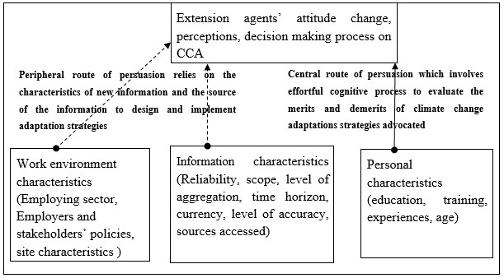
(Petty et al., 2002)

2.5 Conclusion
This chapter presented literature reflecting the perceptions of farmer’s CC in comparison to climate data, responses to perceived CC and impact of climate variability on agriculture as well as the role of agricultural extension and advisory services in CCA. The insights obtained from the pieces of literature reviewed will form a basis for contextualising the findings of this study since AEAS serves as direct linkage between farmers and other stakeholders in agricultural sector hence their perceptions and advices on CC adaptation are likely to be reflected in farmers’ perceptions and responses to CC. Lastly, it discussed the theoretical framework that underpins the study was
reviewed.

CHAPTER 3: METHODOLOGY

3.1 Introduction
This chapter presents the methodology used in carrying out the study. The second section describes the study area. The third section outlines how the data used in the study was obtained. The forth section explains how the data was analyzed whereas the fourth sections presents the limitations of the study.

3.2 Study area
Figure 2: Map of Machakos County
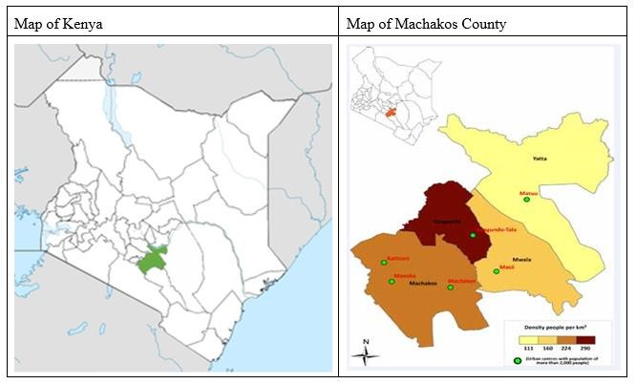
Figure 2 shows the geographical location of Machakos County. Machakos is one of the ASALs Counties of Kenya and was chosen for the study because of its past experiences with recurrent drought and floods often associated with CC. The county is located between latitudes 0⁰.45'S and 1⁰.31'S, and longitudes 36⁰.45'E and 37⁰.45'E, with a total area of 6,051 km2 (Ngugi, 2002).
Machakos consist of hills and small plateaus of altitute between 1800-2100 m above the sea level (Claessens et al., 2012, Jaetzold and Schmidt, 1983). The population of Machakos is approximately 1,100,000 (Claessens et al., 2012).
The rainfall pattern in Machakos is bimodal and is normally concentrated into two short seasons namely: March to May and October to December seasons respectively. February and September are the hottest months in the year with low and unreliable rainfall. The long rains are experienced between March and May and short rains in October and December. The short rains are deemed more reliable than the long rains as it is during the short rains that farmers get yield (Ndambiri et al., 2013). The total annual rainfall averages range between 500 and 1300 mm with 66% rainfall reliability during the growing period of the first rainy season is <100-450 mm, and that of the second rainy season 80-530 mm (Jaetzold and Schmidt, 1983, Claessens et al., 2012).
Agriculture in Machakos is mainly rain fed. The major crops grown by farmers include pigeon peas, maize, cowpeas, green grams, sorghum, beans, millet, cassava and sweet potatoes. Farm sizes ranges from 1.5-6.0 hectares of which 1.5-3.5 hectares are cultivated. Yields are low and crop failure is a common problem in a cycle of four years due to low soil nutrient or weather variability (Claessens et al., 2012).

3.3 Data
The study used climate data obtained from Katumani Meteorological station in Machakos. The data values were derived from daily observations of rainfall amounts for fifty-two years from January 1960 to December 2012 and daily observations of maximum and minimum temperatures for thirty-four years from January 1978 to December 2012.
In addition to the climate data, a survey was carried out. The study population was primarily drawn from extension officers in the private and public sectors who had previously implemented CC adaptation projects in Machakos County. Purposive sampling procedure was employed to select 106 respondents. Data was collected on the extension officers’ perceptions and awareness of CC and recommendations made to facilitate CC adaptation.

3.4 Data analysis
Statistical Analysis System (SAS) was used for qualitative and quantitative analysis. Measures of central tendencies, dispersion and variation for the following climatic variables (season length, season rainy days, season totals and annual totals, minimum and maximum temperatures) were computed to summarise the climate data into two different seasons. Frequencies were used to summarise data collected for extension officers. Other methods used in the analysis include auto regression, factor analysis, cluster analysis and binary logit regressions and are discussed below.

Auto regressive distributed Lag (ARDL) model
An augmented dickey fuller test with and without trend and Jarque Bera’s test for normality conducted to determine the suitability of the model for analysis the time series data. Some of the variables were trend stationary while some were stationary with and without trend thus auto regressive distributed lag model was deemed suitable for the nature of the series and also to allow for the possibility serially correlated errors (Hill et al., 2008, Harris and Sollis, 2003). Some of the climate variables violated the normality assumption thus required transformation.
The auto regressive distributed lag model (ARDL) was used to assess linear trends of climate variables overtime is given by:
Where
(Start of the season, end of the season, rainy days, mean-maximum
temperature, lowest maximum temperatures, highest maximum temperature, mean minimum temperature, lowest minimum temperature and highest minimum temperatures)
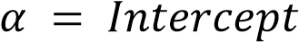

Slopes were examined for any significant trends for all possible data points, from 1961 to 2012 for precipitation aspects and from 1978 to 2012 for temperature aspects. Previous studies by Estrada et al. (2013) and Osbahr et al. (2011) used time series analysis of climate variables which fitted autoregressive integrated moving average and simple regression models respectively understand the trends in climate variables over time.
Bryan et al. (2013) used a choice model used to estimate the factors influencing farmers’ perceptions of long-term changes in rainfall variability. They categorised perceptions regarding long-term change in average temperature and precipitation fall into three (perceived increase, perceived decrease, and no change) and applied a multinomial logit model to analyse the factors affecting these perceptions.

Factor analysis
Factor analysis was used to reduce six original variables known as drivers of recommendations into a few composite factors with minimum loss of information. The six original variables were six statements in the questinnaire specified as follows: (My recommendations on CC strategies are influenced by the socioeconomic characteristics of the farmers, I often implement CC adaptation strategies in collaboration with other development stakeholders, I very knowledgeable on weather variability and CC adaptation strategies, The CC adaptation strategies that I undertake are mainly influence by government policies, I recommend CC adaptation strategies based on scientific information, I recommend CC adaptation strategies based on the policies of international developments agencies)
Principal components analysis was chosen for its capability to transform a group of observations of possibly correlated variables into linearly uncorrelated variables called principal components (Kisaka-Lwayo and Obi, 2012, Haiming and Wenlin, 2005, Field, 2013). Each principal component is a continuous variable associated to the products of the values of the original variables and their component loadings (Kisaka-Lwayo and Obi, 2012, Field, 2013). The implicit form for computing principal components (PC_{n}) is given by:
In case of a number of principal components denoted by n, then a series of n equations can be written each to represent the different principal components as shown below:
Where
The new factors extracted were then used in the logit regressions as explanatory variables influencing recommendations of extension officers.

Logistic regression model
This study used a binary logistic regression model to estimate the probability of extension officers making a given recommendation. The extension officers recommend various adaptation strategies and crops to wealthy and resource poor farmers, these recommendations were the dependent variables hence for each recommendation a logistic regression run to infer the factors that influenced the recommendation. The recommendations to wealthy farmers are assumed to differ from that made to poor farmers to take into account the divergent risk profiles and utility functions for these two categories of farmers.
The cumulative distribution function for a logistic random variable is given by Hill et al. (2008) as shown below:
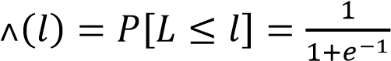
The probability that the i^{th} extension officer chooses recommendation j, lies between 0 and 1.
Probability that the observed value of Y takes the value of 1 given by below:
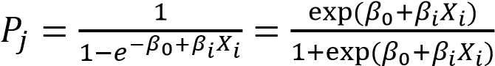
Where
( intercropping, agroforestry, mixed farming, use of long maturing high yielding crops, use manure and fertilizer, drought tolerant crops, crop diversification, irrigation, early planting and early maturing crops, crop recommendations)
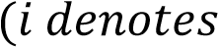 Age of the respondent, sex, level of education, years of experience, employing sector,
perception of the trend in rainfall amount, sources of information, numbers of sources used, perception of risk of climate failure, reliability of information and drivers of recommendations.) The probability that the observed value of Y=0 is given below:
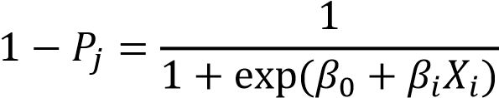
The logistic regression model is thus given below:
(Hill et al., 2008)

Cluster analysis
Cluster analysis was used to group extension officers’ crop recommendations into two groups in such a way the recommendations in the same cluster are more similar to each other than those in the other cluster. The two clusters obtained were formed part of the dependent variables in the logit regression

3.5 Limitations of the study
The study may have a sample selection bias since the sampling procedure employed was not be random but purposive, for only extension agents that have previously designed and implemented CC adaptation programmes were selected to participate in the survey thus may not reflect perceptions and adaptation recommendations of all the extension officers in the region.

3.6 Conclusion
This chapter described the process used in conducting the study but also justifies the choice of the different methods used.

CHAPTER 4: EXTENSION OFFICERS’ PERCEPTIONS ON CLIMATE CHANGE IN RELATION TO CLIMATE DATA

4.1 Introduction
This chapter presents and describes the findings on extension officers’ perceptions on CC in relation to climate data. The second section presents a descriptive analysis of climate variables. The third section compares the first season to the second season based on the climate data and in terms of the extension officers’ perceptions of these two seasons. Section four discusses plot diagrams showing the evolution of temperatures and rainfall related variables. Results of auto regressive distributed lag model for climate variables are presented in section five and section six describes the extension officers’ perceptions on CC.

4.2 Descriptive analysis of climate variables
The start of a season identified as one of the rainfall related variable is defined as the first day after 15th February/ 15th September with a rainfall total of 15mm total over 1, 2, 3 days with no dry spell longer that 10 days in the next 21 days whereas the end of the seasons is defined as first occurrence after 15th May/ 15th December when the water balance fall below 0.5mm (Stern et al., 2006, Stern and Cooper, 2011).
Results in Table 1 show the average start date of the first season (March to May) be 20th March while the average end date of the season was found to 18th May. The average season length and rainy days was established as 59 and 60 days respectively. The first season had an average 270mm of rainfall. The second season (October to December) average start and end date were established as 31st October and 23rd December respectively with an average length of approximately 53 days.
Average number of rainy days is 54 days with a mean seasonal rainfall amount of 275mm.
Table 1: Descriptive analysis of climate variables
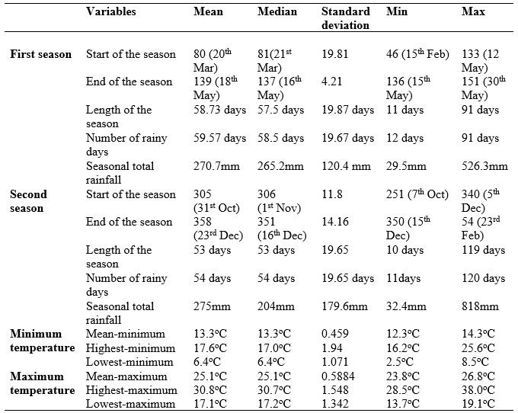
Source: Katumani meteorological station climate data

4.3 Comparison of first and second season
All the years where chances of crop failure were observed because the season did not start effectively were excluded from the analysis hence only 40 years were used in the comparison of the two seasons.
Table 2: Comparison of the first and second season
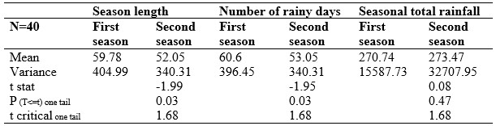
Source: Katumani meteorological station climate data
Results in Table 2 show that first season was significantly better than the second season in terms of the length and the number of rainy days but the second season had a higher mean rainfall total though not significantly different from that of the first season.
The survey results show that 53 (50%) of the extension agent perceived the amount of rainfall in the first season was better than the amount of rainfall in the second season. 59 (55.6%) of the extension officers believes that the first season is longer than the second season while 47 (44.4%) extension officers believes that the second season is longer than the first season.

4.4 Evolution of climate variables
Figure 3, 4 and 5 display the evolution of rainfall related variables from 1961-2012 and that of temperature from 1978-2012. The values of rainfall related variables from the time series fluctuate rapidly from year to year in a seemingly unpredictable manner. There exist years when large values are followed by more large values and years when small values are followed by further small values thus exhibiting time varying instability. The end date of the first and second seasons appear constant around 14th May to 19th May and 17th December to 27th December respectively with a few years where there are late end dates are observed. Temperature variables on the other hand have rapid fluctuation with slight display of an upward trend, with the exception of highest minimum temperatures which seem constant around 16-18 degrees Celsius in most years.

Figure : Time series of temperatures variables
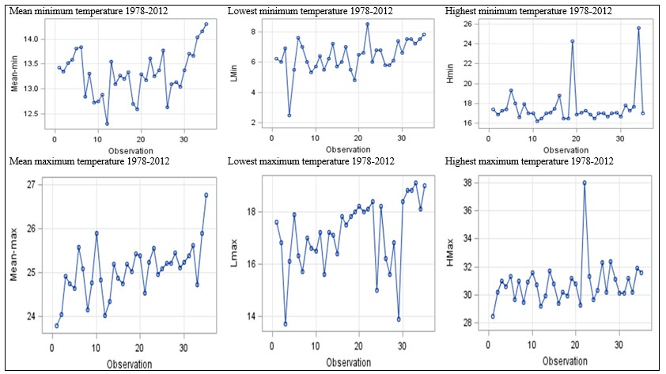
Source: Katumani meteorological station climate data
29

Figure : Time series of first season rainfall related variables
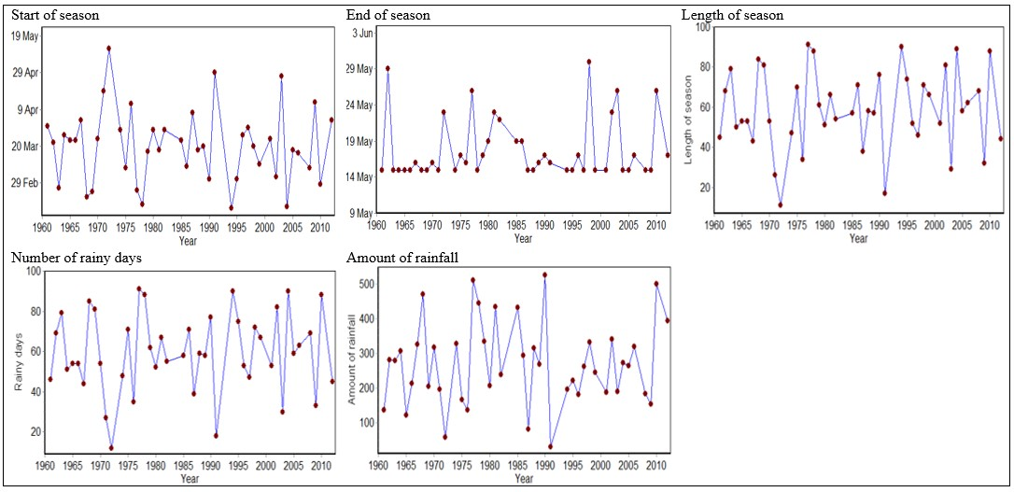
Source: Katumani meteorological station climate data
30
Figure : Time series of second season rainfall related variables
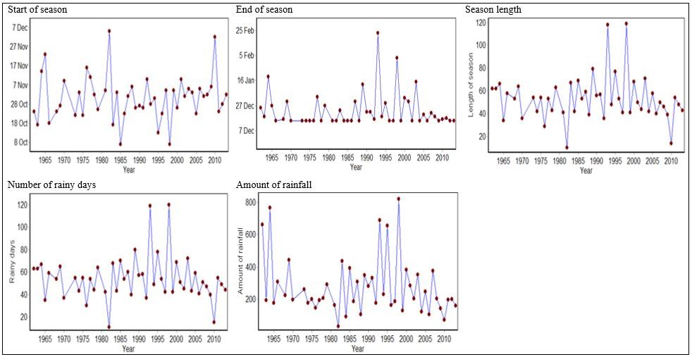
Source: Katumani meteorological station climate data
31

4.5 Results of auto regressive distributed lag model for climate variables
Table 3: Augmented Dickey- Fuller test for stationarity and Jarque Bera’s test for normality of climate variables
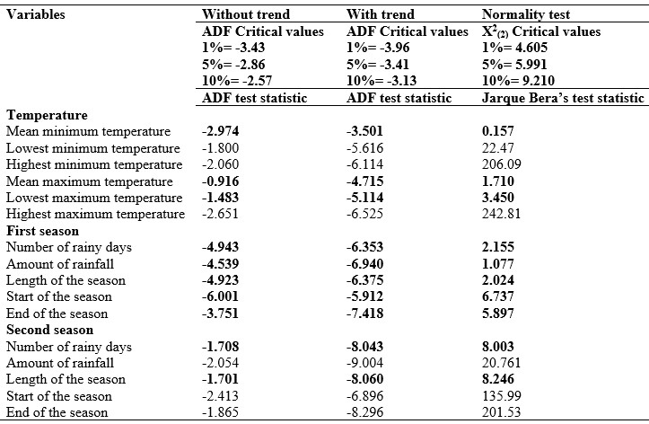
Source: Katumani meteorological station climate data
Results in Table 3 show that all the second season rainfall related variables and temperature variables with exception of mean minimum and highest maximum temperature were non stationary without trend but stationary around a deterministic trend thus could be used in regression relationship when a trend variable is included. The first season variables were stationary with and without trend hence the null hypothesis that the series were non stationary were rejected at 1% level of significance for second season variables. Similarly the null hypotheses is rejected for highest maximum and mean minimum temperatures at 10% and 5% level of significance respectively.
Results of Jarque Bera’s test for normality are also shown in Table 3. The null hypotheses of normally distributed errors were rejected for highest maximum, highest minimum and lowest minimum temperatures at all the three levels of significance. Likewise, normality assumption was found unreasonable for the second season amount of rainfall, start and end of the second season. These variables which violated the normality assumptions were transformed and modelled as loglog models in the regressions.
Table 4: Regression of temperature variables
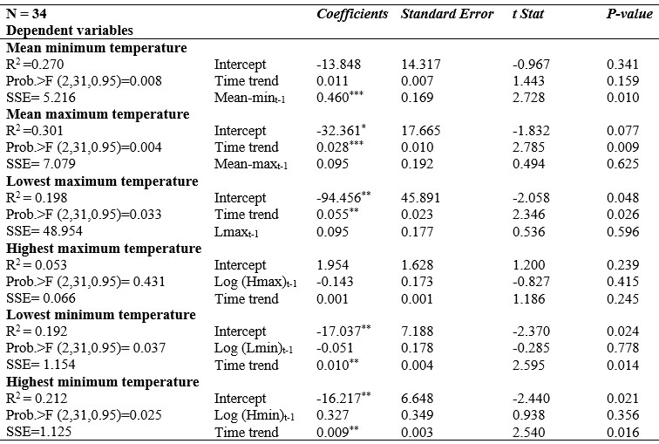
The asterisks [*, **, and ***] represent statistical significance at 1%, 5% and 10% levels respectively
Source: Katumani meteorological station climate data
Results in Table 4 show that one degree Celsius increase in the mean minimum temperature in the previous time period increase the temperature in the current time period by 0.46 degrees Celsius.
There is however no significant trend in mean minimum and highest maximum temperatures. Lagged temperature variables with the exception of mean minimum temperature were
insignificant therefore a likely indication of no autocorrelation between the annual temperatures observation in the present time period and those of the previous time period.
It is estimated that the mean maximum temperature increases by approximately 0.028 degrees Celsius per year while the lowest maximum temperature have increased by 0.055 degrees per year holding other factors constant. Likewise, the lowest minimum and the highest minimum temperatures increases by 1% and 0.9% respectively in a yearly basis, thus a confirmation of the well-established consensus in the literature that temperatures are increasing across sub Saharan Africa (Webber et al., 2014).
The findings are consistent with those of previous studies across Africa which observed widespread warming over time (Ogutu et al., 2008, Osbahr et al., 2011, Lewis and Witham, 2012, Hassan, 2010) but contradicts the findings of Bryan et al. (2013) which found no change and decreasing temperature trends for in data record for some weather stations in Kenya. A trend of increasing temperature has been seen since the 1960s in most parts of Africa with some locational variances (Hassan, 2010). Rise in minimum and maximum temperatures may lead to severe harvest decline and reproductive failure in crops (Thornton and Herrero, 2014). Projections indicate that tropical rain forest and southern regions are warming relatively faster in comparison to the rest of Africa.
Table 5: Regression of change in rainfall related variables
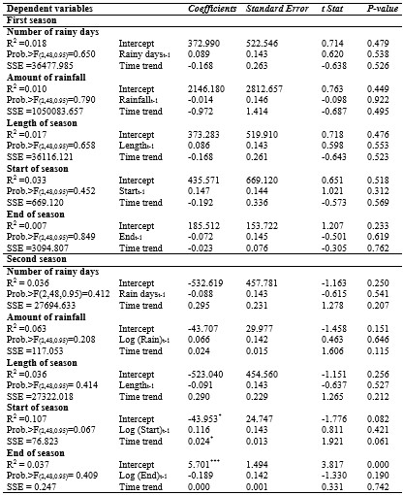
The asterisks [*, **, and ***] represent statistical significance at 1%, 5% and 10% levels respectively Source: Katumani meteorological station climate data

Table 5 summarizes the outcome of the regression of change in rainfall related variables. The F statistics for all the regressions except that of the start of second season were insignificant an indication that none of the explanatory variables explained the variation in the dependent variables. Similarly, all the coefficients of the lagged dependent variable in all the regressions were insignificant an indication than the values of climatic variables in the previous time periods have no effect in current and future periods as well as no possible autocorrelation in seasonal climate related variables.
Insignificant time trend in the start and end of both the first season, end of the second season, amount of rainfall, number of rainy days and length of the season for both the seasons were established thus changes observed are assumed to be due to chance. However the start of the second season has significantly shifted at 10% level of significant. It is estimated that the start of second season shifts forward by 2.4% per year all other factors held constant.
Existence of no significant change in different aspects of rainfall related variables is coherent with the finding in Southern Africa where no long term trend in mean annual rainfall was observed (Hassan, 2010, Hassan and Nhemachena, 2008).
Greater regional variability is represented in literature on rainfall trends (Hassan, 2010). A mixed trend of increased rain in the north and declining patterns in the southern parts of East Africa was noted (Hassan, 2010) and prediction by robust models of an increase in mean precipitation across
East Africa (Webber et al., 2014). In Kenya and Uganda decreasing precipitation was noted (Bryan et al., 2013, Osbahr et al., 2011). Similarly, in West Africa (Sahel), mean annual rainfall recorded a 20–40 per cent decline between 1960 and 1998 whereas rainfall decrease of about 2-4 per cent were detected in tropical rain forest regions but in Guinean Coast rainfall rose by about
10 per cent over a period 30 years (Hassan, 2010).
The insignificant trends on onset of season, end of season, season length and the numbers of rainy days in a season are inconsistent with the observations noted in southern Africa where inter annual and seasonal variability as well as extreme weather has increased (Hassan, 2010).

4.6 Extension officers’ perceptions on climate change
Table 6: Extension officers’ socioeconomic characteristics
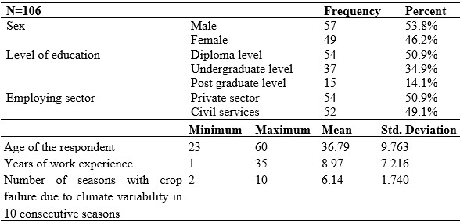
Source: Field data
Table 6 presents a summary of extension officers’ socio economic characteristics. The survey included different age, sex, education and employing sector of extension officers. Majority of the respondents interviewed were men (53.8%). The mean age group of the extension officers 36.8 years. With respect to education, most of the respondents held a diploma level of education (50.9%). Likewise, 50.9% of the respondents interviewed were employed by the private sector depicting an active participation by private sector in Machakos.
The analysis of climatic data showed that probability of crop failure in the first season and second season obtained by getting the proportion of years where there was no proper season are 8/52 (15%) and 4/52 (8%) respectively thus confirming the long term belief held by farmers and some of the extension officers that the second season (short rains) gives better opportunity for food production than the first season (long rains) (Ndambiri et al., 2013, Rao et al., 2011). The extension officers however perceived on average that six out of ten years there are chances of crop failure due to climate variability as shown on climate change
Table 6 above. This is approximately 60% probability of crop failure a figure which is four times higher than that established by the climate data for first season which is the most unreliable season in the area thus depicting a high risk perception by the extension officers.
Figure 6: Extension officers’ perceptions on the start of the season
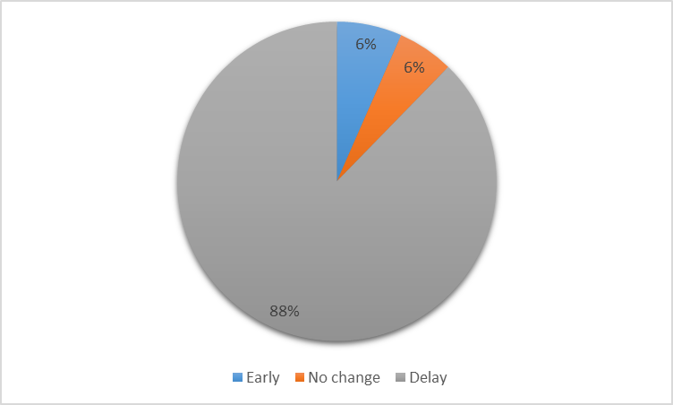
Source: Field data
Figure 6 shows that 7 (6.6%) extension officers perceived an early start of the season, 6 (5.7%) perceived no change while 93 (87.7%) perceived a delay in the start of the season. This is partially consistent with the findings in Table 5 established with climate data that showed significant forward shift in start of second season but incongruous for the start of first season where no trends were established.
Figure 7: Extension officers' perceptions on climate variables
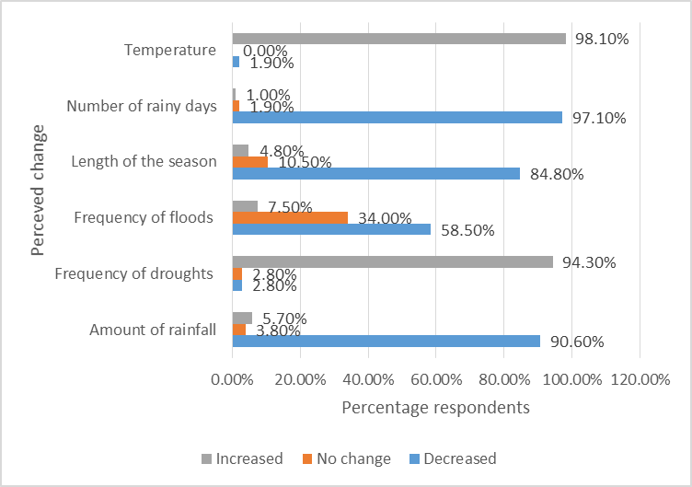
Source: Field data
The perception by majority of the extension officers that temperature is increasing is coherent with climate data findings shown in Table 4. These findings are consistent with those of previous studies in Uganda and Kenya where widespread warming over time have been established (Webber et al., 2014, Lewis and Witham, 2012, Osbahr et al., 2011, Ogutu et al., 2008).
Majority of the extension officers perceived the amount of rainfall, number of rainy days and length of the season to have decreased as shown in Figure 7 thus depicting worsening climate variability. These are however disproved by the results obtained from analysis of rainfall data in Table 5 which showed no significant change in the amount of rainfall, season length and number of rainy days. The perception of worsening climate scenarios is consistent with the findings of Heltberg et al. (2012) who observed that authors of grant proposals perceived deteriorating climate situation. The discrepancies established between perception and climate data on rainfall related variables have also been establishes in previous studies in East Africa (Abongu, 2013, Osbahr et al., 2011, Bryan et al., 2013) thus demonstrating the inadequate knowledge by extension officers on climate science information.
The difference between the perceptions and rainfall data may be attributed to temperature rise, which increases evapotranspiration thus indirectly exacerbating existing water stress which affect crop production and consequently lead to crop failures (Meza et al., 2008). Lewis and Witham (2012) argue that temperature increase not only makes crops susceptible to heat stress and water loss by evaporation but also decrease the areas suitable for arable farming. The temperature rise may translate into price and supply volatility in the global markets of agricultural commodities.
Additionally, the findings from previous studies across Africa has revealed increasing frequency of droughts and floods thus consistent with the perception by majority of the extension officers intensification of droughts but contrast the perception by 58.5% of the respondents that frequency of floods in declining (Hassan, 2010).

Sources of climate information
The extension officers used multiple sources of information. Majority of the respondents 63 (59.4%) received climate/weather information from radio and or television. 52 respondents received (49.1%) information from the Meteorological department, thus contradicting the finding of Heltberg et al. (2012) which revealed a rare reliance on formal source of information. 13
(12.3%) respondents received weather/ climate information from the internet, 12 (11.3%) respondents received information from the Ministry of Agriculture, 7 (6.6%) received information from print media, 4 (3.8%) respondents received information from their colleagues. 3 (2.8%) respondents receive climate/weather information from drought monitoring centre and 3 (2.8) respondents relied on information from traditional weather forecast. 4 (3.8%) respondents never used weather forecast information, 35 (33.1%) respondents rarely use weather forecast and 66 (63.1%) often used the weather forecast to influence farm management decisions.
Characteristics of climate information received:
98.1% (104) of the respondents had received climate information in the last season. 45 extension officers received climate information on a monthly basis, 28 received climate information on a weekly basis and 31 received climate information on a daily basis. However only 20 (19.2%) respondents believes that the weather forecast and climate information they received was accurate, 55 (52.9) believes that the information is somehow inaccurate. 11 respondents were unable to tell the level of accuracy of the weather forecast received. 18 (17.3%) respondents perceived the weather forecast information to be inaccurate. Lack of trust weather/ climate information was also established amongst farmers in Machakos (Ngugi, 2002).
The perception of inaccuracy on weather forecast information and how the information is communicated has been blamed for failure of forecast information to realise its potentials in the agricultural sector (Crane et al., 2011, Webber et al., 2014). Likewise 75 (70.7%) respondent perceived the weather information they received in the last season to be unreliable and 31 (29.3%) perceived the information to be reliable. Despite the perception of inaccuracy of weather forecast information, 58 (55.7%) of respondents asserted that the weather forecast information was important in influencing farmers’ management decisions and 46 (44.3%) respondents thought that the information was unimportant in influencing farmers’ decisions.

4.7 Conclusion
This chapter presented and discussed the perceptions of extension officers on CC in relation to climate data. The extension officers perceive negative changes in both temperature and rainfall related variables. The perceptions on temperature corresponded with climate data hence in agreement about rising temperatures. The climate data showed a forward shift in the start date of the second season which agrees with the perception that the seasons start date shifted frontwards implying a delay in season start date. Perceptions on rainfall related variables differed with the findings from rainfall data which showed no significant change in these variables.

CHAPTER 5: EXTENSION OFFICERS’ CLIMATE CHANGE ADAPTATION RECOMMENDATIONS

5.1 Introduction
This chapter analyses the CC adaptation recommendations made by the extension officers to farmers and identifies factors that influenced the recommendations options. The second section outlines the management practices recommended whereas section three presents key divers of recommendations. Section four analyses and discusses the factors that determined the recommendations of the management practices. The fifth section presents crop combination recommended by extension officers and the sixth section describes the factors that influenced crop recommendations.

5.2 Management practices recommended by extension officers
Figure 8 presents management practices recommended by extension officers to farmers to enable them adapt to CC. The management practices have also been identified by researchers in previous studies on CC adaptation (Abongu, 2013, Meza et al., 2008) to be used commonly by farmers in other parts of Africa.
The most common recommendation made to wealthy farmers is use of fertilizer and manure recommended by 57.5% of the respondents. None of the respondent recommended mixed farming to wealthy farmers; however it is the most popular recommendation to resource poor farmers. Small scale irrigation was the least common recommendation to resource poor farmers and wealthy farmers recommended by 21.3% and 22.3% of the respondents respectively that inconsistent with the findings of Hassan and Nhemachena (2008) which showed increase in use of irrigation in Southern Africa. This may be attributed to cost associated by adoption of irrigation which is unfeasible to most resource poor farmers. These CC adaptation recommendations may motivated by different socio economic factors (Bryan et al., 2013)
Figure 8: Extension officers' CC adaptation recommendations
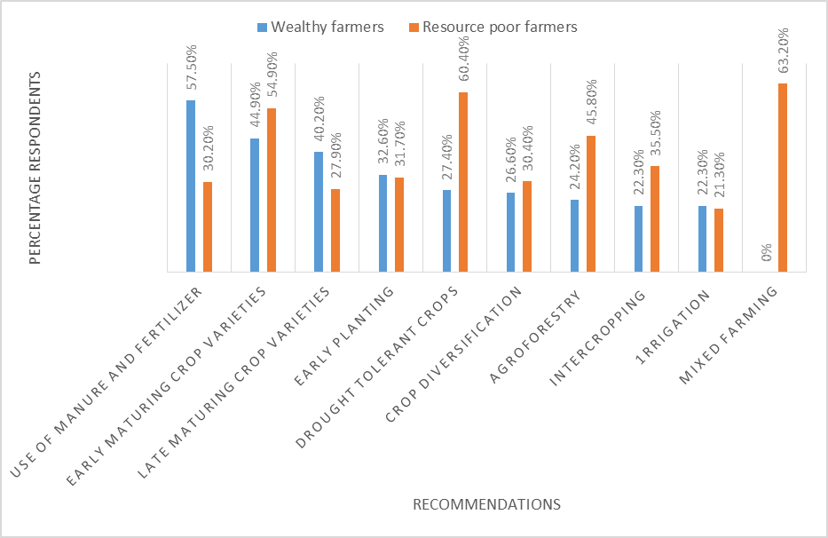
Source: Field data

5.3 Results of factor analysis of drivers of climate adaptation recommendations
The drivers of recommendations refer two latent variables computed from factor analysis namely principal component analysis of six statements shown on Table 7 below. The quality of the sampling was evaluated using Kaiser-Meyer-Olkin (KMO) measure of sampling adequacy and Bartlett's test. The KMO was 0.706 and the Bartlett’s test was significant at P<0.001 thus supporting the factorability of the correlation matrix. The determinant of the R matrix was 0.373 implying that multi-colinearity was not a problem in the factor analysis. The factors had significant correlations.
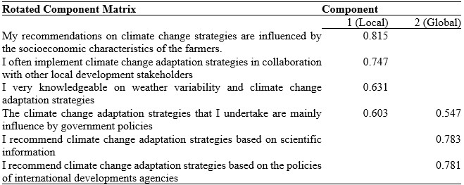
Table 7: Component loadings
Source: Field data
Two components were extracted from the statements and had eigenvalues higher than 1, explaining 58.81% of the variance together. The first component accounted for 33.18% while the second component accounted for 25.62% of the variance. These components were named as local drivers of recommendations and global drivers of recommendations respectively and used as explanatory variables influencing extension officers’ CC adaptation recommendations.

5.4 Results of logit model of extension officers’ climate change adaptation recommendations to farmers
The probabilities of making climate adaptation recommendations to both wealthy farmers and rich farmers as summarised in Table 8, 9, 10 and 11 below. The likelihood ratio test statistic values for the probability of recommending to both poor and wealthy farmers management practices such as intercropping, agroforestry, long maturing crops, manure and fertilizer and early maturing crops were all larger than the 0.95 percentile from the X₍₁₃₎ distribution, 22.362 hence significant. The null hypothesis that none of the explanatory variables help explain the choice of the above recommendations is rejected. The likelihood ratio test statistic values for probability of recommending crop diversification to wealthy farmers, irrigation to poor farmers, drought tolerant crops and early planting to all the farmers were insignificant at 5% level of significance thus excluded from the discussion.

Table 8: Results of logit model of extension officers’ climate change adaptation recommendations to wealthy farmers (Intercropping, agroforestry, long maturing crops, manure and drought tolerant crops)
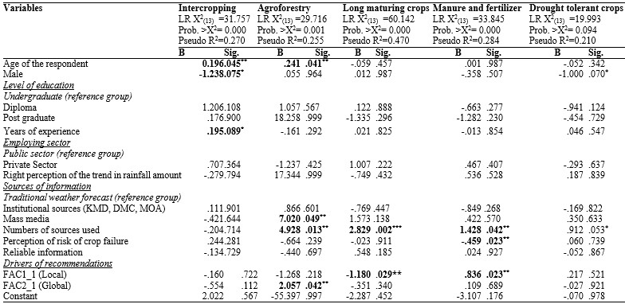
The asterisks [*, **, and ***] represent statistical significance at 1%, 5% and 10% levels respectively
Source: Field data
47
Table 9: Results of logit model of extension officers’ climate change adaptation recommendations to wealthy farmers (crop diversifications, irrigation, early planting, early maturing crops)
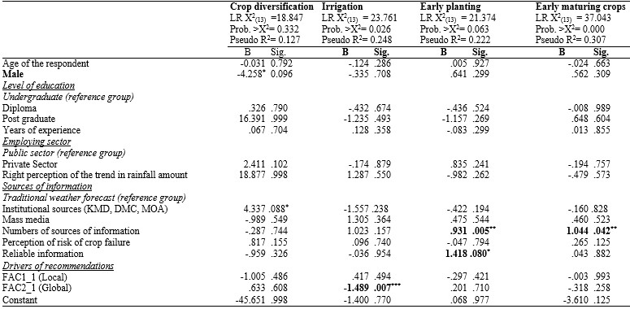
The asterisks [*, **, and ***] represent statistical significance at 1%, 5% and 10% levels respectively
Source: Field data
48

Table 10: Results of logit model of extension officers’ climate change adaptation recommendations to resource poor farmers (Intercropping, agroforestry, long maturing crops, manure and drought tolerant crops)
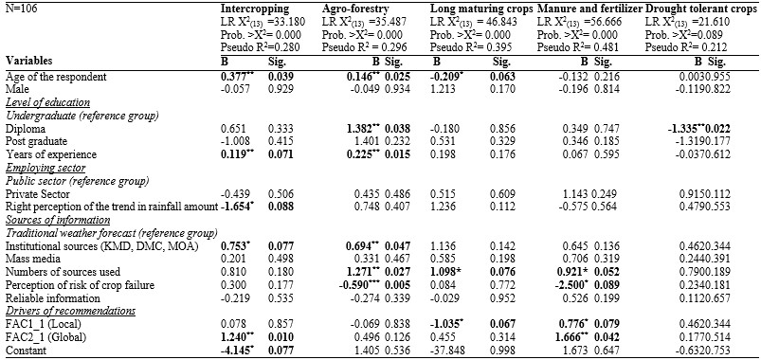
The asterisks [*, **, and ***] represent statistical significance at 1%, 5% and 10% levels respectively
Source: Field data
49
Table 11: Results of logit model of extension officers’ climate change adaptation recommendations to resource poor farmers (crop diversifications, mixed farming, irrigation, early planting, early maturing crops)
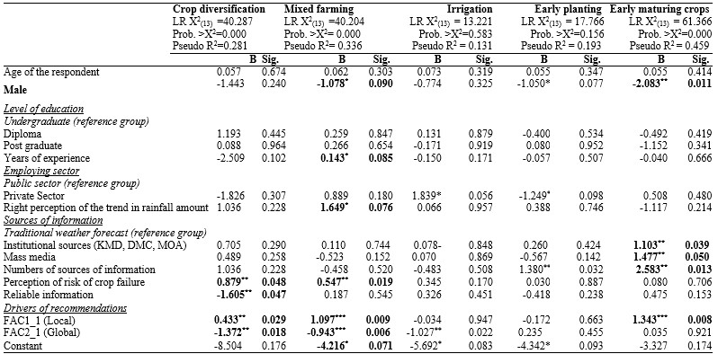
The asterisks [*, **, and ***] represent statistical significance at 1%, 5% and 10% levels respectively
Source: Field data
50

Intercropping
Age and years of experience increases the probability of recommending intercropping to both wealthy and poor farmers as reflected in Table 8 and Table 10, this is because the experienced extension officers have already mastered the benefits of intercropping. Intercropping significantly promotes crop productivity in phosphorus-deficient soils (Yan et al., 2014) and generally well adapted to conditions of small holder farming (Steiner, 1982). Meza et al. (2008) argues that water sufficiency open in warmer climatic scenarios unlocks the option of intercropping and double cropping which then allows farmers to have two crops within the same calendar year. Thornton and Herrero (2014) argue that intercropping phonologically different crop varieties in the past have helped to spread the risk of crop failure.
Sex determined the probability of recommending intercropping as an adaptation strategy to wealthy farmers. Male extension officers in comparison female extension officers are less likely to recommend intercropping to wealthy farmers but is not a significant factor influencing the likelihood of recommending the strategy to poor farmers as shown on Table 8 and Table 10. Wealthy farmers, preference for specialised production in attempts to lower their managements cost fits with that of risk loving male extension workers who recommend crop specialization to help increase income in the events of good weather rather than risk reductions in situations of poor weather (Love et al., 2014).
Global drivers of recommendations increases the likelihood of recommending intercropping to poor farmers and not to wealthy farmers as shown in Table 8 and Table 10 above. This is mainly because of the existence of non-governmental organizations with pro poor mandate that rely on external funding hence more likely to rely on the policies of their donors. The external donors may be basing their policies on the science that intercrop increases yields in the tropics as it enables optimal utilization of land resources and soil nutrients, and also offer great resistance to weeds, pest and diseases (Yan et al., 2014) that are likely to increase in warmers climatic scenarios (Meza et al., 2008).

Agroforestry
Age of an extension officer and the number of sources of information accessed increases the probability of recommending agroforestry to both wealthy and resources poor farmers. Experience also has positive influence on recommendation of agroforestry to poor farmers. Age and more sources an individual access is likely to give insights that trees on farms not only provide livelihood benefits but also contribute to CC adaptation and thus increasing the probability of recommending agroforestry (Mbow et al., 2014b, Mbow et al., 2014a).
Global drivers of recommendations increase the likelihood of recommending agroforestry to wealthy farmers. This is based on the assumption that wealthy farmers have large land holding hence may be able to spare some of their land for agroforestry establishment and wait for higher returns in the long run without compromising their food security situations (Mbow et al., 2014b). There have also been global attempts committed to ensuring that agroforestry gets consideration in the framework of Reduced Emission from Deforestation and forest degradation (REDD+) modalities (Mbow et al., 2014b, Mbow et al., 2014a). Thornton et al. (2010) however argues that agroforestry as a climate adaptation strategy may be a costly to small scale farmer who make trade-offs between adaptation and immediate food security needs.
Extension officers’ perception of risk of crop failure lowers the probability of recommending agroforestry to resource poor farmers. The agroforestry trees are not exempted for failure in the semi-arid areas where climate in highly variable (Claessens et al., 2012) thus extension officers may be reluctant to persuade poor farmers to invest in long term attempt of cultivating trees that may fail in the event of poor weather or benefit the next generation other than the farmers themselves (Mbow et al., 2014b, Mbow et al., 2014a, De Pinto et al., 2013).
Results in Table 8 and Table 10 show that reliance on mass media and institutional sources of information increases the probability of recommending agroforestry practices to wealthy and resource poor farmers in comparison to traditional weather forecast sources of information respectively. This is because these sources emphasize ecosystem services and food security which they closely relate to agroforestry (Mbow et al., 2014b, Mbow et al., 2014a).

Long maturing high yielding crop varieties
The findings in Table 8 and Table 10 show that the probability of recommending late maturing varieties in influenced by age of the respondent, number of sources used and local drivers of recommendations.
The number of source of information used by the extension officers increases the likelihood of recommending late maturing crops to both wealthy and resource poor farmers. The more sources an extension officer have access to increases his/her probability of recommending late maturing varieties. Several sources of agro metrological information advocate the idea that longer maturing high yielding varieties are likely to behave like early maturing varieties in warmer climatic conditions (Meza et al., 2008). Several studies recommend the use of long maturing high yielding varieties to compensate the effect of accelerated phenology due to warmer temperatures (Tingem and Rivington, 2009, Meza et al., 2008). Tingem and Rivington (2009) found that late maturing high yielding varieties compared to currently used varieties had accelerated development due to high temperature in Cameroon. This is because the late maturing crop varieties have the ability to maximize the interception of solar radiation (Meza et al., 2008).
Local drivers of recommendations reduce the probability of an extension officer recommending late maturing high yielding varieties to poor farmers. The extension officers taking into consideration the local situations in Machakos such as short seasons, water stress, highly variable weather patterns and poverty levels may not recommend these varieties as their water requirements is hardly met in semi-arid weather conditions and their management requirements is economically unfeasible to resource poor farmers. The idea that late maturing crops benefits from CC is only applicable to high altitude areas where temperature limits on crop growth are lessened due to gradual warming (Jones and Thornton, 2009).
Older extension officers are less likely to recommend late maturing crop varieties. This is because they have been involved in long term promotion of short season varieties on the presumption that their growing cycle fits with the season length in the region. As a result, they are hesitant to believe that late maturing high yielding varieties could act like early maturing varieties in warmer climatic conditions (Meza et al., 2008).

Use of Manure and fertilizer
Results in Table 8 and 10 show number of sources used and local drivers of recommendations increases the probability of recommending manure and fertilizer both to wealthy and resource poor farmers. Access to information from multiple information sources and local drivers of recommendations is likely to give the extension officers understanding of low soil fertility with most of the soils in the area of study thus increasing their likelihood to recommend application of manure and fertilizer. Global drivers of recommendations increase the likelihood of recommending fertilizer and manure to poor farmers and not to wealthy farmers.
The extension officers with higher perception of risk of crop failure are less likely to recommend the use of manure and fertilizer. The only possible reason for this is that in uncertain farming environments where impact of CC on the variability of yields and production is unknown and the degree and direction of adaptation response to CC is indefinite, it is sensible to help farmers minimize the cost associated with purchase of inputs. Antón et al. (2013) argues that CC presents multidimensional, varied and indeterminate the problem of risk reduction which make it difficult to identify an optimal adaptation strategy thus risk averse extension officers are less likely to recommend costly outputs like fertilizer and manure.

Crop diversification
Global drivers of recommendations, reliable information and sex have negative effect of the likelihood of recommending crop diversification whereas local drivers of recommendations and perception of crop failure increases the probability of recommending crop diversification to poor farmers as shown in Table 11 above. Male extension officers may be more willing to take risk under CC and recommend the most preferred single crops (Huang et al., 2014).
An extension officers with reliable information on seasonal weather forecast and climatic trends are less likely to recommend crop diversification but instead recommend specific crop whose growth requirements is likely to be met by the climate predictions and trends. Antón et al. (2013) argues that introduction of more diverse cultivars that vary genetically in their responsiveness to climate conditions may introduce more water-intensive crops that compete with each other thus causing distress to the farming system (Kandulu et al., 2012). CC adaptation strategies induced by global drivers of recommendations is more likely to encourage commercialization and
specialization of the agricultural enterprises which is a disincentive to crop diversification (Mertz et al., 2005).
Local drivers of recommendations and perception of risk failure may increase the extension officers’ likelihood of recommending crop diversification as it is thought to have the potential to minimise exposure to climate-related risks and raise the flexibility of farm production to changing climatic conditions (Huang et al., 2014, Hassan and Nhemachena, 2008, Thornton and Herrero, 2014).

Mixed farming
Findings in Table 11 indicate that experience of the extension officer, right perception on the trend of rainfall amount, perception of the risk of crop failure and local drivers of recommendations increases the likelihood of recommending mixed farming to resource poor farmers. However, sex and global drivers of recommendations reduces the probability of recommending mixed farming.
Male extension officers because of their risk preferring nature, they are less likely to recommend mixed farming but instead recommend specialized farming which is conventional considered to be profitable.
Mixed farming which involves both crops and livestock systems have long been promoted in the ASALS on basis of the local drivers of recommendations which include highly variable climate and integrated utilization of crop residues in the livestock system or vice versa (Jones and Thornton, 2009, Hassan and Nhemachena, 2008, Seo, 2011) besides. Locally mixed farming has remained is perceived to be advantageous for sustainable agricultural systems especially to resource poor farmers whose accessibility to farm inputs such as fertilizer was adversely impacted by economic liberalization and structural adjustment programs (Sumberg, 1998). Choices between cropping and livestock keeping in mixed farming systems are related to the risk of crop failure and trends in rainfall amounts (Thornton et al., 2010). As the risks of crop failure increases, shift to mixed farming systems is more likely.
Experienced extension in the area are more likely to perceive trends in precipitation and climate related risks of crop failure precisely and recommend with confidence mixed farming which help spread risks as livestock can be used as assets to smooth crop fluctuation while opportunistic cropping provide calories for households and livestock at critical time of shortage (Jones and Thornton, 2009).

Irrigation
Results in Table 9 show that local factor reduces the probability of recommending irrigation to wealthy farmers. Webber et al. (2014) argue that small scale irrigation presents significant opportunities to respond to water variability; however Local drivers of recommendations may be are barriers to use of irrigation as an adaptation strategy in areas with persistent water stress.

Early Maturing crop varieties
Results in Table 9 and 11 shows that the more sources of information an extension officer uses, the more he or she is likely to recommend planting of early maturing crop varieties to farmers. Extension officers with access to multiple sources of information are more likely to gain the knowledge that early maturing crops are effective in tackling late season drought stress and have lower season evapotranspiration which enables them to minimize downside production risks (Cavatassi et al., 2011).
Male extension officers are less likely to recommend use of early maturing crops. Reliance on local drivers of recommendation, institutional and mass media sources of information increases the probability of recommending early maturing crop varieties to resource poor farmers. The reason being that the crops short life cycles help to evade the risks associated with weather variability. Early maturing crop varieties are believed to be low yielding but studies on choice of crop varieties have shown low preference and utility towards high productivity crops but are willingness of the farmers side to forgo some extra yields and income in order to obtain increased longevity of crops that minimises the risks of crop failure (Acheampong et al., 2013).

5.5 Results of cluster analysis of crops recommended by extension officers
Figure 9 present different crop combinations were recommended to resource poor farmers and wealthy farmers by the extension officers.
Figure 9: Crops recommended to farmers
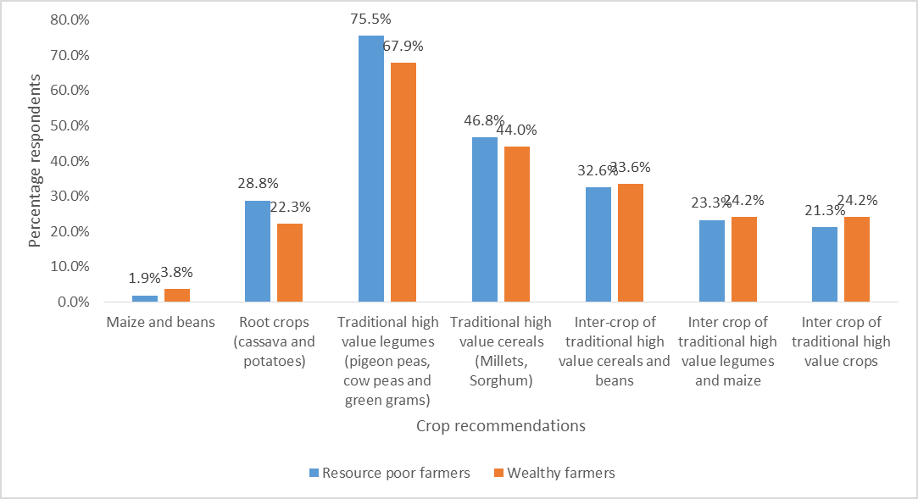
Source: Field data
The most popular crops recommended to farmers by extension officers were traditional high value legumes, followed by traditional high value cereals whereas the least recommended crops were maize and beans. This is associated by recent shift in research and development from the promotion of exotic crops such as maize and bean to advancement of indigenous crops in area which are thought to be more adapted to the local climatic conditions by both government and non-governmental institutions.
Figure 10: Crops recommended to resource poor farmers and cluster differences
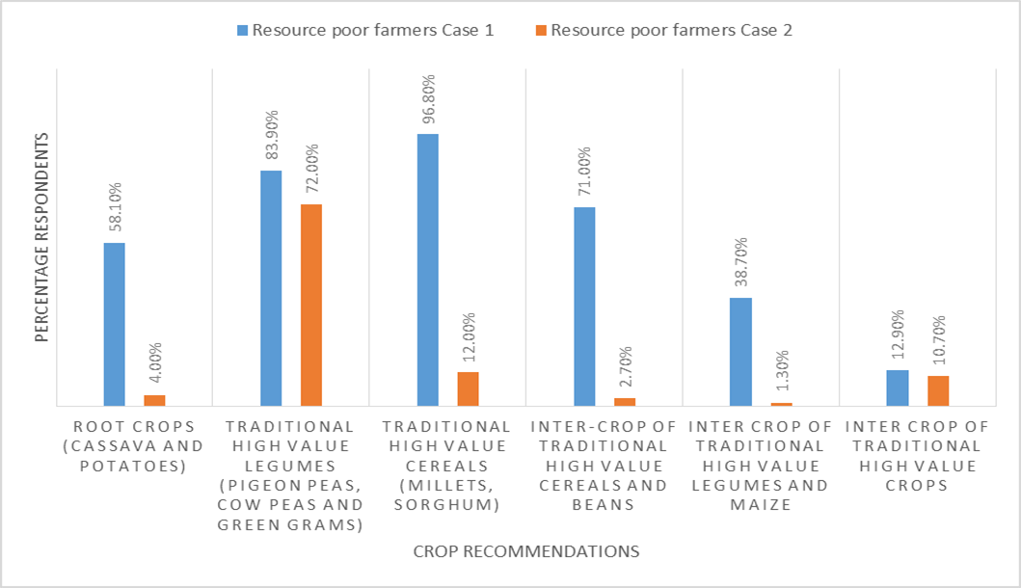
Source: Field data
31 respondents who made crop recommendations to resource poor farmers belonged to the first cluster and 75 respondents belonged to the second cluster. The main distinction between the clusters is that the respondents in the first cluster recommended a combination of all the crops whereas the respondents in the second cluster common recommendation was traditional high value legumes with minimal recommendation of the remaining crops as shown in Figure 10. Monocropped root crops and traditional high value cereal crops were widespread amongst the cases in the first cluster. Intercrops were unpopular with the cases in the second cluster.
Figure 11: Crops recommended to wealthy farmers and cluster differences
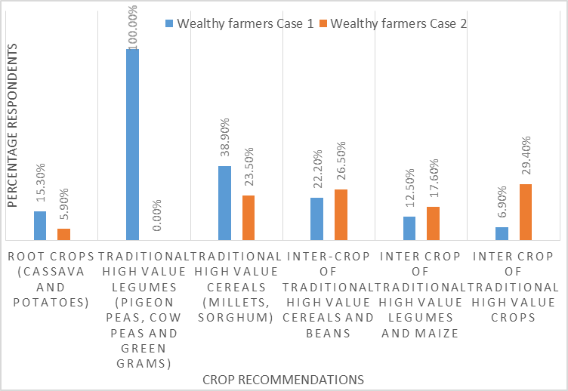
Source: Field data
72 extension officers who made crop recommendations to wealthy farmers belonged to the first cluster and 34 belonged to the second cluster. The main difference between the first and the second cluster is that all cases in the first cluster recommended traditional high value cereals whereas none of the cases in the second cluster recommended the high value legumes as shown in
Figure 11. However there is no clear difference in the other crop recommendations made by the first and second cluster other than of traditional high value legumes. The two clusters obtained for wealthy and resource poor farmers were used as dependent variables in binary logistic regressions
and where factors influencing the crop recommendation were analysed.

5.6 Results of the logit model of extension officers’ crop recommendations

Probability of recommending a combination of crops to resource poor farmers
The logit regression model explaining the probability of recommending a combination of crops to resource to poor farmers is summarized in Table 12 below. The likelihood ratio test statistic value for the model was 96.908 hence larger than the 0.95 percentile from the X ₍₁₃₎ distribution, 22.362. The null hypothesis that none of the explanatory variables explained the probability of recommending a combination of crops to resource poor farmers is rejected at 5% level of significance. A pseudo R² of 0.724 was obtained, indicating that approximately 72% of the variance in the probability of recommending a combination of crops to resource poor farmers is explained by the predictor variables. X² test statistic was statistically significant thus demonstrating the adequacy of the model.
Results in Table 12 show that number of source of information accessed, reliance on mass media, risk of crop failure and employment by the private sectors increases the probability of recommending a combination of crops to resource poor farmers. Mass media sources of information host advocates for different crops which may increase the number of crop combinations that an extension officer recommends to farmers. Similarly a unit increase in the number of information sources used is likely to increases the probability of recommending a combination of crops. This finding is consistent with that of Di Falco (2014) which showed that that information increases awareness of threats posed by CC thus positively increasing the possibility of adopting a combination of adaptations options to averse risk. This is because different sources of information disagrees on what is the optimal crop option for a particular environment and advocates for different crops which leaves the extension officers with a variety of crops to recommend.

Table 12: Results of the logit model of extension officers’ crop recommendations to farmers
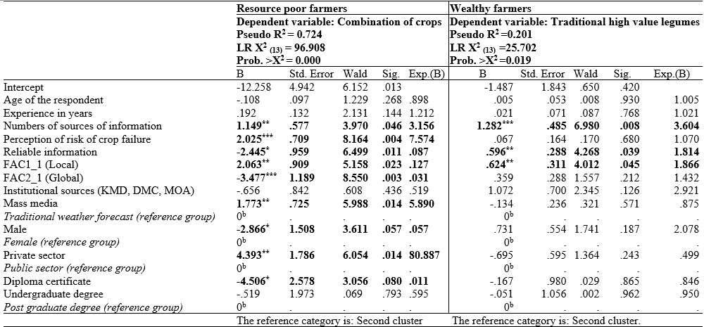
The asterisks [*, **, and ***] represent statistical significance at 1%, 5% and 10% levels respectively
Source: Field data
62

Combination of crops is considered as a risk reduction strategy to cope with variability of meteorological conditions which increases its likelihood of being recommended is situations where crop failure is likely event. Previous study by Cavatassi et al. (2011) in Ethiopia have shown that risk of crop failure due to weather variability significantly influence crop choices and management practices. The private players in the agricultural sector are hardly crop specific but interested with almost all crops grown in a locality which increases their probability of recommending a combination of crops. Male extension officers are less likely to recommend a combination of crops because of their risk preference nature (Huang et al., 2014).
Local and global drivers of recommendations also significantly influence the probability of recommending a combination of crops but with opposite signs thus revealing disconnect between global and local influences (Moser, 2010). Global drivers coming from abroad are spatially variable thus yield debates as to whether CC is real (Clavel et al., 2011). These global influences may be perceived as top down and non-contextual approach to risk reduction hence hindering the recommendation of combination of crops as risk reduction strategy in attempts to reorganise the rural society (Sumberg, 1998). Local drivers of recommendations on the other hand are invariant in time, in the short and medium terms (Clavel et al., 2011) hence better placed to conduct diagnostic climate risk assessment for crops thus increasing their probability of recommending combination of crops as a risk reduction strategy.
Diploma level of education and access to reliable information reduces the probability of recommending a combination of crops. This is because education and reliable information equips and extension officers with an overview of specific crop requirements thus likely to advise specific crop with better yield performance given the climatic challenges as opposed to combination of crops.

Probability of recommending traditional high value legumes to wealthy farmers
Results in Table 12 summarises the probability of recommending traditional high value legumes to wealthy farmers. A pseudo R² of 0.201 is achieved, indicating that approximately 20% of the variation in the probability of recommending the legumes to wealthy farmers is explained by the explanatory variables. The X² and the likelihood ratio test statistics are statistically significant at 5% level of significance thus signifying the adequacy of the model and the non-zero effect of some of the explanatory variables on the probability of recommending traditional high value legumes to farmers.
The coefficients for number of information sources accessed, global and local drivers of recommendations are significant and positive thus increase the probability of recommending traditional high value legumes to wealthy farmers. Locally, the relative importance of cereals and starchy staple crops is declining and that of legumes which are rich sources of protein hence of nutritional value is increasing (Gulati et al., 2007, Grivetti and Ogle, 2000, Tharanathan and Mahadevamma, 2003). These traditional legumes offer nutritional alternative to conventional beans which is not well adapted to semi-arid climate. The growing local demand for traditionally high value legumes is mainly driven by rising incomes, urbanization, changing preferences and adaptability of the crop to semi-arid conditions (Gulati et al., 2007).
Globally the production of the traditional crops is mainly driven by the biological value of the crops which has led to increase in campaigns to conserve genetic biodiversity of different crop species (Gulati et al., 2007). Despite the biological and economic value of traditional high value legumes, the crop recommendation may only suit wealthy farmers who are able to meet the high cost production and marketing risks associated with the crops.

5.7 Conclusion
This chapter explores different CC adaptation recommendations made by extension officers to resource poor farmers and wealthy farmers. The CC recommendations were mainly farm management practices and crops mixtures. Different factors such as risk perceptions and number of sources of information accessed, in addition to extension officers characteristics motivated adaptation recommendations in different directions.

CHAPTER 6: CONCLUSION AND RECOMMENDADTIONS

6.1 Conclusions
The first intention of the study was to assess the perceptions of agricultural extension officers on climate variability and change in relation to historical climate data. Majority of the extension officers perceive a general changing climate. According to them, negative changes have transpired in regards to temperature, amount of rainfall, number of rainy days, start (onset) of seasons as well as with the frequency of droughts and floods (Heltberg et al., 2012). The analysis of climate data however showed no significant change in most of the rainfall related variables and an increasing trend in most temperature parameters.
Results show that the extension officers have precise perception on temperature trends which is supported by temperature data. Conversely, most of their perceptions on rainfall related parameters are contrary to climate data. A finding which is comparable to the well narrated literature on farmers perceptions from the same region and other places across the African continent but were not supported by the observed trends in rainfall data (Rao et al., 2011, Osbahr et al., 2011). This is a likely indication on the influence the extension officers have on farmers’ perceptions on climate change. The results also reflects the extension officers’ incapability to synthesize climate knowledge they have gained which leads them to subjectively judge trends in rainfall related parameters. The biased opinion on trends of rainfall related variables may be linked to multifaceted interactions between rainfall and other factors such as temperature, soil water and fertility and land use which influence the whole effect of climate variability on crop productivity (Rao et al., 2011).
Secondly, the study set out to investigate the climate change adaptation measures which the extension officers recommend to farmers. The climate adaptation recommendations mainly consisted of agronomic management practices and different crop combinations. The most popular management practice recommended to resource poor farmers was mixed farming whereas that for wealthy farmers was use of manure and fertilizers. Mixed farming was however the least recommended strategy to wealthy farmers while irrigation was least recommended to poor farmers. Logit model was used to analyse the determinants of adaptation recommendations. The results show that different factors influenced different climate adaptation recommendations. Number of sources of information used significantly influenced most of the adaptation recommendations made by the extension officers.

6.2 Policy implication
Extension officers’ perception of negative rainfall variability which is not supported by climate has a significant implication for risk assessments in the region and in consequent decision making process. The perception of worsening scenarios create a general higher risk assessments resulting in most extension officers recommending techniques that favour low inputs use which discourage optimization of input use and uptake of improved technologies. Any policy aimed at enhancing the adaptive capacity of AEAS should consider building the capacity of extension officers to provide them with the precise climate information as well as create new technological capabilities of agro metrological extension within the institution.
The findings also revealed wide mistrust of the weather forecast and climate information received by extension officers. This calls for improvement of the collaboration, interaction and communication between providers and users of climate information to build trust and confidence in the use of the weather/ climate information which is a necessity for successful and effective adaptation.
At present, adaptation recommendations are mainly farm based and no distinction can be made of what have been conventional agronomic practices and climate adaptation strategies. Some of the climate adaptation strategies seem contradictory for example use of late maturing high yielding varieties versus use of early maturing crop varieties. It is therefore necessary to make a distinction on the roles of different adaptation strategies. Efforts to promote climate change adaptation strategies in the area should identify optimal combination of agricultural management practices suitable for the area and make use of the significant that influence those adaptation strategies.

6.2 Areas for further research
Non-agricultural adaptation strategies are extremely rare thus research work needs to be devoted to finding and appraising innovative adaptation and coping mechanisms outside agriculture such as building social and community networks and improving markets and economic infrastructure.

REFERENCES
ABONGU, L. 2013. Agricultural Adaptations Strategies to climate Change and Variability in the Extreme North Region of Cameroon. University of Reading: Masters of Science
Dissertation.
ACHEAMPONG, P. P., OWUSU, V. & NURAH, G. K. 2013. Farmers Preferences for Cassava Variety Traits: Empirical Evidence from Ghana.
ADGER, W. N., DESSAI, S., GOULDEN, M., HULME, M., LORENZONI, I., NELSON, D. R., NAESS, L. O., WOLF, J. & WREFORD, A. 2009. Are there social limits to adaptation to climate change? Climatic change, 93, 335-354.
ANTÓN, J., CATTANEO, A., KIMURA, S. & LANKOSKI, J. 2013. Agricultural risk
management policies under climate uncertainty. Global Environmental Change, 23, 17261736.
ASAFU-ADJAYE, J. 2014. The Economic Impacts of Climate Change on Agriculture in Africa. J. Afr. Econ., 23, ii17-49.
BEMBRIDGE, T. 1987. Agricultural extension in the less developed areas of Southern Africa. Agricultural Administration and Extension, 27, 245-265.
BRUCE, J. P., YI, H.-S. & HAITES, E. F. 1996. Climate change 1995: Economic and social dimensions of climate change: Contribution of Working Group III to the second assessment report of the Intergovernmental Panel on Climate Change, Cambridge University Press.
BRYAN, E., RINGLER, C., OKOBA, B., RONCOLI, C., SILVESTRI, S. & HERRERO, M. 2013. Adapting agriculture to climate change in Kenya: Household strategies and determinants. Journal of environmental management, 114, 26-35.
CAVATASSI, R., LIPPER, L. & NARLOCH, U. 2011. Modern variety adoption and risk management in drought prone areas: insights from the sorghum farmers of eastern Ethiopia. Agricultural Economics, 42, 279-292.
CHAUDHRY, M. & AL-HAJ, F. 1985. A critical analysis of agricultural education and extension in developing countries. Agricultural Administration, 20, 169-186.
CHRISTOPLOS, I. 2012. Climate advice and extension practice. Geografisk Tidsskrift-Danish Journal of Geography, 112, 183-193.
CLAESSENS, L., ANTLE, J. M., STOORVOGEL, J. J., VALDIVIA, R. O., THORNTON, P. K. & HERRERO, M. 2012. A method for evaluating climate change adaptation strategies for small-scale farmers using survey, experimental and modeled data. Agricultural Systems, 111, 85-95.
CLAVEL, L., SOUDAIS, J., BAUDET, D. & LEENHARDT, D. 2011. Integrating expert knowledge and quantitative information for mapping cropping systems. Land Use Policy, 28, 57-65.
CRANE, T. A., RONCOLI, C. & HOOGENBOOM, G. 2011. Adaptation to climate change and climate variability: The importance of understanding agriculture as performance. NJAS - Wageningen Journal of Life Sciences, 57, 179-185.
DAVIS, K., NKONYA, E., KATO, E., MEKONNEN, D. A., ODENDO, M., MIIRO, R. & NKUBA, J. 2012. Impact of farmer field schools on agricultural productivity and poverty in East Africa. World Development, 40, 402-413.
DE PINTO, A., ROBERTSON, R. D. & OBIRI, B. D. 2013. Adoption of climate change mitigation practices by risk-averse farmers in the Ashanti Region, Ghana. Ecological Economics, 86, 47-54.
DERESSA, T. T., HASSAN, R. M., RINGLER, C., ALEMU, T. & YESUF, M. 2009.
Determinants of farmers’ choice of adaptation methods to climate change in the Nile Basin of Ethiopia. Global Environmental Change, 19, 248-255.
DESSAI, S., HULME, M., LEMPERT, R. & PIELKE JR, R. 2009. Climate prediction: a limit to adaptation. Adapting to climate change: thresholds, values, governance, 64-78.
DI FALCO, S. 2014. Adaptation to climate change in Sub-Saharan agriculture: assessing the evidence and rethinking the drivers. European Review of Agricultural Economics, 41, 405430.
ESTRADA, F., PAPYRAKIS, E., TOL, R. S. & GAY-GARCIA, C. 2013. The economics of climate change in Mexico: implications for national/regional policy. Climate Policy, 13, 738-750.
FIELD, A. 2013. Discovering statistics using IBM SPSS statistics, Sage.
FIELD, C. B. 2012. Managing the risks of extreme events and disasters to advance climate change adaptation: Special report of the intergovernmental panel on climate change, Cambridge University Press.
GRIVETTI, L. E. & OGLE, B. M. 2000. Value of traditional foods in meeting macro-and micronutrient needs: the wild plant connection. Nutrition Research Reviews, 13, 31-31.
GROTHMANN, T. & PATT, A. 2005. Adaptive capacity and human cognition: the process of individual adaptation to climate change. Global Environmental Change, 15, 199-213.
GULATI, A., MINOT, N., DELGADO, C. & BORA, S. 2007. Growth in High-Value Agriculture in Asia and the Emergence of Vertical Links With. Global supply chains, standards and the poor, 91-108.
HAIMING, L. & WENLIN, Z. 2005. The Relationship between Principal Component Analysis and Factor Analysis and SPSS Software——To Discuss with Comrade Liu Yumei, Lu Wendai etc [J]. Statistical Research, 3, 65-68.
HANSEN, J. W. & INDEJE, M. 2004. Linking dynamic seasonal climate forecasts with crop simulation for maize yield prediction in semi-arid Kenya. Agricultural and Forest Meteorology, 125, 143-157.
HARRIS, R. I. & SOLLIS, R. 2003. Applied time series modelling and forecasting, J. Wiley.
HASSAN, R. 2010. The double challenge of adapting to climate change while accelerating development in sub-Saharan Africa. Environment and Development Economics, 15, 661685.
HASSAN, R. & NHEMACHENA, C. 2008. Determinants of African farmers’ strategies for adapting to climate change: Multinomial choice analysis. African Journal of Agricultural and Resource Economics, 2, 83-104.
HELTBERG, R., GITAY, H. & PRABHU, R. G. 2012. Community-based adaptation: lessons from a grant competition. Climate Policy, 12, 143-163.
HILL, R. C., GRIFFITHS, W. E. & LIM, G. C. 2008. Principles of econometrics, Wiley Hoboken, NJ.
HUANG, J.-K., JIANG, J., WANG, J.-X. & HOU, L.-L. 2014. Crop Diversification in Coping with Extreme Weather Events in China. Journal of Integrative Agriculture, 13, 677-686.
IKEME, J. 2003. Climate Change Daaptational Deficiencies in Developing Countries: the Case of Sub-Saharan Africa. Mitigation and Adaptation Strategies for Global Change, 8, 29-52.
JAETZOLD, R. & SCHMIDT, H. 1983. Farm management handbook of Kenya. Natural conditions and farm information, 11.
JARVIS, A., LAU, C., COOK, S., WOLLENBERG, E., HANSEN, J., BONILLA, O. & CHALLINOR, A. 2011. An integrated adaptation and mitigation framework for developing agricultural research: synergies and trade-offs. Experimental Agriculture, 47, 185-203.
JONES, P. G. & THORNTON, P. K. 2009. Croppers to livestock keepers: livelihood transitions to 2050 in Africa due to climate change. Environmental Science & Policy, 12, 427-437.
KABUBO-MARIARA, J. & KARANJA, F. K. 2007. The economic impact of climate change on Kenyan crop agriculture: A Ricardian approach. Global and Planetary Change, 57, 319330.
KANDULU, J. M., BRYAN, B. A., KING, D. & CONNOR, J. D. 2012. Mitigating economic risk from climate variability in rain-fed agriculture through enterprise mix diversification. Ecological Economics, 79, 105-112.
KIDD, A. D., LAMERS, J. P. A., FICARELLI, P. P. & HOFFMANN, V. 2000. Privatising agricultural extension: caveat emptor. Journal of Rural Studies, 16, 95-102.
KISAKA-LWAYO, M. & OBI, A. 2012. Risk perceptions and management strategies by smallholder farmers in KwaZulu-Natal Province, South Africa. International Journal of Agricultural Management, 1, 28-39.
KURUKULASURIYA, P. & MENDELSOHN, R. O. 2007. Crop Selection, World Bank
Publications.
LEWIS, K. & WITHAM, C. 2012. Agricultural commodities and climate change. Climate Policy, 12, S53-S61.
LOVE, A., MAGNAN, N. & COLSON, G. J. 2014. Male and Female Risk Preferences and Maize Technology Adoption in Kenya.
MBOW, C., SMITH, P., SKOLE, D., DUGUMA, L. & BUSTAMANTE, M. 2014a. Achieving
mitigation and adaptation to climate change through sustainable agroforestry practices in Africa. Current Opinion in Environmental Sustainability, 6, 8-14.
MBOW, C., VAN NOORDWIJK, M., LUEDELING, E., NEUFELDT, H., MINANG, P. A. & KOWERO, G. 2014b. Agroforestry solutions to address food security and climate change challenges in Africa. Current Opinion in Environmental Sustainability, 6, 61-67.
MERTZ, O., WADLEY, R. L. & CHRISTENSEN, A. E. 2005. Local land use strategies in a globalizing world: Subsistence farming, cash crops and income diversification. Agricultural Systems, 85, 209-215.
MEZA, F. J., SILVA, D. & VIGIL, H. 2008. Climate change impacts on irrigated maize in Mediterranean climates: Evaluation of double cropping as an emerging adaptation alternative. Agricultural Systems, 98, 21-30.
MOGAKA, H. 2006. Climate variability and water resources degradation in Kenya: improving water resources development and management, World Bank Publications.
MOLUA, E. L. & LAMBI, C. M. 2007. The economic impact of climate change on agriculture in Cameroon.
MOSER, S. C. 2010. Communicating climate change: history, challenges, process and future directions. Wiley Interdisciplinary Reviews: Climate Change, 1, 31-53.
NDAMBIRI, H. K., RITHO, C. N. & MBOGOH, S. G. 2013. AN EVALUATION OF
FARMERS’PERCEPTIONS OF AND ADAPTATION TO THE EFFECTS OF CLIMATE CHANGE IN KENYA. International Journal of Food and Agricultural Economics (IJFAEC), 1.
NGUGI, R. K. 2002. Climate forecast information: the status, needs and expectations among smallholder agro-pastoralists in Machakos District, Kenya.
OGUTU, J. O., PIEPHO, H. P., DUBLIN, H., BHOLA, N. & REID, R. 2008. Rainfall influences on ungulate population abundance in the MaraSerengeti ecosystem. Journal of Animal Ecology, 77, 814-829.
OPPENHEIMER, M. 2013. Climate change impacts: accounting for the human response. Climatic Change, 117, 439-449.
OSBAHR, H., DORWARD, P., STERN, R. & COOPER, S. 2011. Supporting agricultural innovation in Uganda to respond to climate risk: linking climate change and variability with farmer perceptions. Experimental Agriculture, 47, 293-316.
PETTY, R. E., PRIESTER, J. R. & BRINOL, P. 2002. Mass media attitude change: Implications of the elaboration likelihood model of persuasion. Media effects: Advances in theory and research, 2, 155-198.2002.
PIDGEON, N. 2012. Public understanding of, and attitudes to, climate change: UK and international perspectives and policy. Climate Policy, 12, S85-S106.
RAO, K., NDEGWA, W., KIZITO, K. & OYOO, A. 2011. Climate variability and change: Farmer perceptions and understanding of intra-seasonal variability in rainfall and associated risk in semi-arid Kenya. Experimental agriculture, 47, 267-291.
RAYMOND, C. M. & SPOEHR, J. 2013. The acceptability of climate change in agricultural communities: Comparing responses across variability and change. Journal of environmental management, 115, 69-77.
SEO, N., MENDELSOHN, R., KURUKULASURIYA, P., DINAR, A. & HASSAN, R. 2008. Differential adaptation strategies to climate change in African cropland by agro-ecological zones.
SEO, S. N. 2011. A geographically scaled analysis of adaptation to climate change with spatial models using agricultural systems in Africa. The Journal of Agricultural Science, 149, 437-449.
SIETZ, D., BOSCHÜTZ, M., KLEIN, R. J. & LOTSCH, A. 2008. Mainstreaming climate adaptation into development assistance in Mozambique: Institutional barriers and opportunities. World Bank Policy Research Working Paper Series, Vol.
SIMPSON, B. & BURPEE, C. G. 2014. ADAPTATION UNDER THE “NEW NORMAL” OF CLIMATE CHANGE: THE FUTURE OF AGRICULTURAL EXTENSION AND ADVISORY SERVICES.
STEINER, K. G. 1982. Intercropping in tropical smallholder agriculture with special reference to West Africa. Intercropping in tropical smallholder agriculture with special reference to West Africa.
STERN, R. & COOPER, P. 2011. Assessing climate risk and climate change using rainfall data–a case study from Zambia. Experimental Agriculture, 47, 241-266.
STERN, R., RIJKS, D., DALE, I. & KNOCK, J. 2006. INSTAT climatic guide. Reading (UK): University of Reading.
SUMBERG, J. 1998. Mixed farming in Africa: the search for order, the search for sustainability. Land Use Policy, 15, 293-317.
THARANATHAN, R. & MAHADEVAMMA, S. 2003. Grain legumes—a boon to human nutrition. Trends in Food Science & Technology, 14, 507-518.
THORNTON, P. K. & HERRERO, M. 2014. Climate change adaptation in mixed crop–livestock systems in developing countries. Global Food Security, 3, 99-107.
THORNTON, P. K., JONES, P. G., ALAGARSWAMY, G., ANDRESEN, J. & HERRERO, M. 2010. Adapting to climate change: Agricultural system and household impacts in East Africa. Agricultural Systems, 103, 73-82.
TINGEM, M. & RIVINGTON, M. 2009. Adaptation for crop agriculture to climate change in Cameroon: turning on the heat. Mitigation and Adaptation Strategies for Global Change, 14, 153-168.
WEBBER, H., GAISER, T. & EWERT, F. 2014. What role can crop models play in supporting climate change adaptation decisions to enhance food security in Sub-Saharan Africa? Agricultural Systems, 127, 161-177.
YAN, S., DU, X., WU, F., LI, L., LI, C. & MENG, Z. 2014. Proteomics insights into the basis of interspecific facilitation for maize (Zea mays) in faba bean (Vicia faba)/maize intercropping. Journal of Proteomics, 109, 111-124.

