COMP 125 - Assignment
Ques 1 - Write a note on ubiquitous computing. Justify your answer with examples.
Ans 1 - Ubiquitous computing is the experience of everything within arm’s reach being empowered with instant access to all your data, programs, and more. Computers are not restricted to laptops or desktops anymore- they become smaller, more integrated into our everyday lives, and always on.
Universally, humans have always been looking for ways to improve their lives. However, with our reliance on computers and smartphones more important than ever before, "ubiquitous computing" has found its way into our everyday lives- making technology pervasive in today's world. The concept of ubiquitous computing is that technology embeds itself continuously into everyday life to optimally enhance human experience and interaction with the world around them.
Ubiquitous computing has been embedded everywhere, from smartphones to wristbands and even the ability to control your home with a simple flick of the switch. It is an exciting time for technology, yet it may come at a price.
Through this new tech boom of what is considered "ubiquitous computing", there will be a big shift in how humans interact/interact with machines. Essentially, as technology gets more advanced, people are getting lazier and more dependent on other devices for a lot of daily tasks we used to complete ourselves. This reality has already shown itself in health care, where robots help care for elderly people who can no longer care for themselves. Examples of ubiquitous computer systems include electronic toll systems on highways; tracking apps, such as Life360, that can track user location, speed, and battery capacity of their smartphone; Apple Watch; Amazon Echo; intelligent robots; and Fitbit.
Ques 2 - Explain spam with the help of examples.
Ans 2 -
it occurs when someone sends unsolicited email or posts on a discussion board with the intention of getting people’s attention or persuading them to buy a product or service. Often times this agenda will come with deception and trickery in order to get what they want.
The original form of spam was based on the idea of using one's own identity, which was known at "cookies" and "phishes." Today, it is a lot more sophisticated.
In fact, it is so sophisticated that it contains cyber criminals’ favourite tools: viruses, malware and botnets. All of these help cyber criminals get away with spamming because they are hard to detect and difficult to remove. They also have the unfortunate side effect of impacting computers across the globe all at once and cause severe annoyance to users who receive them.
One way that spam has become more sophisticated over time is through social engineering. This is where the cyber criminals will create fake social media accounts and use a variety of tricks to fool users. It is a common example of the many ways spammers will use to get their messages out there.
Another example that demonstrates how spam has become more sophisticated is through the idea of pop-up ads. Although we have been trying to get rid of these ads for years, they keep coming back in new and creative ways. These days, most pop up ads have been reduced to displays on websites that make us wait 5 seconds before we can leave. However, they can still be very annoying and intrusive. They are also a big turnoff to some users, who might even become upset with the popups. Pop-up ads are a hard thing to get rid of and have been around for years.
Spamming can also occur in many other ways. For example, an internet user may receive one of these messages in the form of an email from a friend:
Ques 3 - Support social networking’s working with the help of examples.
Ans 3 -
Social networking is the act of using a certain internet platform to stay in touch, communicate, and work together with others who share similar interests. People may maintain social ties, keep informed, and access as well as share a variety of information thanks to well-known social networking sites like Facebook, Yelp, Twitter, Instagram, and TikTok. Additionally, these websites let advertisers connect with their target markets.
Since the debut of the first social networking site, SixDegrees.com, in 1997, social networking sites have advanced significantly. Modern society is quickly embracing newer social networking sites. A Kepios investigation from January 2022, according to DataReportal, showed that there are more over 4.62 billion social network users worldwide.
Having relationships in both the physical and digital worlds is what is meant by the term "social networking." These days, this phrase is primarily used to describe social media conversations. People can now find and connect with people they may have never otherwise met thanks to the internet.
Technology and connectivity to the internet are required for online social networking. Users can use their PCs, tablets, or cell phones to visit social networking sites. The majority of social networking sites are powered by searchable databases that are organised, stored, and retrieved using sophisticated programming languages like Python. For instance, Tumblr makes use of
WordPress, Google Workspace, and Google Analytics in their everyday operations.
Ques 4 - How do we broadcast a message using an ARQ algorithm? That is, how do we send the same message to 100 different nodes on a WAN?
Ans 4 -
There are multiple ways to send messages to different nodes on a WAN, but one of the most prevalent ideas is what is called an ARQ packet. This particular packet has three parts: header, payload, and trailer. After receiving the header, node A will then process the payload before sending it with the rest of its data through the trailer to node B. Node A is then responsible for deciphering that trailer and reassembling it at no cost to them in order to receive their own message back from node B.
The header, trailer and payload in this example look like the following:
H(Header) = "This is a message."
Trailer = "This message was sent through an ARQ broadcast. The client should be able to request the same message."
Period = 10ms
There are many different ways to implement something like this, but for clarity lets say that node A has used UDP. In order for the ARQ packet to work using an Unreliable Transport Network (UTN), node B needs to receive the ARQ packet at no cost in order for node A to send it. If you look back in the previous diagram, you will see that UTRANS is used to achieve no cost. But it would not be feasible in most environments. Instead, T3 always requires a connection to be set up. Another option would be using TCP to the destination node because it is more reliable than UDP. This example assumes that both nodes are running Ubuntu Linux OS and have their firewall turned off. But this would also be valid for other distributions as well.
The sender sends 100 copies of the message, each with its own address, using the ARQ method. Copy is then forwarded to the right location over the network.
Ques 5 - a) Assume there are 1 million books in your campus library. Approximate (to the nearest order of magnitude) how many bytes of data there are if all these books were stored online and accessible across a computer network.
b. How long does it take to transfer the entire collection of books if the data rate of the transmission medium is 10 Mbps, the speed of the original Ethernet? How long does it take if we have a line with a speed of 1 Gbps? (This value represents the time needed to download your entire campus library.)
Ans 5 - a)
Total number of books = 10^6
let us consider that average number of pages per book is 500
Average number of words per page = 300
Average number of characters per word = 5
Average number of characters per word = 6(including white spaces) total number of characters = 10^6*500*300*6 = 900 * 10^9
total number of characters = 900 * 10^9 \approx900*2^{30}(10^3 \approx
2^{10})
total number of characters = 900 *2^{30} characters let us consider it takes 1 byte to store a character number of bytes required = 900*2^{30} Bytes = 900GB
b) speed = data transferred / duration
The formula to calculate the data transfer speed is: duration = data transferred / speed
The time taken to transfer 1 GB = 1000mb file over a 10 Mbps data connection.
Duration = (1000 ) Mb / 10 Mbps = 100 seconds = 1 min 40 sec
Ques 6 - Why is the address field needed in an Ethernet LAN protocol? Can you think of a useful situation where you might want either to omit the address field entirely or to use some “special” address value in the address field?
Ans 6 - There are several reasons why an Ethernet LAN protocol might have an address field, such as: sending messages to all the workstations on a LAN, broadcast. Anyone with the correct address can listen in on and/or authorize traffic sent by this station. In many cases, it is not necessary to require that the address be valid – some networks simply use it as a counter for how long they’ve been running. The ARPAnet and IPv4 used addresses as IDs or IDs for routers to which packets were addressed; later developments did away with this usage because they were found to be impractical.
There are also some protocols which allow user authentication by use of the address field. These usually represent the addresses as network or domain names so that it is easier for an unauthorized person to guess and use one of these addresses, rather than a valid IP address.
In many cases, addresses in an Ethernet LAN protocol do not need to be valid; however, in others (for example, IPX and AppleTalk) it would be handy to have some sort of interface identifier that’s accurate to the router next door but not identical to another user’s known address. In such cases, you’re just pretending that the address is valid – it isn’t really – and allowing programs to use it safely. This allows programs that don’t know about stuff like Ethernet to still be able to communicate with other hosts on the same network.
In some cases, it can also be used to make sure that the address isn’t re-used by another station – basically, if you go away and someone else comes along with the same address, they have to have a totally different communication interface card. When sending a message to every machine on the network, it may be best to either completely skip the address field or use a "special" address value in the address field.
Ques 7 - Agree or disagree with the following assertion and state why: In an Ethernet network, even though there are collisions, every message is guaranteed to be delivered in some maximum amount of time T.
Ans 7 -
I disagree with the statement that "In an Ethernet network, even though there are collisions, every message is guaranteed to be delivered in some maximum amount of time T." This statement is not true because more frames live longer than average and eventually get delivered after a collision. Furthermore, it takes about 1 second for just 2% of frames to be retransmitted at a rate much higher than 99%.
This means that if all of the frames get delivered in time T, it is likely to have more frames than 2% of the total that have not been successfully delivered. Calling a collision-based network reliable is misleading because of the high number of data transmissions that fail to deliver every time they are sent. This can also be seen by real-world data. In 2002, there were 2.3 billion people using the Internet and sending 1 terabyte (1 trillion bytes) worth of data daily on average, but only 80% of it was successfully delivered with 2% being retransmitted at a high rate and 18% waiting in buffers while they are resent at a low rate.
This can be a problem for data that is severely time-sensitive. In the late 1990s, one of the problems in the first Internet boom was that many of the transactions would happen at inconvenient times like night or weekends. This problem hurt companies like AOL and CompuServe because they were not able to deliver their services at peak hours.
The reason that packets do get lost is mainly because it takes too long for frames to get across a network like an Ethernet cable and because of delays occurring on intermediate nodes before they are transmitted to their destination.
The maximum time T is related to the speed of light. The speed of light in an Ethernet cable is about 1 foot per nanosecond (≈ 30 cm/µs). This means that it takes 30 cm/µs for a signal to get across a cable (10 meters/about 30 feet). For all packets to be delivered, every packet has to get across the network within 1 second
(1,000 ms or 1,000 µs).
This means that if you have 10 gigabits per second (10 Gbps) of data flowing through a cable, each frame has 10 ns/(10 Gbps) = 100 ns ≈ 3.
Ques 8 - What are some of the specific responsibilities performed by the device called a gateway (diagrammed in Figure 7.19) that is placed between two different types of networks to allow them to communicate?
Ans 8 -
A gateway is a telecommunications network node that joins two networks using various transmission protocols. A gateway acts as a network's entry and exit point because all data must travel through it or connect with it before being forwarded. Only traffic between nodes on the same local area network (LAN) segment does not pass through at least one gateway in the majority of IP-based networks. The same idea may alternatively be referred to as a network gateway or default gateway.
Utilizing a gateway in personal or professional situations has the main benefit of consolidating internet connectivity into one device. A gateway node in an organisation can operate as a firewall and proxy server, too. Gateways can be rented from an internet service provider or bought from well-known tech stores like Best Buy.

Working of a gateway-
All networks have a border that only allows devices that are directly linked to them to communicate with one another. As a result, a network needs the capabilities of a gateway if it wants to communicate with objects, nodes, or networks outside of that barrier. A gateway is frequently described as being made up of a modem and a router.
The gateway controls all data that is sent from a network, whether it is directed internally or outside. It is implemented at the network's edge. The data packet is delivered to the gateway when one network wishes to communicate with another, and it is then routed through the most effective route to the destination. A gateway will retain information about the host network's internal pathways in addition to routing data.
In essence, gateways are protocol converters that operate on any layer of the open systems interconnection (OSI) model and allow interoperability between two protocols.
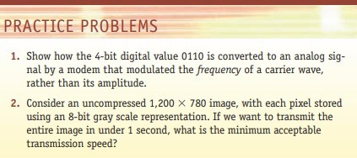
Ans 1 - A modem (modulator-demodulator) converts digital data to analog signal.
There are different ways to modulate a digital signal on an analog carrier signal.
Amplitude shift keying (ASK): is a form of modulation which represents digital data as variations in the amplitude of a carrier wave. Two different amplitudes of carrier frequency represent '0' , '1'.
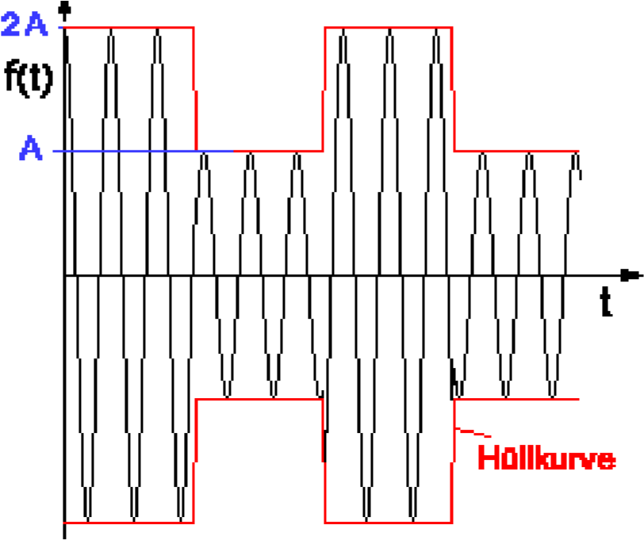
The data can be represented by altering the amplitude, frequency, or phase of the carrier wave. In this case, the data 0110 is represented via frequency modulation, as seen in the diagram below.
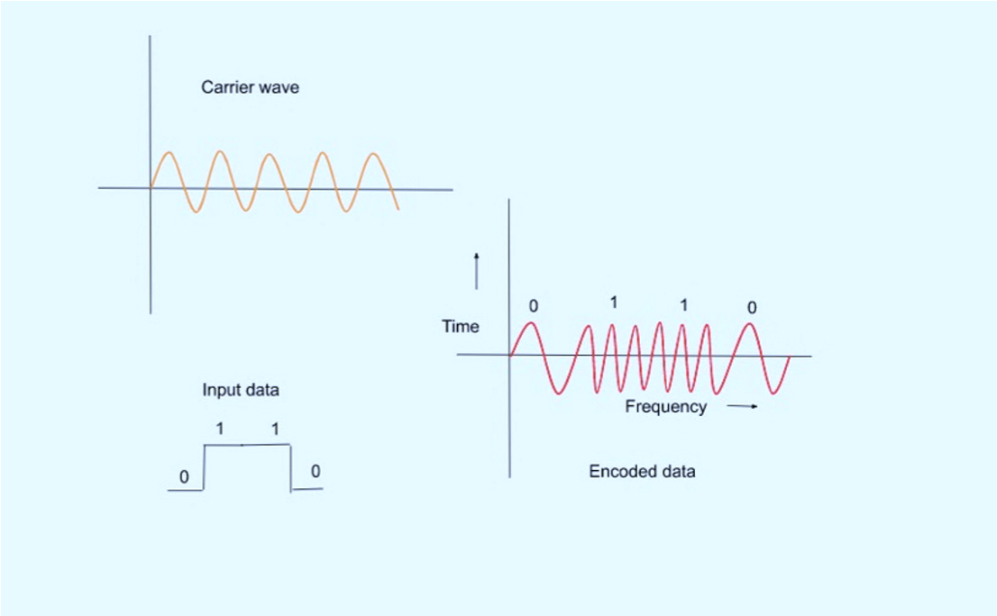
Ans 2 - Consider an uncompressed 1,200 * 780 image, with each pixel stored using an 8-bit Gray scale representation. If we want to transmit the entire image in under 8 -bit color graphics is a method of storing image information in a computer's memory or in an image file, such that each pixel is represented by one 8 -bit byte. The maximum number of colours that can be displayed at any one time is 256.
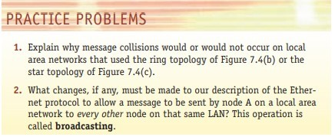
Ans 1 - Ring Topology - A ring topology is a type of Local Area Network (LAN) topology where every device has precisely two communicative neighbours. In a ring, messages typically move in a single direction. Any cable or device failure breaks the loop and brings the entire segment to a stop. The ring's inability to function properly if any component is added to or withdrawn from it is another drawback.
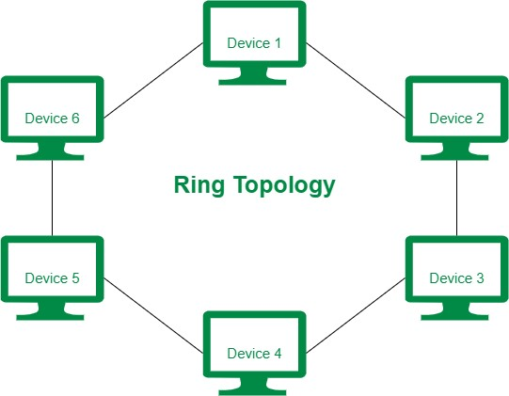
Since data only goes in one direction and there won't be any data collisions, this form of network can transport data swiftly even when there are many linked devices. The biggest drawback is that if any device or the main cable fails, the entire network would go down.
Star Topology - Each network component in a star topology network is physically connected to a hub, router, or switch as the centre node.
The centre hub functions as a server and the connected nodes as clients in a star topology. The central node can send packets to other nodes in the network after receiving them from connecting nodes. A star network is another name for a star topology.
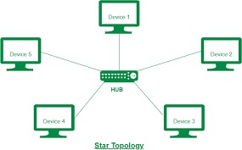
In a star topology, there is only one device at each point of the star. As a result, there is no opportunity for a collision between two devices to happen.
It also reduces a single point of failure's negative effects. Each connecting node in star networks is kept apart from the other connecting nodes. The performance of other connecting nodes in the network is unaffected if one of them fails.
makes it easier to add and remove individual components from networks. Star networks are often maintained small because too many devices jostling for access to the central node might degrade network performance.
Ans 2 - The local area network (LAN) protocol known as Ethernet was initially created to connect computers. The Ethernet technology specification was created by Bob Metcalfe at the Xerox Palo Alto Research Center (PARC) and later improved by Xerox, DEC, and Intel. The IEEE later approved the Ethernet technology definition as standard 802.3.
In the OSI network architecture, the Physical and Data Link layers are where Ethernet protocol functions. However, Ethernet divides the Data Link layer into two independent layers known as the Logical Link Control layer and the Medium Access Control layer.
The hardware components of the network, such as repeaters, cables, and network interface cards, are the primary emphasis of the physical layer (NIC). For instance, an Ethernet network like 100BaseTX or 10BaseT specifies the ideal topology, the type of cables that can be utilised, and the length of the cables.
Protocol Architecture for Ethernet
The network system's data connection layer primarily deals with how data packets are transported from one kind of node to another. Ethernet employs a mode of access known as CSMA/CD.

