CCNA ASSESSMENT 2 INSTALLS NETWORK
Table of Contents

Task 1 .........................................................................................................................................3
Task 2 .........................................................................................................................................4
Task 3 .........................................................................................................................................5
Task 4 .........................................................................................................................................9
Task 5 .........................................................................................................................................9
Task 6 ....................................................................................................................................... 10
Task 7 ....................................................................................................................................... 13
Task 8 ....................................................................................................................................... 14
Task 9 ....................................................................................................................................... 14
Task 10 ..................................................................................................................................... 15
Task 11 ..................................................................................................................................... 15
Task 12 ..................................................................................................................................... 16
Task 13 ..................................................................................................................................... 17
Task 14 ..................................................................................................................................... 18
Task 15 ..................................................................................................................................... 18
References ................................................................................................................................ 21
Task 1

Overview of the scenario
One of the leading mining companies named Western Mining has its head office in Sydney. The company is opening its new branch office in Brisbane. The branch office at Brisbane is needed to be fully equipped with networking facilities. Pacific IT Solutions is a solutions integration that is it is responsible for setting up and configuring the network of workplaces or residence as the case may be. Pacific IT Solutions has been given the responsibility to set up the network of the branch office. A meeting was held at the head office of Western Mining and the requirements of the company were discussed.

Basic requirements of the client
Western Mining’s new branch office at Brisbane has only a few employees and staffs to start with. However, as per the company’s expectation, the number of staffs would increase once the new projects come online. The branch office has a provision for the present number of staffs but it wants to allow a minimum of 510 staffs per department once the network has been set up. There are four departments namely, Operations, Sales, Exploration and Management. So in total, the new network should have provision for at least 2200 staffs. Western Mining requires all the hosts including the servers to have network access.

Hardware requirements
- Network connection - The network connection used in the head office of Western Mining is an E1 connection from Telstra. The company wants the same E1 connection at its branch office also. However, according to the company, this connection is quite expensive. The company wants to move to a cheaper and faster network service in future.
- Router - The Company wants to use a Cisco 2811 router in the branch office as the main router. Moreover, the company wants to use a non-Cisco router at its head office. This router will link the branch office at Brisbane to its head office at Sydney via WAN connection. The company also wants an OSPF connection to run across this link.
- Switch - The Company wants to use Cisco 2960 switches as per requirement in the head
office.
- Server - There are overall four departments. Each department requires an individual server. So in total, there is a requirement of four servers. The choice of server is in Pacific IT Solutions choice.
- Personal Computers - The Company wants to equip its departments with 48 PCs in each department. These PCs will connect to an individual server in each department.
- Cables and connectors - This is left on Pacific IT Solutions’ discretion.

IP requirements
- Western Mining uses the IP 172.20.0.0 for its private addresses in the head office. The head office wants Pacific IT Solutions to use 172.16.0.0 as the private address of the branch office.
- The IPs are to be assigned dynamically.

Security requirements
A corporate office going online is often risked of network-based threats. Western Mining has not much mentioned of its security requirements. The only mentioned security requirement is that the Management department’s server should not be accessed by any of the other department’s staff.
However, the Management department’s staff should have full access to other department’s PCs. Future Planning of the client
- The company wants to shift from E1 service from Telstra to a cheaper and faster connection in future. NBN is an option to be used once it is launched.
- Creating a link between the head office and the branch office using WAN.
- To set up a wireless network.

Other requirements
- The estimated bill of the equipment is needed to be submitted to the Senior Systems Architect.
- After the network is set up, a wireless site survey should be done.

Task 2

Basic overview of the branch office
Western Mining has opened its new branch office at Brisbane. This new branch office will consist of four departments namely, Management, Sales, Operations and Exploration. The branch office is provisioned to occupy only few numbers of staffs but the company wants to increase the provision by the application of the network. The company wants to develop an online provision for 510 employees per department. There will be 46 PCs and 1 server per department. Moreover, the company’s requirement is that the Management department can access every other department’s servers but the Management department’s server can not be accessed from any other department.

The network configuration
- Basic configuration - As per company requirements, the network connection will be availed from Telstra. An E1 connection will be used. This connection will enter the branch office and pass through a hardware firewall and enter the Cisco 2811 router. From the router, the connection will enter a Cisco 2960 switch. This will distribute the network among the four departments. The connection before entering each department will again pass through a firewall (Mestres et al. 2017, p.7). After the connection pass through the firewall, it will enter one more router of each department. In each department, the connection from this router will enter the server and then a switch and get segmented into four, each segment having 12 PCs each.
- IP assignment - The PCs will be configured with an IP address of range 172.16.0.0. The IP configuration of the PC will be done dynamically.
- Security - A VPN will be used in the Management department to provide it with security. A Network Access Control will also be implemented in the Management department network to prevent it from being accessed by any other department.
- WAN setup - The branch office will be connected to the Head office at Sydney via Wide
Area Network. A non-Cisco router will be used in the Head office end for this purpose. An
OSPF protocol will be used across this link between Head office and the Branch office (Shakya et al. 2016, p.213). The head office can remotely login to the switches and router using this link.

Task 3
The estimated cost of materials for Western Mining

Network  Components | Required Quantity | Price(each component) | Total
Switches and Cables
2960 Switch | 5 | $5,995 | $29,975
UTP cables | 250 m | $0.50/m | $125
Hybrid cables | 350 m | $8.00/m | $2,800
Coaxial cable | 600 m | $1/m | $600
Optical fiber cable | 800 m | $15/m | $12,000
Routers and Firewalls
Cisco 2811 | 1 | $2,500 | $2,500
Linksys  WRT1900ACS-AU  Wireless-AC Router | 4 | $297 | $1,188
Dell Networking  N2024 | 1 | $1,100 | $1,100
Cujo AI Smart  Internet Security | 5 | $275 | $1,375
Servers
IBM AC922 server | 4 | $5,100 | $20,400
Estimated Total Cost = $72,063

Table 1: Estimate cost of materials for Western Mining
(Source: Created by Researcher)
The estimated cost of materials for own use
Network  Components | Required  Quantity | Price(each component) | Total | Vendor
Switches and cables
2960 Switch | 5 | $5,995 | $29,975 | Cisco
UTP cables | 250 m | $0.50/m | $125 | StarTech
Hybrid cables | 350 m | $8.00/m | $2,800 | StarTech
Coaxial cable | 600 m | $1/m | $600 | StarTech
Optical fiber  cable | 800 m | $15/m | $12,000 | StarTech
Routers and Firewalls
Cisco 2811 | 1 | $2,500 | $2,500 | Cisco
Linksys  WRT1900ACSAU Wireless-  AC Router | 4 | $297 | $1,188 | Mwave
Dell Networking  N2024 | 1 | $1,100 | $1,100 | Mwave
Cujo AI Smart  Internet Security | 5 | $275 | $1,375 | Mwave
Servers
IBM AC922  server | 4 | $5,100 | $20,400 | Mwave
Estimated Total Cost = $72,063
Table 2: Estimate cost of materials for Own Use (Source: Created by Researcher)

Task 4
Documentation of schemes with respect to the IP address as well as naming for the device is considered to be very essential. In case of smaller network, this is not much essential but in bigger network, this aspect is very crucial. In that case, there is a need to follow some principles.
It is seen that there are 192 PCs which are connected to the network with the help of router. Thus, it is essential to reassign the IP address to the PCs by simply subnetting the masks present in the network (Schmitz, 2020, p.89). The network must be simulated in such a manner that will be able to measure the optimization value of the topology. The necessary components of the topology:
- With the help of router interface, the router must be configured
- It must be checked that the IP addresses are configured dynamically by the users in each computer system (Kovach and Sadler, 2019., p.67)
- For network topology, Cisco 2960 switches and 2811 router are used
- UTP cables, coaxial cables, optic fibers as well as hybrid cables are used where there is a need for connection
Need for documentation
- This is required in order to keep records of all the IP address that are assigned
- The device can be reassigned to the IP address at the time of any repair
- In order to ease the process of maintenance (Laracy and Greenspan, 2019, p.1)
- This is also necessary for reconfiguring the routers as well as PC

Task 5
The file has been attached separately.
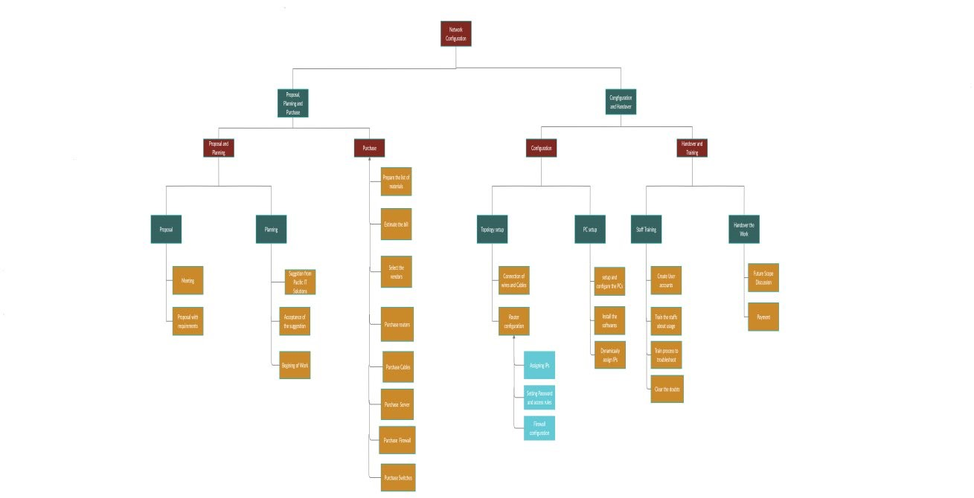
Figure 1: Work breakdown Structure
(Source: created by Researcher)
Task 6

Hazards and Precaution for while installing the Cisco 2811 router and Cisco 2690 Switch Hazards
The hazards in the installation of any network system refer to the ignorance for which the installation gets hampered or some damages are caused to the equipment and system. In the installation of the current network system Cisco 2811 router and Cisco 2690 switch are used. These require special precautions while installing or it can cause problems. The hazards of the components are as follows:

Cisco 2811 router | Cisco 2690 Switch
The hazards in the Cisco 2811 router are:  - The network has a possibility of a cyber attack and causes data to get hampered easily in the absence of proper security (Cooper and Richter,  2019, p. 1547)  - There is a hazardous voltage  generated from the ringer or signal generator present in the system that is connected to the RJ-11 port wires which, in turn, is activated by the incoming call.  - The voltage can also be present in the system via the WAN ports without turning the power unit on.  - Installing an antenna is a risky task that required some degree of precision. Any small deviation in the installation can hamper the circuits of the network.  - The battery of the systems is required to be replaced correctly or there is a chance of explosion and that can damage the network as well as the electrical system. | The hazards related to the Cisco 2690 switch are as follows:  - The TNV circuit related to the WAN ports has an electrical hazard that is subjected to cause damage to the equipment and even system failure if it comes in contact with the SELV circuits of the LAN ports.  - Overheating can cause damage to the switches. The ambient temperature that the switches can withstand is 45 ℃.  - The wiring of the switches in the network requires special care that can subject to cause damage to the machinery and circuits due to short circuits.  - The switches acquire chassis that should not be stacked on anything because it can cause injury to the people and damage to the equipment

Table 3: Hazards of Cisco Equipments
(Source: Cooper and Richter, 2019, p. 1547)

Precautions

Cisco 2811 router |  | Cisco 2690 Switch
The hazards of the Cisco 2811 router can be avoided by the application of the following precautions. The precautions are necessary not only for the safety of the equipment but also, the staff of the office.  - The hazardous port RJ-11 should be made inactive while the power is on or the ringer is activated.  - Power should be turned off while working on the DC circuitry. The DC circuit should always be detached from the power to avoid electrical  short-circuit.  - Power should also be turned off while installing the network set up and circuitry for avoiding the leakage or hazardous voltages and it is obviously the same for the testing of the circuits.  - The threat of cyber attacks can be prevented by the implementation of the proper software on the layers of the network.  - Cabling of the network should be done carefully so that there is no scope of short-circuiting and |  | The precautions should also be taken for the Cisco 2690 switches while installing. Precautions should be taken on the following aspects:  - There must not be any connection either physically or electrically between the SELV circuits in LAN and TNV circuits in WAN.  - The ambient temperature of the switches in the system must be continuously monitored and there should also be an alarming system to warn people the odd temperature reach (Davies et al. 2018, p. 509).  - The wiring should be neatly done and there should not be any  interconnection between the parts in order to avoid the short-circuiting.  - The mounting of the switches should be done according to the guidelines of the installation guide.
 | unnecessary confusion while replacements.
● | The grounding of the circuitry must also be done carefully to avoid shortcircuiting and the leakage of the current.
● | The antenna should be installed carefully by the experts for avoiding unnecessary mishaps. The antenna is installed in the wrong manner can cause electrical leakage that can hamper the system.
● | The battery should be replaced carefully because the mismatch of the type of battery can damage the  systems.

Table 4: Precautions of Cisco Equipments
(Source: Davies et al. 2018, p. 509)

Task 7

Subject: Power and Data quote
This is to inform you and your company, Western Mining that as per requirement the list of materials required for the network set up and configuration in the branch office at Brisbane has been prepared. The costs of individual materials and total cost is also ready. The quote is being sent by me on the behalf of Pacific IT Solutions.
Few vendors have been selected for the delivery of the materials. The vendors and the deal with the vendors will be finalized once the quote is approved. Your opinion is greatly expected.

Task 8
Subject: Designing the network
It is to inform you that our company has chalked out a plan for the setup of wireless network in your office. I am sending you the necessary files with respect to the plan. Hence, it is requested to you to go through the plan and specify the unmet conditions. The system is mainly designed for five departments and there are 510 staffs in each department.
Please check the design and reply to us if required.

Task 9
Subject: Coordination for the installation of network
It is to inform you that our company has successfully acquired the necessary equipments that are needed for the installation of the setup. Thus, for such purpose, there is a need for 6200 Sq. ft room with AC for storing the equipments.

Task 10
The simulated network has been built using Cisco Packet Tracer. The simulated network contains only 2 PCs per department instead of 48 PCs in the real scenario. The PCs have been configured with the IP address of the range 172.16.0.0. The connection coming from ISP enters the firewall, gets filtered and enters the main router. It then enters the switch from which it gets distributed among the departments. Ping can be used to check the connectivity.
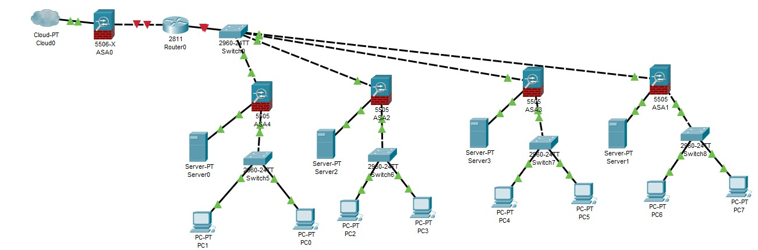
Figure 2: Network build and configuration
(Source: Created by Researcher)

Task 11
Functionality Requirements | Tests and validation |  | Results
Physical Connections | ● Checking the | link | All the connections are on and
 | lights next to RJ-45 port (López-Pérez et al. 2016, p.9863)  - Checking the lights of the PCs and switches are on.  - Switches are plugged in (Singhal and Ou,  2017, p.53) |  | the link lights and lights on switch and PCs are on.  Physical connections are okay.
Login verification | Checking if the users can log in (Diekmann et al.2016,  p.252) |  | Users can log in using correct user id and password
Network configuration | - Click windows+r  - Type cmd and press  enter  - Enter ipconfig (Li and  Hong, 2016, p.5391) |  | A valid IP address is being shown.  IP configuration is set correctly.  DHCP is working correctly.
PCs can ping each other | - Click windows+r  - Type cmd and press  enter  - Enter ping ipaddress |  | PCs can ping each other and transfer packets.
Table 5: Network Functionality Tests
(Source: Created by Researcher)

Task 12

Subject: Request to sign off the completion of work
This is to inform you on the behalf of Pacific IT Solutions that the network set up and configuration is completed. Training the staffs about basic account access and troubleshooting is completed. It is requested to please sign off the project. Thanking You.

Task 13

Subject: Informing about NBN roll out, its implementation, advantages and cost Respected
This is to inform you on the behalf of Pacific IT Solution that NBN has been rolled out in Brisbane. The NBN connection will not cost anything thing while shifted from the existing connection. Charges will be applicable in case of connecting a PC to the internet as per the selected plans. It will cost around $120 as part of casual plan fees.
NBN connection has some benefits over the existing E1 connection. It will be much cheaper and faster compared the existing connection. The connection speed is enough for doing high quality video calls and other official works. The connection drop rate is also minimal.
The security risks involved is that the existing security systems will become obsolete. The issues can be solved by implementing NBN compatible security systems.
Hope the recommendations will be considered.
Task 14
The head office will contain the non-Cisco router. This router will remotely log in and access the switches and routers of the branch office. Many routers are used in WAN connection at multiple access points (Waliullah et al. 2015, 11). The connection between the non-Cisco router and the branch office router will run OSPF protocol. The steps are:
- Setting up router 1 is easy. It will comprise of automatic channel selection and manual file transferring from channel to channel.
- The IPs of Router 2 is to be set up manually to prevent any conflict.
- The gateway of the Router1 is set to the Router 2
Task 15

Process of the site survey for wireless network
There is a requirement for the physical survey of the site where the office will be situated and the network set up has to be installed. This requirement is necessary because the performance and effectiveness of the network are dependent on the proper installation of the system. The proper judgment of the site helps in optimizing the performance of the system. The process for the site survey before the installation of the network system is as follows:

Step 1:  Determining the specifications of the  needs | The whole area of the site is required to survey but before taking the steps it is necessary to judge the area from the maps of the site. The map can be a blueprint of the building, design of the engineers, piping maps. The elevator shafts and staircases are required to be determined (Filimonoff et al. 2018, p. 140).
Step 2:  Taking the map of the sections | The map of the sections can be acquired from the map but it is best to take a tour around the property for noting and evaluating the minute details. The sections’ divisions are required to be assessed to judge where the requirement is for which equipment.
Step 3: | Taking steps on the floor is necessary because only then the practical

Take steps on the  floor | assessment of the field is possible. The maps or the division of the sections do not give the whole idea of the site. This step is also necessary for determining the flaws of the building and how that can be used in the design for effective performance.
Step 4:  Determination of the structure | The detailed floor plan is ready. Now the whole structure is judged depending upon the requirements of the client. This gives the designer an idea of the possibility of the project and also the requirements for the enhancement of the problem. This is also helpful in safeguarding the design and its application.
Step 5:  Assessment of the complete site | This step is essential for designing. The flews found in the previous step are required to be solved that is possible by assessing the details of the site. So the complete evaluation of the site is necessary. In this step, the space-related problems with the design are solved (Airi, and Anderson, 2017, p. 88).
Step 6:  Find positions of the  Access Point location | The access point is the most important thing because the machines will be communicating with the network through this point. So the number of access points is necessary to know. This site survey will also give the idea of the point in the practical field on which the access points will be situated.
Step 7:  Survey of the network by trialing | After all the determination a trial is run with the help of some architectural software. This gives an idea of the implementation and the effectiveness of the network. The simulation run also provides the data related to the flaws in the access point locations and provides suggestions for enhancement.
Step 8:  Pinpointing Access  Point Locations | The access point locations are determined and the flaws in them acquired from the software are assessed. The points are rectified and the required changes are made in the design. The shift in the reallocation is also pointed and the system is made ready to install.
Step 9:  Make  Documentation | The documentation is done throughout the process and the evaluation of the expenses is done. The documents are necessary for keeping the measures of the expenditure for sending it to the client.

Table 6: Steps of Wireless Survey
(Source: Airi, and Anderson, 2017, p. 88)

References
Airi, P. and Anderson, P.K., 2017. Cisco Packet Tracer as a teaching and learning tool for computer networks in DWU. Contemporary PNG Studies, 26, p.88.
Caria, M., Das, T., Jukan, A. and Hoffmann, M., 2015, May. Divide and conquer: Partitioning
OSPF networks with SDN. In 2015 IFIP/IEEE International Symposium on Integrated Network Management (IM) (pp. 467-474). IEEE.
Cooper, C.B. and Richter, C.L., PROOFPOINT Inc, 2019. Method, system, and storage medium for adaptive monitoring and filtering traffic to and from social networking sites. U.S. Patent 10,454,948.
Davies, S.J., Burhan, A.M., Kim, D., Gerretsen, P., Graff-Guerrero, A., Woo, V.L., Kumar, S., Colman, S., Pollock, B.G., Mulsant, B.H. and Rajji, T.K., 2018. Sequential drug treatment algorithm for agitation and aggression in Alzheimer’s and mixed dementia. Journal of Psychopharmacology, 32(5), pp.509-523.
Diekmann, C., Michaelis, J., Haslbeck, M. and Carle, G., 2016, May. Verified iptables firewall analysis. In 2016 IFIP Networking Conference (IFIP Networking) and Workshops (pp. 252-260). IEEE.
Filimonoff, A., Klimova, A. and Muravyov, A., 2019. Experience of Using Multilayer Virtual Partitioning in Laboratory Complex Construction. EdCRUNCH Ural: новые образовательные технологии в вузе–2019.—Екатеринбург, 2019, pp.129-140.
Kovach, J. and Sadler, L., 2019. Integrated Sensor Architecture (ISA) Database/Media Storage
Tool Software Package Documentation (No. ARL-TR-8768). CCDC Army Research Laboratory
Adelphi United States
Laracy, J.R. and Greenspan, R., 2019. Towards a Rigorous Software Architecture Documentation
Process: A Demonstration with the Real-time Immersive Network Simulation Environment (RINSE). IJO-International Journal Of Computer Science and Engineering, 2(12), pp.01-33. Li, F. and Hong, J., 2016. Efficient certificateless access control for wireless body area networks. IEEE sensors journal, 16(13), pp.5389-5396.
López-Pérez, D., Laselva, D., Wallmeier, E., Purovesi, P., Lundén, P., Virtej, E., Lechowicz, P., Malkamaki, E. and Ding, M., 2016. Long term evolution-wireless local area network aggregation flow control. IEEE Access, 4, pp.9860-9869.
Mestres, A., Rodriguez-Natal, A., Carner, J., Barlet-Ros, P., Alarcón, E., Solé, M., MuntésMulero, V., Meyer, D., Barkai, S., Hibbett, M.J. and Estrada, G., 2017. Knowledge-defined networking. ACM SIGCOMM Computer Communication Review, 47(3), pp.2-10.
Schmitz, C., 2020. MBS Network Plugin Documentation.
Shakya, A., Prasad, P.W.C., Alsadoon, A., Zajko, G. and Elchouemi, A., 2016, November.
Development of the Wireless Cisco Networking Laboratory Pod. In 2016 International Conference on Advances in Electrical, Electronic and Systems Engineering (ICAEES) (pp. 208213). IEEE.
Singhal, A. and Ou, X., 2017. Security risk analysis of enterprise networks using probabilistic attack graphs. In Network Security Metrics (pp. 53-73). Springer, Cham.
Waliullah, M., Moniruzzaman, A.B.M. and Rahman, M.S., 2015. An experimental study analysis of security attacks at ieee 802. 11 wireless local area network. International Journal of Future Generation Communication and Networking, 8(1), pp.9-18.

