Boosting Smart Home Device Security Protocol
Question
Task:You have just joined as an IoT Architect at Ingenious IoT. The first project you have been tasked with is the setup of a demo IoT Smart Office, with a link to the company offices. The project is divided into 2 parts:
- Create a smart office with the criteria and devices given
- Control these smart devices from the branch office which is in the same city.
The Main Smart Office includes, but is not limited to the following smart devices:
- Ceiling Fan
- Lamp
- Front Door Lock
- Motion Detector
- Lawn Sprinkler System
- Smoke Detecto
- Temperature Monitor
- Anemometer (Wind Speed Detector)
These devices are linked to a Wireless Router, which is linked via an Ethernet cable to a Cable Modem. The modem is connected to the Internet via an ISP known as Optras. All the devices registered on the Remote Server can be controlled locally by a Tablet which is also connected to the wireless network. There is a Remote Server connected to the Company's Cloud Cluster service (run by Sky Servers), as well as an external server that the Smart office uses for backups
Ensure that you add all necessary screenshots with the documentation as well as the packet tracer file to be presented to the manager for project approval
Tasks:Build and configure a smart office. (Refer to the file on the Student Resources named Assignment_2_Help). Start the smart office from the basic file, available from the link below: https://static-course-assets.s3.amazonaws.com/I2PT/en/index.html#6.2.1.2
Part 1
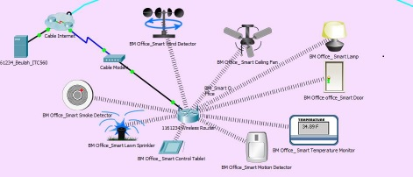
- Add, connect, enable and configure the registration server, tablet and wireless router as shown in the diagram below

  - Add, configure the smart devices mentioned in the case study and name these as given in the diagram below. Note that these devices should be connected to a wireless router wirelessly and should be encrypted using AES by using WPA-PSK (PSK pass phrase must be only your student ID
  - Connect and activate the devices with username and password as Student ID only.
- Set up all the smart device attributes through the tablet web browser for the devices to work as shown in the diagram below
- Show the protocols that are used in transmitting a simple PDU from the tablet to the Server.
Part 2
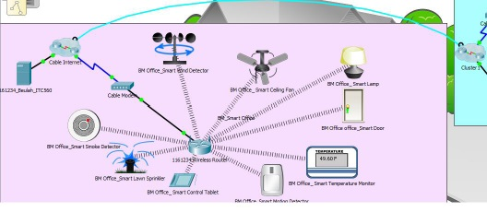
Add a new branch office in the same city. Either move the same tablet to the branch office or use your smart phone and connect to the main smart office server. You can use any connecting and intermediary devices of your choice. Log on to the web browser on your tablet/smart phone and manage the devices.
U se your tablet/smart phone to:
- Turn off the Sprinkler
- Turn off the ceiling fan
- Lock the door
- Dim the lamp
- Turn on the smoke alarm
- Turn on the motion detector
- Turn on the wind detector
Rationale
This assessment covers the following learning outcomes:
- be able to explain and demonstrate various components of Internet of Things (IoT);
- be able to analyse the role and importance of IoT in the modern world;
- be able to investigate and propose various requirements of IoT for real world applications
Answer
Part 1
Introduction:The adoption of smart home technology is on the rise across the globe. The smart device requires to interconnect within a network so as to work effectively. While some are reliant on the internet to establish the connections others simply need to establish a connection between device to communicate and perform effectively.
The previous report has been designed based upon the smart office network and its configuration based upon the requirement of the plan. The report also contains the screenshot of the working of the management so as to get a clear picture of the IoT network and its working. The screenshot also describes the configuration of the device with the help of Wi-Fi network to all the smart home device. In order to connect the Smart home technology with a particular network it has to go through a process of configuring the system with the Wi-Fi device with certain username and password. When the configuration is done successfully, it is necessary to create a new account with the help of a tablet or a smartphone and create a new username and password so that the management of the device and be operated successfully. The tablet or the smartphone will allow to login to the established network and then all the devices can get connected to the same network. The configuration of the wireless device is very essential for establishing an efficient network connection between the device and the wireless connection. It will help in mobility and also help to transfer the device from one place to another without any physical labor. Working and connecting the device with this network is very crucial as it help both the employees and the company to work effectively with the advanced method.
1. Configuring the Smart IOT network within Packet Tracer
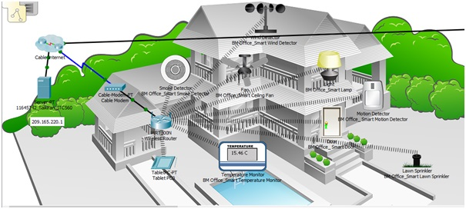
Figure 1: Screen shot of connecting the Smart home technology
2.I. Screenshot of the IoT device connecting and its configuration.
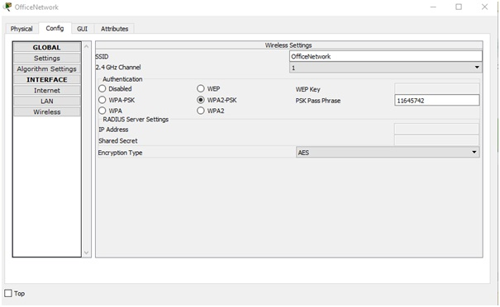
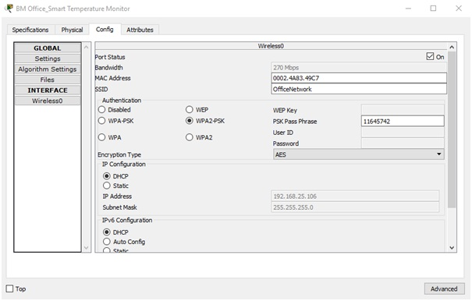
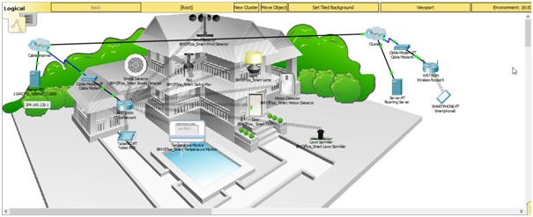
II. Screenshot for registering the device and creating an account
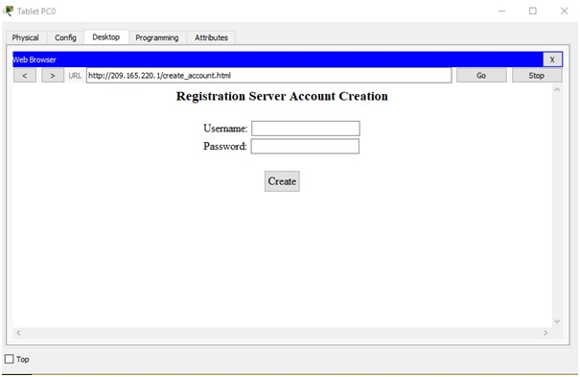
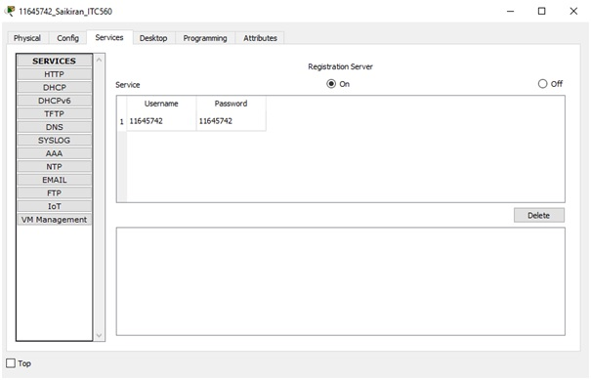
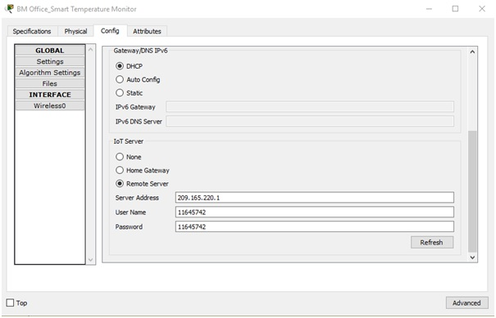
3. Screenshot for opening the Smart IOT device with the help of a smart device
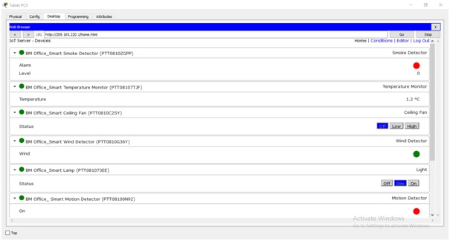
4. Simple PDU from Tablet to the server
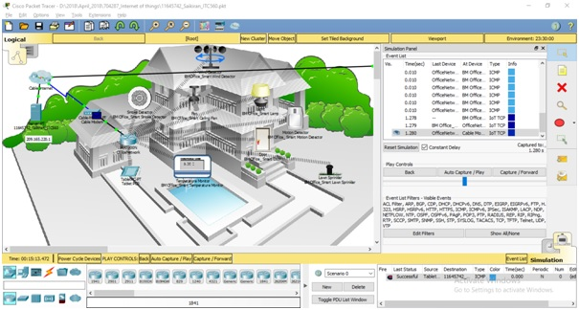
Conclusion
It can be concluded from the above screenshot that all the smart home device has been configured successfully and is able to meet the requirement of the organization in all possible ways. The network is also being tested through the established connection via a smart home device and its process of registration is also being conducted to have an authentic and secured network. The Smart home technology connection is being preferred over the wired network because it helps to connect all the device easily and successfully with the use of wire. This will help to reduce the cost of wiring and even allow the device to have a flexible network that can move from one place to another without any problem. It is also necessary to note the location of the wireless device because it is very important to establish connection within a range so that all the device that are connected with the wireless network can be able to connect with each other with strong network connection. Thus, it is necessary to have to keep and router in a middle position so that it can connect all the device successfully. It must also be noted that Wi-Fi booster can also be installed in those places where connection is weak so that a better network connection can be established.
Part 2
Introduction:The second part of the project deals with the branch of the same management and the organization but is situated to a new and different location. The remote branch of the office and its diagram has also been demonstrated. It must be noted that the new branch is also connected to the same network in which the head office is being registered. This will allow to control the branch office of remote location to be able to control easily from the head office and will have a clear and established connection. Thus, a cable wire has been drawn from the head office to the remote location by which the connection can be established. A switch is also being installed in order to connect and disconnect the established network. The work will be done entirely online and thus a cloud based network has been formed which is directly connected from the head office computer and this is important as the data can be transferred easily via this cloud platform. Employees will have a clear access of all the required data and can be connected easily with the network easily. It is also important to have a access point network which is important to establish connection between the device of the head office with that of the device of the remote location. The access point has been established based upon the requirement of the organization which is important to establish network connection with the smart device to that of the connecting network in order to have a clear access of all the IoT devices which has been installed in all parts of the Smart office location. Establishing the network connection is highly important because it will allow the device to connect with the home network and work efficiently.
The screenshot that has been provided will help to understand the connection of the IoT devices with the help of any smart device or application.
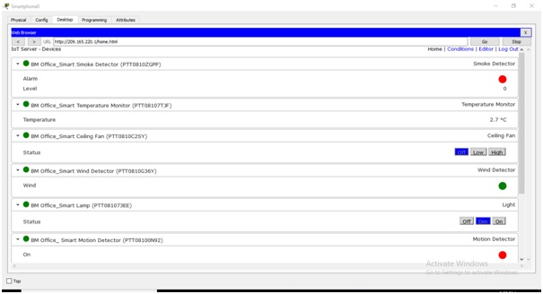
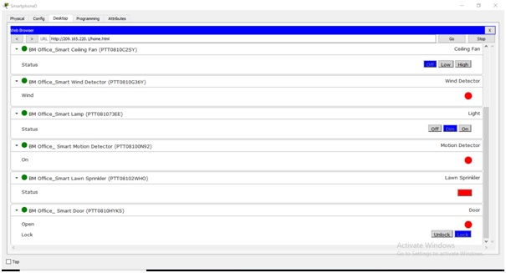
Packet Tracer File

Conclusion
By the above scenario it can be easily stated that with the extreme growth and development of the smart IOT network which is very advanced, in some of the operations it can be done in the automated form. It can creates as well as increases the flexibility of the network by allowing the devices which is linked or merged with the network just to manage or organize from any of the location in this network. This devices basically constructed as per the requirement of the needs and wants too of the corporation and also do research which has been made on the device of IOT only and also construct for the increment of the network’s framework. This IOT device is configured to link up with the wireless access point and accurate authentication which is used especially for the maintenance of the security of the network. To test or check the connection of the network ICMP packets and give in between the sources (tablet/smart phone) and the aim (the registration server) just to decrease the problems or errors within the network and effectively delivered or supplied the project. This IOT network is very advanced in nature and due to this many problems can be sorted out easily. By this we can save a lot of time because it is very helpful in nature. This network can easily connect with the other one or with any other device which is also very advantageous by this doing of work through internet with the help of IOT can do in an easy way. The smartphones and the other devices like computer, tablets etc. are not going to have any damage like virus or any other things them. So, in other words, the devices are also get secured by the use of this IOT network.
Bibliography
Behan, M. and Krejcar, O., 2013. Modern smart device-based concept of sensoric networks. EURASIP Journal on Wireless Communications and Networking, 2013(1), p.155.
Domingo, M.C., 2012. An overview of the Internet of Things for people with disabilities. Journal of Network and Computer Applications, 35(2), pp.584-596.
Kerski, J.J., 2003. The implementation and effectiveness of geographic information systems technology and methods in secondary education. Journal of Geography, 102(3), pp.128-137.
Luftman, J.N., Bullen, C.V., Liao, D., Nash, E. and Neumann, C., 2004. Managing the information technology resource: Leadership in the information age. Upper Saddle River, NJ: Pearson Education.
Mumtaz, S. and Rodriguez, J. eds., 2014. Smart device to smart device communication. Switzerland: Springer International Publishing.
Piyare, R., 2013. Internet of things: ubiquitous home control and monitoring system using android based smart phone. International Journal of Internet of Things, 2(1), pp.5-11.
Vermesan, O. and Friess, P. eds., 2013. Internet of things: converging technologies for smart environments and integrated ecosystems. River Publishers.

