Project stakeholder and Communication Management
Name
Institution
Course
Instructor
Date

Table of Contents
SECTION A 1
Project stakeholder and Communication Management 1
Introduction 1
The Project’s Success Factors 1
Stakeholder Theory 2
SECTION B 4
Stakeholder’s Analysis as Theorised by PMI 2017 4
Application of the Stakeholder Analysis Theory 5
Tools and Techniques Used in Stakeholder Engagement as per PMI (2017) 7
Application of The Engagement Tools on A Hypothetical Project 11
Six Key Points to Be Considered When Preparing a Communication Plan 12
1. Information Should Be Communicated Successfully 12
2.Efficient Channels of Communication 13
3.Sufficient Communication across all borders 13
4.Appropriate Use of Technology 13
5.Application of a Virtual Office 13
6.Conducting Effective meetings 13
Application of Six Key Points to Be Considered When Preparing A Communication Plan in Ensuring there is Effective Communication 14
Conclusion 14
References 15

SECTION A

Project Stakeholder and Communication Management

Introduction
A stakeholder engagement plan permits the project heads to develop a well-structured approach to guarantee anticipations, choices, project issues, and progress. The plan also ensures that the correct level of information reaches the right people at the appropriate time. Stakeholder engagement is a process with various steps (Silvius & Schipper, 2019, p.46). Therefore, the project manager needs to follow the steps to ensure successful engagement that, in turn, assures prosperity in a project (Fewings & Henjewele, 2019). The paper will include the case study’s project success factors alongside the stakeholder theory, which illustrates stakeholder engagement’s usefulness.

The Project’s Success Factors
A project’s success does not occur by accident. It takes a couple of factors to make a project entirely successful. Certain success factors need consideration to ensure that the project in question prospers (Levy, 2018, p.36). The critical elements that led to the case study’s project success include early preparations or planning, effective communication, stakeholder consultations, and excellent project leadership. Firstly, the management informed them earlier enough to prepare adequately before presenting themselves to discuss more project items. The project embraced early planning, which consisted of several steps. Initially, there was identifying the stakeholders and meeting them to discuss their interests regarding the particular activity. Aside from knowing the interests, the preparations involve outlining the stakeholders’ expectations concerning the project, budget, anticipated timeline, and creating project scope starting points (Heagney, 2016, p. 64). Since goals drive every project, the team meet and defined or set their desired objectives to achieve. There was the creation of a project schedule for all the investors to understand the timeline involved. Secondly, the project incorporated effective communication. A project undertaking achieves success when offering a keen eye to the external information sources and looking carefully at details. Generally, providing open communication in a team is critically essential. Several unwanted advances in projects might be barred or in any case be noticed in advance with effective communication. (Lauren, 2018, p.43).
The management ensured proper communication among the team members. Notably, there were meetings where all the stakeholders met up and discussed crucial project issues. Communication was a medium over which important project issues became discussed. Additionally, the element enabled performance, goals, and feedback to be discussed. Thirdly, another project’s vital success factor stakeholder consultations. Understanding stakeholders in a project is crucial contemporarily. Such involves paying close attention to their opinions and beliefs alongside requesting their feedback. They are individuals meant to shape and promote success or failure (Andriof et al., 2017, p.20). Remarkably, the project heads interacted with all the individuals and listened to everyone’s interests before making conclusions or deciding steps to involve in the whole project. Lastly, excellent leadership stimulated the success of the project. Leaders or the top management led the project appropriately and stimulated ultimate prosperity. First and foremost, there was a relatively comprehensive and in-depth stakeholder engagement schedule over the lifecycle or course of the project. Additionally, there was extensive research and developments, discussions, preparation, and assessment of the projected reactions of some great stakeholder groups.

Stakeholder Theory
The stakeholder theory argues that a firm must develop a value for all the stakeholders (Certo & Certo, 2015). Regarding the case study, the value was achievable through embracing a comprehensive stakeholder engagement plan. A project is fruitful whenever it attains its goals and realizes or surpasses the stakeholders’ anticipations. Stakeholders are persons who mind concerning a project or have a particular interest in a specific project at hand. They are persons actively involved with a project’s undertakings or have shares in the project and are liable to gain or lose in the stipulated project. The persons are significant since they might include concerns that necessitate attention (Meredith et al., 2017, p.52). There are different stakeholders in any project and each has different concerns. A list of the stakeholders includes a firm’s top management, project manager, resource managers, internal and external customers, government, contractors, subcontractors, and suppliers. Each has a concern regarding the project at hand; they contribute in any way within the project. The subsequent sections illustrate a generic list of project stakeholders and their generic concerns touching on the project in question according to the stakeholder theory.
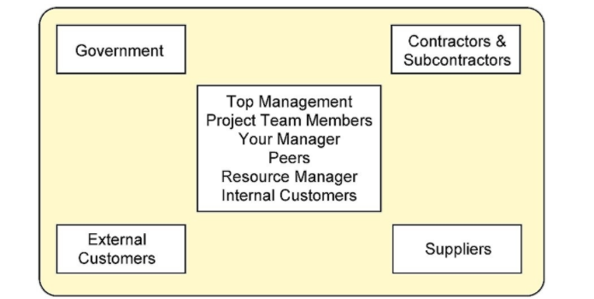
Figure 1: Showing a project’s key stakeholders

The top management may comprise a firm’s president, deputies, directors, managers, the operating committee, among other titles. The main concern regarding the top management is to offer or direct the organizational strategy and progress. Also, they wait for positive feedback concerning potential project risks and impact at all times. Another concern for the management in a project includes approving the top project plans and milestones. Individuals have a role in any project. They decide on the types of assignments to allocate in a project and who can work with them. Since project managers can borrow resources, other heads manage their resources and are called resource managers. Their connection with other people is significant. If the connection is better, they might easily achieve the best equipment and human capital for the stipulated projects. Governments are regulators in every project. They put across legal measures that projects must meet as they operate. Contractors and suppliers are also critical, and their concern is to ensure a project’s success by providing the required necessities.

SECTION B

Stakeholder’s Analysis as Theorised by PMI 2017
A stakeholder’s analysis can primarily be defined as a collection of techniques and tools used when identifying or considering the needs or expectations of main interests either inside or outside the project's environment. To be able to plan strategically on a project, one is required to have a detailed understanding of the existing relationship, traits, and interfaces between project opponents and advocates. From strategic planning, we can obtain the immense viability of our project risks, test its viability, and ultimately obtain and retain. When it comes to big projects, the endeavors require one to be politically stable and smart streetwise. Thus, one is needed to have a proper understanding of the internal environment of the project and other entities like interfaces to factors within the external environment. This process requires a combination of skills for discrimination among project groups and thus help develop a potential coalition aimed at attaining support if need, thus reducing the impact of speculated contingencies (Martinsuo, M. and Geraldi, 2020).
Stakeholders are interested in a given project or a strategy that is being undertaken by an organization. Therefore, this group is likely to be affected in some way by the project since they are interested in the organization. Since they benefit from the project, they have to be optimistic about it and support it. Once the project causes damage to their interest, they are likely to perceive it from a negative perspective and seek to stop it. In most cases, shareholders can be; financiers, neighbors, regulatory bodies, or occupants of a particular building. The influence of shareholders is usually felt in the early stages of the project. During this stage, a project is generally flexible and can therefore be changed to meet stakeholders’ interests. The moment the project begins progressing, it tends to take momentum and power, and it becomes difficult to change or alter it. The influence of stakeholders on the company often drops during construction but begins increasing during handover. The project managers are thus required to ensure they meet shareholders' expectations (Martinsuo, M. and Geraldi, 2020).
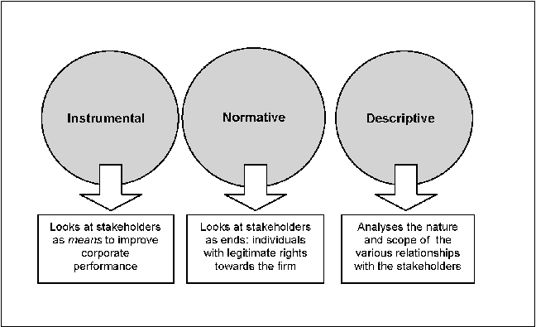
Figure 2: Shows approaches that should be used in the stakeholder theory during analysis

Application of the Stakeholder Analysis Theory
For any organizational project, all people or teams involved in the project are always referred to as stakeholders. One theory used in stakeholder analysis is the stakeholder theory. Edward Freeman's theory holds that the stakeholders of a company are composed of everyone affected by the organization directly or indirectly. The idea opposes the extended existing shareholders theory proposed by Milton Friedman, which suggests that shareholders are the only stakeholders any company should be concerned about (Brugha et al., 2000). According to Friedman, companies are only compelled to make profits to meet the demands of the shareholders. Contrastingly, Dr. Freeman's theory suggests that stakeholders are made up of people who, without them, a company would cease operating. This group of people comprises clients, employees, the community, the media, political groups, financial institutions, and even government groups. From Freeman's view, the corporate world is an ecosystem made up of related groups whose needs need to be considered and met equally (Brugha et al., pg 240).
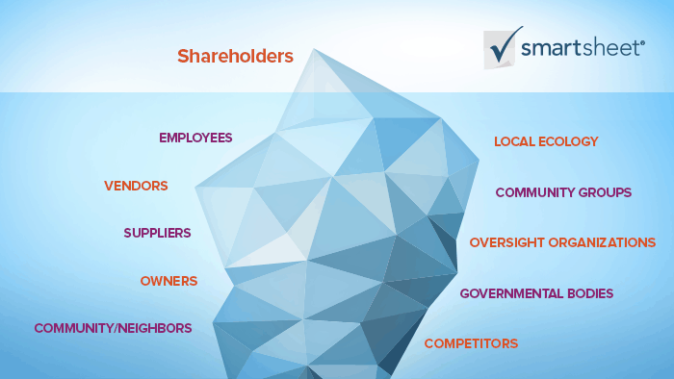
Figure 3: Represents the participants in a corporate ecosystem, according to Dr. Freeman

Craig MacDonald, a professor, teaching Informatics at the University of Australia, has conducted in-depth research on stakeholder theory, highlighting ways in which business ethics can help shape a company's future. According to professor MacDonald, any investor concerned about the future of his business or company should also be interested in protecting the environment by avoiding pollution and using sustainable methods of extraction. Therefore, he believes that business people should act in a way that represents their values and besides in a manner that will make them happy in the long run. In simple terms, MacDonald believes that ethics and social responsibility don't need to be treated in a unique way provided the company is practicing the real stakeholder theory to every participant (Brugha et al., 2000).
Emphasizing the current economy, professor MacDonald's believes that even the consumers should be ready to pay the real prices of goods and services. He gives an example of a hypothetical product manufactured in Asia but sold across the world through majorly in America. He mentions that since the product is manufactured in Asia, there is a possibility that the environment is polluted. The employees involved in the manufacture are probably poorly paid and besides work in unfavorable conditions. According to the professor, the company should be subjected to statutory laws where its directors and chief shareholders will then be made to cater for all the damages they have caused to the environment.
On the other hand, if consumers were not aware of the product's actual price and were probably paying more or less, they should then be told the actual price. However, if they knew the exact price but did not care, they should then help the executives repair the damages. Therefore, the above arguments call for a need to restructure the market for there to be an equal assessment of financial products and services (Brugha et al., p241).

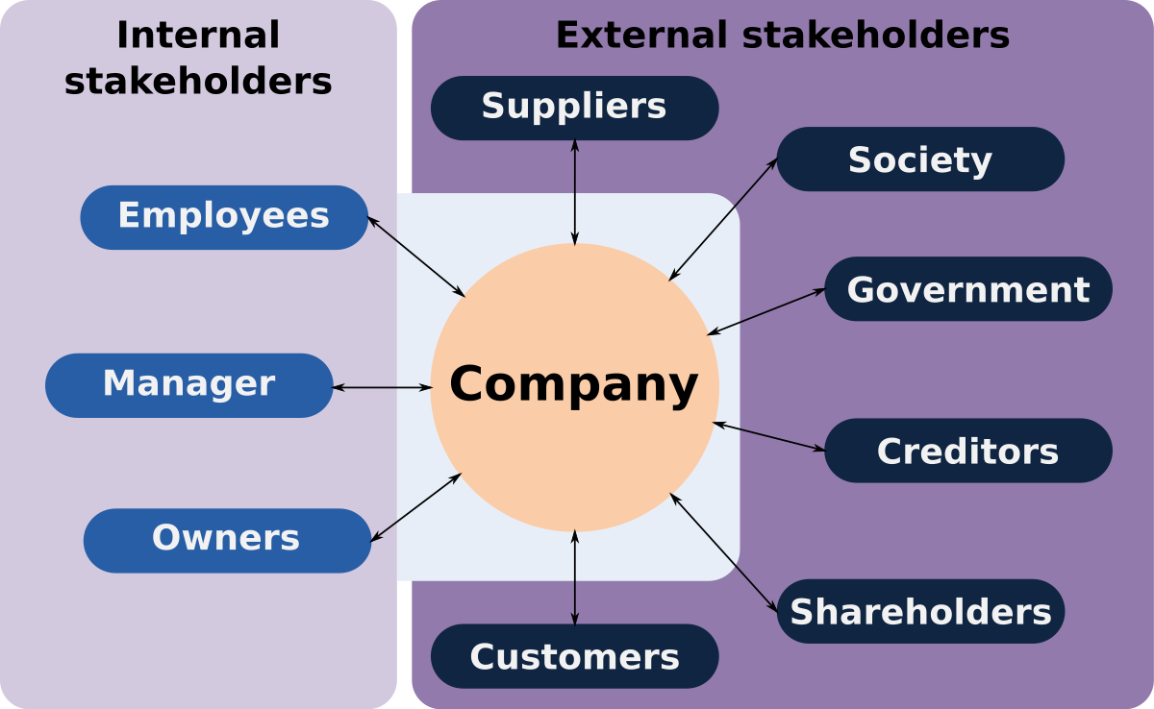
Figure 4:Shows parties affected by the stakeholder theory in a company, according to Dr. Freeman

Tools and Techniques Used in Stakeholder Engagement as per PMI (2017)
Various techniques have been propagated by the PMI (2017) in ensuring that stakeholders' needs are met and that they are besides at par with the project's progress. The techniques include:
- Experts' opinions: For there to be reliable decisions, views on complex issues like the environment of operation, politics, methods to be used in communication, and characteristics of stakeholders should always be made. These opinions will be of help when considering stakeholders' views and will besides enable the project teams to come up with the best solutions (Baker, 2012).
- Methods of communication; When communicating with the company's shareholders, contact should be made effectively and efficiently. The project manager should ensure he obtains feedback from the stakeholders and seek their views regarding the project. This can be achieved through formal or informal conversation, regularly holding meetings, conducting surveys, providing detailed updates about the project, and identifying and seeking to solve a problem when discussing it (Brugha et al., 2000)
- A combination of interpersonal skills and team management; Members of the project team must exhibit specific skills for the project to run and function smoothly. The skills possessed can be used in different ways, including;
a.) managing or solving conflicts; any project manager's primary role is to manage any form of conflict or misunderstanding that may arise among the project team members or the stakeholders.
b.) Creating cultural awareness; The project manager and his team should be aware of all the cultural differences they are likely to encounter when undertaking a project and therefore respect the cultures fully. On the other hand, when handling or communicating with stakeholders, they should always keep in mind that they come from different cultural setups.
c.) Conducting negotiations; Each project manager should utilize his negotiation skills when dealing with stakeholders in ensuring he manages any possible conflicts as possible.
d.) Observation; All actions should be observed and appropriately used to keep used in conversation.
e.) Political awareness: To determine whether the organization should determine whether it has influence politically (Baker, 2012).
Basic regulation; The manager should ensure that the team members follow the rules of stakeholders. These enable team members to know their limits and roles within the company. They provide guidance on how the whole project will be managed to ensure the outcomes are efficient.
5.Conducting meetings.; Meetings are usually held to ensure any existing questions or issues raised by stakeholders are tackled. The problems can range from solving conflicts to giving updates on the project
One frequently asked question is where the question is who is supposed to do this or is the supplier supplying this comes from. However, from the various meetings held by multiple project and client teams, the first step, which is considered the general step, ensures project delivery is a success. There are, therefore, various tools and techniques used in reducing confusion or delays when executing communication and conducting multiple inputs (Baker, 2012).
Issue | Action taken | Possible Outcome
When conducting a project, there is a possibility of confusion occurring in communication and in delegating duties. This could result in complications in running the project, high costs, and delays. | There is a need to use client and stakeholder engagement tools and methodologies. | There will be better engagement and collaboration among team members, which will, in turn, lead to high-quality products, save on cost increasing the success of the project or company.

The first tool used in engaging stakeholders in the stakeholder register. The register mentioned above is a living document of all individuals who work or impact the company in one way or another. Any form of identification information is usually maintained in the stakeholder register. The level of shareholder interest can, besides, be summarized in this document. A stakeholder analysis is used in tracking the organization itself, the name, its role, phone, classification of interest, its engagement assessment, and the organization's classification influence. The second tool is the power or the interesting grid, which classifies stakeholders depending on their level of authority and concern regarding the company's returns (Baker, 2012). The grid is essential as it helps in communication, planning, and working well with stakeholders.
The third tool is the power or the influence grid, which groups investors based on their authority and involvement in the organization’s project (Baker, 2012). The power/ influence grid is essential as it helps in coming up with ways to be used in approaching and resolving issues in an organization. The technique groups individuals into:
- Champions; the influential people who have a significant influence on the business and therefore provide a lot of support to the company
- Blockers; influential people who can block the business from operating
- Supporters; less influential persons who, however, support the business and are in favor of its operation.
- Detractors; the less influential people who are against the operation of the business.
After understanding the power of stakeholders, their interest, and influence, the next step is usually analyzing the level of their engagement and their efforts towards achieving the organization's goals. The next technique used is the stakeholder engagement assessment matrix. The method is a great way to regularly evaluate the participation of members in the project team to ensure they are all on the same page in ensuring the project is completed successfully (Baker, 2012). The levels of engagement under this technique include:
1.The unaware level; in this level, people are not aware of the project and its potential impact.
2.The resistant level; in this level, despite people being unaware of the project, they are resistant to change.
3. The neutral level; People at this level are aware of the project though they neither support nor resist it.
4.The supportive level; comprises people who are aware of the project, understand the potential impact, and therefore support the project.

5.The top level; people in this level are aware of the project and its potential impact and therefore participate actively to ensure the project succeeds (Baker, 2012).
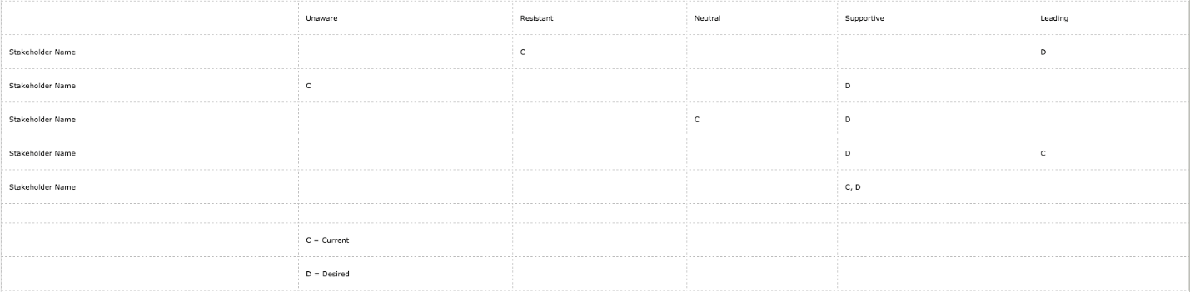
Figure 5: An example of a matrix used by company XYZ
The last tool used in stakeholder engagement is the Responsibility Assignment Matrix, abbreviated as RACI. The device, which takes the form of a chart, is used in clarifying the role of each project team across the functional teams that have several ambiguities.
R-Responsible; project teams who do the work that is required in completing a project.
A-Accountable; project teams who accept the work and only sign off on completion of the task assigned.
C-Consulted; project teams who serve as experts to the project by providing advice used in guiding the team until completion of the task.
I-Informed; project teams that are kept up to date until a project is complete.
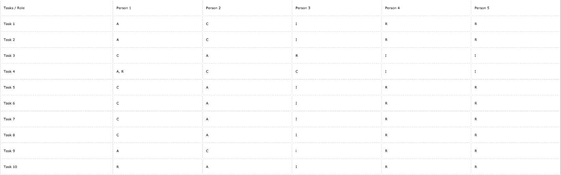
Figure 6: Shows an example of a RACI matrix used by company XYZ

Application of The Engagement Tools on A Hypothetical Project
XYZ is a construction company with an ongoing project of developing two shopping malls with three significant stakeholders who are primarily the financiers of the project. One of the stakeholders in the county government and the other two are non-governmental multinational companies. In one meeting, the three stakeholders got into a conflict where they argued about the basic structure and the design of the shopping malls. In such a situation, the conflict can only be solved by the project team's interpersonal and team skills. Efforts should also be made to ensure the two groups come to a consensus. However, the above technique will only solve the conflict with the help of the project manager, who will, in this case, be required to use his expert knowledge. A combination of the shareholders' knowledge and that of the three shareholders might help solve the conflict since multiple ideas will be put into use.
When it comes to shareholder analysis, the company conducts annual general meetings, roadshows, and briefing after every quarter and also consistent dialogues with analysts and shareholders by sharing the company's position. It engages its clients through visiting them regularly, conducting joint businesses with them, and through their customer care centers and customer surveys. Consumer questions are addressed through hotlines and customer service websites. To meet regulatory requirements, the company uses the recycling and recovery initiative and promotes fitness and diet among public members (Baker, 2012).

Six Key Points to Be Considered When Preparing a Communication Plan
Project communication entails planning and delivering information to stakeholders. Some of the project communication activities include; actions required to handle swift and appropriate meetings, production, distribution, administration, and control of all aspects within the project. It also enables the critical connection between people and the information needed for success. For any project to function well, there must be well-organized and operative communication among its members. Its stakeholders' critical risk assessment should be conducted to ensure all the communication functions properly. The is thus supposed to understand that delivering information does not mean the information is received. The role and responsibility of building or upholding actual communication belong to the manager. Therefore, the manager is expected to concentrate on six key aspects in ensuring that communication within the project works efficiently (Andersen et al., 2006).

1. Information Should Be Communicated Successfully
In most cases, project managers spend their time participating in all communication types, with almost half of their time being with team members. For communication among team members to be enhanced, the project manager should; pay much attention to an interpersonal communication network, the exiting relationship among shareholders, and that between shareholders and team members, keeping in mind that trust is an essential element when it comes to effective communication. There is also a need to accept that communication is a two-way traffic thing, and all members should actively participate in sending and receiving information for the project to be a success.

2.Efficient Channels of Communication
Project managers are supposed to create a platform where formal and informal communication is made with ease. They should be on the front line to start relationships, which will become connections in ensuring there is information flow (Andersen et al., 2006).

3.Sufficient Communication across all borders
To be able to handle specific challenges and, besides, come up with unique approaches in instances where the project teams are diverse.

4.Appropriate Use of Technology
With the rapid changes in technology and the emergence of cloud technology, it aims to provide support to project communications. Choosing a suitable technology is a significant factor since it facilitates communication between projects. This component is essential in projects that target more than one culture or international projects (Andersen et al., 2006).

5.Application of a Virtual Office
One critical consideration that should be considered when intending to strengthen communication is having one unique office virtually where stakeholders can meet with the team members to discuss issues affecting the project. The virtual office can also be used in managing the project and maintaining the latest information about the project.

6.Conducting Effective meetings
One significant project communication activity is through meetings. Effective meetings are those that happen as planned, and they, therefore, call for sufficient preparation and application of leadership skills. With advancements in technology, meetings can now be held without the participants having to meet physically (Andersen et al., 2006).

Application of Six Key Points to Be Considered When Preparing a Communication Plan in Ensuring there is Effective Communication.
Since company XYZ has three stakeholders and team members who may not frequently meet to discuss issues affecting the company, using a virtual office will be a great solution. A virtual office will facilitate communication despite the distance. Installing a technology that will favor all the team members is also one way through which effective communication can be attained in the company.

Conclusion
In conclusion, it takes a couple of factors to make a project entirely successful. Certain success factors need to be put into consideration to ensure that the project in question prospers. The critical elements that led to the case study’s project success include early preparations or planning, effective communication, stakeholder consultations, and excellent project leadership. The stakeholder theory argues that a firm must develop a value for all the stakeholders. Regarding the case study, the value was achievable through embracing a comprehensive stakeholder engagement plan.

References
Andersen, E.S., Birchall, D., Jessen, S.A. and Money, A.H., 2006. Exploring project success. Baltic Journal of management.
Andriof, J., Waddock, S., Husted, B. and Rahman, S.S., 2017. Unfolding stakeholder thinking: Theory, responsibility and engagement. Routledge.
Baker, E., 2012. Planning effective stakeholder management strategies to do the same thing. Project Management Institute.
Brugha, R. and Varvasovszky, Z., 2000. Stakeholder analysis: a review. Health policy and planning, 15(3), pp.239-246.
Certo & Certo, 2015. Stakeholder theory: A Project Management Perspective.
Fewings, P., & Henjewele, C. (2019). Construction project management: an integrated approach. Routledge.
Heagney, J. (2016). Fundamentals of project management. Amacom.
Lauren, B., 2018. Communicating project management: A participatory rhetoric for development teams. Routledge.
Levy, S.M., 2018. Project management in construction. McGraw-Hill Education.
Martino, M. and Geraldi, J., 2020. Management of project portfolios: Relationships of project portfolios with their contexts. International Journal of Project Management.
Meredith, J.R., Shafer, S.M. and Mantel Jr.. S.J., 2017. Project Management: A Strategic Managerial Approach. John Wiley & Sons.
Silvius, G. and Schipper, R., 2019. Planning Project Stakeholder Engagement from a Sustainable Development Perspective. Administrative Sciences, 9(2), p.46.

