- Company Selection & Background
The Kroger Company herein referred to as “the company” is one of the largest grocery store chains in the United States employing almost 453,000 individuals across 2,764 supermarkets. During the financial year 2021, the company generated revenues of USD 132.5 billion leading to a bottom line of USD 2.6 billion and Earnings per Share of USD 3.27 indicating a year-on-year growth of almost 60%. (WSJ, 2021)
- Industry Identification & Analysis
According to IBIS World, a leading provider of industry research the company not only is a part of the Supermarkets & Grocery Stores industry but is an industry leader in terms of market share. Specifically, the company enjoys an overall market share of 13.4% within the industry compared to the 8.3% share of Albertsons Companies Inc. its next closest competitor. The industry size measured in terms of revenues is USD 758 billion making it an important component of the American economy whereas the industry has experienced on average annual growth of 3.1% over the past five years i.e. 2016-21. (IBS World, 2021) Over the same periods, the industry profits have grown on average by 1.9% whereas the net income margins over the past three years have averaged 2% compared to gross margins of 26.2%.
When analyzed from a business cycle perspective the industry over the past five years has benefitted from an improved economy and rising disposable income allowing consumers to spend more. Going forward industry numbers will remain in sync with the overall economy whereas stronger economic numbers will lead to better industry performance as a whole. (IBS World, 2021)
In terms of the competitive environment given the non-discretionary nature of industry produces there is a tendency for demand to remain stable however, the industry faces tough competition from alternative retail and convenience stores as well as other players within the industry given the homogeneous nature of goods sold. Industry players, therefore, rely heavily on completive pricing and use other modes such as customer loyalty rewards to attract and retain customers. (IBS World, 2021) The breakup of products sold by the industry is presented below;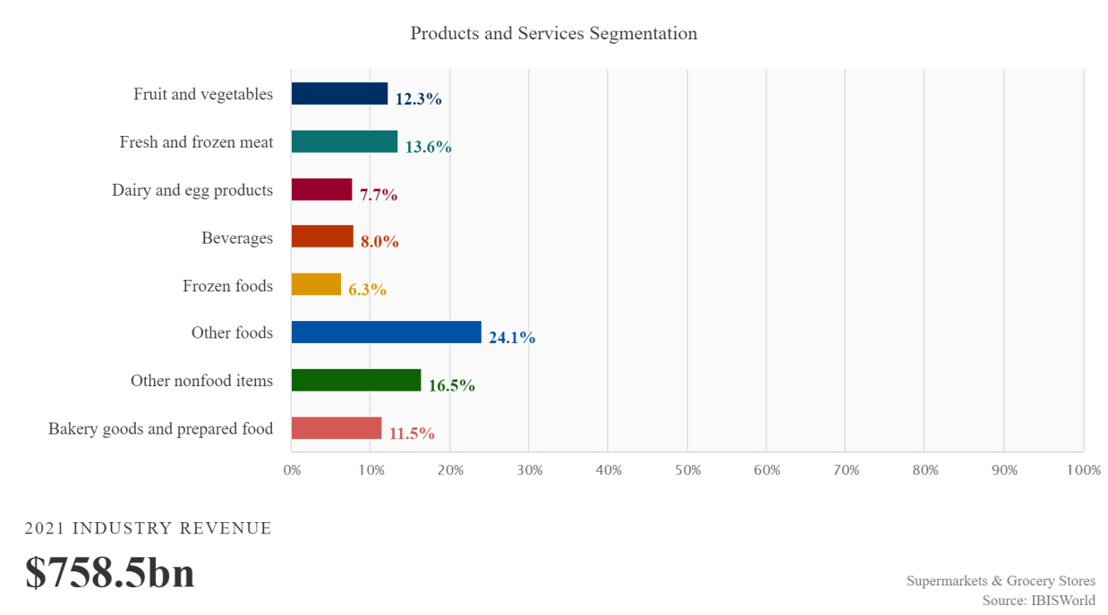
In terms of technological changes, the impact on the industry has remained moderate and has come in the form of competition from players such as Uber Eats, Doordash Inc., and HelloFresh SE, who have disrupted the traditional supermarkets and grocery stores by offering customers of making orders using a mobile app along with flexible delivery hours. (IBS World, 2021)
- Drivers of Change
Following the analysis in section 2 above major drivers for change within the traditional supermarkets and grocery stores industry include the impact of changing technologies and changes in societal attitudes particularly following the Covid 19 pandemic. In terms of the technological impact introduction of mobile app-based ordering services such as those offered by Uber Eats, Doordash Inc., and HelloFresh SE there has been a movement by industry players to introduce their mobile ordering applications. For instance, Kroger Company recently announced its plans to double its revenues from digital sources by the year 2023.
Further, the industry is also destined to change and adapt as a result of changes in customer preferences whereby grocery shoppers have become more used to ordering online especially following the Covid pandemic. (Repko, 2021) For instance, online grocery shopping in the United States which was expected to reach USD 41 billion by 2021 not only surpassed that figure in 2020 but reached almost USD 95 billion indicating the overall change in industry dynamics. (Baduk, 2021)
- Key Success Drivers
Given the competitive environment of the industry as well as the operating conditions key success drivers for industry players include people and finances. Specifically, in terms of finances which include factors such as assets, facilities, and equipment the critical success factor remains the ability of industry players to have facilities in proximity to key markets and populations. Specifically, the proximity of a store to populated areas enables operators to maximize potential sales and easier the access to said store along with appropriate parking space greater the potential customer footfall. (Cox, 2021)
In terms of people having access to a multi-skilled and flexible workforce remains another critical success factor. Specifically, supermarkets having a highly flexible workforce can rotate staff as required, particularly during extended operating hours. Simply put flexible workforce enables industry players to serve customers more efficiently especially during holidays and sales while ensuring better inventory management. (Cox, 2021)
At an operational level success within the industry is dependent on the ability of industry players to manage and control inventory on hand. Effective management of inventory in this context ensures products demanded by customers are always available especially if advertised as weekly special or if in high demand. (Cox, 2021)
- Company Analysis
Given the industry within which it operates The Kroger Company uses a Broad-Low Cost Strategy. Specifically, under the said strategy a business aims to offer a cost-based advantage over a broad market group i.e. the business aims to appeal to a wide range of customers. The company, therefore, is focused on offering customers products which although do not offer the same quality as a company perusing broad differentiation strategy but rewards customers financially for this difference in quality due to lower product prices. (Stanwick, 2020)
In terms of company strengths, the company draws its major competitive advantage from the fact that it has a broad range of store formats and products. The especially, company offers a product range that includes groceries, organic foods, jewelry, fuel, pharmacy services, and home products, among others which intron allows it to provide customers with a one-stop shopping experience. (Dalavagas, 2017) Further, the company also has a strong private label portfolio including private labels within the organic space. These private labels alone generate revenues of over USD 24 billion in the year 2019. (Hensel, 2020)
In terms of weaknesses, one of the key weaknesses associated with the company relates to its high debt levels. For instance, the company's long-term debt to equity ratio at the end of the financial year 2021 was 198.51% whereas its debt to equity ratio was almost 215%. Such high debt levels are not sustainable over the long run and hence represent a significant hurdle in the company’s continued success.

- Opportunities and Threats
Following the Covid 19 pandemic, the company as well as other players within the industry has an opportunity to significantly increase its online presence. For instance, according to a 2021 survey, almost 45% of survey participants indicated that they were shopping more online for groceries as compared to pre-pandemic times. This opportunity was also recognized by company management which was aimed to double its online sales by the year 2023. (Redman, 2021)
Further, the company also faces opportunities associated with strengthening the overall economy following the fading of pandemic effects on the economy. Specifically, company sales will increase as disposable incomes increase and employment numbers improve whereas company costs will also come down as global supply chain issues are resolved. (IBIS World, 2021)
The key threat to the company remains the completion presented by non-traditional firms such as Walmart and Target as well as a business offering online grocery delivery services. As retailers such as Walmart increase their food offerings company revenues may take a hit. Further, online stores such as Amazon have also expanded their presence within the online grocery market representing a threat to Kroger’s e-commerce initiatives discussed above.
Recommendation
Given the industry's overall competitive environment and company-specific factors, it is recommended that the company focuses on its Broad-Low cost strategy while leveraging the key success factors. In this regard, the company should increase focus on digital presence to attain a greater market share of online grocery sales revenues.

References
Baduk. (2021). The COVID-19 Impact on Rising Online Grocery Sales. Retrieved 3 November 2021, from https://clarkstonconsulting.com/insights/covid19-online-grocery-sales/
Cox, E. (2021). Strategic Analysis of Kroger Co Research paper for students. Retrieved 3 November 2021, from https://campuscrosswalk.org/strategic-analysis-of-kroger-co/
Dalavagas. (2017). SWOT Analysis: The Kroger Company. Retrieved 3 November 2021, from https://www.valueline.com/Stocks/Highlights/SWOT_Analysis__The_Kroger_Company.aspx
Hensel, A. (2021). Cheatsheet: Kroger leans on private label growth to drive sales, offset digital investments | Modern Retail. Retrieved 3 November 2021, from https://www.modernretail.co/retailers/cheatsheet-kroger-leans-on-private-label-growth-to-drive-sales-offset-digital-investments/
IBIS World. (2021). Supermarkets & Grocery Stores in the US. Retrieved 3 November 2021, from https://my.ibisworld.com/us/en/industry/44511/about
KR | Kroger Co. Annual Income Statement - WSJ. (2021). Retrieved 3 November 2021, from https://www.wsj.com/market-data/quotes/KR/financials/annual/income-statement
KR | Kroger Co. Financial Statements - WSJ. (2021). Retrieved 3 November 2021, from https://www.wsj.com/market-data/quotes/KR/financials
Redman, R. (2021). Increased use of online grocery shopping ‘here to stay’. Retrieved 3 November 2021, from https://www.supermarketnews.com/online-retail/increased-use-online-grocery-shopping-here-stay
Repko, M. (2021). RETAIL Kroger looks to make online grocery orders more profitable, double digital sales by end of 2023. Retrieved 3 November 2021, from https://www.cnbc.com/2021/03/31/kroger-expects-its-digital-sales-to-double-by-2023.html

