Juvenile Justice System

Student's Name
University
Course
Professor's Name
Date

Question One: School-to-Prison pipeline
School-to-prison pipeline refers to the practices enacted for public safety and education that funnel students into the criminal justice system (Mallett, 2016). Zero-tolerance disciplinary practices in schools, which call the police for infractions and frequently result in detention and referrals to juvenile detention facilities, significantly contribute to the school-to-prison pipeline. According to Mallett (2016), law enforcement's purpose for juveniles is to rehabilitate children and adolescents so that they do not commit further crimes, thus relating to law enforcement.
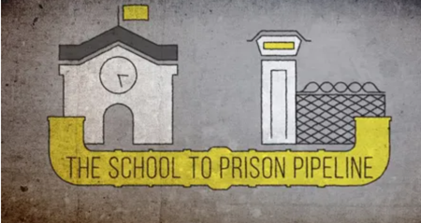
The practice does not discriminate between little and severe transgressions. Instead, it handles all of them the same, even minor infractions that the school administration might efficiently deal with in a more relaxed and casual manner. However, the practice criminalizes minor transgressions, exposing children and teenagers to the criminal justice system at an earlier age than they should have been and given the designation of juvenile offenders.
Question Two: Restorative justice
Restorative justice aims to assist victims in healing and to move on with their lives (Johnstone, 2013). Restorative justice help victims recover from the harm caused to them by the offender via various programs.
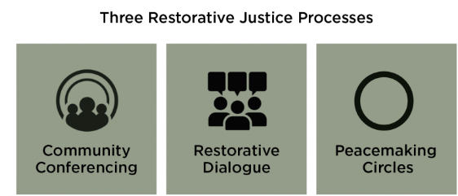
Restorative justice programs aim to work with juvenile delinquents under 18. This measure was implemented to reduce the offender's likelihood of committing other crimes to avoid further proceedings in a court (Johnstone, 2013). Restorative justice acts as a response to wrongdoing and a method of preventing more wrongdoing related to court cases.
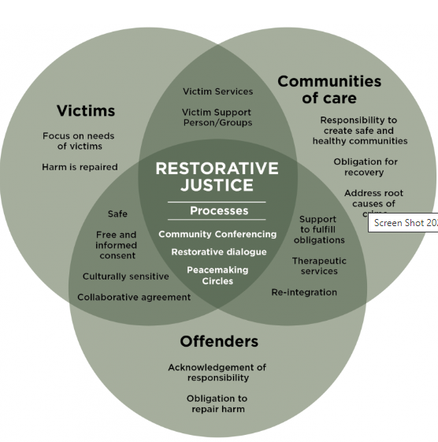
To mend that goes beyond just dishing out punishment, offenders, and victims can have direct conversations with one another. Johnstone (2013) states that communities work together to solve problems in ways that circumvent the need for law enforcement and jail if they are to succeed in their efforts to reduce crime.
Question Three: Juvenile parole/probation officers
Officers for juvenile parole and probation monitor adolescents with a probationary or parole sentence. They work closely with the juvenile's family members to assess and confirm whether or not the child is adhering to the court's requirements (Bolin and Applegate, 2016). Moreover, counseling would be provided to help with and change any potential behavioral problems
According to Bolin and Applegate (2016), when a case is brought before a juvenile court, it is the responsibility of juvenile probation officers to provide testimony on the history of the accused or the progress achieved by the defendant during their time on probation. These experts collaborate closely with corrections that provide social services to assist probationers in obtaining mental well-being or substance misuse assistance.
Question Four: Social Media
The number of people using social media's various platforms is increasing. Several family members and employees interacting with a particular juvenile can learn much about that juvenile on social media.

Juveniles and their families can use social media to understand practical communication skills they can incorporate for proper rehabilitation. Juveniles can use social media to learn straight talking and emotional control skills, which will help them grasp the guidance provided during the probation period.
Question Five: Active Listening
Those actively working with juveniles, including children and adolescents, should develop the skill of active listening and put it into practice. For instance, parole officers, counselors, judges, and parents or guardians. Juveniles must also use active listening skills because, through the skill, they can understand what they should do it not, which will also help them rehabilitate. Active listening is an essential skill that should be used by the people mentioned above because it gives full attention to detail and potentially lead to reduced crime and better lives for juveniles.
Question Six: Cultural Awareness
Cultural awareness is critical, and law enforcement officials who work with adolescents should be able to comprehend the cultural values and practices of the youth they serve. Officers who deal with juvenile children and adolescents should be aware of the fact that to rehabilitate these young people effectively; they must have an understanding of their cultural upbringing, how it puts them at risk for criminal behavior, and how this risk may be reduced (Goldson and Muncie, 2015).
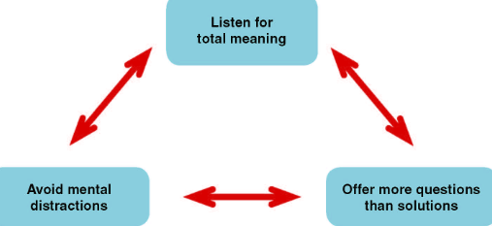

A better grasp of a juvenile's culture and the cultures of parole officers can help them make better decisions, better understand how juveniles make their choices and find ways to rehabilitate effectively.

References
Bolin, R. M., & Applegate, B. K. (2016). Adultification in juvenile
corrections: Examining the orientations of juvenile and adult probation and parole officers. American journal of criminal justice, 41, 321-339.
Goldson, B., & Muncie, J. (Eds.). (2015). Youth crime and justice. Sage.
Johnstone, G. (2013). Restorative justice: Ideas, values, debates. Routledge.
Mallett, C. A. (2016). The school-to-prison pipeline: A critical review of the punitive paradig
shift. Child and adolescent social work journal, 33, 15-24.

