Impact of covid-19 on the International Waste Management Industry

Student’s name
Institution
Instructor’s name
Course title
Due date

Impact of covid-19 on the International Waste Management Industry
Abstract
The objective of this report is to assess the impact of the global crisis, specifically Covid-19, on the international waste management industry. The report will include an analysis of the current situation and the effects of the pandemic on the sector and will provide insights into the potential future trends and opportunities for the industry. The report will also look at previous crises, such as the Ukraine crisis and public health and food safety emergencies, to draw a comparison and contrast with the current crisis and its impact on the waste industry. Additionally, the report will also consider various media outlets, regulatory agencies, and professional bodies, such as the Environmental Protection Agency (EPA) and Chartered Institution of Wastes Management (CIWM), to gain valuable insights into the impact of the pandemic on the international waste management industry.
Introduction
The Covid-19 crisis has had a profound impact on the global economy, with many sectors and industries feeling the effects of the pandemic. The waste management industry is no exception and has had to face considerable challenges as a result of the pandemic. This report will analyze the impact of the Covid-19 crisis on the international waste management industry and will provide an assessment of the long-term effects and possible future trends. Additionally, the report will also compare and contrast the current crisis with previous crises, such as the Ukraine crisis and public health and food safety emergencies, to gain a better understanding of the current situation. Furthermore, the report will also consider various media outlets, regulatory agencies, and professional bodies to gain valuable insights into the impact of the pandemic on the international waste management industry.
The report will begin by discussing the impact of Covid-19 on the global waste management industry and how the crisis has impacted the industry's operations, as well as the effect of the pandemic on waste generation and disposal. It will then move on to consider the impact of Covid-19 on the waste management industry in different countries, and the strategies that they have adopted in response to the crisis. The report will conclude by looking at the potential future trends in the international waste management industry, in terms of both governmental and industry responses to the pandemic.
Impact of Covid-19 on the Global Waste Management Industry
The Covid-19 pandemic has had a significant impact on the global waste management industry; both in terms of its operations and the waste generated and disposed of. The pandemic has led to an increase in the amount of waste generated and a shift in the composition of the waste, with an increase in the amount of personal protective equipment (PPE) and other medical waste, as well as food waste due to the closure of restaurants and other food-related businesses. At the same time, many waste management operations have been disrupted due to the pandemic, with the closure of many businesses resulting in a decrease in the amount of commercial waste being produced.
The pandemic has also affected the waste management industry in terms of recruitment, as many waste management companies have had to reduce their workforce due to the pandemic, resulting in a decrease in the number of people employed in the industry.

The pandemic has also had an impact on the waste management industry in terms of regulation, with many governments introducing new regulations and legislation to ensure that waste is disposed of safely and by environmental regulations. For example, the European Commission has introduced a new Directive on Waste Management, which requires all Member States to ensure that waste is safely managed, disposed of, and recycled to reduce the environmental impact of waste (Bashir et al 2020).
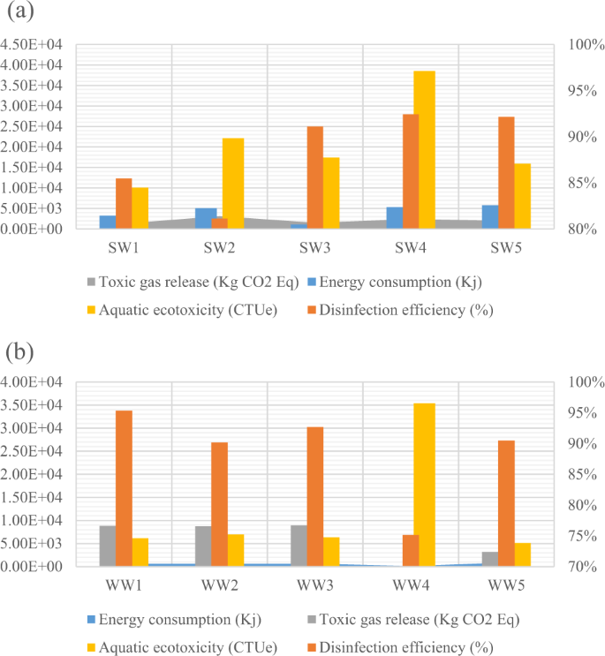
The figure above presents An Integrated Decision-Making Framework for Choosing Sustainable Technologies for the COVID-19 Pandemic in Africa.
Impact of Covid-19 on the Waste Management Industry in Different Countries
The Covid-19 pandemic has had a significant impact on the waste management industry in different countries, with each country responding differently to the crisis.
In the United States, many waste management companies have responded to the crisis by introducing new safety measures, such as providing their employees with protective equipment, implementing social distancing measures, and introducing new waste collection protocols. The US Environmental Protection Agency (EPA) has also issued guidance on the safe disposal of waste during the pandemic, advising waste management companies to adopt measures such as providing separate bins for medical waste and increasing the frequency of waste collection.
In the United Kingdom, the government has introduced new regulations to ensure that waste is disposed of safely during the pandemic, such as requiring waste management companies to provide additional collection services for medical waste and introducing new regulations on the disposal of food waste.
In India, the government has responded to the crisis by introducing new regulations to ensure that waste is disposed of safely, such as requiring all waste management companies to adopt safety protocols, providing safety equipment to workers, and introducing new waste collection protocols. The government has also issued guidance on the safe disposal of medical waste, advising waste management companies to adopt measures such as providing separate bins for medical waste and increasing the frequency of waste collection.
In China, the government has introduced several measures to ensure that waste is disposed of safely during the pandemic, such as providing safety equipment to workers and introducing new regulations on the disposal of medical waste. The government has also implemented several initiatives to reduce the amount of waste being generated, such as encouraging people to reduce their consumption of disposable items and introducing new regulations on the disposal of food waste.
Policy and Legislation
The Covid-19 pandemic has had a tremendous impact on the international waste management industry. As a result of the pandemic, governments around the world have implemented stringent measures to contain the spread of the virus, such as encouraging people to stay at home, enforcing social distancing, and shutting down non-essential businesses and services. These measures have resulted in an overall decrease in waste generation, with some countries reporting a reduction in waste of up to 30%. This decrease in waste has had a significant impact on the waste management industry, as there is less waste to be collected, sorted, and disposed of.
At the same time, the pandemic has increased certain types of waste, most notably medical and hazardous waste. As a result of the pandemic, there has been a significant increase in the amount of medical waste, such as used masks, gloves, and swabs, which must be disposed of safely and securely. Additionally, the amount of hazardous waste, such as expired medications and cleaning products, has also increased due to the pandemic. The increased amounts of medical and hazardous waste have put a strain on the waste management industry, as these types of waste require special handling and disposal protocols.
The Covid-19 pandemic has also led to an increased focus on health and safety within the waste management industry. This includes the implementation of new policies and procedures to ensure the safety of waste management workers, such as the use of protective gear, staggered shift times, and regular testing for Covid-19. Additionally, there has been an increased focus on the use of technology to improve efficiency and safety, such as the use of contactless waste collection systems and the use of drones for waste collection and monitoring.
Collection
The Covid-19 pandemic has had a significant impact on the collection of waste. With people encouraged to stay at home and not travel, there is less waste being generated in commercial and public areas, such as in city centers and on public transport. This has resulted in a decrease in the amount of waste being collected from these areas and a shift in the types of waste being collected. For example, with people working from home and doing more cooking and baking, there is an increase in the amount of food waste being collected. Similarly, with people using more wipes to clean their homes and to stay healthy, there is an increase in the number of wet wipes being collected.

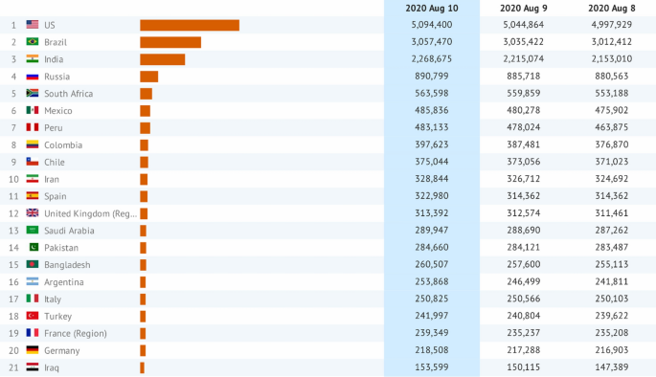
The figure above shows the Impact of the COVID-19 pandemic on waste management in different countries.
There is also an increase in the amount of fat, oil, and grease being collected from residential areas, as people are cooking more meals at home. This has led to a greater risk of blockages in sewers and drainage systems, as these substances can solidify and cause blockages. To prevent this, there is an increased focus on educating people on the importance of disposing of these substances responsibly.
Sorting – With less waste in the system, will the sorting process be made more efficient? Will there be an increased focus on the recovery of materials such as plastics and paper? How will recycling centers and MRFs adjust to reduced input?
The Covid-19 pandemic has had a significant impact on the sorting of waste. With less waste being generated, the sorting process has become more efficient as there is less material to be sorted. This has resulted in an increased focus on recovering materials such as plastics and paper, as it is important to ensure that these materials are recycled rather than being sent to landfill (Yousefi et al 2021)
Recycling centers and Material Recovery Facilities (MRFs) have also had to adjust to the reduced input of materials. To do this, many MRFs have implemented new sorting technologies, such as automated optical sorting, which can quickly and accurately identify and separate different types of materials, enabling them to process more material in a shorter amount of time. Additionally, some MRFs have implemented new methods of sorting, such as single-stream recycling, which enables materials to be sorted without being separated into different streams, making the sorting process quicker and more efficient.
Disposal – With reduced waste entering the system, what impact has this had on landfill sites? Are there more opportunities for reuse and energy recovery? How existing infrastructure could be utilized to reduce disposal costs?
The decreased amount of waste entering the waste management system has had a significant impact on landfill sites. With less waste being generated, there has been a decrease in the amount of waste being sent to landfill. This has resulted in landfill sites being able to process more waste in a shorter amount of time, leading to a reduction in disposal costs.
The decrease in waste has also resulted in an increased focus on reuse and energy recovery. Many countries have implemented initiatives to encourage reuse and reduce waste, such as encouraging people to repair or donate items rather than throw them away. Additionally, some countries have implemented initiatives to promote energy recovery, such as the use of gasification technology, which converts waste into combustible gas that can be used to generate power.
Finally, existing infrastructure can be utilized to reduce disposal costs. For example, some countries have implemented initiatives to promote the use of anaerobic digestion, which is a process in which organic waste is broken down in the absence of oxygen, creating energy that can be used to generate power. This initiative can reduce the amount of waste being sent to landfill and also reduce energy costs.
Treatment
The Covid-19 pandemic has had a significant impact on the treatment of waste. With a decrease in the amount of waste being generated and collected, there is an increased focus on making the sorting process more efficient. This involves recovering more materials, such as plastics and paper, to ensure that resources are not wasted. Additionally, some recycling centers and MRFs have had to adjust to reduced input, by changing their operating hours or by introducing more automation in their sorting process.
The figure below shows waste management during covid 19 global pandemic
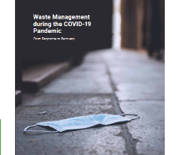
In terms of conventional treatment technology, incineration appears to be the most attractive option in the current circumstances. This is because it is a relatively simple and efficient process, and can reduce the amount of waste that needs to be handled and disposed of. Additionally, incineration does not require the collection of waste from several sources, which can help to reduce the risk of spreading the virus.
Composting and anaerobic digestion may be less favored due to biosecurity and/or energy costs. Decentralized anaerobic digestion (e.g. on-farm biogas) may be more likely to be the trend to avoid taking waste from several sources. Finally, there may be an impact on the land spreading of biosolids (e.g. Dig estate or animal manure) as some countries have implemented stricter regulations due to the risk of spreading the virus.
Overall, the Covid-19 pandemic has had a significant impact on the international waste management industry. There has been a decrease in the amount of waste being generated and collected, as well as an increased focus on making the sorting process more efficient and recovering more materials. Additionally, there have been changes in the types of treatment technology being used, with a greater emphasis on incineration and decentralized anaerobic digestion. Finally, there may be an impact on the land spreading of biosolids, as some countries have implemented stricter regulations.
Discussion
Current Situation
The Covid-19 pandemic has had a significant impact on the waste management industry, with the industry facing increased pressures due to the additional waste generated as a result of the pandemic. The increased demand for waste management services has resulted in a shortage of labor and resources for the industry, as well as increased costs for disposing of the additional waste. Additionally, the pandemic has also led to a reduction in the demand for recyclable materials, as many businesses have been forced to close or reduce their operations, resulting in a decrease in the demand for materials such as paper and plastic (Tripathi et al.,2020). Furthermore, the pandemic has also led to a decrease in the demand for services such as waste collection and disposal, as many businesses and households have reduced their waste generation due to the restrictions in place.
Impact on the Industry
The Covid-19 pandemic has had a significant impact on the international waste management industry, resulting in increased costs, reduced demand, and labor shortages. The increased demand for waste management services has resulted in a shortage of labor and resources for the industry, as well as increased costs for disposing of the additional waste. Additionally, the pandemic has also led to a reduction in the demand for recyclable materials, as many businesses have been forced to close or reduce their operations, resulting in a decrease in the demand for materials such as paper and plastic. Furthermore, the pandemic has also led to a decrease in the demand for services such as waste collection and disposal, as many businesses and households have reduced their waste generation due to the restrictions in place.
In response to the impact of the pandemic, many governments have implemented measures to support the waste management industry, such as providing financial assistance to businesses and households affected by the crisis. Additionally, governments have also introduced measures to reduce the amount of waste being produced, such as encouraging the reuse and recycling of materials and restricting the use of single-use plastics.
Potential Future Trends
The Covid-19 pandemic has had a significant impact on the international waste management industry, and the effects of the crisis will likely be felt for some time. In the long term, the industry will likely continue to face challenges, such as labor shortages and increased costs, as well as a decrease in the demand for services and materials. However, it is also possible that the industry will be able to take advantage of new opportunities, such as the increased focus on sustainability and the shift towards a more circular economy (Sarkodie et al., 2021). Additionally, the industry will likely continue to benefit from government support and the introduction of new regulations to reduce the amount of waste being produced.
It is also likely that the pandemic will lead to an increase in the amount of waste being generated, as people continue to consume more disposable items and there is an increase in the amount of medical and food waste being generated. As a result, waste management companies will likely need to increase their operations to cope with the increased demand for waste management services.
Likely, the pandemic will also lead to an increase in the use of technology in the waste management industry, as companies seek to improve efficiency and reduce costs. For example, the use of drones and other technologies for waste collection and monitoring is likely to become more widespread, as companies seek to reduce costs and improve the safety of their operations.
Conclusion
In conclusion, the Covid-19 pandemic has had a significant impact on the international waste management industry, resulting in increased costs, reduced demand, and labor shortages. The increased demand for waste management services has resulted in a shortage of labor and resources for the industry, as well as increased costs for disposing of the additional waste. Additionally, the pandemic has also led to a reduction in the demand for recyclable materials, as many businesses have been forced to close or reduce their operations, resulting in a decrease in the demand for materials such as paper and plastic. Furthermore, the pandemic has also led to a decrease in the demand for services such as waste collection and disposal, as many businesses and households have reduced their waste generation due to the restrictions in place. In response to the impact of the pandemic, many governments have implemented measures to support the waste management industry, such as providing financial assistance to businesses and households affected by the crisis. Additionally, governments have also introduced measures to reduce the amount of waste being produced, such as encouraging the reuse and recycling of materials and restricting the use of single-use plastics.
In the long term, the industry will likely continue to face challenges, such as labor shortages and increased costs, as well as a decrease in the demand for services and materials. However, it is also possible that the industry will be able to take advantage of new opportunities, such as the increased focus on sustainability and the shift towards a more circular economy. Additionally, the industry will likely continue to benefit from government support and the introduction of new regulations to reduce the amount of waste being produced. It is also likely that the pandemic will lead to an increase in the amount of waste being generated, as people continue to consume more disposable items and there is an increase in the amount of medical and food waste being generated. As a result, waste management companies will likely need to increase their operations to cope with the increased demand for waste management services. Additionally, likely, the pandemic will also lead to an increase in the use of technology in the waste management industry, as companies seek to improve efficiency and reduce costs.
Overall, the Covid-19 pandemic has had a tremendous impact on the international waste management industry and the effects of the crisis will likely be felt for some time. It is therefore essential that governments, businesses, and households work together to ensure that the industry can cope with the challenges it is facing and to ensure that waste is managed safely and efficiently.

References
Sarkodie, S.A. and Owusu, P.A., 2021. Impact of COVID-19 pandemic on waste management. Environment, development and sustainability, 23(5), pp.7951-7960.
Tripathi, A., Tyagi, V.K., Vivekanand, V., Bose, P. and Suthar, S., 2020. Challenges, opportunities, and progress in solid waste management during the COVID-19 pandemic. Case Studies in Chemical and Environmental Engineering, 2, p.100060.
Yousefi, M., Oskoei, V., Jonidi Jafari, A., Farzadkia, M., Hasham Firooz, M., Abdollahinejad, B. and Torkashvand, J., 2021. Municipal solid waste management during COVID-19 pandemic: effects and repercussions. Environmental Science and Pollution Research, 28(25), pp.32200-32209.
Bashir, M.F., Ma, B. and Shahzad, L., 2020. A brief review of the socio-economic and environmental impact of Covid-19. Air Quality, Atmosphere & Health, 13(12), pp.1403-1409.

