Business Plan
Puma Management and Consultancy Firm

Part: One
1.1 Company Description
Puma Management and Consultancy Firm is going to a be USA based management and consultancy company. It is going to offer retail consulting, project consultancy, market research, strategic reports preparation, and others in selected service segments including system integration, management information system, accounting, business strategies, operations, financial advisory, marketing, productivity improvement, quality assurance and control in United States and Europe. The headquarter of the company will be in California. The company will be initially formed as a private limited company. It will be formed with four entrepreneurs (Mr. WWW, MR, XXX, Mr. YYY, and Mr. ZZZ) with total capital of $600,000.
1.2 Industry
1.2.1 Service Description
Management consultancy involves with helping and supporting businesses and organizations to improve their performance through analysis of existing problems and development of strategies and plans. Businesses and organizations depend and hires external consultants or consultancy firms to obtain specialized external advices and services.
1.2.2 Market Size
Current market size of global management and consultancy services is USD 132 Billion (Statista, 2020). USA is the largest market of management and consultancy services followed by United Kingdom (UK), Germany, Australia, France, China, Canada, India, Spain, Japan, Italy, Switzerland, and others. Table 1 depicts the country-wise market size of global management and consultancy services.
Table 1: Country-wise Market Size of Global Management and Consultancy Services

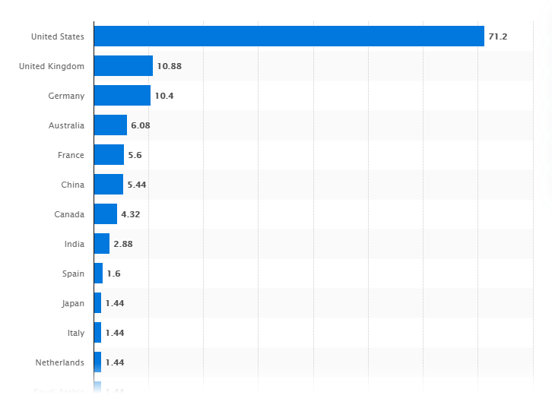

Key segments of the industry include operations consultancy, financial advisory, strategy consulting, HR consultancy, information technology (IT) consultancy etc. Table 2 depicts the market representation of key segments.
Table 2: Market Representation of Key Segments (Consultancy.org, 2019)

Market Segment | Percentage
Operations consultancy | Approximately 30%
Financial advisory | Shortly less than 30%
Strategy consulting | Slightly less than 15%
HR consultancy | Slightly less than 15%
Information technology (IT) consultancy | Approximately 20%

1.3 Market Growth

Global management and consultancy services is now in growing stage. Over 2011-2019, global management and consultancy services has been increased consistently. Table 3 depicts size of global management and consultancy services over 2011-2019.

Table 3: Market Size of Global Management and Consultancy Services over 2011-2020

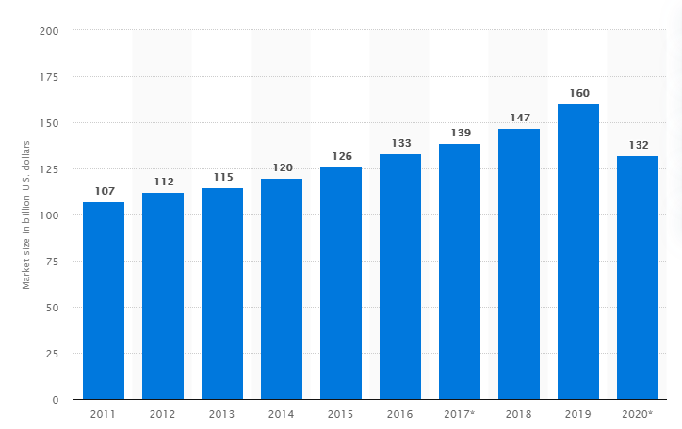

Even though due to outbreak of COVID-19 total market size is expected to drop from USD 160 Billion to USD 132 Billion (Statista, 2020). According to The Business Research Company, global management and consultancy industry is expected to grow by CAGR of 10.6% by 2020. The growth of management and consultancy services is driven by faster growth, emergence of digital technology, and rise of globalization. Factors that can hinder market growth include rising costs and decreasing margin and advancement of artificial intelligence. Rising costs and decreasing margin and advancement of artificial intelligence lead to replacement of management consultancy services and setting-up of in-house consultancy teams by big companies.

1.4 Target Customers

Puma Management and Consultancy Firm will focus on two geographic markets - USA and Europe, and in limited service segments – system integration, management information system, accounting, business strategies, operations, financial advisory, marketing, productivity improvement, quality assurance and control. software, network, and cloud computing. The target customers of the company are owners/presidents of medium-sized corporations and managers of large corporations in a high-growth period.

1.5 Competitors Analysis

The management and consultancy industry are pulverized and disorganized with a lot of individual consultants, small-sized consultancy firms, and few well-known large-sized companies. Existing market players compete in both - prices and service quality. The analysis of the strengths and weaknesses of the existing competitors is as follows.

Competitors | Strengths | Weaknesses
Individual consultants | (i) Less bureaucracy and less flexible services (consultancy services require more word-of mouth services).  (ii) Competitive pricing. | (i) Limited market presence.  (ii) Concentrated services.  (iii) Lack of good business set-up.  (iv) uncertainty in professionalism and service quality.
Small-sized consultancy firms | (i) High economies of scale  (ii) Strong IT support.  (v) Competitive pricing. | (i) Limited market presence.  (ii) Concentrated services.  (iii) Limited distribution services.
Large-sized companies like Boston Consulting Group (BCG), McKinsey, Bain, IDC, Dataquest etc. | (i) Strong brand image.  (ii) Global market share  (iii) High economies of scale  (iv) Strong IT support.  (v) Strong distribution channel. | (i) High bureaucracy and less flexible services (consultancy services require more word-of mouth services).  (ii) High price charger.

Overall market competitive landscape of global management and consultancy services can be better understood with Porter Five Forces Model analysis. Table 4 depicts the results on Porter Five Forces Model of global management and consultancy services.
Table 4: Porter Five Forces Model of Global Management and Consultancy Services

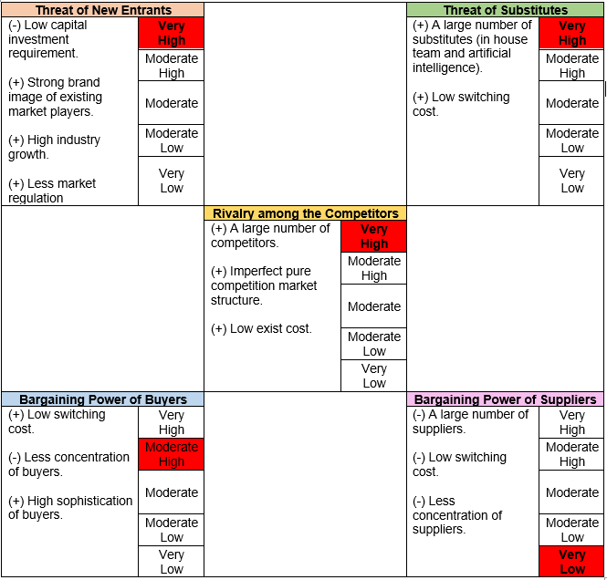

Global management and consultancy services industry is characteristics with very high threat of new entrants, very high threat of substitutes, moderate high bargaining power of buyers, and very low bargaining power of suppliers, and very high rivalry among the competitors. Overall global management and consultancy services industry is very competitive. Existing market players cannot be able to compete and stay in the market without delivering competent services in the market.
1.6 Product/Service Plan

Service lines of Puma Management and Consultancy Firm include Retail consulting, Project consultancy, Market research, Strategic reports, and others in selected service segments include system integration, management information system, accounting, business strategies, operations, financial advisory, marketing, productivity improvement, quality assurance and control. software, network, and cloud computing.
Puma Management and Consultancy Firm will follow ‘premium pricing’ strategy. The pricing strategy of the company fits with its general positioning of provider high-level expertise. The pricing of services is as follows.

Table 5: Pricing of Services

Service Line | Pricing
Retail Consulting | USD 5,000 Per Project
Project Consulting | USD 2,000 Per Project
Market Research | USD 10,000 Per Market Research
Strategic Reports | USD 1,000 Per Report
Others | Vary based on Assignment

1.7 Marketing Plan
Puma Management and Consultancy Firm will pursue aggressive market strategies to promote its brand image and services. The company will mainly pursue Social Media Marketing. The brand and services of the company will mainly be promoted through Facebook Advertising, Instagram Advertising, Twitter Advertising, Pinterest Advertising, LinkedIn Advertising, and Snapchat Advertising.
Social media marketing involves with using of social media platforms to connect and engage audiences for promoting brand, increasing sales, and driving website traffic. Social media marketing has following advantages as compared to traditional marketing (TV ads, Radio ads, banners, posters, leaflets etc.) including less cost, easier dissemination of information about services, promotions, service extensions etc., easier approach to potential customers and turn potential customers into final customers, maintain continuous communication with customers.

Part: Two

2.1 Management Team

Puma Management and Consultancy Firm will be formed as a company. It will be formed by four founding directors (Mr. WWW, Mr. XXX, Mr. YYY, and Mr. ZZZ) equal equal contribution. Top management of the company will be formed with four founding partners. All of them has academic background and long-practical experience (Table 6).

Table 6: Educational Background and practical Experience of Top Management Team
Name | Education | Professional Experience | Role in Puma Management and Consultancy Firm
Mr. WWW | MBA in Finance | More than 20 years’ experience to work in different banks and financial institutions. | Managing Director (MD)
Mr. XXX | MBA in Finance | More than 15 years’ experience to work in different production and manufacturing companies. | Director – Finance
Mr. YYY | MBA in International Business | More than 25 years’ experience to work in different global leading consultancy firms. | Director – Operations
Mr. ZZZ | Graduation in information technology (IT) | More than 25 years’ experience as IT professional in different service-oriented organizations. | Director – IT

Directors will engage in leading the operations of the company. Assignment and works will be handled through different Project Teams consisting of hired consultants. Puma Management and Consultancy Firm will require very highly skilled and expert employees. The business will be initially run with ten consultants, a strong editorial/graphic person, a marketing person, an office manager, an accountant, and a secretary. Later on, more consultants and sales staffs will be hired with the expansion of the business.

2.2 Critical Risks

The operations of Management and Consultancy Firms is subject to less risks as compared to other business organizations. Critical risks of Puma Management and Consultancy Firm and tentative responses of the company in responses to these are as follows.
Critical Risks | Risk Responses
(i) Macroeconomic risk: The business performance of the company will eb subject to macroeconomic conditions of the geographic rejoins in which it will have operations. | Geographic diversification and service diversification will result in lower overall macroeconomic risk exposure of the company.
(ii) Skill and expertise human capital risk: The consultancy business requires highly skilled and experts from diverse backgrounds to apprehend the clients’ requirements and delivery of services. | Puma Management and Consultancy Firm will ensure hiring of very efficient and skilled employees. As well, internal consultants of the company will be properly trained-up and developed.
(iii) Inefficient Planning risk: The activities related to formation of the company can be inefficiently managed and formation can be deferred. | Management of Puma Management and Consultancy Firm will adopt an strategic and disciplined approach in the formation of the company.

2.3 Exit Strategy

The directors of Puma Management and Consultancy Firm has planned to exit after 10 years by taking the company in initial public offering (IPO) after 10 years and selling their shares in the secondary market.

2.4 Operations Plan
Consultancy services are mainly provided (purchased and sold) through word-of-mouth basis with relationship and previous professional experience. Puma Management and Consultancy Firm will have long-passion to develop a sustainable business. Thus, the operations of the company will be handled in structured and professional manner.
The flow of functions to be executed in delivering the services by the company is as follows.
(i) Business lead generation: Business lead will be generated through personal referral and formal tendering process. In the business lead generation process, all terms of agreement and prices of services will be fixed.
(ii) Obtaining contracts: After generating possible business lead, appointment will be confirmed by the clients.
(iii) Formal Meeting: Upon appointment, top management will have a formal meeting with client to discuss scope of work, client expectation, work plan, etc.
(iv) Handing over task to consultancy team: Each assignment will be handed over and deal by separate project team consisting of suitable employees of the company. The project team will take all necessary actions for successful completion of an assignment.
(v) Reviewing the service delivery by top management: Top management will review the quality and standard of services after completed by Project team.
(vi) Billing to customers: Customer will be invoiced and requested for payment before final delivery of assignment (before 7 days of final presentation).
(vii) Assignment delivery: Assignment will be delivered to client through a formal meeting and presentation by top management.

Part: Three

3.1 Non-Compete and Confidentiality Agreement
Directors of Puma Management and Consultancy Firm will make and sign a non-competition & non-disclosure agreement for the best interest of the company. In the agreement directors will agree and provide their signature with respect to non-engagement to personal competing business and non-disclosure of confidential business information (customer information, operational information, assets information, etc.) unless required by laws, regulator, or customers. If any director engages in separate competing business or disclosure of confidential business information, his directorship will be adjourned and cancelled in the event is proved.
3.2 Financial Plan
3.2.1 Funding
Puma Management and Consultancy Firm will be started with USD 600,000. The entire amount of capital will be contributed by four directors with equal contribution (USD 150,000 each). The funding utilization plan of the business is as follows (Table 7).

Table 7: Fund Utilization Plan

Fund Utilization
Particulars | Amount | Percentage
Assets Acquisition | 500,000 | 83.33%
Preliminary Expenses | 25,000 | 4.17%
Cash Balance | 75,000 | 12.50%
Total | 600,000 | 100.00%

Preliminary expenses of USD 25,000 will be incurred for business plan design, logo design, retainer contracts, stationary purchases, Brochures publication, financial backing presentation, initial mailing, office location set-up, and office equipment purchase deed formation. These preliminary activities will be performed over October – December of current year and all associated expenses will be paid in the first month of business operation (January 2021). Table 8 depicts the Milestone of preliminary business formation activities (business plan design, logo design, retainer contracts, stationary purchases, Brochures publication, financial backing presentation, initial mailing, office location set-up, and office equipment purchase deed formation).
Table 8: Milestone of Preliminary Business Formation Activities

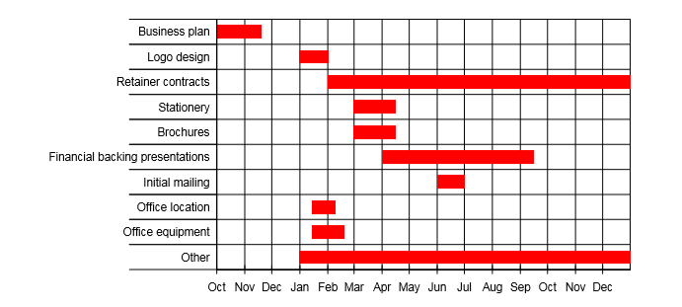

3.2.2 Forecasted Income Statement

Forecasted revenue of Puma Management and Consultancy Firm are USD 592,000, USD 651,200, and USD 748,880 respectively in 2021, 2022, and 2023. Forecasted net income of the company are USD 73,230, USD 93,228, and USD 110,695 respectively in 2021, 2022, and 2023. Forecasted net profit margin are 16.91% (73,230/592,000), 19.57% (93,228/651,200), and 20.21% (110,695/748,880) respectively over next three years. Table 9 depicts Forecasted Income statement of Puma Management and Consultancy Firm.

Table 9: Forecasted Income Statement over Next Three Years

Puma Management and Consultancy Firm
Forecasted Income Statement
Particulars | 2021 | 2022 | 2023
Revenue | 592,000 | 651,200 | 748,880
Less: Cost of Revenue | 159,000 | 174,900 | 201,135
Gross Profit Margin | 433,000 | 476,300 | 547,745
Less: Operating Expenses
Payroll | 144,000 | 158,400 | 174,240
Office Rent | 18,000 | 18,000 | 18,000
Printing and Stationaries | 59,200 | 65,120 | 74,888
Marketing and Advertising Expense | 3,000 | 3,300 | 3,630
Payroll Taxes | 20,160 | 22,176 | 24,394
Utilities | 12,000 | 12,000 | 12,000
Preliminary Expenses | 25,000 | - | -
Amortization | - | 15,000 | 15,000
Depreciation | 54,000 | 58,000 | 78,000
Total Operating Expenses | 335,360 | 351,996 | 400,152
Operating Income | 97,640 | 124,304 | 147,593
Less: Interest Expense | - | - | -
Income Before Tax | 97,640 | 124,304 | 147,593
Tax Expense | 24,410 | 31,076 | 36,898
Net Income | 73,230 | 93,228 | 110,695

3.2.3 Forecasted Balance Sheet

Forecasted revenue of Puma Management and Consultancy Firm are USD 592,000, USD 651,200, and USD 748,880 respectively in 2021, 2022, and 2023. Forecasted net income of the company are USD 73,230, USD 93,228, and USD 110,695 respectively in 2021, 2022, and 2023. Forecasted net profit margin are 16.91% (73,230/592,000), 19.57% (93,228/651,200), and 20.21% (110,695/748,880) respectively over next three years. Table 10 depicts Forecasted Balance Sheet of Puma Management and Consultancy Firm.

Table 10: Forecasted Balance Sheet over Next Three Years

Puma Management and Consultancy Firm
Forecasted Balance Sheet
 | Starting | 2021 | 2022 | 2023
Assets
Current Assets:
Cash | 100,000 | 135,640 | 123,089 | 121,890
Accounts Receivable | - | 55,000 | 97,680 | 112,332
Other Current Assets | - | - | - | -
Total Current Assets | 100,000 | 190,640 | 220,769 | 234,222
Non-Current Assets:
Land | - | - | - | -
Software | - | - | 135,000 | 120,000
Furniture and Fixture (Net) | 500,000 | 526,000 | 468,000 | 590,000
Other Non-Current Assets | - | - | - | -
Total Non-Current Assets | 500,000 | 526,000 | 603,000 | 710,000
Total Assets | 600,000 | 716,640 | 823,769 | 944,222
Owners' Equity and Liabilities
Owners' Equity:
Capital | 600,000 | 600,000 | 600,000 | 600,000
Retained Earnings | - | 73,230 | 166,458 | 277,153
Total Owners' Equity | 600,000 | 673,230 | 766,458 | 877,153
Liabilities:
Current Liabilities:
Accounts Payable | - | 19,000 | 26,235 | 30,170
Short-term Borrowing | - | - | - | -
Tax Payable | - | 24,410 | 31,076 | 36,898
Other Current Liabilities | - | - | - | -
Total Current Liabilities | - | 43,410 | 57,311 | 67,069
Non-Current Liabilities:
Bank Loan | - | - | - | -
Other Non-Current Liabilities | - | - | - | -
Total Non-Current Liabilities | - | - | - | -
Total Liabilities | - | 43,410 | 57,311 | 67,069
Total Owners' Equity and Liabilities | 600,000 | 716,640 | 823,769 | 944,222

3.2.4 Forecasted Cash Flow Statement

Forecasted cash provided from operating activities of Puma Management and Consultancy Firm are USD 115,640, USD 137,449, and USD 198,801 respectively in 2021, 2022, and 2023. Forecasted cash used by investing activities of Puma Management and Consultancy Firm are USD 580,000, USD 150,000, and USD 200,000 respectively in 2021, 2022, and 2023. Forecasted cash provided from financing activities of Puma Management and Consultancy Firm are USD 600,000, USD 0, and USD 0 respectively in 2021, 2022, and 2023. Forecasted year-end cash balance over next three years are USD 135,640, USD 123,089, and USD 121,890 respectively in 2021, 2022, and 2022. Table 11 depicts Forecasted Cash Flow Statement of Puma Consultancy Firm.

Table 11: Forecasted Cash Flow Statement over Next Three Years
Puma Management and Consultancy Firm
Forecasted Cash Flow Statement
Particulars | 2021 | 2022 | 2023
Cash Flows from Operating Activities
Cash from Collection of Accounts Receivable | 537,000 | 608,520 | 748,880
Payment of Accounts Payable | (140,000) | (167,665) | (197,200)
Payment of Payroll | (144,000) | (158,400) | (174,240)
Payment of Office Rent | (18,000) | (18,000) | (18,000)
Payment of Printing and Stationaries | (59,200) | (65,120) | (74,888)
Payment of Marketing and Advertising Expense | (3,000) | (3,300) | (3,630)
Payroll of Payroll Taxes | (20,160) | (22,176) | (24,394)
Payroll of Utilities | (12,000) | (12,000) | (12,000)
Payment of Tax Liabilities | - | (24,410) | (31,076)
Payment of Preliminary Business Expenses | (25,000) | - | -
Net Cash Flow from Operating Activities | 115,640 | 137,449 | 198,801
Cash Flows from Investing Activities
Purchase of Fixed Assets | (580,000) | - | (200,000)
Purchase of Software Solution | - | (150,000) | -
Sales of Long-term Assets | - | - | -
Net Cash Flow from Investing Activities | (580,000) | (150,000) | (200,000)
Cash Flows from Financing Activities
Issuance of Stock | 600,000 | - | -
Payment of Dividends | - | - | -
New Current Borrowing | - | - | -
Repayment of Current Borrowing | - | - | -
New Non-current Borrowing | - | - | -
Repayment of Non-current Borrowing | - | - | -
Net Cash Flow from Financing Activities | 600,000 | - | -
Net Cash Flow | 135,640 | (12,551) | (1,199)
Opening Cash Balance | - | 135,640 | 123,089
Ending Cash Balance | 135,640 | 123,089 | 121,890

References
Beroe Inc. (2019, October 19). Management Consulting Market to Reach $295 Billion by 2020, Says Beroe Inc. Retrieved September 10, 2020, from: https://www.prnewswire.com/news-releases/management-consulting-market-to-reach-295-billion-by-2020-says-beroe-inc-300943883.html
Consultancy UK. (2020, May 26). Market size of the global consulting industry in 2020?. Retrieved September 10, 2020, from: https://www.consultancy.uk/news/24659/market-size-of-the-global-consulting-industry-in-2020
Consultancy.org. (2019). Global. Retrieved September 11, 2020, from: https://www.consultancy.org/consulting-industry/global#:~:text=With%20a%20total%20value%20of,within%20the%20professional%20services%20industry.
Statista. (2020). Size of the global management consulting market in 2019, by country (in billion U.S. dollars). Retrieved September 10, 2020, from: https://www.statista.com/statistics/1065188/management-consulting-market-size-country/
Statista. (2020). Size of the global management consulting market from 2011 to 2020 (in billion U.S. dollars). Retrieved September 09, 2020, from : https://www.statista.com/statistics/466460/global-management-consulting-market-size-by-sector/
The Business Research Company. (2019, April). Management Consulting Market - By Type (Operations Advisory, Financial Advisory, Technology Advisory, Strategy And Hr Advisory), By Country, And By Region, Opportunities And Strategies – Global Forecast To 2022. Retrieved September 10, 2020, from: https://www.thebusinessresearchcompany.com/report/management-consulting-market

Appendices

Appendix 01: Monthly Income Statement of First Year of Operation

Monthly Income Statement
Particulars | Jan | Feb | Mar | Apr | May | Jun | Jul | Aug | Sep | Oct | Nov | Dec
Revenue | 10000 | 10000 | 20000 | 34000 | 58000 | 75000 | 50000 | 35000 | 70000 | 85000 | 90000 | 55000
Less: Cost of Revenue | 2500 | 2500 | 4000 | 8000 | 13500 | 19000 | 12000 | 8000 | 21500 | 24000 | 25000 | 19000
Gross Profit Margin | 7500 | 7500 | 16000 | 26000 | 44500 | 56000 | 38000 | 27000 | 48500 | 61000 | 65000 | 36000
Less: Operating Expenses
Payroll | 12000 | 12000 | 12000 | 12000 | 12000 | 12000 | 12000 | 12000 | 12000 | 12000 | 12000 | 12000
Office Rent | 1500 | 1500 | 1500 | 1500 | 1500 | 1500 | 1500 | 1500 | 1500 | 1500 | 1500 | 1500
Printing and Stationaries | 1000 | 1000 | 2000 | 3400 | 5800 | 7500 | 5000 | 3500 | 7000 | 8500 | 9000 | 5500
Marketing and Advertising Expense | 250 | 250 | 250 | 250 | 250 | 250 | 250 | 250 | 250 | 250 | 250 | 250
Payroll Taxes | 1680 | 1680 | 1680 | 1680 | 1680 | 1680 | 1680 | 1680 | 1680 | 1680 | 1680 | 1680
Utilities | 1000 | 1000 | 1000 | 1000 | 1000 | 1000 | 1000 | 1000 | 1000 | 1000 | 1000 | 1000
Preliminary Expenses | 25000 | 0 | 0 | 0 | 0 | 0 | 0 | 0 | 0 | 0 | 0 | 0
Depreciation | 4167 | 4167 | 4167 | 4167 | 4167 | 4167 | 4833 | 4833 | 4833 | 4833 | 4833 | 4833
Total Operating Expenses | 46597 | 21597 | 22597 | 23997 | 26397 | 28097 | 26263 | 24763 | 28263 | 29763 | 30263 | 26763
Operating Income | (39097) | (14097) | (6597) | 2003 | 18103 | 27903 | 11737 | 2237 | 20237 | 31237 | 34737 | 9237
Less: Interest Expense | 0 | 0 | 0 | 0 | 0 | 0 | 0 | 0 | 0 | 0 | 0 | 0
Income Before Tax | (39097) | (14097) | (6597) | 2003 | 18103 | 27903 | 11737 | 2237 | 20237 | 31237 | 34737 | 9237
Tax Expense | 0 | 0 | 0 | 501 | 4526 | 6976 | 2934 | 559 | 5059 | 7809 | 8684 | 2309
Net Income | (39097) | (14097) | (6597) | 1503 | 13578 | 20928 | 8803 | 1678 | 15178 | 23428 | 26053 | 6928

Appendix 02: Monthly Balance Sheet of First Year of Operation
Monthly Balance Sheet
 | Starting | Jan | Feb | Mar | Apr | May | Jun | Jul | Aug | Sep | Oct | Nov | Dec
Assets
Current Assets:
Cash | 100000 | 57570 | 47640 | 36710 | 32880 | 36650 | 57220 | 11790 | 29860 | 33430 | 57000 | 92570 | 135640
Accounts Receivable | 0 | 10000 | 10000 | 20000 | 34000 | 58000 | 75000 | 50000 | 35000 | 70000 | 85000 | 90000 | 55000
Other Current Assets | 0 | 0 | 0 | 0 | 0 | 0 | 0 | 0 | 0 | 0 | 0 | 0 | 0
Total Current Assets | 100000 | 67570 | 57640 | 56710 | 66880 | 94650 | 132220 | 61790 | 64860 | 103430 | 142000 | 182570 | 190640
Non-Current Assets:
Land | 0 | 0 | 0 | 0 | 0 | 0 | 0 | 0 | 0 | 0 | 0 | 0 | 0
Furniture and Fixture (Net) | 500000 | 495833 | 491667 | 487500 | 483333 | 479167 | 475000 | 550167 | 545333 | 540500 | 535667 | 530833 | 526000
Other Non-Current Assets | 0 | 0 | 0 | 0 | 0 | 0 | 0 | 0 | 0 | 0 | 0 | 0 | 0
Total Non-Current Assets | 500000 | 495833 | 491667 | 487500 | 483333 | 479167 | 475000 | 550167 | 545333 | 540500 | 535667 | 530833 | 526000
Total Assets | 600000 | 563403 | 549307 | 544210 | 550213 | 573817 | 607220 | 611957 | 610193 | 643930 | 677667 | 713403 | 716640
Owners' Equity and Liabilities
Owners' Equity:
Capital | 600000 | 600000 | 600000 | 600000 | 600000 | 600000 | 600000 | 600000 | 600000 | 600000 | 600000 | 600000 | 600000
Retained Earnings | 0 | (39097) | (53193) | (59790) | (58288) | (44710) | (23783) | (14980) | (13303) | 1875 | 25303 | 51355 | 58283
Total Owners' Equity | 600000 | 560903 | 546807 | 540210 | 541713 | 555290 | 576218 | 585020 | 586698 | 601875 | 625303 | 651355 | 658283
Liabilities:
Current Liabilities:
Accounts Payable | 0 | 2500 | 2500 | 4000 | 8000 | 13500 | 19000 | 12000 | 8000 | 21500 | 24000 | 25000 | 19000
Short-term Borrowing | 0 | 0 | 0 | 0 | 0 | 0 | 0 | 0 | 0 | 0 | 0 | 0 | 0
Tax Payable | 0 | 0 | 0 | 0 | 501 | 5027 | 12003 | 14937 | 15496 | 20555 | 28364 | 37048 | 39358
Other Current Assets | 0 | 0 | 0 | 0 | 0 | 0 | 0 | 0 | 0 | 0 | 0 | 0 | 0
Total Current Assets | 0 | 2500 | 2500 | 4000 | 8501 | 18527 | 31003 | 26937 | 23496 | 42055 | 52364 | 62048 | 58358
Non-Current Liabilities:
Bank Loan | 0 | 0 | 0 | 0 | 0 | 0 | 0 | 0 | 0 | 0 | 0 | 0 | 0
Other Non-Current Assets | 0 | 0 | 0 | 0 | 0 | 0 | 0 | 0 | 0 | 0 | 0 | 0 | 0
Total Non-Current Assets | 0 | 0 | 0 | 0 | 0 | 0 | 0 | 0 | 0 | 0 | 0 | 0 | 0
Total Liabilities | 0 | 2500 | 2500 | 4000 | 8501 | 18527 | 31003 | 26937 | 23496 | 42055 | 52364 | 62048 | 58358
Total Owners' Equity and Liabilities | 600000 | 563403 | 549307 | 544210 | 550213 | 573817 | 607220 | 611957 | 610193 | 643930 | 677667 | 713403 | 716640

Appendix 03: Monthly Cash Flow Statement of First Year of Operation

Monthly Cash Flow Statement
Particulars | Jan | Feb | Mar | Apr | May | Jun | Jul | Aug | Sep | Oct | Nov | Dec
Cash Flows from Operating Activities
Cash from Collection of Accounts Receivable | 0 | 10000 | 10000 | 20000 | 34000 | 58000 | 75000 | 50000 | 35000 | 70000 | 85000 | 90000
Payment of Accounts Payable | 0 | (2500) | (2500) | (4000) | (8000) | (13500) | (19000) | (12000) | (8000) | (21500) | (24000) | (25000)
Payment of Payroll | (12000) | (12000) | (12000) | (12000) | (12000) | (12000) | (12000) | (12000) | (12000) | (12000) | (12000) | (12000)
Payment of Office Rent | (1500) | (1500) | (1500) | (1500) | (1500) | (1500) | (1500) | (1500) | (1500) | (1500) | (1500) | (1500)
Payment of Printing and Stationaries | (1000) | (1000) | (2000) | (3400) | (5800) | (7500) | (5000) | (3500) | (7000) | (8500) | (9000) | (5500)
Payment of Marketing and Advertising Expense | (250) | (250) | (250) | (250) | (250) | (250) | (250) | (250) | (250) | (250) | (250) | (250)
Payroll of Payroll Taxes | (1680) | (1680) | (1680) | (1680) | (1680) | (1680) | (1680) | (1680) | (1680) | (1680) | (1680) | (1680)
Payroll of Utilities | (1000) | (1000) | (1000) | (1000) | (1000) | (1000) | (1000) | (1000) | (1000) | (1000) | (1000) | (1000)
Payment of Preliminary Business Expenses | (25000) | 0 | 0 | 0 | 0 | 0 | 0 | 0 | 0 | 0 | 0 | 0
Net Cash Flow from Operating Activities | (42430) | (9930) | (10930) | (3830) | 3770 | 20570 | 34570 | 18070 | 3570 | 23570 | 35570 | 43070
Cash Flows from Investing Activities
Purchase of Fixed Assets | (500000) | 0 | 0 | 0 | 0 | 0 | (80000) | 0 | 0 | 0 | 0 | 0
Sales of Long-term Assets | 0 | 0 | 0 | 0 | 0 | 0 | 0 | 0 | 0 | 0 | 0 | 0
Net Cash Flow from Investing Activities | (500000) | 0 | 0 | 0 | 0 | 0 | (80000) | 0 | 0 | 0 | 0 | 0
Cash Flows from Financing Activities
Issuance of Stock | 600000 | 0 | 0 | 0 | 0 | 0 | 0 | 0 | 0 | 0 | 0 | 0
Payment of Dividends | 0 | 0 | 0 | 0 | 0 | 0 | 0 | 0 | 0 | 0 | 0 | 0
New Current Borrowing | 0 | 0 | 0 | 0 | 0 | 0 | 0 | 0 | 0 | 0 | 0 | 0
Repayment of Current Borrowing | 0 | 0 | 0 | 0 | 0 | 0 | 0 | 0 | 0 | 0 | 0 | 0
New Non-current Borrowing | 0 | 0 | 0 | 0 | 0 | 0 | 0 | 0 | 0 | 0 | 0 | 0
Repayment of Non-current Borrowing | 0 | 0 | 0 | 0 | 0 | 0 | 0 | 0 | 0 | 0 | 0 | 0
Net Cash Flow from Financing Activities | 600000 | 0 | 0 | 0 | 0 | 0 | 0 | 0 | 0 | 0 | 0 | 0
Net Cash Flow | 57570 | (9930) | (10930) | (3830) | 3770 | 20570 | (45430) | 18070 | 3570 | 23570 | 35570 | 43070
Opening Cash Balance | 0 | 57570 | 47640 | 36710 | 32880 | 36650 | 57220 | 11790 | 29860 | 33430 | 57000 | 92570
Ending Cash Balance | 57570 | 47640 | 36710 | 32880 | 36650 | 57220 | 11790 | 29860 | 33430 | 57000 | 92570 | 135640

Appendix 04: Assumptions in Forecasting

(i) Sales revenue is collected after 30 days from the month of sales generated.
(ii) Cost of revenue is paid after 30 days from the month of cost incurred.
(iii) Revenue of the company is expected to increase by 10% in second year and 155 in the third year.
(iv) Cost of revenue of the company is directly proportional to the revenue increase.
(v) Payroll is expected to increase by 10% in second and third year.
(vi) Marketing and Advertising Expense and Printing and Stationaries are directly proportional to sales revenue.
(vii) Utilities and rent expense of the company are assumed as fixed.
(viii) Income tax is assumed to be paid in the following year of tax generation.
(ix) Annual tax rate is 25%.

