Client Registration Process

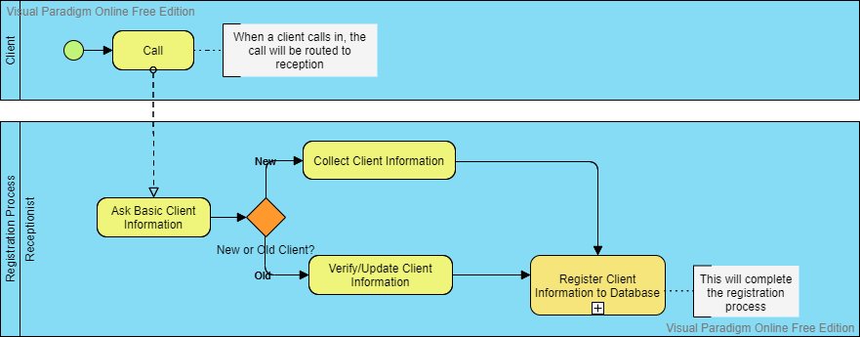

Make Appointment Process

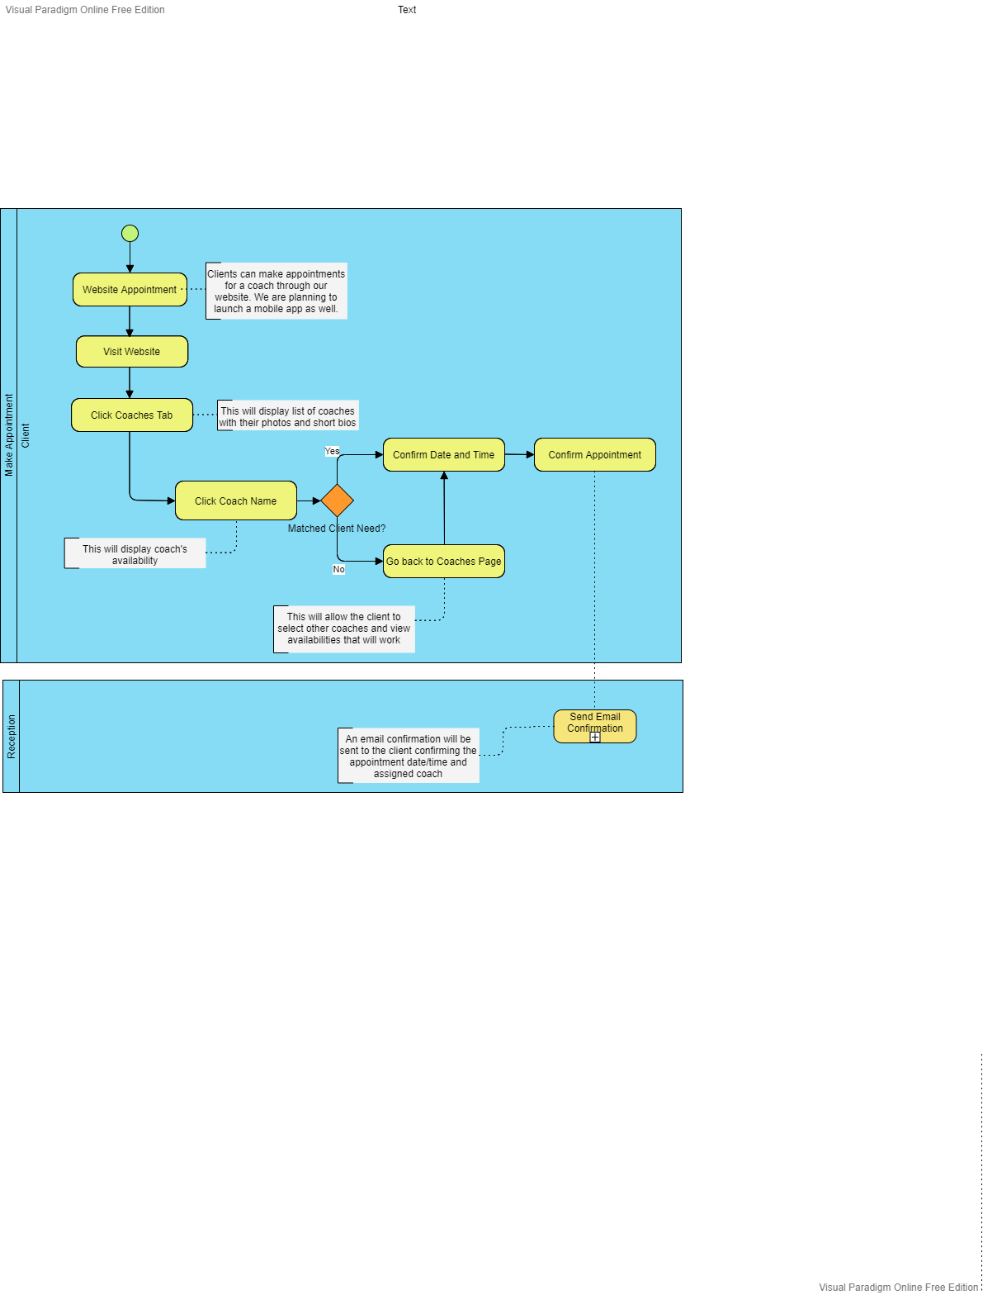
Final Gantt Chart

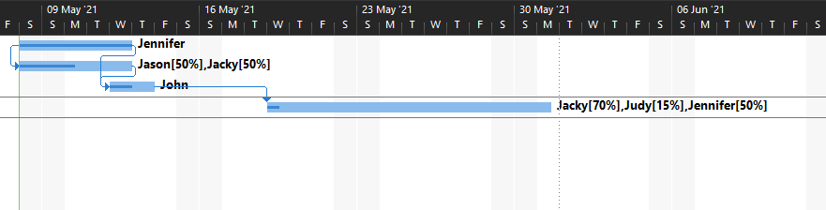

Final Network Diagram

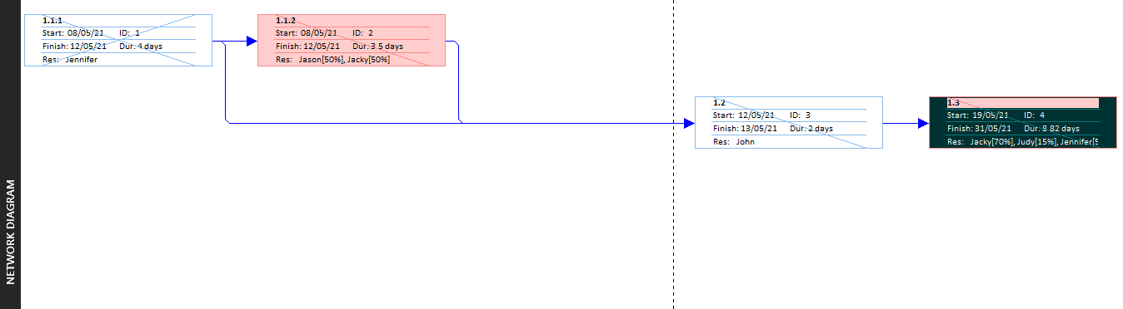

Final Cost Sheet:

Task Name | Fixed Cost | Fixed Cost Accrual | Total Cost | Baseline | Variance | Actual | Remaining
1.1.1 | $0.00 | Prorated | $640.00 | $0.00 | $640.00 | $640.00 | $0.00
1.1.2 | $0.00 | Prorated | $664.00 | $0.00 | $664.00 | $166.00 | $498.00
1.2 | $0.00 | Prorated | $480.00 | $0.00 | $480.00 | $240.00 | $240.00
1.3 | $0.00 | Prorated | $982.00 | $0.00 | $982.00 | $222.80 | $759.20

