Project management
By FirstName LastName

The Name of the Class
Professor’s Name
University
City and the State of University
Date

Table of contents
Question one: project strategy…………………………………………………………….3
Question two: Time management………………………………………………………...5
Question three: Cost management……………………………………………………….7

Question one
Part one
Project management has several areas of knowledge that are approximately ten in number. In general, project management involves applying methods, knowledge, skills, and processes, including experience, to attain particular objectives in accordance to the acceptance of the project criteria within parameters of agreement. The management of a project has definite deliverables confined to finite budget including timescale. However, project management areas are critical subjects of focus (Handzic and Bassi, 2017). The success of a project leads to the success of the strategies of an organization or a business (Javed and Liu, 2017).
The areas of knowledge in management of project include integration management that holds a project; the next area of knowledge is scope management of a project, project time, quality, and cost management. Other areas of knowledge in management of a project include project management of human resources, communication management, risk management that identifies the methods by which the risks are itemized, prioritized, and categorized. Project management of procurement is another area of knowledge in the management of a project, and this involves hiring subcontractors and another area of knowledge in project management of stakeholders.
Out of the ten areas of knowledge, the essential areas are the scope, time and cost management. Scope administration of the project is the task of the entire project. The scope management involves the schedule where it is part of the management plan of a project. During the collection of the final plan, the detailed requirement of scope administration is essential. The statement of the scope may change throughout the project to give control to the scope, especially when the project falls behind schedule.
Time management is one of the most important areas of focus and knowledge in project management, is when the project is divided into jobs scheduled with their relevant start dates and deadlines, including each task's budget. Project time management includes the management schedules of the, including the creation of a schedule for the project and determination of the personnel accountable for each particular section. The control plans for the schedule are necessary once the schedule is made.
Project cost management determines the methods for budget establishment that includes if and how it will transform and the steps used for its regulation. This area of knowledge in the management of a project includes the budget of a project that means applying qualified tools for estimation to ensure funds cover the entire project. The tools are monitored regularly monitoring to keep the stakeholders of the project informed. Every task in the budget has its own estimated cost, meaning all resources like equipment, labor, and materials.

Part two
The management objectives of the project are successful development of the procedure, planning, execution, regulation, closure, and initiation of the project, including giving guidance to the team of operation of the project towards the achievement of every agreed goal. It happens within the scope, quality, time, and standards of the budget. Some of the critical success factors include knowledge management, market orientation, product development process, new strategies, speed of development, effective utilization of the management team, and top management support. All these success factors are important in the fulfillment of the goals and objectives in project management.

Question two
Part one
The Gantt chart is particularly a tool for management of the project used for providing assistance in the scheduling and planning of projects in all sizes and dimensions. The Gantt chart tool is uniquely for the simplification of complex projects. Another purpose of the Gantt chart tool is to help assess the time a long-term project should take to complete. They also help determine the resources required and planning order of completion for the task in progress. The Gantt chart tool is useful in terms of the management of dependencies occurring between tasks. Deliverables in a Gantt chart are a graphical representation of an activity development within a defined period and the milestones.
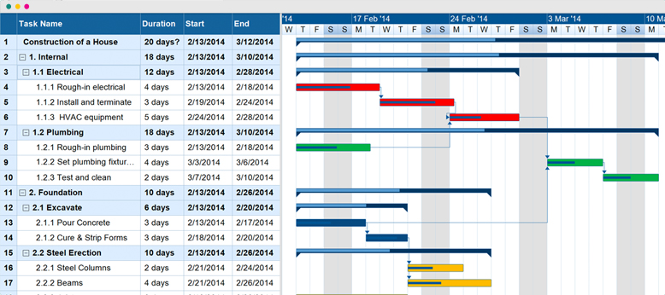
The project's main activities include initiating where there is agreement on whether the initial concept is feasible after scratching on it with the team. The second activity includes planning. The definition of the project's cost, scope and schedule takes place through visualization of the budget, scope, schedule, and budget, including resources necessary for the project. The third activity is the execution that involves starting the project after initiation and planning. The next activity in project management is controlling and comparing project status with the original plan and ensuring everything is moving on as planned. The last activity is the closing activity that involves the approval of the project's entire completion, including the confirmation of whether the projects have met their standards.
Part two
The first activity may take a period of approximately one to two weeks. Planning takes approximately a minimum of two weeks. It is an activity that will take the longest time in project management and may take a minimum of fifteen weeks. The duration is not specific but may the duration from planning to close may take like twenty weeks. Since controlling takes place throughout the project. The closing activity takes about three weeks since it is the final step. The total duration of the projects is approximately twenty-two weeks. By indicating the critical path in red, it becomes so simple to understand the measures and the steps taken to complete the Gantt chart.

Question three
Part one
A project budget is the total approximated cost required to finish the project over a particular period. The budget of the project helps in the estimation of the cost for different phases of the project. It includes the cost of labor, cost of materials for procurement, and operation cost; thus, it is not a static document. When building the project's total budget, it is good to consider the given components, including the direct cost of the project, contingency margin, project baseline, and margin of the management.
The direct cost of the projects includes all the expenses calculated directly tied to the project's budget. Its calculation involves conducting the subtraction between the produced revenues through the goods sales and the addition of every direct cost related to the formation of those goods, then divide by the aggregate revenues. The direct cost margin indicates every revenue dollar portion kept as profit after the accounting of those particular expenses for producing chattels. The direct expenditure is in terms of percentage.
Contingency involves the estimation of the subtraction between the excellent current value and the maximum estimate expected. The margin is the difference between the maximum possible value and the maximum expected value. Positive margins increase the level of contingency, and the negative ones decrease the contingency. When the contingency is added to the resource, they result in the maximum value expected for that resource.
The project's cost baseline deals with the quantity of money that the plan is likely to charge and the methods of spending the funds. It is a budget approved; usually in a distribution of time for estimating, monitoring, and controlling, the overall cost performance of the project. A good example of the cost baseline is providing a budget adjusted to the time. In simple terms, the cost baseline estimation is by taking the cost estimate and then add it to the contingency reserve.
A management margin is a comprehensive approach to managing the business operation's net profit margins by addressing the variability risk in both the cost and the output prices. In other words, margin management is the practice of reducing the rate of cost for running the business to increase profit. To determine this margin, it is essential to first estimate the business's net income by subtracting the revenues from the expenses, then dividing the net income by the revenues then multiply the total by a hundred to get the percentage of the margin of the profit.
The ordinary profitability in use is the profit margin. It includes the ratio used for gauging the degree to which the activities of the business makes money. It portrays the number or the rate at which the sales percentage has transformed into profits. Here there is essentially a division of the incomes by the revenues, and it is expressed as a percentage. It indicates the number of cents the profits has generated for every sold dollar. The four levels of the margins of the projects are the gross profit, net profit, operating profit and pre-tax profit. After having all this knowledge about the profit margin, one can easily estimate the project sale price, especially when the profit margin is fifty percent. However, to estimate the project's price using parametric estimation, one must first split the project into works units. The second step is to evaluate the cost per unit and then conduct a multiplication of the total units by the cost per unit to evaluate a total cost. One can also evaluate the total cost of the purchased units; conduct a division of the total cost by purchased unit’s number to obtain the cost price, and finally utilize the price sale method to evaluate the conclusive price.
Reference List
Handzic, M. and Bassi, A., 2017. Knowledge and Project Management. Springer International Publishing:.
Javed, S.A. and Liu, S.F., 2017, August. Evaluation of project management knowledge areas using grey incidence model and AHP. In Proceedings of the 6th IEEE International Conference on Grey Systems and Intelligent Services. Stockholm, Sweden: IEEE. DOI (Vol. 10).

