LAB REPORT Experiment 43. Effect of Reaction Conditions on the Condensation of Furfural with Cyclopentanone

- Structure of the products:

Product A | Product B
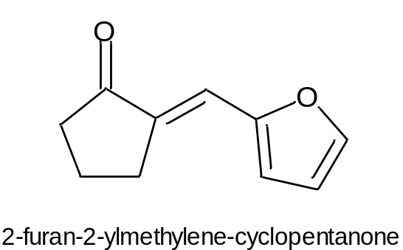 | 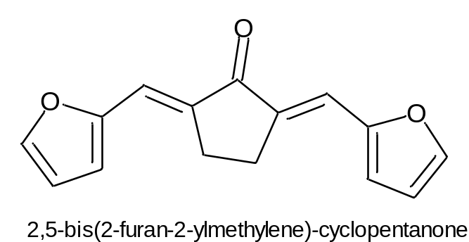

- Determination of the theoretical yield and the % yield of the product:
  - Theoretical yield
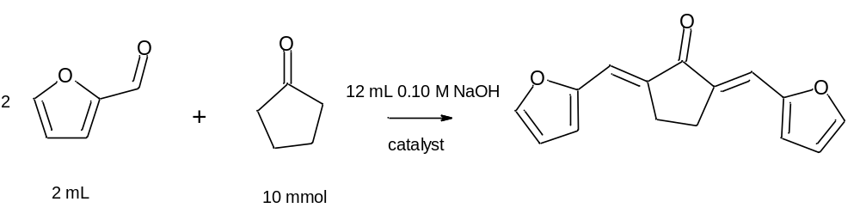

$$moles of furfural=2 mL×\frac{1.159 g}{1 mL}×\frac{1 mol}{96.1 g}=24 mmol$$
$$Moles of cyclopentadienone:10 mmol$$
Limiting reagent: cyclopentadienone
$$Theoretical yield: \\ 0.010 mol×\frac{240.3 g product}{1 mol}=2.403 g product$$

  - Percent yield
$$\% yield=\frac{actual yield}{theoretical yield}×100\%=\frac{actual g}{2.403 g}×100\%=$$

- Melting point range from the product B
Experimental: ⁰C Reported: 162 ⁰C

- NMR analysis
- Product A
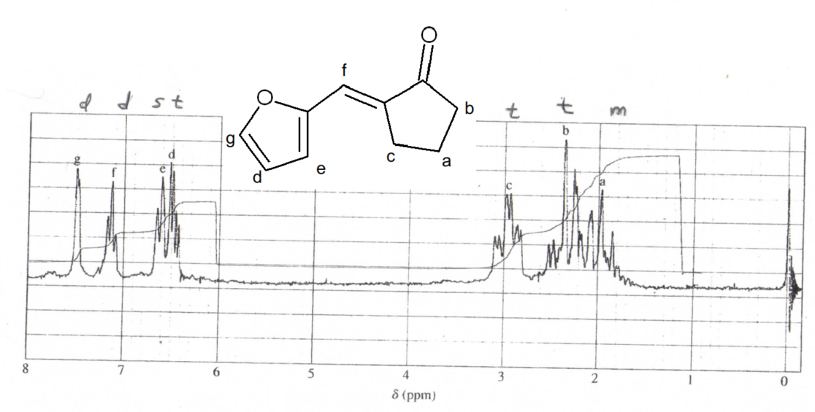
- Product B

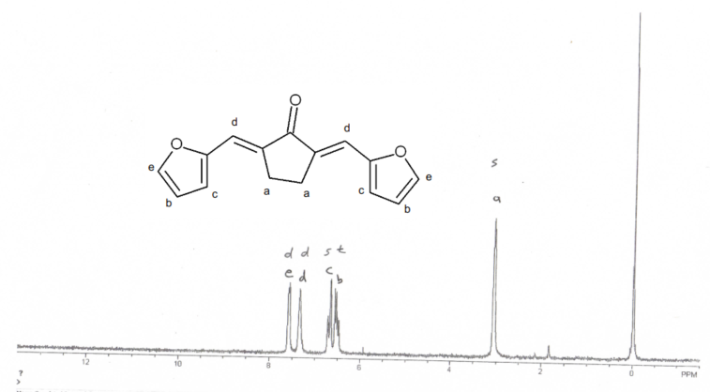
- Answers to Exercises 1, 3, and 5d
Exercise 1
In the first conditions, an organic layer dissolving both the reactants and an aqueous layer which contains the sodium hydroxide is used. Furthermore, equimolar quantities of both organic starting materials are being used. Since the sodium hydroxide is more soluble in water than in ether, the transfer to the organic layer to form the enolate and then the condensation reaction is rather slow. Thus, only one condensation reaction takes place
On the other hand, in the second conditions, 2 equivalents of furfuraldehyde are being used. More importantly, a phase transfer catalyst is being used, making sure more of the sodium hydroxide is able to be transferred to the aqueous phase. This, along with the fact that 2 molar equivalents of the aldehydes are being used, lead to the formation of two condensations.

Exercise 3
- Conditions 1
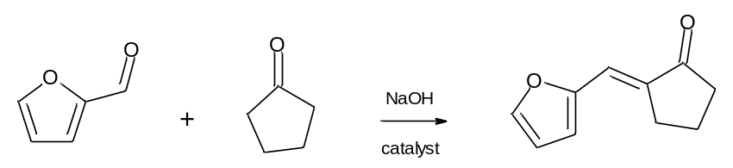
Mechanism:
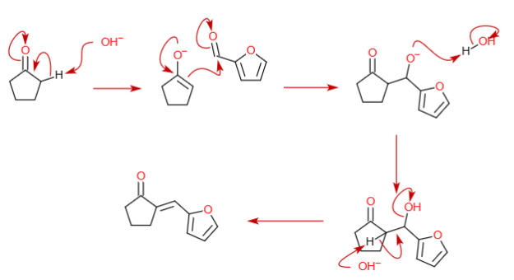

- Conditions 2

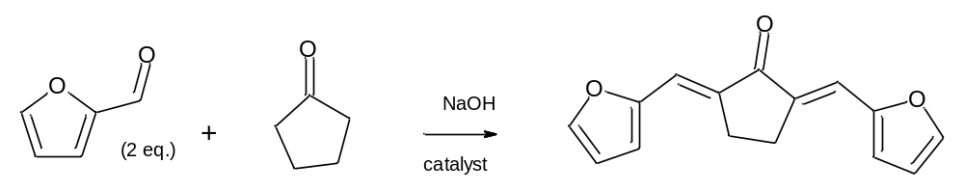

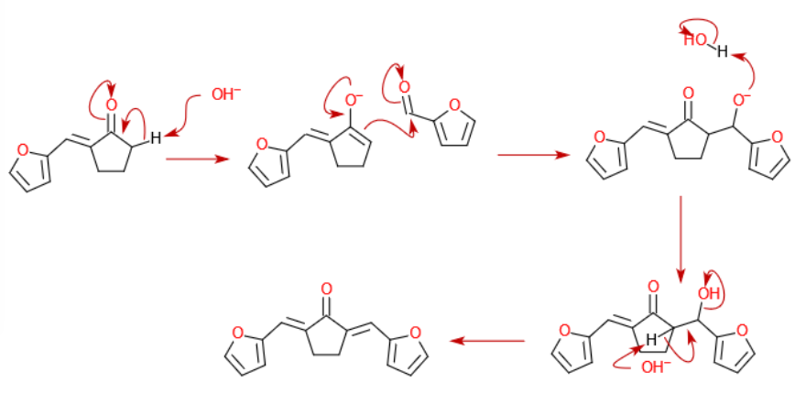

Exercise 5d

The cyclopentanone would be in equimolar relationship with the furfuraldehyde in both cases and thus, the product A would had been obtained in both reactions.

