Name
School
Course Number
May 8, 2021
Report Sheet for the Grignard Experiment (Spring 2021)
1. Write the balanced equation for the reaction between the methyl Grignard reagent and (+)-benzoin (prior to any acid addition). (4 pts.)
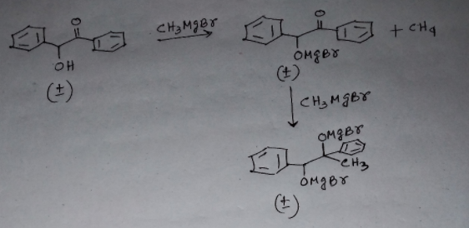

2. Write the balanced equation (for the reaction involved in the acid work-up) step between the sulfuric acid solution and the alkoxide formed through the Grignard reaction in question #1. (5 pts.)
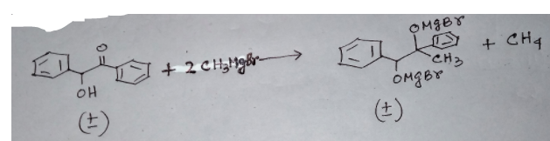

3. Calculate the total moles of protons that the sulfuric acid provided in the work up. Also, calculate the total moles of iodomagnesium alkoxide expected to form (if the reaction proceeded at 100% yield) and determine if enough protons were supplied or not to protonate all of the alkoxide expected to form in the experiment. (4pts.)
100% yield of reaction would require 500ml of sulfuric acid
500mg of 2.36M benzoin together with 10ml of CH2Cl2 and 500ml of sulfuric acid formed 12ml of MeI.
Total moles of protons in H2SO4 would be;
1 mole of protons = 6.02 x 10^-23.
H2SO4 has 32 protons. Therefore, moles of H2SO4 is;
32/6.02 x 10^-23 = 5.32 * 10^23 moles.
Total moles of iodomagnesium expected to form is 12 moles
Enough protons were supplied to protonate all of the alkoxide expected to form in the experiment.

4. The IR spectrum of the benzoin starting material and a model IR spectrum of the 1,2-diphenyl-1,2-propane diol product are posted on the CHEM420-sec01Beachboard site. Compare these two IR Spectra. What features of the Benzoin IR change in going to the IR of the product? (6pts)
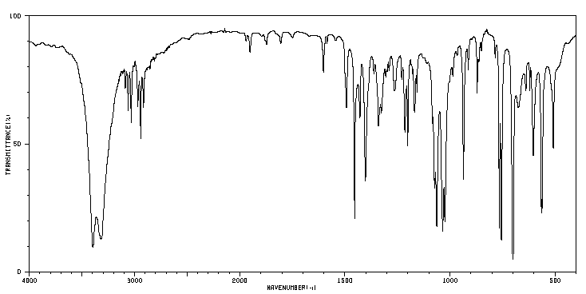
First spectrum : 1,2-diphenyl-1,2-propane diol
It has only O-H functionality appearing at 3350 cm-1
No C=O bond between 1600-1800 cm-1

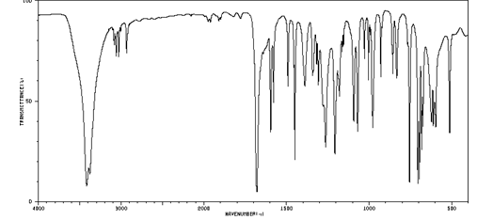
Second spectrum: benzoin
It has both O-H stretch at 3400 cm-1 and C=O stretch at 1680 cm-1

5. Draw the structure of the major diastereomer that is expected to form in this experiment if transition state model based on Cram’s Rule (which was discussed in the recorded lecture) is applied to the R enantiomer of Benzoin. Include a clear drawing of the Newman projection of the transition state. (6 pts.)
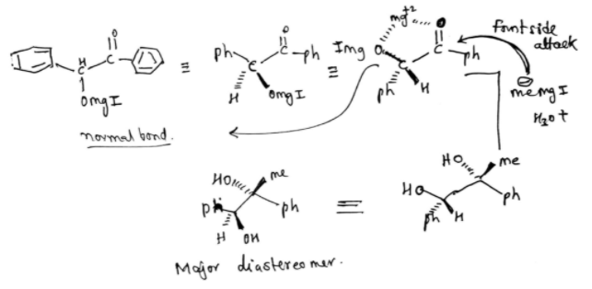

6. Draw the structure of the major diastereomer that is expected to form in this experiment if the Felkin-Anh transition state model (which we discussed in lecture) is applied to the R enantiomer of Benzoin. Include a clear drawing of the Newman projection of the transition state. (6 pts.)
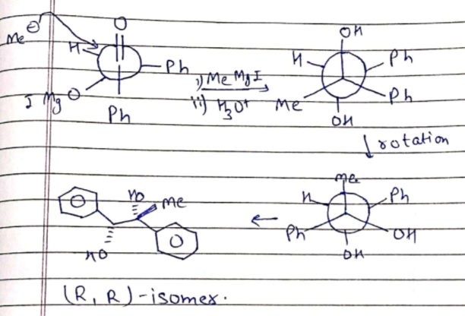

7. Draw the structure of the major diastereomer that is expected to form in this experiment if the Cram chelation transition state model is applied to the R enantiomer of Benzoin. Include a clear drawing of the chelation transition state complex. (6 pts.)
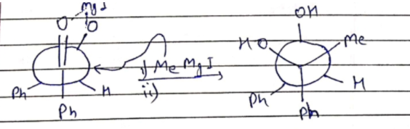
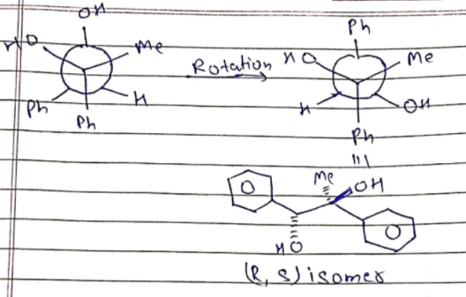

8. Determine which model, Cram’s Rule, the Felkin-Anh or the Cram-Chelate transition state model, predicts the correct diastereomer formed in this experiment. (3 pt.)
Cram’s rule predicts the correct diastereomer formed in the experiment. The rule proved to be effective because it holds true for most dehydes.

