Tip Top Markets

Student's name
Institution Affiliation
Professor's name
Course
Date

Tip Top Markets
Case Analysis: Tip Top Markets
This case study investigates the operational management problems at Tip Top Markets that result in customer dissatisfaction. Customers have frequently expressed their dissatisfaction with the supermarket's administration. Customers are irritated by flaws such as missing goods, difficulty finding stuff, payment issues, poor store amenities, and a lack of hygiene, to name a few. When there are actual actions, harsh remarks and the store's position must be dealt with, aligning every business demands with its goals. Managers may want to start by determining which issues are the most common. Run charts, check sheets, and Pareto diagrams are all useful tools. People can then brainstorm and consider potential solutions using a cause-and-effect diagram. When faced with a problem, managers must carefully consider which strategy will be the most successful and efficient.
Assessment
As previously stated, Tip Top Markets faces many challenges that must be overcome to please and retain customers. As a result, various analytical and dissection methods will be used. Managers can start by using a check sheet to detect problems quickly. Stevenson (2015) Stevenson (2015). The facts provided in Stevenson's (2015) case are used to create a check sheet.
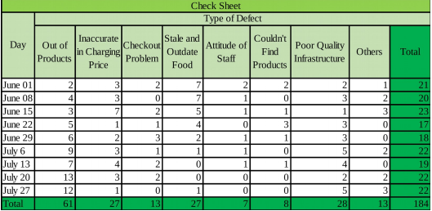
The check sheet describes the many types of problems that occurred at Tip Top Markets on the specified dates and the number of times they occurred. Out-of-stock items, incorrect pricing, checkout trouble, stale and old food, employee antagonism, inability to locate things, and poor infrastructure are all common obstacles. Throughout the time range provided, the issue of not having enough things to give the consumer emerges 63 times. Customers are dissatisfied with Tip Top Markets' amenities and hygiene, as evidenced by the 28 complaints. In addition, 27 customers expressed dissatisfaction with the food's quality and payment troubles. As a result of the checkout issue, the customer has raised their voice 13 times. Users may also notice that the number of times clients complain each day varies between 20 and 30 during a specific period. As a result, Tip Top Markets has been stable and secure for quite some time. It could jeopardize the supermarket's reputation and consumer connections.
Aside from check sheets, the Pareto diagram is another method for keeping track of problems. This method can be used to identify the most common groups in ascending order (Stevenson, 2015).
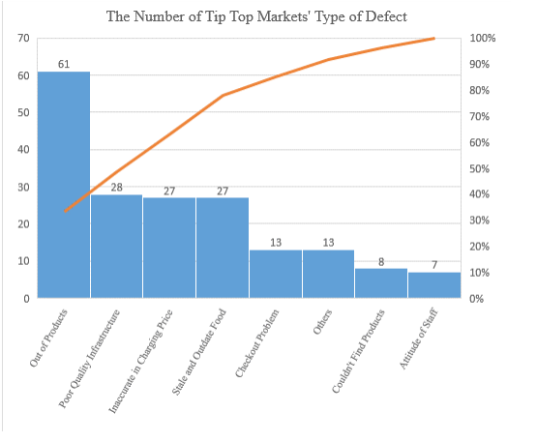
The accompanying Pareto diagram shows the number of Tip Top Markets defect categories, from most to least numerous. The most evident issue is that there is insufficient merchandise to meet customers' needs when they go shopping. Customers may perceive that the most pressing issue is a product shortage, which results in an unending flood of negative reviews about the store.
In addition to checking sheets and Pareto diagrams, run charts can be used to track the change of a specific variable over time for problem evaluation (Stevenson, 2015).
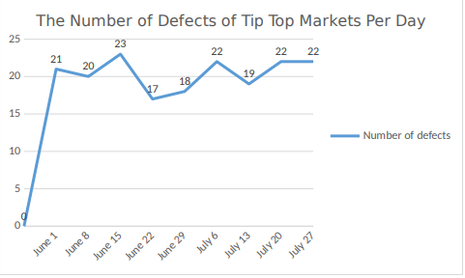
The number of Tip Top Markets defects is displayed on the run chart every day. According to information gathered over time, this store receives approximately 20 consumer complaints about difficulties daily. The trend of this chart is moderately altering, indicating that Tip Top Markets is experiencing a problem for which there is currently no visible solution. The number of errors tends to decrease until June 15, then increase and remain stable until July 27. As a result, the supermarket's management must devise a strategy to deal with the situation.
The three ways mentioned above can be used to identify and address significant issues. Before attempting to solve a problem, it is critical to determine what is causing it. The cause-and-effect diagram is an effective brainstorming tool (Stevenson, 2015). Stevenson (2015). The top group in the Pareto diagram above is devoid of products. Because this is the most widespread sickness, determining the reason and providing appropriate treatment is critical. Based on the cause-and-effect diagram, people have various plausible reasons to come up with it.

Suppliers’ issues:
Late delivery
Increase in price
Decrease in quantity of goods
The reports fail to align to reality:
Stolen goods
Returned goods
Difficulty in Importation of goods to meet actual needs.

Never assess the quantity of goods regularly to determine what products need to be imported

Running out of goods

Spaces in the warehouse, leading unavailability of goods for import.
Staff issues:
Laziness
Failure to fill items on the shelves
Unskilled staff
Inaccurate demand forecast

On July 15, several efforts were made to repair the store's condition. On the other hand, the case demonstrates that no positive changes have occurred. The number of negative customer reviews does not appear to be decreasing over the next two weeks, as concerns about ongoing issues continue to pour in. The single problem with check out and incorrectly calculating pricing has substantially improved, but out-of-stock items and poor facilities remain issues. It denotes that the current method is ineffective.
Conclusion and Recommendation
Depending on what has been researched and dissected above, identifying significant problems and locating the source is critical to devising a therapy. The most severe issue appears to be a lack of merchandise to sell to customers. The warehouse manager can expand it to hold more goods, inspect it regularly to ensure that things arrive on time, properly train workers, and collaborate with multiple suppliers rather than just one to ensure that a backup plan is in place. The techniques discussed above can assist you in avoiding product shortages or running out of inventory to meet client demands. It also helps to disseminate scientific findings.
On the other hand, everything will need time and money to finish. Customers frequently express their dissatisfaction with this issue, so management should prioritize it to address it. They might start by managing inventory and educating their employees. As a result, Tip Top Markets will have to deal with facility upgrades to provide a better shopping experience for its clients. According to management, staff should be held accountable for reporting and addressing store infrastructure issues. It's also possible that the store has been open for a long time and hasn't been properly maintained, necessitating repairs and renovations on the owners' part. The problems can be fixed, but they will be expensive.
Managers should train their employees on how to prioritize facility upkeep. Checkout issues and incorrect product prices should also be investigated. The Tip Top Markets intends to hire extra cashiers to speed up the payment procedure. It is possible to create a self-payment system that allows customers to check out independently. Despite being cutting-edge and simple to use, this technology has the potential to encourage cheating because workers cannot supervise every visitor's activity. As a result, Tip Top Markets should hire more cashiers to reduce the risks and costs of allowing customers to pay for their purchases directly. Hence, management must also require employees to pay attention to promotions and carefully calculate to avoid making a mistake. Fines should be used to hold employees accountable. Managers of supermarkets must also address product quality control and service quality. Regularly inspecting merchandise before importing it; if there is an error, it may be immediately returned to the supplier; training workers, improving accountability, and encouraging them with incentives and rewards are all examples of how it can be done. Tip Top Markets has made a significant commitment to quality improvement, despite all solutions involving time and money.

Reference
Stevenson, W. J. (2015). Operations management. New York: McGraw-Hill Education.

