RESEARCH ON STRATEGIC POSITION OF A COMPANY
Name
Institution Affiliation
Date

WALT DISNEY COMPANY
The foundation of the Company began in the year 1923 in October on 23rd. Its establishment took place in Los Angeles, California, in the United States of America. Many people recognize it as Disney, and it’s a great and much widespread media platform in America (Transit 2019). Its headquarters are in the complex studios of Disney, mainly in California. The Company's main objectives are to entertain, inspire and give information to individuals in every part of the world. It is done through the power of conducting reflection on the iconic brands and storytelling, including mind creativity and innovative technologies that makes them the premier entertainment company of the whole world. The Company operates in the four business segments that include park products, entertainments of the studio, products and parks experiences, media networking and internationally and even direct to consumers. It promotes values like optimism, innovation, decency, quality storytelling, and community.
Walt Disney Company is one of the companies experiencing great financial distress. Revenues and profits have dissolved at the Walt Disney Company from its quarterly earning evaluation. The Coronavirus pandemic is one of the most critical factors that has led destabilization of the business pillars of the Company. The revenues of the Company dropped from twenty-three percent to approximately fourteen billion dollars. The Company reported a loss of seven hundred and ten million dollars instead of seven hundred and seventy-seven million dollars in profit from the record in the year-ago period of the Company. It translated to a twenty percent loss per share compared to the one-dollar earnings per share as described in the reports from the Company in the same quarter in the year 2019. Coronavirus pandemic took away three point one billion dollars bit from the Company's quarterly revenues, including the seven-point four billion dollars from its annual sales. Under the current economy, there is seventy-five percent of Walt Disney Company to experience financial distress in the next two years.
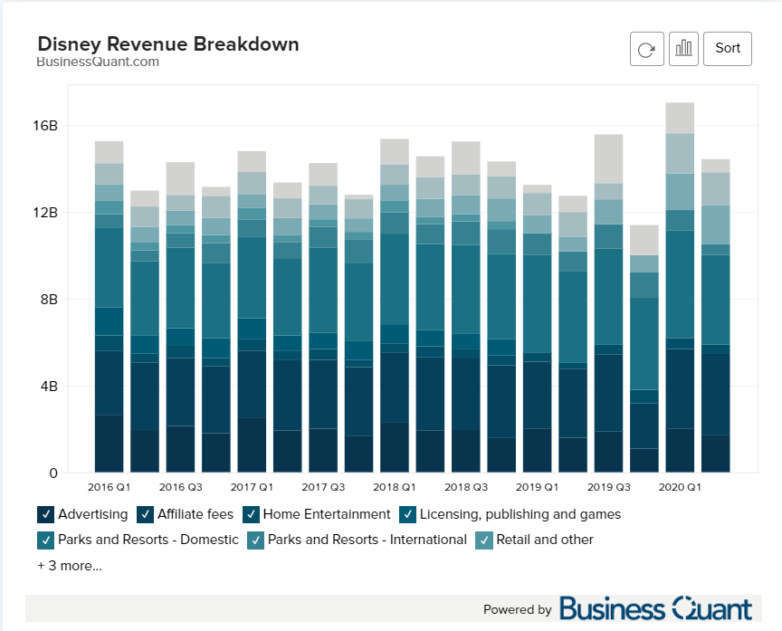
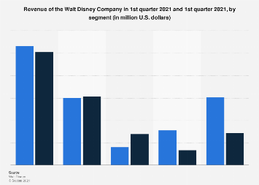
Walt Disney Company can improve its financial status in many different ways. The methods of improvement include adopting new technologies that will help improve Walt Disney Company in the global business. With the implementation of digital technologies, the Company can increase its efficiency and even increase output quality parks and resorts. Some of the Company's threats that need to be so much care on include Competition from rival companies, the disruption of technology, and digital content piracy. However, out of the three threats that the Company must be well prepared to fight against, the most significant and relevant threat they should focus on is the Competition from the rivals. The Company should also focus on improving the competitiveness of its business and the long-term success in the international market. Despite the Company's weaknesses, management changes in the Walt Disney Company, including its strategies, must focus on utilizing the strength as the internal strategic factors for ensuring sustainable growth. The strategies of the Company must also address the impacts of the threats.
In today's market environment, which is very competitive, businesses and firms should develop strategic plans to be sustained in this win-win market. It has become very tough for businesses to remain in this market, especially the still-developing companies and businesses. Although they might be undergoing much pressure and different forms of failures, they are pushed to maintain the market competitiveness and push through by any means. Many forms help to benefit from the market, such as having the Company try as much as possible to lower the cost they use in manufacturing their products. On the one hand, it will help them have savings in the business accounts that would cover up for more productivity or even help improve on the product results. It will also help in coming up with a market price that will cover every productivity cost and fulfill the main aim of any company of having made a profit at the end of the business transaction. The price to the targeted market will be fair and attractive to more customers to venture into the Company's products.
Another strategy that can even maintain the Company at a good and fair market place and have its financial condition root deeply to avoid and prepare for any fall in different times is by trying as much as possible to venture and enter deeply into new markets. New markets in this business analog fully entail having new ideas ever to the Company. We relate it with that new things are ever best, so venturing into new markets will broaden up the companies' network and make it known in many new places. Entrepreneurs will come venture into the Company as they will get to see it thriving into different parts, which will greatly support the Company. Venturing into this market will enable the Company like Walt Disney to understand the competitive state of the markets and instinct strategies to have it withhold the Competition.
Bringing about opportunities and sharing of risks will still have the Company sustain a much competitive market advantage. Opportunities creation will attract more people who want to merge their companies with yours and even would end up funding the Company, which will help boost the business financially. Still, having open opportunities for every person capable will make it an attractive company and boost this will be by acting like giving gifts to workers to motivate them to try as much as possible to give their best. Sharing risks and even more willing to take risks might push the business to a much better angle. Risk-taking will boost the market stability and experience even after a loss, and this in the future will boost the financial status in similar risks.
Adopting many different marketing strategies of improving the advertisement of products will also improve the Company's sales. Disney is planning to expand its content on Disney plus and speed up the direct-to-consumer business, among other plans like expanding its strategy (Crowe, 2021).
Having the best product advertisement on different platforms will boost the sales, and so the Company is to find out best-selling platforms to have their products reach and be known to a wider market in the best way. It will improve the performance of the Company financially.
Plan of Strategy implementation
By the Company being in a critical condition in being near the brink of bankruptcy and financially struggling. The best planning strategy that could help the Company attain its dream state first is by having it get back strongly into the market. It sometimes can be done by asking the Company to try as much as possible to give offers to their customers even more and attract much more customers. We can also merge with similar companies to get related ideas and have them put into practice. Still can second the best marketing of the Company's products by boosting friendly relations with companies that are doing good to boost our capabilities and having the products being together with those doing good, will also have the market see them as best again hence boosting the sales which will reflect with a financial boost. In conclusion, after the analysis of the methods used by the Company to run its large organizational services, the Walt Disney resort is indeed both pushing forward and operating at an optimal level on the productivity frontier for porter (Delay, 2018)

References
Daley, J. M. (2018). The Keys to Disney's Magic and Success.
Crowe, N. (2021). Walt Disney Company: Peter Rice.
Transit, K. (2019). The Walt Disney Company.

