Microeconomics Theory
Name
Institution

Author Note
The IS-LM-PC model is a model with the following representation
IS: investment and savings (representing the goods market)
LM: Liquidity Preference-Money supply) representing the money market
PC: Philips curve (shows the change in inflation)
Question 1: Fiscal policy in the IS-LM-PC model
- The economy is at its equilibrium point at point "A." This point shows the potential level of "r1" as the interest rate and YP as the real GDP, and "iP" showing the inflation rate.
- A decrease in government expenditure causes a shift of IS curve in government spending towards the left from IS1 to IS2. From the graph, the new equilibrium will be at point “B," where the inflation will have moved to "i1" from "iP" which is a reduction in output to “Y” from “YP.” However, at this point, the interest rate does not change.
- Here there is a recessionary gap, and the output is lower than the potential output. For that reason, the central bank will have to adopt an expansionary monetary policy to increase the supply of money in the economy. After adopting the policy, there will be a supply shift of the LM curve to the right due to the increased money supply. Thus, the LM curve will shift from LM1 to LM2. After the shift, a new equilibrium point will be created at point "C." At point "C," the economy will have reached its potential level with "YP" as the output, interest rate decreased from"r1" to "r2," and the inflation rate at "iP."

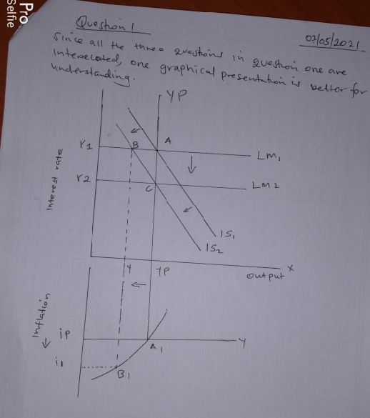

Question 2 (a)
The initial equilibrium in the IS-LM framework occurs at point E_{1.} The tax cut will increase the disposal income of the households (consumers) and lead to an increase in the consumption rate. Thus, the expenditure will increase in the economy from the consumers' side. The increased aggregate expenditure in the economy will lead to a shift of IS from IS to IS₁. For that reason, the shift of IS rightwards will change the equilibrium from E₁ TO E₂. In that connection, the interest rate will also be affected, and it will increase to 0i_{2.} Similarly, there will be an increase in national output from 0Y₁ to 0Y₂, as shown in the second graph below.
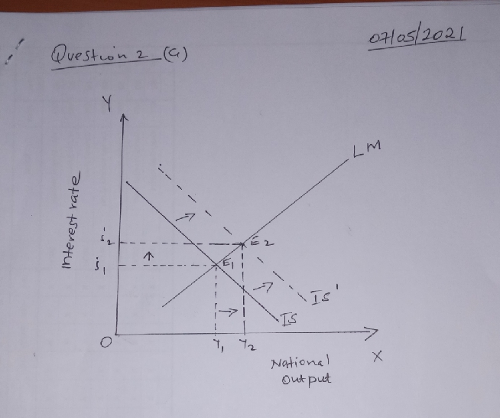
Therefore, the tax cut increases interest rate and output in the short run.
Question 2 (b)
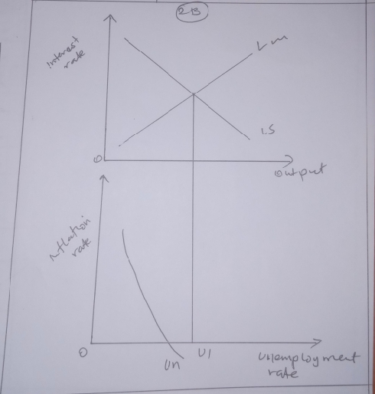
When the output is below the potential level, the unemployment rate will be higher, while the inflation rate will fall. However, in the present period, the inflation rate has to be lower. Under adaptive expectations, people will expect inflation based on the past periods. Thus, people will expect it to below, just like in the past period. For that reason, the Philips curve will have to shift to the left since the expectations are lower. Assuming that inflationary expectation are adaptive, the inflation rate at inflation in period t+1 will increase. However, when the central bank does not react, then inflation period t+2 will escalate creating a galloping inflation to the economy.
Question 2 C
Under inflationary expectations, the people the inflation in period t+1 will affect the economy and supply of money in the economy due to policies which monetary value in circulation. Therefore, if the central bank doesn't react, then the inflation in period t+2 will affect the economic activities and lead to low investment. Thus, the demand for money will fall because of little investment and the escalated interest rates.
Question 2 D
In period t+3, the central bank can use contractor policy to decrease the supply of money and decrease aggregate demand by acts such as leakage in the economy. Thus, bringing potential output and back to 2% inflation will affect the demand for money because it will stimulate production. For that reason, the central bank will have to increase the policy rate because it stimulates the economy and reduces the inflation rate. The central will differ in (b) and (c) because it increases the policy rate to stimulate the economy.

