
EXPERIMENT 10

Determination of Molar Mass:

An Application of Gas Laws

PURPOSE

The goal is to find the molar mass of a volatile liquid that has been converted to the gaseous state by measuring mass, volume, pressure and temperature. The molar mass of the sample will then be calculated from the ideal gas law.

MATERIALS AND EQUIPMENT

600 mL beaker, wire gauze, iron ring, ring stand, universal clamp, Bunsen burner, 125 mL Erlenmeyer flask, two 2-inch square pieces of aluminum foil, sharp pin, analytical balance, 250 mL graduated cylinder, thermometer, unknown volatile liquid.

DISCUSSION

Gases

Whereas it is easy to observe and measure liquids and solids, it is often difficult to remember that we are submerged in an invisible ocean of matter composed of gases. These gases are both more difficult to observe and to measure. Despite this, by understanding physical properties of the gaseous state and application of a set of well-defined relationships described by the gas laws, we can readily measure quantities of gas present.

A solid is defined as a physical state characterized by particles in such close proximity that their random motion appears as vibration about a fixed point. A liquid is defined as a physical state characterized by particles in such close proximity that their random motion appears as vibration about a moving point. Because the particles of matter in a liquid and solid are so close to each other, they are only affected in minor ways by changes in temperature and pressure. A gas is defined as a physical state characterized by the random motion of particles, which are far apart compared to their own diameters. This definition of a gas allows several important conclusions to be drawn concerning their behavior.

- Gases placed in an empty container will uniformly fill and assume the shape of the container.

- The volume of the gas particles themselves will be negligible compared to the volume of the container the gas is in.
- Gases are greatly affected by changes to their physical environment such as changes in temperature and pressure.
- At a given temperature and pressure, the volume of the gas is proportional to the number of gas particles. This is true no matter what the identity of the gas is.
The Ideal Gas Law

The final statement can be expressed quantitatively by a mathematical relationship called the Ideal Gas Law. We consider most gases to be ideal gases. In the Ideal Gas Law, PV = nRT; where P is the pressure of the gas, V is the volume of the gas, n is the number of moles of gas present, T is the Kelvin temperature, and R is the universal gas constant. If we measure gas pressure in units of atmospheres, volume in liters, and T in Kelvin, R has the value of 0.0821 _{K}^{L atm}_{mol} .

The Experiment

In this experiment, we will measure P, V, and T for an unknown gas, and calculate n in the gas sample. We weigh the gas, and divide this mass by the number of moles we calculated (n) to find the

molar mass of the unknown gas in units of _{mol}^{g} . The method we use is called the Dumas method.

Now let us look a bit more closely at how we can experimentally determine the mass, pressure, volume and temperature of our unknown sample..

We will first weigh an “empty” Erlenmeyer flask covered with a piece of aluminum foil with pinhole. We can consider this flak as empty even though it contains air (which has mass) because this flask will always contain air when the flask is weighed and the mass of our sample will be obtained by difference. Next, we will add excess volatile liquid to this flask, cover it with the foil and heat the flask in a hot water bath. This will vaporize the volatile liquid, driving both the air and excess liquid through the pinhole and out of the flask. Our flask will now be filled with our volatile liquid in its gaseous state. We will want to know P, V, T and the mass of this sample. We will then remove this sample from the hot water bath and dry the flask. The gas that formed will condense back into a liquid. The covered flask, now containing the liquid, will be reweighed. The difference in masses between the “empty” flask and the flask containing the condensed liquid will yield the mass of the unknown sample. The temperature of the sample will be the same as the temperature of the water in the hot water bath. The pressure of the gas in the sample is the same in the atmospheric pressure in the laboratory, which will be measured by the instructor using a barometer. Finally, the volume of gas can be obtained by filling the Erlenmeyer flask with water and measuring this volume of water with a graduated cylinder. Figure 10.1 gives a schematic diagram of this procedure.


Weigh “empty”

Erlenmeyer flask
covered with foil.

Add excess volatile

liquid to the flask.
Make small pinhole
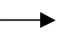
in foil.
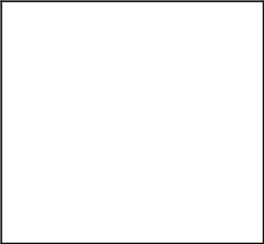

Heat flask in hot

water bath until all
liquid evaporates.
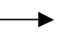
Excess liquid and air

originally in the
flask will escape
through the pinhole.


Figure 10.1 A schematic diagram of an experiment designed to find the molar mass of a gas.

Fill flask completely with water. Measure volume of water in flask with a graduated cylinder.

After doing twice.
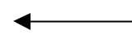

Cool flask to room temperature. Gas formed from volatile liquid will condense. Air from room will flow back into flask. Reweigh flask.

The experimental apparatus for the molar mass determination of a gas is shown in Figure 10.2.
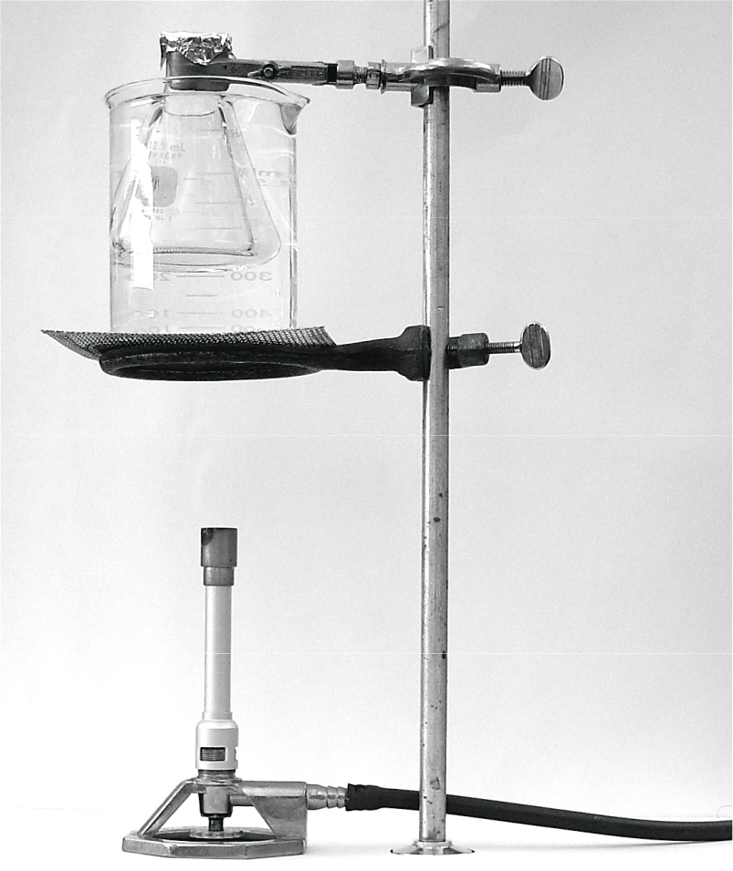

Figure 10.2 Experimental apparatus for measuring the molar mass of a gas.

PROCEDURE


SAFETY Do not inhale vapor from the unknown liquid. The unknown liquid may be flammable. Keep it away from flames. Wear Safety Goggles.

- Set up a boiling water bath in your work area. Do not add water yet, and do not light the burner.

- Weigh a clean, dry, 125-mL Erlenmeyer flask together with a 2-inch square of aluminum foil on an analytical balance. Record the mass to the nearest .0001 g (4 decimal places!). Pour about 3 mL of your unknown volatile liquid into the flask. Cover the top of the flask tightly with the aluminum foil, and make a small pinhole in the center of the foil. Most of this volatile liquid will vaporize when you heat it and exit the flask through the pinhole.

- Clamp your flask at the top with a universal clamp. Attach the clamp to your support rod and lower the flask as far as you can into the beaker. Add as much water to your large beaker as you can while still keeping the aluminum foil above the water. Have your instructor check your experimental set-up. Your set-up should look like that pictured in Figure 10.2.
- Light your burner, and start heating the beaker gently. You want the water to boil gently without splashing water onto the top of your flask (a boiling stone may be added to the hot water bath to facilitate this process.) Measure the temperature of the boiling water as accurately as you can

(± 0.1°C) . Convert the Celsius temperature to Kelvin by adding 273.2

- The volatile liquid in the flask should vaporize completely and be no longer visible, as the excess passes out the pinhole.

- Turn off the burner when no more drops of volatile liquid are visible in the flask.

- Carefully remove the flask from the hot water bath. Remove the clamp, and dry the outside of the flask completely. At this time a few drops of condensed volatile liquid may appear in the flask. This is normal as the temperature goes down.

- When the flask is cool, thoroughly dry the outside of it and weigh it with the aluminum foil still in place on the analytical balance. The mass should be more than at the beginning of the experiment, because the flask contains your unknown.

- Dispose of the small amount of the liquid in the flask as directed by the instructor. Dry the inside of the flask thoroughly. Repeat steps 1 through 8 until you have completed two trials.

10. Remove the foil and fill the Erlenmeyer flask with tap water completely to the brim. Pour this water into the 250 mL graduated cylinder. This volume is the volume of your Erlenmeyer flask. This volume is the volume, V, of the ideal gas law and should be more than 125 mL.
 |  |  | Name___________________________
 | REPORT | Determination of Molar | Name___________________________
 | 10 | Determination of Molar | Section _________Date _________ Instructor_____________
 | 10 | Mass: an Application of | Section _________Date _________ Instructor_____________
 | 10 | Mass: an Application of | __________________
 |  | Gas Laws | __________________


DATA AND CALCULATIONS

Measure Quantity | Trial 1 | Trial 2
Mass of empty Erlenmeyer flask and foil | 94.12 g | 94.53 g
Mass of flask, foil, and volatile liquid | 95 g | 94.12 g
Temperature of boiling water bath (T, °C) | 95 | 96
Atmospheric pressure (P, mm Hg) | 745 | 745
Volume of flask (V, liters) | 0.232
Unknown Sample Number | Ethyl Acetate

Calculated Quantity | Trial 1 | Trial 2
Mass of volatile liquid by difference  (show calculation setup) | 95.07 g – 94.12 g =0.95 g | 94.53 g – 94.12 g =0.41 g
Temperature of boiling water in Kelvin  (show calculation setup) | (95 + 273.15) = 368.15 K | (96 + 273.15) = 369.15 K
Atmospheric pressure in atm  (show calculation setup) | (745 mm Hg x 1 atm )/760 mm Hg =0.985 atm | (754 mm Hg x 1 atm )/760 mm Hg =0.9921 atm
Moles of volatile liquid remaining in  Erlenmeyer flask from Ideal Gas Law  (show calculation setup) | T=368.15 K  P=0.985 atm  V=0.232 L  Pv=nRT  n =(0.985 atm x 0.232 L)/(0.08321 x 368.15 k) =0.00748 moles | T=369.15 K  P=0.992 atm  V=0.152 L  Pv=nRT  n =(0.992 atm x 0.152 L)/(0.08321 x 369.15 k) = 0.00497 moles
Molar mass of volatile liquid  (mass/number of moles) (show calculation setup) | 0.950 g/0.00748 = 127.03 g/mol | 0.41 g/0.00497 moles = 83 g/mol

QUESTIONS AND PROBLEMS

- Calculate the molar mass of a gas if a 0.950 gram sample of it occupies 232 mL at 95 °C and 0.985 atm. Show your work!

Mass of the sample = 0.95 g
Volume occupied = 232 ml = 232 x 10⁻³L
Temp = 95 ºC = (95 + 273)K = 368K
Pressure = 0.985 atm

For an ideal gas…. pV = nRT

Therefore; n = pV/RT
But n = mass/Molar mass
m/M = pV/RT
M = mRT/ pV

= [(0.95 x 0.0821 x 368) ÷ (0.985 x 232 x 10⁻³)] g/mol

Molar mass = 125.6 g/mol
_______________

- How would these errors affect the results of your experiment? Would they make your calculated molar mass too high or too low or have no effect? Explain the reason for your choice.

(a) You do not dry the flask completely before weighing it at the end of the experiment.
NO EFFECT

TOO HIGH TOO LOW (circle one, explain)

The water vapor does not change its amount since the gas behaves ideally or does not interfere in measuring the molar mass of the sample.

- You assume that the temperature of the boiling water is 100. °C instead of your measured value.
NO EFFECT

TOO HIGH TOO LOW (circle one, explain)

Molar mass of the sample is equal to 127.3 g/mol which is more than the 125.6 g/mol when we use temperature 0f 100 ºC hence there will be no effect.

- Calculate the number of moles of gas present in a sample whose volume is 1.00 Liter, at a pressure of 745mm Hg, and a temperature 93.0 °C. Use the Ideal gas law. Show your work!
R = 0.0821 _{K}^{L atm}_{mol} .

Let number of moles be = n
And the volume of sample = 1 L
Pressure = 745 mm Hg = (745 mm Hg x 1 atm)/760 mm Hg = 0.98 atm
Temperature = 93.0 °C (273 + 93) K = 366K
R = R = 0.0821 _{K}^{L atm}_{mol}
But; PV = nRT

n =PV/RT = (0.98 x 1)/(0.0821 x 366) mol
Moles = 0.0326 moles

_______________

