Report

Physics concept:

There are 2 physics concept used in this problem namely Momentum conservation and Energy Conservation. In the closed system, any collision between particles in the system conserves the total momentum. Now, A perfectly elastic collision is defined as one in which there is no loss of kinetic energy in the collision. So, if the collision type is perfectly elastic, then the kinetic energy is conserved too in that collision. Thus, with the help of both of these concepts, we will solve the given problem.

Known and Unknown

Known:

Mass of 2 small hockey pucks (let us call them B and C) = m = 2.5kg

Mass of the hockey puck (let us call it A) = M = 5kg = 2m

Initial velocity of A = V = 10m/s

Initial velocity of B and C = 0m/s

Final velocity (velocity after collision) of B = v1 = 1.5m/s
Angle at which B moves from horizontal (after collision) = θ1 = 30°
Unknown:

Final velocity (velocity after collision) of A = v
Angle at which A moves from horizontal (after collision) = θ
Final velocity (velocity after collision) of C = v2
Angle at which C moves from horizontal (after collision) = θ2

Diagram:

We will now show momentum and its component on each puck before and after collision.
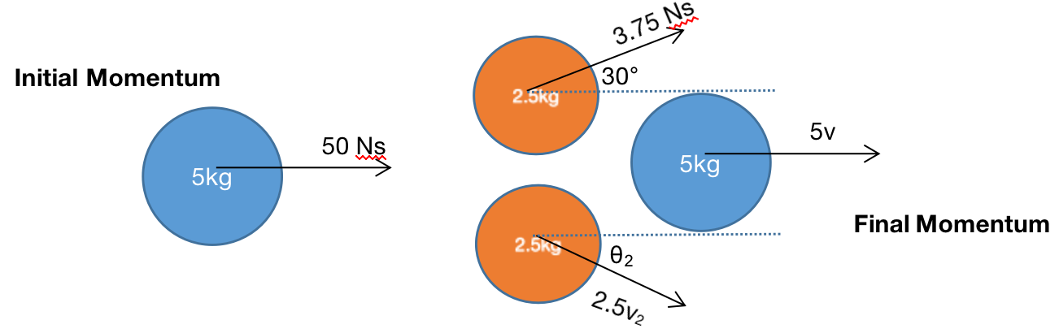
Solve the Problem

The hockey puck A exerts an impulse on pucks B and C, such that the pucks B and C leave the collision along the lines (shown in the diagram), while the puck A leaves the collision along the x axis. Thus θ = 0.

Conserving the x component of the total momentum

Momentum initial in x-direction = Momentum final in x-direction
50 = 3.75*cos(30) + 5v + 2.5*v2*cos(θ2)
46.7524 = 5v + 2.5*v2*cos(θ2)
v2*cos(θ2) = 18.701 - 2v ... (1)
Conserving the y component of the total momentum

Momentum initial in y-direction = Momentum final in y-direction
0 = 3.75*sin(30) - 2.5*v2*sin(θ2)
v2*sin(θ2) = 0.75 ... (2)
Conserving the total kinetic energy

$$\frac{1}{2}MV^{2}=\frac{1}{2}Mv^{2}+\frac{1}{2}mv_{1}^{2}+\frac{1}{2}mv_{2}^{2}$$

$$2mV^{2}=2mv^{2}+mv_{1}^{2}+mv_{2}^{2}$$

$$2V^{2}=2v^{2}+v_{1}^{2}+v_{2}^{2}$$

$$2*100=2v^{2}+{1.5}^{2}+v_{2}^{2}$$

$$2v^{2}+v_{2}^{2}=197.75$$

Squaring and adding equation (1) and (2) gives:

$$v_{2}^{2}=4v^{2}−74.804v+350.29$$

This gives v = 9.9 m/s or v = 2.568 m/s
If v = 9.9 m/s, we get v2 = 1.315 m/s and this gives θ2 = 34.77°
And if v = 2.568 m/s, we get v2 = 13.585 m/s and this gives θ2 = 3.165°
Based on the value of v1 (1.5 m/s) and θ1 = 30°, the more logical value of the unknown variables will be v = 9.9 m/s, v2 = 1.315 m/s and θ2 = 34.77° (due to being symmetrical in nature).

The problem was challenging as it was difficult to understand the fact on what to conserve in these situations. Once, it was decided that we need to conserve the momentum and kinetic energy, the problem solving became easier.

