Thermistor Applications and Sensors

Measure your thermistor’s resistance at three temperatures
Condition | Temperature (degrees Celsius) | Thermistor resistance (ohm)
Free Air | ~+20 | 11.7k
Ice water | 0 | 20.4k
Between hands | ~+37 | 8.8k

Build this temperature-sensitive voltage divider

Circuit Schematic:
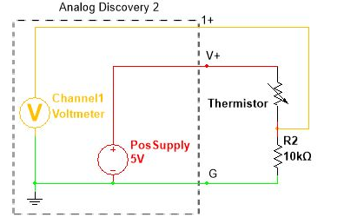

Solution:
Condition | Temperature (degrees Celsius) | Predicted Output voltage (volts) from voltage divider rule | Measured output voltage
Free Air | ~+20 | 2.70v | 2.65v
Ice water | 0 | 3.35v | 3.1v
Between hands | ~+37 | 2.34v | 2.5v

? The output voltage increases when the temperature is high or it’s hot and decreases when cold, since by increasing the temperature, the thermistor resistance will fall (decrease) leading to higher voltage over the R2 compared to the voltage drop across the Thermistor, and the same for decreasing temperature (cold), the Thermistor resistance will increase taking more voltage drop compared to that across R2.

Add a buffer to your divider circuit

Circuit Schematic:
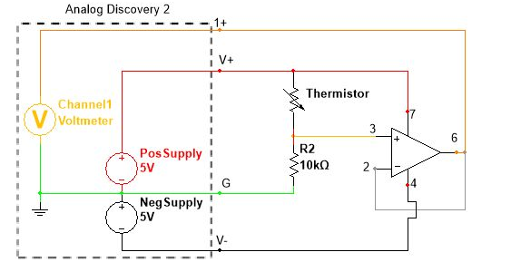

Solution:

Add an LED as a load to the buffer circuit

Circuit Schematic:
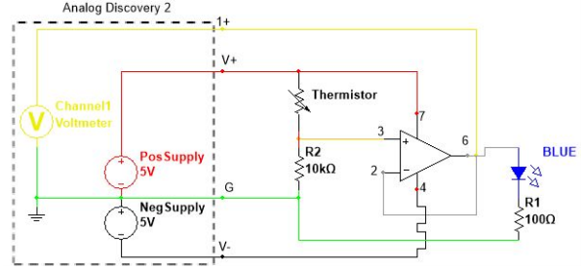

Solution:

Condition | LED Description (qualitative)
Free air | Medium light intensity
Ice water | Weak light/no light
Between hands | Strong light intensity

Reflection Questions
? If we swapped the positions of the thermistor and fixed resistor; then the operation of Thermistor will be reversed, since with increasing temperature the resistance of Thermistor will decrease, and thus the output of the buffer or OPAMP will also decrease while the LED light may be weak or even doesn’t give light, and vice versa.
? If the water shorted the thermistor; the thermistor resistance will appear as a short circuit, and thus all voltage will be applied across the fixed resistance giving a very large value at the output and the LED will be turned on all time irrelated of the temperature applied to the thermistor.
? Relatively small changes in temperature can produce larger changes in brightness; as the Buffer amplifier uses the small current generated as a result of variation in thermistor resistance at its input to give larger current in the order of milliamps at the output circuit of the LED, which causes larger changes in the brightness of the LED.
? The given circuit will not work, since at high temperature the thermistor resistance will be low (in the order of 2-8 kilo ohm) causing an electric current less than or close to 1mA to pass through the circuit which is not sufficient to turn on the LED and also the voltage drop across the LED will be very high, while in case of low temperature the Thermistor resistance will be larger in value causing a small current and smaller drop across the LED which may result in very low current passing through the circuit which is also not sufficient for the LED to turn on which requires at least 30-40mA to turn on.

