Report Title: Applications of resistors in electric circuits
Student’s name:
Class:
Date: 05/05/2021
Resistors are one of the most useful elements of an electric circuit, the main function is to control the current the flows through them, controlling the voltage of the individual elements and preventing overloading in the circuit.
An electric circuit and its components are ruled by a physics law called Ohm´s law. This law is the result of the research in electricity that Georg Simon Ohm (March 16, 1789 - July 6, 1854) a German mathematician and physicist did between 1826 and 1829, where he discovered a relation between the voltage and the current in a circuit (https://www.facebook.com/thoughtcodotcom, 2016).
Ohm´s law describe the relation between voltage, current and resistance. The equation that represents this law is:
$$I=\frac{V}{R}$$
Where:
I = Current [=] Amperes (A)
V = Voltage [=] Volts (V)
R = Resistance [=] Ohms (Ω)

This means that the current increases when the voltage increases, in other words, the current and the voltage are directly proportional; whereas if the resistance increases, the current decreases; so current and resistance are inversely proportional. This law is important because with these mathematical equations we can control a circuit and the amount of current that flows through them by putting some resistors, so the circuit can have lots of applications and can be safe to manipulate.
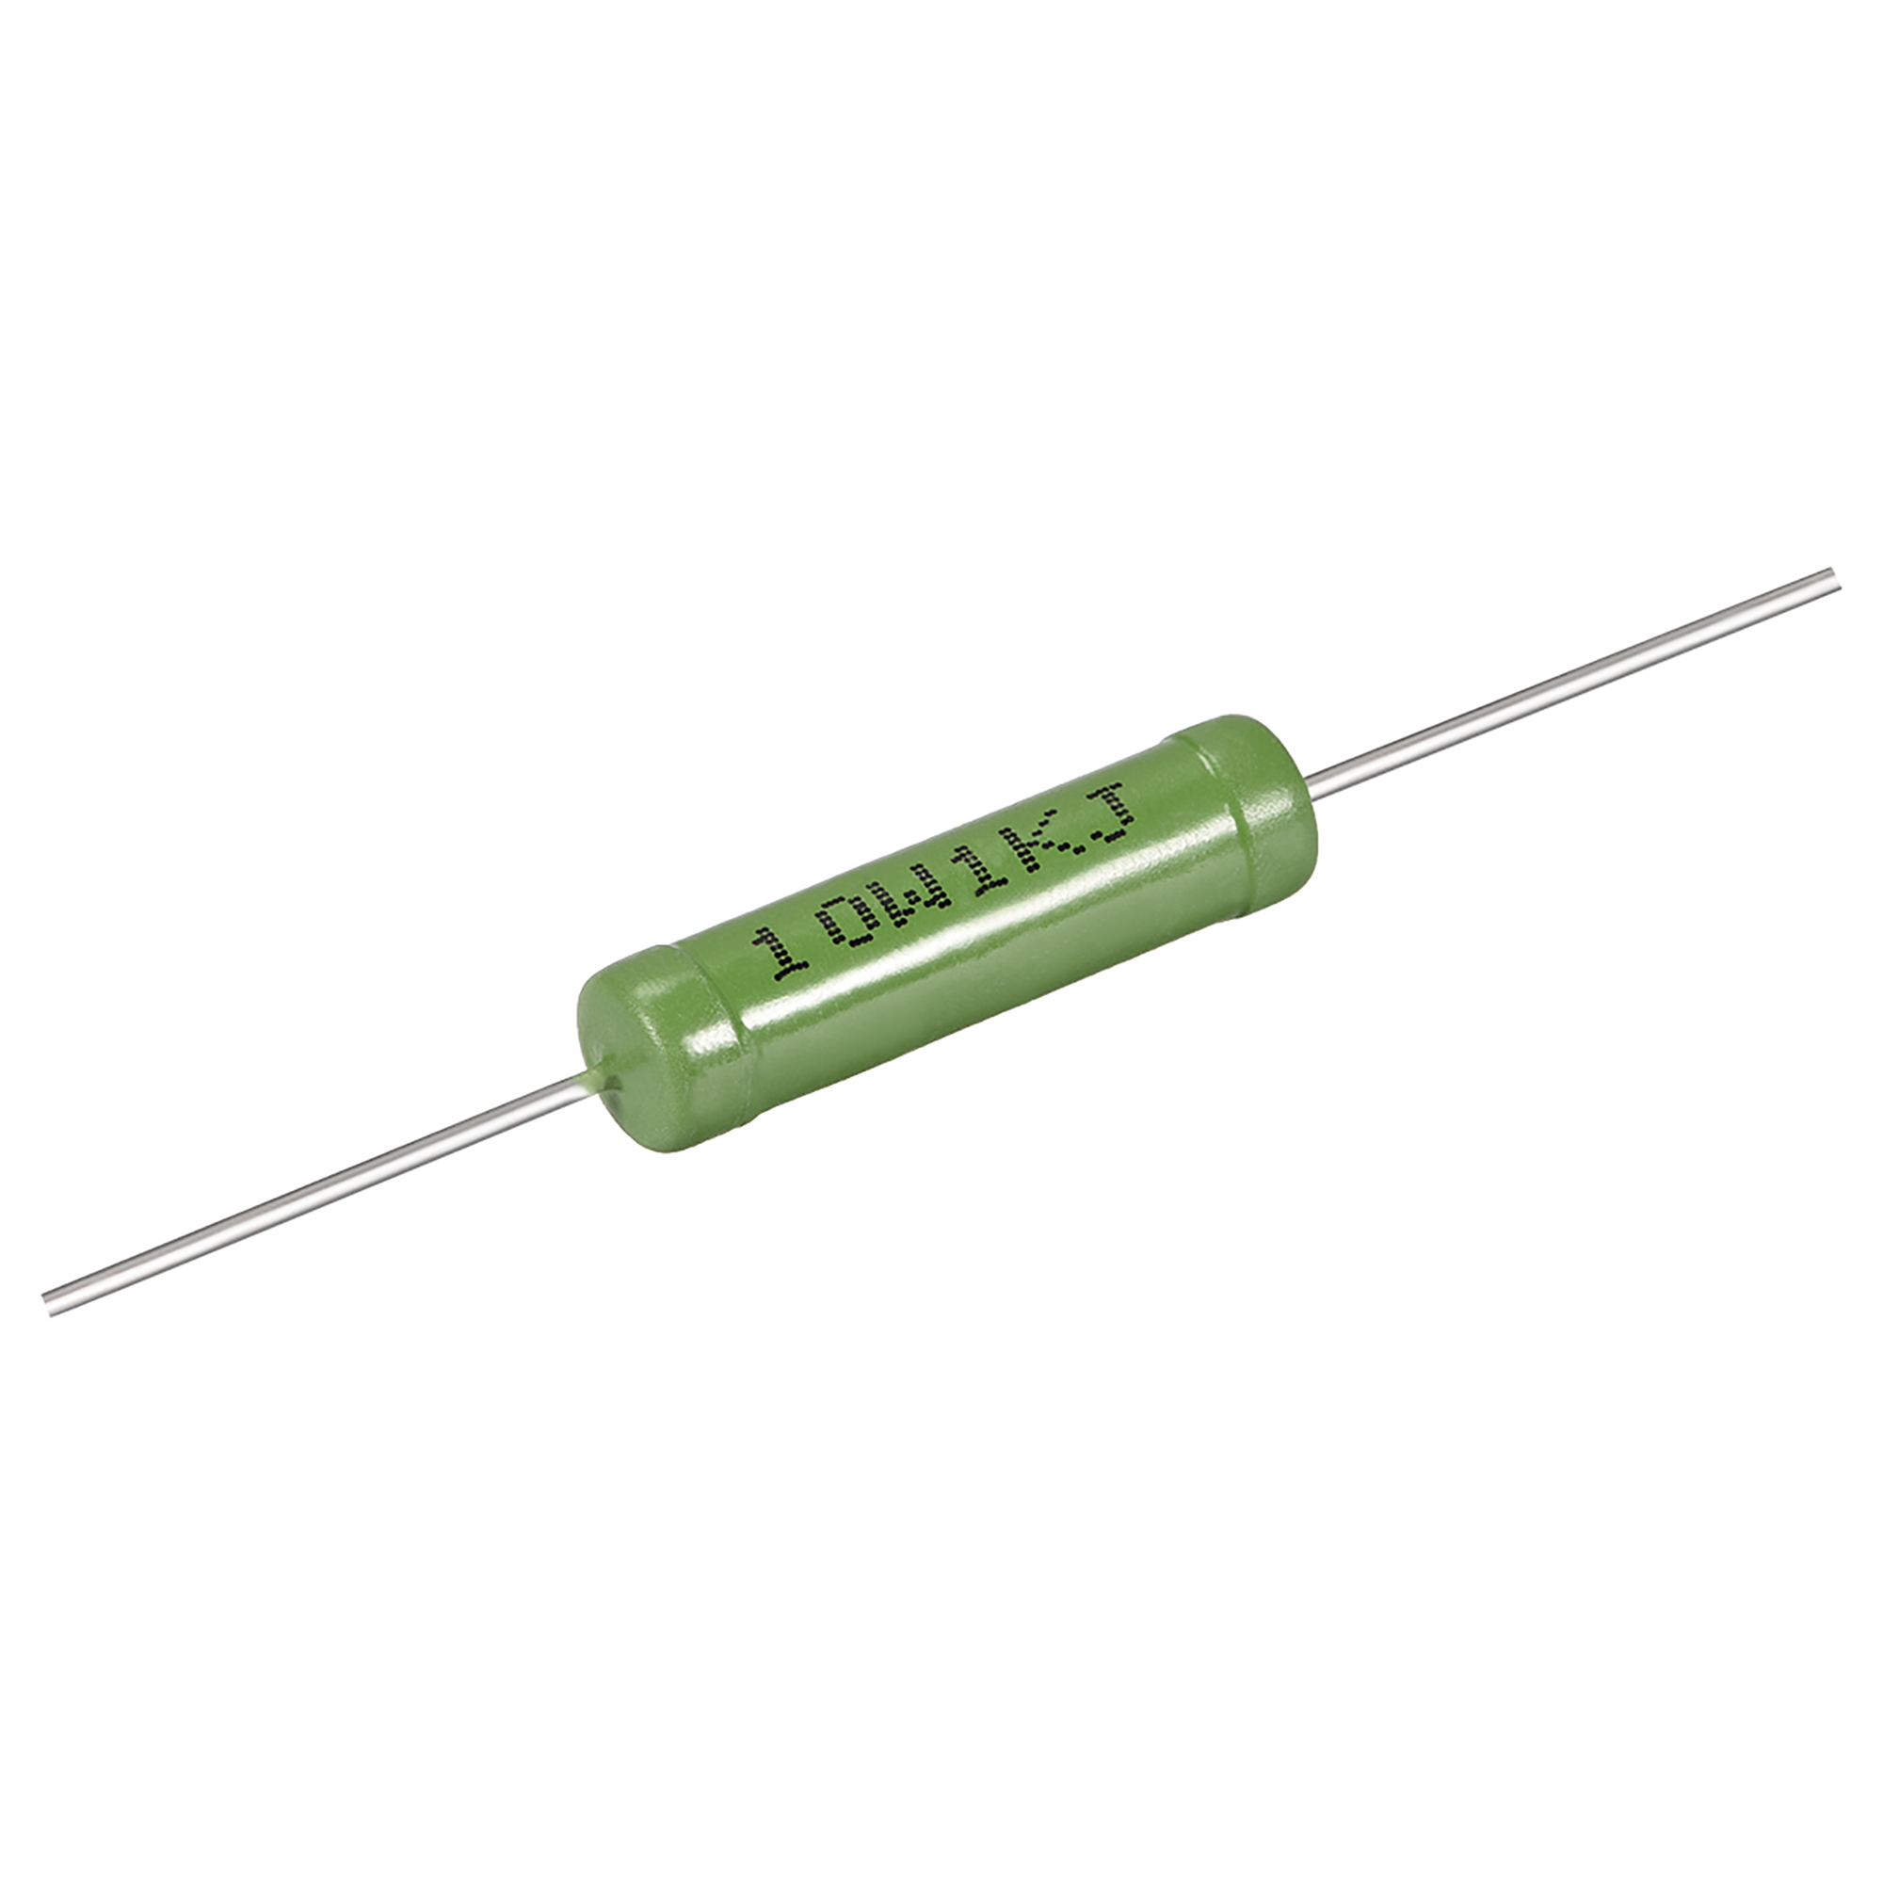
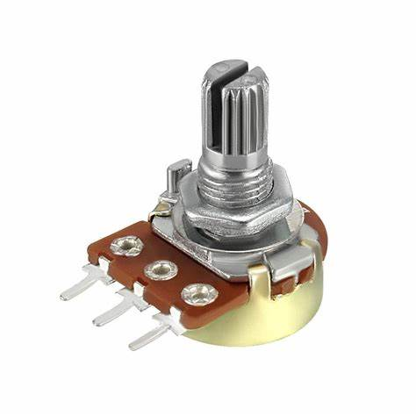
There are many types of resistors that can be used for many different things, but these are derived from two types of resistors that group all the others together, linear resistors and non-linear resistors. A linear resistor is a resistor whose resistance does not change with the variation of current flowing through it (What Is a Linear Resistor? n.d.) Examples of this type of resistors could be fixed resistors as wire-wound resistors (Figure 1), and variable resistors as potentiometers (Figure 2).
Figure 1. (2017). Walmartimages.com. https://i5.walmartimages.com/asr/9848f7fe-c974-4d7e-ae94-81c113d155db_1.d0623b7a04f94549186f0f7c3c925120.jpeg

‌
Figure 2. (2021). Bing.com. https://th.bing.com/th/id/OIP.DawUIVPsjihuq7CduWTVSAHaHa?pid=ImgDet&rs=1

‌

Non-linear resistors are those types of resistors where the electric current flowing through it changes with the exchange in applied voltage or temperature and does not change according to Ohm’s law (Types of Resistors - Linear and Non-Linear Resistors, Video, n.d.). Examples of non-linear resistors are thermistors (Figure 3) and photo resistors (Figure 4).
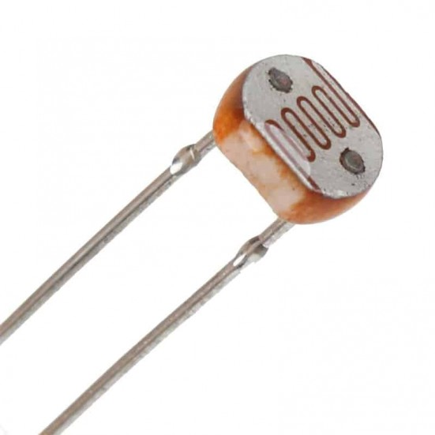
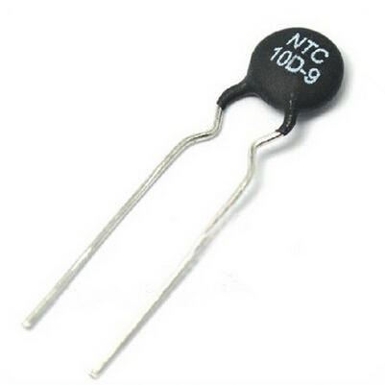
Figure 4. (2021). Pcboard.ca. https://www.pcboard.ca/image/cache/catalog/products/resistors/gl5528-ldr-02-551x551.jpg

‌
Figure 3. (2021). Imimg.com. https://4.imimg.com/data4/JM/JI/MY-3596629/thermistors-500x500.jpg

‌

Resistors in electric circuits have various applications depending on what the circuit will do. Without resistors, machines simply would not work, hence the importance that these elements have not only in the industry, but also in our daily lives since the devices we occupy day by day such as irons, fryers, the chargers of our devices, and other devices use resistors.
Resistors also play a fundamental role in security; they protect the components of the circuit from voltage spikes by providing the proper voltage to each of the components in the circuit.
In conclusion, electrical circuits have had a great impact on human history, because thanks to these we can have electricity in our homes and amenities that in previous centuries would never have imagined. Ohm's law has been a big factor in this process as it allowed us to understand and control the current within a circuit; however, despite being a fundamental law, it is basic and others have a greater application, like Kirchhoff’s laws.
Resistors are one of the most important components within the circuits, its invention has allowed us to create circuits with different applications, from controlling the volume on an electric guitar by means of a potentiometer to industrial applications such as heating air by means of heating resistors.

References:
- The Functions and Applications of Resistors. (n.d.). Www.kynixsemiconductor.com. Retrieved May 6, 2021, from http://www.kynixsemiconductor.com/News/72.html
- What is Resistor | Resistance | Applications. (2020, April 11). CircuitCloud. https://circuitcloud.in/what-is-resistor/
- Different Types of Resistors and its Applications. (2016, September 14). Buy Electronics & Electrical Projects in Europe. https://www.efxkits.co.uk/different-types-resistors-applications/
- Types Of Resistors - Linear and Non-Linear Resistors, Video. (n.d.). BYJUS. https://byjus.com/physics/types-of-resistors/
- What Is a Linear Resistor? (n.d.). Reference.com. https://www.reference.com/world-view/linear-resistor-bb0c79e84cfef968
- Basic Electronics - Linear Resistors - Tutorialspoint. (n.d.). Www.tutorialspoint.com. https://www.tutorialspoint.com/basic_electronics/basic_electronics_linear_resistors.htm
- Scherf, K. (2016, August 4). What Does A Resistor Do And Why Is It Important? Del City Blog. https://blog.delcity.net/what-does-a-resistor-do-and-why-is-it-important/
- https://www.facebook.com/thoughtcodotcom. (2016). Ohm’s Law: the current-voltage relationship revealed. ThoughtCo. https://www.thoughtco.com/ohms-law-4039192

