Surrealism
Surrealism is the use of principles, ideals, or practices in paintings, film, and literature to produce incongruous or fascinating effects of the unconscious mind through strange or ridiculous combinations and juxtapositions. Surrealism was first adopted in paintings inspired by Giorgio de Chirico's paintings, an artist in the 20th century who had joined the surrealist movement in Europe. The surrealist movement was officially formed in 1917 in Dada (Grant, 2005). The artist who joined the surrealism movement painted to revolutionize the human experience by altering rational thinking in favor of one that asserted the value of the unconscious mind and dreams. The surreal artists such as Salvador Dali and Rene Magritte found magic and odd beauty in the unexpected and the unconventional.
The Persistence of Memory Art was painted by Salvador Dali, a Spanish Surrealist painter. Dali painted the art with the idea of time and its passage and the relation between real-time and remembered time (The Dalí Museum, 2018). However, the wilting form of the pocket watch is the most dominant charm for surrealist Dali, which symbolized the paradox of rendering the hardest, most mechanical of objects into the present soft situation (Barney, 2021). The paint embodies the futility of time and the sensibilities of the surrealism movement with its strange melting clocks and the dreamlike atmosphere.
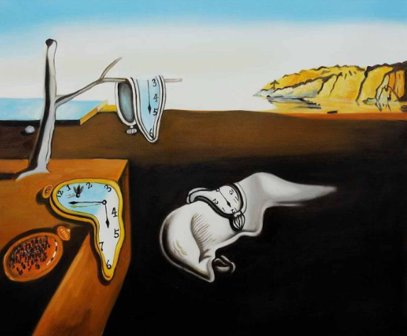
Figure 1: The Persistence Memory, Salvador Dali
The Grape Harvest, painting by Rene Magritte, a Belgium Surrealist painter, depicts a window that looks out to the world rather than the most dominant army of men, which is just aggressive. Rene painted The Grape Harvest with an idea about a time and existence that goes on without you (Pichlmair & Putney, 2020). The emptiness of the room depicts how individuals start from nothing. Above the identical army of men, space depicts surrealism to mean one can rise up with the intent to look forward that is full of potential rather than focusing on monotone passivity held by all.
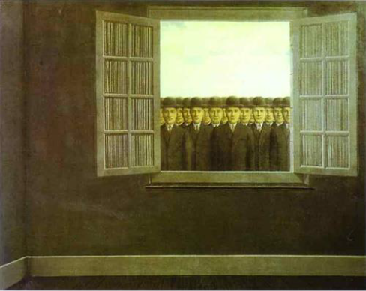
Figure 2: Grape Harvest, Rene Magritte

References
Barney, L. (2021). Salvador Dali: Memories of Surrealism.
Grant Ph.D., K. (2005). Surrealism and the visual arts: theory and reception. Cambridge University Press.
Pichlmair, M., & Putney, C. (2020, September). Procedural Generation for Divination and Inspiration. In International Conference on the Foundations of Digital Games (pp. 1-7).
The Dalí Museum, (2018). surrealism - Bing video. [online] Bing.com. Available at: <https://www.bing.com/videos/search?q=surrealism&amp;docid=608005427652463491&amp;mid=857878C5AA77217A79CF857878C5AA77217A79CF&amp;view=detail&amp;FORM=VIRE> [Accessed 6 May 2021].

