- The plot below gives quarterly auto sales (in millions) for the first quarter of 2000 through the last quarter of 2001.
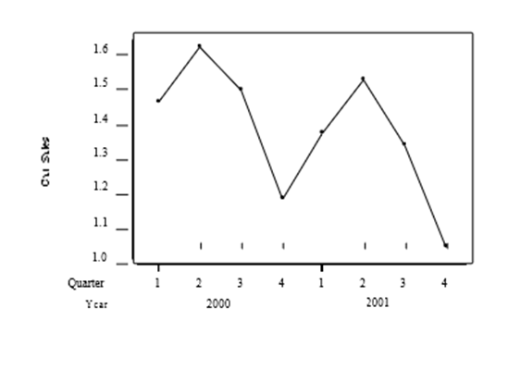
Using regression software, the estimated linear trend model is:
Sales = 1.60 – 0.0482x
where x is the number of quarters elapsed since the beginning of the series. Using this trend-only model, the predicted sales for the first quarter of 2002 are million cars.
 | A. | 1.17
 | B. | 1.36
 | C. | 1.55
 | D. | 1.60

- The plot below gives quarterly auto sales (in millions) for the first quarter of 2000 through the last quarter of 2001.
This two-year time series of sales exhibits:
 | A. | seasonal variation.
 | B. | an increasing trend.
 | C. | biannual variation.
 | D. | seasonal variation with a decreasing trend.

QUESTION 3
- Determining the sale price of a home is an important task for city assessors as it helps the city project future tax revenue. Regression models using the physical characteristics of a home to predict the sale price is standard practice for many assessors. A random sample of 724 homes sold in Ames, Iowa, between 2006 and 2010 was obtained to build such a model for the city of Ames. The assessor considered the following variables in their initial model:

Variable Description

LotArea Lot size (in thousands of square feet)
LivingArea Living space (in thousands of square feet)
Bedrooms Number of bedrooms
Rooms Number of rooms
Fireplaces Number of fireplaces
Bath Number of bathrooms
Age Age of the home (in years)
Price Sale price of the home (in thousands of Below is

the output obtained from the statistical software:
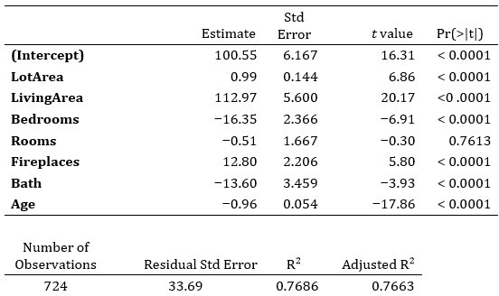

Suppose the assessor wanted to add a variable for the type of dwelling into the model. The possible dwelling types include single-family detached, two-family conversion, duplex, townhouse end unit, and townhouse inside unit. How can this variable be used as a predictor?
 | A. | by using a numeric scale from 1 to 5
 | B. | by using the original labels
 | C. | by using a set of four indicator variables
 | D. | Categorical variables cannot be used as predictors.
1 points

QUESTION 4
- Moneyball tells the story of the 2002 Oakland Athletics, a Major League Baseball (MLB) team, and how they found ways to improve despite being one of the poorest teams in baseball. To do this, Billy Beane (the general manager) and Paul DePodesta (a Harvard graduate) analyzed available data on what made teams successful. After their initial analysis, they determined that scoring runs was very important to a team's success. In this problem you will explore what variables can be used to predict how many runs a team will score in a season.

The data set you will use contains information on all MLB teams between 1999 and 2012 (420 total observations). The variables available include

Variable Description

Team Abbreviated team name
League What league the team belongs to (0 = AL, 1 = NL)
Year Year
RS Runs scored
RA Runs allowed
OBP On-base percentage
SLG Slugging percentage
BA Batting average

The following models were fit using statistical software:
Model Predictors R2 Adj. R2
1 | League, RA, OBP, SLG, BA | 0.9285 | 0.9276
2 | League, OBP, SLG | 0.9281 | 0.9276
3 | OBP, SLG | 0.9198 | 0.9194
4 | OBP | 0.8024 | 0.8019
5 | SLG | 0.8285 | 0.8281
6 | BA | 0.6506 | 0.6498

What is the proportion of the variation in runs scored (RS) does model 1 explain?
 | A. | 0.9285
 | B. | 0.9276
 | C. | 0.2247
 | D. | 0.3814
1 points

QUESTION 5
- Determining the sale price of a home is an important task for city assessors as it helps the city project future tax revenue. Regression models using the physical characteristics of a home to predict the sale price is standard practice for many assessors. A random sample of 724 homes sold in Ames, Iowa, between 2006 and 2010 was obtained to build such a model for the city of Ames. The assessor considered the following variables in their initial model:

Variable Description

LotArea Lot size (in thousands of square feet)
LivingArea Living space (in thousands of square feet)
Bedrooms Number of bedrooms
Rooms Number of rooms
Fireplaces Number of fireplaces
Bath Number of bathrooms
Age Age of the home (in years)
Price Sale price of the home (in thousands of Below is

the output obtained from the statistical software:

What proportion of the variation in sale price does this multiple regression model explain?
 | A. | 0.3369
 | B. | 0.7686
 | C. | 0.7663
 | D. | 0.2314
1 points

QUESTION 6
- 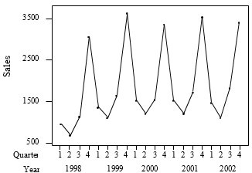
Indicator variables corresponding to first, second, and third quarters were added to the linear trend model. These indicator variables are X1, X2, and X3. The estimated trend- and-season model is
Sales = 3096 + 26.6x – 1971X1 – 2300X2 – 1818X3
where x is the number of quarters elapsed since the beginning of the series. Using this estimated trend-and-season model, the predicted sales for the second quarter of 2003 are:
 | A. | $849.2 million.
 | B. | $1381.2 million.
 | C. | $3096 million.
 | D. | $3681.2 million.
1 points

QUESTION 7
- Determining the sale price of a home is an important task for city assessors as it helps the city project future tax revenue. Regression models using the physical characteristics of a home to predict the sale price is standard practice for many assessors. A random sample of 724 homes sold in Ames, Iowa, between 2006 and 2010 was obtained to build such a model for the city of Ames. The assessor considered the following variables in their initial model:

Variable Description

LotArea Lot size (in thousands of square feet)
LivingArea Living space (in thousands of square feet)
Bedrooms Number of bedrooms
Rooms Number of rooms
Fireplaces Number of fireplaces
Bath Number of bathrooms
Age Age of the home (in years)
Price Sale price of the home (in thousands of Below is

the output obtained from the statistical software:

What is the interpretation of the slope associated with Bedrooms?
 | A. | For each additional bedroom, the sales price of the house will decrease by $16,350.
 | B. | For each additional bedroom, the sales price of the house will decrease by $16,350, holding all other variables constant.
 | C. | For each additional bedroom, the expected sales price of the house will decrease $16,350, holding all other variables constant.
 | D. | For each additional $1,000 in sales price, the average number of bedrooms in the house decreases by 16.35, holding all other variables constant.
1 points

QUESTION 8
- Moneyball tells the story of the 2002 Oakland Athletics, a Major League Baseball (MLB) team, and how they found ways to improve despite being one of the poorest teams in baseball. To do this, Billy Beane (the general manager) and Paul DePodesta (a Harvard graduate) analyzed available data on what made teams successful. After their initial analysis, they determined that scoring runs was very important to a team's success. In this problem you will explore what variables can be used to predict how many runs a team will score in a season.

The data set you will use contains information on all MLB teams between 1999 and 2012 (420 total observations). The variables available include

Variable Description

Team Abbreviated team name
League What league the team belongs to (0 = AL, 1 = NL)
Year Year
RS Runs scored
RA Runs allowed
OBP On-base percentage
SLG Slugging percentage
BA Batting average

Note that these are average statistics for the entire team, not individual players.

Below is a scatterplot matrix of the available quantitative variables. Notice that the lower triangle provides the pairwise correlations and that the diagonal displays a histogram of each variable.
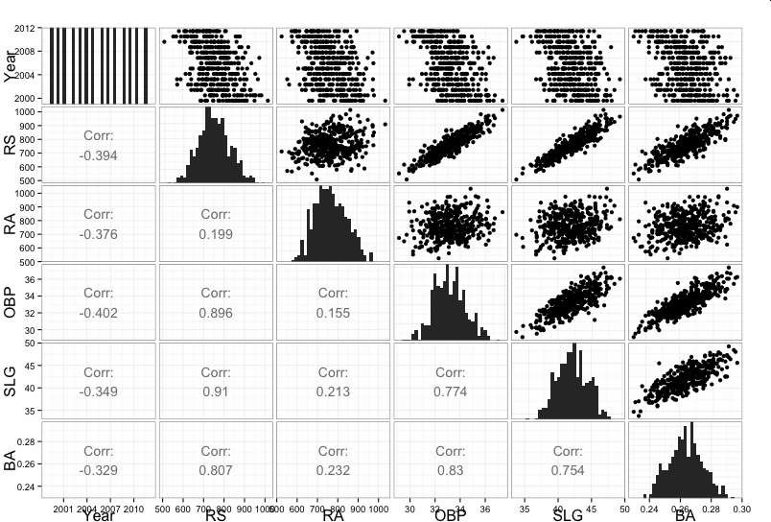

The following models were fit using statistical software:
Model Predictors R2 Adj. R2
1 | League, RA, OBP, SLG, BA | 0.9285 | 0.9276
2 | League, OBP, SLG | 0.9281 | 0.9276
3 | OBP, SLG | 0.9198 | 0.9194
4 | OBP | 0.8024 | 0.8019
5 | SLG | 0.8285 | 0.8281
6 | BA | 0.6506 | 0.6498

Rank the following variables with respect to their correlation with runs scored (RS) from most correlated to least correlated.
 | A. | RA, OBP, SLG, BA
 | B. | BA, RA, OBP, SLG
 | C. | SLG, OBP, BA, RA
 | D. | OBP, RA, SLG, BA
1 points

QUESTION 9
- Moneyball tells the story of the 2002 Oakland Athletics, a Major League Baseball (MLB) team, and how they found ways to improve despite being one of the poorest teams in baseball. To do this, Billy Beane (the general manager) and Paul DePodesta (a Harvard graduate) analyzed available data on what made teams successful. After their initial analysis, they determined that scoring runs was very important to a team's success. In this problem you will explore what variables can be used to predict how many runs a team will score in a season.

The data set you will use contains information on all MLB teams between 1999 and 2012 (420 total observations). The variables available include

Variable Description

Team Abbreviated team name
League What league the team belongs to (0 = AL, 1 = NL)
Year Year
RS Runs scored
RA Runs allowed
OBP On-base percentage
SLG Slugging percentage
BA Batting average

This question focuses on model 2. Below is the output from statistical software.

 | Estimate | Std. Error | t value
(Intercept) | –885.8 | 26.658 | –33.23
League | –15.54 | 2.241 | –6.93
OBP | 28.78 | 1.239 | 23.23
SLG | 16.61 | 0.672 | 24.72

Consider two teams with identical on-base and slugging percentages, but one is in the National League (NL) while the other is in the American League (AL). How many more/fewer runs is the NL team expected to score than the AL team?
 | A. | The NL team is expected to score 885.8 fewer runs than the AL team.
 | B. | The NL team is expected to score 2.241 more runs than the AL team.
 | C. | The NL team is expected to score 15.54 fewer runs than the AL team.
 | D. | The NL team is expected to score 26.66 more runs than the AL team.
1 points

QUESTION 10
Indicator variables corresponding to first, second, and third quarters were added to the linear trend model. These indicator variables are X1, X2, and X3. The estimated trend- and-season model is:
Sales = 3096 + 26.6x – 1971X1 – 2300X2 – 1818X3
where x is the number of quarters elapsed since the beginning of the series. The estimated trend-and-season model has an R2 value of 97.4%, whereas the trend-only model has an R2 value of 9.6%. This indicates that:
 | A. | the trend-and-season model explains much more of the variability in the series than the trend-only model.
 | B. | predictions from the trend-and-season model will have 10 times the accuracy of the trend-only model.
 | C. | neither model will produce very good predictions of future sales.
 | D. | the trend-and-season model explains much more of the variability in the series than the trend-only model and predictions from the trend-and-season model will have 10 times the accuracy of the trend-only model.
1 points

QUESTION 11
- The relationship between a statistic and a sample is the same as the relationship between:
 | A. | Descriptive statistics and inferential statistics
 | B. | Dependent variable and an independent variable
 | C. | Parameter and population
 | D. | Mean and µ
1 points

QUESTION 12
- Assume that you choose to fit an AR(1) model. The output obtained from statistical software is displayed below.

Term Estimate Std. Error

Intercept 11.77 9.372
Lag1 0.99 0.007
The price of gold was $1,196.325 on December 31, 2014.
Predict the price of gold on January 1, 2015:
 | A. | $1,196.132
 | B. | $1,196.325
 | C. | $1,208.095
 | D. | None of the answers is correct.
1 points

QUESTION 13
- A time series plot of the log transformed monthly drug sales is displayed below.
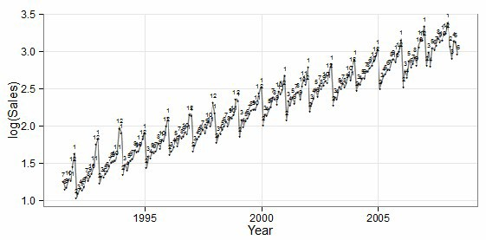

Choose the BEST description of the seasonal/cyclical component of this time series.
 | A. | Sales show no seasonality.
 | B. | Sales show strong seasonality.
 | C. | Sales show a strong cyclical pattern.
 | D. | Sales show random pattern
1 points

QUESTION 14
- Regardless of the model you chose, would you recommend making forecasts using your MA model?

 | A. | Yes, an MA model always provides good forecasts for time series data.
 | B. | Yes, the MA model in this situation provides accurate forecasts for the observed data.
 | C. | No, MA models do not account for trend in its forecasts.
 | D. | No, it is impossible to obtain forecasts from MA models.
1 points

QUESTION 15
- For a large retailer, the plot below gives quarterly sales for the first quarter of 1998 through the last quarter of 2002 in millions of dollars.
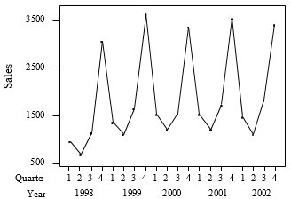
Using regression software, the trend component for this series is:
Sales = 1322 + 50.7x.
The seasonality factors are calculated to be 0.77, 0.58, 0.84, and 1.80 for the first, second, third, and fourth quarters, respectively. The average of these seasonality factors is 0.9975. Thus, the seasonality factor of 1.80 for the fourth quarter indicates that fourth-quarter sales:
 | A. | are typically 80% higher than third-quarter sales.
 | B. | are typically 80% above the average for all four quarters.
 | C. | are typically 1.8 times third-quarter sales.
 | D. | have 1.8 times the variability of other quarters.
1 points

QUESTION 16
- The plot below gives quarterly auto sales (in millions) for the first quarter of 2000 through the last quarter of 2001.
The trend-only model:
 | A. | should overpredict fourth-quarter sales.
 | B. | will explain less variation than a trend-and-season model.
 | C. | should be adjusted for seasonal effects.
 | D. | All of the answers are correct.
1 points

QUESTION 17
- A time series plot of the log transformed monthly drug sales is displayed below.
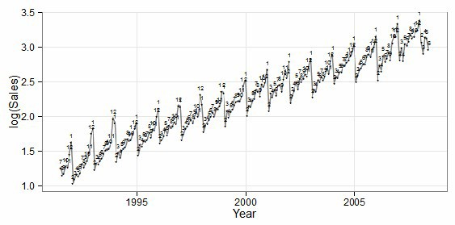
Choose the BEST description of the trend component of this time series.
 | A. | positive, linear
 | B. | positive, quadratic
 | C. | positive, exponential
 | D. | positive nonlinear
1 points

QUESTION 18
- In multiple regression analysis, if the model provides good fit, this indicates that the:
 | A. | sum of squares for error will be small.
 | B. | value of the regression standard error will be small.
 | C. | squared multiple regression correlation value is will be close to 1 or –1.
 | D. | All of the answers are correct.
1 points

QUESTION 19
- Below are the VIF values from the full model. Do these indicate any potential issues with the model?

LotArea LivingArea Bedrooms Rooms Fireplaces Bath Age

1.84 4.577 2.279 4.152 1.407 3.066 1.503
 | A. | Yes, all VIF values are below 10 so the model suffers from multicollinearity.
 | B. | No, all VIF values are below 10 so the model does not suffer from multicollinearity.
 | C. | No, statistical software was able to estimate the model, so there is no problem.
 | D. | None of the answers is correct.
1 points

QUESTION 20
- ______________refers to how much the estimate varies from sample to sample, _________________refers to whether or not an estimator tends to overestimate or underestimate a parameter.

 | A. | Sample variability; Bias
 | B. | Standard deviation; Mean
 | C. | Standard error; Bias
 | D. | Sample variability; Mean
1 points

QUESTION 21
- Which of the following is likely to have a mean that is smaller than the median?
 | A. | the salaries of all National Football League players
 | B. | the scores of students (out of 100 points) on a very easy exam in which most score perfectly, but a few do very poorly
 | C. | the prices of homes in a large city
 | D. | the scores of students (out of 100 points) on a very difficult exam in which most score poorly, but a few do very well
1 points

QUESTION 22
- Assume that you choose to fit an AR(1) model. The output obtained from statistical software is displayed below.

Term Estimate Std. Error

Intercept 11.77 9.372
Lag1 0.99 0.007
Specify the fitted model:
 | A. | y_{t} = 11.77 + y_{t-1}
 | B. | y_{t} = 11.77 + 0.99y_{t-1}
 | C. | y_{t} = 11.77 * 0.99^{y}_{t-1}
 | D. | y_{t} = 0.99y_{t-1} + 0.01y_{t-1}
1 points

QUESTION 23
Using regression software, the estimated linear trend model is
Sales = 1322 + 50.7x
where x is the number of quarters elapsed since the beginning of the series. Using this trend-only model, the predicted sales for the second quarter of 2003 are:
 | A. | $1322 million.
 | B. | $1423.4 million.
 | C. | $2386.7 million.
 | D. | $2437.4 million.
1 points

QUESTION 24
- Moneyball tells the story of the 2002 Oakland Athletics, a Major League Baseball (MLB) team, and how they found ways to improve despite being one of the poorest teams in baseball. To do this, Billy Beane (the general manager) and Paul DePodesta (a Harvard graduate) analyzed available data on what made teams successful. After their initial analysis, they determined that scoring runs was very important to a team's success. In this problem you will explore what variables can be used to predict how many runs a team will score in a season.

The data set you will use contains information on all MLB teams between 1999 and 2012 (420 total observations). The variables available include

Variable Description

Team Abbreviated team name
League What league the team belongs to (0 = AL, 1 = NL)
Year Year
RS Runs scored
RA Runs allowed
OBP On-base percentage
SLG Slugging percentage
BA Batting average

Note that these are average statistics for the entire team, not individual players.

Below is a scatterplot matrix of the available quantitative variables. Notice that the lower triangle provides the pairwise correlations and that the diagonal displays a histogram of each variable.

The following models were fit using statistical software:
Model Predictors R2 Adj. R2
1 | League, RA, OBP, SLG, BA | 0.9285 | 0.9276
2 | League, OBP, SLG | 0.9281 | 0.9276
3 | OBP, SLG | 0.9198 | 0.9194
4 | OBP | 0.8024 | 0.8019
5 | SLG | 0.8285 | 0.8281
6 | BA | 0.6506 | 0.6498

Which of the following BEST describes the association between runs scored (RS) and slugging percentage (SLG)?
 | A. | strong, negative, linear association
 | B. | moderate, positive, linear association
 | C. | moderate, positive, nonlinear association
 | D. | strong, positive, linear association
1 points

QUESTION 25
- A random variable has mean and standard deviation . Suppose independent observations of are taken and of these observations are computed. If is very large, the law of large numbers implies that:

 | A. | will be close to
 | B. | will be approximately normally distributed
 | C. | the standard deviation of will be close to
 | D. | All of the answers are correct.
1 points

QUESTION 26
- Below is a time series plot of the quarterly number of passenger vehicles (in thousands of cars) produced in the United Kingdom between the first quarter of 1989 and the first quarter of 2005 (note that the quarters are labeled on the plot). A table containing the seasonality ratios for each quarter is also provided.
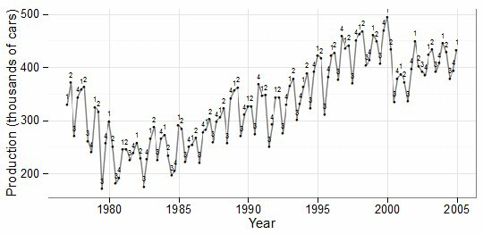
Quarter | Seasonality ratio
1 | 1.083
2 | 1.064
3 | 0.859

Interpret the ratio for the second quarter.
 | A. | Car production in the second quarter is typically 6.4% above the average for all four quarters.
 | B. | Car production in the second quarter is typically 6.4% below the average for all four quarters.
 | C. | A total of 1.064% of cars are produced in the second quarter.
 | D. | None of the answers is correct.
1 points

QUESTION 27
- Given the sample space and events A, B, and C as defined in the Venn Diagram below, what is the probability of B P(B):
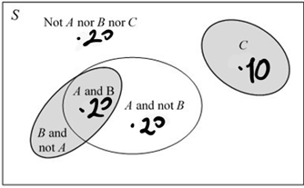
 | A. | .20
 | B. | .30
 | C. | .40
 | D. | .50
1 points

QUESTION 28
- For a large retailer, the plot below gives the sales for the first quarter of 1998 through the last quarter of 2002 in millions of dollars.

This time series of sales exhibits:
 | A. | seasonal variation.
 | B. | an increasing trend.
 | C. | biannual variation.
 | D. | seasonal variation with an increasing trend.
1 points

QUESTION 29
- Determining the sale price of a home is an important task for city assessors as it helps the city project future tax revenue. Regression models using the physical characteristics of a home to predict the sale price is standard practice for many assessors. A random sample of 724 homes sold in Ames, Iowa, between 2006 and 2010 was obtained to build such a model for the city of Ames. The assessor considered the following variables in their initial model:

Variable Description

LotArea Lot size (in thousands of square feet)
LivingArea Living space (in thousands of square feet)
Bedrooms Number of bedrooms
Rooms Number of rooms
Fireplaces Number of fireplaces
Bath Number of bathrooms
Age Age of the home (in years)
Price Sale price of the home (in thousands of Below is

the output obtained from the statistical software:

What is the response variable?
 | A. | lot area
 | B. | living area
 | C. | age
 | D. | sale price
1 points

QUESTION 30
- For a large retailer, the plot below gives quarterly sales for the first quarter of 1998 through the last quarter of 2002 in millions of dollars.
Using regression software, the trend component for this series is:
Sales = 1322 + 50.7x.
The seasonality factors are calculated to be 0.77, 0.58, 0.84, and 1.80 for the first, second, third, and fourth quarters, respectively. The trend-and-season model is
Sales = (1322 + 50.7x) *SF
where x is the number of quarters elapsed since the beginning of the series. Using this estimated trend-and-season model, the predicted sales for the second quarter of 2003 are:
 | A. | $1322 million.
 | B. | $1413.7 million.
 | C. | $1423.4 million.
 | D. | $2437.4 million.

