Title:
Name:
School:
Date:

Table of Contents
ABSTRACT 3
Introduction 4
How it works 5
Distributed Computing Management Server 6
Distributed Systems Vs Other Trends 7
Distributed Computing Applications 8
Peer-to-peer Networks/ Telecommunication Networks 8
Distributed Rendering 8
Simulation and complex modeling 9
What Next? 9
Effects on choice of equipments to purchase 10
Conclusion 10
Reference 12

ABSTRACT
In the computing world, technology has advanced dramatically, resulting in new inventions and discoveries. Increased desktop CPU power and communications capacity have resulted in the discovery of a new computer environment. As a result of the advent of this new environment, distributed computing has become a more realistic technology. A distributed system is a group of autonomous entities that work together to solve a problem that cannot be handled separately (Kshemkalyani et al, 2011). In this paper, we will look at how distributed computing works and how it differs from previous technologies. We also investigate the sectors in which this technology may be used, as well as the degree of security and standards that underpin it.

Introduction
The phrase "distributed computing" refers to computation that is spread out over a large area. As a result, distributed computing is an activity carried out on a geographically dispersed system (Lamport et al, 1990). Distributed systems have been around since the beginning of time. The concept of distributed computing systems as a valuable and extensively deployed technology is becoming a reality, thanks to the broad use of the internet and the emergence of the global village (Kshemkalyani et al, 2011). As previously said, as desktop CPU power and communications bandwidth have increased, distributed computing has become a more viable option. Various companies have recently announced several efforts and architectures that enable distributed data and object processing over a network of linked equipment.
The presence of a computing environment where you can harness the idle CPU cycles and storage space of hundreds or thousands of networked computers to work together on a processing-intensive issue is one of the areas of attention in this technology. This is also an area where we will concentrate our efforts in this article. However, because of a lack of compelling applications and bandwidth difficulties, as well as severe security, management, and standards problems, the adoption of this processing paradigm has been limited.
Several process models are distinguished by the technique utilized for distributed system interprocess communication. The most typical ones include message passing in-process communication, where a message is placed in a message queue and then received by another process by removing the message from the queue. The length of message queues and the amount of time between when a message is delivered and when it may be received differ between these types.

How it works
There are software agents deployed on numerous client systems, as well as dedicated distributed computing management servers, in a distributed computing architecture. Within the network, there may be numerous of these servers. There are also currently seeking clients that have software installed that allows them to submit jobs together with listings of the resources they require.
An agent operating on a processing client detects when the system is rendered idle. This agent also informs the management server of the system's readiness for processing and, in most cases, requests an application package. After receiving an application package from the server, the client executes the software when it has free CPU cycles and sends the results back to the server. If the user of the client system needs to execute an independent program at any time, the control response is sent back instantly, and the distributed application package's operation is terminated.

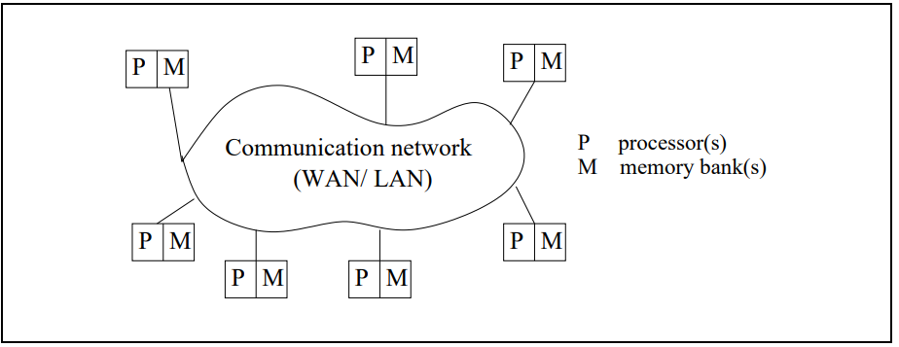
Figure 1: A distributed system (Kshemkalyani et al, 2011)

We can observe that there is no shared memory in the design above. This is a characteristic that enables message forwarding in communication by implying the absence of a shared physical clock. It's worth noting that a distributed system may still use the distributed shared memory abstraction to give an abstraction of common address space. In the literature on distributed computing, several elements of shared-memory multiprocessor systems have been investigated (Kshemkalyani et al, 2011). The processors are likewise separated geographically, yet they are connected via the network. The processors do not, however, have to be connected to a wide-area network (WAN) for the system to be termed as a distributed system. The processors are also may run various operating systems with different speeds. They aren't normally part of a specialized system, but they do work together to provide services or solve problems (Kshemkalyani et al, 2011).

Distributed Computing Management Server
Servers are crucial in these systems because they handle all computing requests and distribute jobs to client PCs. They also reply to all demands, such as distributing application packages and client management software to idle client systems following the requests. They also keep an eye on the client machines' employment status. After such packages have been launched on the client workstations, they combine the findings and arrange them for display, generally using a database.
The server is also in charge of administering any security, policy, or other administrative duties inside the system, such as dealing with IP address inconsistencies across numerous users on the network. The complexity of this system design grows as the size and kind of environment grows, requiring more complicated resource identification, policy administration, authorization, cryptography, and secure firewall capability. Access levels can also be set depending on a project's hierarchy, deadlines, and perceived relevance. Unauthorized access to systems and data inside distributed systems that are supposed to be inaccessible necessitates the use of security methods.

Distributed Systems Vs Other Trends
Looking at other trends in the current generation, one can identify the merits and demerits of these distributed systems. Below is a table summary of the comparison with other trends.

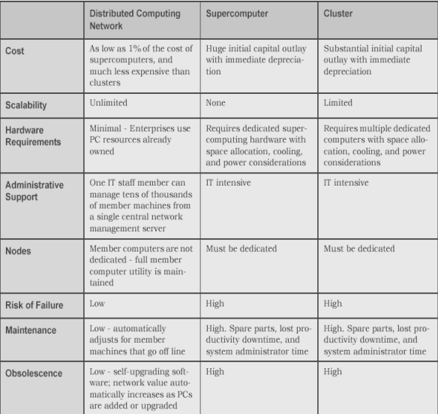

Distributed Computing Applications

Peer-to-peer Networks/ Telecommunication Networks
Most companies throughout the world must have at least a basic communication and data exchange system. However, some of these businesses may find the technologies that allow them to access data and communicate difficult to use. Several solutions have been devised to address various challenges, but only a handful have proven to be successful. The distributed system, on the other hand, is the most effective approach for resolving such challenges.
One of the primary issues recognized in the present situation is information exchange with organizations. This is much more difficult for businesses with offices or satellite outlets in different parts of the country. In most circumstances, a branch depends solely on data about its activities. Individual branches require less information on the firm as a whole than the main branch or the headquarters. As a result, the necessity for any central information from the other branches would be inconsistent. The main office, on the other hand, needs a continual input of data from the many branches in various places, which is where a distributed database system may help because it allows each location of the company to interface directly with its database. The organizations will therefore be able to access information from several places more efficiently and cost-effectively.

Distributed Rendering
Also known as parallel rendering, is the application of parallel programming to the computer graphics computational domain. "why do we need to be distributed rendering?" There are two general reasons why distributed computing is usually recommended. It's due to a shortage of processing power and memory (Bogdanova et al, 2016).

Simulation and complex modeling
To improve the accuracy of the results, distributed computing techniques are used. This is accomplished by increasing the number of random trials that may run simultaneously on several computers and then combining them to gain more statistical significance.

What Next?
According to Larry Smarr (2020), the computer industry is on the verge of big changes, even though many people don't see it that way. There is a bright, challenging, and exciting future of the distributed system. One reason for this is because there is a constant improvement of hardware. A single server is now capable of having more memory, storage, and CPUs than numerous clusters could supply ten years ago. As a result, you may now handle issues that formerly needed a cluster with a single workstation (Tony Mason 2017).
We're expanding as well, and some businesses have begun to use cloud computing. In a few years, we'll have other teams and corporations running and managing our services and infrastructure from afar. We won't have perfect control over our stack any longer, and other people's problems might suddenly become our own. Thus the distributed systems in cloud computing will be embraced more. Companies like AWS will be running a lot of other companies' operations.
We will be having a data-centered world. “A data-driven world is inherently scattered. Apps operating on a wide range of computers all over the world contribute to and share the data and world models that are now available to us all. In the new world, if I create a social network, everyone has immediate access to it. That social network, instead of being a closely guarded corporate asset, becomes a common engine for change. The move to data-driven apps will begin with businesses and smart equipment” (Mehtap Ozkan 2017).

Effects on the choice of types of equipment to purchase
This technology will automatically affect the choice of types of equipment to purchase if I were to recommend it for any given client. The first thing to look at is how technology is growing. This is what we have looked into in our previous discussions including its operations. Having all this in mind, it will now call for having the types of equipment that will support this technology. At first, the devices purchased such as pcs and servers should be of at least 4th generation so that they can support the application software that is used in the distributed systems. The server should be first enough to support a good number of client systems and also have a security capability that is up to date to ensure the propers security of the resources and data within the system.
The distributed computing types of equipment also depend on the purpose of having the system. For instance, if the device to be purchased is going to be used for distributed rendering then it means that the processing speed has to be high, the storage capacity has to be big enough as well since the resources used are of huge capacity, the RAM as to be also big so that the rendering speed is also fast. In conclusion, the choice of types of equipment is largely affected by this type of technology and if I'm to recommend to a client the best types of equipment to purchase, it will depend on the task that the equipment is going to perform, in as far as distributed computing is concerned.

Conclusion
For the correct sorts of applications, the benefits of this form of architecture are considerable. One of the most significant achievements of these distributed systems is the establishment of information exchange across firms. One of the most significant benefits of distributed computing is its scalability. Scaling up a distributed computing system is as simple as adding more systems to the environment. Systems may be introduced within or outside the company firewall in a corporate distributed computing environment. For the time being, however, the potential of distributed computing resides mostly in utilizing system resources that are contained behind the firewall. Years will pass before Internet systems can share compute resources as easily as they can exchange information.

Reference
Kshemkalyani, A. D., & Singhal, M. (2011). Distributed computing: principles, algorithms, and systems. Cambridge University Press.
Lamport, L., & Lynch, N. (1990). Distributed computing: Models and methods. In Formal models and semantics (pp. 1157-1199). Elsevier.
Bogdanova, A., Ivashchenko, A., & Belezeko, A. (2016). Creating distributed rendering applications. In CEUR Workshop Proceedings (Vol. 1787, pp. 130-134).
Larry Smarr (2020).The Future of Distributed Computing. Retrieved on February 18, 2022.From https://www.hpcwire.com/2020/08/25/larry-smarr-the-future-of-distributed-computing-is-here/
Tony Mason (2017). What is the future of distributed systems?. Retrieved on February 18, 2022. From https://www.quora.com/What-is-the-future-of-the-distributed-system
Mehtap Ozkan (2017). 7Reasons Why the Future of Computing is Distributed. Retrieved on February 18, 2022.From https://medium.com/@goldenhornventures/7-reasons-why-the-future-of-computing-is-distributed-be28caa262dd

