Task 1 – Preparation for Application and Interviews
Leadership for Organizational Vision and Strategy
Leadership, as discussed in the strategic management assignment, involves maximizing one's assets and attributes while also addressing one's weaknesses in the most effective way. This is referred to as "balanced leadership." A company organization with the ability to identify and capitalize on leadership strengths is more likely to chart a route that leads to success, while coping with shortfalls via its ability to anticipate problems and provide appropriate solutions. This means that leaders should focus on the problem rather than defining a set of goals, and that the issue should be addressed by providing a solution. Strategic management and strategy, on the other hand, are two complicated topics that may be explained from a variety of perspectives, but the common thread between the two is that they both have an impact on the success or failure of a company (Rahman, et al., 2018). If the organization's purpose and vision concept demand failure in order to separate itself from the competitors, it will not prosper. Since this is a top priority, executives are responsible for creating a compelling vision that differentiates the company from its rivals. The following abilities of initiative will have a significant impact on everything in a competent hierarchical vision and process:
- Having the ability to encourage and inspire others- Rahman et al. (2018) cite the increasing relevance of natural inspiration, whereas McGahan (2019) emphasizes the need of taking the initiative to inspire people to reach their goals. Initiatives that are unable to create a dream that generates energy within the current pool of talented workers are unlikely to be successful. Traditional propelling devices, such as benefits and compensation augmentation, are being phased out in favor of natural motivation. There are a variety of ways in which workers may be encouraged to follow a strategic path for the firm, such as a greater level of support, the opportunity to communicate, and so on and so forth.
- Proliferation and communication- Interpersonal connections are being used to multiply since the younger generation is more familiar with these technological developments in the process of communication. To address the company's essential new direction, management must become familiar with and embrace these technical advancements.
- Cooperation and Adaptation- There is some disagreement about whether or not the vertical style of management with learned forms of initiative is still possible, as argued by Jaleha and Machuki (2018) in the context of 21st century culture and emerging situations. As a result, management needed to adapt to a more communal technique that would include talented and capable labor from the twenty-first century. Initiative cannot have a mandate or a specific approach in conjunction with top-down communication in order to achieve the desired result.
- Capacity to explore and resolve issues- According to Sun and Henderson (2017), effective administration necessitates the demonstration of strong and swift dynamic capacity. Individuals working in a 21st century commercial organization, nonetheless, need close supervision to ensure that their collaboration and more significant interest requirements are met. As a consequence, management must include personnel inside the company entity to assess and provide means to adapt them to the vision while also instilling a sense of pride in them as a result of their shared responsibility and value addition.
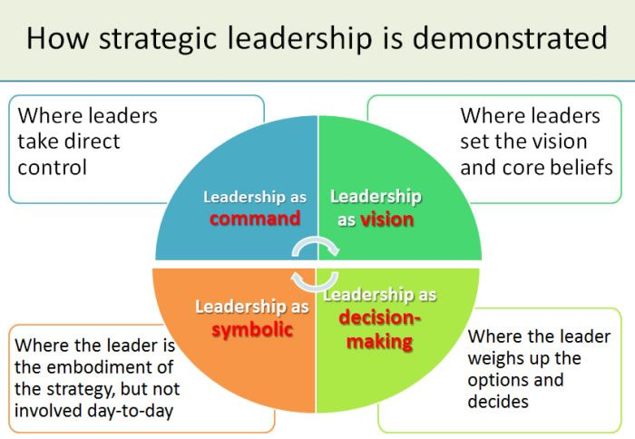
Figure 1. Strategic Leadership. Source: Managementguru
Other Factors for Organization Vision
Rahman et al (2018) suggested that as organizations undergo changes, different leadership styles may be used to better align with the situational hypothesis of leadership (Rahman et al 2018). Learning and experimenting with authority styles is required for initiative. Leaders have long seen pressure as a useful weapon in times of crisis. In this case, a transitory hypothesis applies. Marchionne has tried an authoritative and orderly manner at Fiat. The order style is based on McGregor's leadership model, and the serious and mandate style on quality. The company's pace-setter is Sergio Marchionne. At Fiat, he has focused on change management professionals rather than being directly engaged in transformation. Assuring that the company's goal is kept in focus is his proposal. By accumulating the consistent modifications, he has adopted revolutionary method. Regarding the present climate, Rahman, et al. He advocated for a leadership style that adapts to changing organizational needs. As seen in the accompanying graphic, it seems to support the situational leadership concept.
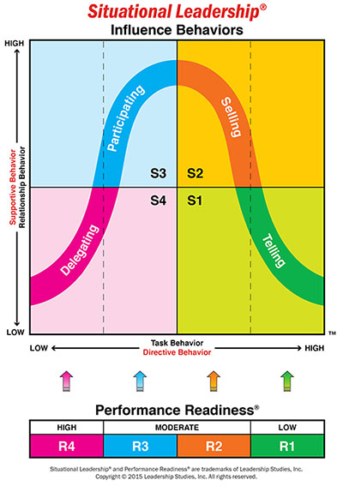
Figure 2. Situational Leadership. Source: situational.com
However, corporate entities establish goals and develop strategies to gain competitive advantage. According to Sun & Henderson (2017), a strong system is one that can provide long-term benefits to a firm. The investor hypothesis, on the other hand, has been attacked for its short-sightedness, i.e., maximizing investor profits. The advantages of outstanding and stable relationships with outside partners are mentioned by Ionescu & Bolca (2019). Thus, Prasad & Junni (2016) hypothesize about inner and outer partners' needs and aspirations. Regardless, there will likely be disparities in force and interest among the partners gathered. Thus, an administration hypothesis can't reveal or examine individual increase wants. True leadership progress requires balancing information exchange, action and contemplation, and balancing the individual's requirements with those of the corporate organization. Executives and initiative have been shown to function in a variety of settings, according to Burgoyne, Jaleha, and Machuki (2018). In reality, this means that gaining the support of executives and advancing initiatives involves developing specific techniques rather than adopting a generic model of best practice.
Thus, selecting a development strategy is not an easy task. Companies must carefully assess what they want to achieve and how best to achieve it. McGahan (2019) discusses a Japanese management development program for high-potential executives that involves taking them to a mountain retreat to learn the art of tea pouring and watching carp grow. This software, it is said, sought to influence, self-restraint, and restrict design recognition in ways that more conventional methods couldn't. When it comes to the success of a leadership model development intervention, one of the most critical components is an acknowledged premise of advancement that motivates alluring kinds of actions (Sun & Henderson, 2017). According to a number of studies, pace-setting management and transformative leadership are the future of 21st-century corporate executives

Ranking of the Leadership and Management Knowledge and Skills
- Strategic thinking skills
The capacity to dig deep and think imaginatively is maybe the most important talent a leader needs to stand out from a manager. This means having a vision for the organization's future and attempting to realize it. As a result, excellent communication skills are essential in the set of fundamentals of a successful leader. Superior strategic logic must be able to gather and evaluate facts from many sources. It is about understanding the organization's market and clients, not just quantity. Great strategic thinking requires the ability to gather and analyze data from a variety of sources. Furthermore, understanding your market and your customers is critical to making strategic decisions.
- Delivery and arranging skills
While being organized and convinced is important as a pioneer, having the opportunity to develop and provide them for the company is maybe even more significant. These underlying zones are strategic management sources and fundamental administrative competencies, and good leaders will use them to the advantage of the business and the workforce. A good vision is pointless unless it is implemented, and this distinguishing feature differentiates the leader from the manager (McClanahan, 2020). The ability to organize organizational operations chronologically and categorize preferences is essential to achieving the organization's goal.
- Individuals Management Skills
In this context, the leader will need to be able to work with others in a team atmosphere, as well as having the means and methods to cope with a wide range of situations that commonly emerge in the volatile and dynamic 21st century commercial world. He should also be able to prepare short-term scenarios and anticipate future events in the company. Administrators need a lot of these skills. Specifically, leaders must be able to inspire and encourage their subordinates both directly and indirectly. He must have a clearly rigorous set of recruiting standards backed up by his own analytical talents to evaluate the potential employee's effectiveness and validity to the firm.
- Change Management and Innovation Skills
Leadership is an important component of the actions necessary throughout an organizational shift. To navigate the company through change, a pioneer must understand the subtleties of change management. For example, a successful change management framework includes visioning and communication. It will also need that the management conform to the changes. As a result, strong leaders are able to grow themselves and motivate others to do the same thing.
- Communication abilities
Communication is important for everyone, but leaders and directors may need it more. However, good leaders will demonstrate excellent talents in these attributes. Terrific leaders have always been great listeners, inviting the speaker to participate in whatever he has to say after his speech (Walker, 2014). His marking abilities will also be accurate and decisive, allowing him to reach legitimate findings that can be understood by everybody. To lead effectively, leaders must understand how to provide people their opinions on topics and how to guide their thinking.

Leadership in Organizational Operations versus Strategy
It is possible to describe strategic leadership as the application of a method to the supervision of a group of people. It's the power to sway employees and bring about alterations at the corporate level. It is the responsibility of strategic leaders to build strong organizational structures, implement efficient resource distribution, and display a clear strategic vision (Mayfield et al., 2015). For strategic organizations, the primary goal has always been to obtain strategic advantage. Effective leaders allow representatives in a company organization to act on their own ideas. Strategic leaders use a reward and motivator framework to motivate profitable and high-quality employees to perform better for their company (Mayfield et al., 2015). Practical strategic initiative entails inventiveness, judgment, and the intent to assist a person in comprehending his or her ambitions and objectives. A key project necessitates the ability to forecast and comprehend the workplace. Looking at the bigger view requires objectivity and possibility.

Task 2
Audit of Personal Management and Leadership Skills
Close examination of leadership theories, such as situational leadership theory, has proven useful in establishing a good notion of identifying employee behaviors before making any sort of choice. It has helped me realize that I need to strengthen my leadership skills so that I can better understand the cultural views of the employees and so treat them appropriately. The examination of the leadership trait theory has been beneficial in increasing my knowledge of the many qualities that a leader must possess. Developing my critical thinking abilities will allow me to better manage the organization of my leadership talents in the workplace. The audit of personal leadership skills has highlighted the many cultural traits that must be incorporated in the course of executing an outstanding working experience as an efficient leader. There were several insights gained from conducting an audit, such as discovering that external and internal work hurdles would be inspected in an effort to improve team competency. I was able to see that I would need to improve on my persuasion abilities and so strengthen my interpersonal skills inside the working sphere. In order to help the business achieve its goals, I need to improve my management and leadership skills in five key areas: negotiation, issue solving, analytical development, knowledge management development, and leadership development.

Objectives of Personal Development
The following are the objectives I've set for myself in light of the development of these criteria in the context of strategic organizational needs:
- Decision-making - To successfully manage scenarios that will need strategic thinking and on which a key objective of the business rests.
- Prioritizing - In today's business, everyone has a job to do, and a good leader will have an intuitive sense of how to assign value to each activity based on its importance.
- Communication - I've realized that the value of effective communication extends beyond just influencing the workforce.
- Leadership - I believe in the potential of transformative leadership and have set out to acquire the necessary abilities.

Personal Development Plan
The key precept of an effective organizational leader is the increase of the ability to induce and support team members. These attributes will assist me in meeting the organization's goals with precision and on schedule. If I am a good leader, I will be able to utilize this to fulfill the organizational goals and objectives. The development of these talents would aid in the advancement of the team and the attainment of annual objectives. I'm aware that effective management and leadership need collaboration and open lines of communication. These abilities are important to me because of their ability to inspire teamwork and self-confidence improvement. These abilities will assist me to build my leadership skills, which will allow me to work in accordance with the organization's established criteria in order to realize the entity's goal.

Justifying Objectives and Plan for Personal Development
Communication, decision-making, effective leadership, and the ability to prioritize activities were all part of my personal growth strategy. The goals and personal development plan that I have recommended in the preceding two sections are critical to the attainment of the corporate vision because they may provide teamwork, flexibility and analytical activity. In order to fulfill the organization's objective and its goals, a leader has to have a wide range of talents, including teamwork, flexibility, and analytical abilities. These are just a few of the many aspects of leadership that are needed of a leader who wants to succeed in his or her role.

Personal Development Activity
I've chosen to enlist the assistance of the community in order to further improve the talents and knowledge that were recognized throughout the personal development audit process. The business community will be the most effective in keeping me updated on my progress and bolstering my belief systems regarding the criteria I've listed. Participating in the following activities may help you achieve this through public forums, focus group discussions, internships, meeting different leaders and books.

Task 3 – Developing and Communicating Organizational Vision
Factors which Impact the Creation of Organizational Vision
The intellectual and conceptual depiction of a commercial organization is referred to as vision. An entity's long-term aim is represented as a mental construct and cognitive representation by the entity. The organization's vision inspires control and serves as the guiding force for intellectual growth and mental depiction or model. The following factors have an influence on a corporate entity's vision:
- Ideology - The inherent ideology of every organization shapes its personality, suggesting that a firm conviction in the appropriate course of action is a critical source and component of building an organization's vision. The sufficiency and clarity of the vision are dependent on the philosophy that the organization promotes.
- Core Values and Purpose - Engaging, adjusting, and building a normal and shared working environment culture increases the commitment of any firm. They increase the efficacy and efficiency of the corporate entity. The purpose serves as the foundation for vision development, while the core values define the organization's daily behavior and belief structure.
- Leadership - The presence of business executives in these companies is a common thread that connects all top firms with outstanding vision. The organizational philosophy provides moral authority and strength to the leadership. It is the leaders' responsibility to forecast the proper path and status of the firm through time, and they develop the organizational vision based on an evaluation of the two.
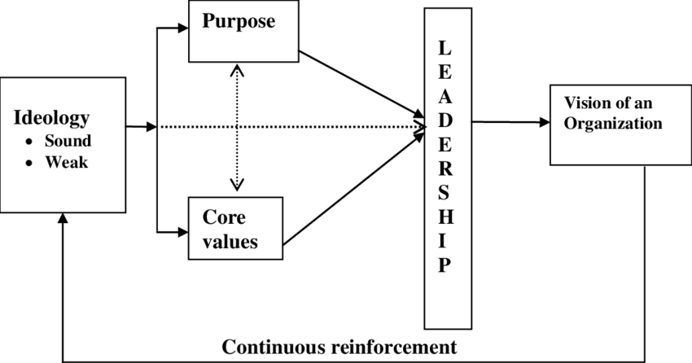
Figure 3. Factors Impacting Organizational Vision

Different Approaches to Developing Vision
A vision must be focused on the future and constitute a real basis for the organization's behavior. The company's mission may change over time, but the organization's vision stays steadfast no matter what happens in the world around it. Although it is intended for the future, a living, breathing vision will always give an organization with a clear organizational image that is built for the here and now. The vision must be able to convey a sense of integrating work and life in order to achieve real and identifiable goals. The organizational vision must enhance a wide range of performance indicators in order to drive change and assist strategic goals. It should encourage employees and spark talent recruiting.

Communication to External Stakeholders
At all times, organizations strive to keep their external stakeholders inspired and upbeat. This is especially true for startups. Consequently, in this respect, communication of the corporate vision becomes critical for achieving success for the company, and it should be done on a frequent basis.

Internal Stakeholders' Commitment
An internal stakeholder is a person who works for the company and has a direct interest in its success. In other words, these people are in charge of really running the firm. In order to achieve the goal that the business has set for itself, it will be necessary to manage them and secure their long-term commitment. A supportive operational environment may be created via stakeholder management by laying the groundwork and developing frameworks. When it comes to major initiatives, stakeholder management is essential. When new employees are brought on board, it's critical for businesses to begin gaining their cooperation, engagement, and commitment right away. In order to get internal stakeholders on board with the organization's vision, it's essential to have good relationships with them, define clear responsibilities, spell out the procedures, include them in the training process, and make reports and schedules readily accessible to them.

Task 4
Benefits of Organizational Review
In order to improve an organization, information must be shared, interpreted, assessed, organized, and collected. The goal is to enhance the company's success by gaining new knowledge and understanding about the firm itself. An evaluation of an organization is necessary for three basic reasons such as strategic, foundation and improvement.
- The capacity to make judgments that are beneficial to long-term goals is improved.
- Perception of critical functions and evaluation of individual responsibilities are made easier with the help of this tool.
- Understand the internal structure of the company and identify the ideal and appropriate responsibilities of the internal stakeholders. Prioritize them based on the current scenario.
- Increased productivity and efficiency in the company model.
- Allows a framework for imagining future company plans.
- Precision in team responsibilities and duties, as well as possibilities for professional advancement
- Employees are happier because they know exactly what is expected of them, which leads to higher morale.
Sources of Information to Review Personal Development Plans
Prioritizing, communication, decision making, and leadership were four of my personal development requirements that I had listed in a previous portion of my incumbent report. Since my professional success depends on it, I must conduct an analysis of the information sources I'll need to consult in order to analyze my personal development objectives. It's a good idea to be familiar with the many resources for learning and growth which can be obtained through:
- Manager
- The organization
- Secondary sources
- Social interaction
- Company regulations and procedures
- Experience
- Miscellaneous sources

Task 5 – Progress Review
Following the establishment of a personal development plan, I will be required to evaluate my performance on a regular basis in relation to the stages and requirements outlined in the agenda for the year. Following are the reviewing measures that I want to include as part of my growth program, which I have determined to be the most effective:
- Make use of an online tool or a template to keep track of the events as they unfold in accordance with the plan that has been laid out.
- Maintain open lines of communication with my superiors and managers to get their feedback on where I am doing wrong or where I need to improve.
- Discover the development needs inside the organization and make an effort to include them into the development strategy.
- Incorporating the finer details of the refresher and training programs into the overall strategy is essential.
- Regular review dates should be established in order to ensure that everything is checked and taken care of as soon as possible.
The examination of the progress using the appropriate evidences has been examined effectively. I'd want to focus on events in which I was in a severe scenario. There had been a major argument among the members of the gang, and the situation was deteriorating. It provided me with several opportunity to assess my problem-solving abilities. I took the effort to learn about the fight's core problems. A miscommunication between two groups of people was found to be the root cause of the issue. One-on-one meetings were set up for both sides to present their side of the story in front of me. The discussion was beneficial in decreasing misunderstanding and allowing team members to tackle their difficulties. This demonstrates that my problem-solving abilities are increasing as a result of my recognized and designed strategy.
The personal development plan has helped to improve leadership abilities. I also want to emphasize evidence when I get a complaint regarding employee wrongdoing. I used my analytical skills to look into the issues. It was difficult for me to assess that the workers were experiencing difficulties as a result of different cultural influences. The early identification of the problems demonstrates that I am strengthening my knowledge management and observational abilities. As a result, the reflection of the success of personal growth has been effective with the display of data. However, evidence was assessed when I was having difficulty finishing a task on time. My leadership ability has been successful despite the delay. I took advantage of the work break to seed structures, ensuring that the task division was done as soon as possible. Because of this, I was able to complete the project on time, boosting my ability to focus on each individual component. This was a great example of how my time management abilities have improved. Over time, I will improve my leadership abilities with the assistance of the planned personal development plan.

References
Rahman, N., Othman, M., Rahman, M., Yaakob, S., Masri, A., Ramli, R., & Ibrahim, S. (2018). Impact Of Strategic Leadership on Organizational Performance, Strategic Orientation and Operational Strategy Management Science Letters.
McGahan, A. (2019). My Presidency of the Academy of Management: Moral Responsibility, leadership, Governance, Organizational Change, And Strategy. Journal Of Management Inquiry.
Walker, R. (2014). Strategic management communication for leaders Nelson Education.
McClanahan, K.J. (2020). Viva la evolution: Using dual-strategies theory to explain leadership in modern organizations. The Leadership Quarterly.
Mayfield, J., Mayfield, M. & Sharbrough III, W.C. (2015). Strategic vision and values in top leaders’ communications: Motivating language at a higher level. International Journal of Business Communication.

