Financial Analysis with Microsoft Excel
Over the past few weeks, I have learned important analysis skills and technique from the Financial Analysis with Microsoft Excel course. As the curtains fall in a weeks’ time for my course, I feel more knowledgeable and skilled in Excel as a financial analysis tool. From the chapters that we managed to cover, I have enjoyed a great deal of learning right from introduction to the complex models I had no idea of previously.
From the course, I have learned a wide range of skills critical in aiding decision-making as a process in the business world. I was particularly impressed with what chapter four had to offer on cash budgeting, enabling me to learn essential skills and financial models that depict the health situation of balance books. In chapter 4, I find the Ending Balance calculation fascinates and presents ingenuity in solving the issue of borrowing. The amount to be borrowed is determined using the Excel build-in What-if-analysis checks through the model by running arguments in logic nature on selected cells. Managers are better placed when such analysis are assisting in decision making.
I seem to have embraced financial models that try to answer uncertainties, especially on cash flows. In Chapter 13, which also is about cash budgeting and risk, the Sensitivity Analysis is a marvel of a cash flow model. What I like most about the model is the ability to test several variables and run those tests in hundreds of iterations to give a picture of possible outcomes. The model also serves better to give the Net Present Value (NPV) when different variables assume certain values. In this report, I will present two models that make use of some interesting excel features.
Financial models usually involve more than one functions to express outcomes. Cash flow and Capital budgeting models are important and present a good measuring point of the company’s business health. Both the models can be used by investors in making informed decisions.
Cash Budgeting
Cash budgeting is an ingenuity model that enables management and investors to weigh options on whether to make an investment. Cash budgeting is essential because it primarily enables to company to manage cash flows efficiently and with prudence. That said, a company with better liquidity ratio is deemed better placed to pay its short-term debts with ease than a company facing cash crunch.
How to go about with Cash Budgeting
The most important thing is to understand that budgeting for cash flow is more of forecasting than real. The worksheet area for cash budgets is designed to accommodate both the collections (funds from sales) and the payments section (funds moving out to settle needs). However, as for our case, the model carries many assumptions with it, including that of sales will be made in cash and not credit. The difference between the totals for both collections and payments makes the ending cash balance.
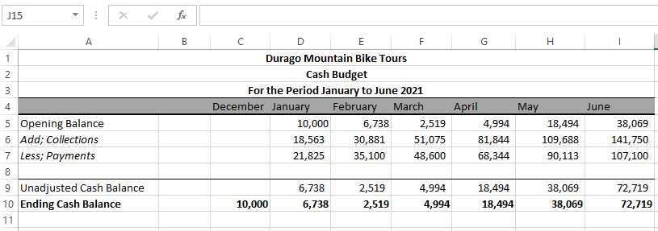
The models further can be used to determine the ending balance when a condition is placed under it. In the above caption, the ending balance is not conditioned to a specific outcome, explaining why the balances are uneven. We can add a condition that the ending balance should never be lower than 12000. That way, we will have to borrow more to meet that demand, but only when the actual balance is under the set limit. The caption below shows the new ending balances after inserting the condition. The amount to be borrowed is also indicated where the unadjusted cash balance falls below the limit. The What-If-Analysis method is highly used in the model to forecast borrowing. Here is the formula; IF (LOGICAL_TEST, VALUE_IF_TRUE, VALUE_IF_FALSE)
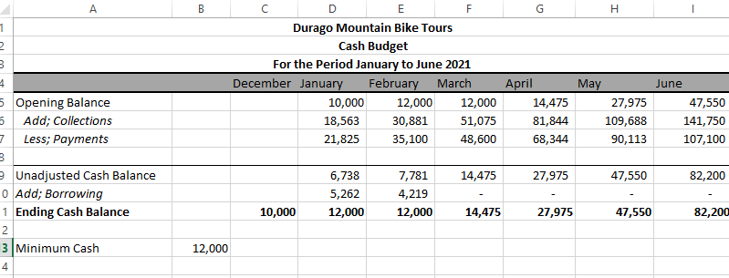
We can further narrow down our demands to compel to company to invest any excess of the cash above 12000. That way, we have to adjust the formula to enable the function to consider investing all funds above our limit. This also helps the company to avoid staying with idle cash that could be injected elsewhere for profit generating purposes.
The illustration below shows the ending balances with any excessive funds above 12000 going to repay the borrowed amount. We can see that inside the amount borrowed in January and February was projected to be paid off inside the month of March and April. This is the part where the MIN function is introduced to the logic statements. A business model that is able to pay off short-terms debts and maintain a set limit of cash balance is deemed healthy for investment.

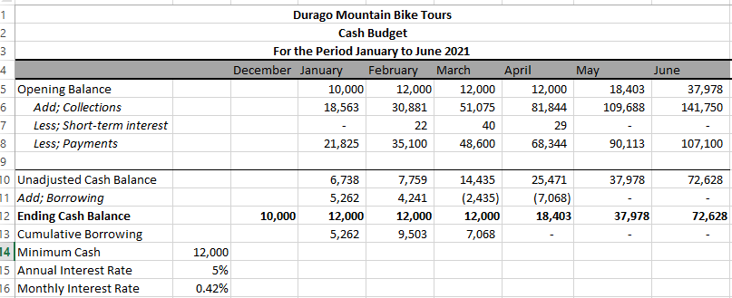

Risk Analysis
Risk analysis is a strong financial checkpoint that enables financial analysts to make predict outcomes on possible investments to make an informed decision. Risk is calculated within capital budgeting to assess viability of the project. This type of financial model is ideal because it helps management and investors have a futuristic view of what the outcomes might have been if a certain investment decision is made. The threshold in this model is the NPV which gives way for analysts to measure Internal Rate of Return (IRR) and also the MIRR. A better IRR and MIRR is the one higher than the stated WACC.
To start off the process of checking the risk in capital budgeting, it is ideal to itemize all variables and calculate any missing key points. The use the MACRS depreciation serves the purposes of compliance with the IRS requirements for taxes. For my example, we have information that is adequate to carry out our cash flows calculations and the NPV, IRR, and MIRR.
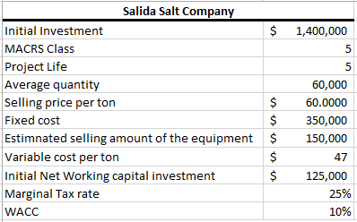
Using the above information, we can fill out our cash statements for the 5 years period. Again, we can use the cash flows to perform other calculations on NPV, IRR, and MIRR.
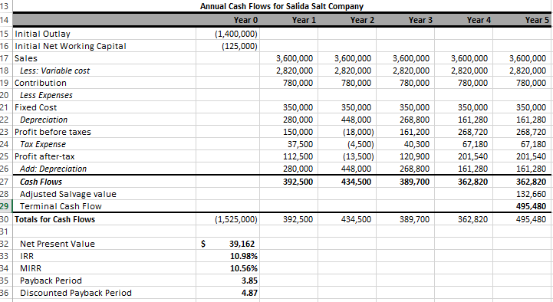
From the above excel sheet, there is a more information we can learn from the model. First, the results obtained here show the IRR and MIRR and well above the WACC. This means that the project is able to pay off its initial cost and exceed by a few points. Furthermore, we can see the payback period and discounted payback period remained below the project expected life, meaning the investment will pay off its cost on capital inside the projected life period. The above statements makes the project safe for investment.
Lastly, as learned in a number of chapters, we can play around with the variables to see what happens with other variables. In chapter 13, the Monte Carlo simulation is such a tool that randomizes the three factor variables to predict different outcomes. Upon running 1000 iterations using our data above, the results indicates a 25.86% chance of the NPV going under zero. Although the percentage seems quite high, that doesn’t make the project less viable.
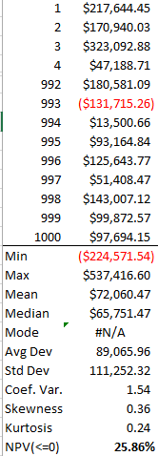

Conclusion
Financial models are useful when making investment decisions. The above two models have been set up to showcase how cash flows and budgeting can be managed. Making an investment carries a certain level of risk that when not determined, it could outweigh the weighted average cost of capital WACC. Cash flow statements help investors determine the liquidity levels of company before making an investment. For managers, this model is adequate to tell many aspects of financial health of the company. Risk analysis on capital budgeting helps the invest make shrewd decisions as directed by the rates of IRR, MIRR and the chances of the NPV<=0. From the above model, we can see both our companies are in the right course to effectively manage cash and capital budgets.

