Project development plan

Student name
Institution
Course
Instructor
Date

Introduction
Project report is an important aspect of project management since it enables the project manager and the stakeholders to have a direction on how the project operates. It is essential for the project development plan to have estimations, artifacts and other essentials that enable it to have a viable structure. A project manager uses the plan to map out the deliverables and easily distribute tasks to other members of the project management team.
Project report progress is always represented in different ways. The project manager's role is to ensure that the project team is within the deliverable timeline, and it ensures that the process is realistic. Also, progress reports are crucial for the project team to ensure that the process is more realistic.
There should be other processes and management tools to ensure that the project goes well. A project plan outlines the necessary process to ensure that other natural processes enable its completion. Together with the project team, crucial deliverables are handled towards a more natural process.
Project communication tools are crucial since they help the project manager organize their thoughts towards more realistic communication handling. Certain tools like email, status reports, and standup meetings are crucial to help in communication—the clearer the communication, the better the process for the long-term estimation of the project deliverable.
There should be a reality show of progress to help discuss the project deliverables (Oppong et al., 2017). Other communication tools deemed effective include instant chat tools that help prompt communication with the project team regarding the progress and any further updates of the project.
Having a project timeline process is crucial since it makes it easier to look at how other project deliverables are more believable. It is important to showcase the importance of the project timeline since it determines the project's budget estimates and eventuality. Stakeholders might object to the idea of having a budget overestimated since it only makes the transparency issue invalid for the long term.
A project proposal plan also helps update the stakeholders on the progress of the project. There should be a realistic way to showcase the plans for the project and make them believable. Also, the artifact gives the project managers leverage with stakeholders on how best to handle any project processes for the long term.
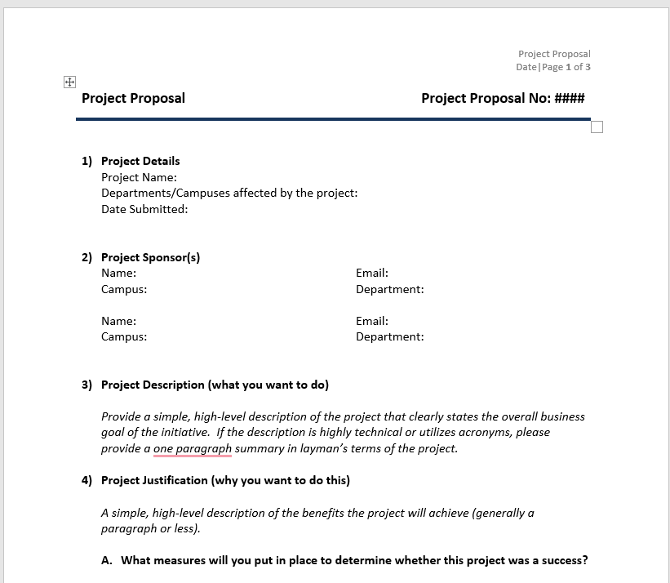
There should be revisions on the project report since it shows the proper ethical guidelines used to draft the project proposal plan. The project dynamics can change by considering the budgets and location of the project (Oppong et al., 2017). For instance, a project initiative helping the needy might have budget overestimates due to traveling and inflation in the economy due to purchases. The intentional process is also crucial since it shows that other progressive things only occur when the process is handled.
There should be practical ethical guidelines in project reporting to ensure that information is divulged appropriately. For instance, the project budget and other crucial information should be reported promptly to ensure no second-guessing of the project process. There should also be a realistic way to showcase how well the process helps drive the project.
Project data usually collected is crucial for the long-term outcome of the project deliverables. The data collected usually should be in the form of figures or text, and it makes it crucial to have structures. For instance, having interviews, data collection software, and artificial intelligence helps to integrate a full system in data analysis (Schzensy, 2014). Analyzing project data also helps to showcase the preventative process. A long-term program shows how well the project data helps determine the timeline and outcome of the data.
Project management artifacts

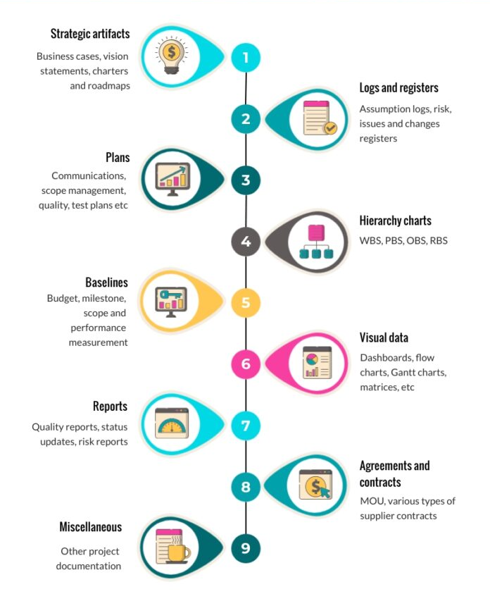
The project management artifacts can also showcase the strategy required to complete the project. For instance, having the right project information, timeline, charts and project team helps them complete the project. There should also be realistic plans to help in the long-term process of handling the long-term progress reports of the projects.

References
Oppong, G. D., Chan, A. P. C., & Dansoh, A. (2017). A review of stakeholder management performance attributes in Construction Projects. International Journal of Project Management, 35(6), 1037–1051. https://doi.org/10.1016/j.ijproman.2017.04.015
Schzensy, M. (2014). Project plan development. Project Management Theory and Practice, 142–149. https://doi.org/10.1201/b17589-15

