Student’s Name
Institutional Affiliation
Course Name and Code
Instructor’s Name
Date

Q.1 Explain the fundamental objectives of the Network Security.
Answer:
Network security refers to the process of safeguarding the network's infrastructure from illegal access. Through the use of software and hardware technologies, a set of rules and configurations is designed to safeguard the integrity, confidentiality, and accessibility of computer networks (Marin, 2005). Network security attempts to accomplish several key objectives. Confidentiality, Integrity, and Availability are the fundamental objectives of network security. Confidentiality is intended to ensure that only authorized individuals and computer systems have access to and view confidential information and data on a network. Integrity, as a network security objective, attempts to ensure the accuracy and reliability of data on the network. As a core goal, availability ensures that data and network resources are always accessible to authorized users when they need them.
Q.2 What do you mean by Message integrity. How to check the integrity of a message?
Answer:
It is vital to understand message integrity when it comes to the security of communications through networks and computer systems. Message integrity verifies the validity of the message being transmitted. This means that message integrity assures that the message is not altered or tampered with during transmission. The concept of message integrity extends further to ensure that no data is modified during transit. Typically, the hashing algorithm implements the concept of message integrity (Nielson & Monson, 2019).
After grasping the concept of message integrity, it is critical to understand how a message's integrity is checked and validated. Message Authentication Codes (MACs) and hash functions are two methods for checking and authenticating a message while it is in transit. When an application program sends a message, it generates an authentication code using Message Authentication Codes. The message's MAC header contains an encrypted checksum that is created and sent along with it. This verifies that the message is genuine and unaltered during transmission (Smart, 2016). On the other hand, hash functions generate a hash-based code that combines both a hash function and a cryptographic key for authenticating the message. Both the server and client are issued with a hashed private key. The mechanisms described above, Message Authentication Codes and hash functions, are used to check and validate a message's integrity.
Q.3 What is digital signature, explain in detail? What kind security aspect covered by digital signature?
Answer:
Digital signatures are a type of authentication technique that utilizes mathematical schemes to verify the authenticity of digital messages. When a digital signature is utilized, the recipient has a strong conviction in the message's integrity. In most circumstances, a digital signature makes use of the Public Key Infrastructure (PKI) to ensure the message's security and acceptability. Additionally, a digital signature utilizes encryption-decryption technology to secure the data being transmitted. Through the use of digital signatures, asymmetric cryptography is used to provide a layer of validation and security to messages exchanged via unsecured networks (Nia, Sajedi, & Jamshidpey, 2011).
Digital signatures cover various security aspects. The first aspect is data protection and privacy. There are various sensitive data and information transmitted through insecure networks. Employing digital signatures ensures that data is protected from malicious access and alteration and does not violate the intended privacy. The other aspect of network security covered by digital signatures is the prevention of network intruders. Digital signatures are applied to authenticate the legitimacy of the person sending a message via a network by ensuring that the private key has not been compromised.
Q.4 Give an overview of the biometric systems using suitable block diagram.
Answer:
Individuals can be recognized automatically using biometric systems. Individuals are recognized based on both their biological traits and their behavior. The block diagram in Figure 1 (National Research Council, 2010) illustrates how a biometric system works. The biometric system serves two fundamental functions: it captures and stores biometric samples. Additionally, it collects fresh biometric samples and compares them to those already recorded in the reference database, a process called matching. The components of the biometric system block diagram are the capture, which is where the biometric system collects samples via the sensor, the reference database, which stores previously collected samples, the matcher, which compares the new samples to the stored ones, and the action, which makes a recognition decision.
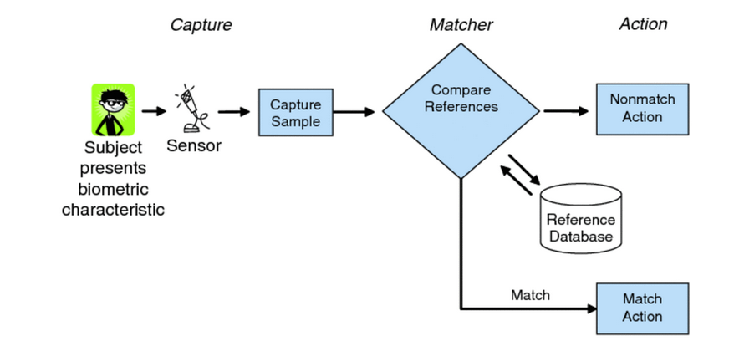
Figure 1: Block Diagram of a Biometric System

References
Marin, G. (2005). Network Security Basics. IEEE Security & Privacy, 3(6). doi:https://doi.org/10.1109/MSP.2005.153
National Research Council. (2010). Summary. In N. R. Council, L. I. Millett, & J. N. Pato (Eds.), Biometric Recognition: Challenges and Opportunities. Washington DC: National Academies Press. doi:10.17226/12720
Nia, M. A., Sajedi, A., & Jamshidpey, A. (2011). An Introduction to Digital Signature Schemes. Cryptography and Security.
Nielson, S. J., & Monson, C. K. (2019). Message Integrity, Signatures, and Certificates. Practical Cryptography in Python, 165-212. doi:https://doi.org/10.1007/978-1-4842-4900-0_5
Smart, N. P. (2016). Hash Functions, Message Authentication Codes, and Key Derivation Functions. In N. P. Smart, Cryptography Made Simple (pp. 271-294). Springer.

