To: Manager
From:
Date: August 10, 2021
Subject: Portugal Research
Below is some information that is useful in the evaluation and also helps the company in making decisions. My task was to gather information about Portugal.
Portugal Facts
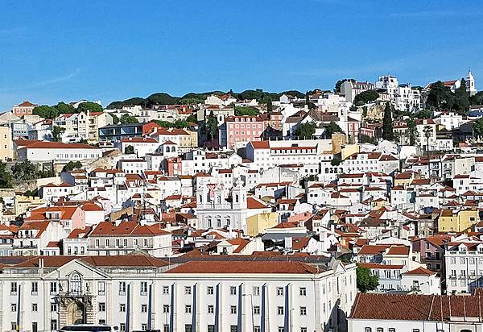
View of Lisbon, Portugal’s largest city and capital, which often goes by the moniker of the “White City.”
Portugal is located in Southern Europe, bordering the North Atlantic Ocean, west of Spain. It has coastlines of approximately 1793km. The climate in Portugal is favorable, cool, rainy in the north, warmer, and drier in the south. Portugal's natural resources are fish, forests, zinc, tin, tungsten, gold, uranium, hydropower, and many more. By 2018, Portugal's land use was as follows 39.7% agricultural land, 37.8% forest, and 22.5% other. Portugal’s population by now is approximately 10,263,850 with its nationality being Portuguese. The most popular religion in Portugal is Roman Catholic with 81%. Many of the people living in Portugal are mainly aged between 25-54 years having 41.49% followed by 65 years and above having 20.92% by 2020. Portugal has continually shown a steady growth rate in GDP and its comparison to the world being 126. The inflation rate by 2019 was 0.3% from 1.3% by 2017. Overall, Portugal has a 76.5 score in ease of doing business. Portugal mainly exports cars and vehicle parts, refined petroleum, leather footwear, paper products, and tires. The main export partners are Spain 23%, France 13%, Germany12%, the United Kingdom 6%, and the United States 5% (2019). (The World Factbook, n.d.)
International Trade Administration Commercial Guide – Portugal
Portugal offers American exporters a market of approximately a 10.3million people. The borders of Portugal and ports are always open for the free flow of trade to the EU members’ countries. Political stability in Portugal also assists foreign businesses and investment. Some of the top exporting U.S. states are Texas, Pennsylvania, California, Florida, Louisiana, Kansas, and Ohio. Outside of the EU, the U.S. states are the largest trading partner. (International Trade Administration, 2020)
Websites of U.S. Embassies, Consulates, and Diplomatic Missions
U.S. Embassy Lisbon
Avenida das Forças Armadas
1600-081 Lisboa
Phone: 351-21-727-3300
Fax: 351-21-726-9109

U.S. Consulate Ponta Delgada Azores
Avenida Príncipe do Mónaco, 6-2 F
9500 Ponta Delgada
Phone: 351 296 308 330
Individuals that work with the US Commercial Services
Name: | Ana Vila, Commercial Specialist
 | Phone: | 351-21/770-2532
 | Fax: | 351-21/726-8914
 | Email: | Ana.Vila@trade.gov
 | Post: | Lisbon
 | Industries: | Advanced Ceramics, Agricultural Chemicals, Agricultural Machinery & Eq., Agricultural Services, Apparel, Artwork, Audio/Visual Eq., Automobile/Light Truck/Vans, Automotive Parts/Services Eq., Books/Periodicals, Business Eq. (Non-Computer), Commercial Fishing Eq., Commercial Vessel/Eq. (Non-Fisheries), Consumer Electronics, Cosmetics/Toiletries, Education/Training Services, Films/Videos, Food Processing/Packaging Eq., Foods - Processed, General Consumer Goods, Giftware, Hotel/Restaurant Eq., Household Consumer Goods, Jewelry, Lawn/Garden Eq., Leather/Fur Products, Marine Fisheries Products (Seafood), Musical Instruments, Packaging Eq., Pet Foods/Supp., Pleasure Boats/Accessories, Printing/Graphic Arts Eq., Pulp/Paper Machinery, Sporting Goods/Recreational Eq., Textile Fabrics, Textile Machinery/Eq., Textile Products - Made-Up, Toys/Games, Travel and Tourism Industries, Yarns

References
International Trade Adiministration. (2020, 11 10). International Trade Adiministration. Retrieved from Portugal - Country Commercial Guide: https://www.trade.gov/knowledge-product/portugal-market-overview
The World Factbook. (n.d.). The World Factbook. Retrieved from Portugal: https://www.cia.gov/the-world-factbook/countries/portugal/
Official list of embassies from the U.S. Department of State. (2021). Retrieved 11 August 2021, from https://www.usembassy.gov/#results

