Question 1
- Permanent rise in productivity growth rate g:
In economics, for any positive level of k, there exist a unique level so that c=(𝑘̇)– (𝑔+𝑛+𝛿) 𝑘̇, (𝑘̇ =0). Therefore, any increase in g would make the level of c to decline since the break-even investment, (𝑔+𝑛+𝛿) 𝑘̇ is higher. he 𝒌 =𝟎 curve will shift down as we decrease consumption in order to
save more to maintain current level of capital stock per effective labor. As the graph shows, (𝑔+𝑛+𝛿) 𝑘̇ rises more when k is higher, thereby the 𝑘̇ =0 curve shifts down more at higher level of k.
For ċ=0, we have 𝑓’(𝑘̇)−𝛿 = 𝜌+ 𝜃𝑔. If g increases, 𝑓’(𝑘̇) must be higher to satisfy the condition
ċ=0. From lecture 3, 𝑓′′(𝑘̇) is negative. We could infer that the level of k will falls. That is, the ċ=0line shift level
After g change, the level of consumption per effective labor, c, can react immediately. However, the
stock of capital per effective labor, k, cannot change immediately to reach 𝒌_{𝒏𝒆𝒘}∗ . For the economy to
reach the new steady state 𝑬_{𝒏𝒆𝒘}, where both c* and k* are lower, it has to go through the saddle path.
Whether the saddle path cross the original equilibrium is unclear, so the instant change of c is unclear.
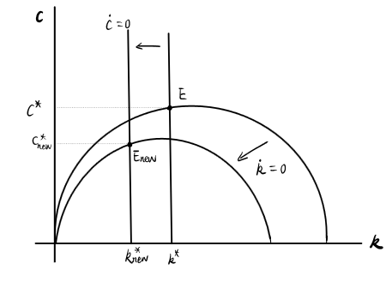

- Rise in the preference for today’s consumption θ:
It is worth noting that θ determines HH’s to shift consumption between different times. Any increase in θ implies that the consumption utility’s decrease more quickly. Therefore, the HH is less willing to enable consumption’s variation over a period of time.
In addition, for or ċ=0, we have 𝑓’(𝑘̇)−𝛿 = 𝜌+ 𝜃𝑔. 𝑓’(𝑘̇) is now higher and 𝑓′′(𝑘̇)<0, so the
value of 𝒌𝒏𝒆𝒘∗ is lower to maintain ċ=0. The ċ=𝟎 locus shifts to the left. Besides, θ does not affect the equation of capital evolution.

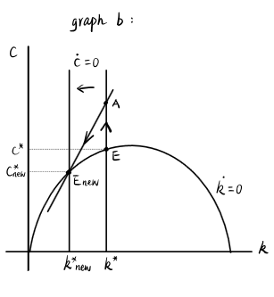

- Proportional Downward Shift of Production Function f(k)
Assuming that the proportion fxn shift downwards, the 𝑓(𝑘̇)𝑛𝑒𝑤 and 𝑓’(𝑘̇)𝑛𝑒𝑤 are both lower that initial for every provided value k (of graph c-1). Since we know that the shift is proportional, 𝑓(𝑘̇)𝑛𝑒𝑤 shifts down more at
higher k value. For 𝑘̇ =0, we have the equation: 𝑐 = 𝑓(𝑘̇)– (𝑔+𝑛+𝛿) 𝑘̇. The 𝒌 =𝟎 locus will shift down. Therefore, for ċ=0, we have 𝑓’(𝑘̇)−𝛿 = 𝜌+ 𝜃𝑔. For each given k, 𝑓’(𝑘̇)𝑛𝑒𝑤 is lower now, in order to satisfy ċ=0, k should be lower. Thereby, the ċ=𝟎 locus shifts left.
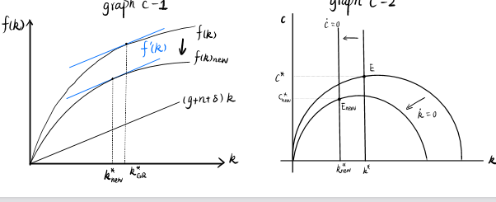

d) Decrease in the depreciation rate of capita δ.
A decrease in depreciation rate of capital δ leads to rise in capital stock and the level of output. in this case, k>0. And since the capital stock will increase, S<D, and there will be more generation of capital in the economy. C=0 is an autonomous consumption. When there is a decrease in depreciation rate of capital, more goods are brought to the market shifting c>0 since many people will be willing to buy. The change in capital is then balance between new investment and depreciation K ̇(t) = I(t) − δK(t) = sY(t) − δK(t)
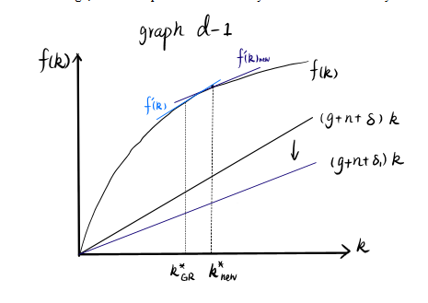
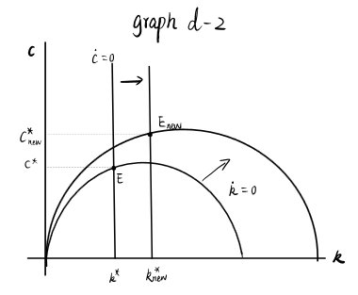

Question2
- HH’s Dynamic Optimization Problem
It is worth noting that the representative HH wishes to maximize the utility of its lifetime which is subjected to budget constraint, initial stock of asset 𝑎(0), limit of debt, ad non-negative consumption choice. Moreover, the HH has an obligatory to pay consumption tax. Therefore, maximizing the sum of the utility of lifetime, of all individuals in the economy, we can use the equation below:
Max= ∫(_{(ct+gt)}^{1- θ})/ (1- θ) e^{-(p-n}₎^{t}dt, from 0 to infinity
Also note that the HH’s budget constraint is given following equation:
d assets/dt=labor incom+capital income-consumption-consumption tax
=L(t)w(t)+L(t)r(t)a(t)-c(t)L(t)-tcc(t)L(t)
=a*(t)=d assets/dt.1/l(t)-assets.L*(t)/L(t)
=dassets/dt.1/L(t)-na
Therefor, toget the budget constraint per capita terms is:
a*(t)=w(t)+[r,t)-n]a(t)-(1+Tc)ct
Thus, the HH’S dynamic optimization problme is obained by:
max U=∫(ct+gt) ^{1- θ}e—^{(p-n)t}dt
a*(t)=w(t)+[r(t)-n] a(t)-(1+Tc) c(t)

- FOCs of the HH’s Optimization Problem
The relation that plays a significant role here is the present value Hamiltonian given by:
H=u[c(t).g(t)]e^{-(p-n)t}+u(t){w(t)+l*r(t)-n)a(t)-(1+Tc)c(t)
The FOCs are:
- Dh/Dc=0
- Dh/Da=-U
- The transversality condition=lim u(t)a(t)=0, t is tending to infinity
Now that we have u(t)=u’(ct+gt)^{e-(p-n)t}
=r(t)-n
- Euler Equation
(u’’ (ct.gt) (ct+g*t) e-(p-n)t)/1+Tc)-u”(ct.gt)(p-n)e^{-(p-n)t}
(u”(ct.gt).(ct*+g*t))/u’(ct,gt)=r(t)-p

Thus, the Euler equation= r(t)-p
- Government’s budget constraint, the government spending per capita, and ġ.
It is worth note that the total tax revenue for government is spent on its purchases, G.
In this case, the government budget constraint will be given as
T=Gt=Tc C(t)L(t)
Note hat in capita term as per the question, gt=tcC(t)
Thus;
g*=dg/dt=d(Tc
- Euler Equation in terms of of c, r, θ, and ρ and the effect of tax on the consumption choice
By employing assured CRRA utility fxn we have:
u(ct,gt)=(ct+g^{1- θ}
ct+gt=(1+Tc)ct
=(u’’(ct,gt).(ct+gt))/u’(ct,gt)
= u’’(ct,gt).(ct+gt))/u’(ct,gt)=0
Rearranging h equation we have:r(t)-p

Therefore, the Euler equation will be:
c*t/ct=1/𝜃[r(t)-p]
Remember that all the tax revenue is utilizes in government purchases which ultimately affects the utility. Also, worth noting that is that the purchases of the government substitutes for the private sector which is the consumption tax. Therefore, they shift the private consumptions the public economy. Hence, the consumption tax does not affect the consumption choice.
- Profit-maximizing Representative Firm and Competitive Market Equilibrium.
The first profit fxn = y-(r+ δ) k-wl
=Ak^{α}-y(r + δ)k-w
=dπ/dk=Aαk^{α-1}-(r+ δ)=0
irst order condition:
The rate of rentalis given by :
Thus, in equilibrium, the rate of interest (r) is equivalent to marginal product of capital less the depreciation. Also, labor should be enumerated its marginal product
w=dy/dl=df(k,l)/dl
=d(l.f(k))/dl
=f(k)+lf’(k)dk/dl
Therefore,
dk/dl=d(k/l)/dl=-k/l²
thus, w=f(k)-f’(k).k
Thus, wage is given as
w=Ak^{α}-Aαk^{α-1}k
=(1-α)Ak^{α}
Note that a(t)=k(t). Thus, the budget constraint is given as
which could be rewritten as:
a*(t)=w(t)+[r(t)-n]a(t)-(1+Tc)c(t)
k*=w(t)+[r(t)-n]a(t)-(1+Tc)c(t)
=(1- α)Ak ^{α}+A αk ^{α}-( δ+n)k+(1+Tc)c(t)

Therefore,
k*=Ak ^{α} –( δ+n)k-(1+Tc)c(t)
Thus, we do substitution from the Euler equation then we finally have:
c*/c=1/ θ[r(t)-p]
=1/ θ(A αk ^{α-1}- δ-p)
At this point of the competitive market, he conditions for equilibrium are:
k*=Ak^{α}-( δ+n)k-(1+Tc)c(t)
c*/c=1/ θ(A αk ^{α-1}- δ-p)
- Conditions for Steady-State Level of Capital and Consumption per Capita and the Base Diagram
The conditions for steady state is given as
k*=0
this imples that Ak^{α} =( δ+n)k+(1-Tc)c(t)
and
c*= Aαk^{α-1}
= δ+p
Based on the two equations above, a diagram can be drawn. In this case, it should be noted that:
- consumption is an increasing fxn of capital up to the point of the golden level of capital (KGR)
- At the same time, c*=0, f’(k) represent a constant. The fixed level of capital is represented by a vertical line
- The four Quadrats
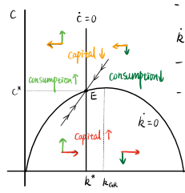k

- The values of k* for α =0.5, A=4, δ=0.4, and ρ=0.
c*=0 implyng Aαk^{α-1}= δ+p
4*0.5*k^-0.5=0.4+0.6
k*^-0.5=0.5
Thus, k*=4
In this case, the equilibrium level of capital stock per capital equals to 4 units.
- Note that the government has a balance budget given as
T=Gt=TcCtLt
Thus, any temporary increase in government purchases depicts an increase of consumption tax.
In this case Tc increases.
c*=f’(k)= δ+p and is independent of c
In other words, locus will never change and this implies that k* will remain unaltered
Therefore
k*=0, f(k)=( δ+n)k+(1+Tc)c(t) will automatically affected by Tc
What should be noted is that higher tax rate, and that in order to make a satisfaction k=0 condition while maintaining similar capital level, the consumption level should be lower. In other words, k=0 locus will shift downwards, do that C* _{new} is lower than the initial value.
