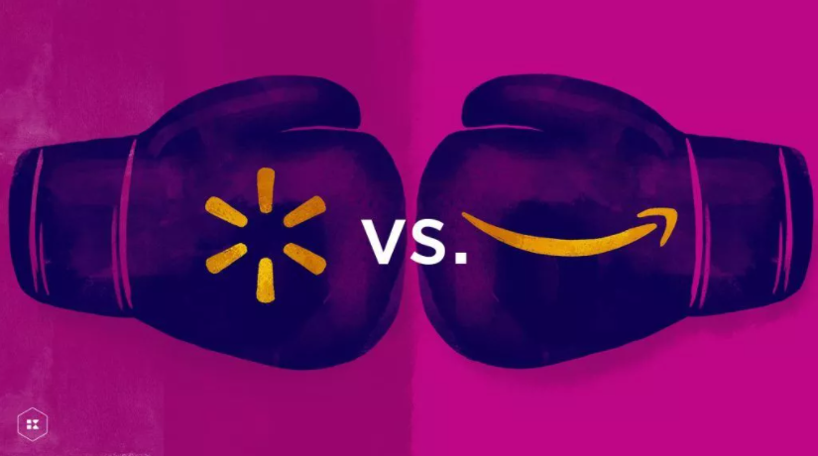

Abstract
The aim of this report is to define e-commerce and provide insight of its growth among companies in this century. The scope of this in-depth research will span on two largest players in e-commerce industry – Amazon and Walmart. With Amazon’s stranglehold on e-tailing market, Walmart is currently their biggest contender as a largest brick-and-mortar retailer. (eTail, n.d.). The researcher will investigate the competition and comparison in features and shopping aids between these two tycoons and distinguish the factors that helped them achieve their dominance in retail and e-commerce. Additionally, the researcher analysis will dive into disadvantages and factors that are preventing these companies from maximizing their full potential.

Table of Contents
Abstract 1
Introduction 4
Digital Business and E-commerce 5
E-commerce marketing 5
Amazon & Walmart - similar concepts and features 6

Table of Figures

Introduction
The technology has changed the ways of business operations in global marketplace. With the incremental increase in use of online systems, the businesses took advantage of finding new ways to build closer relationship with customers. Electronic commerce, or widely known as e-commerce, is a relatively new business and management area. E-commerce mainly involves all electronically mediated transactions between a business and any audience it deals with. The internet enabled customers from all over the world to reach different content using a search engine. In this report, the comparison between Amazon and Walmart will take place regarding their strategies and ways of operating. Although is Amazon knows as the most customer-centric company in the world with specialty in e-tailing, Walmart is the largest company by revenue generating 548.743$ billion according to Fortune Global 500 list, and their enormous amount of retail stores could contribute to their e-commerce success. (Wikipedia, 2021). Both companies are aware that e-commerce is the future of shopping, where in the next figure we can see that the demand for online shopping has seen a rise in recent years in the USA.
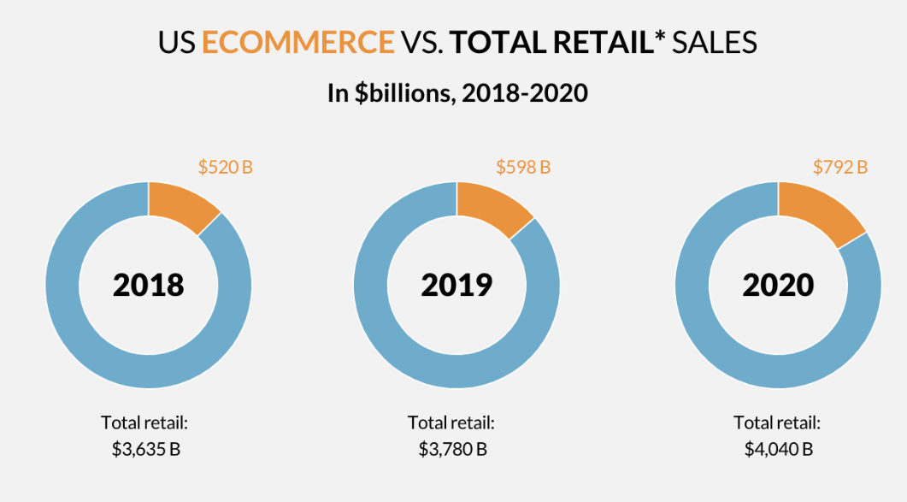
Figure 1: US ECOMMERCE VS TOTAL RETAIL SALES

Digital Business and E-commerce
Since the creation of the first online website, businesses decided to transition and transform their services and operations. Innovative digital technologies allowed businesses to capitalize on opportunities offered on online platforms. In order to succeed competitively and take on the risks in this new area, businesses had to evolve by innovation and digital communications approach (Chaffey, Hemphill and Edmundson-bird, 2018, p.6). The e-commerce would be considered as a narrower term within digital business, which is mainly referred to buying and selling. However, in reality e-commerce represents every electronically mediated transaction between two parties on different platforms including non-financial transactions such as customer service and support (Chaffey, Hemphill and Edmundson-bird, 2018, p.11). The online established business models have not only benefited from generated demand but also in cost-reduction and increased efficiency (Helpme, n.d). One of the most well-known and successful precursors in e-tailing is Amazon company.

E-commerce marketing
Unlike traditional marketing where the products and services are offered and advertised on platforms such as billboards and printed media (Bailey, 2019), the digital marketing allows the direct connection with customers on online platforms such as social media ads, email marketing and PPC advertising (Carmicheal, 2019). Customers are often the first who initiate the contact with online platforms seeking for information which led to the term called inbound marketing. The inbound marketing consists of search, content and social media marketing, which are utilized to generate demand from customers on national and international base. (Chaffey, Hemphill and Edmundson-bird, 2018, p.7).

Amazon & Walmart - similar concepts and features
Walmart is a supreme US brick-and-mortar corporation, that generated enormous wealth over the years from retailing, and it is now focused on digitalization to improve customer image and grow its sales. Amazon started as an online book e-tailer and throughout the time expanded their business, becoming complex supplier of almost anything. There are many similarities shared between these two brands in terms of operating, business, customer experience, products and other business strategies. Amazon now offers different services for grocery shopping, such as Amazon Fresh, Prime Pantry and Whole Foods with Amazon subscription. Basically, Amazon allows you to shop online and then pick up your groceries one hour after ordering for specific pickup fee. On the other hand, Walmart does not charge any pickup fees and there is no subscription needed. However, in the same instance as with Amazon, you must collect your own groceries (Rawes and Lacoma, 2020). In 2017, Walmart has launched Two Day Delivery to compete with Amazon’s 2 day shipping. After certain period, Walmart introduced one day delivery service. In 2020, Walmart decided to launch Walmart+ a subscription service similar to Amazon prime that offers many unique services and set of perks (kaspien, 2020). Figure 2 represents the features included in subscriptions.

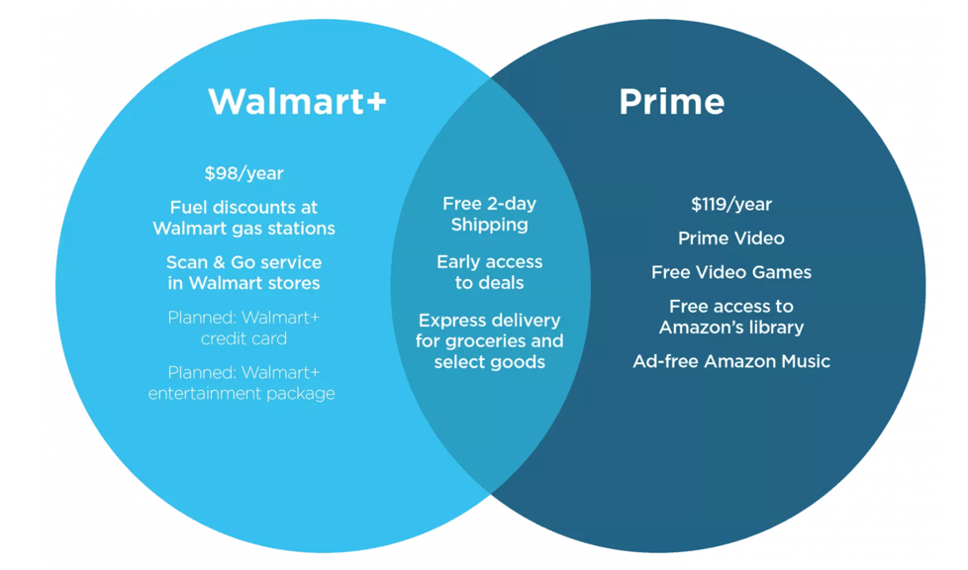
Figure 2: Walmart Plus vs Amazon Prime
Amazon and Walmart offer many incentives for their customers. For instance, Amazon offers coupons, and with Prime membership, there are discounts available. In case with Walmart, they provide things such as clearance items and rollback discounts, furthermore, the shipping is free even with subscription (Rawes and Lacoma, 2020). Both companies offer the benefits of online shopping. They both offer stuff for similar prices and products such as Electronics, Movies, Music, Sports, Beauty, Clothing and much more. (Lawaspect, n.d.)

Amazon Advantages, Shopping Aids and Disadvantages
Amazon.com, the company’s main website, is a recent solution replacing the traditional retailing business. The company incorporates an effective model of electronic commerce (e-commerce), which provides an extensive selection of book stores, computer devices, video games, furniture, and even clothing. Amazon has advantages and even disadvantages. Most importantly, the company has a firm brand name, technological familiarity, and expertise, including a long-term investment strategy. Amazon invests heavily in increasingly innovative technologies year in year out, and they connect to e-commerce, shopping aids, and even Artificial Intelligence (Carmicheal, 2021). The Amazon Corporation has a development and outstanding software department that its significant competitors can hardly and presently compete with them.
However, Amazon finds it relatively hard to expand its product line to market perishable commodities like food products. Such hinder the firm’s market chance since individuals prefer to purchase food items using traditional approaches. Highly valued things like jewelry are hard to deal with while using an e-commerce strategy. Due to security interests, individuals always feel scared paying for expensive or luxurious goods using the electronic technique. Although Amazon presents easy access to its services, processing products’ delivery such as books remains a problem. A client may be forced to wait for a week or more before delivering a physical product. Amazon also includes shopping aids as part of its services. The most commonly used shopping aid is Amazon Mom. The assistance is crucial because it allows students and parents to shop their items at relatively lower prices. The shopping aid is enabled through discounted student account, whereby parents can purchase commodities at reduced prices. Additionally, there is Amazon Prime that provides a prime feature, which provides one month free trial, allowing a free shopping advantage (Amazon vs. Walmart: The Battle for the eCommerce Crown, 2021).
Walmart Advantages, Shopping Aids and Disadvantages
Walmart is an international retail-based firm having several grocery stores, departmental stores, and hypermarkets that serve the existing customers. Remarkably, the company fetches a lot of revenue yearly as it serves its customers while providing products and services at the lowest prices possible. Many controversies about the firm exist, and many argue whether the retail organization influences society positively or negatively. It has various advantages and disadvantages. Firstly, Walmart offers clients the lowest and most affordable prices. Most commodities at the premises are always sold at reduced prices than that of other merchandising stores. Only a single trip to the company saves considerable individual funds compared to what they expend at other retail outlets. Secondly, shopping at Walmart means accessing a diversity of products at only one place or destination. Specifically, there is nothing that one can never find or access at Walmart since almost every commodity is present. The products range from electronics, clothes, groceries, and food to service or repair a car. Therefore, the multinational operates as a one-stop-shop (Ali & Young, 2021). A family can fulfill its weekly or monthly needs with only a single visit to any Walmart outlet. The third benefit entails massive employment chances. Alongside the merit of advancing the nation’s economy to higher heights, Walmart is an employer saving an individual from unemployment problems since it can employ skilled and unskilled labor.
However, despite its advantages, Walmart also presents drawbacks. Most importantly, there is inadequate healthcare coverage at Walmart, which is known to possess one of the worst health-related policies in the whole of the corporate domain. Instead of offering sufficient health-related coverage, the company’s workers are encouraged to have government-funded healthcare plans like the popular Medicaid services. Secondly, Walmart lacks relevant employee-related policies. It is typical among the citizens across the American continent that Walmart Corporation hardly respects its staff through engaging them appropriately, including proper treatment and a conducive working environment. For instance, the firm has been part of numerous class action lawsuits in different parts of the continent. The lawsuits incorporate both past and existing workers. Also, Walmart’s operations tend to harm the adjacent environment because it violates various environmental legislation put across, ending up paying for the ecological damage. Moreover, racism and employing illegal or illegible citizens have been observed on various occasions. For instance, the company made headlines in 2003 for hiring illegal individuals to perform menial tasks such as floor cleaning (Amazon vs. Walmart: The Battle for the eCommerce Crown, 2021). Walmart also has several shopping aids. Coupons, feedback, privacy, security, return policy, and gift cards are most used. All of them make it easier for consumers to shop at Walmart stores.
Amazon VS Walmart


Figure 3: Which is the best retailer?
Walmart and Amazon are the planet’s giant retailers experiencing minimal competition from others, especially the new companies in the industry. However, the question of who is on top overall remains. The two multinational firms set the bar for other stores in every aspect, including innovation, logistics, and even customer service. If Amazon and Walmart do it, all other small retailers follow. The two’s constant push for clients helps motivate other retailers to embrace a stronger customer focus. Walmart and Amazon always compete for a similar customer base. As two of the largest retailers around the planet, they also set the place for other online retailers. If the two companies engage in any activity, it is undoubtedly that other companies within the industry will follow their steps (Morgan, 2021).
Since 2020, Walmart’s total equity stands at $74.66 billion. For the financial year 2020, Walmart’s income rose 6.7% to reach $559 billion. Regarding 2021’s first quarter, which closed on May 1, the firm obtained$138.31 billion as its total revenue, a 6.2% rise compared to the previous quarter. On the other hand, as of 2020, $93.4 billion was Amazon’s total equity, although the estimations continue growing. Amazon achieved $108.5 billion in net sales in the first quarter of 2021. The estimations translated to a 43.8% rise. Financial progress is significant to any company. However, the progress implies nothing without a concentration on customers, particularly in the competitive e-commerce sector. Amazon is recognized for its customer-obsession culture. Its product approvals and personalization are unmatched, with about half of Amazon sales originating from recommendations. On the other hand, Walmart also acknowledges customer experience value and has made most of its current changes with customers in mind (Walmart vs. Amazon - Law Essays, 2021). Walmart’s new store design intends to get clients to the exact products they need as swiftly as possible. There is also improved stress on mobile and online shopping to satisfy customer needs.
Conclusion
From the data and information presented above and by reasoning from the world’s market perspective, it is clear that the winner might be Amazon. However, we might need to keep an eye on Walmart. With an improved customer focus and a well-recognized retail presence, Walmart might continue to witness fantastic progress. They all have exceptional merits and demerits, but one aspect for sure is that Amazon remains ahead of other competitors, including Walmart, who will need to put in more effort to attain Amazon’s level. They all provide exceptional features and shopping aids. However, in my view, Amazon, like its name (the most significant forest on the planet), remains the leading e-commerce firm in the world, and as Bezos claims, the best is yet to be witnessed.

References List
Book:
Chaffey, D., Edmundson-Bird, D. and Hemphill, T., 2019. Digital business and e-commerce management. Pearson UK.
Web Sources:
2021. Amazon vs Walmart: How Do They Compare? - Kaspien, Inc.. [online] Available at: <https://www.kaspien.com/blog/walmart-vs-amazon-how-do-they-compare/> [Accessed 8 December 2021].
Ali, F. and Young, J., 2021. US ecommerce grows 32.4% in 2020 | Digital Commerce 360. [online] Digital Commerce 360. Available at: <https://www.digitalcommerce360.com/article/us-ecommerce-sales/> [Accessed 8 December 2021].
En.wikipedia.org. 2021. Walmart - Wikipedia. [online] Available at: <https://en.wikipedia.org/wiki/Walmart> [Accessed 8 December 2021].
Carmicheal, K., 2021. Traditional Marketing vs. Digital Marketing: Why Not Both?. [online] Blog.hubspot.com. Available at: <https://blog.hubspot.com/marketing/traditional-marketing-vs-digital-marketing> [Accessed 8 December 2021].
eTail Boston 2022. 2021. Amazon vs Walmart: The Battle for the eCommerce Crown. [online] Available at: <https://etaileast.wbresearch.com/blog/walmart-not-surviving-but-thriving-strategy-ecommerce-war-against-amazon> [Accessed 8 December 2021].
LawAspect.com. 2021. Walmart vs Amazon - Law Essays. [online] Available at: <https://lawaspect.com/walmart-vs-amazon/> [Accessed 8 December 2021].
Morgan, B., 2021. Who Wins The Battle Of Walmart Vs. Amazon?. [online] Forbes. Available at: <https://www.forbes.com/sites/blakemorgan/2021/06/14/who-wins-the-battle-of-walmart-vs-amazon/?sh=2bba4d765ba7> [Accessed 8 December 2021].
Rawes, E. and Lacoma, T., 2020. Walmart vs. Amazon | Digital Trends. [online] Digital Trends. Available at: <https://www.digitaltrends.com/home/walmart-vs-amazon/> [Accessed 8 December 2021].

