Name
Professor
Course
Date
Virtual Trip to the Metropolitan Museum Assignment.
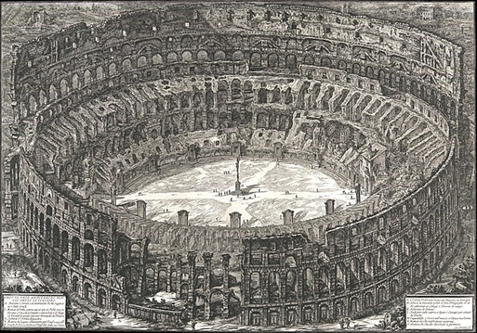
Figure 1: Name: Veduta dell’Anfiteatro Flavio deto il Colosseo, URL: https://www.metmuseum.org/art/collection/search/360270. The object is an etching on a 30*40 inches sheet made by Giovanni Battista Piranesi. Piranesi created this three-dimensional etching as an art presented from an aerial perspective of the Roman ruins. The architecture walls presented in the image depict a sense of space bolstered by the layers of blocks arranged in a circular pattern and with small objects etched at the middle part of the round architectural form. Piranesi also presents writings in the bottom part of the etching with the information provided by Piranesi regarding the position that each member of the Roman rank would be seated. The etching is a black and white artwork with values adjusted to create a 3D impression. What I like about this piece is the effectiveness of the three-dimensionality that the artist presents in a visually appealing format. I chose this piece from my interest in ancient significant Roman and Greek architectures that offered specific services to these societies.
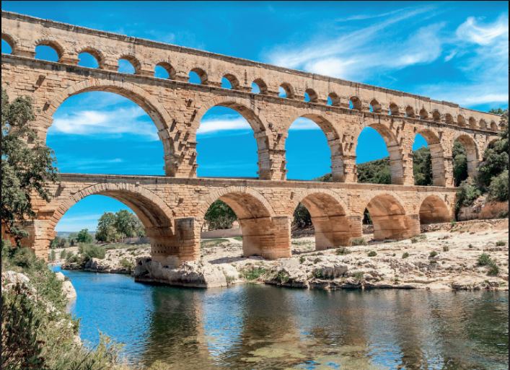
Figure 2: The Pont du Gard.
From Chapter three, there is a significant architecture that drew my interest. The Pont du Gard is a Stone architectural structure that is one of Rome’s spectacular architectures (Fiero, 77). I like the architectural structure from its beautiful appearance, which the architect designed through the arch principle and arch construction technique. I chose this piece because I admire ancient Roman architecture, which was created with phenomenal mastery. The artist made the architectural structure with wedge-shaped blocks that form a barrel or tunnel vault at the bottom part where a river flows between the semi-circular barrel closest to the viewer. The stone structures are brown, white, and grey in color and with vegetation on the front side of the structure and also on the back where the structure submerges into the vegetation. Beyond the river flowing below the barrel is dry ground which is whitish and with scarce vegetation. The structure forms domes on the lower side of the structure. Six wedge-shaped blocks support the bottom part of the horizontal structure. The other seven wedge-shaped blocks support a series of curved blocks that form arches, with the bottom part supported by the horizontal inter-joined wedge-shaped structures. The structure has post-and-lintel formed by the wedge-shaped blocks.
A similarity between the two pieces is that they both are of Roman origin. The structures are also stone-oriented designs which the Romans found possible to create. Another similarity is that the designs revolve around circular designs created with the architectural consideration of including arch principle and art construction with structures such as barrels, post-and-lintel, and cross or groined vault. A difference between the structures is the materials used. The Veduta dell’Anfiteatro Flavio deto il Colosseo is an etching created for the Roman Ruins, while the Pont du Gard is a real-world structure made of stones and sand-lime, and water and brick-and-stone rubble. Another difference is the purpose of the structures, with the Pont du Gard as a bridge across a river. At the same time, the Veduta dell’Anfiteatro Flavio deto il Colosseo refers to a performance theatre. Another difference is that the Veduta dell’Anfiteatro Flavio deto il Colosseo occupies a specific space while the Pont du Gard occupies natural space with vegetation too.
These two works are critical Roman architecture pieces that observe Roman architecture and engineering principles. The roman structures have a formal structure dependent on the function of the building. The Veduta dell’Anfiteatro Flavio deto il Colosseo theatre would serve the entertainment purposes such as gladiatorial contests, chariot races, and brutal blood sports(Fiero, 78). A value in the architectural considerations is the arch which offered excellent building options. The Pont Du Gard delivered water to the city as part of its immense capabilities.

Works cited.
Fiero, Gloria, K. Landmarks in Humanities- 5th Ed, 2021 McGraw Hill.

