CDA 4213 001L/CIS 6930 012
Fall 2021
CMOS VLSI Design

Question 1 (5 pts): NMOS Transistor

I used 2sk2654 N-Channel MOSFET for this Demonstration

Include the following

- Transistor level diagram

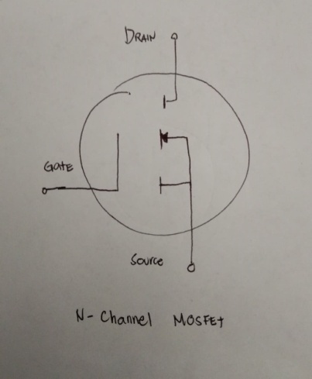

b) Screenshot of schematic



c) Waveform results

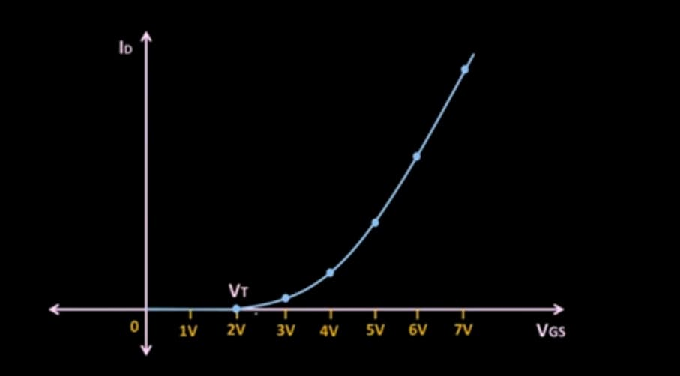

d) Explain how you demonstrate that NMOS transistor is good (poor) conductor of 0 (1).

Using the Multimeter range: Diode Test
N-Channel MOSFET

Step 1: Set Range to Diode Test
(+) Test Probe to “source”
(-) Test Probe to “drain”

Reading:
0.3V – 0.97 = Good
OV= Defective
OPEN = Defective

Step 2
(+) Test Probe to “drain”
(-) Test Probe to “source”
Reading:
No Reading = Good
OV = Defective

Step 3: Set Range to Resistance
(+) Test Probe to “source”
(-) Test Probe to “drain”

(+) Test Probe to “drain”
(-) Test Probe to “source

Reading:
High Resistance = Good
Low resistance/Shorted= Defective

Step 4:
(+) Test Probe to “gate”
(-) Test Probe to “source”

(+) Test Probe to “source”
(-) Test Probe to “gate”

Reading:
High Resistance = Good
Low resistance/Shorted= Defective

Step 5
(+) Test Probe to “gate”
(-) Test Probe to “drain”

(+) Test Probe to “drain”
(-) Test Probe to “gate”

Reading:
High Resistance = Good
Low resistance/Shorted= Defective

Question 2. (5 pts.) PMOS Transistor

- Transistor level diagram

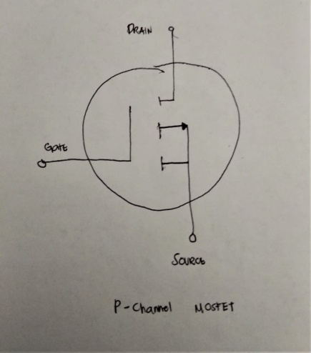

b) Screenshot of schematic

c. ) Waveform results
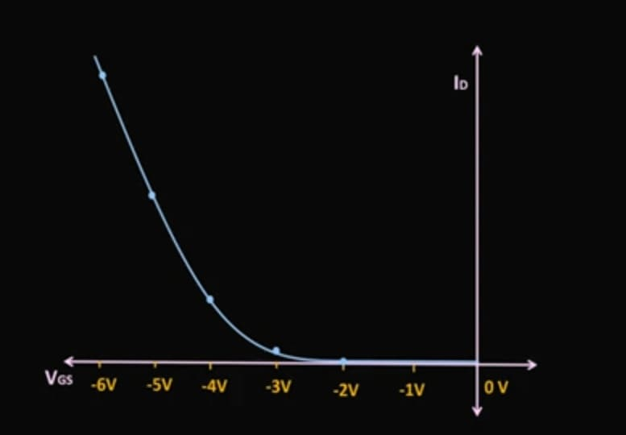

d) Explain how you demonstrate that PMOS transistor is good (poor) conductor of 1 (0).

Using the Multimeter range: Diode Test
P-Channel MOSFET

Step 1: Set Range to Diode Test
(+) Test Probe to “drain”
(-) Test Probe to “source”

Reading:
0.3V – 0.97 = Good
OV= Defective
OPEN = Defective

Step 2
(+) Test Probe to “source”
(-) Test Probe to “drain”
Reading:
No Reading = Good
OV = Defective

Step 3: Set Range to Resistance
(+) Test Probe to “source”
(-) Test Probe to “drain”

(+) Test Probe to “drain”
(-) Test Probe to “source

Reading:
High Resistance = Good
Low resistance/Shorted= Defective

Step 4:
(+) Test Probe to “gate”
(-) Test Probe to “source”

(+) Test Probe to “source”
(-) Test Probe to “gate”

Reading:
High Resistance = Good
Low resistance/Shorted= Defective

Step 5
(+) Test Probe to “gate”
(-) Test Probe to “drain”

(+) Test Probe to “drain”
(-) Test Probe to “gate”

Reading:
High Resistance = Good
Low resistance/Shorted= Defective

Question 3 (10 pts): Transmission Gate: Using Motor Control Circuit

Include the following

- Transistor level diagram

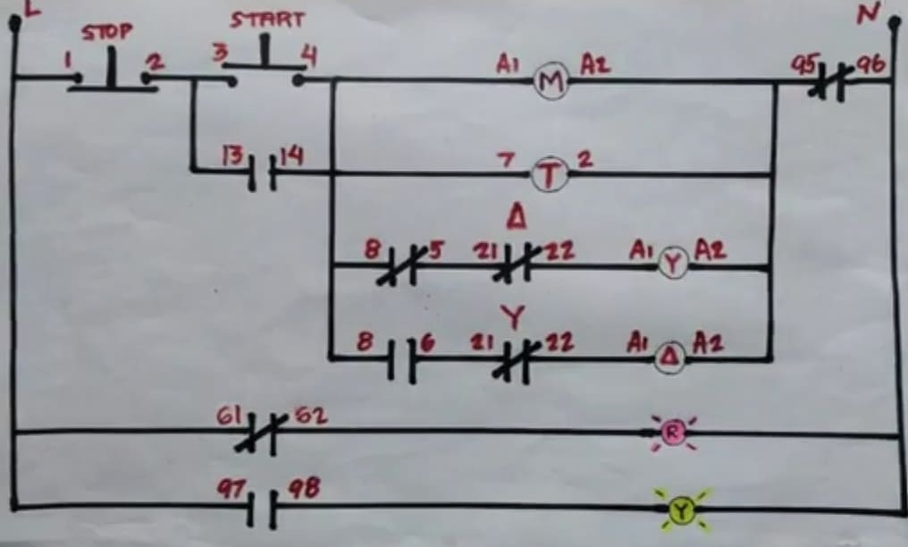

- Screenshot of schematic

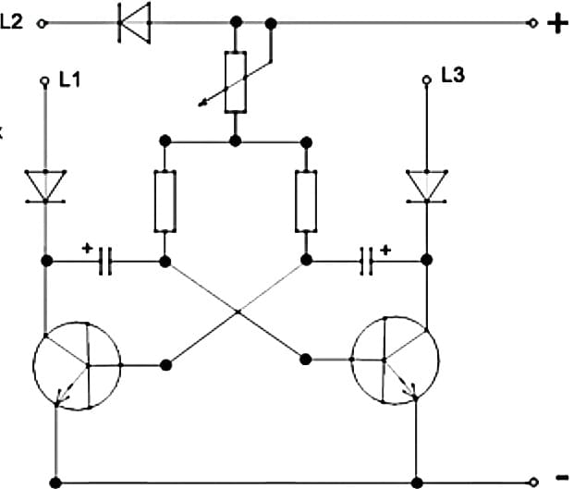

c) Waveform results
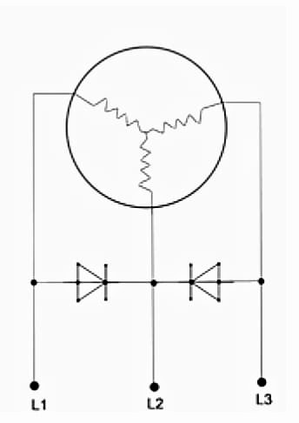
Question 4 (10 pts): 2-input Multiplexor using Motor Design
Include the following

- Transistor level diagram

- Screenshot of schematic

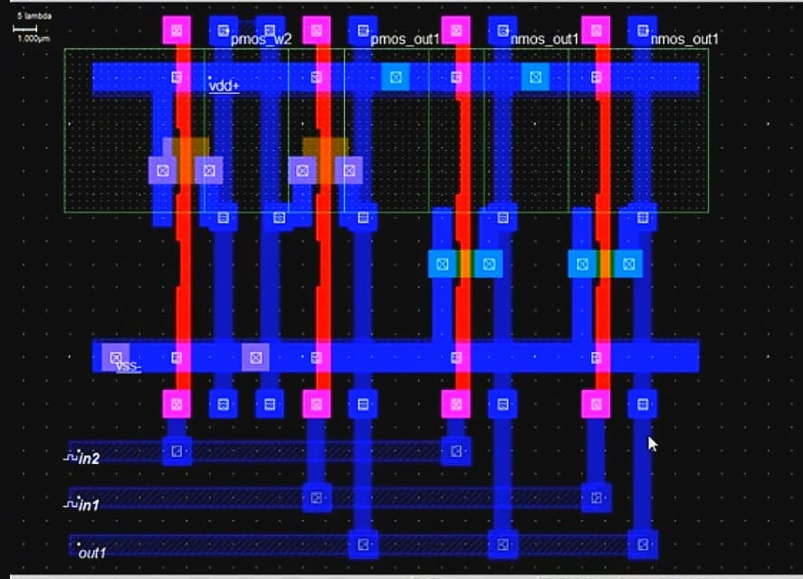

- Waveform results

