Human Development

Student Name
Institution Affiliation
Course Code
Tutor Name
Date Submitted

Human Development

Social Development
Infants between 0-2 years are social beings. From early days, infants begin to learn from the people close to them for example, mothers or caregivers. For this age, children develop relationships that encompass trust and optimism. During these formative years, the child develops personal interests and an increased desire for exploration. For preschoolers (age 3-5), the children begin to discover more about themselves (Kail & Cavanaugh, 2018). As a result, they become less dependent on their parent because their sense of identity is now profound. During this phase, the child makes friends from within the social circles. For the elementary student, his world expands beyond the family scope. They form relationships with neighbors, teachers, and others with who they interact (Rojas, 2018). The child also becomes competitive and possessive of belongings. At this phase, the child recognizes authority and rules within various contexts such as school. Adolescent social development involves adolescents distancing themselves from their parents and beginning to spend more time with their peers. They also begin engaging in romantic relationships which involve them making their own decisions without relying on parents to make every decision for them.
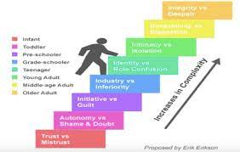

Biological Development
An infant’s biological development starts from the head downwards. At birth, the infant cannot hold up his head because the neck muscles are not strong enough. As the infants grow, the muscles develop and the infant begins to use their hands to grab objects and crawl using the limbs. For preschoolers, biological development mainly involves the development of limbs. The child can now walk without support. Elementary students develop fine motor skills which enable them to perform tasks such as dressing themselves. The child's height and weight are expected to increase within this age bracket. Adolescents' biological development is characterized by physical changes depending on the gender of the individual. Boys experience physical changes such as deepening of the voice while girls experience breast development.
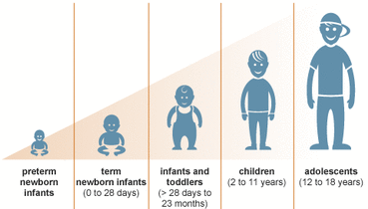

Cognitive Development
Infants are born with cognitive skills that enable them to respond to caregivers. This response includes crying and laughing. Infants can recognize familiar faces and recognize the smell of their mother’s milk. Preschoolers' cognitive development involves developing skills such as problem-solving and symbolic play (Levine & Munsch, 2016). Children are likely to ask many questions to understand their environment better. Elementary students' cognitive development also involves gaining cognitive skills such as learning, thinking, and understanding. During this phase, these skills will be more developed since the child is also going to school and interacting with friends. During the adolescent stage, cognitive skills are well developed. The child can memorize, do critical thinking, and problem-solving. However, as the child interacts with more people in various environments, the cognitive skills continue to develop.
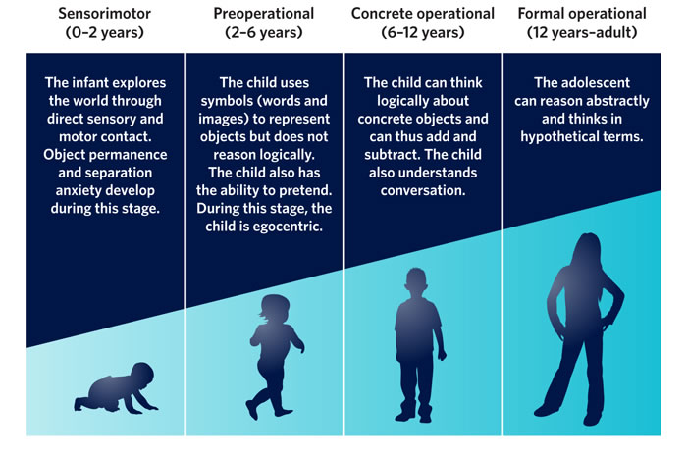

References
Kail, R. V., & Cavanaugh, J. C. (2018). Human development: A life-span view. Cengage Learning .
Levine, L. E., & Munsch, J. (2016). Child development from infancy to adolescence: An active learning approach. SAGE Publications, Inc.
Rojas, Y. (2018, October 5). The stages of child development. Children’s Health Care. https://www.chcmass.com/2018/10/05/the-stages-of-child-development/

