American History

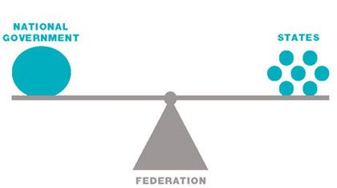
I used this image to show that when the national government joins with the state governments, they become one and share equal responsibilities such that none is on top of the other.
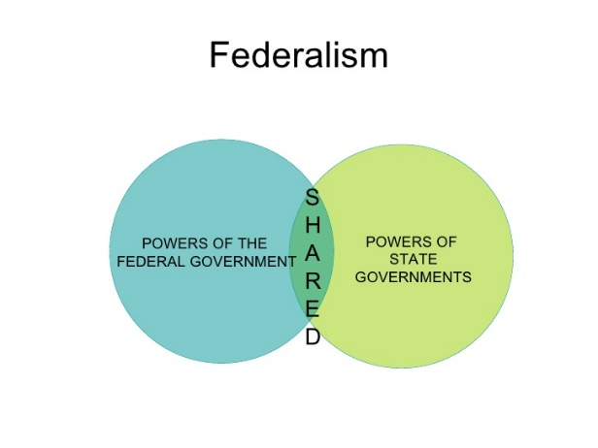
I used this image because it shows that when the two governments combine, they do not just share their responsibilities, but also power, and in this case, np government has greater power than the other.

Anti-federalism

This image is a good representation of anti-federalism because it shows how the national government increased its power. The states government was just another consideration and not a primary consideration.
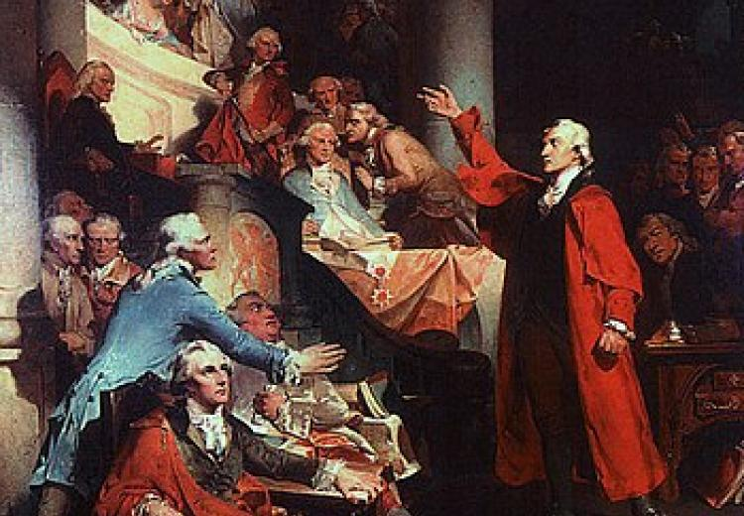
This image is a good representation of anti-federalism because it shows that one government had more power than the other governments and that they were not on the same page when dealing with Americans' needs.
- In federalism, no individual/ government has more power over the other; therefore, all citizens have equal opportunities.
Federalism also makes it easy to manage the entire government easily because it is easy to see the citizens' needs and address them.

Anti-federalism protects the citizens from any shady government surveillance, which creates more opportunities for the Americans.
Anti-federalism also managed to control and construct the economy. It claimed that the state's policies did not support the economy (Would you have been a Federalist or an Anti-Federalist? n.d.).
- I would favor federalism because the states government has greater chances of knowing what citizens want; therefore, they are likely to help achieve them.
The national government can also keep Americans in total control and deny them some fundamental rights making anti-federalism unfavorable, especially when the central government gets more power.

