University of Waterloo

MICROECONO AFM101

Answers are highlighted

Chapter 6
1)The graph shows the supply curve for a vital-to-life drug on which the government has imposed a $2 per dose sales tax.
Buyers end up paying the entire tax.
Draw and label a demand curve for this drug. The more the demand, .
- elastic; the more equally is the tax split between buyers and sellers
- elastic; the larger is the amount of the tax paid by buyers
- inelastic; the larger is the amount of the tax paid by buyers
- inelastic; the more equally is the tax split between buyers and sellers

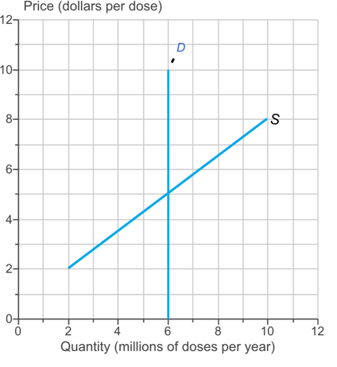

- Complete the following sentence.
The opportunity cost of a good is equal to .
- the price of the good
- the price ceiling
- the price of the good plus the value of the search time spent finding the good
- the value of the search time spent finding the good

- The graph shows the market for pillows in which the government has imposed a sales tax of $6 per pillow on sellers.
Draw a point to show the price of a pillow and the quantity of pillows bought and sold with no tax. Label it 1.
Draw a point to show the price paid by buyers and the quantity of pillows bought following the tax. Label it 2.
Draw a point to show the price received by sellers and the quantity of pillows sold following the tax. Label it 3.
The tax is .
- paid by buyers and not sellers because tax is always added to the sale price at the check-out
- split between sellers and buyers, with buyers paying more than sellers
- paid by sellers and not buyers because the government imposed the tax on sellers
- split evenly between sellers and buyers
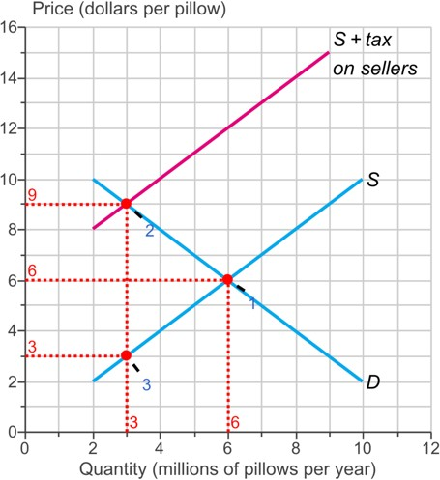

- Complete the following sentence.
In a black market for housing, the rent paid is .
- close to the unregulated rent if there is strict enforcement of the rent ceiling
- independent of how tightly the rent ceiling is enforced
- equal to the rent ceiling
- close to the unregulated rent if there is loose enforcement of the rent ceiling

- Complete the sentence.
In the labour market, the supply curve measures the marginal social cost of labour to , and the demand curve measures the .
- workers; marginal social benefit from labour
- firms; consumer surplus earned by the people who buy the goods produced
- firms; marginal social benefit from labour
- workers; consumer surplus earned by the people who buy the goods produced

- The graph shows the market for apartments in Kitchener, Ontario. Suppose there is a strictly enforced $1,200 rent ceiling in this market.
With the rent ceiling, the market is because .
- inefficient; the marginal social cost of the last apartment rented is greater than its marginal social benefit
- inefficient; the marginal social benefit from the last apartment rented is greater than its marginal social cost
- efficient; a rent ceiling gives poorer people greater access to housing
- efficient; the marginal social cost of the last apartment rented is greater than its marginal social benefit

- With the rent ceiling, the housing market is by the fair rules view of fairness and by the fair results view of fairness.
- unfair; fair
- fair; unfair
- fair; fair
- unfair; unfair
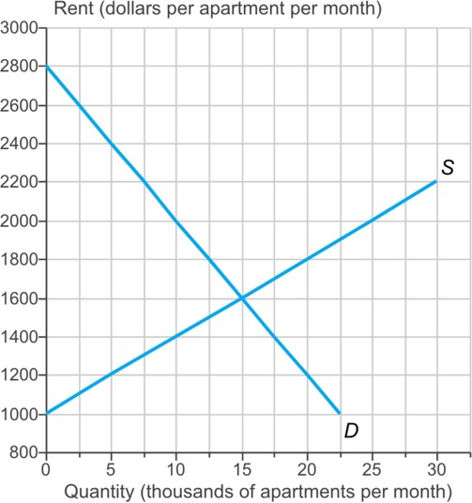

- The table shows the market for chocolate bars. A tax of $0.20 per chocolate bar is imposed on sellers.
What is the new price of a chocolate bar? Who pays the tax? The new price of a chocolate bar following the tax is
$1.40.
The tax is .
- paid totally by the seller
- split between the buyer and the seller
- paid totally by the buyer

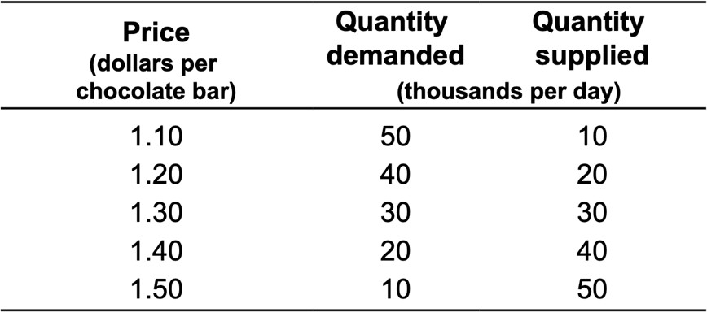

- Complete the sentence.
A fact that argues in favour of prohibition and against taxes on illegal drugs is that .
- search activity decreases with prohibition
- prohibition sends a signal that might influence preferences
- a black market is easier to maintain under prohibition than under the tax code
- penalties for illegal activities with prohibition are less than the penalties for tax evasion

- The graph shows the market for dried milk.
Draw a point at the equilibrium price and quantity. Label it 1.
Now the Milk Marketing Board places an effective production quota on dried milk. Draw a vertical line that shows the production quota. Label it Quota.
Draw a point to indicate the new price of milk and the quantity of milk produced. Label it 2.

An effective production quota .
- makes marginal benefit less than marginal cost
- makes marginal benefit equal to marginal cost
- is efficient
- lowers the marginal cost of production

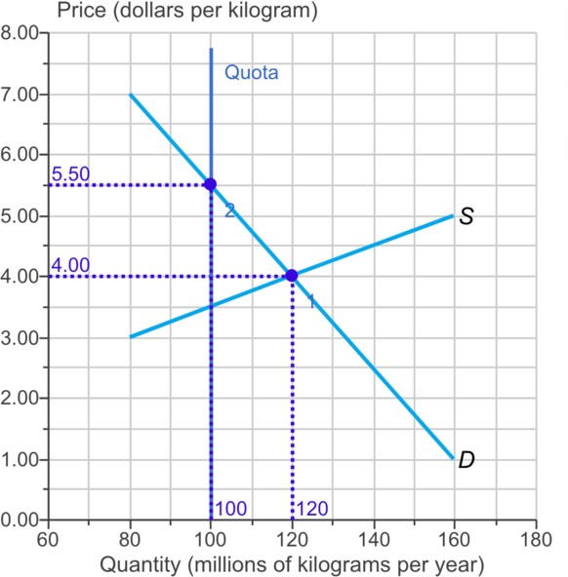

- Complete the sentence.
When a minimum wage is set above the equilibrium wage rate, .
- the supply of workers decreases
- job search activity decreases
- unemployment increases
- unemployment decreases

- The graph shows the demand curve for coal. The government imposes a sales tax on coal. It turns out that the buyers end up paying the entire tax.
Draw the supply curve of coal. Label it S .
Draw a second supply curve that shows the effect of the tax. Label it S + tax.
>>> Make sure your supply curves intersect the demand curve. The more the supply, .
- elastic; the larger is the amount of the tax paid by sellers
- inelastic; the larger is the amount of the tax paid by buyers
- elastic; the larger is the amount of the tax paid by buyers
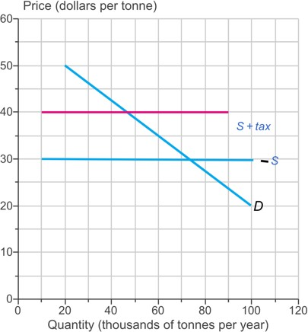
- elastic; the more equally is the split of the tax between buyers and sellers
- Draw a line corresponding to an ineffective rent ceiling. Label it Ineffective. Draw a line corresponding to an effective rent ceiling. Label it Effective.
A price ceiling .
- is a regulation that makes it illegal to offer less than a specified quantity of a good or service for sale
- set below the equilibrium price encourages illegal trading in a black market
- is a regulation that makes it illegal to offer more than a specified quantity of a good or service for sale
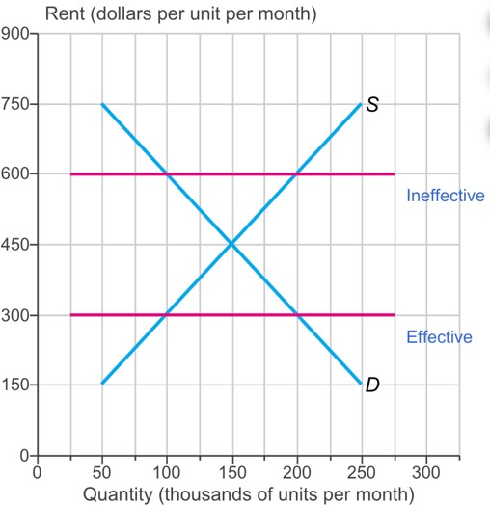
- always prevents the price from regulating the quantities demanded and supplied

- The graph shows the market for pillows in which the government has imposed a sales tax of $4 per pillow on buyers.
Draw a point to show the price of a pillow and the quantity of pillows bought and sold with no tax. Label it 1.
Draw a point to show the price paid by buyers and the quantity of pillows bought with the tax. Label it 2.
Draw a point to show the price received by sellers and the quantity of pillows bought with the tax. Label it 3.
The incidence of tax depends on .
- the tax laws
- how motivated the firm is to make the sale
- the price elasticity of demand and the price elasticity of supply
- the deadweight loss created by the tax

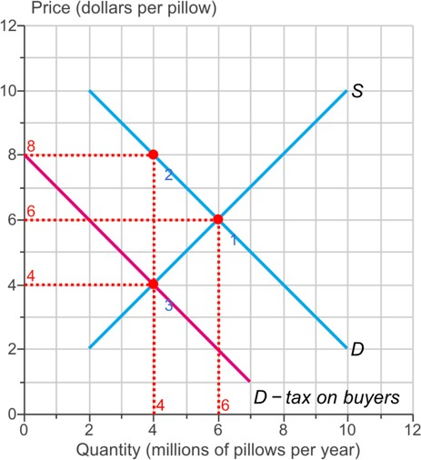

  - The graph shows the market for drugs.
Draw a point at the market equilibrium if drugs are legal goods and traded freely. Label it 1.
Draw a curve that shows what happens if drugs are made illegal and suppliers face penalties for selling drugs. Label it. (Note: CBL is short for Cost of Breaking the Law.)
Draw a point at the market price and quantity in the illegal drug market. Label it 2. When selling drugs is illegal, the cost of breaking the law is .
- added to the minimum supply-price and subtracted from the maximum price buyers are willing to pay
- subtracted from the minimum supply-price
- added to the minimum supply-price
- subtracted from the minimum supply-price and added to the maximum price buyers are willing to pay

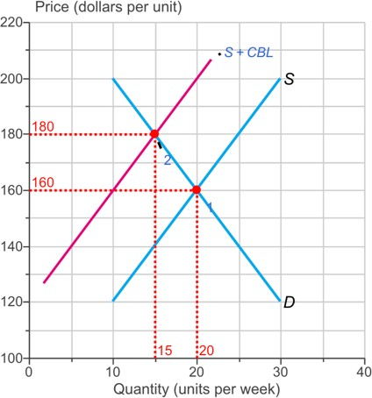

  - The graph shows the market for dried milk.
The government decides to subsidize the production of dried milk by $2 a kilogram. Draw a curve that shows how the subsidy changes supply. Label it
Sminus−sub.
Draw a point at the new equilibrium price and quantity.
In the graph, when the $2 a kilogram subsidy is introduced .
- the marginal cost of milk decreases.
- the price falls by less than $2 a kilogram and the quantity increases.
- the price falls by $2 a kilogram and the quantity increases.
- the marginal cost of milk increases and the quantity of milk decreases.

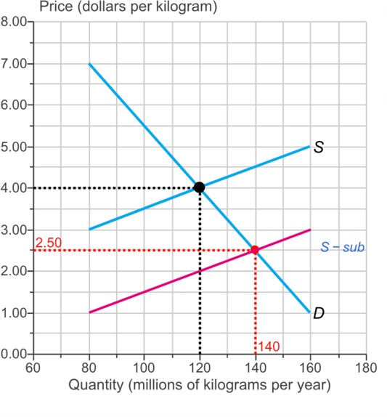

19) The graph shows a market for labour.
Draw a line corresponding to a minimum wage that creates unemployment of 3 million hours a year. Label it.
>>> Make sure the minimum wage line intersects the S and D curves. A minimum wage is a applied to labour markets.
- quantity ceiling
- quantity floor
- price ceiling
- price floor

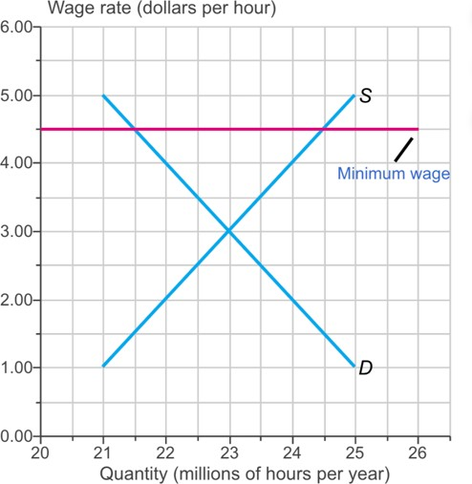

Complete the sentence.
20. The minimum wage delivers result and imposes rule.
- an unfair; an unfair
- an unfair; a fair
- a fair; a fair
- a fair; an unfair

CHAPTER 6B
  - The graph shows the market for books.
The market for books initially has no taxes and is in competitive equilibrium. Then a tax of $6 a book is imposed on the sellers of books.
What is the tax paid by sellers on a book and what is the tax paid by buyers on a book? The tax paid by the seller is a book and the tax paid by the buyer is a book.
A. $0; $6
B. $4; $2

C. $3; $3
D. $6; $0
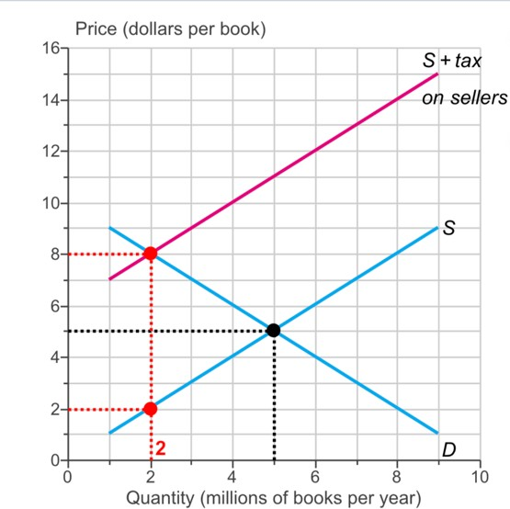

  - The graph shows the supply curve of no-name soda. The government has imposed a sales tax of $2 per case on no-name soda.
The sellers of no-name soda end up paying the entire tax. Draw and label the demand curve for no-name soda.
The more the demand, .
- inelastic; the larger is the amount of the tax paid by sellers
- inelastic; the more equally is the tax split between buyers and sellers
- elastic; the more equally is the tax split between buyers and sellers

elastic; the larger is the amount of the tax paid by sellers

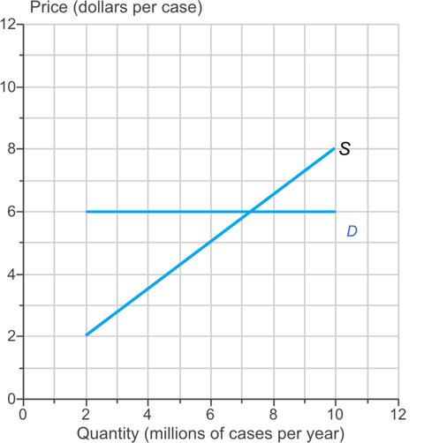

  - Complete the sentence.
When an effective minimum wage is introduced, the number of hours of labour employed is determined by the and the .

demand for labour; minimum wage
- supply of labour; minimum wage
- supply of and demand for labour; the minimum wage
- demand for labour; supply of labour

  - Choose the statement that is correct.
- The minimum wage results in decreased job search.
- An unregulated labour market cannot allocate the economy's scarce labour resources to the jobs in which they are valued most highly.

In a labour market with an effective minimum wage, the marginal social benefit of labour is greater than its marginal social cost.
- The marginal social benefit from labour to workers is leisure forgone.

  - Complete the following sentences.
When a subsidy is paid to potato growers, the market equilibrium quantity of potatoes and maket price .
A. decreases; falls B. increases; falls
- increases; rises
- decreases; rises

In the market for potatoes, the marginal social cost marginal social benefit.
- is less than

exceeds
- equals

  - A fact that argues in favour of taxes on illegal drugs and against prohibition is that .
- penalties for tax evasion are less than the penalties for illegal activities under prohibition
- a black market is easier to maintain under the tax code than under prohibition

the tax revenue can be used to make law enforcement more effective
- search activity decreases with higher taxes

  - Choose the statement that is correct.

When a price is regulated and there is a shortage, search activity increases.
- Search activity occurs only in markets where there is a shortage.
- Search activity decreases the cost of housing in a rent-controlled market.
- The opportunity cost of a good is equal to its price.

  - The graph shows the market for office space in a crowded city centre. The government has imposed a sales tax on city centre office space.
It turns out that the sellers end up paying the entire tax. Draw and label the supply curve of city centre office space.

The more the supply, .
- inelastic; the larger is the amount of the tax paid by buyers

inelastic; the larger is the amount of the tax paid by sellers
- elastic; the larger is the amount of the tax paid by sellers
- elastic; the more equally is the split of the tax between buyers and sellers
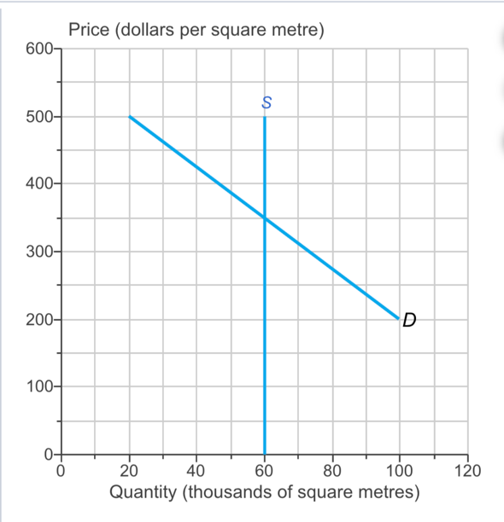

  - The graph shows the market for housing with a strictly enforced rent ceiling. Draw a point at the maximum black market rent.
Draw an arrow that shows the housing shortage at the rent ceiling price. Draw the arrow at the rent ceiling price.
With loose enforcement of a rent ceiling, .
- the market for housing is efficient

the black market rent is close to the unregulated rent
- the black market does not exist
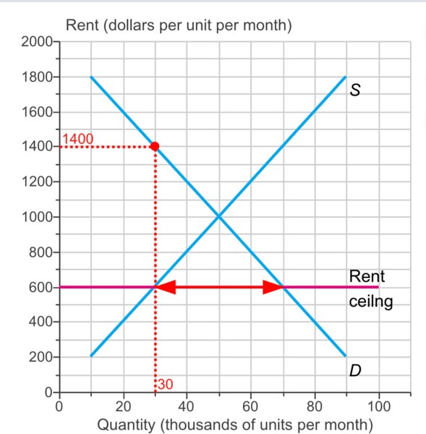
- the black market rent is equal to the minimum price that renters are willing to pay

- A minimum wage set above the equilibrium wage rate .
- creates more prosperity among younger people
- creates more employment opportunities for low-skilled workers
- increases the number of good paying jobs available to young people

creates unemployment

- Choose the statement that is correct.
- The benefits principle results in a tax system that is efficient and fair.
- The ability-to-pay principle can justify high fuel taxes to pay for freeways and high taxes on alcoholic beverages and tobacco products to pay for public health-care services.
- The ability-to-pay principle results in a tax system that is efficient and fair.

The benefits principle is a fair arrangement because it means that those who benefit most pay the most taxes.

- Complete the following sentences.
When an effective production quota is applied in the market for rice, the quantity produced and the price .
- decreases; falls

decreases; rises
- increases; rises
- increases; falls

- When an effective production quota is applied in the market for rice, the marginal social benefit marginal social cost.
- is less than

exceeds
- equals

- When the rent is not permitted to allocate scarce housing, .
- a fair allocation method is first-come, first-served
- a fair allocation method is a lottery
- a fair allocation method is discrimination

neither a lottery nor first-come, first-served is a fair allocation method

- The table shows the market for apartments.
If a rent ceiling is set at $900 a month, what is the housing shortage?
If a rent ceiling is set at $1,500 a month, what is the housing shortage?
If a rent ceiling is set at $900 a month, the housing shortage is apartments a month.
300
If a rent ceiling is set at $1,500 a month, the housing shortage is
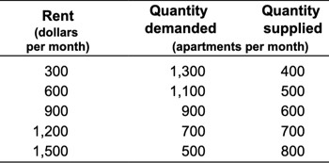
apartments a month.
0

- Choose the statement about an effective minimum wage that iscorrect.
- The minimum wage imposes a fair rule because it is legislated by the government and passed into law by majority rule.

The result of the minimum wage is unfair because only those people who have jobs and keep them benefit from the minimum wage.

- The minimum wage is a fair rule because otherwise low-skill workers would earn a lower wage.
- The result of the minimum wage is fair because those who find jobs are the least well off.

- The graph shows the market for books.
The market for books initially has no taxes and is in competitive equilibrium. Then a tax of $4 a book is imposed on the buyers of books.
What is the tax paid by sellers on a book and what is the tax paid by buyers on a book? The tax paid by the seller is a book and the tax paid by the buyer is a book.
A. $0; $4
B. $1; $3
C. $4; $0
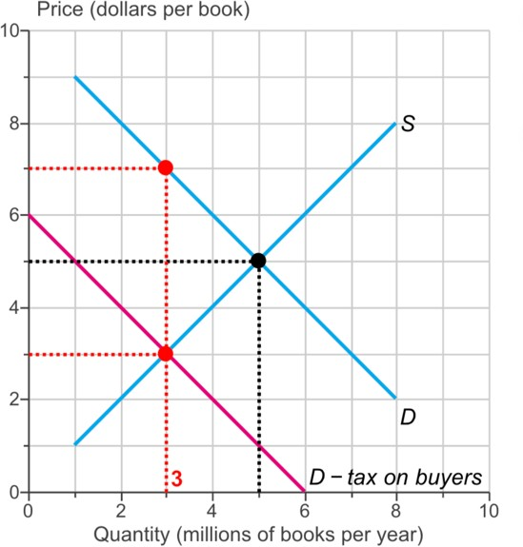
D. $2; $2

- Concerned about the political fallout from rising gas prices, the government decides to impose a price ceiling on gasoline of $4.00 a litre. If the oil´producing nations increase production and drive the equilibrium price of gasoline to §3,00 a litre, . The market for gasoline is .
    - A shortage of gasoline emerges and a black market emerges: efficient
    - a surplus of gasoline emerges and a black market emerges ; inefficient
    - a shortage of gasoline emerges and a black market emerges inefficient
    - a surplus of gasoline emerges and a black market does not emerge, efficient
    - neither a surplus nor a shortage of gasoline emerges and a black market does not emerge; efficient.

